BudgetMinder

# User’s manual

## Tim Mcvicker

## Clemson CPSC4820

## spring 2017

### Table of Contents

##### Introduction 3

##### Abstract 4

##### Benefits of use 5

##### Before you log in for the first time 6

##### Logging in for the first time 7

##### Your home screen 8

##### Transactions 9

##### Updating your profile 10

##### Introduction

This manual is intended for those who wish to download and use the Android Application *BudgetMinder*. The manual will provide a thorough overview of the application and its different functions.

The target audience for the application *BudgetMinder* is all adults or people in control of their own finances. The application is intended to be more attractive to younger people who are still trying to figure out how best to control their budget due to its simplistic design and ease of use.

##### Abstract

*BudgetMinder* is an application that will track and remember purchases and incomes that a user enters through the app. It will keep track of how much money a user has (their balance), and help to alert the user when he or she is spending over what they should. It will provide detailed statistics of expenses and suggestions for how to save more money. There will be multiple users and each user will be able to specify a location for their expense. The application will then display statistics based on the sum of all users’ expenses, and will use these statistics to suggest deviations to everyday expenses that will help the user.

##### Benefits of use

*BudgetMinder* will help users keep better track of their finances, and hopefully empower them to make better choices regarding purchases. It will increase their financial awareness and help compare their spending to the average person. It will also serve as a purchase history for users, to help compare with account statements and answer their own questions about where their money went.

##### Before you Log in for the first time

In order to ensure that all features of the application work appropriately, please ensure that your Android device has access to the Internet.

Please ensure to download the correct application and ensure that you are able to launch the application without it crashing.

Please have your current balance on hand, as it will need to be entered upon registering for an account.

##### Logging in for the first Time

If you have not created an account, please click on the **Register** button on the Login page of *BudgetMinder:*

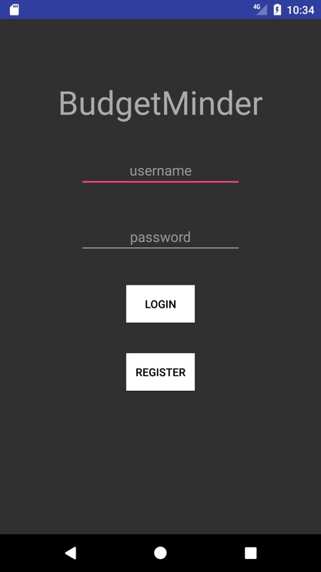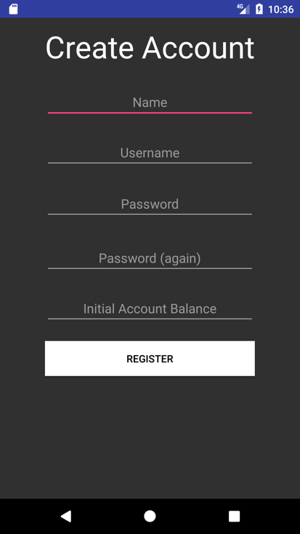

You should then enter your information as prompted. After clicking the second **Register** button, your account information will be added to our list of users and you will be redirected to the Login page. Enter the account information you just created and click **Login.**

##### your home screen

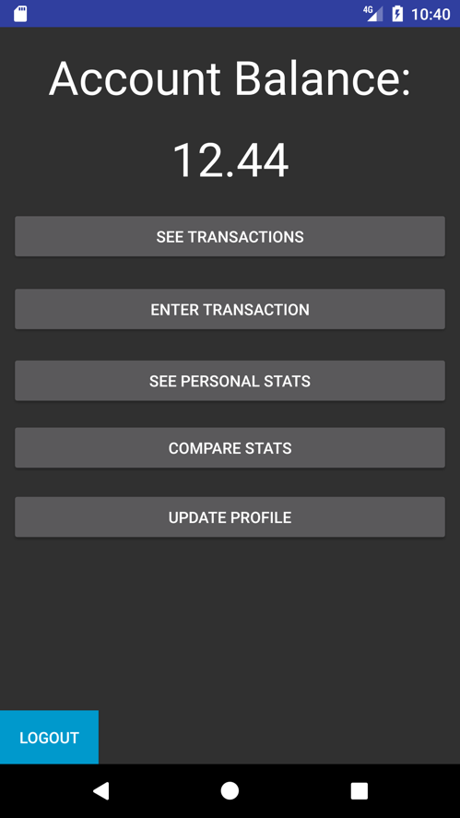After logging in every time that you access the application, you will see the same home screen below. Each option will serve a purpose, which is briefly explained below.

The number you see at the top of your screen is your current account balance, as calculated by your entries. From the home screen, you are able to see a list of your entered transactions, you are able to enter new transactions, you are able to display statistics about your transactions as well as compare those statistics to other users, and you are able to update your username, name, or password.

##### Transactions

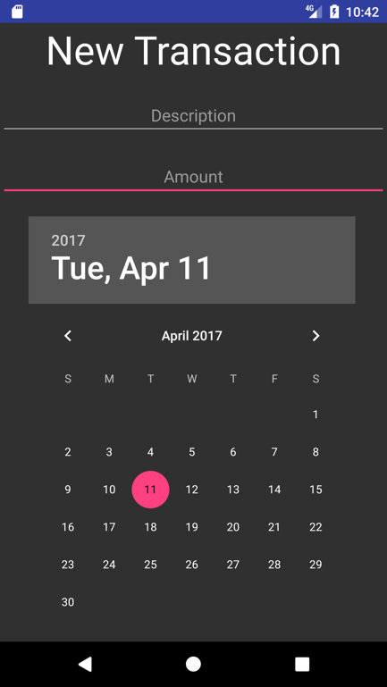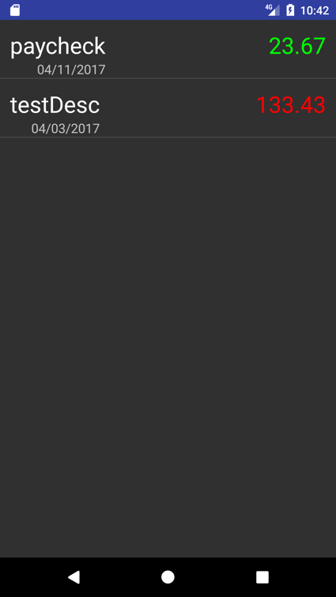

By clicking on the **See Transactions** option on the home screen, you will be redirected to the screen on the left. This screen will list all of your recent transactions in order of newest to oldest. The description, date, and amount of your transaction will be listed. If you have no transactions so far, the application will alert you to that. Amounts that are in green were input as Incomes, and amounts that are in red were input as Expenses.

By clicking on the **Enter Transaction** option on the home screen, you will be able to create new transactions. You will give each transaction a name (description), an amount, a date, and you will be able to select the type of transaction that it is (expense/income). After clicking add on the New Transaction screen, you will see the transaction displayed on the transaction list.

##### Updating your profile

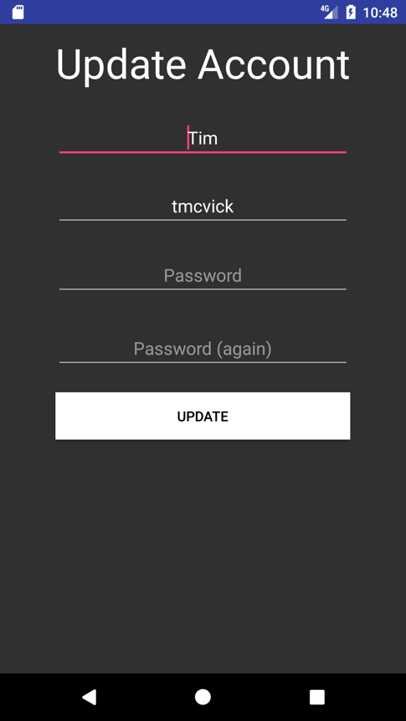

By clicking on the **Update Profile** option on the home screen, you will be redirected to the screen above. Your username and name will be preloaded into the form, but your password will not. You have the option of editing either name fields, and you **MUST** enter either a new password or the previous password. You can hit the back button on your device at any time to exit the update and it will not update your account until after you click **Update.**