BudgetMinder

# User’s manual

## Tim Mcvicker

## Clemson CPSC4820

## spring 2017

### Table of Contents

##### Introduction 3

##### Abstract 4

##### Benefits of use 5

##### Before you log in for the first time 6

##### Logging in for the first time 7

##### Your home screen 8

##### Transactions 9

##### PErsonal Statistics 12

##### Compare Statistics 13

##### Updating your profile 14

##### Introduction

This manual is intended for those who wish to download and use the Android Application *BudgetMinder*. The manual will provide a thorough overview of the application and its different functions.

The target audience for the application *BudgetMinder* is all adults or people in control of their own finances. The application is intended to be more attractive to younger people who are still trying to figure out how best to control their budget due to its simplistic design and ease of use.

##### Abstract

*BudgetMinder* is an application that will track and remember purchases and incomes that a user enters through the app. It will keep track of how much money a user has (their balance), and help to alert the user when he or she is spending over what they should. It will provide detailed statistics of expenses and suggestions for how to save more money. There will be multiple users and each user will be able to specify a location for their expense. The application will then display statistics based on the sum of all users’ expenses, and will use these statistics to suggest deviations to everyday expenses that will help the user.

##### Benefits of use

*BudgetMinder* will help users keep better track of their finances, and hopefully empower them to make better choices regarding purchases. It will increase their financial awareness and help compare their spending to the average person. It will also serve as a purchase history for users, to help compare with account statements and answer their own questions about where their money went.

##### Before you Log in for the first time

In order to ensure that all features of the application work appropriately, please ensure that your Android device has access to the Internet.

Please ensure to download the correct application and ensure that you are able to launch the application without it crashing.

Please have your current balance on hand, as it will need to be entered upon registering for an account.

##### Logging in for the first Time

If you have not created an account, please click on the **Register** button on the Login page of *BudgetMinder:*

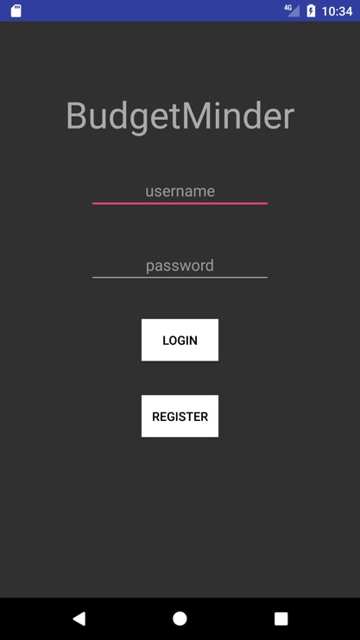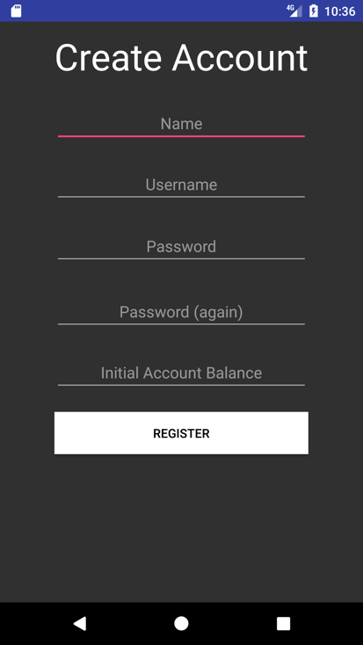

You should then enter your information as prompted. After clicking the second **Register** button, your account information will be added to our list of users and you will be redirected to the Login page. Enter the account information you just created and click **Login.**

##### your home screen

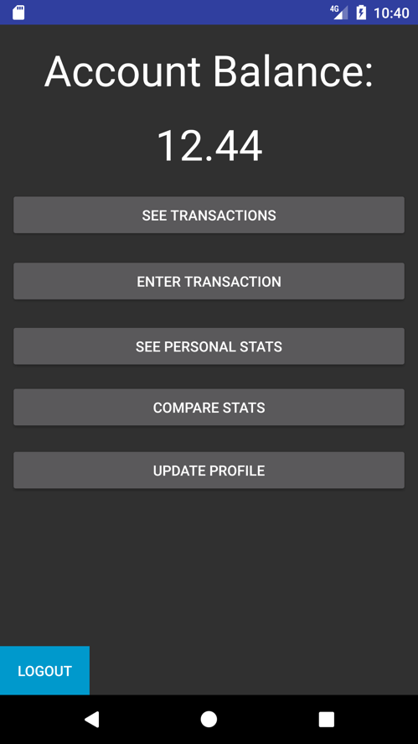After logging in every time that you access the application, you will see the same home screen below. Each option will serve a purpose, which is briefly explained below.

The number you see at the top of your screen is your current account balance, as calculated by your entries. If the balance is negative, then it shows up in bright red. From the home screen, you are able to see a list of your entered transactions, you are able to enter new transactions, you are able to display statistics about your transactions as well as compare those statistics to other users, and you are able to update your username, name, or password.

##### Transactions

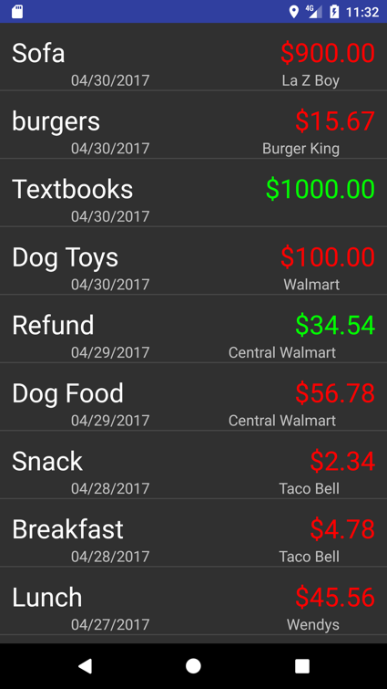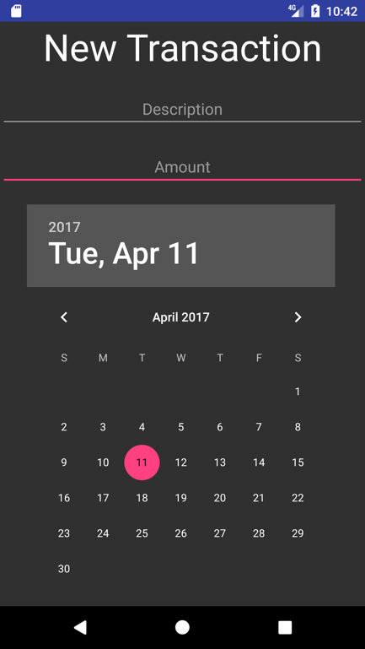

By clicking on the **See Transactions** option on the home screen, you will be redirected to the screen on the left. This screen will list all of your recent transactions in order of newest to oldest. The description, date, amount, and location of the transaction will be listed. If you have no transactions so far, the application will alert you to that. Amounts that are in green were input as Incomes, and amounts that are in red were input as Expenses.

By clicking on the **Enter Transaction** option on the home screen, you will be able to create new transactions. You will give each transaction a name (description), an amount, a date, and you will be able to select the type of transaction that it is (expense/income). After clicking add on the New Transaction screen, you will be prompted to input the location, seen below.

##### ../../../Desktop/Screenshot_1493176591.pngTransactions (Cont.)

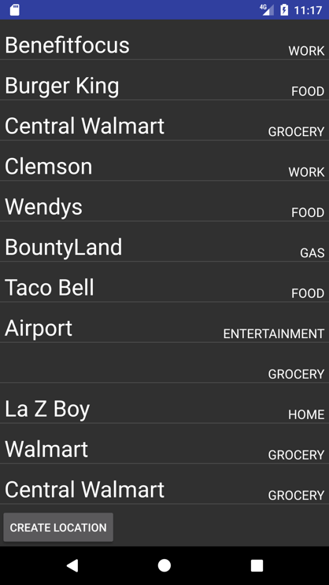

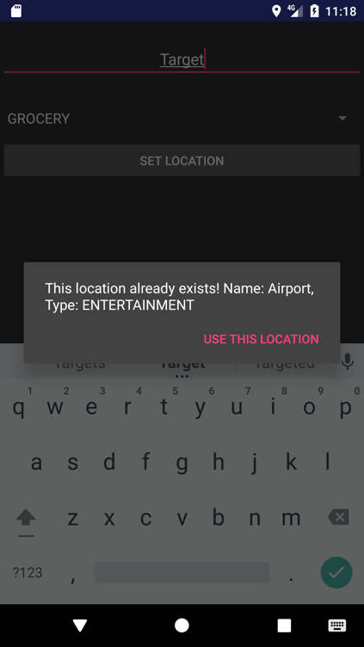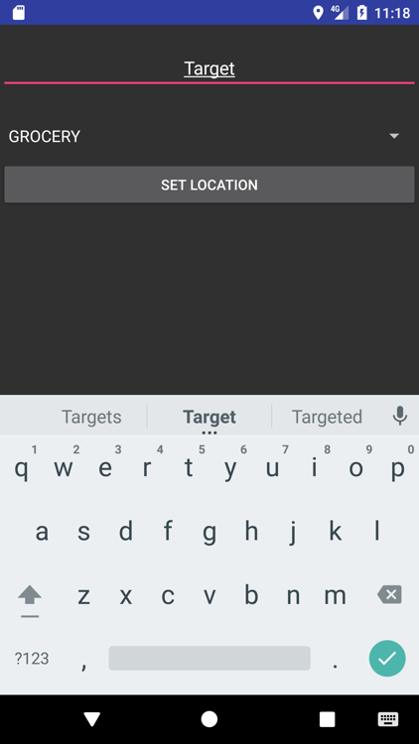Figure A Figure D

Figure B Figure C

##### Transactions (Cont.)

When clicking **Add** on the New Transactions screen, you will be shown the prompt in Figure A. This location will be the location that the transaction is listed at. By selecting the **Create New** option, you will be redirected to the screen in Figure B. Here you will enter the name of the location, and you will select the type of location from the dropdown (these options are pre-populated). When you click **Set Location**, the application will use your GPS to set the location to your current location. If it is the first time you are using the application, you may be prompted for permission. Please click **Allow**. If there is already a location that exists at your current location, you will be shown the prompt in Figure C, and your new location will not be created. Finally, by clicking **Search** in Figure A, you will be redirected to the screen in Figure D. This contains a list of all known locations, with a name and type. Clicking any item in this list will select it and set the transaction location to that location. After setting the location, you will be redirected back to the **Home Screen**.

##### Personal Statistics

By clicking on the **See Personal Stats** option on the home screen, you will be redirected to the page below. This page lists statistics that are unique to you. You will see up to three of your most frequented locations, with the name, type, and total money spent/earned at that location. You will then see the total amount that you have spent and the total amount that you have earned since creating a BudgetMinder account, according to your transaction history.

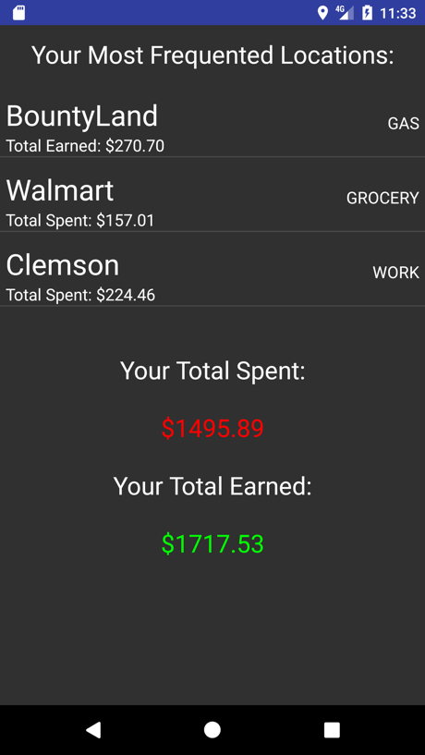

##### Compare STatistics

By clicking on the **Compare Stats** option on the home screen, you will be redirected to the page below. This page lists statistics that refer to all users of BudgetMinder. You will see up to three of the overall most frequented locations, with the name, type, and total money spent/earned at that location. You will then see the total amount that users have spent and the total amount that users have earned since creating a BudgetMinder account, according to the transaction history that each user has entered.

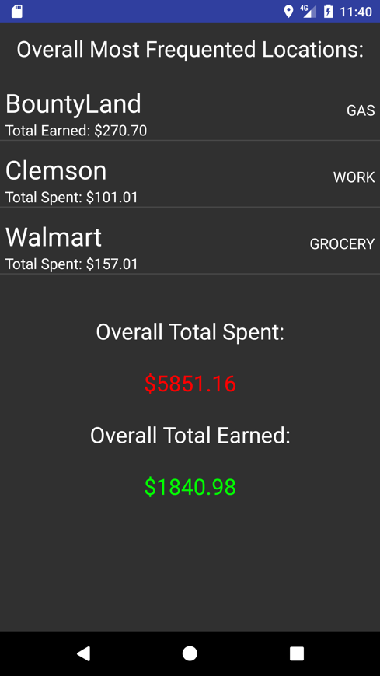

##### Updating your profile

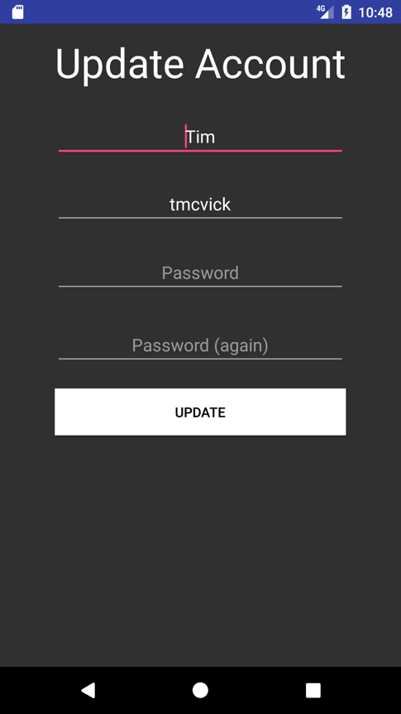

By clicking on the **Update Profile** option on the home screen, you will be redirected to the screen above. Your username and name will be preloaded into the form, but your password will not. You have the option of editing either name fields, and you **MUST** enter either a new password or the previous password. You can hit the back button on your device at any time to exit the update and it will not update your account until after you click **Update.**