**CPSC X82: Mobile Device Programming Using iOS**

**Preliminary Project Proposal (Assignment P0)**

**Due 12:00 noon, Wednesday, March 15, 2017**

**(Submit through handin.)**

**App Name:** (ten words or less)

BudgetMinder

**Team Members (first name is Team Leader):**

Tim McVicker

**Project Description:**

Target audience: All adults or people in control of their own finances. It will probably be more attractive to younger people who are still trying to figure out how best to control their budget.

Target device: Both

Abstract:

BudgetMinder is an app that will track and remember purchases and incomes that a user enters through the app. It will keep track of how much money a user has, and help to alert the user when he or she is spending over what they should. It will provide detailed statistics of expenses and suggestions for how to save more money. Because there will be multiple users, each user will be able to specify a location for their expense. The app will then display statistics based on the sum of all users’ expenses, and will use these statistics to suggest deviations to everyday expenses that will help the user.

Benefits:

This app will help users to keep better track of their financials, and hopefully empower them to make better choices regarding purchases. It will increase their financial awareness and help compare their spending to the average person. It will also serve as a purchase history for users, to help compare will account statements and their own questions about where their money went.

Technical Features:

* GPS: will be used to show locations for spending
* Phone notifications to alert user of actions

Additional devices:

None

Internal Database:

Yes I will need to maintain a local copy of the user’s information and input because not all the information/entries need to be accessible to others, and its more efficient.

External database:

Yes it will maintain an external database in order to gather statistics of other users’ spending.

Functionality:

1. Allow a user to register and create an account
2. Allow a user to change their password/username/name
3. Allow users to enter purchases and incomes
4. Keep track of user's balance and display to the user
5. Display purchase/income history
6. Allow user to enter location of purchase
7. Show statistics of user’s purchases/incomes based on location
8. Allow user to use GPS for location
9. Auto-complete location based on GPS/preset locations
10. Allow user to save location as a preset location
11. Show statistics of other users compared to user

Schemas:

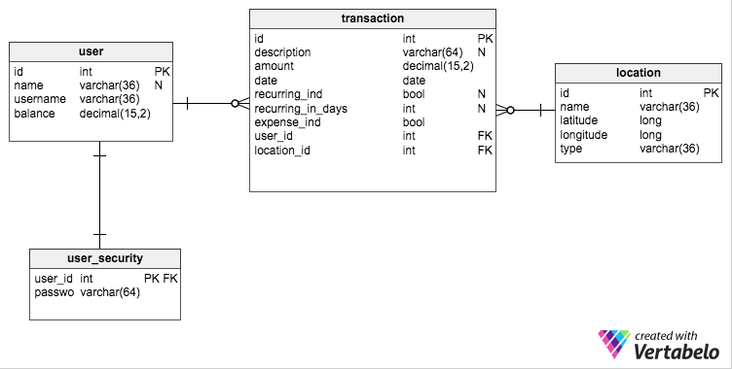

The internal database will have all three tables except the user_security table. The only rows that will be synced with the external database are rows where the user_id is located in the internal database’s user table.

Storyboard:

