Assignment 10 Report

Professor Nelson

By Tyler Medina

5/1/17

**Part 1**

**1.1 Using cosine to get the knn**

To get the cosine between the 1000 dimension vectors, I replaced the euclidean() function with a cosine() function. The knnestimate() functionuses this distance to compute the nearest neighbors.

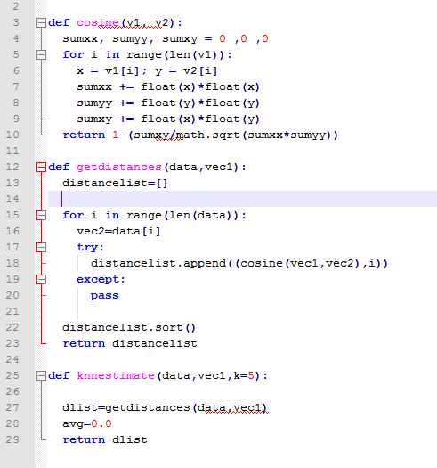

**1.2 Nearest Neighbors for f-measure**

When k=1:



When k=2:



When k=5:

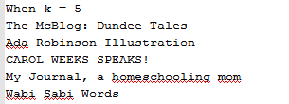

When k=10:



Whenk=20:



**1.3 Nearest neighbor for ws-dl**

When k=1:



When k=2:



When k=5:

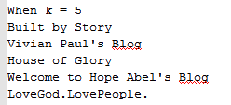

When k=10:



When k=20:

