Assignment 7 Report

Professor Nelson

By Tyler Medina

4/6/17

**Part 1**

**1.1 Getting Substitute Candidates**

To get candidates to substitute me for the assignment, I searched the data set for people that had a similar age (23), gender (male), and occupation (student). I decided to use the first three hits that were returned. This ended up being users 33, 37, and 66.

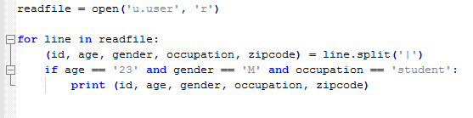

**1.2 Finding the Right Substitute**

I used the loadMovieLens function provided in the textbook to get the all the movies my substitute candidates reviewed. With the full list, I could manually see the top 3 movies and bottom 3 movies each candidate had rated.

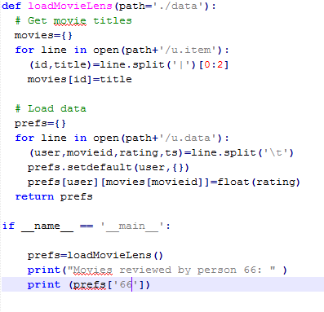

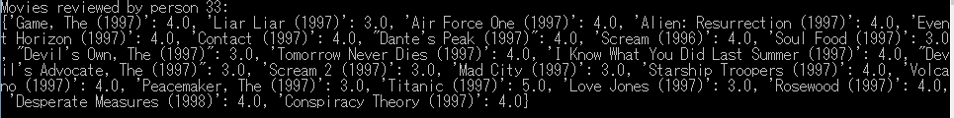

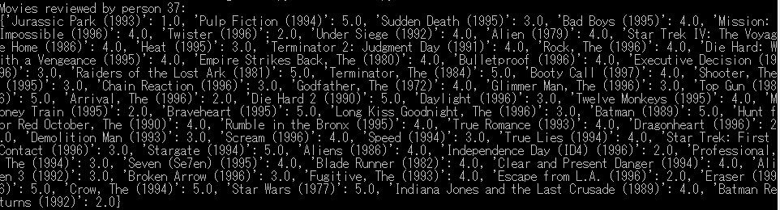

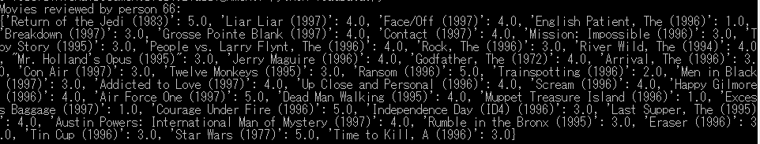

**1.3 Analysis**

By taking the data I gathered, I could create this table below to organize the data. This makes it simple to pick out the person that would best represent my taste in movies in this assignment.

Person 33’s top 3:

|  |  |
| --- | --- |
| Movie Title | Rating |
| Titanic (1997) | 5.0 |
| Air Force One | 4.0 |
| Alien: Resurrection (1997) | 4.0 |

Person 33’s bottom 3:

|  |  |
| --- | --- |
| Movie Title | Rating |
| Liar Liar (1997) | 3.0 |
| Soul Food (1997) | 3.0 |
| Devil’s Own, The (1997) | 3.0 |

Person 37’s top 3:

|  |  |
| --- | --- |
| Movie Title | Rating |
| Pulp Fiction (1994) | 5.0 |
| Raiders of the Lost Ark (1981) | 5.0 |
| The Terminator (1984) | 5.0 |

Person 37’s bottom 3:

|  |  |
| --- | --- |
| Movie Title | Rating |
| Jurassic Park (1993) | 1.0 |
| Twister (1996) | 2.0 |
| The Arrival (1996) | 2.0 |

Person 66’s top 3:

|  |  |
| --- | --- |
| Movie Title | Rating |
| Return of the Jedi (1983) | 5.0 |
| Air Force One (1997) | 5.0 |
| Ransom (1996) | 5.0 |

Person 66’s bottom 3:

|  |  |
| --- | --- |
| Movie Title | Rating |
| English Patient, The (1996) | 1.0 |
| Muppet treasure Island (1996) | 1.0 |
| Excessive Baggage (1997) | 1.0 |

The person that would most accurately represent me is person 37. I was close to choosing person 33, but the gave Alien: Resurrection a 4.0, and that’s unacceptable. Person 66 was appealing, but when you put Air Force One in the same tier as Return of the Jedi, then you can’t be taken seriously. Person 37 on the other hand, gave Terminator and Pulp Fiction a 5.0, so he knows what he’s doing.

**Part 2**

**2.1 Finding Correlated users**

By using the sim_pearson and topMatches functions that are provided in the Collective Intelligence textbook, I could find the users that most and least correlate with the substitute me.

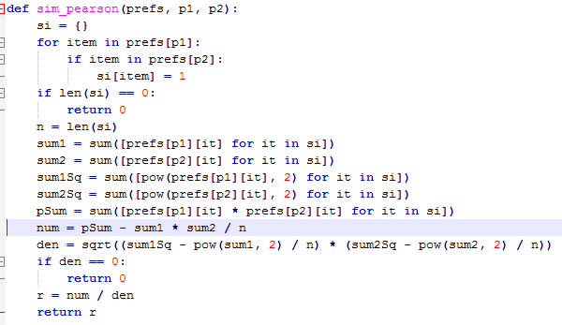

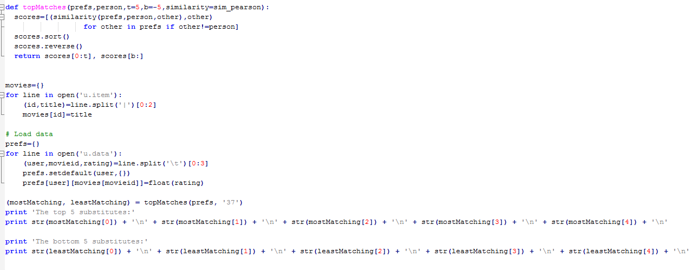

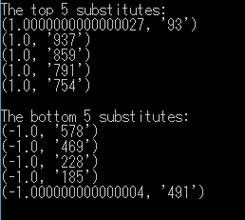

**Part 3**

**3.1 Calculating Recommendations**

To get the recommendations, I used the getRecommendations function found on page 16 in the Collective Intelligence textbook.

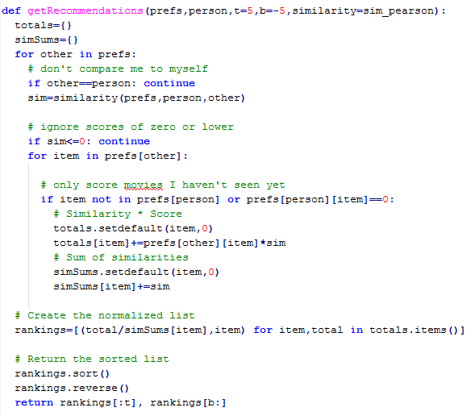

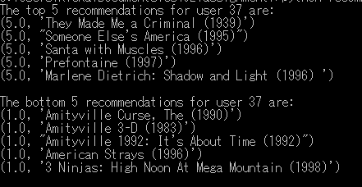

**3.2 Analyzing the Results**

I am unfamiliar with these recommendations. After reading all the synopsis’ of the top five recommendations I can honestly conclude that none of these movies interest me. The bottom five recommendations have low ratings. This is probably why they were the bottom recommendations, but I wouldn’t mind watching the three Amityville movies that were recommended. I am a fan of horror movie. Even if they are terrible, I can still find valuable entertainment in them. This disparity can be a result of two things. One possibility is that I could have some far outlier of movie preferences that can’t be reasonably be catered to by this recommendation function. The other possible reason is that there could be a wider difference in movie preferences between me and my substitute. Maybe the substitute would be satisfied with these recommendations, and he just isn’t a very good substitute for me. This could be a problem with getting substitutes strictly off age, occupation, and gender.

**Part 4**

**4.1 Getting Personal Correlations**

On page 18 in the Collective Intelligence textbook there is a transformPrefs function. This function swaps the items and people. Instead of searching for similarities between people, it will look for similarities between movies. This allows me to search for recommendations based of my favorite and least favorite movies in the data set. The movie I chose for my favorite is Aliens (1986) and the movie I chose as my least favorite is Jaws 3-D (1983).

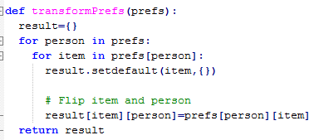

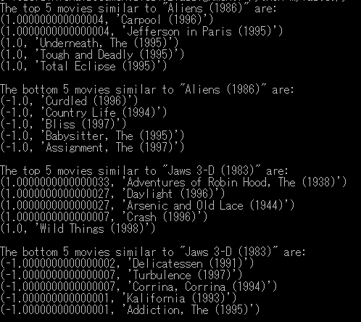

**4.2 Analyzing the Results**

I haven’t seen any of these movies. After reading the synopsis of each of the correlated films, I am disappointed. A lot of the movies aren’t horror, and the ones that are, are about serial killer. I was hoping that the movies that were determined to be correlated would have monsters in them like in Jaws 3-D and Aliens. My hypothesis would be that there is a small pool of films containing monsters in the data set and that it’s unrealistic to expect the functions to find significant correlation between them.