Abstract
As interest in nuclear systems in space undergoes a modern rebirth, a critical gap remains between historical engineering precedents and contemporary launch governance. This report examines the technical legacy of the US Systems for Nuclear Auxiliary Power (SNAP) program and its impact on the evolution of space nuclear launch regulations. Particularly, this paper focuses on SNAP-10A, the first US nuclear reactor in space. The study reviews the reactor’s design, testing programs, and in-orbit performance, highlighting its successful startup before an electrical failure in the host component ended the mission after 43 days in orbit.

The report also studies the development of launch safety policy from the early SNAP era to the modern framework established in NSTPM-20. Through a review of historical sources, it identifies a shift from deterministic safety standards based on population exposure limits to a risk-informed approach centered on probability assessments of individual risk. Finally, the study discusses key gaps in current funding, including limited disposal strategies and insufficient integration of historical flight data into modern analyses. The findings suggest that a stronger connection between past experiences and current policy is essential for the safe development of future space systems.

1. Introduction
Working nuclear reactors for space applications still represent a major milestone for the aerospace and nuclear industries. Significant challenges are presented in design, materials, and policy, as well as loss in practical industry knowledge of manufacturing and implementing these systems. As such a comprehensive review of prior successes and failures is necessary, especially those which have operated in space. This review aims to study the SNAP program, with a focus on the SNAP-10A reactor, using the existing literature and reports.
In 1948, the Air Force (AF) commissioned the Rand Corporation in Santa Monica, California to recommend development work in reconnaissance satellite programs known as Project Feedback [2]. This resulted in a 1949 Rand Corporation produced a report, reaching two key conclusions:
- A radioactive cell–mercury vapor system was technically feasible for space power
- Such a system could supply 500 watts of electric power for up to one year aboard a satellite
In 1951, the Atomic Energy Commission (AEC) commissioned formal industry studies for a 1-kilowatt electrical space power plant using either reactors or radioisotopes. Several companies concluded isotopes were the preferred approach.
With reconnaissance satellite power needs now clearly defined, the Department of Defense formally requested in August 1955 that the AEC develop a nuclear reactor auxiliary power unit for the Air Force satellite program. The AEC agreed and stated it would "explore the possibilities of using both radioisotopes and reactors as heat sources". The program ran under the classified code name "Pied Piper" between 1955 and 1957. It was later changed to SNAP (Systems for Nuclear Auxiliary Power).
The AEC began parallel power plant efforts with two private corporations. Odd-numbered SNAP programs using radioisotopes were spearheaded by contractual work at the Martin Company, shown in Table 1. Even-numbered SNAP reactor power systems were developed through contractual work with the Atomics International Division of North American Aviation, Inc, shown in Table 2.
Table 1: SNAP projects by Martin
SNAP-1 | This was an early effort by the Martin Company to use the decay heat of cerium-144. The design involved using this heat to boil liquid mercury to drive a small turbine. It was eventually superseded by static conversion technologies that did not require moving parts.
SNAP-3/ SNAP-3A | Known as the "salesman" of the program, SNAP-3 was a proof-of-principle device utilizing a thermopile to convert heat directly into electricity.  President Eisenhower unveiled the 5-pound "atomic battery" in the Oval Office on January 16, 1959.  A modified version, SNAP-3A, fueled by plutonium-238, was launched aboard the Navy Transit 4A satellite on June 29, 1961. This marked the first time a nuclear power source was used in space, providing roughly 2.7 watts of electrical power.
SNAP-7 | This series consisted of prototype units fueled with strontium-90. Unlike the space-focused units, these were designed for terrestrial applications in severe environments, such as powering Navy and Coast Guard navigation aids and automatic weather stations.
SNAP-9A | Designed for operational Navy Transit satellites, these were significant for providing the entire electrical power for a spacecraft.  These units provided approximately 25 watts and were designed for a 5- to 10-year lifespan.  Two units successfully achieved orbit in 1963. However, a mission abort in April 1964 resulted in a unit burning up and dispersing in the upper atmosphere as designed, which later prompted a shift toward "intact re-entry" safety concepts for future units.

Table 2: SNAP projects developed by Atomics International Division of North American Aviation, Inc.
SNAP-2 | This was a Zirconium-Hydride (Zr-H) reactor system designed to produce 3 to 5 kWe.  It utilized a Mercury-Rankine power conversion cycle where sodium-potassium (NaK) coolant transferred heat to mercury vapor to drive a Combined Rotating Unit (CRU).  Two prototypes were tested: the SNAP Experimental Reactor (SER), which operated from 1959 to 1961, and the SNAP 2 Developmental Reactor (S2DR), which operated from 1961 to 1962. The program was cancelled in 1963 due to budget cuts.
SNAP-8 | A larger-scale joint effort between the AEC and NASA, designed to produce 35 kWe (later pushed toward 50 kWe).  Like SNAP-2, it used a Zr-H reactor and a Mercury-Rankine cycle, but with a much higher performance goal of 600 kWt thermal power.  Testing was conducted on the SNAP 8 Experimental Reactor (S8ER) and the SNAP 8 Developmental Reactor (S8DR). Both tests concluded with the discovery of cracked fuel cladding, highlighting technical hurdles in the high-power reactor program.
SNAP-10A | This remains the only nuclear reactor the United States has ever flight-tested.  It was a 500-watt Zr-H reactor that utilized thermoelectric conversion instead of a rotating turbine.  Launched on April 3, 1965, it achieved a circular polar orbit and operated successfully for 43 days.  It was shut down prematurely due to a high-voltage failure in the spacecraft's electrical system (the voltage regulator), rather than a failure of the reactor itself. Ground testing of a twin unit continued for 10,000 hours without interruption.

2. SNAP 10A
The Systems for Nuclear Auxiliary Power (SNAP) 10A was a compact nuclear reactor system developed to provide reliable, long-term electrical power for space applications. Designed as a Zirconium-Hydride (Zr-H) reactor, its primary objective was to produce a minimum of 500 watts of electrical power (We) for an operational lifespan of one year or longer.
SNAP 10A holds the distinction of being the only nuclear reactor the United States has ever flight-tested. It was successfully launched on April 3, 1965, and placed into a circular polar orbit. The system operated successfully for 43 days before a high-voltage failure in the electrical system of the Agena spacecraft, not the reactor itself, caused a premature shutdown. Despite this, the mission was considered a success, demonstrating that a reactor could be safely launched, automatically brought to power in orbit, and operated as predicted by ground testing [2].

2.1 Full Element Design
Two major environments were considered in designing the SNAP-10A reactor: launch and orbital operation.
Basic design requirements [4]:
- Productions of 500 W at 28 vd-c for one year in space.
- Capability of remote startup in orbit by ground command.
- Capability for handling, transport, and launch within acceptable safety criteria and currently accepted launch base procedures.
- No requirement for long-term dynamic control.
- Sufficient instrument capability on the SNAP-SHOT launch to monitor system performance fully.
- Radiation shielding to attenuate realtor leakage to acceptable levels within the spacecraft.
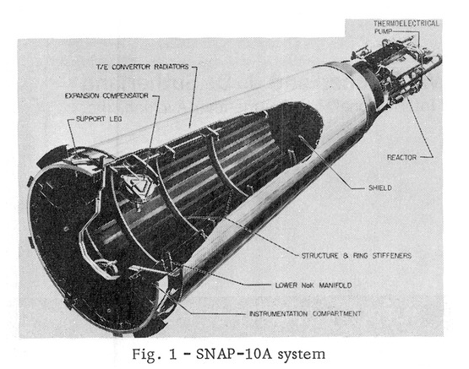
Figure 1. An overview of the SNAP-10A System [5]
The reactor is the ZrH type with about 4.8kg of fully enriched (93%) 235-Uranium fuel mixed into the metal hydride.
The SNAP 10A consists of 5 major components:
- The reactor structure
- Radiation shield
- Reflector assembly
- Reactor control equipment
- Reactor core, composed of 37 fuel elements, each 32.64 cm long, and 3.17 in diameter.

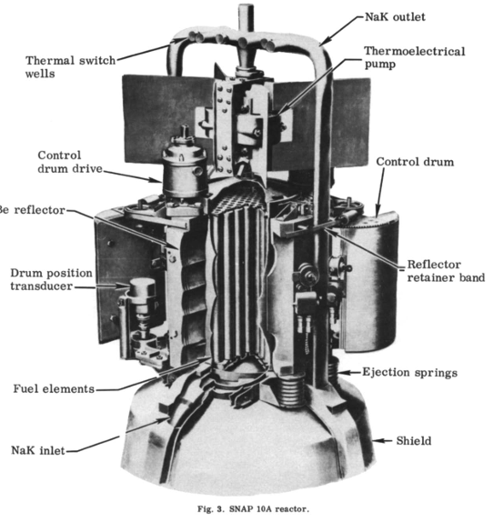
Figure 2. SNAP-10A Structure [5].

2.2 SNAP-10A Reactor Core
The SNAP-10A core is a right circular cylinder consisting of a hexagonal array of 27 fuel elements surrounded by Beryllium reflectors to form the cylindrical geometry.
Each fuel element is a cylinder 12.450 in. long with an outside diameter of 1.25 in. The fuel material is a zirconium-10 weight % uranium alloy hydrided to a nominal N_{H} of 6.35 (that is, 6.35 × 10²² atoms of hydrogen per cc of fuel). Each element contains approximately 128 grams of U²³⁵, 10 grams of U²³⁸, 25 grams of hydrogen, and 1240 grams of zirconium, yielding the stoichiometric ratio UZrH_{1.6}. This alloy shows very attractive properties in terms of the amount of required uranium; it also shows a decrease in fission-gas diffusion and internal ​pressure compared to other typical fuels, a good thermal conductivity (7 times better than UO₂), and resistance to radial cracking​. The figure below shows the microstructure of the fuel, where the grey region corresponds to ZrH_{1.6} and the dark region is the U.
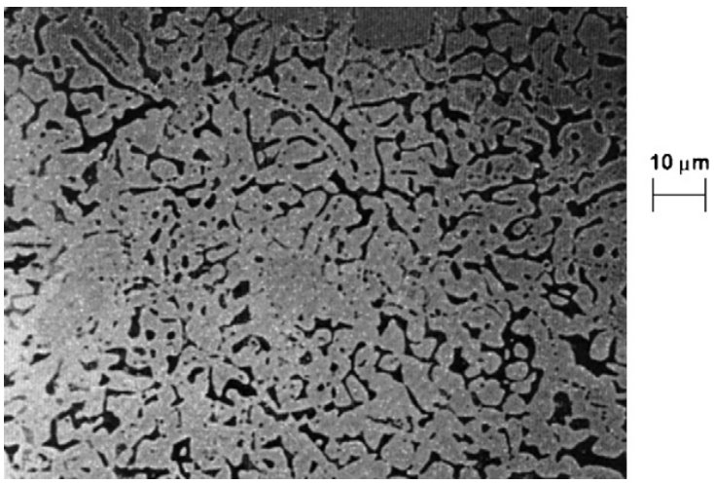
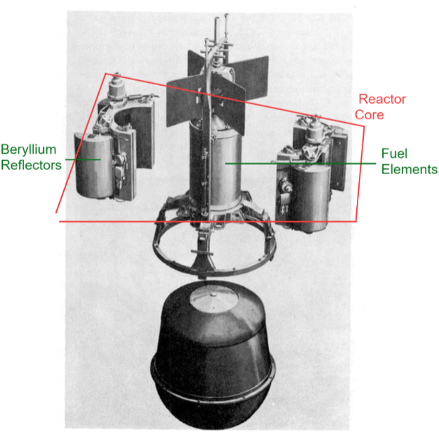
Figure 3. Microstructure of UZrH_{1.6}.
Figure 4. SNAP-10A Reactor core, fuel elements, shield, and Beryllium reflectors [5].
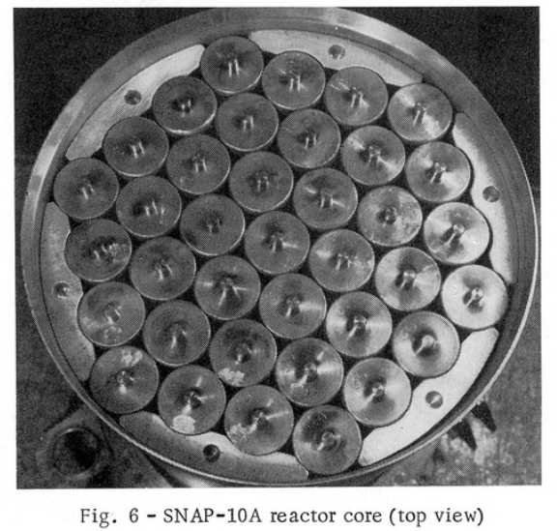
Fuel elements are clad in Hastelloy-N tubes having a wall thickness of 0.015 in. Hastelloy-N was selected as the cladding material because of its superior creep properties at operating temperatures to the 300 series stainless steels, and also because its coefficient of thermal expansion is much closer to that of the fuel material.
Figure 5. Top view of the reactor core [5]
The ends of the fuel elements are sealed with Hastelloy-N caps welded to the cladding tube. End pins, which position the fuel elements in the grid plates, are integral with the end caps. The pins on each end are of different diameters, ensuring proper orientation of the elements. Internal surfaces of the cladding tube and end caps are coated with a 0.003 in. layer of a ceramic material. This coating acts as a barrier, preventing hydrogen leakage from the fuel material in the high-temperature and high-radiation environment of the reactor core. The weight of each fuel element is 3.4 lb.
Six internal neutron reflectors are six solid blocks of Beryllium. Holes in each end of the reflectors are used for positioning. The reflectors have a nominal length of 12,455 in. The reflectors carry the precompression load of the core hold-down springs. Each reflector weighs 1.5 lb.
The upper and lower grid plates support and position the fuel elements and internal reflectors within the reactor vessel. Both plates are circular, 8.750 in. in diameter. The upper grid plate is 0.125 in. thick, made from a solid piece of type 316 stainless steel. The lower grid plate is a brazed assembly consisting of two 0.060 in. thick sheets with spacers between them. Overall thickness is 0.50 in. The lower plate is also type 316 stainless steel brazed with Nicrobraze 50 alloy. A composite structure was selected for the lower grid plate because it provides lighter weight than a solid plate of the same rigidity. The lower plate carries three times the load of the upper plate during the launch phase.
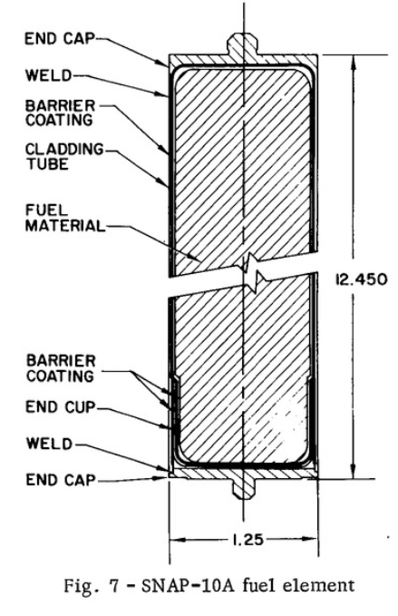
Each grid plate is perforated with 109 holes on a 0.728 in. triangular pitch. Thirty-seven of these holes are used for positioning the fuel elements. The remaining 72 are coolant flow holes. Coolant flow through the core is modified by the lower grid plate. The coolant holes in the lower sheet of the lower grid plate vary from 0.250 in. (surrounding the central fuel element) to 0.188 in. (at the outermost channels). In this fashion, the coolant flow profile across the core is matched with the radial power distribution, permitting all fuel elements to operate at approximately the same temperature. The coolant holes in the upper grid plate and the upper sheet of the lower grid plate are perforated with uniform holes 0.375 in. in diameter.
Figure 6. Design diagram of the SNAP-10A fuel element [5]
Six pins are attached to each plate to position the internal reflectors. Twelve additional pins are attached to the upper grid plate to locate the core hold-down springs [2].

2.3 Reactor vessel
The reactor vessel is a thin-walled cylindrical shell, closed at one end. The inside diameter was determined by the core size. The overall height was established by core size plus the required NaK inlet and outlet plenum size as determined by hydraulic flow tests.
Type 316 stainless steel was chosen to be the vessel material.
The vessel shell is 0.032 in. thick in the core region, 0.063 in. thick in the region of the lower head, and 0.125 in. thick elsewhere.
A shell maximum thickness of 0.125 in. is required in the region of the top head attachment to transmit bending moments induced by external reflector and NaK pump side loads. The shell is also 0.125 in.
The reactor core is supported by the grid plate support ring. THe ring is attached to the vessel inner wall by 11 spot welds. A step is then milled in the ring forming the platform for the lower grid plate.
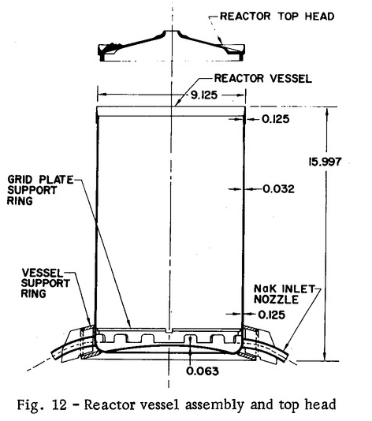
Figure 6. Design diagram of the reactor vessel assembly and the top head [5]
Two brackets, located diametrically opposite each other, are welded to the vessel in the region of the top head. These brackets serve to locate the external reflectors and distribute reflector side loads during launch. A secondary function of the stops is to provide lateral support for the NaK return tubes.
NaK inlet nozzles are welded on diametrically opposite sides of the vessel lower plenum. The nozzles are type 316 stainless steel tubing flattened to form an ob-round cross-section. Weight of the reactor vessel assembly is 26 lb. [2].

Twelve compression springs are positioned between the upper grid plate and the top head .The springs are made of Rene 41 material. The spring rate is 357 lb/in. and each spring nominally exerts a force of 35 lb on the upper grid plate. The choice of material was made because of its low relaxation rate at operating temperatures [2].
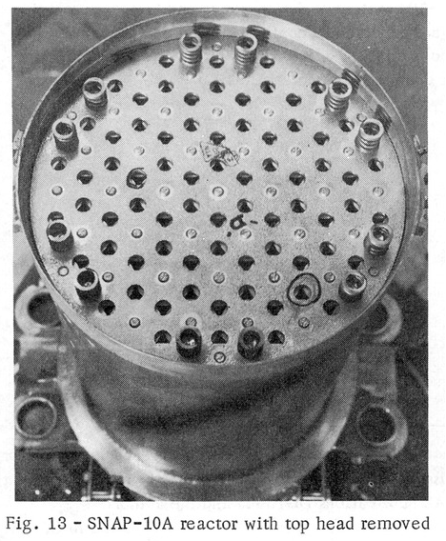
Figure 7. Core hold-down springs [5]

2.4 Reactor Top Head
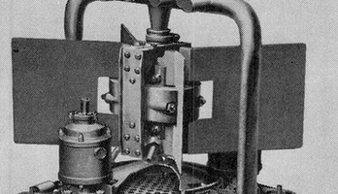
Figure 8. Reactor top head [5]
The vessel top head is designed to support the thermoelectrical NaK pump and to distribute external reflector side loads. The pump support requirement necessitates a head thickness greater than that necessary for pressure containment and meteoroid protection.
The head is made from a type 316 stainless steel forging [2].

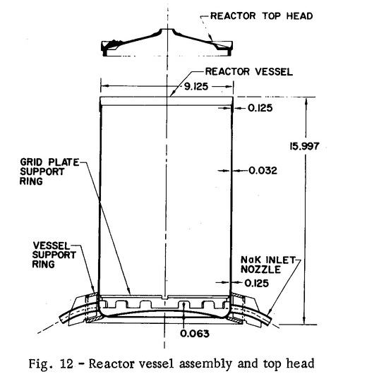
Figure 9. Design diagram of the reactor assembly and top head [5]

2.5 Reactor Support Legs
The reactor is supported from the converter structure by four support legs (Fig. 14). The support legs are designed to withstand reactor and reflector loads during the launching operation, and to permit relative thermal expansion between the reactor and converter structure during high-temperature operation.
The support legs are essentially box sections, hot formed and welded from 0.032 in., 6A1-4V titanium alloy. The support legs are fastened to the reactor vessel box ring by “blind-bolts.” Ten “blind-bolts” are used on each leg. At the lower end, the support legs are riveted to a torque box which forms part of the converter structure.
NaK inlet and outlet pipes are routed through the support legs. The legs thus afford meteoroid protection to the piping, permitting thinner walls to be used [2].
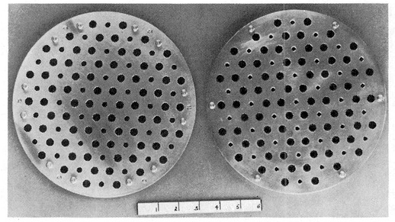
Figure 10. Grid plates [5]
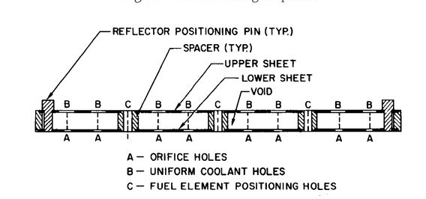
Figure 11. Design diagram of the lower grid plate cross-section

2.6 Reactor Reflector and Control Assembly
The reactor reflector and control assembly is a critical subassembly consisting of an approximately 5.08-cm-thick beryllium shell that surrounds the SNAP 10A core to manage the nuclear chain reaction by regulating neutron leakage. Constructed in two hinged halves, the assembly is wrapped around the reactor vessel and held securely by a stainless steel retaining band, with graphite blocks positioned between the reflector and vessel to prevent them from "self-welding" at high operating temperatures. Built into this shell are four semicylindrical beryllium control drums, measuring approximately 25.72 cm long with a radius of 8.89 cm, which are rotated to vary the effective thickness of the reflector, thereby controlling the reactor's power level during startup and operation. The assembly serves as the primary safety mechanism; upon the release of the retaining band, compression springs pivot the reflector halves away from the core, immediately stopping the reaction by allowing neutrons to escape into space. A second band release device at the top perimeter of Beryllium reflector assembly is also provided to separate the reflector retaining band. Actuated by the NaK outlet temperature, it will be released if the coolant temperature drops below a specified value or upon reentry heating to ensure that the reflector assembly will be rejected before impact and allow fuel element dispersion from the core.
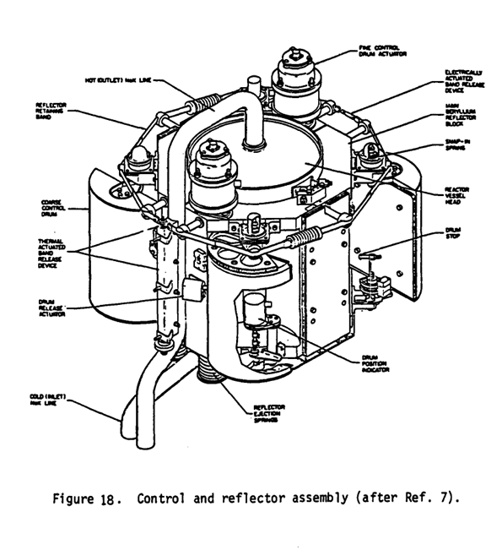
Figure 12. Design diagram of control reflector assembly [2]

2.7 Heat Transfer and Power Conversion System
The heat transfer medium (coolant) used in the SNAP-10A space nuclear reactor was NaK-78. This eutectic alloy has excellent thermal properties and is liquid at STP. The NaK was circulated through the reactor and the power conversion system by a DC conduction-type electromagnetic pump. This pump was powered by its own dedicated lead-tin-telluride (PbSnTe) thermoelectric converters. The PbSnTe was chosen for its thermoelectric figure of merit described in Equation 1.
$zT=\frac{S^{2}σT}{κ}$ | (1)
Where zT is a function of the temperature, $σ$is the electrical conductivity, $κ$ is the thermal conductivity, and S is the Seebeck coefficient. The goal was to decrease the thermal conductivity and increase the electrical conductivity to obtain the highest possible figure of merit. The figure below shows the thermoelectrical figure of merit of several materials, including the PbTe compounds, and also the N-type and P-type doped SiGe in the thermocouples.
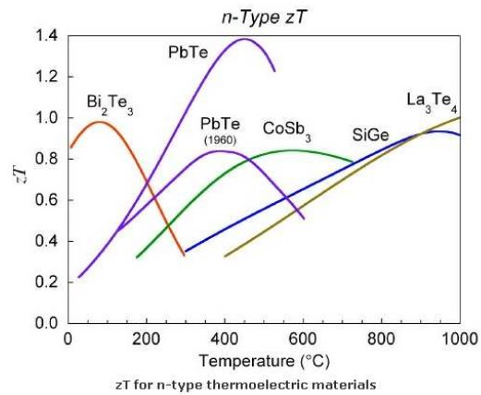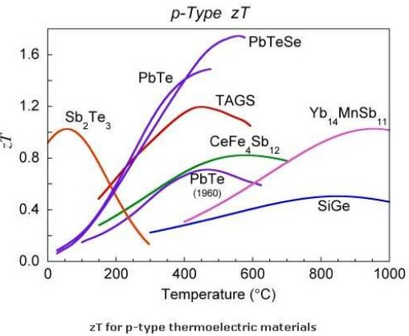
Figure 13: Figure of merit of different N-type and P-type semiconductors.
The power conversion system was made of N and P-doped SiGe thermoelectric materials to transform thermal energy directly into electricity. The dopants were needed to increase even more the charge-carrier mobility in the materials to get a higher conversion rate. In principle, it is less effective than PbTe but shows a lower sublimation rate and better mechanical behavior. The figure above shows an increase in the figure of merit of PbTe in comparison with PbTe (1960). This is because the figure of merit also has a strong dependence on grain size in materials. The most recent synthesis methods of the materials could give a small grain size reaching the nanometers and improve the efficiency of the material.
The system contained 2880 SiGe pellets placed between the hot NaK tubes and the cold radiator panels. To prevent electrical short circuits, the pellets were separated from the NaK tubes by thin alumina (ceramic) discs, which provided insulation while still allowing heat to pass through. The SNAP-10A system was designed to provide at least 500 watts of electrical power
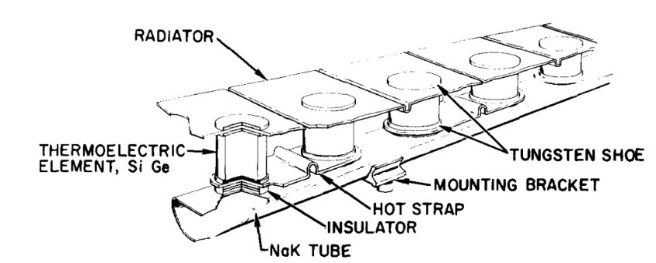
Figure 14. Thermoelectric converters, the radiator, and the 405 SS tubes.
This system was designed for a coolant outlet temperature of 543.3 Celsius degrees, and NaK shows a liquid phase above the eutectic point at -12.6 Celsius degrees, as shown in the figure below, providing a broad temperature range to avoid solidification. To keep the NaK flowing smoothly without bubbles or "voids," two bellows-type expansion compensators maintained a steady internal pressure of about 2.41 kPa. An ejectable heat shield was wrapped around the system during launch to prevent the NaK from freezing before the reactor was started. The NaK shows a very strong reactivity effect, making it harder to manipulate. According to O’donell W in 1989, NaK shows a strong influence on corrosion rates in reactor materials, that's why 405 stainless steel is required to reduce the probability of damage by corrosion.
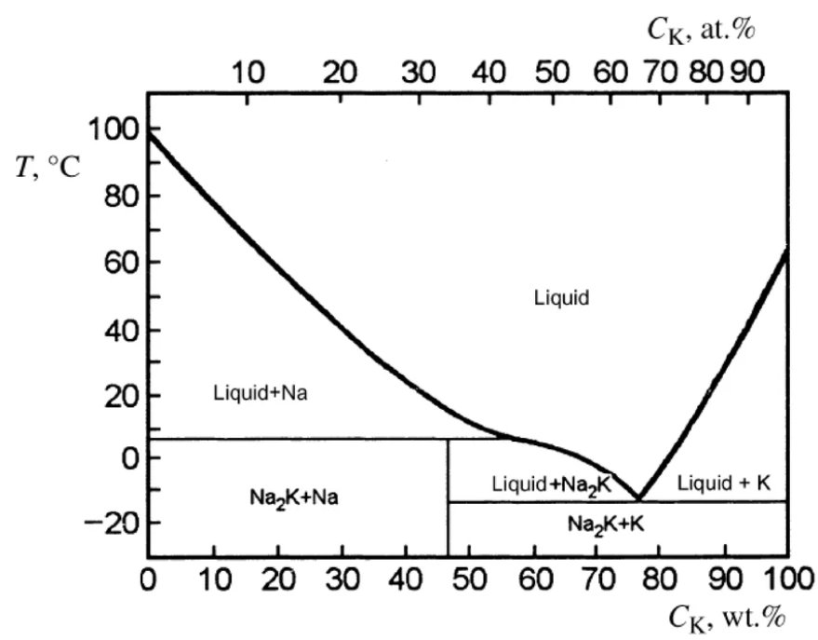
Figure 15: Phase diagram of Sodium and Potassium.

2.8 Radiation Shield
Located directly beneath the reactor, the shield assembly, fabricated from a cold pressed LiH shielding material reinforced with stainless steel in a stainless steel casing, possesses the honeycomb design to minimize crack propagation and sustain thermal gradients. To withstand the severe mechanical stresses of launch, the shield utilized a set of eight spring assemblies attached to the shield casing and the parabolic plate to support the hydride from beneath. was engineered to limit the total integrated nuclear radiation at the reference dose plane that is located 533.4 cm below the reactor core. [2]
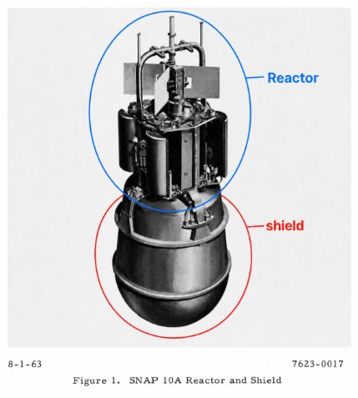
Figure 16. SNAP-10A Reactor and Shield [5].

3. SNAP-10A Test History
8 prototype and qualification systems were built and tested: ​
- 3 for structural tests​
- 3 for thermal vacuum performance test ​
- 2 for final complete system qualification models and the final flight system

 | Timeline | Description
Nonnuclear Thermal Test  PSM-3 | Between April 10 and October 12, 1962 | - Tested for thermal, hydraulic, and heat transfer characteristics using an electric heater and a partial PbTe converter.  - Over 1000 hours of testing at operating temperatures between 93 and 482 Celsius degrees.
Flight System Prototype  FSM-1 | Between September 8, 1963 and January 16, 1964 | - A full-scale, nonnuclear mock-up with a special heating unit to simulate the reactor heat source to simulate ground launch and nuclear start-up.
Flight System Mockup  FSM-4 | Between August 5, 1964 and June 17, 1964 | - A nonnuclear test system loaded with NaK and thermal performance to demonstrate successful start-up in the initial temperature transient with a focus on NaK loaded system, simulated orbital operation and start-up sequence and thermal reference endurance.
Agena Compatibility Testing  FSEM-2, FSEM-2A, FSEM-3 | Between May 1964 and February 1965 | - Tested for simulating flight environmental conditions, initial investigation of electromagnetic reference and electrical mockup testing.
Ground Qualification System  FS-3 (or S10F-3) | Between January 22, 1965 and March 15, 1966 | - Tested for the thermal behavior of astronuclear power systems during ground test.  - Operated at 35 kW thermal for 390 days and then 44 kWt with active control for the first 3 days followed by 25 days of static control, the system had over 10,000 hours of uninterrupted operation.  - After one year of operation, the test concluded that the hydrogen redistribution caused the reactor’s outlet temperature to drop more than expected along with some uncertainties about the reactor dynamics.

3.1 SNAP-10A Flight Tests
The SNAP program had one successful flight test, SNAP-10A. The SNAP-10A reactor was attached at the top of an Agena rocket, and was the primary power unit for the rocket systems once in orbit. SNAP-10A added several novel features for the Agena, such as a NaK cooling system, thermoelectric power conversion system, and a nuclear reactor (Johnson et al.1967).
3.1 Ascent​
Launched from Vandenburg AFB on April 3, 1965 where a nominal launch occurred​, SNAP-10A's structure was well within tolerance's, vibration measurements were 50% higher than expected due to the Agena's length, but the reactor was unharmed. ​Pre-startup​ NaK temperature was the main concern during the pre-startup phase, since it would freeze in the system if it fell below 12° F. An ejectable heat ensured that radiative losses were minimal, and it was designed in such a way to increase the temperature. ​The NaK maintained a temperature of 85 OF during launch, with the heat shield staying below its degradation temperature. ​The liquid metal pump kept a flow of 1.2 GPM, above the 0.26 GPM minimum. ​The pump was powered by an onboard battery and a thermoelectric system interacting with the NaK. ​After the second burn of the Agena rocket, tracking data showed it had entered a stable orbit around earth, and the AEC authorized a reactor startup (Johnson et al.1967).
3.2 Reactor Start Up​
Once the reactor was in orbit the startup process began. This used external protons from space to create a neutron source by interacting with the Beryllium reflectors. The startup process took over 8 hours to complete and for the NaK outlet temperature to reach sufficient levels. No abnormalities were seen in the startup phase (Johnson et al.1967).​
3.3 Active Control Period ​
After reactor start up the core was controlled by commands sent from earth. This was done to closely monitor power output, hydrogen redistribution, Xenon buildup, and temperature The reactor maintained an outlet temperature of ~1020 oC and power output of 550-600 W. At the end of the active control period a decision was made to rotate the drums more than initially planned to ensure an output 500 watts of power after 90 days (Johnson et al.1967).
3.4 Passive Control Period​
The SNAP-10A mission wanted to prove that a reactor could operate for months at a time without constant intervention After the active control period ground crews deactivated the reactor control systems letting the reactor self-regulate, through negative reactivity with temperature. If the reactor heated up the reactivity would decrease, thus reducing the temperature While they no longer controlled the reflector drums they monitored the reactor closely to track performance, coolant temperature, hydrogen redistribution and other metrics. The in-space performance was very similar to ground tests with the exception of a voltage leakage that occurred reducing the usable power output (Johnson et al.1967).
3.5 Shut Down​
On May 16, 1965 the spacecraft did not respond to ground commands, and did not transmit data for 40 hours. At this point the spacecraft was powered by the backup battery supply, and data showed the AC power system which powered the NPU telemetry was inoperable, and could not transmit NaK outlet temperature or flow data. The APU data showed that the reflectors were ejected from the reactor and electrical power was 0 W. The status of the spacecraft did not change while the backup battery had power. A comprehensive investigation was conducted to determine what could have caused this type of failure. An analysis of the electrical system of the spacecraft showed that a failure of the voltage regulator, would allow a high voltage to key components of the reactor. The voltage from the thermoelectrical system could reach the AC inverter and command system and shut them down. The automatic systems operated correctly under these circumstances and SCRAMed the reactor.Ground testing of the electrical bus and voltage regulator showed that this type of failure was possible and would cause the observed configuration (Johnson et al.1967).

Future Technical Work

Radiator Panels
- • Change the material of the radiator panel core but keep the honeycomb structure
- • Change the orientation to the outside of the shield
- • Route the NaK flow through heat pipes under the panels

Potential Improvements
- • Evaluate transition from U-ZrH to Uranium Nitride (UN) or Uranium Carbide (UC)
- • Increase conversion efficiency from ~1.5% (thermoelectric baseline) to 20-30% via advanced Stirling or Brayton cycles

Literature Review: U.S. Space Nuclear Launch Regulation, From SNAPSHOT to NSPM-20

Introduction and Scope
The literature on how the United States authorizes the launch of nuclear systems into space falls into two bodies that rarely speak to each other. The first is the engineering and safety documentation produced around the SNAPSHOT program in the early to mid 1960s, when the SNAP-10A reactor became the only fission reactor the country has ever flown. The second is the contemporary policy and implementation literature that has grown up around National Security Presidential Memorandum 20, issued in 2019. This review covers both, treats them as a single regulatory lineage rather than two unrelated topics, and argues that the gap between them is itself the most important finding. The older material is dense with accident analysis but predates any codified approval regime, while the modern material is rich in process description but thin in independent critique, and almost nobody connects the two. The SNAP-10A precedent, which ought to be the natural test case for current rules, is invoked far more often than it is actually analyzed.

The Early Regime and Its Documentary Record
The primary record of the SNAPSHOT era is largely contractor documentation produced by Atomics International for the Atomic Energy Commission, and it is surprisingly candid. The 1961 flight safety program plan lays out the safety philosophy that would govern the flight, namely launch the reactor cold, defer criticality until a long-lived orbit is confirmed, and rely on that orbit for disposal, and it is unusually honest about what had not yet been solved, especially accidental criticality on water immersion and the absence of an inherently subcritical core (Atomics International 1961). The capstone of this record is the final safeguards report, which structured its analysis in three phases running from launch through orbit injection to reactor startup and reentry, and which was submitted to the AEC, the Air Force, and the Navy Pacific Missile Range for approval (Atomics International 1965). The flight itself is documented in the open literature by the Atomics International team, whose account doubles as the post-flight report and records the voltage-regulator fault that ended the mission after forty three days (Johnson, Morgan, and Rocklin 1967). For anyone trying to navigate this body of work, the annotated bibliography compiled in 1966 remains the single best index to the hundreds of reports the program generated (Atomics International 1966).
What this literature establishes is a regime that was rigorous in its engineering but improvised in its governance. There was no statute or directive that set quantitative pass-fail criteria. Authority flowed from the Atomic Energy Act of 1954, and review was handled by a panel assembled for the occasion. The safety standard that does appear in the technical work is deterministic and population based. The clearest statement of it is the reentry-burnup analysis that adopted the International Commission on Radiological Protection limit of two rem over thirty years and recommended that SNAP applications be held to a quarter of a rem over thirty years (Willis 1965). The reentry and disposal studies that sit alongside it, including the aerospace safety reentry program, treated the question as one of bounding the dose if the reactor came down, not of demonstrating a controlled disposal system (Elliott 1963). The AEC’s own evaluation of the SNAP program rounds out the period as a statement of agency thinking rather than a binding rule (U.S. Atomic Energy Commission 1964).

The Codification of the Federal Framework
The transition from this improvised regime to a codified one is best documented not in the primary sources but in a small secondary literature. The most useful single account is the Institute for Defense Analyses study by Behrens and colleagues, which states plainly that a high-level launch approval procedure was first formalized only in 1977 with Presidential Directive NSC-25, and which is candid that the modern process inherited from radioisotope missions may not transfer cleanly to fission reactors (Behrens et al. 2018). This is one of the few pieces of analysis that treats the history as a problem to be learned from rather than a story to be retold. The National Environmental Policy Act of 1969 added an environmental review layer that simply did not exist for SNAP-10A, and the layering of NEPA, PD/NSC-25, NSPM-20, and Space Policy Directive-6 is now the backbone of the system (U.S. White House 2019; U.S. White House 2020).

The Contemporary NSPM-20 Literature
The modern literature is dominated by the documents that implement NSPM-20 and by agency descriptions of them. The most cited analytical piece is the Sandia-authored article on implementing the memorandum for civil missions, which works through the tier structure and the risk-informed criteria and is effectively the reference text for how the new metrics are meant to function (Voss et al. 2021). On the regulatory side, the Nuclear Regulatory Commission’s literature review is the most comprehensive survey of the approval process and is itself a useful map of the field (U.S. Nuclear Regulatory Commission 2023). NASA’s procedural requirement is the operative implementation for civil missions and is where the abstract policy becomes concrete obligation, including the tiered safety analysis, the role of the standing review board, and the disposal clause that requires a highly reliable operational system for controlled disposition of a reactor in low Earth orbit (NASA 2022). NASA’s own account of how it has reworked its safety program to infuse risk-informed thinking rounds out the picture (NASA 2023). What is striking about this body of work is how much of it is produced by the agencies that the rules govern. It explains the system clearly, but it rarely steps back to question whether the system is well designed.

Cross-Cutting Themes and Debates
A few themes run through both bodies of literature and deserve to be drawn out. The first is the shift in how safety is even measured. The 1960s work fixed a population dose ceiling and asked whether the expected dose stayed under it (Willis 1965), whereas the modern regime asks a probabilistic question, namely whether there is a one in a million chance or greater of exposing any single member of the public to more than twenty five rem (U.S. White House 2019). This is a genuine change in the philosophy of safety, and it is underexamined. The implementation literature describes the new metric but does not really interrogate what is lost or gained by moving from a deterministic population standard to a probabilistic individual one.
The second theme is fuel. SNAP-10A ran on highly enriched uranium, which the period documents treated mainly as a criticality and material-at-risk concern (Atomics International 1965). The modern literature folds enrichment into tiering and into a broader security and nonproliferation conversation, and the policy drift toward low-enriched fuel is visible but not deeply theorized in the launch-safety sources specifically. The third theme is disposal, and here the literature is genuinely thin. The modern rule requires a sufficiently high disposal orbit together with a reliable system for controlled disposition of the reactor (NASA 2022). SNAP-10A is an instructive case precisely because its operational orbit was also its disposal orbit, reached by the launch vehicle and verified before the reactor was started, so the reactor ended its life shut down and nuclearly safe in a stable, long-lived orbit. The fault that ended the mission was in the spacecraft payload rather than the reactor, and it left the nuclear safety and the disposal intact. Whether that arrangement satisfies the modern reliability language is therefore a live question rather than a settled failure, and almost no published work runs it through. The wrinkle the literature does underplay is orbital debris, since the spacecraft later released NaK coolant and shed fragments, which is exactly the kind of outcome the current rule’s orbital debris provisions would scrutinize even though the radiological disposal was held. The fourth theme is the commercial pathway, which has no historical analog at all and which the existing literature barely addresses beyond noting that it now exists.

Gaps in the Literature
Three gaps stand out. The first is the shortage of independent critique. The strongest analytical voices, the IDA study and the Sandia implementation article, are valuable precisely because they are uncommon, and most of the rest of the corpus is agency self-description (Behrens et al. 2018; Voss et al. 2021). A policy analyst entering this field will find plenty of explanation and very little adversarial assessment. The second gap is that disposal reliability, which is the requirement most likely to constrain a real reactor mission, is asserted more than it is studied. There is no substantial body of work analyzing what counts as a sufficiently reliable disposal system or how a designer would demonstrate it. The third gap is the disconnection between the historical and contemporary literatures. SNAP-10A is constantly cited as heritage, but it is rarely run through the current rules as a worked example, even though it is the only real data point the field has.

Conclusion
Read together, these two bodies of literature tell a coherent story even though their authors were not in conversation. The engineering rigor was present from the start, and the operating concept of launching cold and starting in a safe orbit has survived intact. What changed is the governance around it, from an improvised, deterministic, population-based regime to a codified, probabilistic, tiered one that now reaches into operation and disposal. The most useful contribution an analyst could make is not another description of NSPM-20 but the work the existing literature keeps gesturing at and never completes, namely a rigorous treatment of disposal reliability and a clear-eyed application of the modern standard to the one reactor the country has actually flown.

4. Policy Recommendations
The two literatures and the SNAP-10A case converge on a practical agenda. SNAP-10A is the only reactor the United States has flown, which makes it the only flight data point the field has and the foundation that forward work on nuclear electric propulsion will rest on, whether or not that reliance is stated. The recommendations below follow from treating that single case rigorously rather than rhetorically, and from building the analytical apparatus the probabilistic modern standard now demands.

4.1 Run SNAP-10A through the modern standard as the field's reference case
The literature cites SNAP-10A as heritage and almost never runs it through the current rules, which is the gap most worth closing first. Because it is the only mission that actually flew, a careful application of NSPM-20 and NPR 8715.26 to it is not a historical exercise but the closest thing the field has to a validated end-to-end example. The case is favorable on the points that matter. The reactor launched cold, started only after reaching a stable and long-lived orbit that doubled as its disposal orbit, and shut down nuclearly safe when the spacecraft payload failed (U.S. White House 2019; NASA 2022). Documenting that as a worked NSPM-20 submission, with the dose calculation, the tier determination, and the disposal argument written out in full, gives future applicants a template and gives regulators a concrete reference rather than an abstraction.

4.2 Treat the reimplemented analysis models as launch-approval infrastructure
The shift from the 1965 deterministic population standard to the probabilistic twenty five rem at one in a million changes what an applicant has to prove (Willis 1965; U.S. White House 2019). A probabilistic individual-dose case rests on transient and source-term analysis that the original SNAPSHOT codes performed but that no longer exists in runnable form. Reconstructing those models in modern code and validating them against the documented SNAPSHOT results turns the single flight case into a calibrated analytical base, because a model that reproduces the one reactor the country flew carries evidentiary weight that an unvalidated model cannot. Since every future safety case will lean on this lone data point, the value of anchoring a modern model to it is hard to overstate. This work should be funded and framed as safety-case infrastructure for future missions, not as historical reconstruction.

4.3 Hold the safety bar constant across fuel types and let enrichment raise review depth, not block a mission
SNAP-10A ran on highly enriched uranium, which the period documents treated as a criticality and material-at-risk concern and which the modern regime folds into tiering and into the nonproliferation conversation (Atomics International 1965). Higher enrichment should raise the tier and the depth of review, which is what the framework intends, without functioning as a practical veto. If highly enriched or high-assay low-enriched fuel is the near-term path for a capable reactor, a review process that treats the higher tier as de facto prohibition would foreclose the mission class the national strategy is trying to enable (U.S. White House 2020). The recommendation is to keep the radiological safety standard fixed across fuel types and to vary only the rigor of the demonstration.

4.4 Write disposal reliability around the distinction between a parked reactor and a transiting one
SNAP-10A satisfies modern disposal logic because its operating orbit was a stable, long-lived orbit it never left (NASA 2022). That is the easy case, and it does not transfer to nuclear electric propulsion, where the reactor is designed to move and may operate in or transit the regimes the disposal rules most want to keep clear. Reading the SNAP precedent as general reassurance would paper over the harder problem. The recommendation is to write the disposal reliability requirement in two regimes, one for missions that operate and dispose in a high, long-decay orbit where the SNAP precedent applies directly, and one for transiting propulsion missions where disposal is an unsolved problem that needs its own demonstrated standard. This also answers the gap the literature names, since disposal reliability is asserted far more than it is studied.

4.5 Fold orbital debris and coolant containment into the nuclear safety review
The honest weakness in the SNAP-10A case is not the reactor or the radiological disposal, both of which held, but the later release of NaK coolant and the fragments the spacecraft shed (NASA 2022). That is the outcome the current orbital debris provisions would scrutinize, and it sits at the seam between the nuclear safety review and the debris review, where it can fall through. A liquid-metal-cooled space reactor should have to demonstrate coolant containment through end of life as part of its nuclear safety case, and the Orbital Debris Program Office assessment should be integrated into the NSPM-20 review rather than run as a parallel track. The one mission flown shows that the radiological case can be made and the mission still lost on debris, which is exactly why the two reviews should not be separate.

References
[1] Idaho National Engineering Laboratory. (1987). Atomic power in space: A history (DOE/EG-0072). U.S. Department of Energy.
[2] Corliss, William R (1966). SNAP Nuclear Space Reactors.
[3] Voss, S. S. (1984). SNAP reactor overview (Report No. AFWL-TN-84-14). Air Force Weapons Laboratory.
[4] Johnson, R. A., Morgan, W. T., & Rocklin, S. R. (1967). Design, ground test and flight test of SNAP 10A, first reactor in space. Nuclear Engineering and Design, 5(1), 7–21. https://doi.org/10.1016/0029-5493(67)90111-4
[5] Dalcher, A. and Sutherland, J., "Design of the SNAP 10A Reactor," SAE World Congress & Exhibition, Detroit, Michigan, United States, January 1, 1964, https://doi-org.offcampus.lib.washington.edu/10.4271/640218.
[6] Beyond NERVA. (2018, November 26). History of US astronuclear reactors (Part 1): SNAP-2 and 10A. WordPress. https://beyondnerva.wordpress.com/2018/11/26/history-of-us-astronuclear-reactors-part-1-snap-2-and-10a/

Literature Review Sources (Chicago)
Atomics International. 1961. SNAPSHOT Nuclear Flight Safety Program. NAA-SR-MEMO-6224. Canoga Park, CA: Atomics International, Division of North American Aviation.
Atomics International. 1965. Final SNAPSHOT Safeguards Report. NAA-SR-10022 (Rev). Canoga Park, CA: Atomics International.
Atomics International. 1966. Annotated Bibliography, SNAP 10A Program. NAA-SR-MEMO-12023. Canoga Park, CA: Atomics International.
Behrens, Jonathan, Reina Bueconsejo, Bhavya Lal, and Susannah Howieson. 2018. Developing a Launch Approval Process for Nuclear Fission Reactors: Lessons Learned from Risk Mitigation and Approval Processes in Other Sectors. In Proceedings of Nuclear and Emerging Technologies for Space (NETS) 2018. Washington, DC: Institute for Defense Analyses.
Elliott, R. D. 1963. Aerospace Safety Re-entry Analytical and Experimental Program, SNAP 2 and 10A (Interim Report). NAA-SR-8303. Canoga Park, CA: Atomics International.
Johnson, Richard A., William T. Morgan, and Sol R. Rocklin. 1967. Design, Ground Test and Flight Test of SNAP 10A, First Reactor in Space. Nuclear Engineering and Design 5 (1): 7-21.
National Aeronautics and Space Administration. 2022. Nuclear Flight Safety. NPR 8715.26. Washington, DC: NASA.
National Aeronautics and Space Administration. 2023. Evolution of NASA’s Nuclear Flight Safety Program to Infuse Risk. NTRS 20230018172. Washington, DC: NASA.
U.S. Atomic Energy Commission. 1964. An Evaluation of Systems for Nuclear Auxiliary Power. TID-20079. Washington, DC: U.S. AEC.
U.S. Nuclear Regulatory Commission. 2023. Literature Review: Safety Review Process for Space Nuclear System Launches. ML23226A004. Washington, DC: U.S. NRC.
U.S. White House. 2019. Presidential Memorandum on Launch of Spacecraft Containing Space Nuclear Systems (NSPM-20). Washington, DC: The White House.
U.S. White House. 2020. Memorandum on the National Strategy for Space Nuclear Power and Propulsion (Space Policy Directive-6). Washington, DC: The White House.
Voss, Susan S., et al. 2021. Considerations for Implementing Presidential Memorandum-20 Guidelines for Nuclear Safety Launch Authorization for Future Civil Space Missions. Nuclear Technology 207 (6): 814-829.
Willis, C. A. 1965. Radiological Aspects of Reentry Burnup of SNAP Reactors. NAA-SR-11761. Canoga Park, CA: Atomics International.

