Апроксимация нейронной сетью

#### Using neural network for create regression model CLIs-CRNs

* <https://yandex.ru/maps/-/CZwvQZpz>

rm(list=ls())  
assign("last.warning", NULL, envir = baseenv())  
#source("http://tmeits.github.io/24516/transect/setdw.R")  
#wd <- "C:/Users/IVA/Dropbox/24516/nnet_transect/nnet_24643"  
#wd <- "Z:/home/larisa/Dropbox/24516/nnet_transect/nnet_24643"  
#setwd(wd)

#### Reading generalized chronologies from the site <https://www.ncdc.noaa.gov/paleo/chron_table.html>

* <https://www.ncdc.noaa.gov/paleo/meas_table.html>
* <ftp://ftp.ncdc.noaa.gov/pub/data/paleo/treering/updates/schweingruber/chronologies/russ055/russ055w_tabs.crn>
* <ftp://ftp.ncdc.noaa.gov/pub/data/paleo/treering/updates/schweingruber/chronologies/russ055/russ055w_out.txt>
* <https://s3.amazonaws.com/assets.datacamp.com/img/blog/data+table+cheat+sheet.pdf>

library(reshape2)  
library(data.table)

##   
## Attaching package: 'data.table'

## The following objects are masked from 'package:reshape2':  
##   
## dcast, melt

# http://meteo.ru/data/155-meteostations  
# 63.23, 125.48 63.95, 124.83 https://yandex.ru/maps/-/CZwvQZpz  
DTw <- fread("ftp://ftp.ncdc.noaa.gov/pub/data/paleo/treering/updates/schweingruber/chronologies/russ055/russ055w_tabs.crn")  
DTe <- fread("ftp://ftp.ncdc.noaa.gov/pub/data/paleo/treering/updates/schweingruber/chronologies/russ055/russ055e_tabs.crn")  
str(DTw)

## Classes 'data.table' and 'data.frame': 703 obs. of 8 variables:  
## $ YEAR: int 1568 1569 1570 1571 1572 1573 1574 1575 1576 1577 ...  
## $ NUM : num 1 1 1 1 1 1 1 1 1 1 ...  
## $ SEG : num 356 356 356 356 356 356 356 356 356 356 ...  
## $ AGE : num 1 2 3 4 5 6 7 8 9 10 ...  
## $ RAW : num 0.25 0.31 0.51 0.29 0.31 0.34 0.23 0.44 0.57 0.28 ...  
## $ STD : num 0.762 0.917 1.436 0.858 0.907 ...  
## $ RES : num 0.825 1.033 1.496 0.703 0.924 ...  
## $ ARS : num 0.773 0.905 1.411 0.886 0.922 ...  
## - attr(*, ".internal.selfref")=<externalptr>

head(DTw)

## YEAR NUM SEG AGE RAW STD RES ARS  
## 1: 1568 1 356 1 0.25 0.762 0.825 0.773  
## 2: 1569 1 356 2 0.31 0.917 1.033 0.905  
## 3: 1570 1 356 3 0.51 1.436 1.496 1.411  
## 4: 1571 1 356 4 0.29 0.858 0.703 0.886  
## 5: 1572 1 356 5 0.31 0.907 0.924 0.922  
## 6: 1573 1 356 6 0.34 0.982 1.029 0.969

DTw[YEAR %in% c(1:5000)]

## YEAR NUM SEG AGE RAW STD RES ARS  
## 1: 1568 1 356 1 0.25 0.762 0.825 0.773  
## 2: 1569 1 356 2 0.31 0.917 1.033 0.905  
## 3: 1570 1 356 3 0.51 1.436 1.496 1.411  
## 4: 1571 1 356 4 0.29 0.858 0.703 0.886  
## 5: 1572 1 356 5 0.31 0.907 0.924 0.922  
## ---   
## 699: 2266 1 557 553 0.19 1.169 1.131 1.172  
## 700: 2267 1 557 554 0.16 1.011 0.923 1.024  
## 701: 2268 1 557 555 0.17 1.079 1.049 1.080  
## 702: 2269 1 557 556 0.19 1.206 1.167 1.205  
## 703: 2270 1 557 557 0.21 1.335 1.234 1.341

length(c(min(DTw[,YEAR]): max(DTw[,YEAR]))) == length(DTw[,YEAR])

## [1] TRUE

DTw[, .(YEAR,STD)]

## YEAR STD  
## 1: 1568 0.762  
## 2: 1569 0.917  
## 3: 1570 1.436  
## 4: 1571 0.858  
## 5: 1572 0.907  
## ---   
## 699: 2266 1.169  
## 700: 2267 1.011  
## 701: 2268 1.079  
## 702: 2269 1.206  
## 703: 2270 1.335

DTw[, plot(YEAR,STD,type="l", col="green")]

## NULL

DTw[, lines(YEAR,RES,type="l", col="red")]

## NULL

DTw[, lines(YEAR,ARS,type="l", col="blue")]

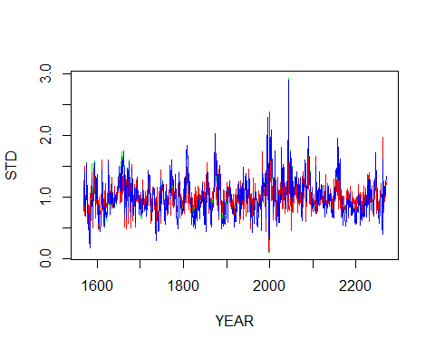

## NULL