BLOCK RUNNER - THE CHARACTERS
How every character looks, written down so they stay the same in every mission. The portraits are pixel art, 48 x 48, head and shoulders in a 3/4 view turned toward the speech bubble, on a night-dark ground with a glow in the character's bubble colour. Each has three faces: calm, angry and smiling - the game picks one from the mood written on each line (angry: shouting, furious, screaming, barking, gritted, urgent, angry, hard, impatient, snarling, breathless, yelling; smiling: grinning, laughing, warm, amused, smiling, wry, relieved, silky, scoffing, moved, teasing, proud; anything else: calm).
They are drawn by tools/portraits.py from the recipes in the character table (js/01y-character-data.js; to change one, edit the table - or the exported spreadsheet - and run the tool again). A picture of your own in img/chars/ with the same name replaces a drawn one.

MARCO VALE (M)
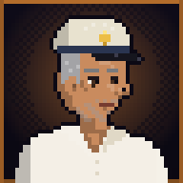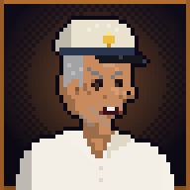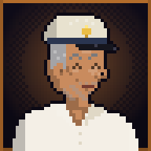
calm - angry - smiling
Who | Owns Sunset Harbor's charter boats and the fuel dock; Lucia's uncle. Slow to anger, hard to stop.
Looks | Fifties, tanned and weathered, grey stubble, grey hair at the sides, a faded captain's cap with a gold badge, a white linen shirt open at the collar.
Bubble colour | #ff9a3d
In the city | shirt #f4efe6, trousers #2a2d3a
Portrait recipe | skin #c98b5e; hair #a3a3a6 (sides); facial hair: stubble; eyes #4a3020; hat: captain; glasses: none; top: openshirt (#f4efe6 / #e0d8c6); extras: wrinkles; old, broad build
Mumble | triangle wave, 95-140 Hz, 7 syllables a second, pauses 0.22 s

LUCIA VALE (L)
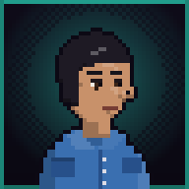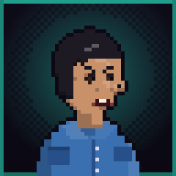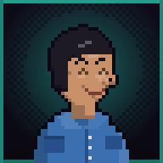
calm - angry - smiling
Who | Marco's niece; runs the fuel dock and anything with an engine. Quick, dry, fearless.
Looks | Late twenties, olive skin, short dark hair with a side fringe, a small gold earring, a denim work shirt with the sleeves rolled.
Bubble colour | #2fe0c8
In the city | shirt #3a6fb0, trousers #1c1c26
Portrait recipe | skin #c8916a; hair #1e1a24 (pixie); facial hair: none; eyes #3a2418; hat: none; glasses: none; top: denim (#3a6fb0 / #27508a); extras: earring; young, slim build
Mumble | triangle wave, 230-360 Hz, 12 syllables a second, pauses 0.05 s

TITO RUIZ (T)
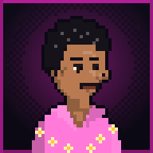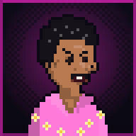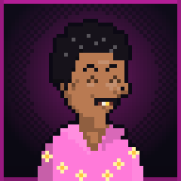
calm - angry - smiling
Who | Marco's courier who skimmed the takings; all nerve until he is caught.
Looks | Twenties, wiry, curly black hair, a thin moustache, a gold tooth he flashes when he grins, a loud pink flower shirt.
Bubble colour | #ff2bd6
In the city | shirt #ff7ad9, trousers #f4efe6
Portrait recipe | skin #b97a52; hair #16121a (curly); facial hair: moustache; eyes #2a1a12; hat: none; glasses: none; top: flowershirt (#ff7ad9 / #fff3a8); extras: goldtooth; young, slim build
Mumble | square wave, 200-320 Hz, 14 syllables a second, pauses 0.04 s

ROCCO (R)
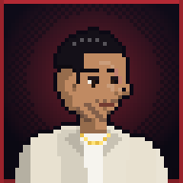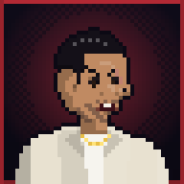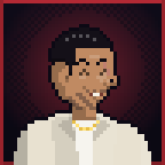
calm - angry - smiling
Who | Nico's collector on the waterfront; smug until it goes wrong.
Looks | Forties, heavy, slicked black hair, a scar across one cheek, a cream jacket over a white vest, a gold chain.
Bubble colour | #ff3b4a
In the city | shirt #e8e1d0, trousers #2a2d3a
Portrait recipe | skin #c08a62; hair #141018 (slick); facial hair: stubble; eyes #2a1a12; hat: none; glasses: none; top: jacketvest (#e8e1d0 / #f6f4ee); extras: chain, scar; mid, broad build
Mumble | sawtooth wave, 110-170 Hz, 9 syllables a second, pauses 0.1 s

VARGA MAN (V)
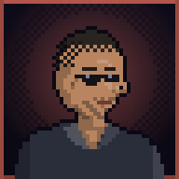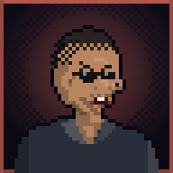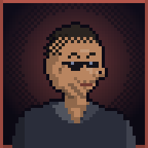
calm - angry - smiling
Who | One of Nico's men - every one of them looks much like the next.
Looks | Thirties, a buzz cut, dark glasses, stubble, a dark shirt open at the neck.
Bubble colour | #ff7a6a
In the city | shirt #2a2d3a, trousers #14121c
Portrait recipe | skin #b98560; hair #2a2420 (buzz); facial hair: stubble; eyes #2a1a12; hat: none; glasses: shades; top: darkshirt (#2a2d3a / #1c1e28); extras: none; mid, broad build
Mumble | sawtooth wave, 120-180 Hz, 11 syllables a second, pauses 0.08 s

DEL RAMOS (D)
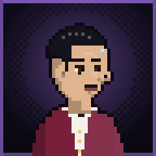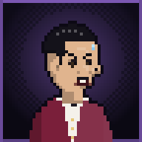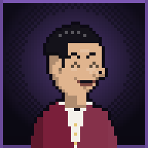
calm - angry - smiling
Who | A croupier at the casino strip who keeps the Vargas' books; nervous, clever, always counting.
Looks | Thirties, thin and pale, slicked black hair, a pencil moustache, a white shirt, a black bow tie and a wine-red croupier's waistcoat.
Bubble colour | #b07cff
In the city | shirt #7a1f3a, trousers #16161c
Portrait recipe | skin #e0b48e; hair #14121a (slick); facial hair: pencil; eyes #3a2a1a; hat: none; glasses: none; top: waistcoat (#7a1f3a / #f4f1ea); extras: sweat; mid, slim build
Mumble | square wave, 260-420 Hz, 15 syllables a second, pauses 0.02 s

NICO VARGA (N)
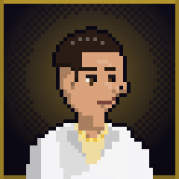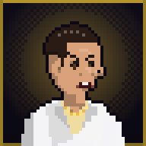
calm - angry - smiling
Who | Ivo's nephew, head of the Varga crew while Ivo is inside; charming, vain, ruthless.
Looks | Thirties, slicked-back dark hair, a pleasant smile that never reaches his eyes, a white linen suit, a pale gold shirt open at the neck, a gold chain.
Bubble colour | #ffd23f
In the city | shirt #f4f4f6, trousers #16161c
Portrait recipe | skin #d9a27a; hair #2a1c14 (slick); facial hair: none; eyes #5a3a1a; hat: none; glasses: none; top: suit (#f4f4f6 / #efdca0); extras: chain; mid, normal build
Mumble | sine wave, 150-230 Hz, 8 syllables a second, pauses 0.18 s

SOL OKAFOR (S)
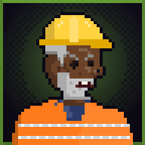
calm - angry - smiling
Who | The crane foreman at Dockside; owes Marco a boat. Steady, funny, a shotgun in the cab.
Looks | Fifties, broad, dark skin, a short grey beard, a yellow hard hat, an orange hi-vis vest with silver stripes over a navy shirt.
Bubble colour | #8fe04a
In the city | shirt #ff7a1a, trousers #2a3a6a
Portrait recipe | skin #6b4228; hair #b8b8b8 (short); facial hair: beard; eyes #1e1410; hat: hardhat; glasses: none; top: hivis (#ff7a1a / #2a3a6a); extras: wrinkles; old, broad build
Mumble | sawtooth wave, 85-125 Hz, 9 syllables a second, pauses 0.12 s

OFFICER DUNN (O)
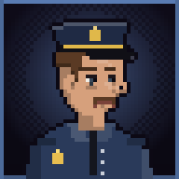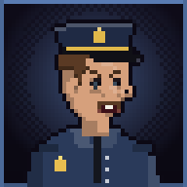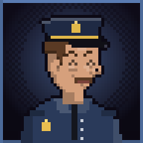
calm - angry - smiling
Who | A prison officer at Iron Key's gate; tired, fair, by the book until the riot.
Looks | Forties, ruddy, a brown moustache, tired eyes with bags under them, a navy police cap with a gold badge, a navy uniform shirt, a black tie and a badge.
Bubble colour | #7fb0ff
In the city | shirt #2a3a5a, trousers #1a2230
Portrait recipe | skin #d6a07c; hair #5a3a24 (short); facial hair: moustache; eyes #3a4a5a; hat: police; glasses: none; top: uniform (#2a3a5a / #14161e); extras: tired; mid, normal build
Mumble | square wave, 140-190 Hz, 10 syllables a second, pauses 0.1 s

IVO VARGA (I)
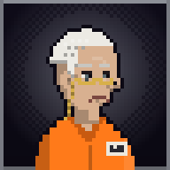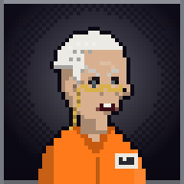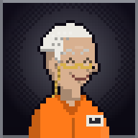
calm - angry - smiling
Who | Nico's uncle and the head of the family before him; six years in a cell on Iron Key, still giving orders.
Looks | Sixties, gaunt, white hair combed straight back, deep lines, reading glasses on a gold cord, a prison-orange jumpsuit with a number on the chest.
Bubble colour | #c8ccd8
In the city | shirt #ff7a1a, trousers #ff7a1a
Portrait recipe | skin #d8b090; hair #eceae4 (combed); facial hair: none; eyes #5a6a70; hat: none; glasses: reading; top: jumpsuit (#ff7a1a / #c85a10); extras: wrinkles; old, slim build
Mumble | sine wave, 80-115 Hz, 6 syllables a second, pauses 0.26 s

DANNY CRUZ (Y)
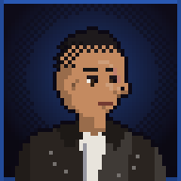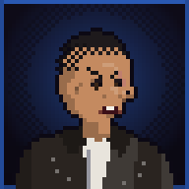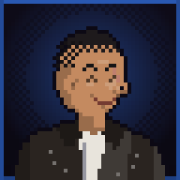
calm - angry - smiling
Who | The hero: came to Miravista on the last flight to find his missing brother Mateo; worked the boats up north (Marco calls him "boatman"). Few words, hard to stop.
Looks | Thirties, a hard face, a buzz cut, a scar on the cheek, a leather jacket over a white T-shirt (his portrait wears the top and hat he has on).
Bubble colour | #3a7dff
In the city | shirt #2a2420, trousers #2a3040
Portrait recipe | skin #c48a60; hair #1e1a1c (buzz); facial hair: none; eyes #3a2618; hat: none; glasses: none; top: leather (#2a2420 / #e8e4dc); extras: scar; mid, broad build
Mumble | triangle wave, 105-155 Hz, 10 syllables a second, pauses 0.1 s

PAPA JOE (J)
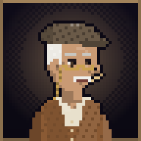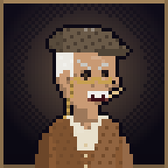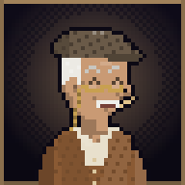
calm - angry - smiling
Who | The oldest cabbie at the airport, seventy; picks Danny up on the first night, talks too much, knows everyone and gives him his first jobs.
Looks | Seventy, white hair and a white moustache, a flat cap, a brown cardigan over a cream shirt, reading glasses on a cord, a toothpick.
Bubble colour | #e6b980
In the city | shirt #8a5a34, trousers #5a5248
Portrait recipe | skin #c99a74; hair #eceae4 (sides); facial hair: moustache; eyes #4a3828; hat: flatcap; glasses: reading; top: cardigan (#8a5a34 / #e8e0cc); extras: wrinkles, toothpick; old, slim build
Mumble | sine wave, 120-210 Hz, 16 syllables a second, pauses 0.03 s

ESTHER BLOOM (E)
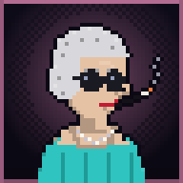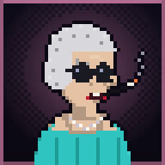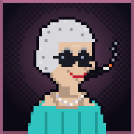
calm - angry - smiling
Who | Owner of the Colony Hotel since the 50s, a sharp old widow who refuses every offer from Crane; gives Danny a room on credit.
Looks | Seventies, silver hair in a 50s wave, big round sunglasses, pearls, red lipstick, a turquoise dress like the hotel's bands, a cigarette holder.
Bubble colour | #ff9ad0
In the city | shirt #2fc4c0, trousers #2fc4c0
Portrait recipe | skin #e6c2a4; hair #d8d8dc (wave); facial hair: none; eyes #3a4a5a; hat: none; glasses: roundshades; top: dress (#2fc4c0 / #1f9a96); extras: wrinkles, pearls, holder, lipstick; old, slim build
Mumble | sine wave, 220-330 Hz, 9 syllables a second, pauses 0.16 s

VICTOR CRANE (C)
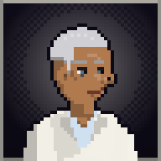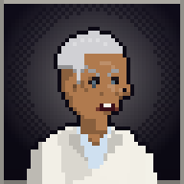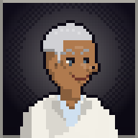
calm - angry - smiling
Who | Crane Development - his name is on every crane in Miravista; running for mayor. Smiles on every billboard; the street knows better.
Looks | Fifties, silver hair swept back, a deep tan, a white linen suit over a pale blue shirt, a gold watch.
Bubble colour | #f4f0e6
In the city | shirt #f2efe6, trousers #f2efe6
Portrait recipe | skin #b07a4e; hair #d0d0d4 (slick); facial hair: none; eyes #5a7080; hat: none; glasses: none; top: suit (#f2efe6 / #cfe0f0); extras: none; old, normal build
Mumble | sine wave, 100-150 Hz, 7 syllables a second, pauses 0.2 s

MATEO CRUZ (Z)
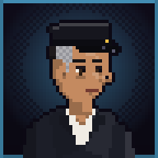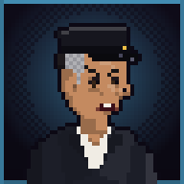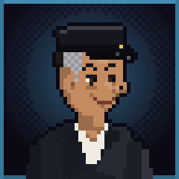
calm - angry - smiling
Who | Danny's older brother: Crane's driver and fixer, hiding the proof that could bring Crane down, trying to get out.
Looks | Like Danny but neat and older: the same jaw, slicked-back hair grey at the temples, a chauffeur's dark suit and cap, tired eyes; no scar.
Bubble colour | #5ec8ff
In the city | shirt #1c1e28, trousers #1c1e28
Portrait recipe | skin #c48a60; hair #1e1a1c (slick); facial hair: none; eyes #3a2618; hat: chauffeur; glasses: none; top: suit (#1c1e28 / #f0ece4); extras: temples, tired; mid, normal build
Mumble | triangle wave, 100-150 Hz, 9 syllables a second, pauses 0.14 s

BULL KESSLER (B)
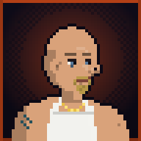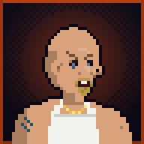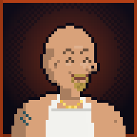
calm - angry - smiling
Who | Bruno "Bull" Kessler, Crane's muscle and the Dockside gang boss; loud, likes tough men, fears only Crane.
Looks | Forties, huge, a big neck, a shaved head, a blond goatee, a white tank top, gold chains, a tattoo on the shoulder.
Bubble colour | #ff5a1f
In the city | shirt #f2f2ee, trousers #3a4a6a
Portrait recipe | skin #d9a27a; hair #e0c070 (bald); facial hair: goatee; eyes #5a7a9a; hat: none; glasses: none; top: tanktop (#f2f2ee / #d8d8d2); extras: chain, tattoo; mid, broad build
Mumble | sawtooth wave, 70-110 Hz, 11 syllables a second, pauses 0.06 s

ROSA ORTEGA (R)
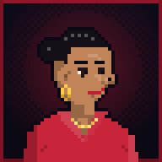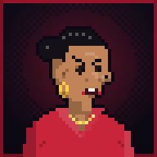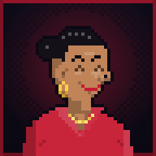
calm - angry - smiling
Who | Mercado's market boss: tough and warm; takes Danny in against Kessler and becomes part of his crew.
Looks | Forties, black hair pulled back tight, big gold hoop earrings, red lipstick, a red blouse with rolled sleeves, a gold chain.
Bubble colour | #d41e3c
In the city | shirt #c8243a, trousers #1a1a20
Portrait recipe | skin #c08458; hair #141018 (pulled); facial hair: none; eyes #2a1a12; hat: none; glasses: none; top: blouse (#c8243a / #9a1a2c); extras: hoops, lipstick, chain; mid, normal build
Mumble | triangle wave, 190-300 Hz, 12 syllables a second, pauses 0.08 s

NINA PARK (N)
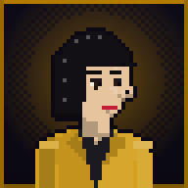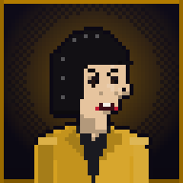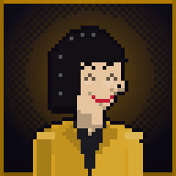
calm - angry - smiling
Who | A Bay TV reporter who has dug into Crane for years; quick and fearless; trades what she knows for Danny's help.
Looks | Thirties, a sharp black bob, a mustard blazer with big 90s shoulders over a black top, small gold earrings.
Bubble colour | #ffb000
In the city | shirt #d4a020, trousers #1a1a20
Portrait recipe | skin #e6c49e; hair #121014 (bob); facial hair: none; eyes #2a1a14; hat: none; glasses: none; top: blazer (#d4a020 / #1a1a20); extras: earring, lipstick; mid, slim build
Mumble | square wave, 240-380 Hz, 15 syllables a second, pauses 0.03 s

LEONARD SACHS (A)
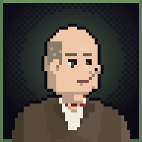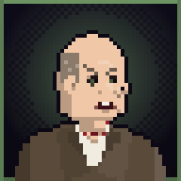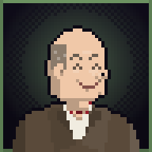
calm - angry - smiling
Who | Crane's lawyer, who moves the money; cheerful, friendly - and dangerous under the smile.
Looks | Fifties, round and cheerful, thinning hair, a brown suit, a red bow tie, a pocket watch.
Bubble colour | #9ad08a
In the city | shirt #5a4a3a, trousers #5a4a3a
Portrait recipe | skin #f0c8a8; hair #8a7a6a (sides); facial hair: none; eyes #4a5a3a; hat: none; glasses: none; top: suit (#5a4a3a / #f0ece0); extras: bowtie, jowls; mid, broad build
Mumble | sine wave, 130-200 Hz, 10 syllables a second, pauses 0.12 s

CHIEF HOLLOWAY (H)
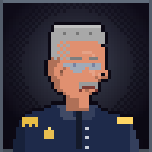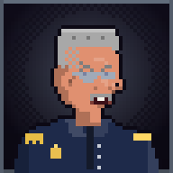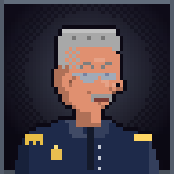
calm - angry - smiling
Who | Chief Ray Holloway, Miravista's police chief, who keeps the police off Crane.
Looks | Fifties, a red face, a grey flat-top, a thick moustache, the chief's navy uniform with gold braid, mirror shades.
Bubble colour | #8a9ab0
In the city | shirt #1e2a4a, trousers #1e2a4a
Portrait recipe | skin #e09070; hair #a8a8a8 (flattop); facial hair: moustache; eyes #4a5a6a; hat: none; glasses: shades; top: uniform (#1e2a4a / #141a2a); extras: braid; old, broad build
Mumble | square wave, 90-130 Hz, 8 syllables a second, pauses 0.14 s

DEAN PRATT (P)
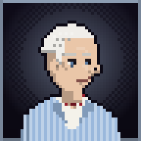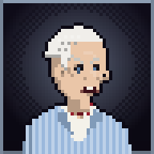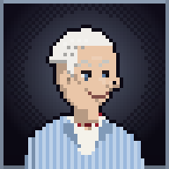
calm - angry - smiling
Who | Councilman Dean Pratt, who sells Crane the city's land; old-school charm.
Looks | Sixties, white hair, a seersucker suit and a bow tie.
Bubble colour | #c8e0ff
In the city | shirt #c8d8ec, trousers #c8d8ec
Portrait recipe | skin #eac6a8; hair #f0eeea (combed); facial hair: none; eyes #5a7aa0; hat: none; glasses: none; top: seersucker (#9ab8dc / #f4f2ea); extras: bowtie, wrinkles; old, normal build
Mumble | triangle wave, 140-220 Hz, 11 syllables a second, pauses 0.1 s

SAL MORETTI (S)
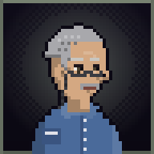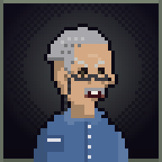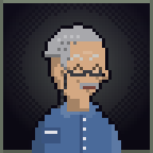
calm - angry - smiling
Who | A lifer on Iron Key: Crane's first partner in the 70s, framed by Crane for a murder Crane did; twenty years inside, calm, patient, plays chess.
Looks | Sixties, short grey hair combed back, a grey moustache, reading glasses, prison blues buttoned to the top; calm eyes.
Bubble colour | #a8b8a0
In the city | shirt #4a6a9a, trousers #3a5480
Portrait recipe | skin #d4a882; hair #a8a8ac (combed); facial hair: moustache; eyes #4a4030; hat: none; glasses: reading; top: buttoned (#4a6a9a / #3a5480); extras: wrinkles; old, slim build
Mumble | sine wave, 90-130 Hz, 6 syllables a second, pauses 0.24 s

DR. IRIS KAHN (K)
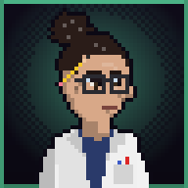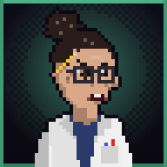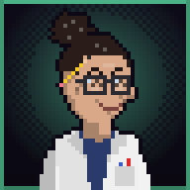
calm - angry - smiling
Who | A rocket engineer at the space center, brilliant and stubborn; her last launch is all that keeps the center open.
Looks | Forties, dark curly hair in a messy bun, big square glasses, a white lab coat over a mission T-shirt, a pencil behind her ear.
Bubble colour | #6affc0
In the city | shirt #f0f0f0, trousers #2a2a40
Portrait recipe | skin #d8a888; hair #2a1c18 (bun); facial hair: none; eyes #3a2a1a; hat: none; glasses: square; top: labcoat (#f0f0f0 / #2a3a6a); extras: pencil; mid, slim build
Mumble | triangle wave, 230-360 Hz, 14 syllables a second, pauses 0.04 s

