TM Forum Guidebook

Use Case: Communication Interaction Management

TMFS033
Maturity Level: Alpha | Team Approved Date: 01-Oct-2026
Release Status: Pre-production | Approval Status: Team Approved
Version 1.0.0 | IPR Mode: RAND

Notice
Copyright © TM Forum 2026. All Rights Reserved.

This document and translations of it may be copied and furnished to others, and derivative works that comment on or otherwise explain it or assist in its implementation may be prepared, copied, published, and distributed, in whole or in part, without restriction of any kind, provided that the above copyright notice and this section are included on all such copies and derivative works. However, this document itself may not be modified in any way, including by removing the copyright notice or references to TM FORUM, except as needed for the purpose of developing any document or deliverable produced by a TM FORUM Collaboration Project Team (in which case the rules applicable to copyrights, as set forth in the TM FORUM IPR Policy, must be followed) or as required to translate it into languages other than English.

The limited permissions granted above are perpetual and will not be revoked by TM FORUM or its successors or assigns.

This document and the information contained herein is provided on an “AS IS” basis and TM FORUM DISCLAIMS ALL WARRANTIES, EXPRESS OR IMPLIED, INCLUDING BUT NOT LIMITED TO ANY WARRANTY THAT THE USE OF THE INFORMATION HEREIN WILL NOT INFRINGE ANY OWNERSHIP RIGHTS OR ANY IMPLIED WARRANTIES OF MERCHANTABILITY OR FITNESS FOR A PARTICULAR PURPOSE.

Direct inquiries to the TM Forum office:

100 Enterprise Drive
Suite 301 #1649
Rockaway, NJ 070866, USA
Tel No. +1 862 227 1648
TM Forum Web Page: www.tmforum.org

Table of Contents
Notice 2
Table of Contents 3
Executive Summary 5
1. Introduction 7
1.1. Context 7
1.2. Objective of the use case 8
1.2.1. Target Audience 8
1.2.2. Business problems addressed, and business value. 8
1.2.3. User Story 9
1.3. Scope and assumptions 9
1.3.1. Scope 9
1.3.2. Assumptions 11
1.3.2.1. Actors 11
1.3.2.2. Preconditions 12
1.3.2.3. Postconditions 12
1.3.2.4. Working hypotheses 13
1.3.3. References 13
1.3.3.1. Structured Relationships 13
1.3.3.2. Other References 16
2. Description 17
2.1. Notification scenarios 17
2.2. Delivery steps common to every scenario 18
2.3. The inbound direction 18
2.4. Requirements not satisfiable by a notifying component alone 19
2.5. Business process view 20
3. Views 21
3.1. Information View 21
3.1.1. Information available at the start 21
3.1.2. Information produced 21
3.1.3. Notification state model 24
4. Diagrams 25
4.1. Sequence Diagrams 25
4.1.1. SD1 : Notification requested and delivered 26
4.1.2. SD2 : Reply received and consent applied 27
4.1.3. SD3 : Consent applied by message class 28
4.1.4. SD4 : Coordination between notifications 29
4.1.5. SD5 : Delivery record queried 30
4.2. ODA Component & Canvas Interaction Diagrams 31
5. Conclusion 32
5.1. Lessons learned 32
5.1.1. Reuse of ODA Assets 32
5.1.2. No component exposing TMF681 Communication Management 33
5.1.3. No event schemas defined for TMF681 Communication Management 35
5.1.4. No representation in TMF681 of the reason for non-delivery, or of the route used 35
5.1.5. Notification delivery functions absent from the Functional Framework 36
5.1.6. Function 1241 Customer Outbound Interaction Initiation is claimed by no component 36
5.1.7. Event distribution between components, and the deprecation of TMF688 37
5.1.8. No component terminating inbound channel transports 37
5.1.9. Reuse potential and future phases 38
5.2. Impacts identified 38
6. Administrative Appendix 41
6.1. Document History 41
6.1.1. Version History 41
6.1.2. Release History 41
6.2. Acknowledgments 41

Executive Summary
Across an ODA implementation many components need to notify (We are talking about comms sent to customers here, not system to system notifications) a customer or a business partner. Product Order Delivery and Orchestration Management notifies on order status, Usage Management on a spend threshold, Customer Bill on bill availability, Account Management on an overdue payment, Privacy Management on a consent change, Partner Management on an ecosystem event. Each is a different business trigger, and each is delivered by the same means: a message to a person, over a channel, subject to that person's consent and contact preferences, with a record of what was sent.
Today each notifying component implements that delivery itself. This use case examines the delivery being consolidated instead — one capability any component can call, which applies consent, contact policy, channel selection, retry and delivery recording uniformly on behalf of all of them.
The use case describes the notification scenarios common to an ODA implementation, the inbound direction when a recipient replies, and the interactions between components in each case. It then records what the current TM Forum asset set does and does not provide for them. The result is uneven, and the unevenness is the principal finding.
TM Forum asset | State against these scenarios
eTOM GB921 | The activities exist — 1.3.5.5 Notify Customer and 1.6.9.2 Notify Business Partner
SID GB922 | The information exists — the Communication Interaction ABE carries the entities produced
Open APIs | Sufficient — 15 of the 16 APIs involved are used unchanged; TMF681 Communication Management already models the delivery contract
Functional Framework GB1033 | One function of approximately twenty required, and it is claimed by no component
ODA component inventory | No component exposes TMF681. TMFC023 Party Interaction Management declares it as a dependent API
Table 1. State of TM Forum assets against the notification scenarios
The frameworks that describe this capability are complete. The frameworks that assign it to a component are not.

Conclusions. The use case identifies a candidate ODA component, Communication Interaction Management, to provide TMF681; approximately twelve additions to the Functional Framework; and three gaps in TMF681 v4.0.0 — no event schemas on the /hub resource, no representation of the reason a notification was not delivered, and no representation of the channel and address actually used where the route is substituted. No change is required to eTOM or SID.
Next steps. The impacts recorded in 5.2 are raised with the owning projects, beginning with the TMF681 event schemas and the Functional Framework additions, both of which precede the component proposal. A subsequent version extends the scope to bulk notification and the admission control it requires, notification-led purchase intent, and sender identity across multiple brands, as set out in 1.3.1.

Introduction
Every communication service provider notifies its customers and business partners continuously, from many components, on many channels, under consent and data-protection obligation. The notification is generally treated as a concern of whichever component raised it, and each therefore implements its own address resolution, consent check, channel handling, retry and delivery record.
The consequences are not visible from within any one component. They become visible when the notifications raised by all of them to one recipient are considered together, which is what this use case does.

Context
Business context. Notification of customers and business partners is common to every communications service provider, across all market segments and product lines. It is subject to consent and data-protection obligations in every market, and in some cases — arrears, price change, outage — to an obligation to notify and to evidence having notified.
Business problem. Notification is triggered by many components and delivered by each of them independently. The effects are:
- Inconsistent enforcement. Consent and contact policy are applied as each notifying component implements them, so the effective standard is that of the least rigorous implementation.
- No coordination between notifications. No component sees notifications raised by another component to the same recipient, so ordering, spacing and frequency across all traffic to one recipient are not governed.
- No owner for the inbound direction. When a recipient replies to a notification, including with a consent keyword, no component is responsible for receiving it, interpreting it, and applying the result across all notifying components.
- No consolidated delivery record. Delivery evidence is held per notifying component and per channel, so the question was this recipient notified, when, and at what address has no single answer.
- Duplicated build and operation. The same delivery capability is built once per notifying component, and then operated, monitored, patched and re-certified once per notifying component.

Proposing workgroup. Proposed to the End-to-End ODA project, based on that project's asset set: the ODA component inventory (IG1242), the TM Forum Open API suite, eTOM GB921, SID GB922 and Functional Framework GB1033.
Current situation the use case intends to clarify. The TM Forum frameworks address notification partially. eTOM defines the activity, SID defines the information, and TMF681 Communication Management defines the API. The Functional Framework decomposes the capability into a single function, and no published component claims that function or exposes TMF681. TMFC023 Party Interaction Management declares TMF681 among its dependent APIs, so the asset set contains a consumer of communication and no provider of it. This use case examines whether that is a deliberate boundary or a gap.

Objective of the use case

Target Audience
Audience | Knowledge Level | Use
Enterprise and solution architects | business and technical | where notification delivery belongs in an ODA architecture
ODA component and Open API owners | technical | the boundary against TMFC023, Party, Privacy and Product Order, and the TMF681 gaps identified
Compliance and regulatory functions | business | how consent and evidence-of-notification obligations are met by architecture rather than per system
Software vendors implementing ODA | technical | the scope of a capability currently implemented within each notifying component
Table 2. Target audience
Operator categorization, per IG1363: a ServCo concern. It has no NetCo or InfraCo content beyond the channel transports it terminates.

Business problems addressed, and business value.
Value | Mechanism
Consistent consent and contact-policy enforcement | one enforcement point applied to all notification traffic on every submission path
Evidence of notification | one delivery record across all notifying components and all channels
Coordination across notifying components | ordering, spacing and frequency governed across all traffic to one recipient
Reduced cost to build | the delivery capability is adopted once rather than implemented per notifying component
Reduced cost to operate | one system to operate, monitor and support; one integration per channel rather than one per notifying component per channel
Faster delivery of notifying components | a notifying component integrates one API and inherits governance
Table 3. Business value and the mechanism that delivers it
The scenarios span the Order to Activate, Usage to Payment and Request to Answer value streams. Capability identifiers are to be confirmed against GB1029C.

User Story
- As a customer or business partner, I need the messages an operator sends me to respect the preferences I have expressed and the channel I have chosen, so that I can rely on the messages that require my action.
- As an operator compliance owner, I need one record of what was sent to a recipient, when and by what means, across every notifying component and channel, so that I can evidence compliance without reconciling multiple systems.
- As an architect of a notifying component, I need to request a notification and have consent, contact policy, channel selection, retry and recording applied on my behalf, so that I do not implement them again.
Of the two objective types the template distinguishes, this use case is both. It addresses a business problem, and in doing so it examines the boundaries and interactions of a capability not present in the component inventory, so that the capability can subsequently be detailed.

Scope and assumptions

Scope
In Scope
# | Included
S1 | The notification scenarios of 2.1 — the delivery of each notification, not the business event that triggers it
S2 | Consent and contact-policy enforcement at the point of dispatch, differentiated by message class
S3 | Coordination between notifications raised by different components to the same recipient
S4 | The inbound direction — receipt of a reply, its association with the originating notification, and consent keywords
S5 | Delivery state normalised across channels and routes, and the resulting delivery record
S6 | Notification of business partners as well as customers, where the delivery is governed identically
Table 4. Scope — included

Out of Scope
# | Excluded | Owned by
X1 | The decision whether to notify, and the content of the notification. GB1033 is consistent with this, placing 39 Bill Dispute Customer Notification, 296 SLA Violation Notification and 1341 Product Specification Change Notification in the domains that raise those events | the notifying component
X2 | Campaign management, targeting and segmentation | campaign and marketing components
X3 | Order lifecycle, fulfilment and order status | Product Order
X4 | Mastering of party and customer data, including the customer hierarchy | Party and Customer components
X5 | Storage of content assets and documents | Document Management
X6 | Mastering of the privacy profile — its definition, amendment and erasure. This use case addresses enforcement at the point of dispatch | Privacy Management
Table 5. Scope — excluded, and the owning capability
Planned for later releases. Bulk notification and the admission control it requires; notification-led purchase intent and the hand-off to Product Order; sender identity across multiple brands and hosted operators; the front-end interaction pattern of Approach A and Approach B, which no scenario in this release exercises.

Assumptions
      - Actors
Actor | Type | Role
Recipient | person | a customer or a business partner; receives notifications and may reply
Notifying component | ODA component | determines that a notification is required and requests it
Compliance or audit function | person or system | queries the delivery record
Channel transport | non-ODA | the bearer for each channel; terminated by the delivery capability and not an ODA interface. Examples below
Table 6. Actors
A channel transport is whatever actually carries the message on a given channel. It is not a TM Forum interface, and it is usually not an ODA component:
Channel | Channel transport
SMS | an SMPP bind to a short message service centre, or an aggregator's messaging gateway
Email | an SMTP relay, or an email service provider's submission API
Mobile app push | the platform notification service for the device — for example APNs or FCM
RCS | an RCS hub, or a Messaging-as-a-Platform provider
Voice and IVR | a voice platform reached over SIP
OTT messaging | the business messaging interface of the OTT provider
Print and post | a print-and-mail fulfilment provider
Table 7. Examples of a channel transport

Two properties are common to all of them and are why they are modelled as an actor rather than as an interface. Each has its own protocol, its own delivery-receipt semantics and its own failure modes, which is what step 7 of 2.2 abstracts and step 10 normalises. And each carries traffic in both directions, which is why the inbound direction of 2.3 has no TM Forum interface: a capability that terminates a transport for dispatch already terminates it for receipt.

      - Preconditions
# | Precondition
P1 | The recipient exists as a Party with at least one contact medium, mastered outside the delivery capability
P2 | A privacy or consent profile exists for the recipient, mastered outside the delivery capability
P3 | The notifying component determines from its own business event that a notification is required
P4 | Each notification carries a message class, supplied by the notifying component, which determines whether consent may suppress the notification, whether the channel may be substituted, and how long delivery may be attempted
P5 | At least one channel transport is available for at least one of the recipient's contact media
Table 8. Preconditions

      - Postconditions
# | Postcondition
Q1 | Every notification requested has reached a terminal state — delivered, or not delivered with a recorded reason
Q2 | A record exists per notification of the contact address used
Q3 | A reply from the recipient is recorded as a party interaction, associated with the notification that preceded it
Q4 | A consent change expressed by a reply is applied to subsequent notifications from every notifying component, according to message class
Q5 | The delivery record can be queried for a recipient across all notifying components and channels
Table 9. Postconditions

Success conditions. A notification whose message class permits suppression is not delivered after consent is withdrawn. A notification whose message class does not permit suppression is delivered. Both hold without change to any notifying component.

      - Working hypotheses
# | Hypothesis
H1 | Consent enforcement, contact policy, channel handling and delivery recording are the same concern for every notification scenario, and can be factored out of the notifying components
H2 | The decision to notify is specific to each notifying component and is not factored out (X1)
H3 | Coordination across notifications (S3) and the inbound direction (S4) require visibility of all notification traffic for a recipient, and are not achievable within an individual notifying component
H4 | The existing Open API set is sufficient for these scenarios without new APIs. Examined in 5.1
Table 10. Working hypotheses

References
      - Structured Relationships

Referenced ODA Components
ODA Components used, referenced, or illustrated within the use case. Component identifiers and the confirmation that these groupings match the inventory's component boundaries are to be established against IG1242.
Component | Notes
Communication Interaction Management | Proposed by this use case; no identifier exists. Provides TMF681. See 5.1.2
Party Interaction Management (TMFC023) | Records the party interaction for each notification and each reply. Consumes TMF681; the counterpart to the proposed component
Party Management ( TMFC027) | Where a notifying component references a customer rather than a party
Party Privacy Management (TMFC022) | Master’s the consent profile enforced at dispatch
Product Order  Capture &  Validation (TMFC002) | Notifying component — order status scenario
Service Order  Management (TMFC007) | Notifying components — service and outage scenarios
Service Usage Management (TMFC015) | Notifying component — usage and spend threshold scenario
Product Usage Management (TMFC040) | Notifying component — usage and spend threshold scenario
Billing Account Management (TMFC024) | Notifying components — bill availability scenario
Payment Management (TMFC029) | Notifying components — payment overdue scenario
Product Catalog Management (TMFC001) | Notifying component — product and price change scenario
Party Management (TMFC027) | Notifying component — partner and ecosystem event scenario
Document Management (TMFC051) | Retrieves an attachment referenced by a notification
Product Inventory (TMFC005) | Referenced when resolving the entity a notification concerns
Table 11. Referenced ODA Components

Referenced Open APIs
API | Notes
TMF681 Communication Management v4.0.0 | The delivery contract. Exposed by the proposed component. Verified against the specification. Three gaps identified — see 5.2
TMF683 Party Interaction Management v4.0.0 | Records each notification and each reply. direction and interactionRelationship carry the inbound direction and the association without extension. Verified
TMF632 Party Management | Resolves a party reference to contactMedium, with mediumType, preferred and validFor. Verified
TMF622 Product Ordering Management | Trigger source — order status scenario. Verified
TMF629 Customer Management | Resolves a customer reference. Verified
TMF666 Account Management | Trigger source — payment overdue scenario; account contacts. Verified
TMF667 Document Management | Attachment retrieval. Verified
TMF637 Product Inventory Management | Resolves the entity a notification concerns. Verified
TMF620 Product Catalog | Trigger source — product and price change scenario. field-level detail to be confirmed
TMF635 Usage Management | Trigger source — usage and spend threshold scenario. field-level detail to be confirmed
TMF636 Bill Presentation | Trigger source — bill availability scenario. field-level detail to be confirmed
TMF640 Service Activation and Configuration | Trigger source — service and outage scenarios. field-level detail to be confirmed
TMF641 Service Ordering | Trigger source — service activation scenario. field-level detail to be confirmed
TMF644 Privacy Management | Consent profile mastering. field-level detail to be confirmed
TMF676 Payment Management | Trigger source — payment overdue scenario. field-level detail to be confirmed
TMF678 Customer Bill Management | Trigger source — bill availability scenario. field-level detail to be confirmed
Table 12. Referenced Open APIs
Sequence diagrams in 4.1 carry field-level parameters only for the APIs marked as verified. The remainder appear at resource and operation level.

Related Use Cases
Use Case | Relationship
TMFS009 Usage and Balance Management | Input — raises the usage and spend threshold scenario (S3 in 2.1)
TMFS005 Billing Fiber Contract | Input — raises the bill availability scenario
TMFS003 Order Capture — Fiber Contract | Input — raises the order status scenario
TMFS004 Order Delivery — Fiber Contract | Input — raises the order status and service scenarios
TMFS008 Service and resource order management for postpaid mobile subscribers | Input — raises the service scenarios
TMFS012 Product Catalog — Launching a new Product Offering | Input — raises the product and price change scenario
TMFS011 Order Fallout Management | Related lifecycle — fallout is a notification trigger
TMFS001 New Party — Create your "account" | Related lifecycle — party creation precedes precondition P1
TMFS006 Legal Guardian | Complementary — party roles, and the distinction between information view and data model view
TMFS020 Multi Party Contract management for a large Enterprise | Complementary — business partner notification (S6)
TMFS026 Commercializing CAMARA APIs with Operate APIs | Complementary — ecosystem event notification
Table 13. Related Use Cases
The relationships above are derived from the business events each use case raises; a notification scenario in 2.1 is the delivery leg that follows. To be confirmed against IG1228.

      - Other References
Reference | Type | Notes
SID Shared_Domain / Communication_Interaction_ABE | Information Framework | Carries the entities the use case produces. GB922 v25.0. No change required
SID Party, Customer, Party Privacy, Customer Account domains | Information Framework | Read during the use case
eTOM 1.3.5.5 Notify Customer | Process Framework | The activity the use case realizes for customers. GB921 v24.0
eTOM 1.6.9.2 Notify Business Partner | Process Framework | The activity the use case realizes for business partners
eTOM 1.3.5.9.3 · 1.6.9.6 Mediate & Orchestrate Interactions | Process Framework | Interaction mediation and orchestration
GB1033 Functional Framework v24.0 | TM Forum Framework | Function 1241 Customer Outbound Interaction Initiation is the one existing function that applies. Additions identified — see 5.2
GB1029C TM Forum Capability Map v3.0.3 | TM Forum Framework | Capability identifiers to be confirmed
IG1242 ODA Component Inventory | Implementation Guide | Source of component identifiers and of the functional block that determines each component's colour in 4.1
IG1228 E2E ODA Use Case Inventory | Implementation Guide | Carries this use case as TMFS033
IG1363 Modernizing Services: delayering to ServCo and NetCo | Implementation Guide | Basis of the operator categorisation in 1.2
Table 14. Other References

Description

Notification scenarios
The scenarios below are those common to an ODA implementation. Each is a different business trigger raised by a different component, and each requires the same delivery.
# | Scenario | Notifying component | Trigger API | Message characteristics
S1 | Order status and confirmation | Product Order Delivery and Orchestration Management | TMF622 | transactional; recipient's preferred channel
S2 | Service activation, and service outage | Service Ordering, Service Activation | TMF641 · TMF640 | transactional or advisory; outage may address many recipients
S3 | Usage or spend threshold reached | Usage Management | TMF635 | advisory; time-sensitive
S4 | Bill available | Customer Bill, Bill Presentation | TMF678 · TMF636 | statutory; recurring; may carry an attachment
S5 | Payment overdue | Account Management, Payment | TMF666 · TMF676 | regulatory; evidence of delivery required; not suppressible by consent
S6 | Consent or preference change confirmed | Privacy Management | TMF644 | transactional; confirms an action the recipient took
S7 | Partner or ecosystem event | Partner Management | Event Hub of the raising API | recipient is a business partner; eTOM 1.6.9.2
S8 | Product or price change | Product Catalog | TMF620 | regulatory notice period; addresses many recipients
Table 15. Notification scenarios common to an ODA implementation

Delivery steps common to every scenario
Each scenario differs in what triggers it, whom it addresses and what it says. Each requires the same sequence of delivery steps.
Step | Description
1 | Accept the notification request, independently of whether delivery is currently possible
2 | Suppress a duplicate request
3 | Determine whether consent permits delivery, given the message class
4 | Determine whether contact policy permits delivery now — send window, quiet hours, frequency
5 | Coordinate against other notifications in flight to the same recipient
6 | Resolve the recipient reference to a contact address, honouring the preferred medium and its validity dates. Not required where the notifying component supplies an explicit address
7 | Select the channel and the route
8 | Render the message for the channel, in the recipient's language, with any required compliance text
9 | Dispatch, and retry within bounds; substitute route or channel where the message class permits
10 | Normalise the delivery outcome to one state model
11 | Record what was sent, to which address, and with what outcome
12 | Bring the notification to a terminal state
Table 16. Delivery steps common to every notification scenario

This sequence is the subject of the use case. It is identical across the eight scenarios of 2.1, and it is currently implemented within each notifying component.

The inbound direction
A recipient may reply to a notification. The reply arrives on the channel transport that carried the notification, not over a TM Forum interface. Three requirements follow.
# | Requirement
I1 | The reply is associated with the notification that preceded it
I2 | The reply is recorded as a party interaction, in the inbound direction
I3 | Where the reply is a consent keyword, the consent change is applied to subsequent notifications from every notifying component, according to message class
Table 17. Requirements arising from a reply
I3 cannot be met within an individual notifying component. A reply arrives on one channel, in response to one notification, and must take effect for all.

Requirements not satisfiable by a notifying component alone
Four requirements above cannot be satisfied by a notifying component acting alone, because each requires visibility of notification traffic beyond that component's own.
# | Requirement | Why a notifying component cannot satisfy it
C1 | Uniform consent enforcement (S2) | Each notifying component enforces its own interpretation. The effective standard is that of the least rigorous implementation, and no component establishes a common one
C2 | Consent differentiated by message class (S2, I3) | Consent withdrawal suppresses some notifications and not others — a regulatory notice under S5 or S8 is delivered, a marketing notification is not. Enforcement therefore depends on the message class of each notification at the point of dispatch, and cannot be represented as a single state that each notifying component reads independently
C3 | Coordination between notifications (S3) | A notifying component sees only the notifications it raises. Ordering, spacing and frequency across all traffic to a recipient require visibility of all of it
C4 | Consolidated delivery record (S5) | Evidence held per notifying component and per channel cannot answer a query about a recipient across all of them
Table 18. Requirements not satisfiable by a notifying component acting alone
On C2, the consequence of error is bidirectional: a notification that is required is suppressed, or a recipient who has withdrawn consent is contacted. Both are visible to the recipient.
On C4, TMF681 v4.0.0 defines a /hub resource and no event schemas, so delivery-state transitions cannot be subscribed to in a standardised way. Delivery state is available by query only.

Business process view
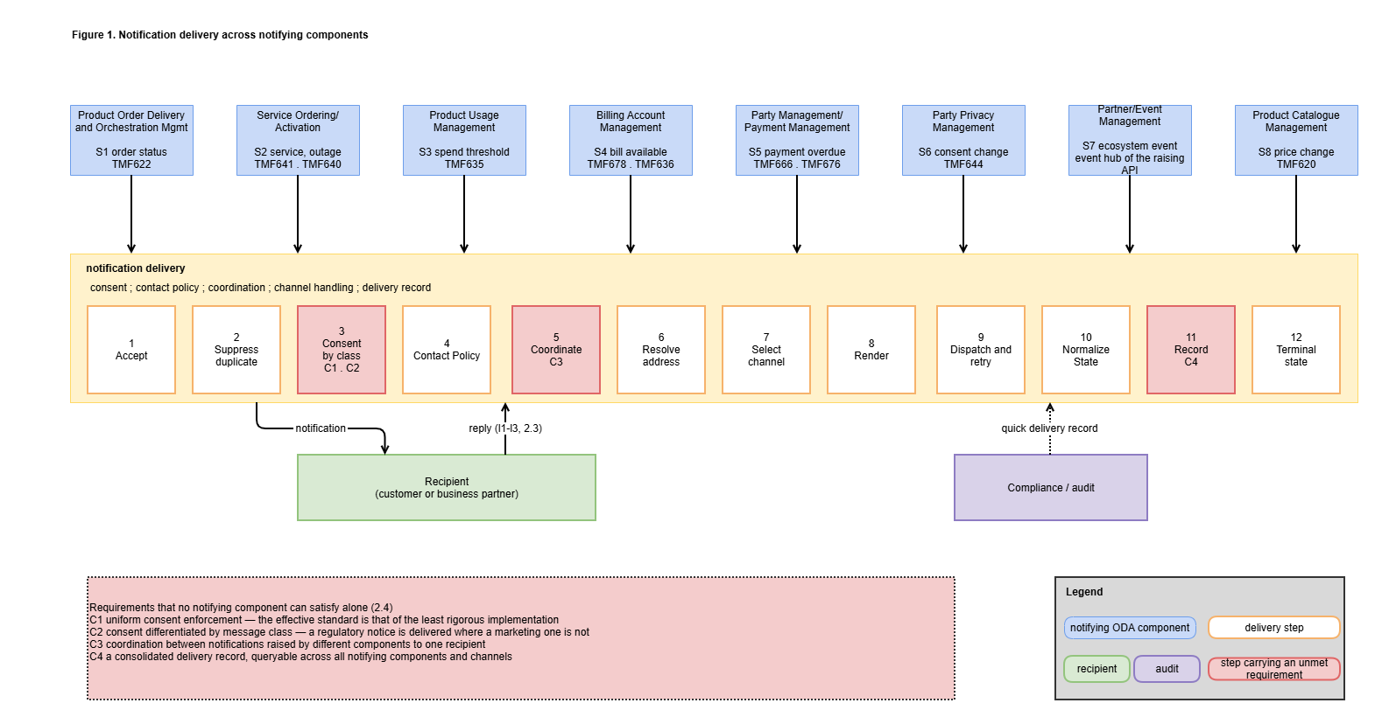

Figure 1. Notification delivery across notifying components

Views
The Information View is mandatory for End-to-End ODA use cases and is given below. The Value Network/Streams View and the Capability View are not applicable to this use case and have been removed.

Information View

Information available at the start
Information | SID ABE | Read over
Party, and contact media with mediumType, preferred and validFor | Party | TMF632 individual
Customer, where the notifying component references a customer | Customer | TMF629
Privacy and consent profile | Party Privacy | TMF644
Billing account and its contacts | Customer Account | TMF666 billingAccount
The business entity the notification concerns — order, product, service, bill | Product Order · Product · Service · Customer Bill | TMF622 · TMF637 TMF640 TMF678
Document referenced as an attachment | Document | TMF667
Table 19. Information read during the use case, and its source

Information produced
Information | SID ABE | Produced at | Represented by
CommunicationMessage — the notification and its lifecycle | Communication Interaction | request | TMF681 communicationMessage
Channel and route used | Communication Interaction | dispatch | not represented in the API — see 5.2
Normalised delivery state | Communication Interaction | outcome | TMF681 state
Delivery record, including the contact address used | Communication Interaction | dispatch | TMF681 and TMF683
PartyInteraction — one per notification and one per reply | Party Interaction | dispatch, reply | TMF683 partyInteraction
Association of a reply with its notification | Party Interaction | reply | TMF683 interactionRelationship
Consent change expressed by a reply | Party Privacy | reply | TMF644
Table 20. Information produced during the use case, and its representation

The SID Communication Interaction ABE carries CommunicationInteraction, CommunicationInteractionItem, CommunicationInteractionMeans, CommunicationInteractionResult and Notification. CommunicationInteractionMeans corresponds to the channel and route, and CommunicationInteractionResult to the normalised delivery state. No new information model is required.
Shared_Domain / Communication_Interaction_ABE is shared with TMFC023. A SID ABE describes shared data structures rather than responsibility, and more than one component may reference the same ABE.
The view below is drawn at instance level, following the convention used by TMFS002 and TMFS003. It carries the worked example of 4.1 rather than entity types alone, so that the entities produced by the use case can be read as concrete values rather than as a schema.
Each SID entity appears as a box, and the instance values it takes for Alice appear as chips beneath it. The entities are grouped by ABE, and each group is labelled with the component responsible for it: Party with Party Management, Party Privacy with Privacy Management, Party Interaction with TMFC023 Party Interaction Management, Document with Document Management, and Communication Interaction with Communication Interaction Management, drawn with a dashed border because it has no identifier.

Three things are visible in the instance values that are not visible in the entity types:
- The four messages sent to Alice occupy one CommunicationInteraction set, with their message class and terminal state shown per instance. The suppressed marketing offer carries state="cancelled" rather than being absent, which is what makes the suppression auditable (Q2, Q4).
- The consent profile appears twice, once as read at SD-1 and once as written at SD-2, which distinguishes enforcement from mastering (X6).
- Two chips are marked as not representable in the published API — the channel and route actually used, and the reason for non-delivery. These are the two gaps recorded in 5.1.4, shown here at the point where the value would otherwise be held.

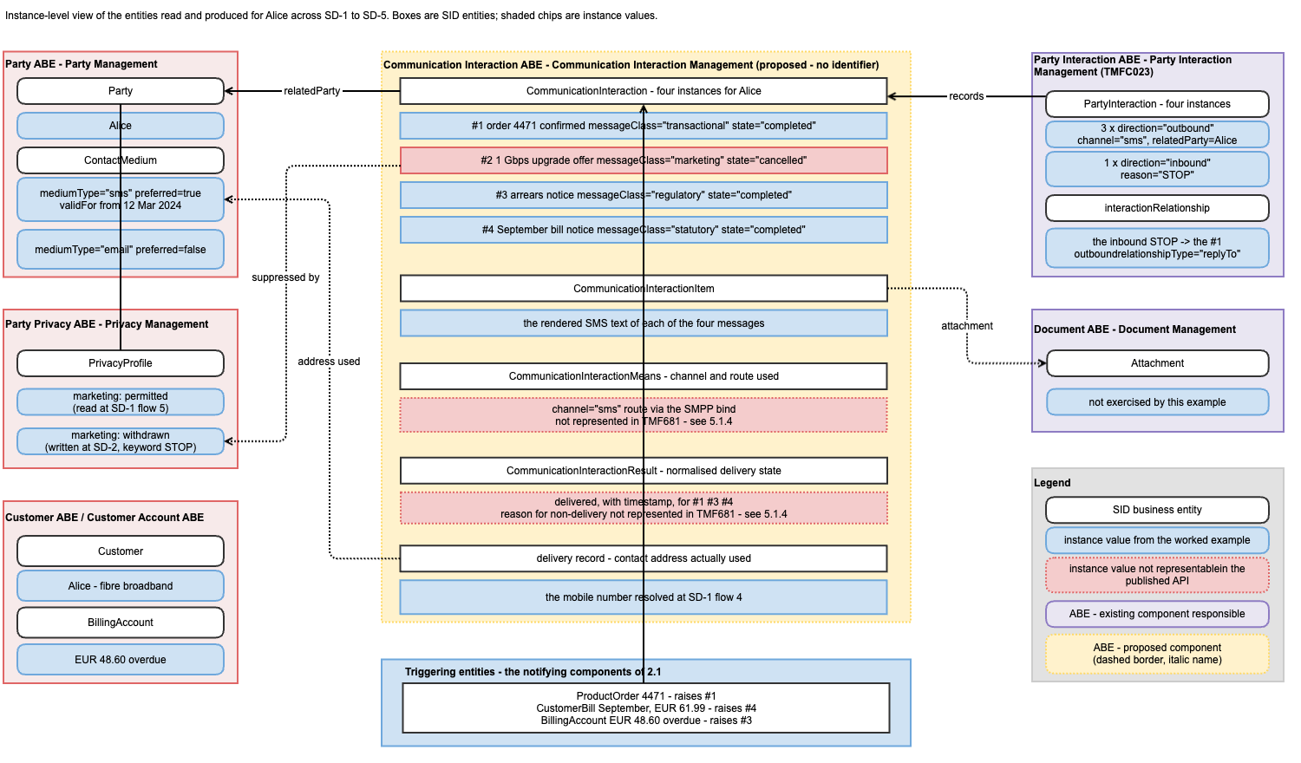

Figure 2. Communication Interaction view — the worked example as SID entities

Notification state model
TMF681 v4.0.0 defines the enumeration, adopted without extension:
initial → inProgress → completed | cancelled | failed
Two properties required by the postconditions are not represented in the published model:
- Reason for non-delivery (Q1). TMF681 carries tryTimes and state = failed, and no field for the reason — hold time exceeded, routes exhausted, contact medium unusable.
- Channel and route used (Q2). receiver[] records the address requested. Where the route or channel is substituted, the address used is not represented.
The diagram shows the five states and their transitions, with the conditions annotated on the transition to failed, and marks the two properties above that the published model does not represent.

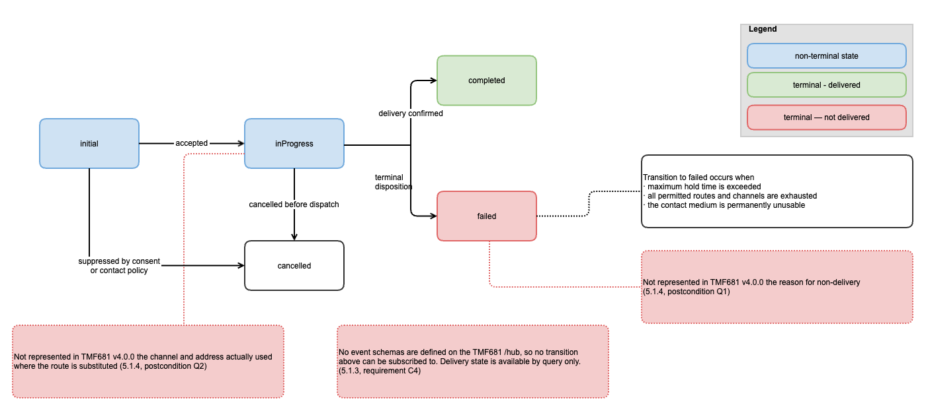
Figure 3. Notification lifecycle

Diagrams
Sequence diagrams are mandatory for mature End-to-End ODA use cases and are not required for initial publication. They are included in 4.1. An ODA component interaction view is included in 4.2. Collaboration and Activity diagrams are not included: the interactions they would carry are already visible in the sequence diagrams of 4.1 and the process view of 2.5.
Approach A and Approach B for front-end interaction are not described, as no scenario in 2.1 involves a user interface; every trigger is a business event raised by a component.

Sequence Diagrams
Conventions. ODA components appear as swim lanes with their full name, coloured by functional block per the template's convention: Engagement Management purple, Party Management red, Core Commerce Management black, Production medium blue. Non-ODA elements are pale blue and Canvas or technical functions grey. Arrows are numbered. The component proposed by this use case, having no identifier, is named in italics.
The functional block of each component named, and therefore its colour, is to be confirmed against IG1242.
Message class values shown are illustrative categories, not a proposed enumeration.
Worked example. So that the functional content of each flow is concrete, the five diagrams below follow one recipient through one sequence of events.

Alice has a fibre broadband subscription. She places an order to add an optional static IP address to it. Her Party record holds two contact media — a mobile number marked preferred and an email address — and a consent profile that permits marketing. Over the following weeks she receives the order confirmation, replies STOP, and then receives a bill notice carrying her September bill document and an arrears notice.

Diagram | What happens to Alice | Message class
SD1 | Product Order Delivery and Orchestration Management confirms the static IP order confirms the static IP order; Alice is notified by SMS | transactional
SD2 | Alice replies STOP to that SMS | inbound
SD3 | A marketing offer is suppressed; an arrears notice is delivered | marketing, then regulatory
SD4 | A bill notice referencing her bill document and an arrears notice arrive in the same hour and are ordered | statutory, regulatory
SD5 | Compliance asks what Alice was sent, and when | —
Table 21. The worked example followed through the sequence diagrams

SD1 : Notification requested and delivered
The sequence common to all eight scenarios of 2.1, shown with Product Order Delivery and Orchestration Management (S1). The other scenarios differ in the notifying component, the trigger and the message class.
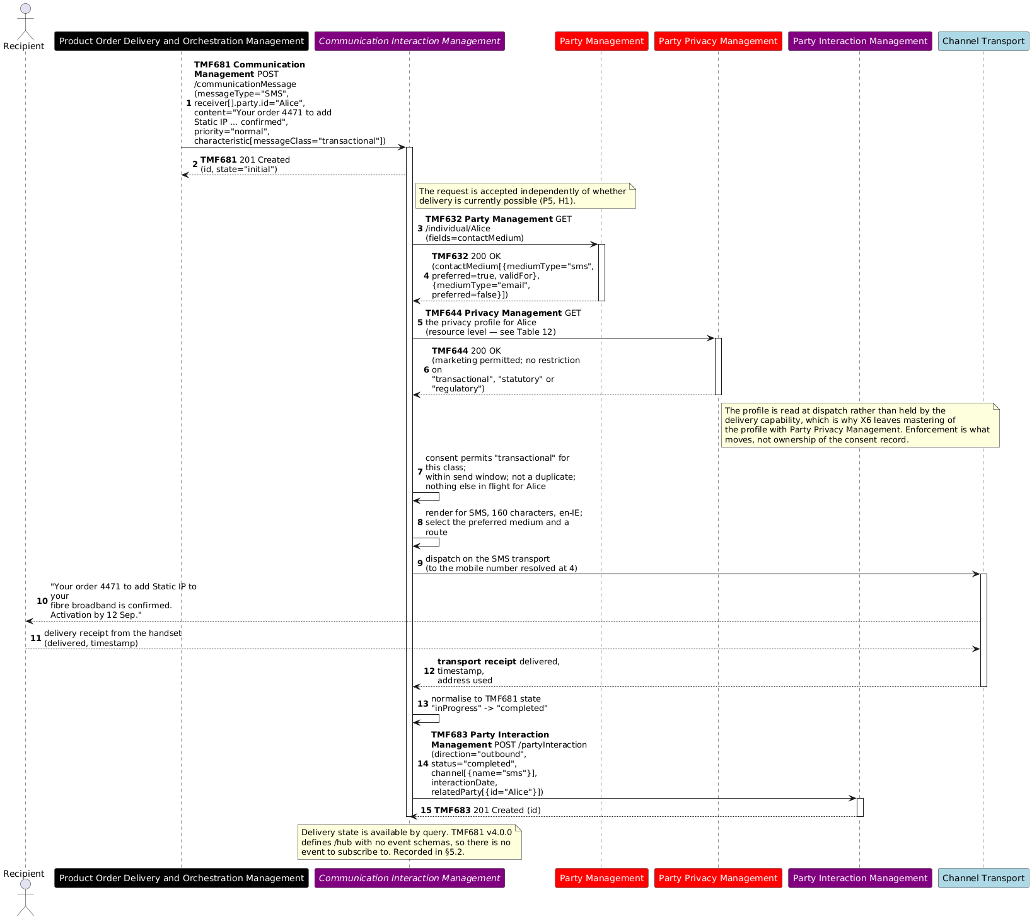
Figure 4. Notification requested and delivered

SD2 : Reply received and consent applied
The inbound direction of 2.3. Alice replies to the order confirmation of SD-1. The reply arrives on the channel transport that carried it, not over a TM Forum interface.
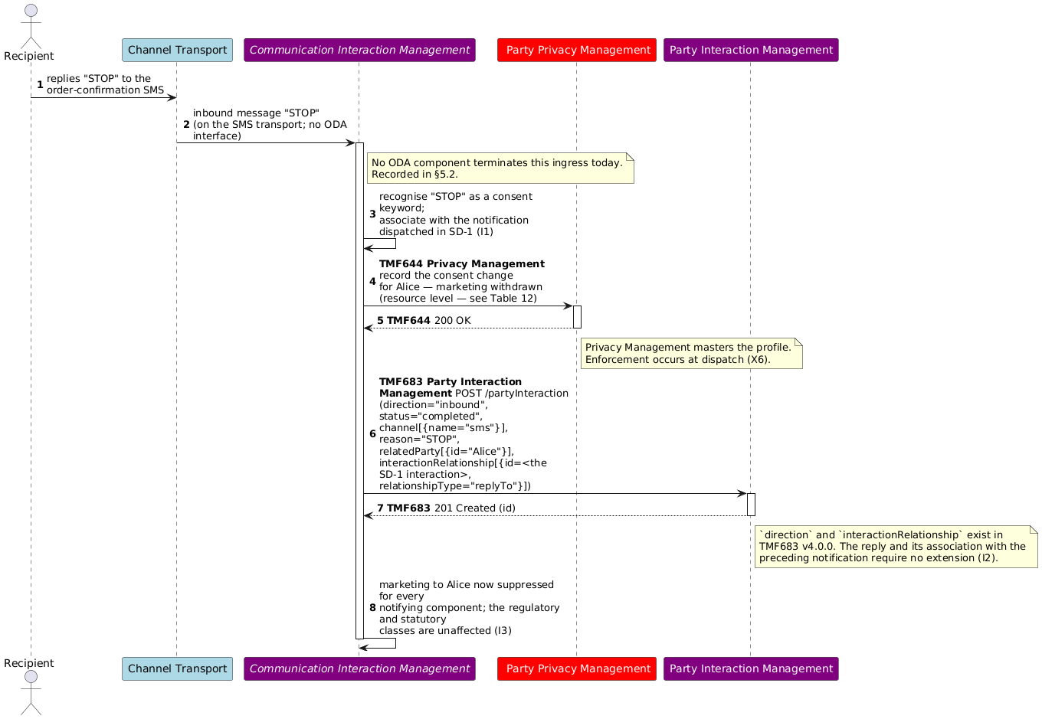
Figure 5. Reply received and consent applied

SD3 : Consent applied by message class
Two notifications to Alice from different components, after the STOP of SD-2. The message class determines the outcome. Neither notifying component changes.

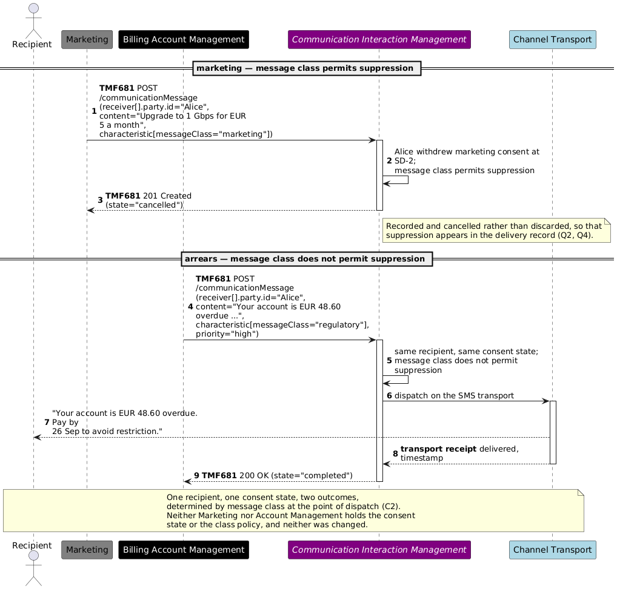
Figure 6. Consent applied by message class

SD4 : Coordination between notifications
The arrears notice of SD-3 does not arrive alone. Customer Bill raises Alice's September bill notice in the same hour, and neither notifying component can see the other's traffic.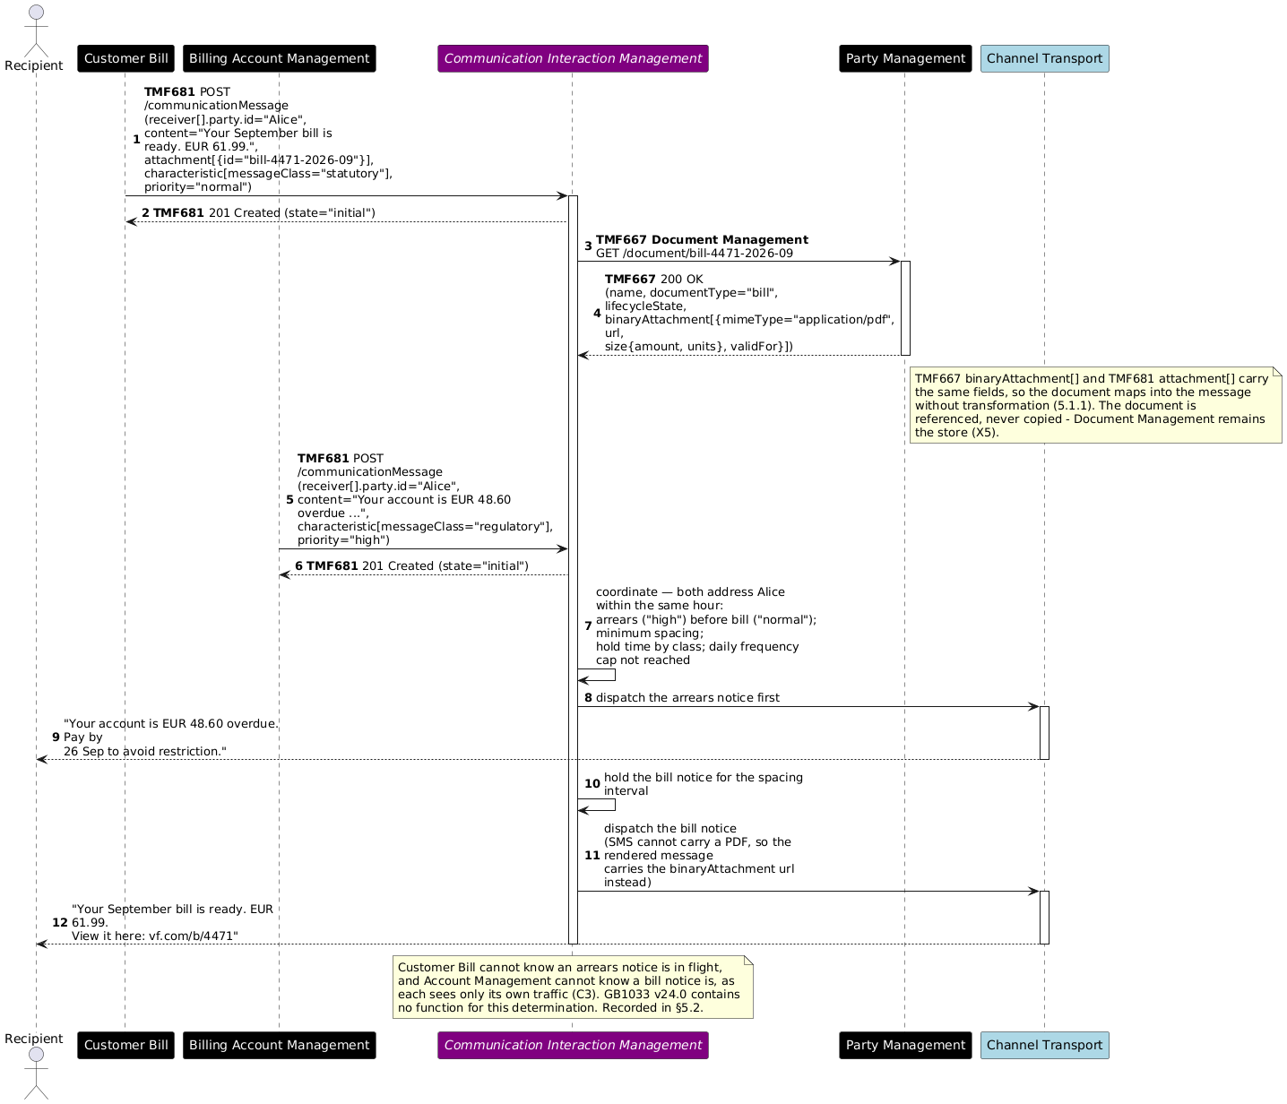
Figure 7. Coordination between notifications

SD5 : Delivery record queried
Compliance asks what Alice was sent, and when.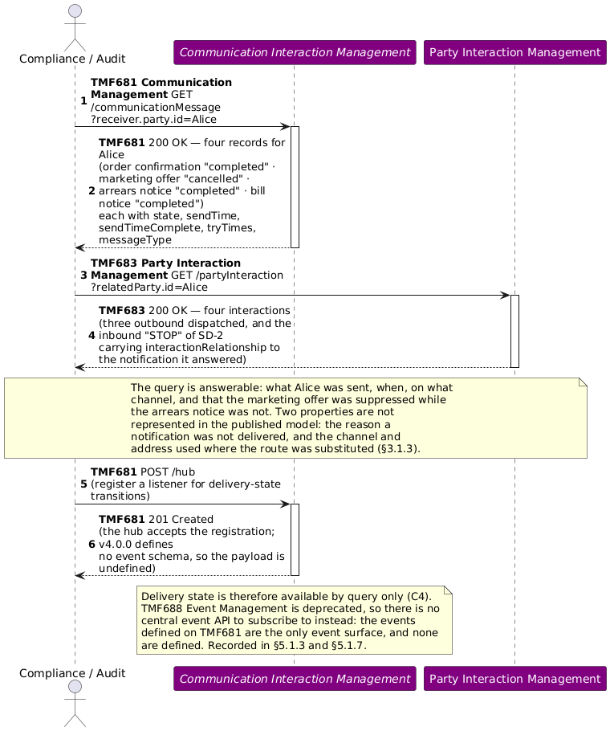
Figure 8. Delivery record queried

ODA Component & Canvas Interaction Diagrams
A high-level architectural view of the components involved in the notification scenarios of 2.1 and the interfaces between them. The view is organised by ODA functional block, and the component identified in 5.1.2 is shown with a dashed border and an italic name, having no identifier.
Three properties of the view carry the analysis of 5:
- One exposed API. The component exposes TMF681 Communication Management and nothing else. Every notifying component on the left consumes that one interface, which is the reuse position of 5.1.9.
- No mandatory dependency. Every consumed interface on the right is optional, because a notifying component may supply an explicit delivery address rather than a party reference.
- The inbound direction is not an ODA interface. Channel transports are drawn as non-ODA. They are terminated by the component in both directions, which is the observation recorded in 5.1.8.
Party Interaction Management is shown separately from the consumed interfaces because the relationship is reciprocal rather than one-way: it exposes TMF683, which this component consumes, and it consumes TMF681, which this component exposes. See Table 23.

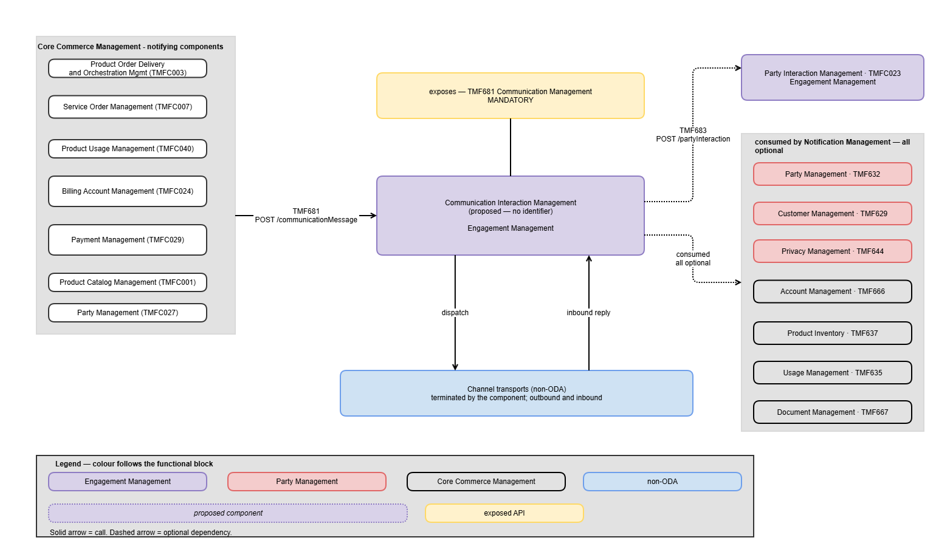

Figure 9. ODA component interaction

Conclusion

Lessons learned

Reuse of ODA Assets
The scenarios of 2.1 were examined against GB921 v24.0, GB922 v25.0, GB1033 v24.0 and the published Open API set.
Asset class | Involved | Reused unchanged | Extension identified | Newly identified
eTOM business activities | 4 | 4 | 0 | 0
SID ABEs | 10 | 10 | 0 | 0
Open APIs | 16 | 15 | 1 | 0
ODA components | 14 | 13 | 0 | 1
Functional Framework functions | ~20 required | 1 | 0 | 12
Table 22. Reuse of ODA assets across the notification scenarios

The fourteen ODA components, sixteen Open APIs, four eTOM activities and ten SID ABEs are enumerated in Table 11, Table 12 and Table 14. Reuse is therefore 100% for eTOM and SID, 94% for the Open APIs, 93% for components, and 5% for Functional Framework functions.
eTOM defines the activities required, at both customer and business partner level. No contribution arises.
SID defines the information produced, in an ABE whose entities correspond to the delivery steps of 2.2. No contribution arises.
The Open API set is sufficient. TMF681 CommunicationMessage represents the delivery contract without extension — messageType, sender, receiver[] accepting either an address or a party reference, content, subject, characteristic[], priority, scheduledSendTime, tryTimes, attachment[], logFlag, and state with its five values. TMF683 represents a reply and its association with the preceding notification through direction and interactionRelationship. One extension is identified, concerning TMF681. TMF667 binaryAttachment[] and TMF681 attachment[] are field-identical — id, href, attachmentType, content, description, mimeType, name, url, size and validFor — so a document retrieved from Document Management maps into a notification without transformation, as SD-4 shows.

The Functional Framework decomposes the delivery sequence into one function. The other notification-related functions in GB1033 — 39 Bill Dispute Customer Notification, 296 SLA Violation Notification, 1341 Product Specification Change Notification, 583 Activation Notification — each describe a business event that triggers a notification and belong to the domain that raises it, consistent with X1. No function describes channel handling, delivery orchestration, retry or route substitution, consent enforcement at dispatch, coordination between notifications, or the inbound direction.
No component in the inventory exposes TMF681. TMFC023 declares it as a dependent API.

No component exposing TMF681 Communication Management
Currently, no ODA component exposes the TMF681 Communication Management API. TMFC023 Party Interaction Management declares TMF681 among its dependent APIs, so the asset set contains a consumer of communication and no provider of it.
Three alternatives are considered.
Alternative #1. Extend TMFC023 Party Interaction Management to expose TMF681. TMFC023 is already positioned adjacent to this capability and consumes the API, so no new component would be required. Against this: TMFC023's own specification declares TMF681 as a dependent API, which positions it as a consumer rather than a provider. Its eTOM claim covers 1.3.5 Customer Interaction Management and 1.6.9 Business Partner Interaction Management — the recording and management of interactions — whereas the delivery steps of 2.2 are a different responsibility from recording that a delivery occurred. Adopting this alternative would place channel adapters, route selection, retry, route substitution and consent enforcement at dispatch inside the system of record for party interactions, and would additionally require TMFC023 to terminate the inbound channel transports of 2.3, which it does not do today.
Alternative #2. Assign TMF681 to another existing component. The capability is customer-engagement facing, so a component in the Engagement Management functional block would be the natural candidate. Of the published component specifications examined, none claims eTOM 1.3.5.5 Notify Customer or 1.6.9.2 Notify Business Partner, and none claims Functional Framework function 1241 Customer Outbound Interaction Initiation. The full candidate set cannot be enumerated without IG1242. Any candidate identified would still require the delivery steps of 2.2, the inbound direction of 2.3 and the Functional Framework additions of 5.1.5 to be added to its scope, which is the same functional extent as Alternative #3.

Alternative #3. Introduce a new component. A component whose responsibility is the delivery steps of 2.2 and the inbound direction of 2.3, exposing TMF681:
Communication Interaction Management — accepts notification requests from any ODA component and delivers them under uniform governance: consent enforcement at dispatch by message class, contact policy, coordination between notifications to one recipient, channel handling, delivery orchestration with bounded retry and route substitution, normalised delivery state with terminal disposition, the delivery record, and the inbound direction including association with the preceding notification and consent keywords.
Functional block: Engagement Management. The enumeration value is to be confirmed against IG1242.
Exposes: TMF681 Communication Management, mandatory.
Consumes, all optional: TMF683 for the interaction record, TMF632, TMF629, TMF644, TMF666, TMF637, TMF667, TMF635, TMF622. None is mandatory, as a notifying component may supply an explicit address.
Out of scope: X1 to X6 of 1.3.1.

Under this alternative TMFC023 retains its boundary, and the two components sit in opposite positions on the same two interfaces.
API | TMFC023 | Communication Interaction Management
TMF681 Communication Management | consumes | provides
TMF683 Party Interaction Management | provides | consumes
Table 23. Interface positions of TMFC023 and the candidate component

Neither exposes an API the other exposes, satisfying the expectation that a given Open API is exposed by one functional ODA component. The eTOM activities claimed are those TMFC023 does not claim; the Level 2 parents 1.3.5 and 1.6.9 remain with TMFC023.
Two naming conventions are visible in the published inventory, and they disagree here. TMFC005 Product Inventory and TMFC023 Party Interaction Management each take the name of the API they expose, which would give Communication Management — identical to TMF681 itself. The name proposed instead follows the SID ABE whose entities the component masters, Communication Interaction, giving Communication Interaction Management. This is preferred for two reasons. It avoids a component and an Open API sharing one name, which is ambiguous in any sentence that does not say which is meant. And it reads as the counterpart to TMFC023 Party Interaction Management, which is what Table 23 shows the two components to be. The final name is for the project to settle.
Assessment. Alternative #3 is considered the more appropriate choice. The delivery steps of 2.2 form a single coherent responsibility; the twelve Functional Framework functions of 5.1.5 group under one component; and TMFC023's declaration of TMF681 as a dependent API indicates that its own scope was not intended to include providing it. Alternative #1 remains viable if the project prefers not to add a component, in which case TMFC023's functional scope, eTOM claims and Functional Framework functions would need to expand to cover 2.2 and 2.3.

No event schemas defined for TMF681 Communication Management
TMF681 v4.0.0 defines a /hub resource and /hub/{id}, and defines no event schemas. A subscriber can register a listener, and the specification does not define what that listener receives. A delivery-state transition therefore cannot be subscribed to in a standardised way, and delivery state is available by query only, as shown in SD-5.
This affects requirement C4 of 2.4. Continuous monitoring of delivery outcomes across notifying components — which is what an evidence-of-notification obligation requires in practice — is not achievable over the published API without polling.
Comparable observations have been recorded elsewhere in the ODA asset set where an API defines a hub without defining the events it carries. The gap here appears to be an omission rather than a design decision, since the hub resource itself is specified.

No representation in TMF681 of the reason for non-delivery, or of the route used
Two properties required by the postconditions of 1.3.2 are not represented in TMF681 v4.0.0.
Reason for non-delivery (postcondition Q1). The model carries tryTimes and state = failed, and no attribute for the reason — hold time exceeded, all permitted routes exhausted, or the contact medium permanently unusable. For an evidence-of-notification obligation the distinction matters: a record showing that delivery was attempted and failed is materially different from one showing that the contact medium held for the recipient was invalid from a given date.
Channel and route actually used (postcondition Q2). receiver[] records the address requested. Where the route or channel is substituted under 2.2 step 9, the address actually used is not represented, and that is the value an audit query requires.

In the meantime, a generic mechanism could be used — for example recording both values in characteristic[] on the communicationMessage, or in the note attribute of the corresponding TMF683 partyInteraction. Neither is a standard approach, so records produced by different implementations would not be comparable.

Notification delivery functions absent from the Functional Framework
The delivery steps of 2.2 decompose into approximately twenty distinct functions. GB1033 v24.0 provides one that applies: 1241 Customer Outbound Interaction Initiation.
The other notification-related functions in GB1033 — 39 Bill Dispute Customer Notification, 296 SLA Violation Notification, 1341 Product Specification Change Notification and 583 Activation Notification — each describe a business event that triggers a notification, and belong to the domain that raises that event, consistent with X1 of 1.3.1. None describes the delivery of a notification as a capability. There is no function for channel abstraction, delivery orchestration, retry or route substitution, consent enforcement at dispatch, coordination between notifications, or the inbound direction.
Twelve additions are identified: Notification Request Acceptance · Duplicate Suppression · Consent Enforcement · Send-Time Governance · Notification Coordination · Address Resolution · Rendering · Channel Abstraction · Delivery Orchestration · Delivery State Normalisation · Delivery Record · Inbound Notification Handling.
Two alternatives are considered for their placement. Alternative #1, a new Aggregate Function Level 2 grouping Notification Delivery Management under the existing Level 1 Welcome and Interaction. That Level 1 already holds six Level 2 groupings of between two and fifteen functions, so a grouping of twelve is proportionate. Alternative #2, addition to the existing Level 2 grouping Customer Interaction Management. This would nearly double that grouping and would combine the recording of interactions with the delivery of notifications, which is the distinction the component boundary in 5.1.2 rests on. Alternative #1 is considered the more appropriate choice.
This contribution is a prerequisite of the component identified in 5.1.2 rather than a consequence of it: a component is specified against the functions it performs.

Function 1241 Customer Outbound Interaction Initiation is claimed by no component
1241 Customer Outbound Interaction Initiation is described in GB1033 v24.0 as the outbound triggering of direct interaction with customers, by any channel. It is claimed by no published ODA component, although it sits under the same Aggregate Function Level 2 grouping as functions that TMFC023 does claim. The function that most directly describes this capability exists in the framework and is unallocated, which is consistent with the observation in 5.1.2.

Event distribution between components, and the deprecation of TMF688
An earlier version of this use case named TMF688 Event Management as the trigger source for the partner and ecosystem event scenario (S7 of 2.1) and recorded its role in the ODA asset set as unresolved. The API team has since confirmed that TMF688 is deprecated and is to be removed from all use cases. It has been removed from this one. The asset counts in 5.1.1 are unchanged by the removal, because the sixteen Open APIs enumerated in Table 12 had been understated by one.
Events are instead carried by the events defined within each individual Open API. This use case shows those events passing directly between the raising component and the consuming component. That point-to-point depiction is a functional illustration and not a target architecture — it shows which component needs to learn what, not how the event should be transported. An event broker may be used instead, and in most implementations will be.
The confirmation removes the alternative this use case had been holding open, and in doing so it makes the finding in 5.1.3 materially more important rather than less. If every component's event surface is the set of events defined on the API it exposes, then TMF681's empty /hub is not an inconvenience to be worked around by subscribing to a central event API — it is the entire event surface of the notification delivery capability, and it is empty. There is no longer a fallback. The delivery-state event schemas identified in 5.1.3 are the only route to a subscribable delivery state.
Two observations recorded earlier remain consistent with this direction and are retained as corroboration. Both published component specifications examined populate their event notification through their own per-API hub — TMF637's and TMF683's respectively — and neither uses TMF688. And the use case template's own sequence-diagram convention lists "an Event Bus or Event Management" among technical components and Canvas functions, to be drawn in grey, rather than among business components.

No component terminating inbound channel transports
The inbound direction of 2.3 arrives on the channel transport that carried the notification, not over a TM Forum interface. No published ODA component terminates channel transports for inbound messages, or takes responsibility for interpreting a reply, associating it with the notification that preceded it, and applying a consent change expressed in it across all notifying components.
TMFC023 records party interactions, including inbound ones, but recording an interaction presumes it has already been received and interpreted. The receipt itself is unallocated. A component that abstracts channels for dispatch already terminates those channels, which is why requirement I1 to I3 of 2.3 is placed with the component identified in 5.1.2 rather than treated separately.

Reuse potential and future phases
The eight scenarios of 2.1 are each a distinct business trigger followed by the same twelve delivery steps of 2.2. A component providing those steps is consumed by every notifying component, and the delivery capability is implemented once rather than once per notifying component. The scenarios also bound the scope: the notifying component determines whether and when to notify, and what the notification says; the delivery capability determines how it is delivered.
The scenarios required no new Open API and no new information model, which indicates the existing asset set is well suited to this capability and that specifying a component for it is tractable.
Future phases are listed in 1.3.1. Each concerns delivery at greater scale — bulk notification and admission control — or a boundary better settled after the core boundary is agreed: notification-led purchase intent, sender identity across brands, and the front-end interaction pattern.

Impacts identified
Asset Type | Asset | Impact Description | Related Work Item(s)
ODA Component | Communication Interaction Management (proposed) | No component in the inventory exposes TMF681, and TMFC023 declares it as a dependent API. A candidate component providing notification delivery is required in the Engagement Management functional block, per 5.1.2. Arises from 5.1.1 and SD-2 |  TAC-1416 - New Component - Communication and Interaction Management backlog
ODA Component | ODA Component Inventory (IG1242) | The functionalBlock enumeration value for Engagement Management requires confirmation; the Component CRD does not constrain it
Open API | TMF681 Communication Management | v4.0.0 defines /hub and /hub/{id} with no event schemas, so a delivery-state transition cannot be subscribed to. Event schemas are required to satisfy C4. With TMF688 deprecated there is no central event API to subscribe to instead, so this is the only available route — see 5.1.7. Arises from SD-1 and SD-5 |  AP-7806 - Improvements to TMF681 open
Open API | TMF681 Communication Management | No field represents the reason a notification was not delivered. The model carries tryTimes and state = failed only. Required by postcondition Q1. Arises from 3.1.3 and SD-5
Open API | TMF681 Communication Management | No field represents the channel and address actually used where the route or channel is substituted. receiver[] records the address requested. Required by postcondition Q2. Arises from 3.1.3 and SD-5
Open API | TMF688 Event Management | Confirmed deprecated by the API team and removed from this use case. The consequence is recorded rather than the deprecation itself: with no central event API, the events defined on each Open API are a component's only event surface, which makes the missing TMF681 event schemas above the sole route to a subscribable delivery state. Arises from 5.1.7 | Closed — no action
Business Process (eTOM) | GB921 1.3.5.5, 1.6.9.2, 1.3.5.9.3, 1.6.9.6 | No change required. The activities exist and are claimed by no published component; only assignment to a component is absent | n/a
Information Model (SID) | GB922 Communication Interaction ABE | No change required. The entities exist and correspond to the delivery steps of 2.2 | n/a
Other | GB1033 Functional Framework | The delivery sequence of 2.2 decomposes into approximately twenty functions; one exists. Twelve additions are identified, in a new Aggregate Function Level 2 grouping Notification Delivery Management under the existing Level 1 Welcome and Interaction: Notification Request Acceptance · Duplicate Suppression · Consent Enforcement · Send-Time Governance · Notification Coordination · Address Resolution · Rendering · Channel Abstraction · Delivery Orchestration · Delivery State Normalisation · Delivery Record · Inbound Notification Handling | ISA-1636 - GB1033 Notification Delivery Management Functions and Function 1241 Component Allocation backlog
Other | GB1033 function 1241 | 1241 Customer Outbound Interaction Initiation is claimed by no published component, though it sits under the same Aggregate Function Level 2 as functions TMFC023 claims
Table 24. Impacts Identified

Administrative Appendix

Document History

Version History
This section records the changes between this and the previous document version as it is edited by the team concerned. Note: this is an incremental number which does not have to match the release number and used for change control purposes only.
Version Number¹ | Date Modified | Modified by: | Description of changes
1.0.0 | 01 Oct 2026 | Mayur Khedkar | Initial release.

Release History
Release Status | Date Modified | Modified by: | Description of changes
Pre-production | 01 Oct 2026 | Kaushik Mohta | Initial release.

Acknowledgments
This document was prepared by the members of the TM Forum ‘End to End ODA’ project team.
Team Member (@mention) | Company | Role*
Kaushik Mohta | Vodafone | Author
Dominic Oyeniran | Vodafone | Contributor
Mayur Khedkar | Vodafone | Contributor
Declan McArdle | Vodafone | Contributor
Elisabeth Andersson | Amdocs | Contributor
Jan Lowdon | TM Forum | Reviewer
*Select from the following three roles; Author, Contributor or Reviewer as highlighted in the Collaboration Playbook

