TM Forum Use Case

Use Case: Browse B2C Catalogue and Check Fiber Technical Eligibility

TMFS002

Maturity Level: General availability (GA) | Team Approved Date: 24-Apr-2025
Release Status: Production | Approval Status: TM Forum Approved
Version 3.1.2 | IPR Mode: RAND

Notice
Copyright © TM Forum 2025. All Rights Reserved.

This document and translations of it may be copied and furnished to others, and derivative works that comment on or otherwise explain it or assist in its implementation may be prepared, copied, published, and distributed, in whole or in part, without restriction of any kind, provided that the above copyright notice and this section are included on all such copies and derivative works. However, this document itself may not be modified in any way, including by removing the copyright notice or references to TM FORUM, except as needed for the purpose of developing any document or deliverable produced by a TM FORUM Collaboration Project Team (in which case the rules applicable to copyrights, as set forth in the TM FORUM IPR Policy, must be followed) or as required to translate it into languages other than English.

The limited permissions granted above are perpetual and will not be revoked by TM FORUM or its successors or assigns.

This document and the information contained herein is provided on an “AS IS” basis and TM FORUM DISCLAIMS ALL WARRANTIES, EXPRESS OR IMPLIED, INCLUDING BUT NOT LIMITED TO ANY WARRANTY THAT THE USE OF THE INFORMATION HEREIN WILL NOT INFRINGE ANY OWNERSHIP RIGHTS OR ANY IMPLIED WARRANTIES OF MERCHANTABILITY OR FITNESS FOR A PARTICULAR PURPOSE.

TM FORUM invites any TM FORUM Member or any other party that believes it has patent claims that would necessarily be infringed by implementations of this TM Forum Standards Final Deliverable, to notify the TM FORUM Team Administrator and provide an indication of its willingness to grant patent licenses to such patent claims in a manner consistent with the IPR Mode of the TM FORUM Collaboration Project Team that produced this deliverable.
The TM FORUM invites any party to contact the TM FORUM Team Administrator if it is aware of a claim of ownership of any patent claims that would necessarily be infringed by implementations of this TM FORUM Standards Final Deliverable by a patent holder that is not willing to provide a license to such patent claims in a manner consistent with the IPR Mode of the TM FORUM Collaboration Project Team that produced this TM FORUM Standards Final Deliverable. TM FORUM may include such claims on its website but disclaims any obligation to do so.
TM FORUM takes no position regarding the validity or scope of any intellectual property or other rights that might be claimed to pertain to the implementation or use of the technology described in this TM FORUM Standards Final Deliverable or the extent to which any license under such rights might or might not be available; neither does it represent that it has made any effort to identify any such rights. Information on TM FORUM's procedures with respect to rights in any document or deliverable produced by a TM FORUM Collaboration Project Team can be found on the TM FORUM website. Copies of claims of rights made available for publication and any assurances of licenses to be made available, or the result of an attempt made to obtain a general license or permission for the use of such proprietary rights by implementers or users of this TM FORUM Standards Final Deliverable, can be obtained from the TM FORUM Team Administrator. TM FORUM makes no representation that any information or list of intellectual property rights will at any time be complete, or that any claims in such list are, in fact, Essential Claims.

Direct inquiries to the TM Forum office:

181 New Road, Suite 304
Parsippany, NJ 07054, USA
Tel No. +1 862 227 1648
TM Forum Web Page: www.tmforum.org

Table of Contents
Notice 2
Table of Contents 4
1. Introduction 5
1.1. Context or Background 5
1.2. Objective of the use case 5
1.3. Scope and assumptions 5
1.3.1. Scope 5
1.3.2. Assumptions 5
1.3.3. References 5
2. Description 7
3. Information View 9
4. Sequence diagrams 10
4.1. Step 1 - Build the B2C Catalogue start screen 10
4.2. Step 2 - Build the Internet Line of Product screen 10
4.3. Step 3 - Test Fiber Product Technical Eligibility 11
5. Conclusion 12
5.1. Lessons learned 12
5.2. Impacts identified 12
6. Administrative Appendix 13
6.1. Document History 13
6.1.1. Version History 13
6.1.2. Release History 13
6.2. Acknowledgments 13

Introduction

Context or Background
This use case illustrates a set of ODA components and TMF Open APIs that can provide Product Catalog information and Product Offering recommendations, based on marketing rules and/or customer context analysis.
This use case follows TMSF001.

Objective of the use case
The objective of this use case is to show how a front-end user can search and get Product Catalog information, and how to push him marketing recommendations.
This use case also demonstrates that a front-end can directly use TMF Open APIs to query information - and build and fill its GUI with the results.

Scope and assumptions

Scope
In this use case, John Smith, the front-end user, is interested in Internet offers, and more specifically by Fiber offers. He browses the B2C catalog, and a technical eligibility test is proposed, to check if Fiber is available for him or not.

Assumptions
In this use case we consider that the CSP decided to use the Fiber technology as a sales argument - so he makes it explicit in the contract names, and for the technical eligibility test. This is possible and common because B2C customers are well aware that Fiber technology exists, permits higher speeds and is not available in every location because a new Fiber network takes time to be deployed. B2C customers also know that Fiber contracts are more expensive.
Another possibility would be to name contracts as "High speed Internet offers", and at technical eligibility level to only share with B2C customers a range of speeds available in a specific location. So Fiber and ADSL technologies are only explicit at technical solution level (RFS specification).
These 2 options are possible and consistent with ODA architecture and decoupling principles, and with the Catalog information model. CSP business owners can choose.

References
SID ABEs:
- Product Offering ABE
- Product Specification ABE

ODA components:
- IG1242 ODA components inventory v10.0.0
- TMFC001 Product Catalog Management v1.2.1
- TMFC009 Service Qualification Management v1.0.1
- TMFC023 Party Interaction management v1.0.1
- TMFC027 Product Configurator v1.0.1
- TMFC050 Product Recommendation Management v1.0.0

Open APIs:
- TMF620 Product Catalog Management v4
- TMF645 Service Qualification v4
- TMF679 Product Offering Qualification v4
- TMF680 Recommendation Management v4
- TMF701 Process Flow v4

Description
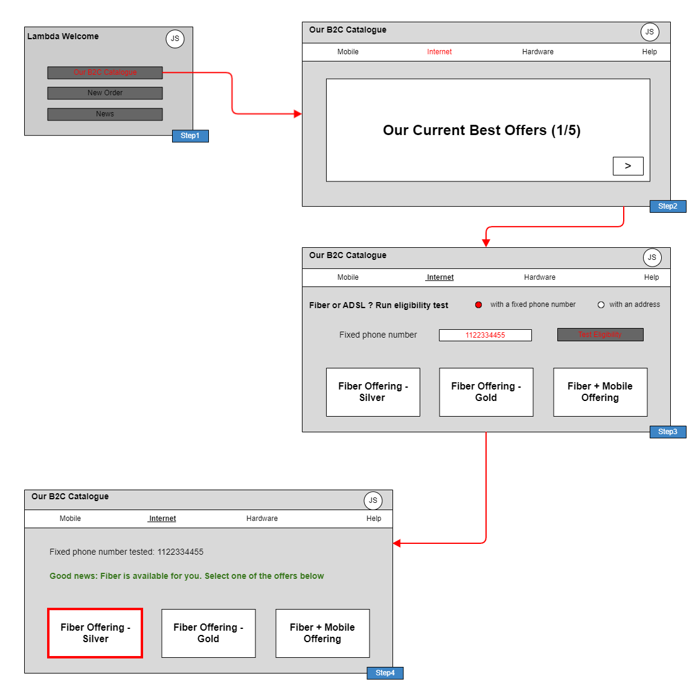

- Step 1
  - John Smith is identified / authenticated on the CSP website (or mobile app) and the list of available actions is displayed (following TMSF001)
  - He chooses to browse the operator catalogue.
  - The list of available actions is refreshed (same list)
  - The Front-End builds the B2C Catalogue start screen, by directly querying the Product Catalog component to retrieve the lines of products (managed as categories), and the Product Recommendation Management component to retrieve the product offerings to push¹.

- Step 2
  - The front-end presents the lines of products, as well as the operator current best offers
  - John Smith chooses the Internet Line of Product
  - The Front-End identifies the product offerings corresponding to this line of products
- Step 3
  - The Front-End analyses the description of the Fiber Product specification included in the 3 possible offers, and identifies that a technical eligibility test is mandatory.
  - The front-end displays the selection of internet offers, and proposes to check fiber technical eligibility based on the person's fixed phone number or geographical address
  - John Smith enters his fixed phone number and triggers the test
- Step 4
  - Eligibility check is OK.
  - John Smith can now start an order capture process, choosing one of the proposed fiber offers

¹ We consider here that the Product Recommendation Management component, as part of Intelligence Management is able to check the product offering qualification before pushing them.

Information View
This view presents 3 examples of contract level Product Offerings commercializing a Fiber Access product. It illustrates that:
- The same product specification can be commercialized through several product offerings, and even more that a product offering can restrict the characteristics values of the product specification.
- The same product offering can be packaged in several composite product offerings
- Product offering pricing rules (POP) can evaluate product specification characteristics values
- Product offerings can be associated to market segments and sales channels - and classified in line of products (as categories - not described in the view)
- The Fiber Access product specification is based on a CFS specification - this link will be used for the technical eligibility test, that is configured as mandatory for this product specification as the Fiber Network is not available in all locations.

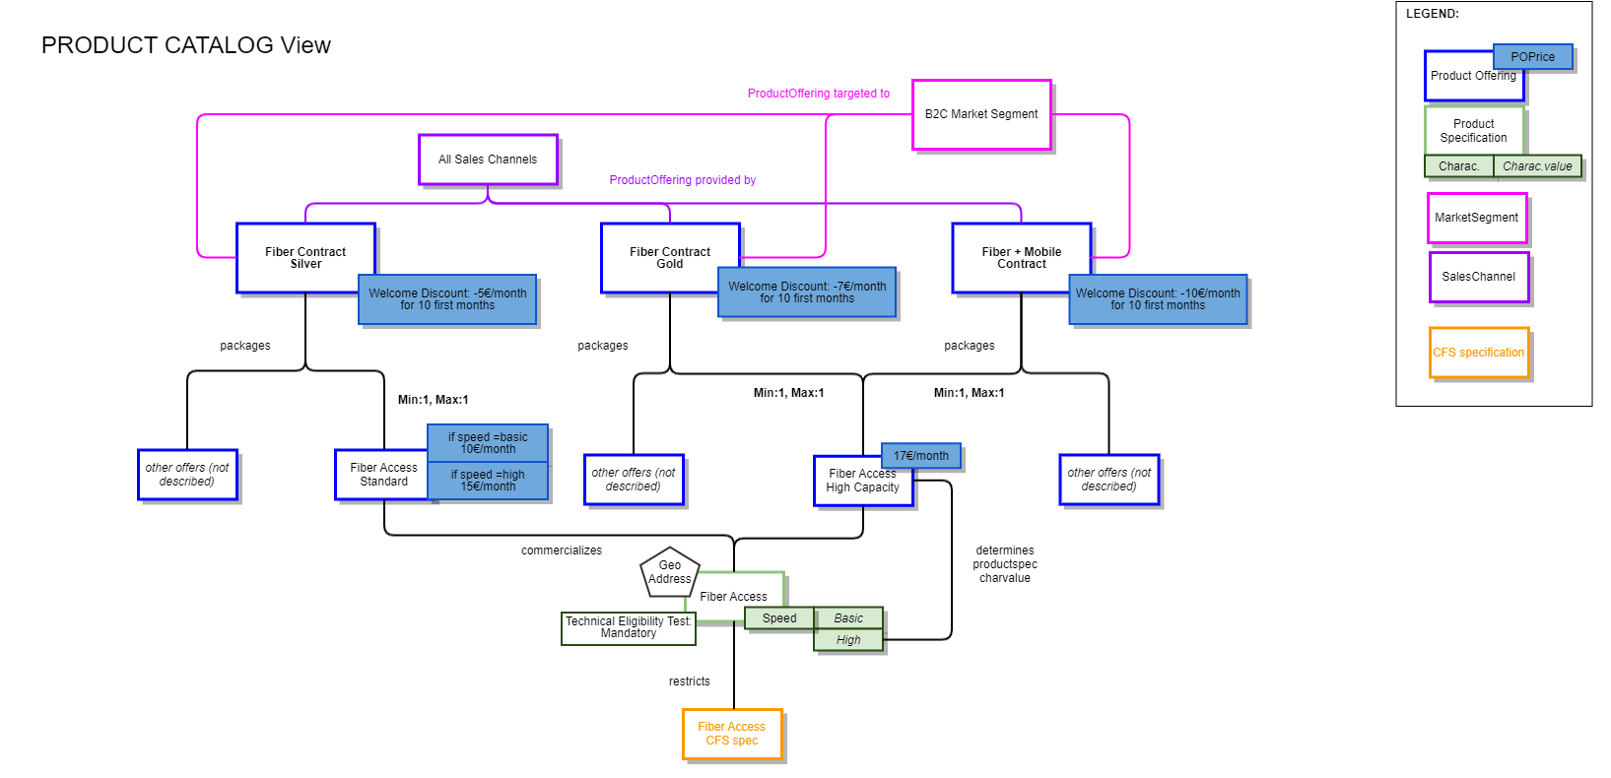

Sequence diagrams

Step 1 - Build the B2C Catalogue start screen
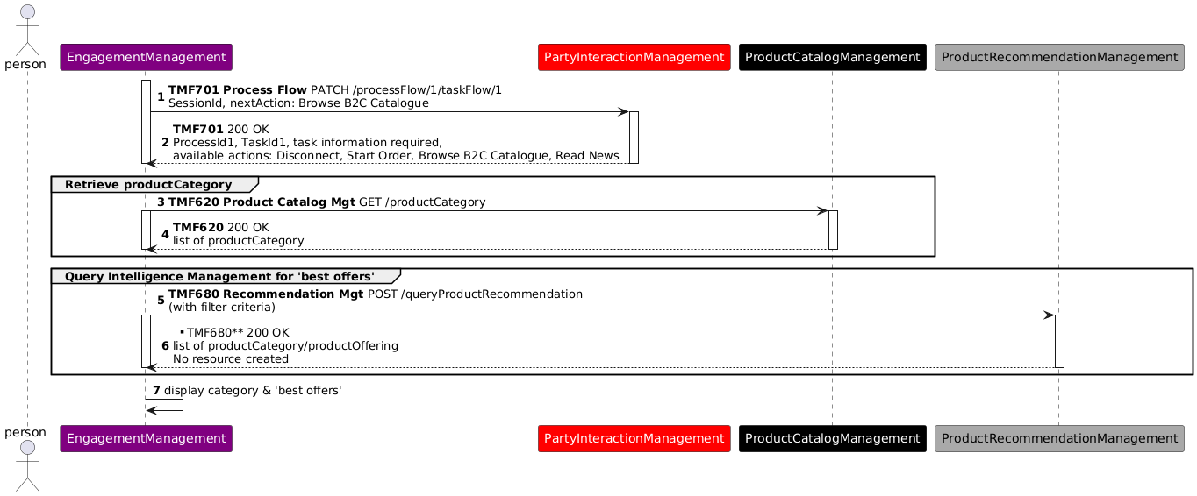

Step 2 - Build the Internet Line of Product screen
The front-end can use 3 ways of identifying the product offerings of this Line of Product to display:
- a simple query of the Product Catalog, to display all the possible product offerings
- a query based on the Product Configurator, to only display the product offerings commercially available for John Smith
- a query based on the Product Recommendation engine, to display the product offerings recommended for John Smith, according to marketing criteria and John Smith individual information.

When the list of product offerings is available, the front-end also query the Product Catalog at Product Specification level to identify if a technical eligibility test is needed, according to catalog parameters.
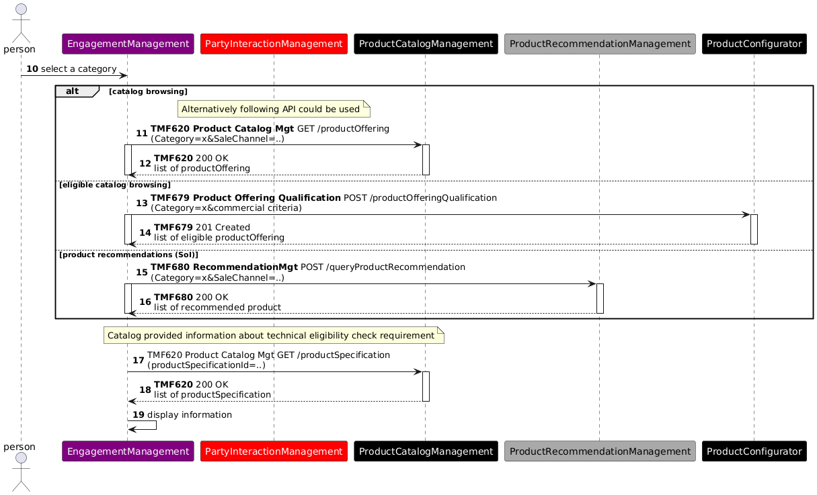
Note: TMF679 Product Offering Qualification API V4 is used in the previous diagram. With the V5 of this API now available we should rather have at this step a POST /QueryProductOfferingQualification.

Step 3 - Test Fiber Product Technical Eligibility
As in the Product Catalog the Fiber Access product specification is defined with a mandatory eligibility test, this test is directly proposed to John Smith who provides a phone number and launches the test.
The test is configurated with the CFS specification identifier associated to the Fiber Access Product specification.
As the test is OK, the list of proposed Fiber contracts remains the same, and John Smith can choose one of them to start an order capture process (continued in TMFS003).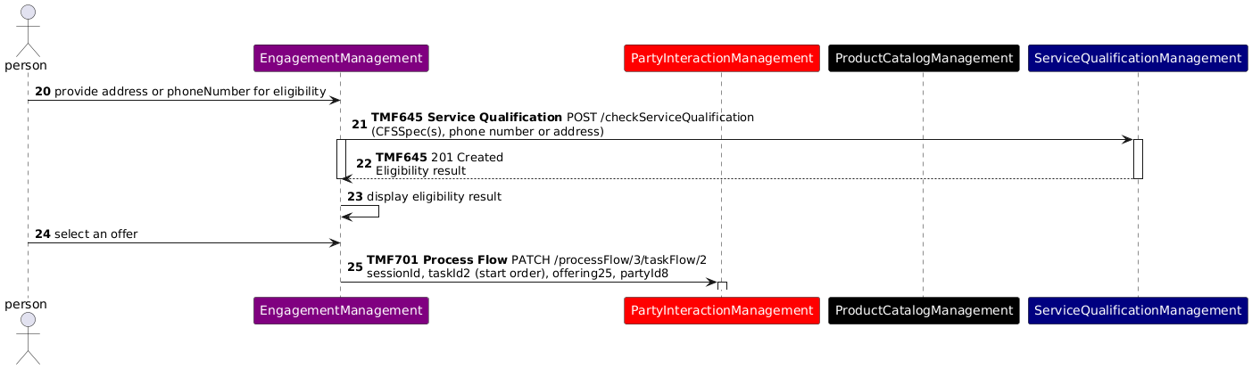

Conclusion

Lessons learned
ODA Functional Architecture introduces a strong decoupling principle between Engagement Management and all the other ODA Functional Blocks in charge of business processes. So front-ends cannot directly create or update information, only a business process layer can.
But this use case illustrates that front-ends can directly query information to build and fill their different screens, here Product Catalog and Product Recommendation information.

Impacts identified
[AP-4744] TMF620 - Explicit impact of characteristic values on pricing - TM Forum JIRA
TMF620 Product Catalog API: permit to associate product offerings to market segments (as possible in SID model)
[ISA-898] Product Specification ABE - Add attributes to manage technical eligibility check and geographic address need - TM Forum JIRA
[ISA-899] Service Specification ABE - Add attributes to manage technical eligibility check and geographic address needs - TM Forum JIRA
TMF620 Product Catalog API and TMF633 Service Catalog API: treat impacts of the SID Jira tickets ISA-898 and ISA-899 on the API resource model
As many APIs will be modified with the V5 transformation, sequence diagrams will need to be checked when the APIs V5 are published.

Administrative Appendix

Document History

Version History
This section records the changes between this and the previous document version as it is edited by the team concerned. Note: this is an incremental number which does not have to match the release number and used for change control purposes only.
Version Number | Date Modified | Modified by: | Description of changes
3.0.1 | 19 Oct 2023 | Sylvie Demarest | Updated to the new Use Case Template
3.1.1 | 15 Dec 2023 | Sylvie Demarest | Minor add-ons and reformulations
3.1.2 | 10 Apr 2025 | Rosie Wilson | Version updated and minor formatting changes ready to receive minor updates.
3.1.2 | 19 May 2025 | Rosie Wilson | Administrative Updates Prior to Publication

Release History
Release Number | Date Modified | Modified by: | Description of changes
Pre-production | 19 Oct 2023 | Joseph Guei | First Publication
Production | 08-Dec-2023 | Adrienne Walcott | Updated to reflect TM Forum Approved status
Pre-production | 15 Dec 2023 | Joseph Guei | Updated to version v3.1.1
Production | 09-Feb-2024 | Adrienne Walcott | Updated to reflect TM Forum Approved status
Pre-production | 19 May 2025 | Rosie Wilson | Updated to version v3.1.2
Production | 11-Jul-2025 | Adrienne Walcott | Updated to reflect TM Forum Approved status

Acknowledgments
This document was prepared by the members of the TM Forum End-to-End ODA project team.
Team Member (@mention) | Company | Role*
Sylvie Demarest | Orange | Author
Ludovic Robert | Orange | Author
Alexis de Peufeilhoux | Deutsche Telekom | Author
olivier arnaud | Orange | Additional Input
Abel Ruiz Huerta | SATEC | Reviewer
Manoj Nair | Netcracker | Reviewer
Elisabeth Andersson | MATRIXX | Reviewer
Dmytro Gassanov | Netcracker | Reviewer
Jonathan Goldberg | AMDOCS | Reviewer
Cece Li | TM Forum | Reviewer
*Select from: Project Chair, Project Co-Chair, Author, Editor, Key Contributor, Additional Input, Reviewer

