TM Forum Introductory Guide

TMFS004 Order Delivery – Fiber contract

TMFS004

Maturity Level: General Availability (GA) | Team Approved Date: 26-Feb-2024
Release Status: Production | Approval Status: TM Forum Approved
Version 1.0.0 | IPR Mode: RAND

Notice
Copyright © TM Forum 2024. All Rights Reserved.

This document and translations of it may be copied and furnished to others, and derivative works that comment on or otherwise explain it or assist in its implementation may be prepared, copied, published, and distributed, in whole or in part, without restriction of any kind, provided that the above copyright notice and this section are included on all such copies and derivative works. However, this document itself may not be modified in any way, including by removing the copyright notice or references to TM FORUM, except as needed for the purpose of developing any document or deliverable produced by a TM FORUM Collaboration Project Team (in which case the rules applicable to copyrights, as set forth in the TM FORUM IPR Policy, must be followed) or as required to translate it into languages other than English.

The limited permissions granted above are perpetual and will not be revoked by TM FORUM or its successors or assigns.

This document and the information contained herein is provided on an “AS IS” basis and TM FORUM DISCLAIMS ALL WARRANTIES, EXPRESS OR IMPLIED, INCLUDING BUT NOT LIMITED TO ANY WARRANTY THAT THE USE OF THE INFORMATION HEREIN WILL NOT INFRINGE ANY OWNERSHIP RIGHTS OR ANY IMPLIED WARRANTIES OF MERCHANTABILITY OR FITNESS FOR A PARTICULAR PURPOSE.

TM FORUM invites any TM FORUM Member or any other party that believes it has patent claims that would necessarily be infringed by implementations of this TM Forum Standards Final Deliverable, to notify the TM FORUM Team Administrator and provide an indication of its willingness to grant patent licenses to such patent claims in a manner consistent with the IPR Mode of the TM FORUM Collaboration Project Team that produced this deliverable.

The TM FORUM invites any party to contact the TM FORUM Team Administrator if it is aware of a claim of ownership of any patent claims that would necessarily be infringed by implementations of this TM FORUM Standards Final Deliverable by a patent holder that is not willing to provide a license to such patent claims in a manner consistent with the IPR Mode of the TM FORUM Collaboration Project Team that produced this TM FORUM Standards Final Deliverable. TM FORUM may include such claims on its website but disclaims any obligation to do so.

TM FORUM takes no position regarding the validity or scope of any intellectual property or other rights that might be claimed to pertain to the implementation or use of the technology described in this TM FORUM Standards Final Deliverable or the extent to which any license under such rights might or might not be available; neither does it represent that it has made any effort to identify any such rights. Information on TM FORUM's procedures with respect to rights in any document or deliverable produced by a TM FORUM Collaboration Project Team can be found on the TM FORUM website. Copies of claims of rights made available for publication and any assurances of licenses to be made available, or the result of an attempt made to obtain a general license or permission for the use of such proprietary rights by implementers or users of this TM FORUM Standards Final Deliverable, can be obtained from the TM FORUM Team Administrator. TM FORUM makes no representation that any information or list of intellectual property rights will at any time be complete, or that any claims in such list are, in fact, Essential Claims.

Direct inquiries to the TM Forum office:

181 New Road, Suite 304
Parsippany, NJ 07054, USA
Tel No. +1 862 227 1648
TM Forum Web Page: www.tmforum.org

Table of Contents
Notice 2
Table of Contents 4
1. Introduction 5
1.1. Context or Background 5
1.2. Objective of the use case 6
1.3. Scope and assumptions 7
1.3.1. Scope 7
1.3.2. Assumptions 7
1.3.3. References 8
2. Description 10
3. Information View 11
3.1. Global catalog view 11
3.2. Order delivery view 11
4. Sequence diagrams 12
4.1. High level view 12
4.2. Step 2 12
4.2.1. Step 2.1: From ProductOrder to RFS Service determination (including resource identification) 13
4.2.2. Step 2.2: Product Order & inventory update once delivery done 13
4.3. Step 3 14
4.4. Step 4 14
4.4.1. Shipping Order & Shipment definition 15
4.4.2. Shipment tracking management 16
5. Conclusion 17
5.1. Lessons learned 17
5.2. Impacts identified 17
6. Administrative Appendix 18
6.1. Document History 18
6.1.1. Version History 18
6.1.2. Release History 18
6.2. Acknowledgments 18

Introduction
This use case illustrates the delivery of a customer order, driven by the catalog model and content, and the set of related ODA components and TMF Open APIs.
This use case follows TMFS003.

Context or Background
This use case is based on the organization of the Production functional block in several domains each of them being responsible of a set of services (CFS specification), for which the domain implementation is able to manage fulfillement, assurance and usage processes.
As described in IG1167 ODA Functional Architecture Exploratory Report, the Orange implementation scenario for the Production block called these domains "factories".
Each domain or factory exposes to the Core Commerce Management functional block its services specificaitons (CFS specification) to permit it to define the commercialized products and packaged offers (Product specification and Product Offerings).
We will consider in this use case several services provided by different factories:
- Landline Access, managed by the Access Factory
- Landline Connectivity, managed by the Network Services Factory
- TV channels, managed by the Soft Services Factory
- Box and Shipping Conditions, managed by the Supply Chain Factory

According to ODA principles, the Core Commerce Management is totally agnostic of technical solutions (RFS specification) managed by the factories to deliver their services. It uses the services definitions (CFS specification) of each factory to define the commercialized products (Product specificaiton).
In some cases the technology can be a marketing or business argument - so it is also possible to instantiate services associated to a specific technology and related products, as we do here for the Fiber Access.

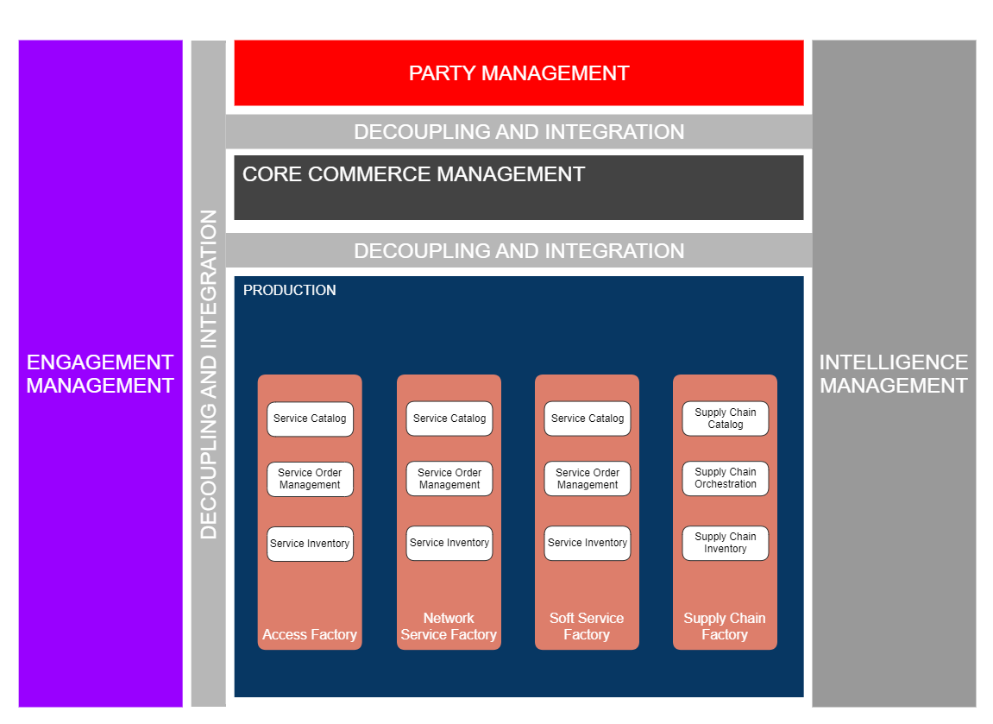

Objective of the use case
The objective of this use case is to illustrate with the delivery of a customer order, including different factories/domains, the capabilities defined by the ODA functional architecture, and provided by the ODA components and Open APIs.
- Core Commerce Management - Production decoupling: the main information shared by these 2 functional blocks correspond to the service layer
  - CFS specification at catalog level for Product specification definition, as illustrated in TMFS012 (or Stock Item definition for tangible products)
  - Product specification - CFS specification relationship usage at global orchestration level by TMFC003 Product Order Delivery Orchestration and Management (POOM) - or Product Specification - Stock Item relationship for tangible products
- Process delegation and decoupling: TMFC003 Product Order Delivery Orchestration and Management (POOM), the component in charge of the global orchestration of the delivery process, will delegate the sub-processes it is not directly responsible for to the dedicated components
  - the delivery of a tangible product is the responsability of the Supply Chain (TMFC032)
  - the delivery of an intangible product is the responsability of the Service Order Management component (TMFC007) of the related factory/domain.
  - etc
- Date driven process: the order delivery process is totally driven by the Product Catalog and the Service Catalog models and contents

Scope and assumptions

Scope
Several steps are described:
- The global orchestration of the delivery of the products ordered by the customer
- The delegation of the delivery of tangible products to the supply chain
- The delegation of the delivery of products based on CFS to a service order delivery system
- The detailed orchestration of the delivery of the service order
- The closure of the customer order, after the delivery of each product.
- The interaction triggered to inform the customer that his order is fulfilled

Assumptions
The delivery process is entirely driven by the catalog model and information:
- no product offering level information is needed for the delivery process
- the product catalog is explicit and describes all the products that need to be delivered (even if they are free of charges)
- each product described in the use case corresponds to an atomic product in the SID model (no composite product used here)
- each intangible product specification is based on a CFS specification, and associated to the factory/domain in charge of its delivery
- each tangible product specification is associated to a set of stock items and to the supply chain system for its delivery.
- functional pre-requisite relationships are defined between product specifications and used by the global orchestration process to build and manage the delivery graph
- Service Order Management components (TMFC007) are responsible for the entire lifecycle of service orders
- Product Order Delivery Orchestration and Management component (TMFC003) triggers the update of the status of the product order items and their related product inventory items, according to the correct execution of the delivery process
- Product Order Capture and Validation component (TMFC002) is in charge of the closure of the product order, according to the delivery of each customer order item, but also the respect of commercial conditions such as the contract document is signed by the customer, or proof of identity are provided by the customer.

References
SID ABEs:
- Product Specification ABE
- Product Order ABE
- Product ABE
- Service Specification ABE
- Service Order ABE
- Service ABE
- Resource Specification ABE
- Resurce Order ABE
- Resource ABE
- Stock Item ABE

ODA components:
- TMFC001 Product Catalog Management
- TMFC002 Product Order Capture & Validation
- TMFC003 Product Order Delivery Orchestration and Management
- TMFC005 Product Inventory
- TMFC006 Service Catalog Management
- TMFC007 Service Order Management
- TMFC008 Service Inventory
- TMFC009 Service Qualification Management
- TMFC010 Resource Catalog Management
- TMFC011 Resource Order Management
- TMFC012 Resource Inventory
- TMFC023 Party Interaction Management
- TMFC028 Party Management
- TMFC032 Supply Chain Management

Open APIs:
- TMF620 Product Catalog Management
- TMF622 Product Order Management
- TMF632 Party Management
- TMF633 Service Catalog Management
- TMF637 Product Inventory Management
- TMF638 Service Inventory Management
- TMF639 Resource Inventory Management
- TMF641 Service Ordering Management
- TMF645 Service Qualification Management
- TMF652 Resource Ordering Management
- TMF681 Communication Management
- TMF683 Party Interaction Management
- TMF688 Event Management
- TMF700 Shipping Order Management
- TMF711 Shipment Management
- TMF701 Process Flow

To notice: The next chapters of this document will be improved and enriched in a next version

Description
Order fulfillment and confirmation to customer

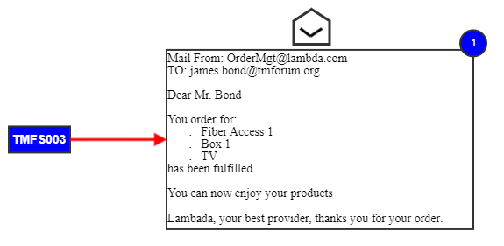

Information View

Global catalog view
refer to comment in TMFS003 about order structure ("Same comment about the order structure as in UC3 - need product order as container, and the structure is by the order items not by the products.")

Order delivery view
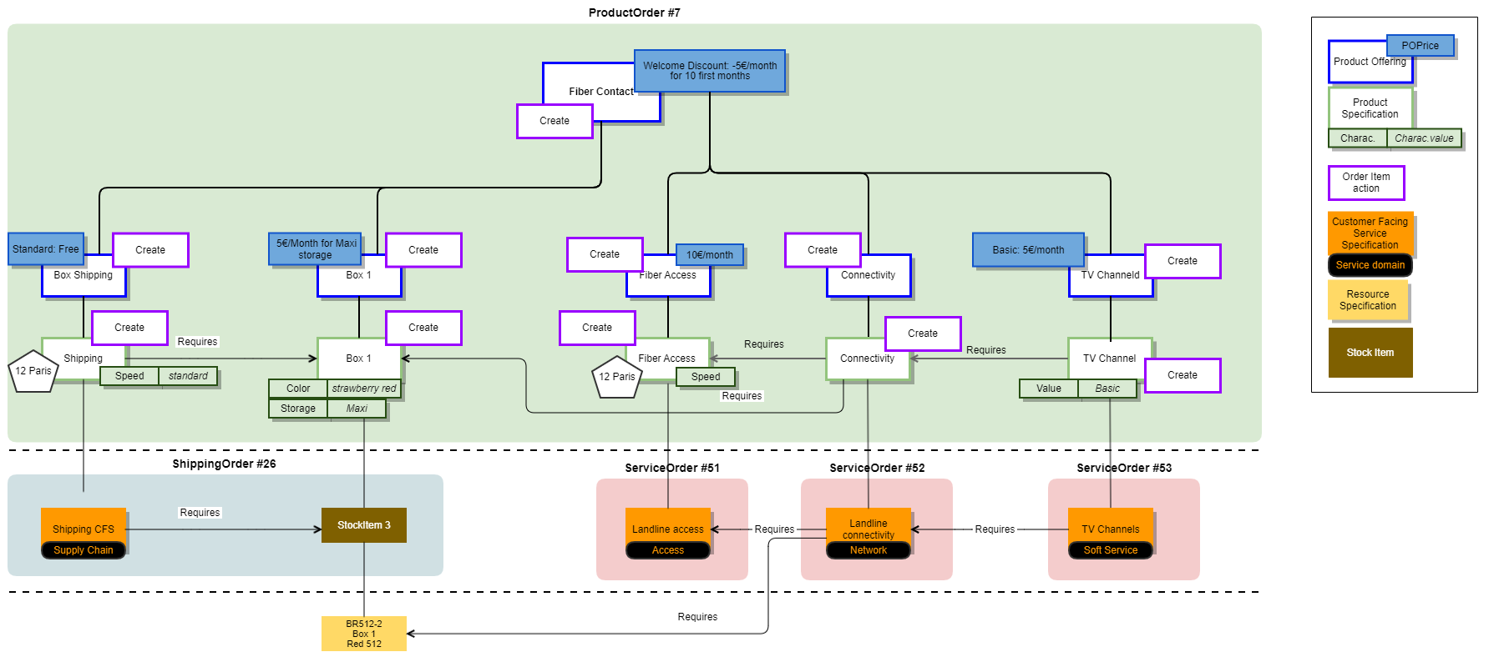

Orchestration of orders:

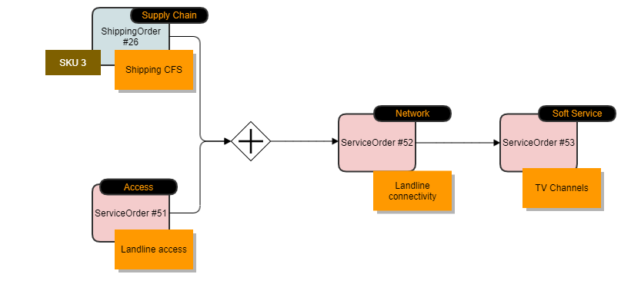

Sequence diagrams

High level view
Following diagram shows the high level view for delivery of the product order. Additional diagrams are provided for each delivery depending on the 'support' entity (CFS or stock-based).
- An "Order Capture Completed" or "ProductOrderStateChange" (to inProgress.accepted) event from Product Order Capture Validation (POCV) triggers order delivery process
- Assumption: Product Order Orchestration Management (POOM) did not own a catalog copy but instead query the catalog in real time.
- POOM is only in charge of the delivery of the order item at product specification level.
- POOM delivery graph is built from 'constraint' (requires link) between order item.
- POOM manages the orchestration of the Service Order / Shipping Order accordingly as SOM and logistic system are not "aware" of this orchestration.

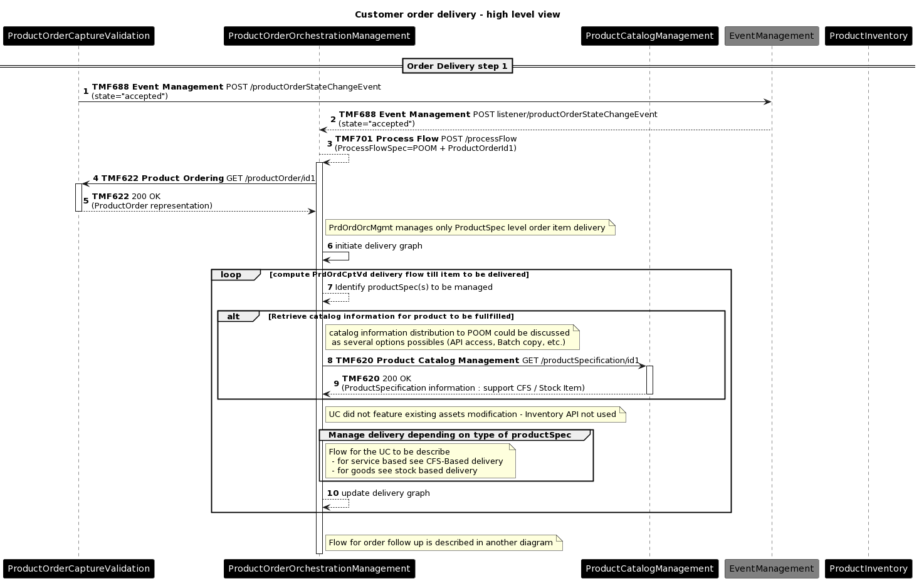

Step 2
Zoom on delivery for product Specification based on Service Specification - This flow uses the landline access as example.

Step 2.1: From ProductOrder to RFS Service determination (including resource identification)
- For this service, the service order is triggered to the Access Domain Service Order Management (SOM). Note that other factories will be used for the 3 other services.
- SOM uses Service Catalog to identify potential RFS specification, based on that, SOM determines the RFS to use for this particular CFS delivery, and then SOM identify if existing resource instance could be re-used.

Note: add a Service Qualification check in the next version
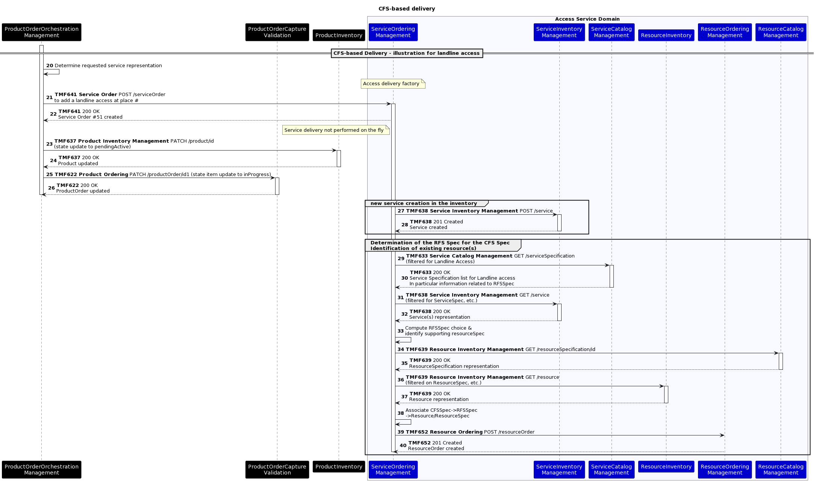

At this stage we do not illustrate further the Resource delivery and the Service order update from the ROM.

Step 2.2: Product Order & inventory update once delivery done
- Once a service order item delivered (or fails), the SOM triggers an event (State change event)
- This event is listened to by POOM component.
- POOM triggers accordingly Product inventory & Product order update
- POOM also triggers an event change.

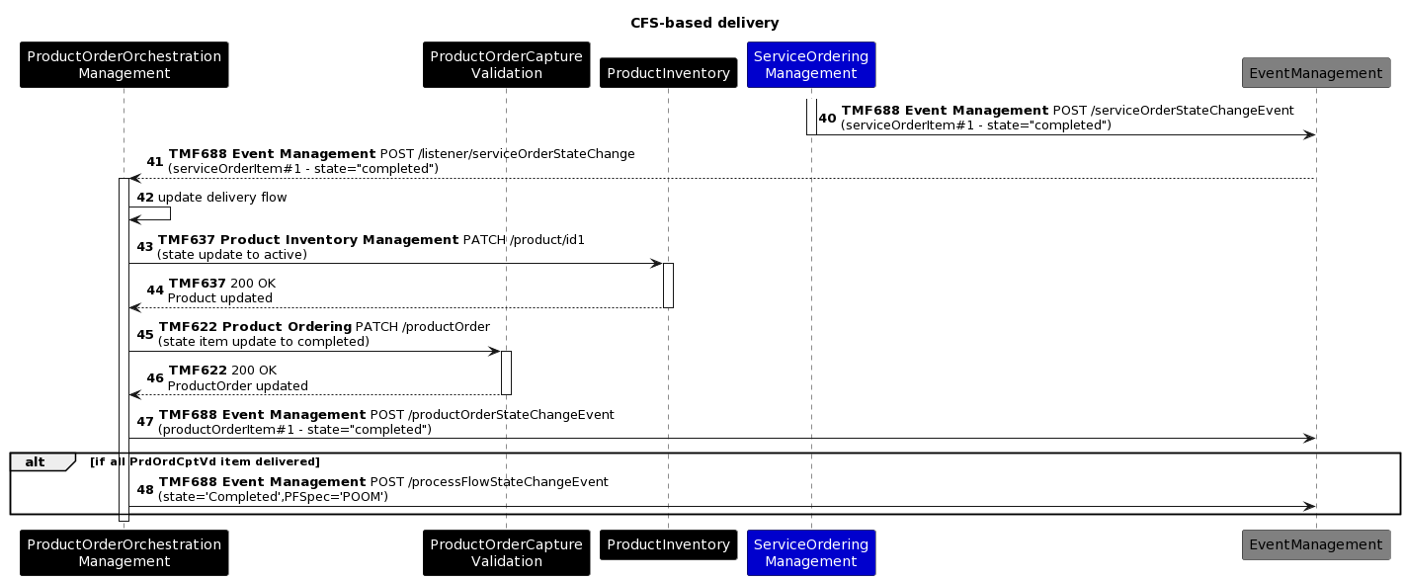

Step 3
Zoom on order follow-up (performed by the Product Order Capture & Validation)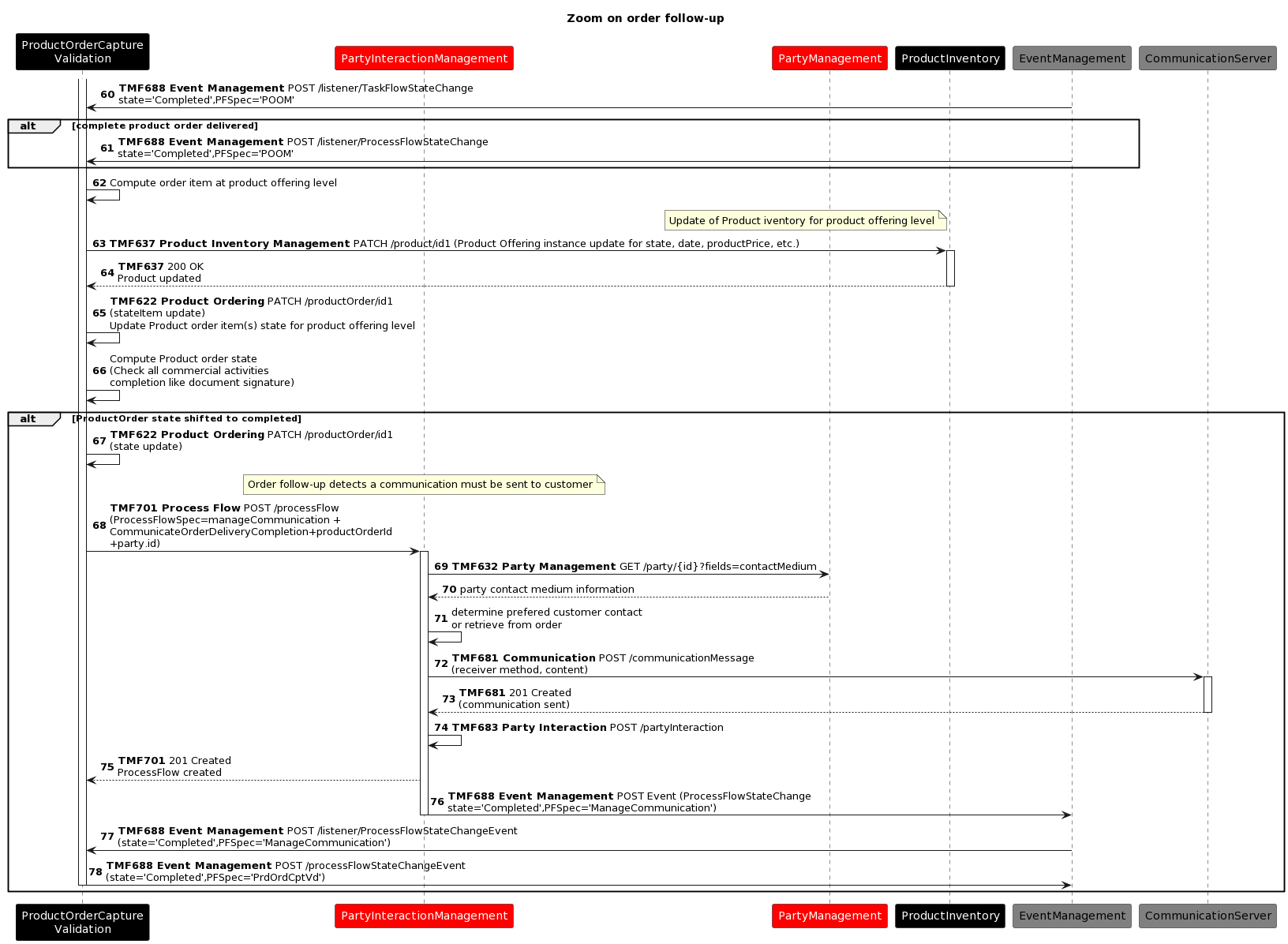

Step 4
The step 4 focuses on the delivery of 'goods' product involving the supply chain.
In this example we describe a delivery with 2 partners for the Service Provider (SP):
- A warehouse partner - The SP has the management of the supply chain but the goods themselves are stored in a partner warehouse. The warehouse partner has the responsibility to manage the stock but also to prepare the shipment at SP request.
- A shipping Partner - This partner has the responsibility to move goods from point A to point B under defined shipping options.

In our example the warehouse partner triggers directly the shipping partner to expedite shipment (assumption)
Note: this step will be reviewed in a next version, and harmonized with TMFS008. Shipping and logistics partners may well have its own standards governed by other SDOs, since they are not unique to communications industry.

Shipping Order & Shipment definition
In this part:
- POOM triggers a ShippingOrder to SP supply chain. The Shipping order should describe the product configuration ( following SID it should be stockItem), place where it must delivered and what are the shipping condition. The reference of the productOrder is passed.
-  As of now product configuration is defined through ShippingOrder→ shippingOrderItem → Shipment - this is an issue because POOM cannot compute the shipment (this is Logistic responsability) so we need a link shippingOrderItem → ProductConfiguration/stockItem.
-  Is really the shippingOrder the right API for the interaction between POOM and the supply chain?
- SP Supply chain identifies if and which logistic partner will be involved. Then SP Supply chain computes the shippment to be done by regrouping ShippingOrderItems.
- SP Supply chain triggers to Logistic Partner a Shipping Order with Shipment described
- Logistic Partner picks the goods and then packs them following shipment decription.
- Logistic Partner triggers shippment request to transport partners and then updates the shipping order with the link(s) to the shipment.  reference of the productOrder should be added in the shipment
- Events are triggering on shipment and are used to updat the shipping orders.
- POOM updates accordingly the product inventory and the product order.

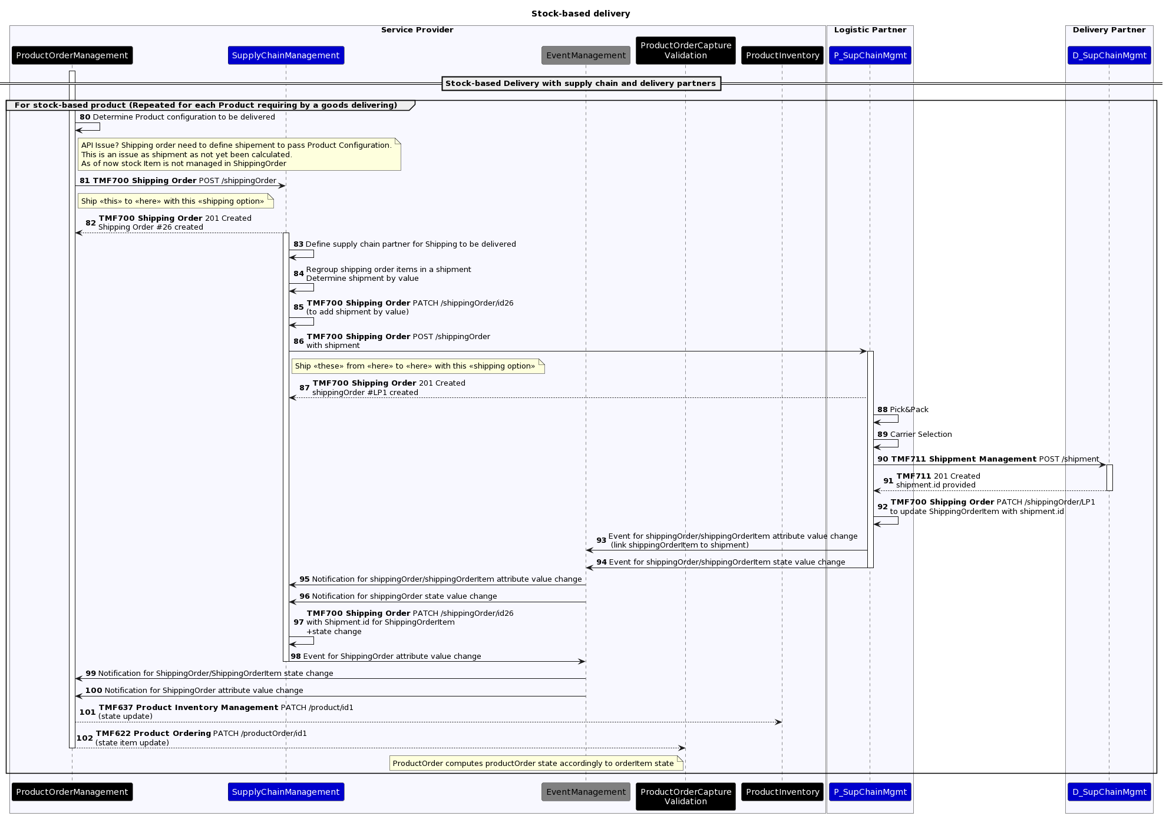

Shipment tracking management
In this second part:
- We illustrate how "any" user on the UI can query to know where the package is.
- Then we illustrate the shipping completion with event going from the transport partner to the POOM.
- Product Inventory & Product order are updated accordingly.

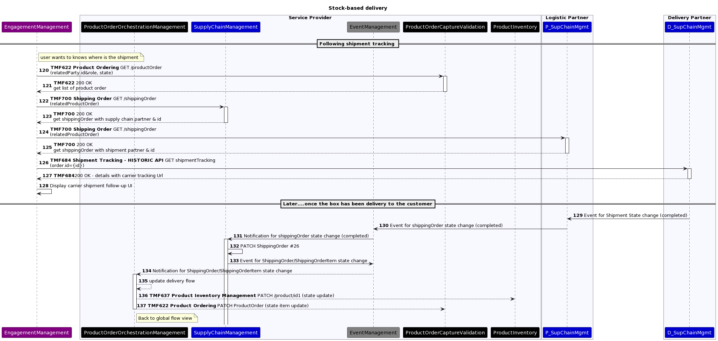

Conclusion

Lessons learned
This use case illustrate how the delivery of a multi-products order can be globally orchestrate at Core Commerce level, by a Product Order Delivery Orchestration and Management component (TMFC003) and delegated to several factories or domains in Production.
It also demonstrates the capabilities of the global catalog model to drive the delivery process.

Impacts identified
- [ISA-905] Add a relationship between CFS Spec and Resource Spec - TM Forum Jira
- trace Jira related to APIs
  - TMF700 Shipping Order Management
  - TMF711 Shipment Management

Administrative Appendix

Document History

Version History

Version No. | Date Modified | Modified by: | Description of changes
1.0.0 | 26-Feb-2024 | Joseph Guei | Initial Release

Release History
Release Status | Date Modified | Modified by: | Description of changes
Pre-production | 26-Feb-2024 | Joseph Guei | Initial Release
Production | 26-Apr-2024 | Adrienne Walcott | Updated to reflect TM Forum Approved status

Acknowledgments
This document was prepared by the members of the TM Forum End-to-End ODA team.
Team Member (@mention) | Company | Role*
Sylvie Demarest | Orange | Author
Pascal Delvallet | Orange | Additional Input
Abel Ruiz Huerta | SATEC | Additional Input
Manoj Nair | Netcracker | Additional Input
Elisabeth Andersson | MATRIXX | Additional Input
Jonathan Goldberg | AMDOCS | Additional Input

