TM Forum Use Case

Use Case: Billing - Fiber Contract

TMFS005
Maturity Level: General availability (GA) | Team Approved Date: 10-Jul-2025
Release Status: Pre-production | Approval Status: TM Forum Approved
Version 2.2.0 | IPR Mode: RAND

Notice
Copyright © TM Forum 2025. All Rights Reserved.

This document and translations of it may be copied and furnished to others, and derivative works that comment on or otherwise explain it or assist in its implementation may be prepared, copied, published, and distributed, in whole or in part, without restriction of any kind, provided that the above copyright notice and this section are included on all such copies and derivative works. However, this document itself may not be modified in any way, including by removing the copyright notice or references to TM FORUM, except as needed for the purpose of developing any document or deliverable produced by a TM FORUM Collaboration Project Team (in which case the rules applicable to copyrights, as set forth in the TM FORUM IPR Policy, must be followed) or as required to translate it into languages other than English.

The limited permissions granted above are perpetual and will not be revoked by TM FORUM or its successors or assigns.

This document and the information contained herein is provided on an “AS IS” basis and TM FORUM DISCLAIMS ALL WARRANTIES, EXPRESS OR IMPLIED, INCLUDING BUT NOT LIMITED TO ANY WARRANTY THAT THE USE OF THE INFORMATION HEREIN WILL NOT INFRINGE ANY OWNERSHIP RIGHTS OR ANY IMPLIED WARRANTIES OF MERCHANTABILITY OR FITNESS FOR A PARTICULAR PURPOSE.

TM FORUM invites any TM FORUM Member or any other party that believes it has patent claims that would necessarily be infringed by implementations of this TM Forum Standards Final Deliverable, to notify the TM FORUM Team Administrator and provide an indication of its willingness to grant patent licenses to such patent claims in a manner consistent with the IPR Mode of the TM FORUM Collaboration Project Team that produced this deliverable.

The TM FORUM invites any party to contact the TM FORUM Team Administrator if it is aware of a claim of ownership of any patent claims that would necessarily be infringed by implementations of this TM FORUM Standards Final Deliverable by a patent holder that is not willing to provide a license to such patent claims in a manner consistent with the IPR Mode of the TM FORUM Collaboration Project Team that produced this TM FORUM Standards Final Deliverable. TM FORUM may include such claims on its website but disclaims any obligation to do so.

TM FORUM takes no position regarding the validity or scope of any intellectual property or other rights that might be claimed to pertain to the implementation or use of the technology described in this TM FORUM Standards Final Deliverable or the extent to which any license under such rights might or might not be available; neither does it represent that it has made any effort to identify any such rights. Information on TM FORUM's procedures with respect to rights in any document or deliverable produced by a TM FORUM Collaboration Project Team can be found on the TM FORUM website. Copies of claims of rights made available for publication and any assurances of licenses to be made available, or the result of an attempt made to obtain a general license or permission for the use of such proprietary rights by implementers or users of this TM FORUM Standards Final Deliverable, can be obtained from the TM FORUM Team Administrator. TM FORUM makes no representation that any information or list of intellectual property rights will at any time be complete, or that any claims in such list are, in fact, Essential Claims.

Direct inquiries to the TM Forum office:

100 Enterprise Drive
Suite 301 #1649
Rockaway, NJ 070866, USA
Tel No. +1 862 227 1648
TM Forum Web Page: www.tmforum.org

Table of Contents
Notice 2
Table of Contents 3
1. Introduction 4
1.1. Context or Background 4
1.2. Objective of the use case 4
1.3. Scope and assumptions 4
1.3.1. Scope 4
1.3.2. Assumptions 4
1.3.3. References 5
2. Description 7
3. Information View 10
3.1. Inputs 10
3.2. Applied Customer Billing Rate Information view: 11
3.3. Applied Customer Billing Taxe Rate Information View : 12
3.4. Product Usage Rating & Bill Generation : 13
4. Sequence diagrams 15
5. Conclusion 18
5.1. Lessons learned 18
5.2. Impacts identified 18
6. Appendix 19
7. Administrative Appendix 21
7.1. Document History 21
7.1.1. Version History 21
7.1.2. Release History 22
7.2. Acknowledgments 23

Introduction

Context or Background
This use case is a continuation of use cases TMFS003 and TMFS004:
- TMFS003 illustrates the order capture for a fiber contract, describing the fiber contract in the product catalog, a product order of this fiber contract, and the resulting product inventory.
- TMFS004 addresses the order delivery, and the update of the product inventory.

Objective of the use case
This use case details the calculation of billable items and the preparation of the first invoice post-order delivery. It focuses on the mechanisms for cost calculation and invoice presentation.
- Next Version Highlights: In a next version, we could add a sequence diagram to illustrate intermediate bill preparation.

Scope and assumptions

Scope
TMFS005 Illustrates the billable items calculation and the bill presentation for:
- Recurring costs
- One-time costs
- Usage-based costs
- Discounts
- Taxes

As part of preparing the first invoice, we will illustrate the calculation of prorated amounts for recurring costs.
Please note: Invoice delivery is out of scope for this use case.

Assumptions
- Costs are due from the date a product status is updated to activated. We consider here that all the products are activated at the same date.
- Recurring costs are billed in advance.
- The first bill is produced according to the billing cycle corresponding to the billing account associated to the Fiber Contract
- The first bill includes the costs related to the period between the activation date of the products and the starting date of the billing period. This corresponds to the operator choice, for example another scenario could be to trigger the first bill directly after activation.
- Taxation is a complex topic, and the approach taken in this use case involves calculating taxes as part of the billing process. This approach aligns with certain regulatory frameworks where charges are exclusive of tax. However, it's important to note that this is an operator choice, and in some cases, regulations may require charges to be inclusive of tax.
- The bill also includes the rating of service usage based on the collected CDRs, considering the specification of these usages in the catalog and the applied taxes.
- The bill generation is triggered by a timer according to the billing cycle

References
SID ABEs:
- Product & Offering Instance ABE
- Product Spec ABE
- Product Offering Spec ABE
- Party Roles ABE
- Party Individual ABE
- Customer Billing Account ABE
- Customer Bill ABE
- Applied Customer Billing Rate ABE
- Product Usage ABE

ODA components:
- TMFC005 Product Inventory
- TMFC040 Product Usage Management
- TMFC024 Billing Account Management
- TMFC035 Permissions Management
- TMFC031 Bill Calculation
- TMFC030 Bill Generation Management
- TMFC015 Service Usage Management
- TMFC028 Party & Party Role Mgt
- TMFC001 Product Catalog
- TMFC030 Bill Generation Management

Open APIs:
- TMF637 Product Inventory Management
- TMF688 Event Management
- TMF666 Account Mgt
- TMF678 Customer Bill Mgt
- TMF637 Product Catalog Management
- TMF635 Usage Management
- TMF637 Product Catalog Management
- TMF 727 Service Usage Management
- TMF767 Product Usage Management

Description
We illustrate here the production of monthly bills, based on bill cycles associated to each billing account, and that takes into account differently the different types of charges. As an example, the bill corresponding to month N will cover:
- Recurring fees: These are fixed fees that occur every month, such as a subscription. They are usually paid in advance, so correspond to month N.
- One-time fees: These are unique fees that are charged only once (e.g., activation fees) and occurred since the last bill. They correspond to month N-1.
- Usage fees: These are charges based on your use of the services since the last bill. They correspond to month N-1.
If a new contract is subscribed during month N - or modified during this period - we consider in this use case that the impacts are covered by the month N+1 bill.
Note: Other choices could be done by CSPs. For example, some CSPs could prefer to produce a dedicated bill, covering the period between the delivery date of the new products and the standard monthly bill date. Other CSPs could propose to the customer to choose the starting date of his billing period.
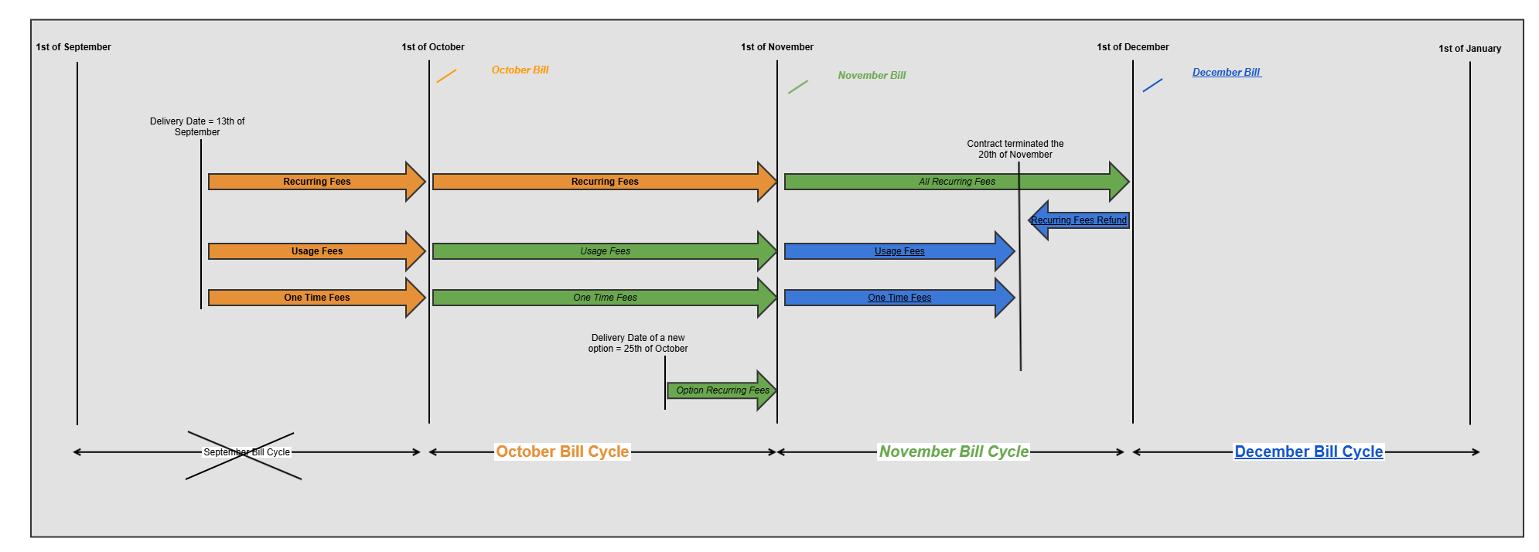

For the first bill covering the month of October, we also take into account the period before the beginning of the month. As the products are activated on September 13th, the October bill will include:
- Prorated charges for the period from September 13th to September 30th,
- October's recurring fees, as they are usually billed in advance,
- Usage Fees related to September
- One time Fees also related to September.

To illustrate the second bill, covering the month of November, we consider that a new option of the contract has been ordered and delivered the 25th of October, so the November bill will include:
- November's recurring fees, as they are usually billed in advance,
- Prorated charges related to the new option for the period from October 25th to October 31st,
- Usage Fees related to October
- One time Fees also related to October, if any.

When the contract is cancelled by the customer, here November 20th, the last bill related to December will include:
- Refund of prorated recurring charges related to the period from November 20th to November 30th, as they were paid by advance with the November bill.
- Usage Fees related to November
- One time Fees also related to November, if any.

Each bill cycle not only defines the period of charges to take into account to prepare the bill, but it also defines:
- The bill sending date,
- The payment deadline,
- The date of reminders in case of non-payment,
- The date of the bank automatic debits (if it is the payment mean chosen by the customer),
- The dates of usage limitations measures in case of non-payment (service restriction, additional fees),
- ...

Bill Life Cycle:

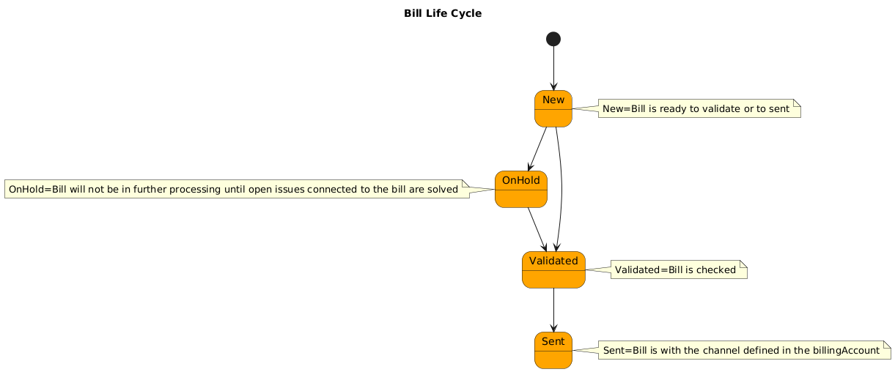

Information View

Inputs
The product inventory view is the output produced by the previous use cases TMFS003 and TMFS004. It includes the Product Prices calculated during the order capture process. Their starting date has been initiated as a result of the order delivery, as the active status of the product and product offering instances.
The inventory view has been updated to include tax rate values that are dependent on the product price type. A 20% tax is levied on recurring prices, while a 10% tax is imposed on one-time fees.

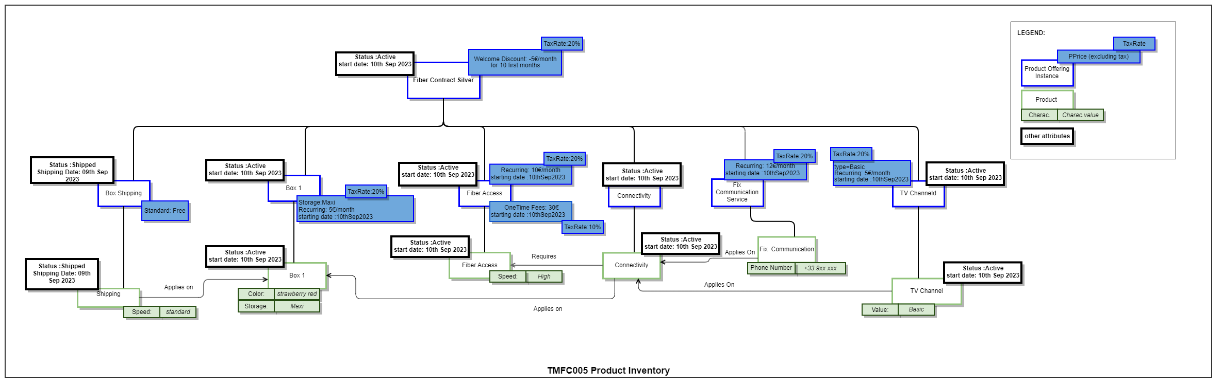

The diagram below illustrates the link between the active products that will be charged to John's billing account, which has been assigned a billing cycle. It also highlights that John as a customer holds a fiber contract and has been assigned a billing account.
To each product offering instance is assigned one (or several) price(s) and a corresponding tax rate described as an alteration.

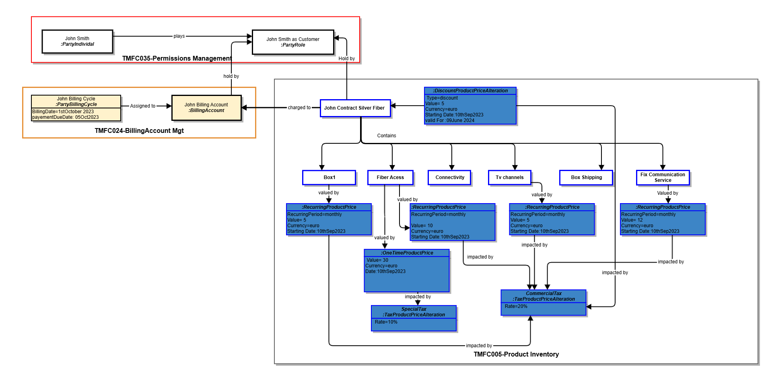

Applied Customer Billing Rate Information view:
The diagram outlines how the billable items relating to the first invoice are generated, using the product prices described in the product inventory, the billing cycle and performing pro-rata temporis calculations

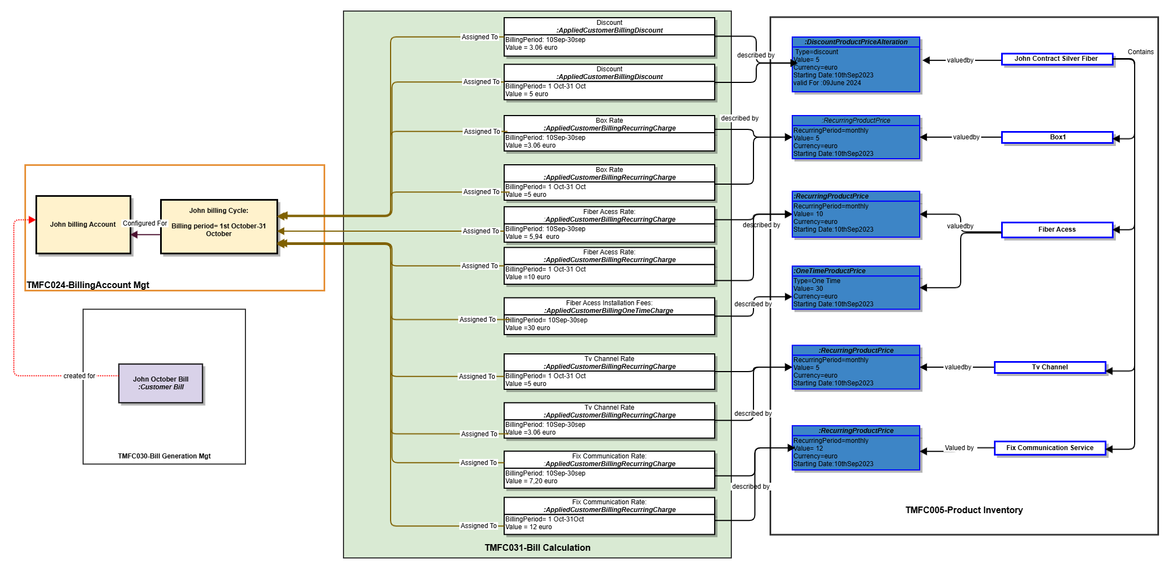

Please note :
- Monthly discount: -5 €
  - Daily discount: -5€ / 30 days ≈ -0.17€ per day
  - Calculate total discount: Discount for 18 days: -0.17€/day * 18 days = -3.06€
- Monthly Price:5 €
  - Price per day: 5 € / 30 days ≈ 0.17 € per day
  - Amount for 18 days: 0.17 €/day *18 days = 3.06 €
- Monthly Price:10 €
  - Price per day: 10 € / 30 days ≈ 0.33 € per day
  - Amount for 18 days: 0.33 €/day * 18 days = 5.94 €

Applied Customer Billing Taxe Rate Information View :
In order to calculate the elements required for generating the first invoice in the diagram below, we proceed with the calculation of the tax value. This tax value is applied to the pre-calculated 'appliedCustomerBilling charge'. The sum of 'appliedCustomerBilling taxe rate' and 'appliedCustomerBilling charge' corresponds to the price already displayed to customers during Order Capture (for an entire billing period).

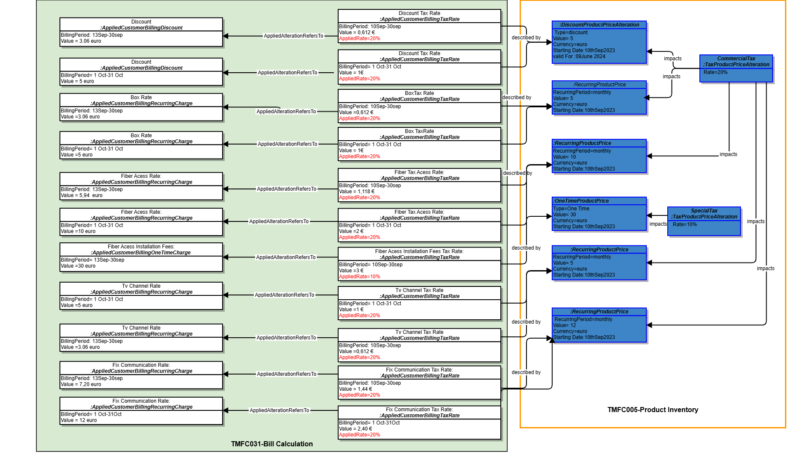

Product Usage Rating & Bill Generation :
The data model below will rely on the following usage table, which is an input from TMFS003.
Product Usage specification | Usage Product Offering Price Charge (excluding tax) | Tax Product Offering Price Alteration (tax rate)
Data | 1 € per Mo | 20%
Voice for national fix number | 0,1 € per minute | 20%
Voice for mobile in Europe | 0,5 € per minute | 20%

This diagram illustrates a process for rating usage records related to "fix communication" product. It involves several steps like :
- Identifying and retrieving service usage records associated with the "fix communication" product. These records capture information about the specific usage of the product, such as duration, data consumption, or other relevant metrics.
- Based on the retrieved service usage records, new product usage records are created. These records serve as the foundation for the rating process, providing a structured representation of the usage data.
- The calculated usage ratings are determined by applying specific rating criteria to the product usage records. These criteria may involve factors such as:
- The Usage product offer price defined in the product catalog is used to determine the base rate for each usage record.
- Applicable taxes
- Specific metrics, such as usage duration or data consumption...
- Based on the Calendar Event generated by the Bill Generation Component, the bill will be generated for specific billing accounts that have a cycle aligned with the Calendar Event date.

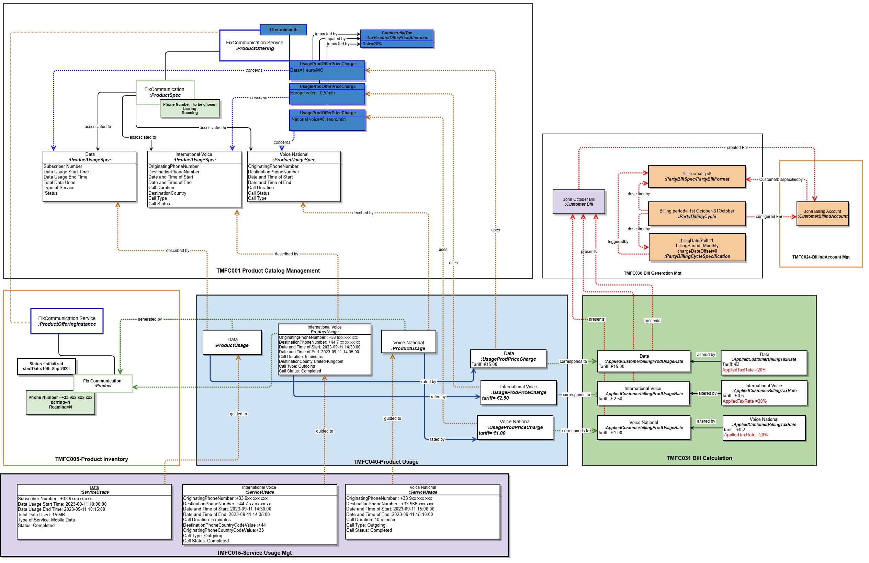

Sequence diagrams
In our use case, we've selected the event that triggers the calculation of the billable items (excluding usages) to be the change in the product item status. Specifically, when the product item status changes from 'Created' or 'Initialized' to 'Active' - or from 'Active' to 'Inactive'.
These events will be consumed by the 'Bill Calculation Management' component and initiate its internal process for creating the Applied Customer Billing Rate item. It permits to prepare as soon as possible the inputs for the next bill along the way, and not be obliged to wait the beginning of the bill cycle.
It is important to note that The 'Bill Calculation Management' component is subscribing to events signaling status changes for product inventory items of 'product offering' type.
These events trigger the calculation of the initial invoice items upon a transition to the 'Active' status, and the final refund invoice items upon a transition to the 'Inactive' status.
For intermediate bills, the triggering event might be a calendar-based event or business rules.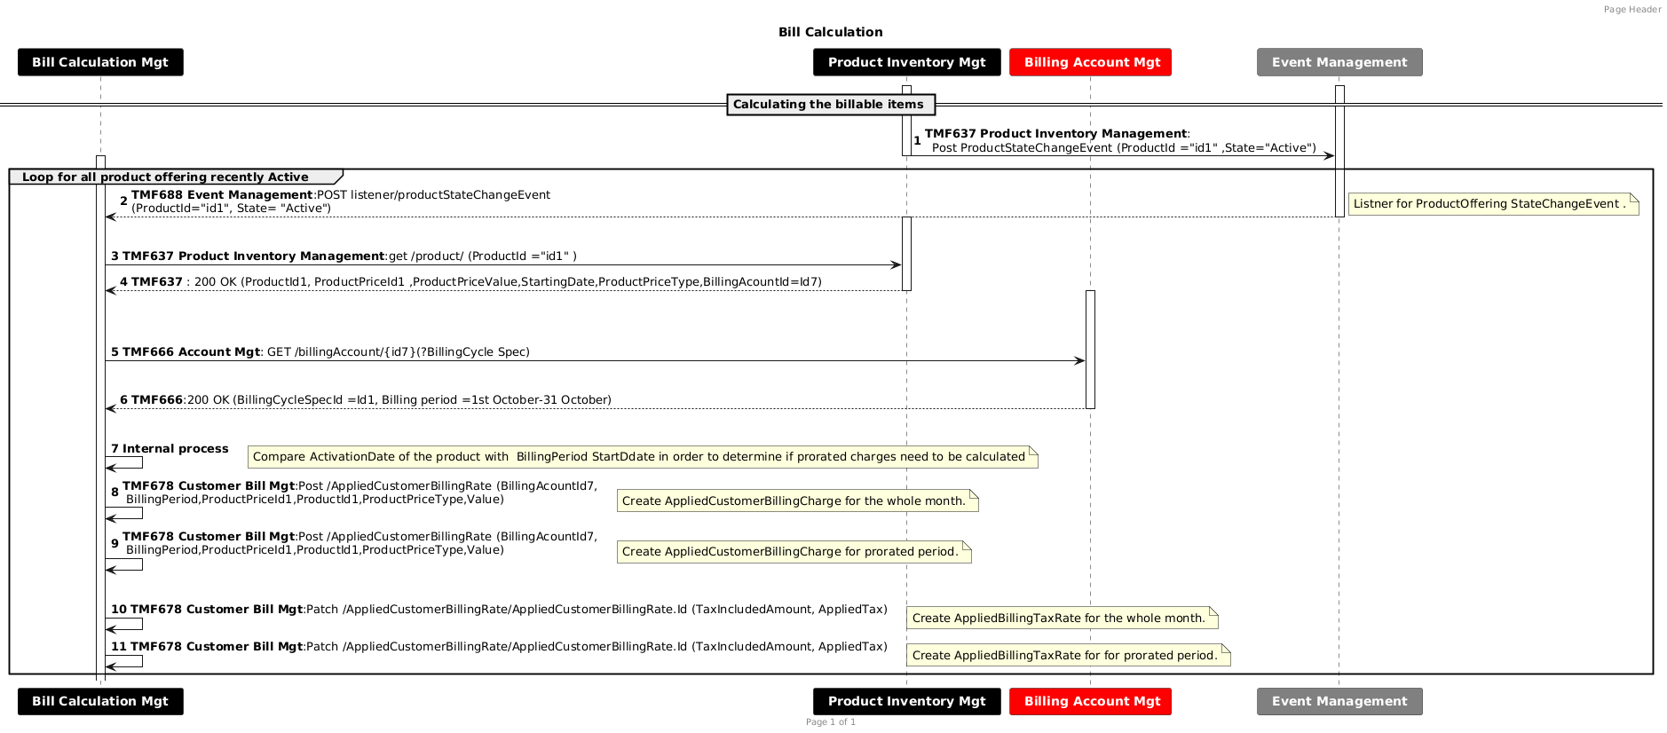

TMF 678 :In our use case, to fulfill the functional requirement of creating and updating AppliedCustomerBillingRate using the TMF 678 API, we need to introduce 'POST' actions for creation and 'PATCH' actions for updates, exposed internally to the 'bill calculation' component. (Jira Ticket Created)
- Usage Record Rating:
In the diagram below,we start with a CDR that has been created and validated as a consequence of a "ServiceUsage" generated by the service usage management component. This CDR is sent as an event to the product usage management component which will initialize a "ProductUsage" records based on information collected form the inventory and the catalog. These records are then rated, and the resulting data serves as a trigger for the calculating the "AppliedCustomerBillingRate". We are using the TMF727 and the TMF767 APIs in V5 which will replace the TMF635 as it is being deprecated
This scenario demonstrates a usage-based trigger designed to track consumption with the highest possible precision. However, other triggers could also be considered, such as:
- A time-based trigger, where charges are calculated at regular intervals (e.g., weekly event).
Or we may expand the main scenario by:
- An event-driven trigger, where usage is rated again due to changes in the customer's subscription, contract, or promotions applied.
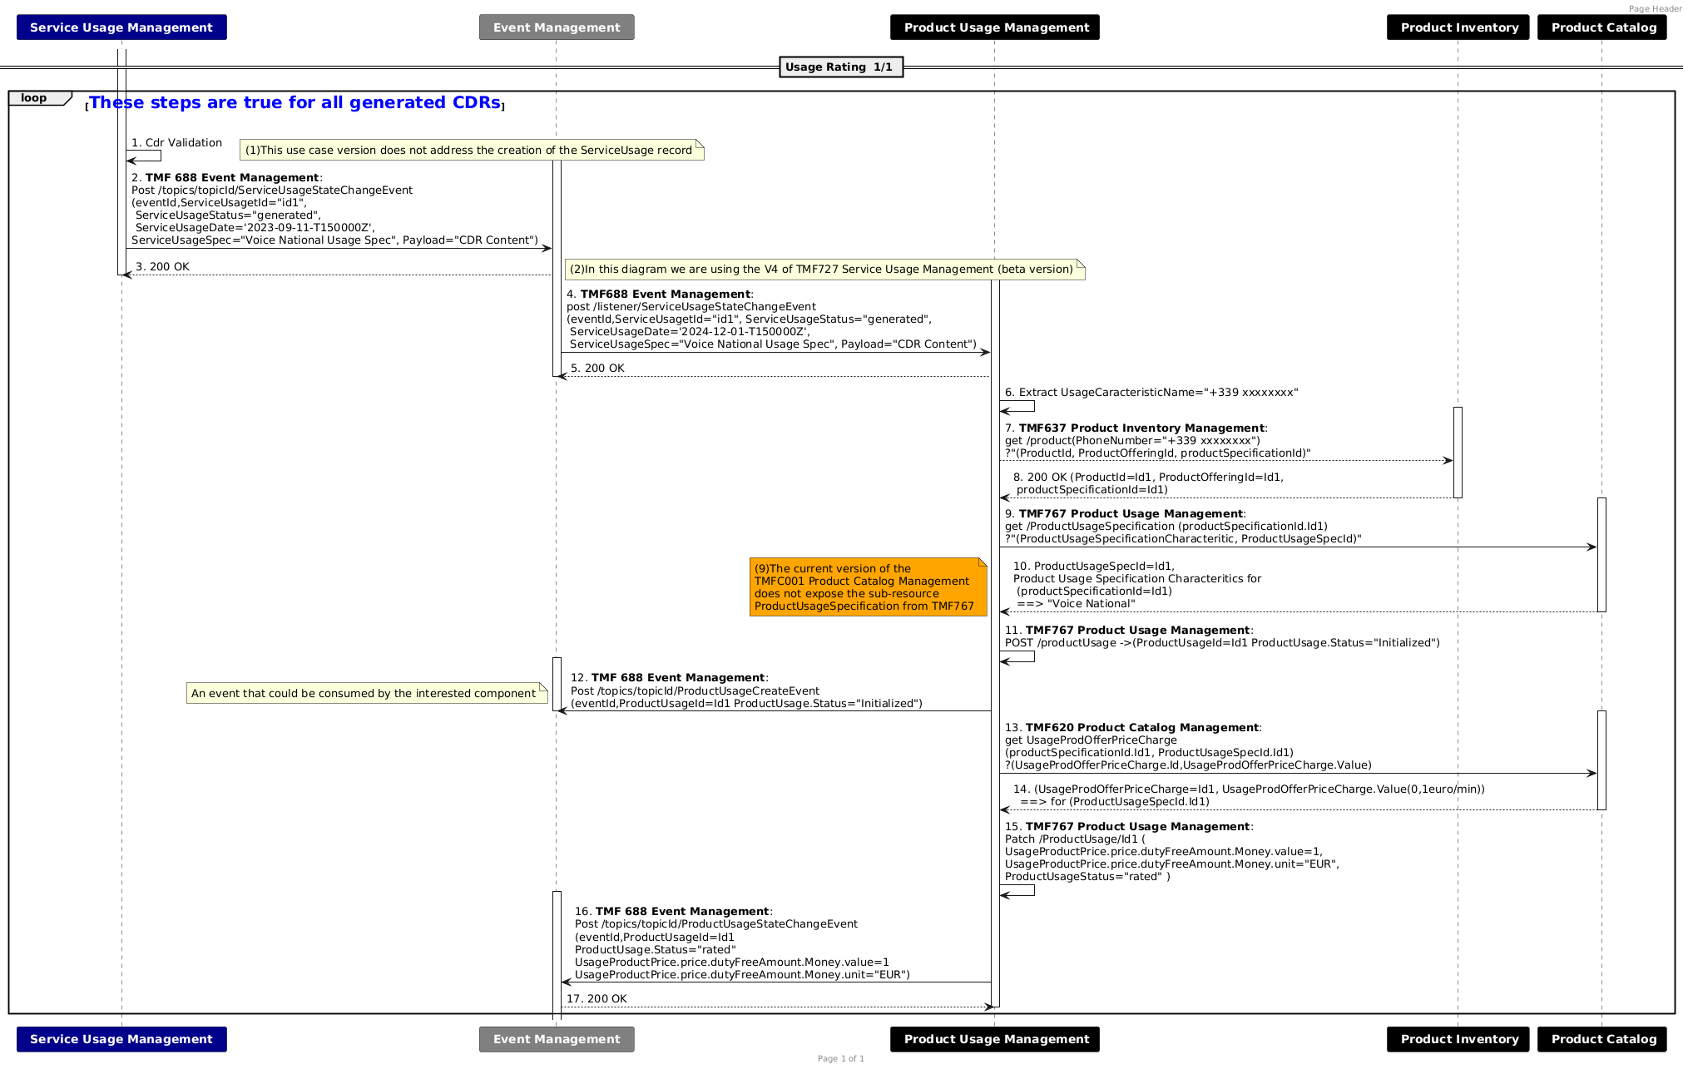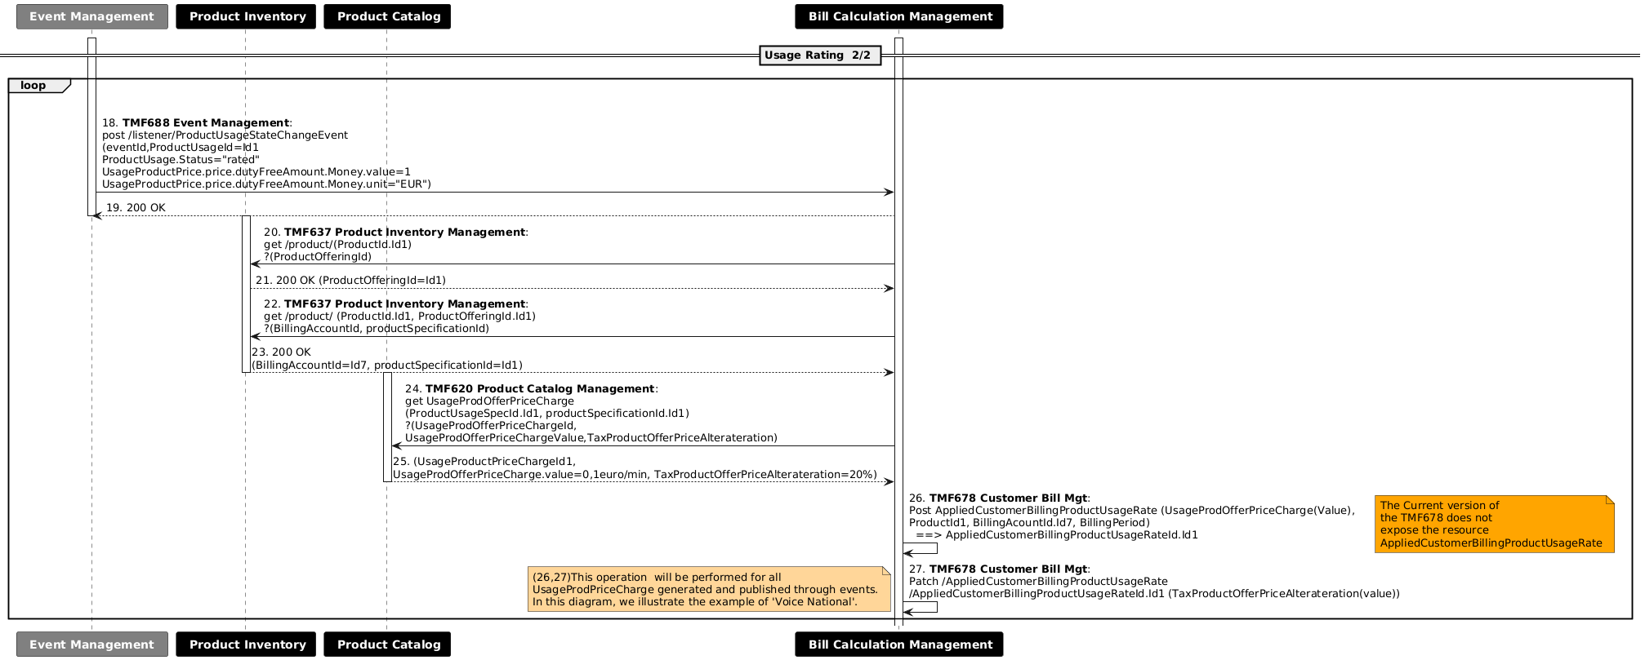

Bill Generation Diagram is described below:
In the diagram below, the invoice generation process is triggered by a calendar event configured at the bill generation management component, while knowing that other methods or triggers could also be implemented to initiate this process.
- A threshold-based trigger, where billing is initiated once a predefined consumption limit is reached. (as a prequisitie : usage has alrealdy been rated ) ==>this scenario serves as a complementary approach enabling the generation of an intermediate bill.
In our example below, we will describe John's invoice generation on October 1st.

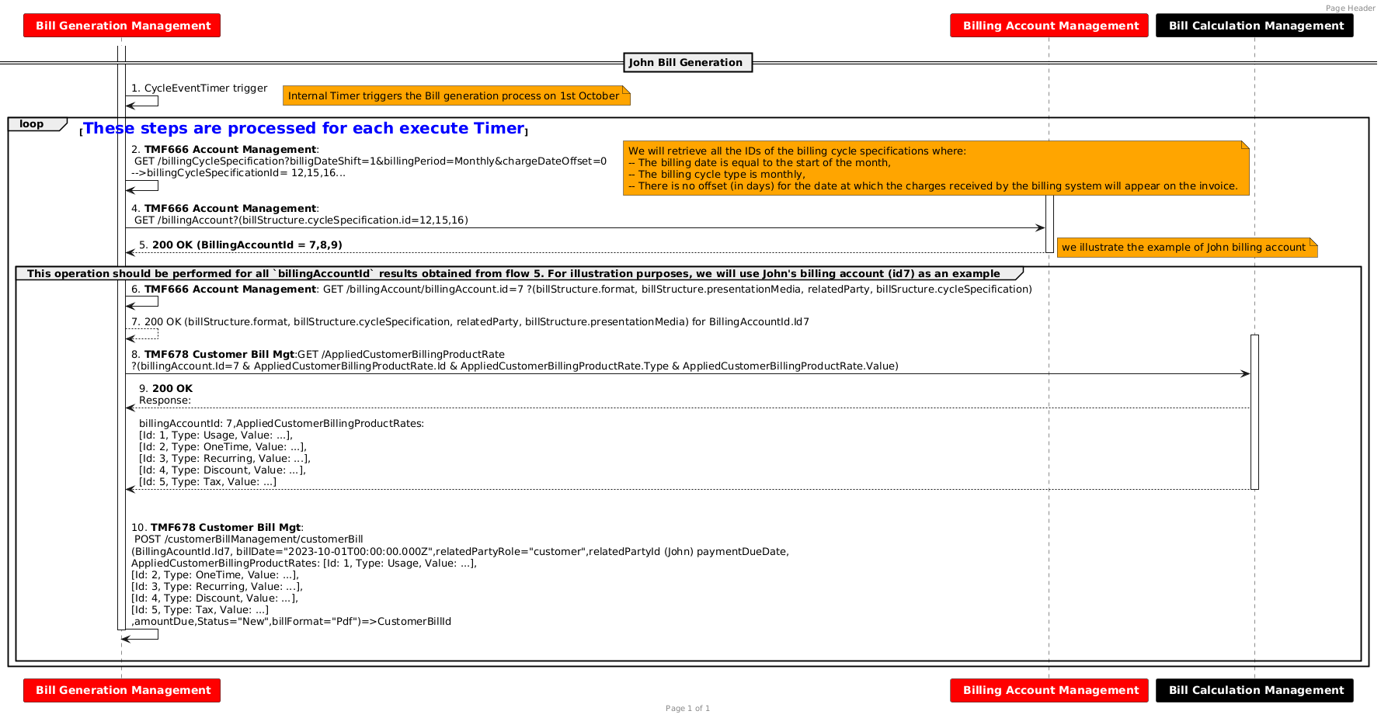

Conclusion

Lessons learned
- Billing calculation scenarios are highly customizable, allowing each operator to tailor them to their specific business requirements.
- The Bill calculation management component employs internal processes and rules to handle the initialization of the first invoice, intermediate invoices, and subsequent post-billing tasks.
- The triggering of the bill can be initiated from a calendar event as described in the example of this use case version, but could have other types such as a termination order, or reaching a well-defined consumption threshold to which an intermediate bill is associated.

Impacts identified
Project | Jira identifier
API | - [AP-6883] TMF678 - add POST, PATCH, DELETE operations on appliedCustomerBillingRate - TM Forum JIRA
API | - [AP-6884] TMF678 - specialize applicationCustomerBillingRate - TM Forum JIRA
API | - Evolution of Usage APIs from v4 to v5:
API | - The Current version ofthe TMF678 does not expose the resourceAppliedCustomerBillingProductUsageRate ->covered by [AP-6884] TMF678 - specialize applicationCustomerBillingRate - TM Forum JIRA
API | - TMF767 :Replace "received" by "initialized" for ProductUsage Status. → Update willbe done without Jira Ticket
Oda-Component | - The current version of theTMFC001 Product Catalog Management does not expose the sub-resource ProductUsageSpecification from TMF767 ->decision to be made to determine whether productUsageSpecification remains in TMF767 or will move to TMF620  AP-4783 - Move/rename UsageSpecification from TMF635 Usage Management to TMF620 Product Catalog backlog

Appendix
To effectively manage events, a foundation for data exchange between producers and consumers must be established. This call flow diagram illustrates the essential steps involved in configuring the consumer-producer relationship. Producers must first configure topics to categorize and organize their events. Once topics are defined, producers can generate and emit events aligned with these categories. Consumers then subscribe to specific topics of interest, enabling them to receive and process relevant events efficiently. This foundational setup ensures seamless event delivery and consumption.
This diagram provides a simplified overview of an event-driven architecture based on the TMF688 standard. It illustrates the fundamental interactions between a Producer, an Event Management (Broker), and a Consumer. This diagram serves as a reference model for designing and implementing event-driven systems.
- Components and Interactions:
- Producer:
  - The Producer initiates the process by creating a topic on the Event Management Broker. This topic acts as a channel for specific types of events.
  - The Producer publishes events to the created topic. Each event is associated with an event type and carries specific data.
- Event Management (Broker):
  - The Broker handles the creation and management of topics, as well as the processing of subscriptions from consumers.
  - It delivers events to subscribed consumers based on their specified filters and interests.
- Consumer:
  - The Consumer subscribes to specific topics of interest (or Events), providing a callback URL to receive event notifications.
  - The Broker sends events to the Consumer's callback URL. The Consumer processes the received events and performs necessary actions.
- Event Management and Alternative Implementation Scenarios
We will describe two possible scenarios for event management :
- Centralized Scenario: Where event management is handled by a dedicated component (Event Management) using the standard TMF 688 API.
- Point-to-Point Scenario: Where events are consumed and published directly via the notification sub-resource of a given API, without relying on a central event broker.

In the diagram below, we clearly illustrate that event management is centralized within the Event Management component, utilizing the TMF 688 API as the standard interface for event handling.
However, it is important to note that in certain implementations, some event brokers—such as Kafka or others—do not expose the standard API (TMF 688) but instead provide their own proprietary APIs for event handling.

  - Centralized Scenario:
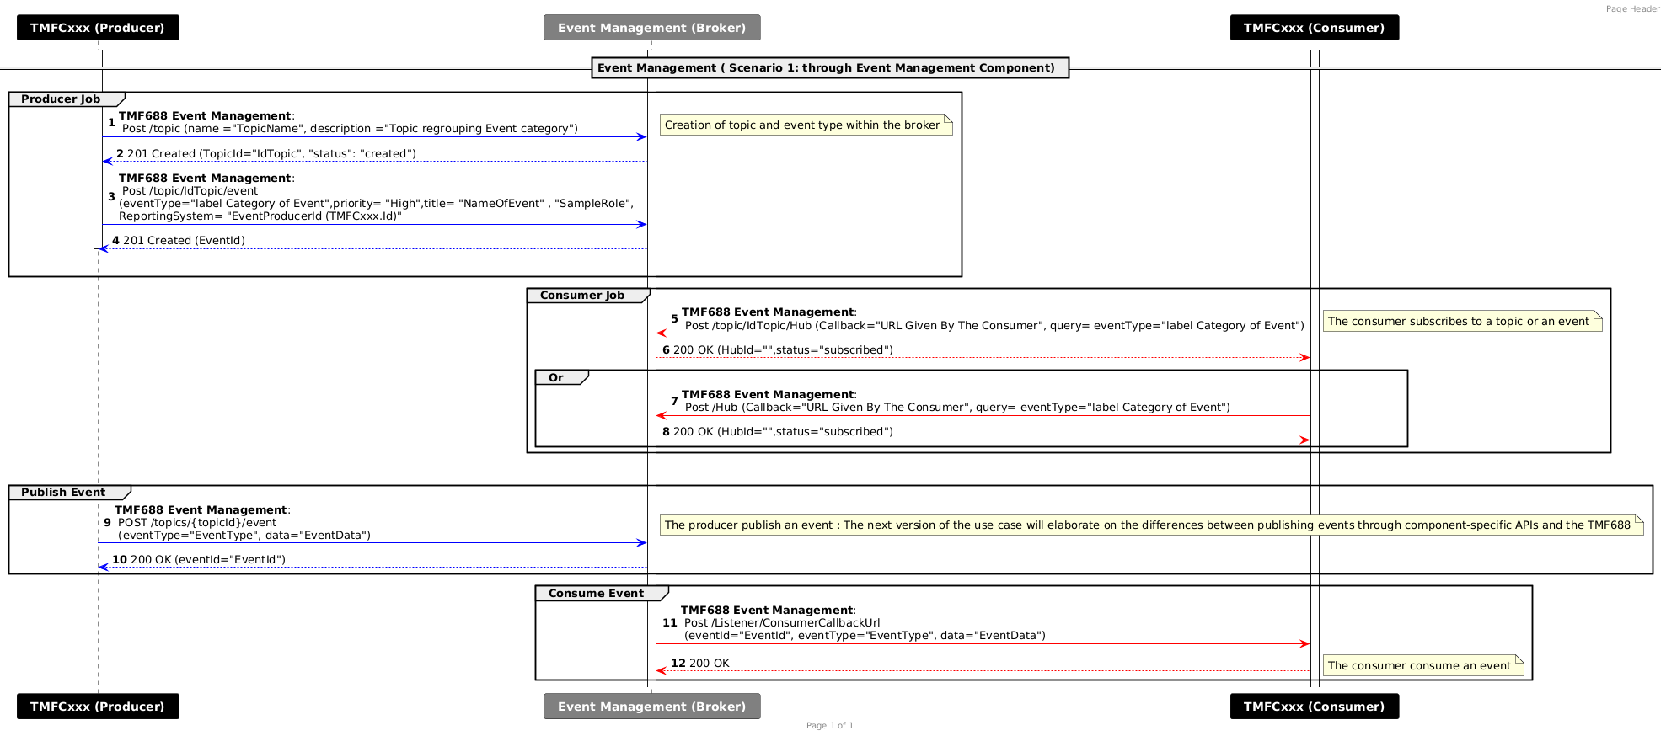

Additionally, we present a second diagram, which illustrates an alternative scenario. In this case, event consumption and publication are handled through the notification sub-resource of a given API, rather than relying on a centralized event management component. This represents a point-to-point integration model, where events are consumed and published directly between services without a centralized event broker.

  - Point-to-Point Scenario:
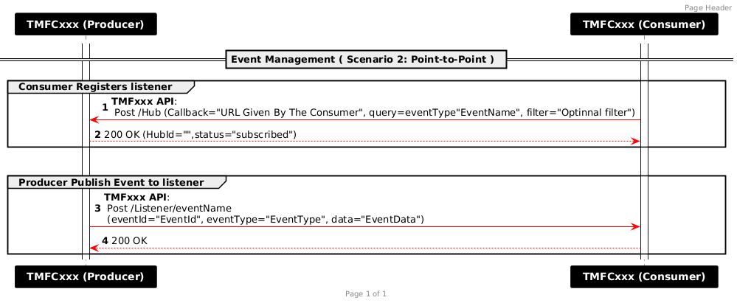

Administrative Appendix

Document History

Version History
This section records the changes between this and the previous document version as it is edited by the team concerned. Note: this is an incremental number which does not have to match the release number and used for change control purposes only.
Version Number | Date Modified | Modified by: | Description of changes
1.0.0 | 24 Oct 2024 | haifa benyoussef  Sylvie Demarest | First version of the use case.
2.0.0 | 07 Nov 2024 | haifa benyoussef  Sylvie Demarest | - Update of the product catalog with Fix Communication Product Offering and Product Offering Price (According to TMFS003).  - Update product inventory with:  - Fixed communication for product offering instances  - Recurring and one-time pricing  - Tax product price alterations  - Usage Rating  - Define Applied customer billing tax rate definition  - Add a general sequence Diagram related to event production and consumption
2.0.0 | 27 Dec 2024 | Rosie Wilson | - Final administrative edits
2.1.0 | 02 Jan 2025 | haifa benyoussef  Sylvie Demarest | - Add bill life cycle description  - Update Information view:  - Add JohnCustomerBill linked to JohnBillingAccount  - Link AppliedCustomerBillingProdUsageRate with JohnCustomerBill  - Update sequence diagram:  - Calculation of AppliedCustomerBillingProdUsageRate  - Calculation of AppliedCustomerBillingTaxRate  - John bill generation triggered by internal timer  - Add alternative scenario for Event Management.
2.1.0 | 13 Mar 2025 | Rosie Wilson | - Final administrative edits
2.2.0 | 09 Jun 2025 | haifa benyoussef | - Incorporating the comments raised in the previous version V1:  - Update of the introduction with points to be integrated in the next version.  - SID: Update of TMFC030 (integrating "PartyBillSpec", "PartyBillFormat", "PartyBillingCycleSpecification") following comments of Sylvie Demarest  - SID: Wording corrections following comments raised by olivier arnaud & Elisabeth Andersson  - Sequence Diagram Usage Rating 1/1: correction of Flows (11,14,15,16) with the correct API parameters  - Sequence Diagram Bill Generation: (Update Flows 6,7) in consistency with the SID view
2.2.0 | 10 Jul 2025 | Rosie Wilson | - Final administrative edits

Release History
Release Status | Date Modified | Modified by: | Description of changes
Pre-production | 31 Oct 2024 | Amaia White | Initial release 1.0.0
Production | 07-Mar-2025 | Adrienne Walcott | Updated to reflect TM Forum Approved status
Pre-production | 27 Dec 2024 | Rosie Wilson | Updated to release v2.0.0
Production | 07-Mar-2025 | Adrienne Walcott | Updated to reflect TM Forum Approved status
Pre-production | 13-Mar-2025 | Rosie Wilson | Updated to release v2.1.0
Production | 09-May-2025 | Adrienne Walcott | Updated to reflect TM Forum Approved status
Production | 10 Jul 2025 | Rosie Wilson | Updated to release v2.2.0
Production | 05-Sep-2025 | Adrienne Walcott | Updated to reflect TM Forum Approved status

Acknowledgments
This document was prepared by the members of the TM Forum End-to-End ODA team.
Team Member (@mention) | Company | Role
Sylvie Demarest | Orange | Additional Inputs
haifa benyoussef | Orange | Author
Elisabeth Andersson | Matrixx | Reviewer
Margaret Pan | China Telecom | Reviewer
David Richards | Enable | Reviewer
Abinash Vishwakarma | Netcracker | Reviewer
Alix Marès | Orange | Reviewer
olivier arnaud | Orange | Reviewer
*Select from: Project Chair, Project Co-Chair, Author, Editor, Key Contributor, Additional Input, Reviewer

