TM Forum Introductory Guide

Legal Guardian

TMFS006

Maturity Level: General availability (GA) | Team Approved Date: 22-Aug-2024
Release Status: Production | Approval Status: TM Forum Approved
Version 4.0.0 | IPR Mode: RAND

Notice
Copyright © TM Forum 2024. All Rights Reserved.

This document and translations of it may be copied and furnished to others, and derivative works that comment on or otherwise explain it or assist in its implementation may be prepared, copied, published, and distributed, in whole or in part, without restriction of any kind, provided that the above copyright notice and this section are included on all such copies and derivative works. However, this document itself may not be modified in any way, including by removing the copyright notice or references to TM FORUM, except as needed for the purpose of developing any document or deliverable produced by a TM FORUM Collaboration Project Team (in which case the rules applicable to copyrights, as set forth in the TM FORUM IPR Policy, must be followed) or as required to translate it into languages other than English.

The limited permissions granted above are perpetual and will not be revoked by TM FORUM or its successors or assigns.

This document and the information contained herein is provided on an “AS IS” basis and TM FORUM DISCLAIMS ALL WARRANTIES, EXPRESS OR IMPLIED, INCLUDING BUT NOT LIMITED TO ANY WARRANTY THAT THE USE OF THE INFORMATION HEREIN WILL NOT INFRINGE ANY OWNERSHIP RIGHTS OR ANY IMPLIED WARRANTIES OF MERCHANTABILITY OR FITNESS FOR A PARTICULAR PURPOSE.

TM FORUM invites any TM FORUM Member or any other party that believes it has patent claims that would necessarily be infringed by implementations of this TM Forum Standards Final Deliverable, to notify the TM FORUM Team Administrator and provide an indication of its willingness to grant patent licenses to such patent claims in a manner consistent with the IPR Mode of the TM FORUM Collaboration Project Team that produced this deliverable.

The TM FORUM invites any party to contact the TM FORUM Team Administrator if it is aware of a claim of ownership of any patent claims that would necessarily be infringed by implementations of this TM FORUM Standards Final Deliverable by a patent holder that is not willing to provide a license to such patent claims in a manner consistent with the IPR Mode of the TM FORUM Collaboration Project Team that produced this TM FORUM Standards Final Deliverable. TM FORUM may include such claims on its website but disclaims any obligation to do so.

TM FORUM takes no position regarding the validity or scope of any intellectual property or other rights that might be claimed to pertain to the implementation or use of the technology described in this TM FORUM Standards Final Deliverable or the extent to which any license under such rights might or might not be available; neither does it represent that it has made any effort to identify any such rights. Information on TM FORUM's procedures with respect to rights in any document or deliverable produced by a TM FORUM Collaboration Project Team can be found on the TM FORUM website. Copies of claims of rights made available for publication and any assurances of licenses to be made available, or the result of an attempt made to obtain a general license or permission for the use of such proprietary rights by implementers or users of this TM FORUM Standards Final Deliverable, can be obtained from the TM FORUM Team Administrator. TM FORUM makes no representation that any information or list of intellectual property rights will at any time be complete, or that any claims in such list are, in fact, Essential Claims.

Direct inquiries to the TM Forum office:

181 New Road, Suite 304
Parsippany, NJ 07054, USA
Tel No. +1 862 227 1648
TM Forum Web Page: www.tmforum.org

Table of Contents
Notice 2
Table of Contents 4
1. Introduction 5
1.1. Context or Background 5
1.2. Objective of the use case 5
1.3. Scope and assumptions 5
1.3.1. Scope 5
1.3.2. Assumptions 5
1.3.3. References 5
2. Description 7
2.1. As-Is Data Model View 8
2.2. View Data Model after Guardianship operation: 8
2.2.1. Focus on Communication Interaction: 8
2.2.2. SID representation :"Bob Party Role & Permissions" : 9
2.2.3. SID representation : " Marie Party Role & Permissions ": 10
3. Sequence diagrams 11
4. Conclusion 12
4.1. Lessons learned 12
4.2. Impacts identified 12
5. Administrative Appendix 13
5.1. Document History 13
5.1.1. Version History 13
5.1.2. Release History 13
5.2. Acknowledgments 13

Introduction

Context or Background
This use case is a description to illustrate a set of identified ODA components, and how they interact and collaborate using TMF Open APIs to manage a business process.
As it includes manual tasks and front-end interactions, it also permits to illustrate approach regarding front-end layer and process layer articulation.

Objective of the use case
Bob, a client of a telecommunications operator "Lambda", has subscribed to a service plan. In this use case, the court decides to place him under the guardianship of Marie, who becomes his legal guardian. This decision may occur in situations where Bob is deemed incapable of making decisions for himself, whether due to mental health issues, protection of his interests, or other circumstances where he is considered to require special assistance. As a result, Marie will act as Bob's legal guardian, making decisions on his behalf and ensuring his interests, including those related to his relationship with the telecommunications operator and the management of his subscription.

Scope and assumptions

Scope
Bob, an individual customer (party individual) with a postpaid subscription (offering) from Operator Lambda, has his legal guardianship transferred to Marie. Marie assumes the role of Bob's legal guardian (party role) and gains permission to manage Bob's subscription.

Assumptions
- Bob's initial status: Individual customer with a prepaid subscription under Operator Lambda.
- Legal Intervention: Marie assumes the legal guardianship of Bob.
- Guardianship Implications: Marie gains permission to manage Bob's prepaid subscription.
- Operator Involvement: Bob is a customer of Operator Lambda.
This use case demonstrates the handling of subscription management when a customer's legal status changes, involving the transfer of subscription management permissions to a legal guardian. It highlights the ability of telecommunications providers to adapt to such changes and ensure continuity of service for their customers.

References
SID: GB922 Common v22.5
- Communication Interaction ABE
- Party ABE
- Party Role ABE
- Party Permission ABE
- Document ABE

ODA components:
- IG1242 ODA Components Inventory v12.0.0
- TMFC023 Party Interaction Management v1.0.0
- TMFC028 Party Management v1.2.0
- TMFC035 Permissions Management v1.0.0
- TMFC051 Document Management

Open APIs:
- TMF632 Party Management v4
- TMF669 Party Role Management v4
- TMF672 User Role Permission v4
- TMF683 Party Interaction v4
- TMF701 Process Flow v4

Description
John, an agent working for a CSP (Communications Service Provider) agency, will configure Marie as Bob's legal guardian based on a legal document she provides.
John's Actions:
- Identify Bob: John will first search for the existing party record associated with Bob.
- Add Legal Guardian: John will then add a new legal guardian association to Bob's party record.
- Validate and Attach Document: Finally, John will validate the legal document provided by Marie and attach it to Bob's party record as proof of guardianship.
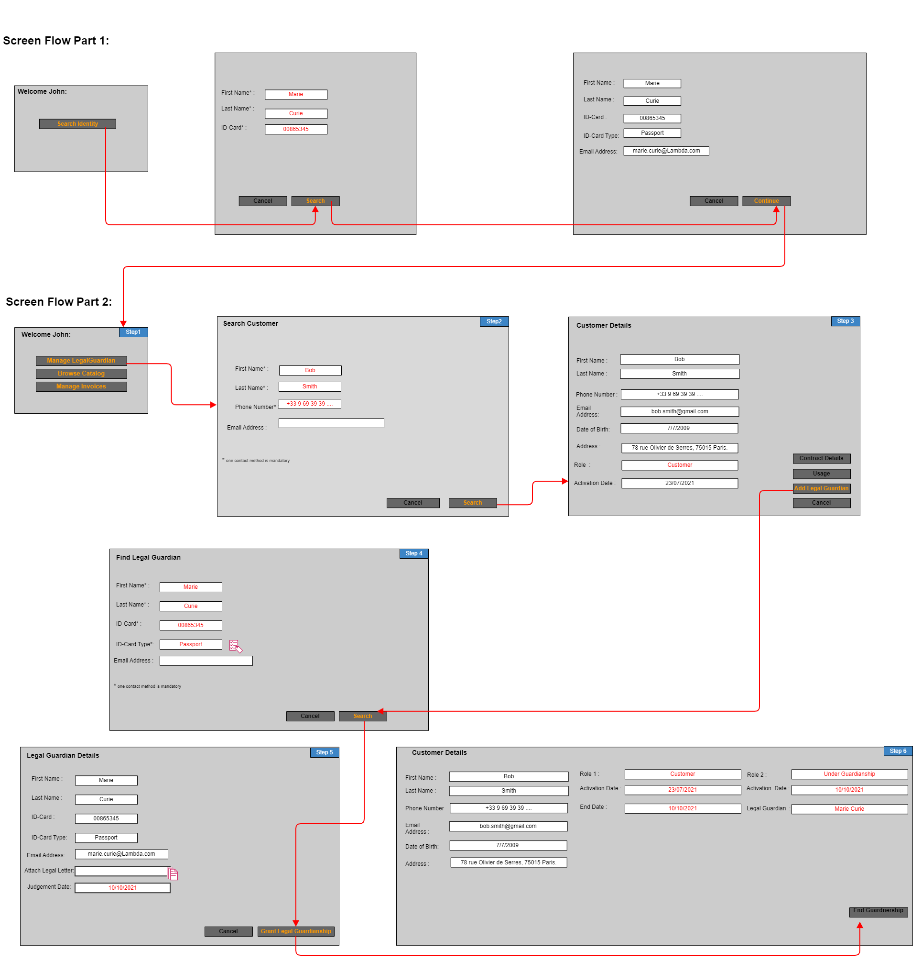

BPMN Diagram :
[BPMN diagram TMFS006 powered by viadee]

As-Is Data Model View

This data model outlines the parties, roles, and permissions involved in the "legal guardian" configuration use case before the "legal guardian" is set up. It serves as a foundation for modeling the changes introduced by the "legal guardian" configuration.

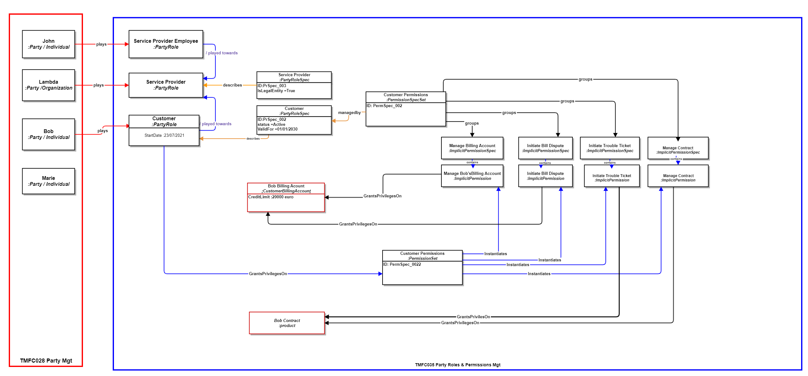

View Data Model after Guardianship operation:

Focus on Communication Interaction:

This data model segment focuses on the interaction initiated by Marie, where she contacts John, an employee of the operator, to request her configuration as Bob's legal guardian. She provides the court judgment as supporting documentation.

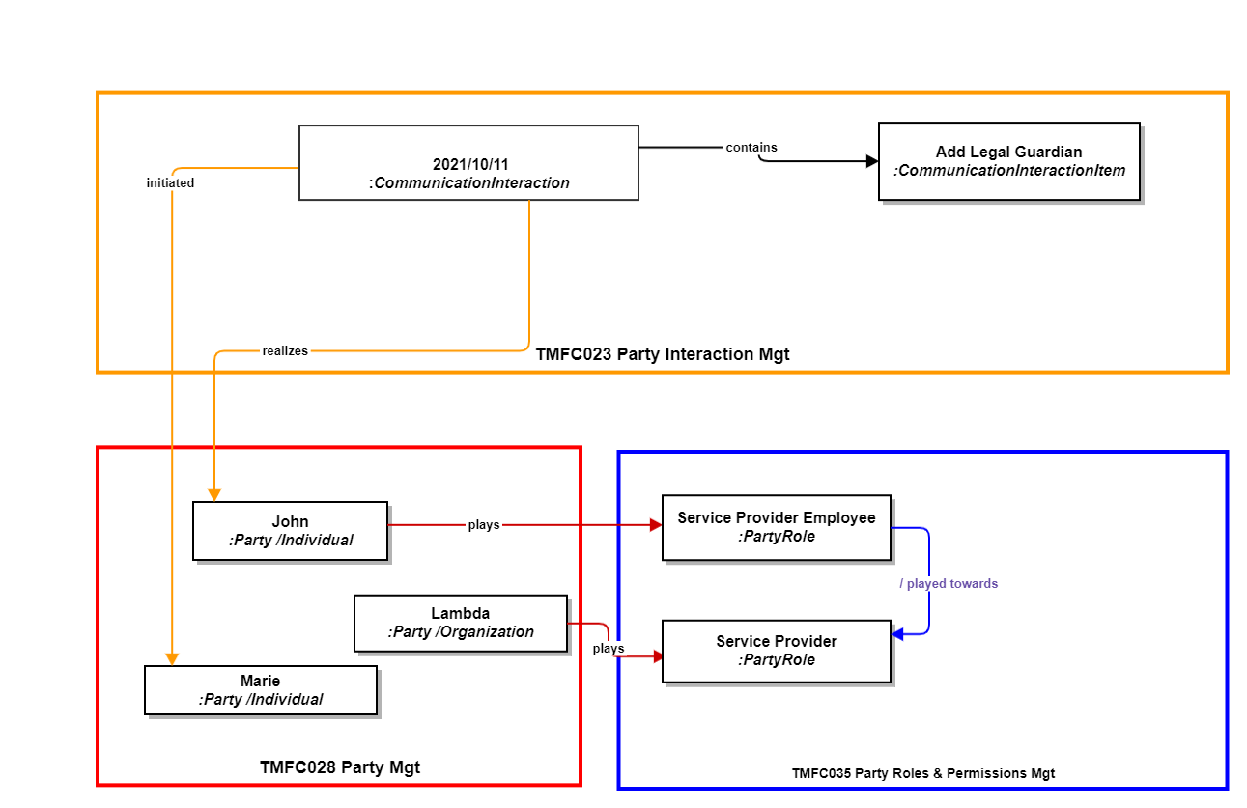

SID representation :"Bob Party Role & Permissions" :
This section of the data model demonstates the impact on Bob's party role and permissions following his placement under Marie's guardianship. As a result of this change, Bob assumes a new role as a "Protected Customer" with restricted permissions.

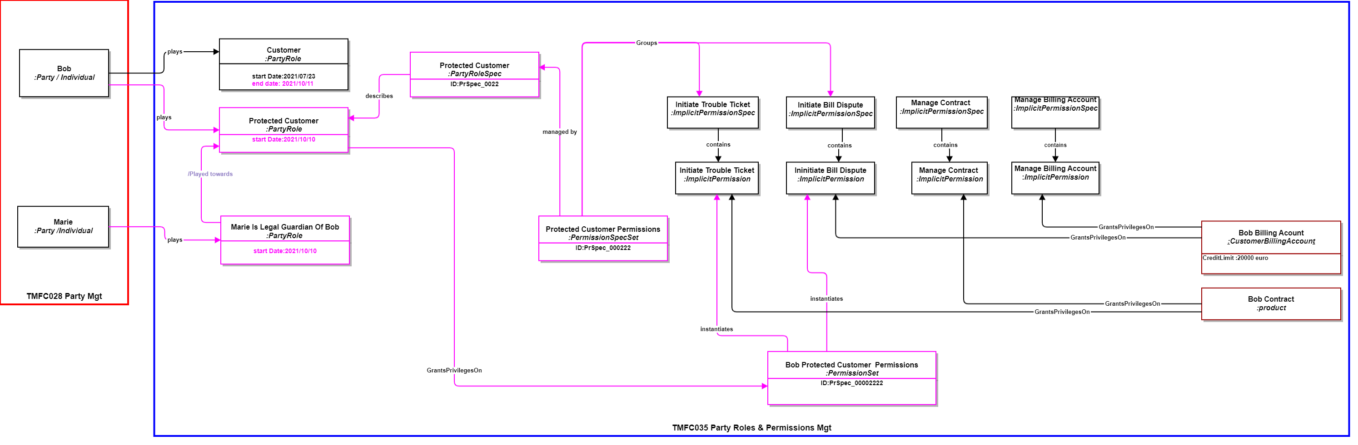

SID representation : " Marie Party Role & Permissions ":
This segment of the data model depicts the representation of Marie's new party role as Bob's legal guardian and the permissions associated with this role.

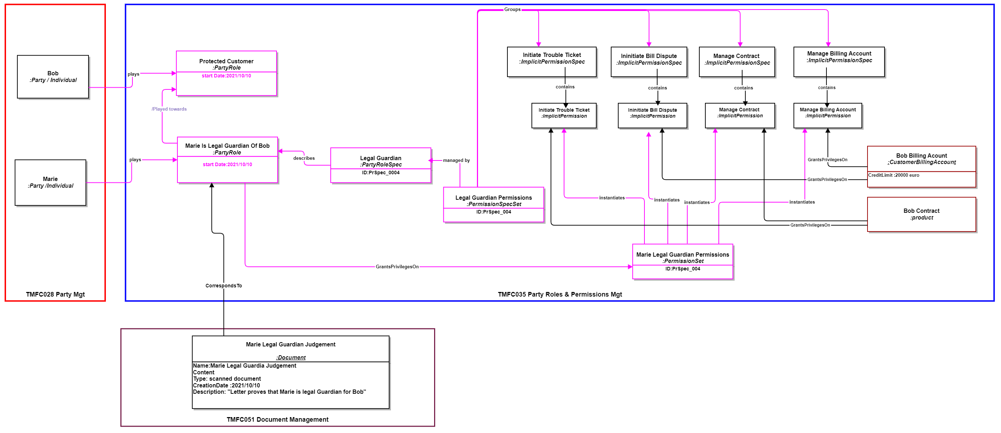

Sequence diagrams
Part 1: Search tutoree &Legal Guardian:
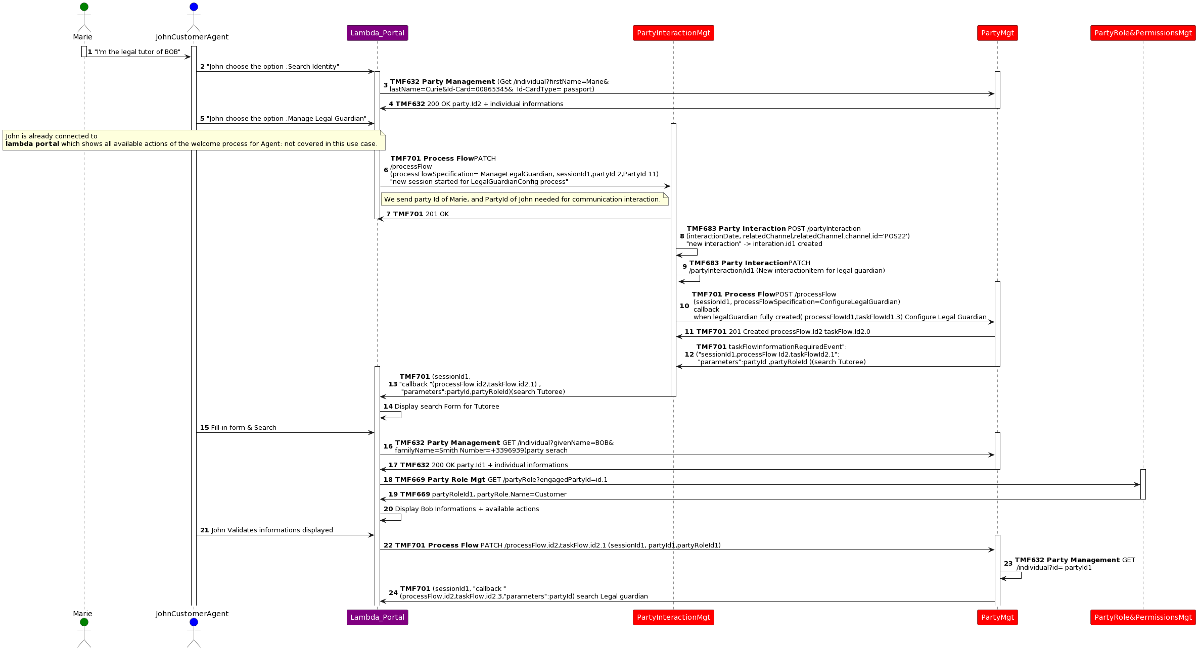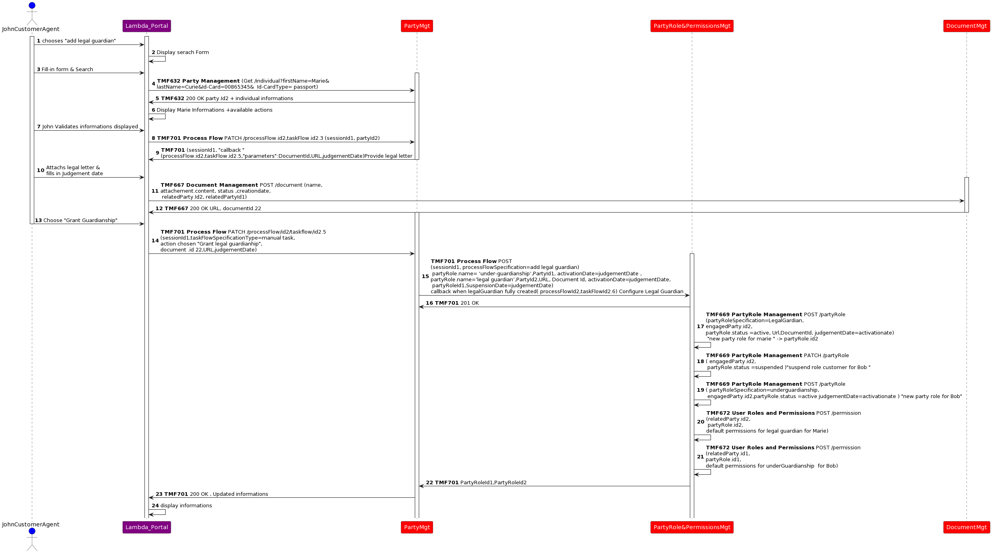

Conclusion

Lessons learned
This use case is a first example that shows how the document management component works. It also shows how the party management component handles the complex process of setting up a new party role and how this affects existing roles.

Impacts identified
This use case will serve as an input for the specification work of the document management component

Administrative Appendix

Document History

Version History
Version Number¹ | Date Modified | Modified by: | Description of changes
v2.0.0 | 06 Apr 2023 | Sylvie Demarest | Last version published in IG1228 v14.0
v3.0.0 | 04 Jul 2024 | haifa benyoussef | Updated to the latest template  Improvment of description and information view chapters.
v4.0.0 | 22 Aug 2024 | haifa benyoussef | Add of BPMN view and sequence diagrams
v4.0.0 | 29 Aug 2024 | Amaia White | Final edits prior to publication

Release History
Release Status | Date Modified | Modified by: | Description of changes
Pre-production | 06 Apr 2023 | Joseph Guei | Updated to version v2.0.0
Pre-production | 04 Jul 2024 | Amaia White | Updated to version v3.0.0
Production | 30-Aug-2024 | Adrienne Walcott | Updated to reflect TM Forum Approved status (v3.0.0)
Pre-production | 22 Aug 2024 | Amaia White | Updated to version v4.0.0
Production | 01-Nov-2024 | Adrienne Walcott | Updated to reflect TM Forum Approved status

Acknowledgments
This document was prepared by the members of the TM Forum End-to-End ODA team.
Team Member (@mention) | Company | Role*
Sylvie Demarest | Orange | Reviewer
haifa benyoussef | Orange | Author
*Select from: Project Chair, Project Co-Chair, Author, Editor, Key Contributor, Additional Input, Reviewer

