TM Forum Introductory Guide

ODA Flow with NaaS Support

TMFS010

Maturity Level: General availability (GA) | Team Approved Date: 18-Dec-2023
Release Status: Production | Approval Status: TM Forum Approved
Version 1.0.0 | IPR Mode: RAND

Notice
Copyright © TM Forum 2024. All Rights Reserved.

This document and translations of it may be copied and furnished to others, and derivative works that comment on or otherwise explain it or assist in its implementation may be prepared, copied, published, and distributed, in whole or in part, without restriction of any kind, provided that the above copyright notice and this section are included on all such copies and derivative works. However, this document itself may not be modified in any way, including by removing the copyright notice or references to TM FORUM, except as needed for the purpose of developing any document or deliverable produced by a TM FORUM Collaboration Project Team (in which case the rules applicable to copyrights, as set forth in the TM FORUM IPR Policy, must be followed) or as required to translate it into languages other than English.

The limited permissions granted above are perpetual and will not be revoked by TM FORUM or its successors or assigns.

This document and the information contained herein is provided on an “AS IS” basis and TM FORUM DISCLAIMS ALL WARRANTIES, EXPRESS OR IMPLIED, INCLUDING BUT NOT LIMITED TO ANY WARRANTY THAT THE USE OF THE INFORMATION HEREIN WILL NOT INFRINGE ANY OWNERSHIP RIGHTS OR ANY IMPLIED WARRANTIES OF MERCHANTABILITY OR FITNESS FOR A PARTICULAR PURPOSE.

TM FORUM invites any TM FORUM Member or any other party that believes it has patent claims that would necessarily be infringed by implementations of this TM Forum Standards Final Deliverable, to notify the TM FORUM Team Administrator and provide an indication of its willingness to grant patent licenses to such patent claims in a manner consistent with the IPR Mode of the TM FORUM Collaboration Project Team that produced this deliverable.

The TM FORUM invites any party to contact the TM FORUM Team Administrator if it is aware of a claim of ownership of any patent claims that would necessarily be infringed by implementations of this TM FORUM Standards Final Deliverable by a patent holder that is not willing to provide a license to such patent claims in a manner consistent with the IPR Mode of the TM FORUM Collaboration Project Team that produced this TM FORUM Standards Final Deliverable. TM FORUM may include such claims on its website but disclaims any obligation to do so.

TM FORUM takes no position regarding the validity or scope of any intellectual property or other rights that might be claimed to pertain to the implementation or use of the technology described in this TM FORUM Standards Final Deliverable or the extent to which any license under such rights might or might not be available; neither does it represent that it has made any effort to identify any such rights. Information on TM FORUM's procedures with respect to rights in any document or deliverable produced by a TM FORUM Collaboration Project Team can be found on the TM FORUM website. Copies of claims of rights made available for publication and any assurances of licenses to be made available, or the result of an attempt made to obtain a general license or permission for the use of such proprietary rights by implementers or users of this TM FORUM Standards Final Deliverable, can be obtained from the TM FORUM Team Administrator. TM FORUM makes no representation that any information or list of intellectual property rights will at any time be complete, or that any claims in such list are, in fact, Essential Claims.

Direct inquiries to the TM Forum office:

181 New Road, Suite 304
Parsippany, NJ 07054, USA
Tel No. +1 862 227 1648
TM Forum Web Page: www.tmforum.org

Table of Contents
Notice 2
Table of Contents 4
List of Figures 5
1. Introduction 6
1.1. Context or Background 6
1.2. Objective of the use case 6
1.3. Scope, assumptions, and considerations 7
1.3.1. Scope 7
1.3.2. Assumptions 7
1.3.3. References 7
2. Description 10
2.1. Internet Product with Fiber using NaaS 10
2.2. Modularization & Abstraction using NaaS & its E2E SM 10
2.3. Screen Flows 11
3. Information View 12
3.1. Service Exposure for Technology Focused Product Models 12
3.2. Service Exposure for Technology Agnostic Product Models 12
4. Sequence diagrams 14
4.1. Service Specification Design (Sequence Diagrams) 14
4.2. API call flows 15
5. Conclusion 17
5.1. Lessons learned 17
6. References 18
7. Administrative Appendix 19
7.1. Document History 19
7.1.1. Version History 19
7.1.2. Release History 19
7.2. Acknowledgments 20

List of Figures
Figure 1: Open Digital Architecture Functional Architecture 6
Figure 2: Production functional Block with ODM 8
Figure 3: Comparison of Production functional block without and with NaaS 10
Figure 4: Example of CSP intent request for technology-agnostic product offering 11
Figure 5: Product and service catalogue view supporting technology-focused product offerings 12
Figure 6: Product and service catalogue view supporting technology agnostic product offerings 13
Figure 7: Sequence diagram showing the creation journey of "E2E Connectivity Service" composite service 14
Figure 8: Sequence diagram showing the service qualification check at the requested address 15
Figure 9: Sequence diagram showing the Service Order Delivery via E2E SM and NaaS approach 16

Introduction

Context or Background
The TM Forum's Open Digital Architecture has been designed to enable members to build highly complex, but very flexible solutions by using sets of loosely coupled components, that expose their business functionality via a set of industry agreed Open APIs.
This use case proposes that every production group (e.g., Transport, IP, access, media, etc.) exposes and manages service capabilities (i.e., Network as a Service) in the Open Digital Architecture (ODA) from the Production function block to other ODA functional blocks (such as Core Commerce Management, Intelligence Management) via the decoupling and integration function block (i.e., APIs and API gateway) to allow for zero touch automation.
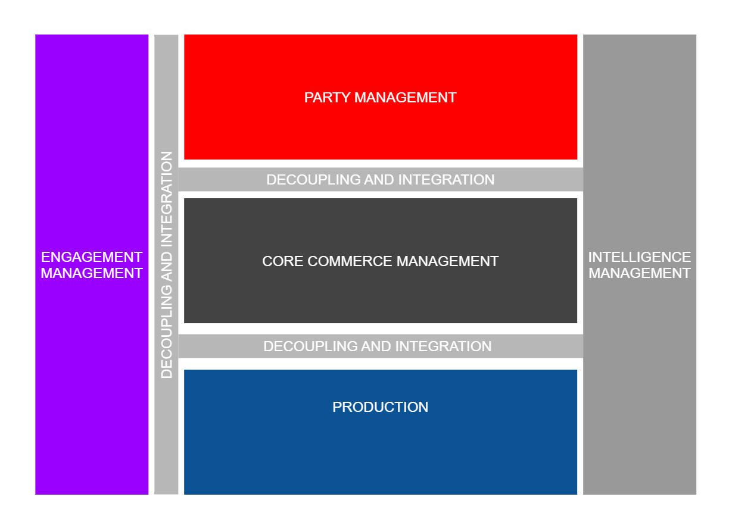
Figure 1: Open Digital Architecture Functional Architecture

Objective of the use case
NaaS simplifies the Networks to IT Communication and is fundamental to network of the future. Today most OSSs and BSSs need to understand how the underlying network works and how each product is designed down to each resource used, which makes change costly, manual, and slow. In this ODA Functional Architecture, traditional Business Support Systems would be in the Core Commerce Management and in the party management functional blocks managed by IT while most of the Operational Support Systems would be in the Production functional block managed by Operational Domain Management (ODM)- typically technology/network - teams.
Today these systems are inter-connected using suppliers' custom APIs for each network domain making product additions or modifications, a large project within both IT and Network domains. As per ODA principles, NaaS enables network capabilities to be exposed as reusable services, hiding "How" (typically resource level) the capabilities are defined and using standards Open APIs, agnostic of technology and vendor.
NaaS is changing the current lengthy processes used from idea to product delivery and maintenance leading to shortened time to market and enhanced customer experience. For best practices around NaaS, refer to IG1224 NaaS Service Fulfillment Guidelines.

Scope, assumptions, and considerations

Scope
The purpose of this document is to demonstrate the benefits and agility brought by NaaS and its E2E Service Management in ODA Production block and how it simplifies the design, fulfillment, and assurance on the original Internet product with Fiber use case TMSF003 and TMSF004.

Assumptions
This use case does not intend to describe how to perform a NaaS Transformation or what domains are needed in order to support NaaS. It focuses on the comparison between traditional and NaaS abstraction processes, architecture and separation of concerns.

References
- TMF909 NaaS API component suite
- IG1224 NaaS Transformation v12.0.0 - TM Forum
- GB999 ODA Production Implementation Guidelines v4.0.1 - It describes the range of implementation options for ODA Production covering ODM E2E SM and topics such as the use of RFS and RF. The critical point is that all these options result in exposing an SM NaaS interface from ODA Production (supported by one e2e ODM) which defines what is provided (as CFS) and hides the 'how'. The exposed CFS can be associated with multiple ProductSpecs in Core Commerce that are all different restrictions of the exposed CFS.
- IG1233 Product & Service Modelling Best Practices – Conforming to ODA v2.0.0 - It provides an example of modeling best practices using a broadband and email example

This Use Case reviews the original Internet product with Fiber use cases TMSF003 and TMSF004 and adapts these with the NaaS principles to demonstrate the simplification that NaaS brings to the design, fulfillment, and assurance.
The ODA functional architecture has been adapted in Figure 2 to reflect Network as a Service concepts of Operational Domain Management (ODM), within the ODA Production function block, use cases include:
- exposing abstracted services (customer facing services - CFS) to Core Commerce Management (CCM) function block, so they become product(s)
- exposing abstracted services to other ODMs, so they become reusable services in complex multi-operational domain services
- exposing abstracted services to external developers

Depending on the service provider management capabilities and choice, multi-operational domain services can be managed by E2E Service Management (E2E SM) domain, or one Operational Domain Manager can orchestrate across another Operational Domain for example the optical domain orchestrating and consuming the cloud domain CFS for its VNF/CNF support. At a minimum, the TMF909 NaaS API component suite is used between CCM and Production and within the Production function block.
While the traditional method of assembling at the product level with Product Order and Orchestration Management (POOM) is still valid, NaaS moves the management of the entire lifecycle of a composite service (across multiple domains) within the E2E SM domain using Service Orchestration Management (SOM) function and supporting real-time closed-loop capability. There is now one domain within Production, responsible for the composite E2E service versus managing that service via disparate domains from Core Commerce Management.
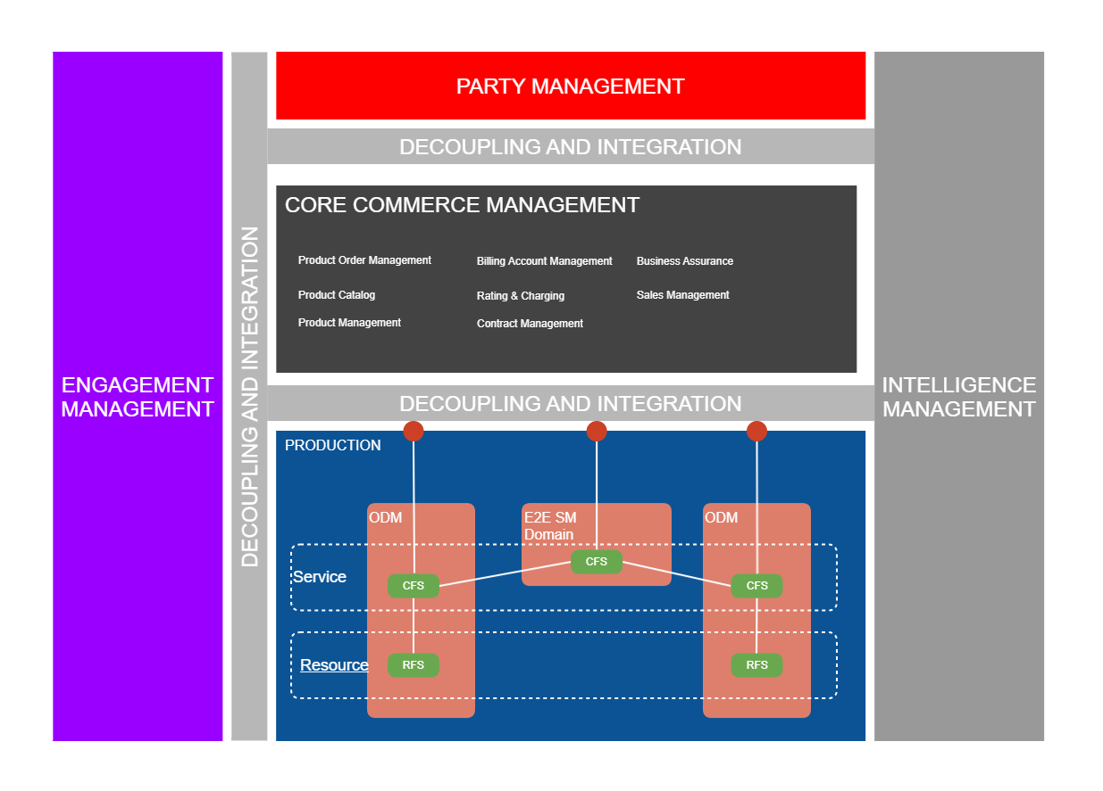Figure 2: Production functional Block with ODM

Each operational domain, including the E2E SM domain publishes its services in the NaaS Catalog service specifications using the TMF633 API. NaaS API gateway / Event bus in the Decoupling and Integration functional block notifies the subscribers such as Product Catalog and E2E Service Management domain.

Description

Internet Product with Fiber using NaaS
The purpose of this document is to demonstrate the benefits and agility brought by NaaS and its E2E Service Management in ODA Production block and how it simplifies the design, fulfillment, and assurance on the Internet product with Fiber use case TMSF003 and TMSF004. The original IG1228 TMSF003 and TMSF004 use cases used ODMs from Production block namely the Access, Network Service and Soft Service Domains. Below diagram shows the change in landscape of Production block with introduction of NaaS and E2E Service Management Domain.

Production block as per TMSF003 & TMSF004 | Production block with introduction of NaaS and E2E Service Management Domain
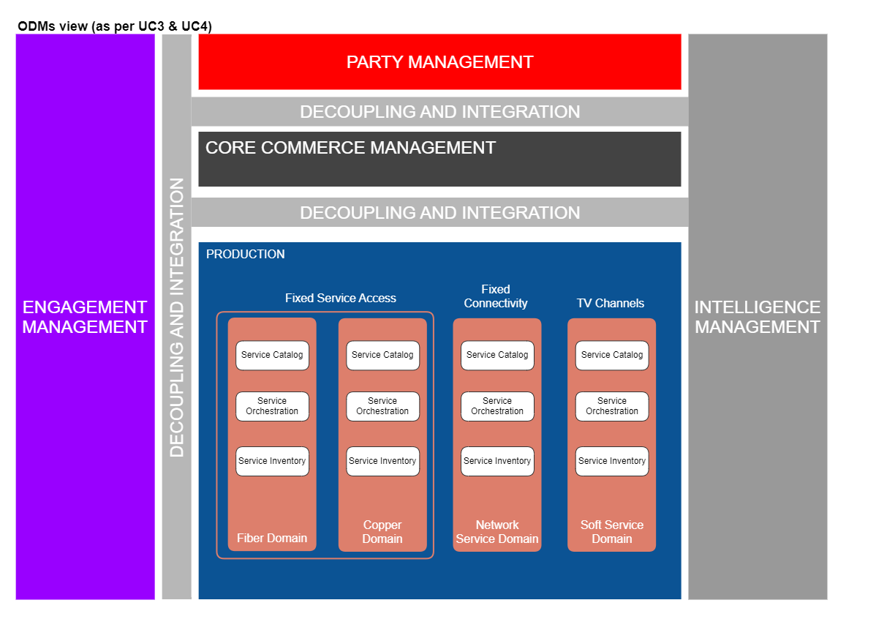 | 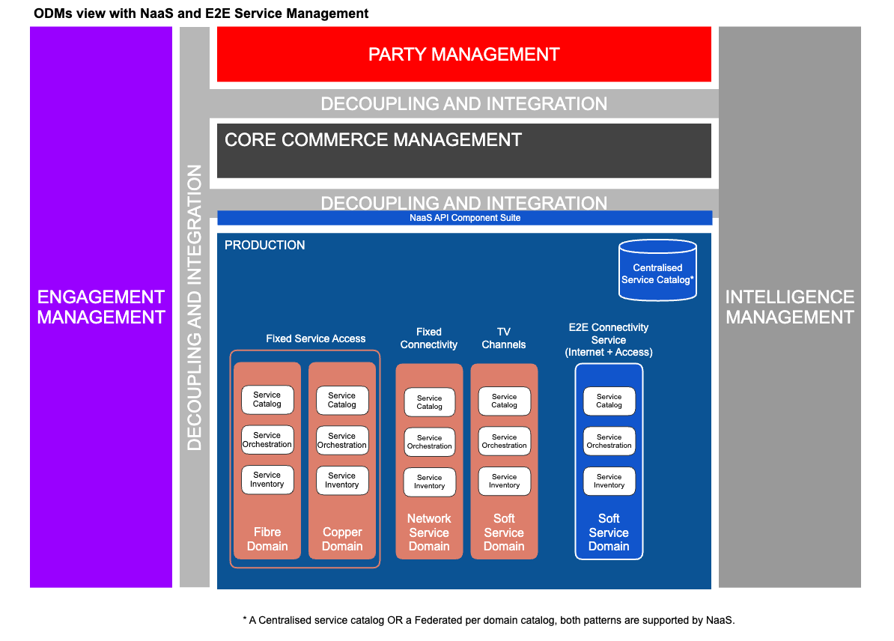

Figure 3: Comparison of Production functional block without and with NaaS
The role of E2E Service Management Domain and NaaS are documented in IG1224 NaaS Service Fulfillment Guidelines.

Modularization & Abstraction using NaaS & its E2E SM
A simplified, modularized and abstracted Composite Service (E2E Connectivity Service CFS) is designed using E2E Service Management Domain, by composing the services offered by each domain. The introduction of this Composite Service in the Production Domain abstracts away all the orchestration complexities (including network dependencies) and simplifies the overall provisioning. Also, post activation, the E2E service management domain is also responsible for all the other life cycle functions such as assurance. A detailed view of revised service models and the consumption by product models are shown in the sections below.

Screen Flows
Having the E2E SM Domain hiding the technology complexity, CSPs can move away from selling technology to selling Product offers agnostic of technology. This helps CSPs migrating technologies, using 3rd parties or even start with one technology available (e.g. Mobile) and change it later when, for example Fixed access is available; providing another way to differentiate. Refer to the example below where the current offers have been dynamically generated according to the technologies available returned by the E2E SM Domain for the requested address (or landline phone number).

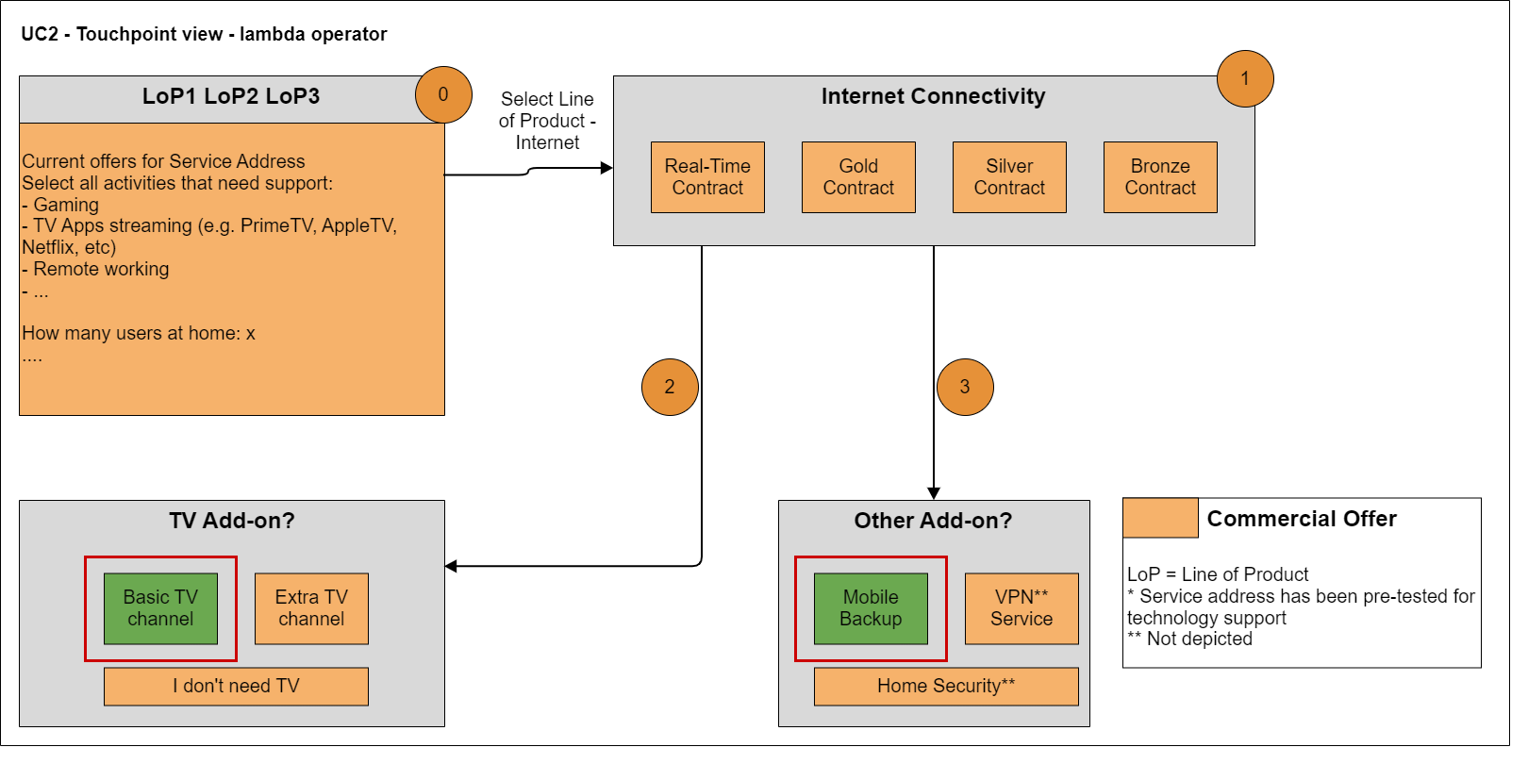

Figure 4: Example of CSP intent request for technology-agnostic product offering

Information View

Service Exposure for Technology Focused Product Models
Below is the service model with technology agnostic service specifications supporting Technology-focused Products. The E2E Connectivity Service CFS contains information from every Access technology domain available, the Network Service domain and the mobile domain (which can be possibly used as a backup service). The product specification "Connectivity over Fibre Access" will instantiate the E2E Connectivity Service with its choice of Fibre technology as per the Product offering sold to the customer.

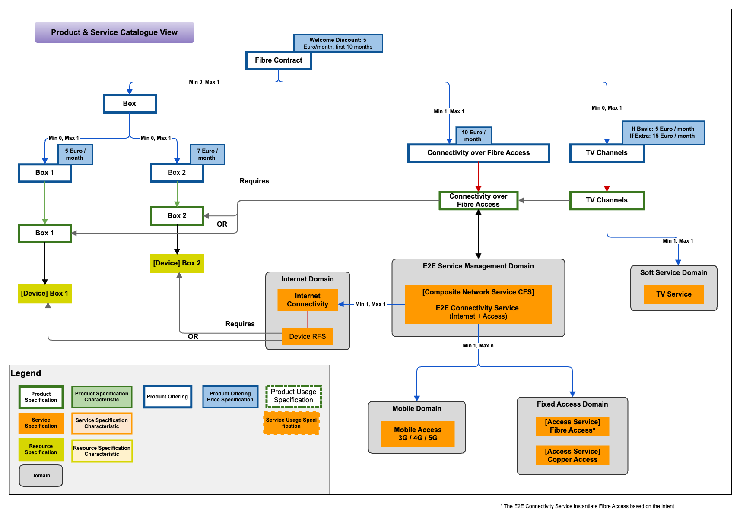
Figure 5: Product and service catalogue view supporting technology-focused product offerings

Service Exposure for Technology Agnostic Product Models
Below is the service model with technology agnostic service offerings supporting non-technology focused Products. The same E2E Connectivity Service CFS as above is used but this time Product Offers are not tied to technologies. Product specifications can still be created for access, connectivity and TV channels if these can be sold individually or as Add-On or can be combined in one product specification. The right technology to deliver the customer intent will be determined by the E2E Connectivity Service.

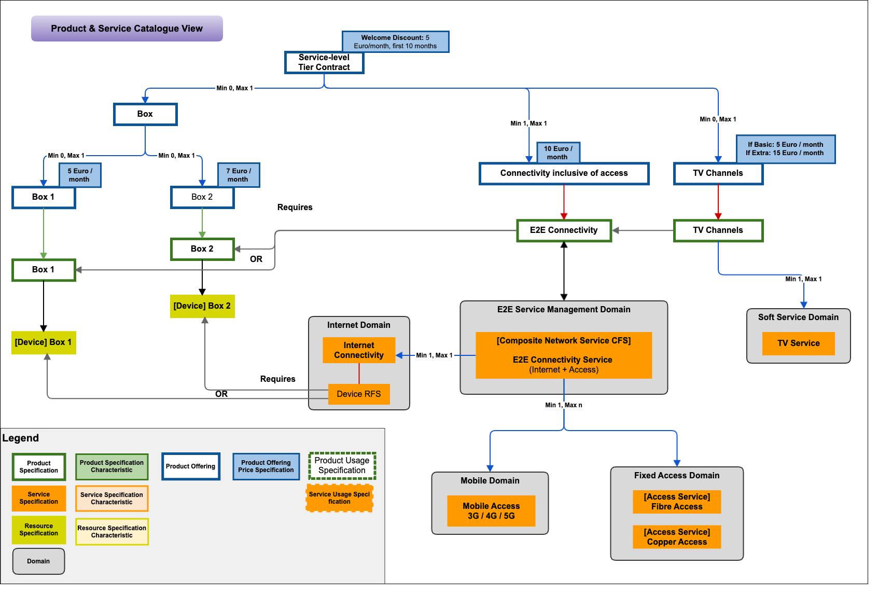

Figure 6: Product and service catalogue view supporting technology agnostic product offerings

Sequence diagrams

Service Specification Design (Sequence Diagrams)
Each domain designs its own services such as "Copper Access" CFS specification (CFSS), "Fiber Fixed Access" CFSS, "TV Service" CFSS, "3rd Party Access" CFSS, "Mobile Access" CFSS, etc. While each of these CFSSs can be exposed to the product catalog in an individual fashion, the E2E SM domain within NaaS, brings the capability to compose these CFSSs into a comprehensive E2E service across domains, and only expose the comprehensive service specification to the product catalog. Benefits of using the E2E SM Domain is the support for the complete service lifecycle within that overarching E2E domain including closed loop automation and autonomous network capability. Doing the composition not only for fulfillment but assurance at the Product level with siloed network domains sending their individual alarms and events in their own format would need network experts in CCM and would be a lot more complex for cross-domain services.
Services once designed are published to NaaS Catalog for exposure to other domains and product catalog for the non-internal services. Composite services are created in E2E Service Management domain by composing various NaaS services, in this example "E2E Connectivity Service". The E2E SM can compose any type of cross-domain services reusing atomic services exposed from each domain. Each domain is responsible for providing E2E lifecycle management for their services and the E2E SM provides the complete lifecycle management with closed-loop support across domains in real-time.
The below sequence diagram shows the creation journey of "E2E Connectivity Service" composite service.
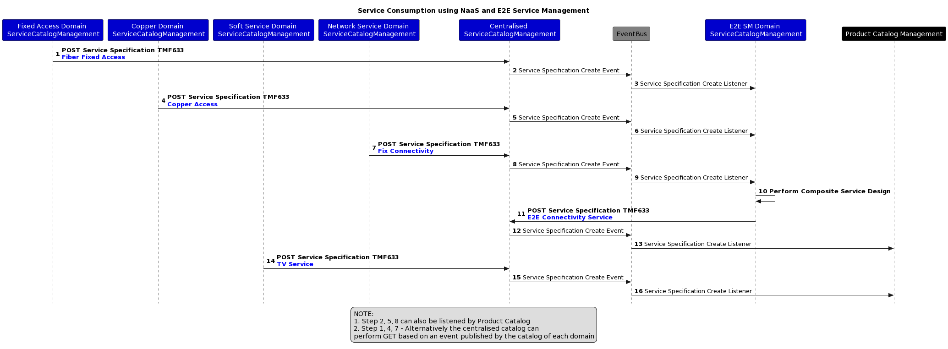
Figure 7: Sequence diagram showing the creation journey of "E2E Connectivity Service" composite service

API call flows
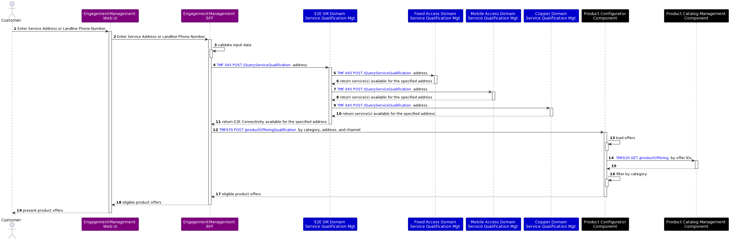
Figure 8: Sequence diagram showing the service qualification check at the requested address

Service Order Delivery via E2E SM and NaaS approach
The below sequence diagram explains the service order delivery with NaaS approach. The CCM will perform the Order Capture first with the requested Products and the Product Order Delivery Orchestration & Management subsequently send a service order to activate connected "Add-On" with necessary parameters to E2E Service Management Domain.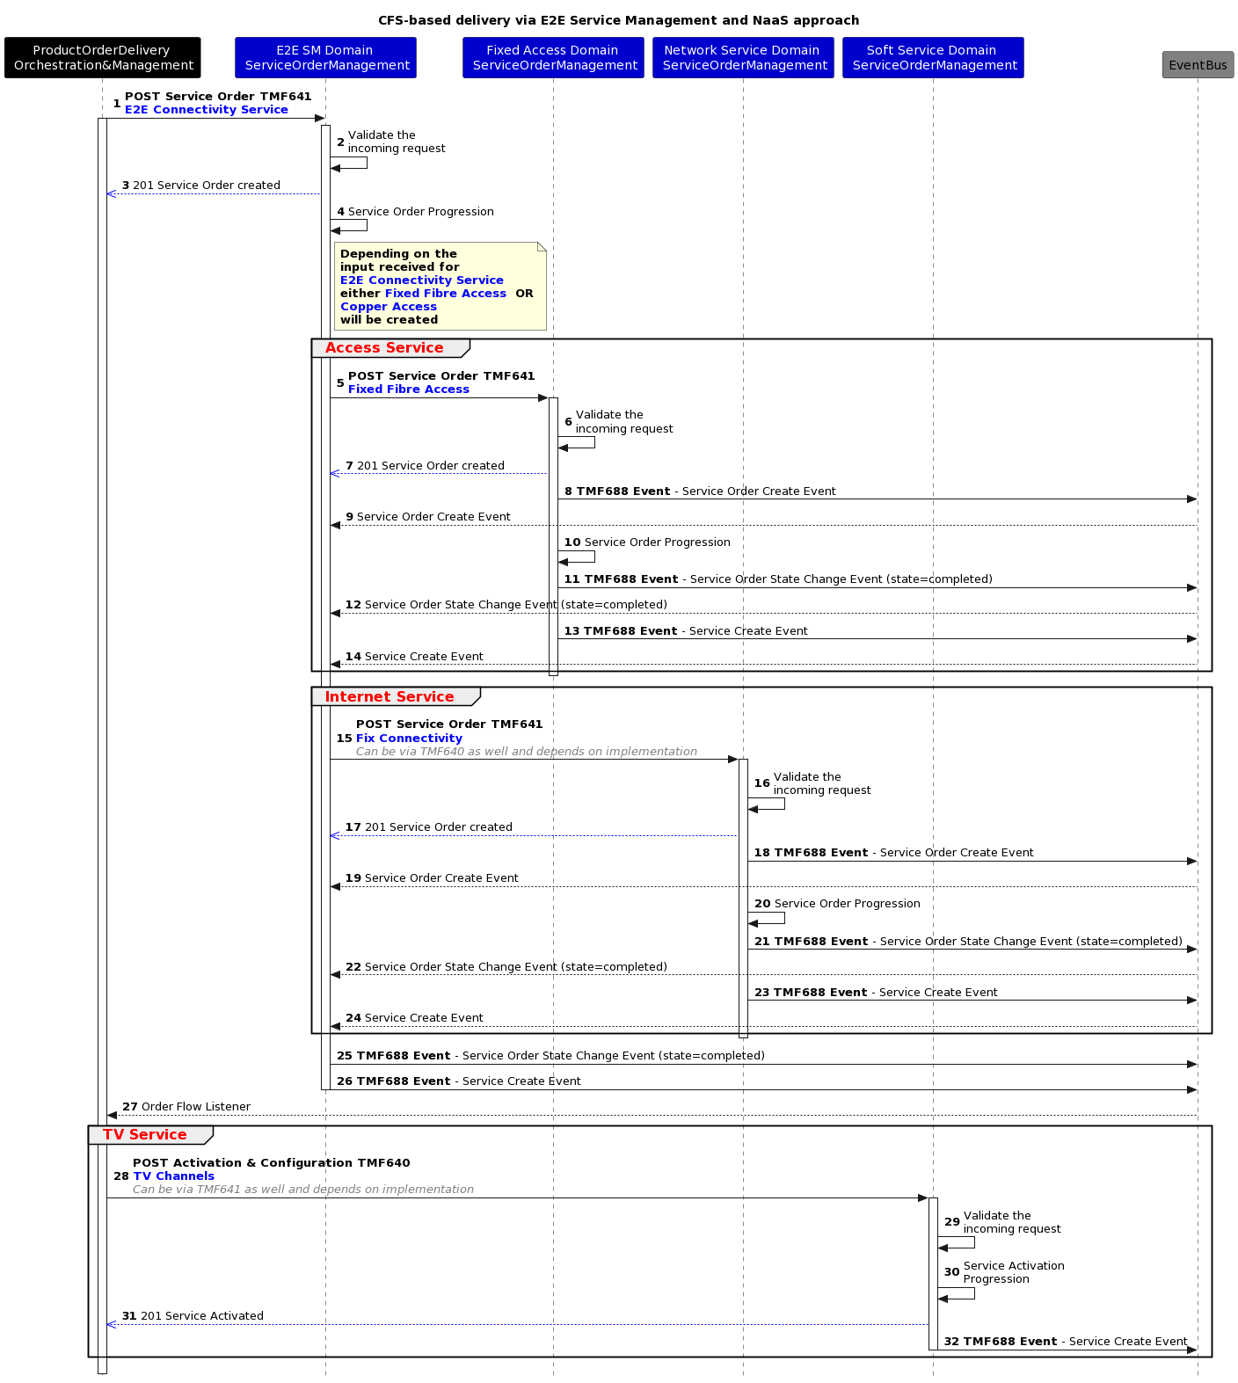
Figure 9: Sequence diagram showing the Service Order Delivery via E2E SM and NaaS approach

Conclusion

Lessons learned
- NaaS and E2E Service Management in ODA Production block brings agility and simplifies the design, fulfillment, and assurance of the services.
- NaaS allows product specifications to evolve independently without any dependency on service layer from ODA Production block.

References
Other examples you can refer to:
- GB999 ODA Production Implementation Guidelines v4.0.1
It describes the range of implementation options for ODA Production covering ODM E2E SM and topics such as use of RFS and RF. The critical point is that all these options result in exposing a SM NaaS interface from ODA Production (supported by one e2e ODM) which defines what is provided (as CFS) and hides the 'how'. The exposed CFS can be associated with multiple ProductSpecs in Core Commerce that are all different restrictions of the exposed CFS.
- IG1233 Product & Service Modelling Best Practices – Conforming to ODA v2.0.0
It provides example of modeling best practice using a broadband and email example

Administrative Appendix

Document History

Version History
Version Number | Date Modified | Modified by: | Description of changes
01.0.0 | 30-Jul-2021 | Amaia White | Initial contribution
02.0.0 | 25-Nov-2021 | Amaia White | Removed the reference to a 3rd party ODM (e.g., representing an access provider or public cloud provider) in the various Figures.
03.0.0 | 04-Apr-2023 | Joseph Guei | - Figure 8 Rename Product Offering Qualification component name to Product Configurator (which exposes TMF679 API)  - Figures 5 & 9 updated the shortened component names to the longer names  - Figure 4 update to align with Figure 7: Only the Product Offer changes between the two figures  - Figure 3 right side updated to reflect the Fixed Access Domain encompassing Fibre and Copper aligning with Figure 4 & 7  - Figure 5 update of Connectivity and TV services that were starting from the wrong domain  - Includes small text edits such benefits of E2E SM Domain
1.0.0 | 18-Dec-2023 | Joseph Guei | Modified the images into Gliffy and content aligned to the new documentation template

Release History
Release Status | Date Modified | Modified by: | Description of changes
Pre-production | 18-Dec-2023 | Joseph Guei | Initial release
Production | 09-Feb-2024 | Adrienne Walcott | Updated to reflect TM Forum Approved status

Acknowledgments
This document was prepared by the members of the TM Forum End-to-End ODA team.
Acknowledgments
Team Member (@mention) | Company | Role*
Abdul Majid Hussain | Telstra | Author
Varun Nair | Telstra | Author
Johanne Mayer | NaaS Compass | Author

