TM Forum Introductory Guide

Use Case: Product Catalog - Launching a New Product Offering

TMFS012

Maturity Level: General availability (GA) | Team Approved Date: 19-Oct-2023
Release Status: Production | Approval Status: TM Forum Approved
Version 2.0.2 | IPR Mode: RAND

Notice
Copyright © TM Forum 2023. All Rights Reserved.

This document and translations of it may be copied and furnished to others, and derivative works that comment on or otherwise explain it or assist in its implementation may be prepared, copied, published, and distributed, in whole or in part, without restriction of any kind, provided that the above copyright notice and this section are included on all such copies and derivative works. However, this document itself may not be modified in any way, including by removing the copyright notice or references to TM FORUM, except as needed for the purpose of developing any document or deliverable produced by a TM FORUM Collaboration Project Team (in which case the rules applicable to copyrights, as set forth in the TM FORUM IPR Policy, must be followed) or as required to translate it into languages other than English.

The limited permissions granted above are perpetual and will not be revoked by TM FORUM or its successors or assigns.

This document and the information contained herein is provided on an “AS IS” basis and TM FORUM DISCLAIMS ALL WARRANTIES, EXPRESS OR IMPLIED, INCLUDING BUT NOT LIMITED TO ANY WARRANTY THAT THE USE OF THE INFORMATION HEREIN WILL NOT INFRINGE ANY OWNERSHIP RIGHTS OR ANY IMPLIED WARRANTIES OF MERCHANTABILITY OR FITNESS FOR A PARTICULAR PURPOSE.

TM FORUM invites any TM FORUM Member or any other party that believes it has patent claims that would necessarily be infringed by implementations of this TM Forum Standards Final Deliverable, to notify the TM FORUM Team Administrator and provide an indication of its willingness to grant patent licenses to such patent claims in a manner consistent with the IPR Mode of the TM FORUM Collaboration Project Team that produced this deliverable.

The TM FORUM invites any party to contact the TM FORUM Team Administrator if it is aware of a claim of ownership of any patent claims that would necessarily be infringed by implementations of this TM FORUM Standards Final Deliverable by a patent holder that is not willing to provide a license to such patent claims in a manner consistent with the IPR Mode of the TM FORUM Collaboration Project Team that produced this TM FORUM Standards Final Deliverable. TM FORUM may include such claims on its website but disclaims any obligation to do so.

TM FORUM takes no position regarding the validity or scope of any intellectual property or other rights that might be claimed to pertain to the implementation or use of the technology described in this TM FORUM Standards Final Deliverable or the extent to which any license under such rights might or might not be available; neither does it represent that it has made any effort to identify any such rights. Information on TM FORUM's procedures with respect to rights in any document or deliverable produced by a TM FORUM Collaboration Project Team can be found on the TM FORUM website. Copies of claims of rights made available for publication and any assurances of licenses to be made available, or the result of an attempt made to obtain a general license or permission for the use of such proprietary rights by implementers or users of this TM FORUM Standards Final Deliverable, can be obtained from the TM FORUM Team Administrator. TM FORUM makes no representation that any information or list of intellectual property rights will at any time be complete, or that any claims in such list are, in fact, Essential Claims.

Direct inquiries to the TM Forum office:

181 New Road, Suite 304
Parsippany, NJ 07054, USA
Tel No. +1 862 227 1648
TM Forum Web Page: www.tmforum.org

Table of Contents
Notice 2
Table of Contents 4
1. Introduction 5
1.1. Context or Background 5
1.2. Objective of the use case 5
1.3. Scope and assumptions 5
1.3.1. Scope 5
1.3.2. Assumption 6
1.3.3. References 6
2. Description 8
3. Information View 9
3.1. Lifecycles 9
3.1.1. Product Specification Lifecycle 9
3.1.2. Product Offering Lifecycle 10
3.1.3. Product Offering Price Lifecycle 11
4. Sequence diagrams 12
4.1. Step 1: Create a Product Specification derived from a new CFS (Customer Facing Service) Specification 12
4.2. Step 2 : Create a new Product Offering to market the Product Specification 13
4.3. Step 3 : Create a Product Offering Price for recurrent charge 14
4.4. Step 4 : Link the Product Offering Price to the Product Offering 15
4.5. Step 5 : Product Offering testing 16
4.6. Step 6 : New Product Specification & Product Offering 'activation' 18
4.7. Step 7 : Marketing launch 18
5. Conclusion 20
5.1. Lessons learned 20
5.2. Impacts identified 20
6. Administrative Appendix 21
6.1. Document History 21
6.1.1. Version History 21
6.1.2. Release History 21
6.2. Acknowledgments 21

Introduction

Context or Background
The Product Catalog Management is a major ODA component. It implements a very rich and powerful information model, able to drive customer oriented business processes such as order capture and delivery orchestration.
So it is important to describe how this Product Catalog can be initialized and updated, and to illustrate the links it has with the Service Catalog (or Resource Catalog in some cases) as they will permit an easy articulation between order capture and delivery processes.

Objective of the use case
The objective of this use case is to illustrate Product Catalog Management common operations such as the design, test and commercial launch of a new offer (Product Offering), with the different steps needed and actors involved.
It will also illustrate the reuse of different elements of the Product Catalog as building blocks, for example how several offers (Product Offering) can market the same product (Product Specification) with different conditions or prices.
As this use case includes manual tasks and front-end interactions, it permits to illustrate the decoupling between front-end and process layers, as recommended in ODA Functional Architecture.
It also illustrates the publication of events related to each information creation or update in the Product Catalog or Service Catalog.

Scope and assumptions

Scope
For release v1/v2 :
- We create a new product (Product Specification) based on a new designed service (Customer Facing Service Specification or CFS Specification)
- We create a new offer (Product Offering) to market this new product (Product Specification), and a new pricing rule (Product Offering Price) for a recurring charge
- We test the order capture and delivery of the new offer (Product Offering)
- We launch it to the market
In future releases we could extend to:
- reuse of a product in several offers description (Product Offering)
- cretaion of several intangible products based on the same service description (CFS specification)
- creation of a tangible product (or good product) based on stock items described in the Resource Catalog
- bundled offers management use case - and reuse of an offer in several bundled offers
- onboarding of partner products and offers
- modification of an 'active' offer (leveraging version management)
- impacts of the modification of an existing service description on the related products
- manage end of selling
- add catalog federation use case
- catalog publication
- catalog entities deprecation
- leverage existing Test API (704-709)

Assumption
The use case is based on a macro-processus description presented in chapter 3, and on information lifecycles presented in chapter 4.
It involves actors with roles such as Marketer, Technical Expert and Catalog Administrator, using a Product Catalog Management front-end, with different possible actions (or rights). This is entirely configurable, according to each company organisation.
As this use case includes manual tasks and front-end interactions, we choose to leverage TMF701 Process Flow API to manage them.

References
SID: GB922 Common v22.5
- Product Specification ABE
- Product Offering ABE
- Product Offering Price ABE
- Service Specification ABE
ODA components:
- IG1242 ODA components inventory v8.0.0
- TMFC001 Product Catalog Management 1.1.0
- TMFC006 Service Catalog Management 1.0.0
- TMFC007 Service Order Management 1.0.0
- TMFC014 Location Management 1.0.0
- TMFC002 Product Order Capture & Validation 1.0.0
- TMFC003 Product Order Delivery Orchestration & Management 1.0.0

Open APIs:
- TMF620 Product Catalog Management v4
- TMF633 Service Catalog Management v4
- TMF641 Service Ordering Management v4
- TMF674 Geographic Site Management v4
- TMF688 Event Management v4
- TMF701 Process Flow v4

Description
This macro process represents the end to end use case and the steps described by sequence diagrams in chapter 5.

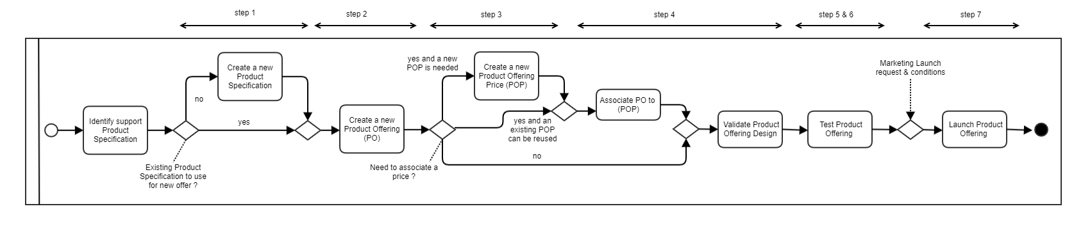

Information View

Lifecycles
As lifecycles are not provided in SID or in TMF620 Product Catalog Management API, we use following lifecycle state engine for illustration. This is informative and not normative information.

Product Specification Lifecycle
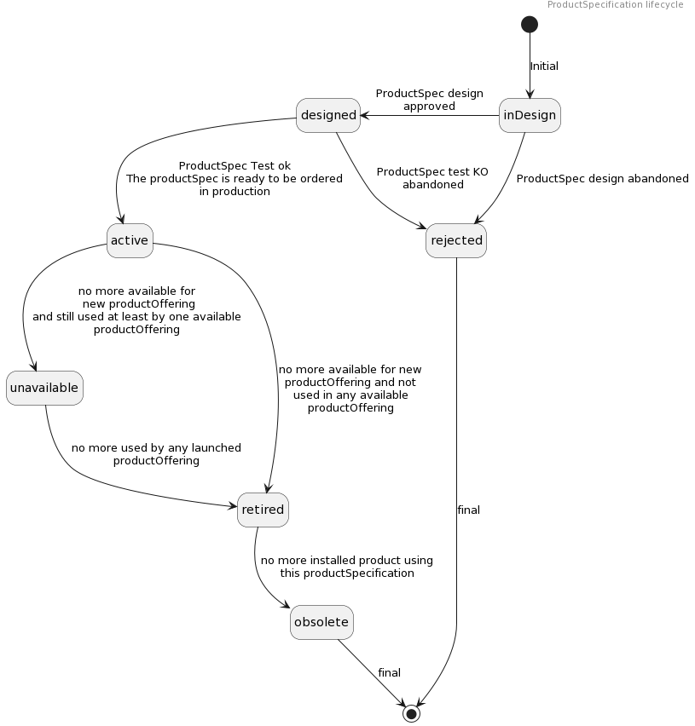

Product Offering Lifecycle
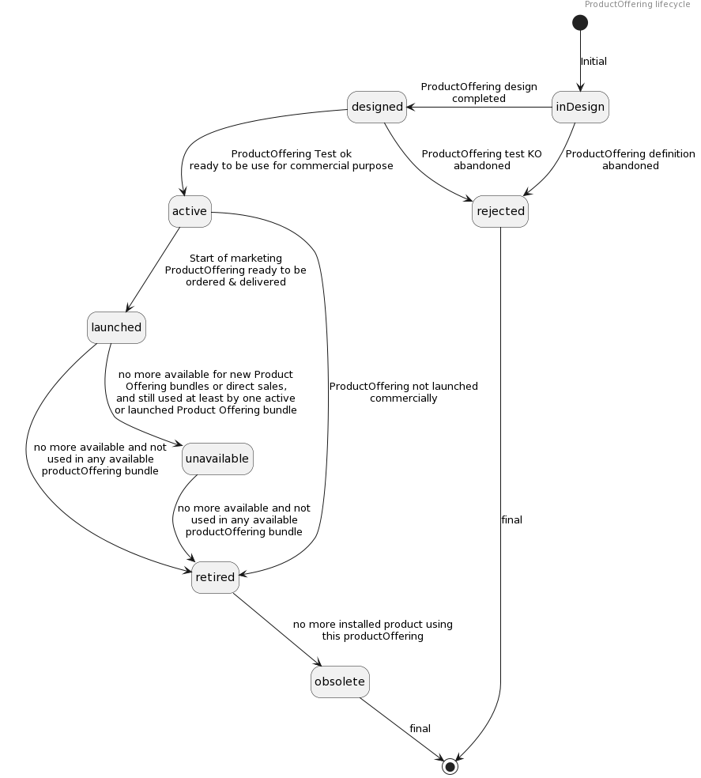

Product Offering Price Lifecycle
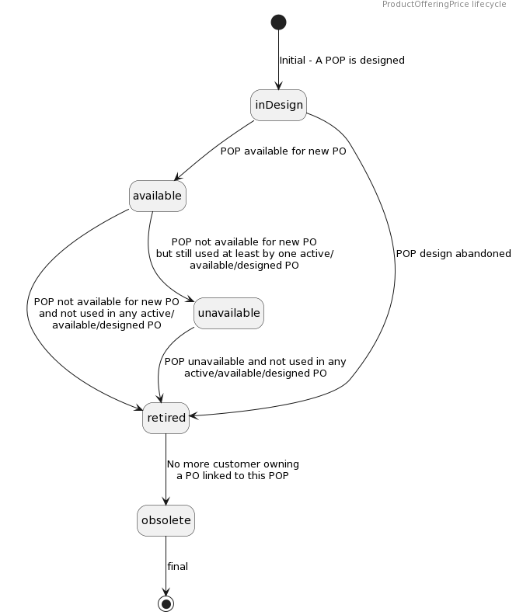

Sequence diagrams

Step 1: Create a Product Specification derived from a new CFS (Customer Facing Service) Specification
In this first diagram we illustrate:
- A new service description (CFS Specification) is available in the Service Catalog, and so ready to be used as support for new products specifications definition. Product Catalog application (and product catalog user as the techical expert in charge of product specification design) could receive notification about this CFS Specification availability via en event. This event could provide complete CFS Specification representation or only id. This is an illustration about service catalog → product catalog synchronization.
- A new product description (Product Specification) guided creation step by step automated by a process. At each step the process checks the data, in particular the consistency between the 'root' CFS Specification and the Product Specification.
  - ProductSpecification characteristicSpecification and relationship has to be checked from the CFS Specification
  - We added in our example management of usageSpecification & operationSpecification - please note that currently these specifications are not fully managed in the ProductSpecification resource model in TMF620.
- at the end, the Product Specification is directly created with the "Designed" state.
Note: The update of the catalog database could be discussed. Several options could exist:
- At each step the database is updated, first with a POST and then a PATCH
- Only when mandatory steps are completed the POST operation is completed and then PATCH (illustrated for ProductSpecification creation)
- Only when the creation is completed (or when Admin save for later) then the POST is performed. (illustrated for ProductOffering creation)
- ...
All these scenarios are valid from an API perspective, but the choice is dependent on the responsability of data. Additionnal event triggers is also a factor to pick option.
Note: We could illustrate other ways of synchronisation between the service catalog and the product catalog. As an example the receip of the event published by the service catalog could automatically trigger in the Product Catalog the creation of a new Product Specification with all the characteristics and values, operations and usages described at CFS specification level. Then restrictions could be introduced by an actor in charge of Product design.

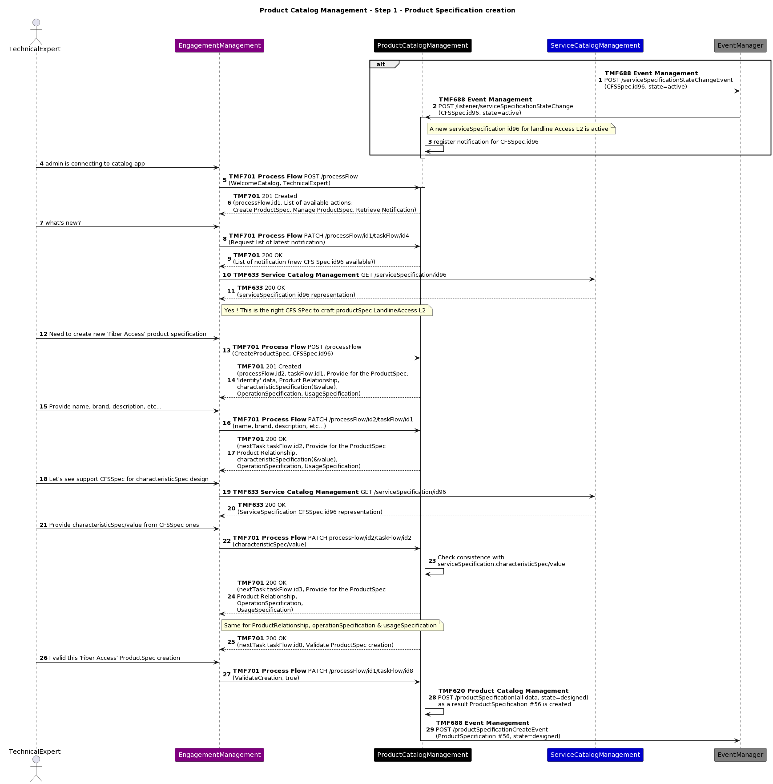

Step 2 : Create a new Product Offering to market the Product Specification
Now that the Product Specification is ready, the marketer is able to create a new Product Offering to market it.
As for the Product Specification creation, we illustrate a process-guided creation: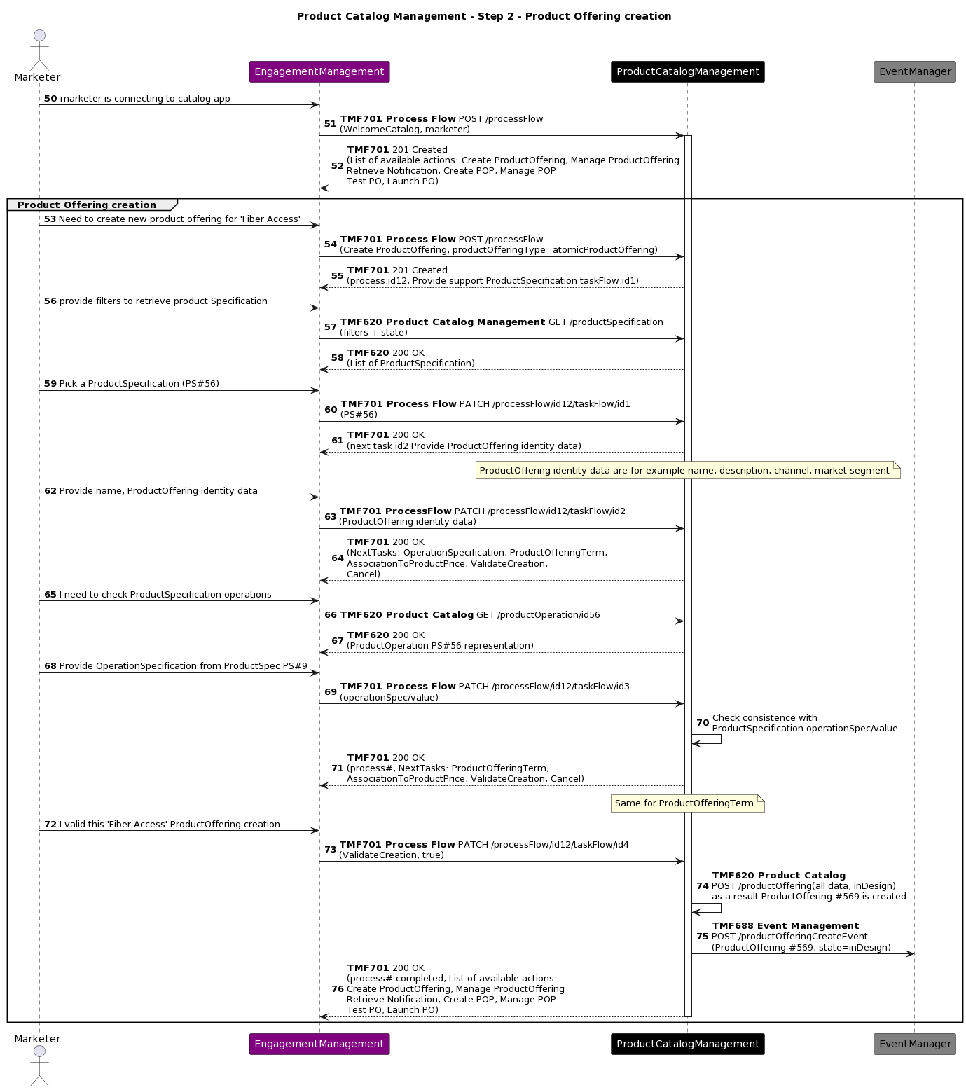

Step 3 : Create a Product Offering Price for recurrent charge
The creation of the Product Offering Price to define recurrent fees is the next step.

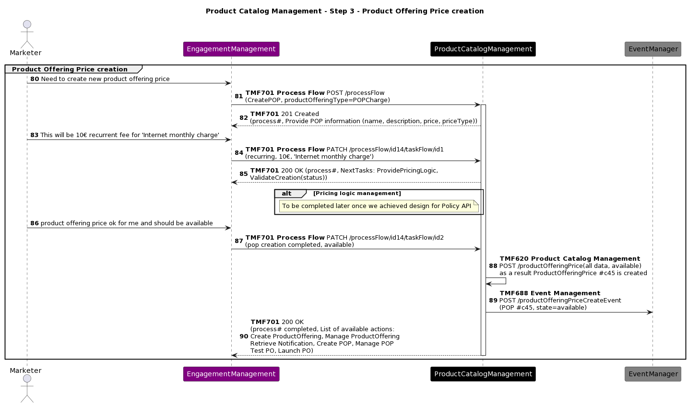

Step 4 : Link the Product Offering Price to the Product Offering
Once the Product Offering Price is created, the marketer can link it to the Product Offering.
As the Product Offering is still "inDesign" state, it is possible to directly update it without managing versioning.
After this operation, the description of the Product Offering is completed so the marketer validate its design, and its state becomes "Designed"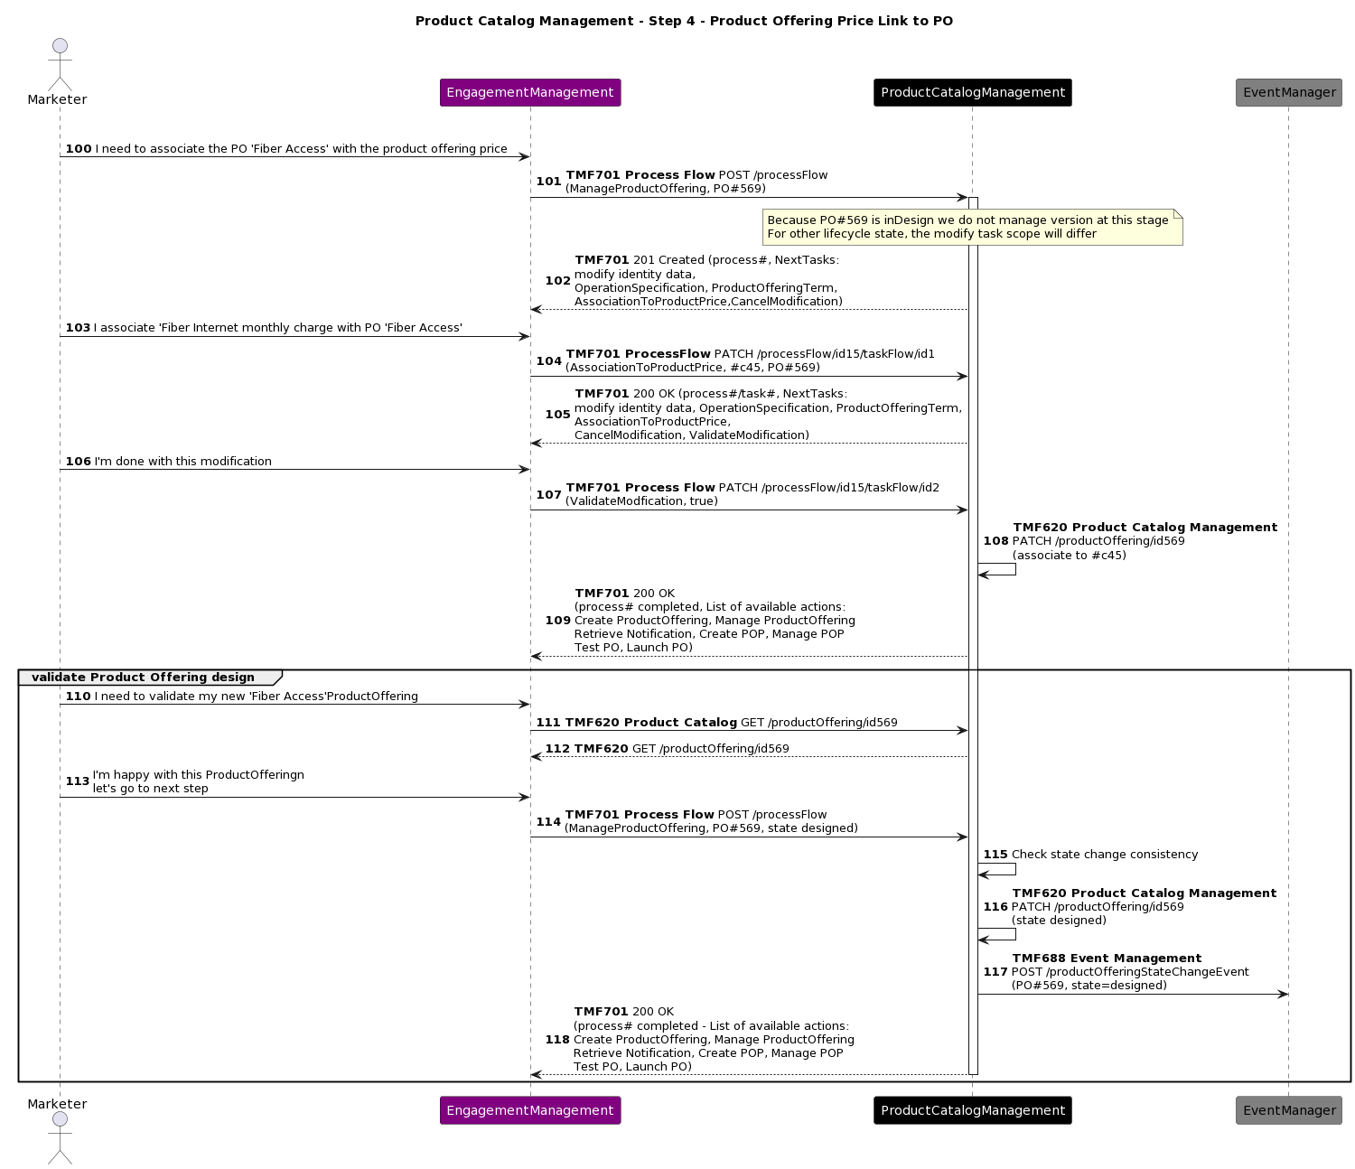

Step 5 : Product Offering testing
Now that the Product Offering definition is completed, it should be tested before to be launched.
Note: The use of 'designed' ProductOffering on order capture/management applications needs a specific attention. Indeed, from a standard perspective a 'designed' offering cannot be visible/orderable. This test could be performed on specific IT chain (as described here).
As assumption, we consider that all tests related to the provisionning, activation and usage have been done during the Service Specification design, and are not required to be done again.
To be addedd: Test recurrent charge inclusion in billing & bill invoice production → This part will be described for production in future TMSF005.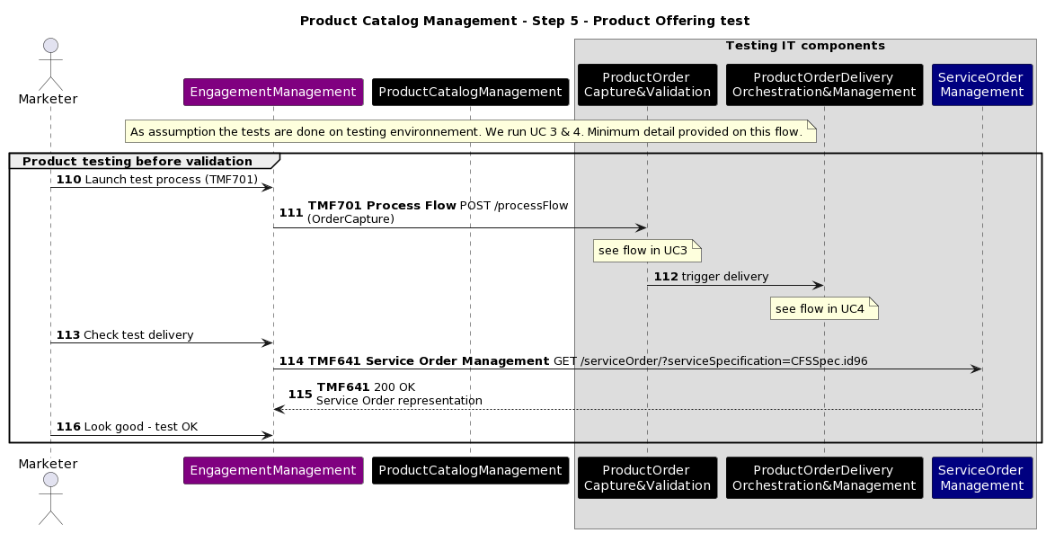

Step 6 : New Product Specification & Product Offering 'activation'
Once the test is successful, the Product Specification and the Product Offering can be shifted to state "active"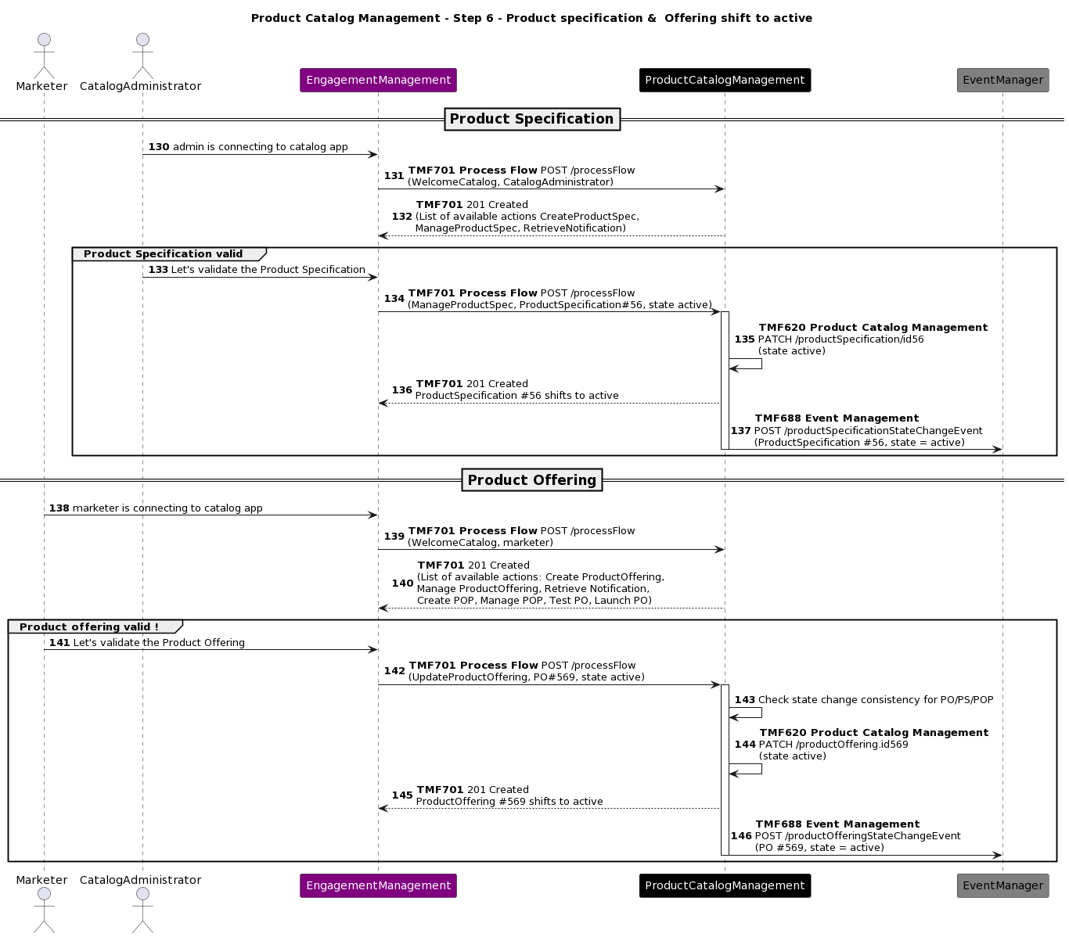

Step 7 : Marketing launch
Now that everything is ready & running, it is up to the marketing team to launch the Product Offering.
In this example, we have a soft launch of the Product Offering in a couple of shops in Lyon.
As a result the Product Offering state is updated to "Launched"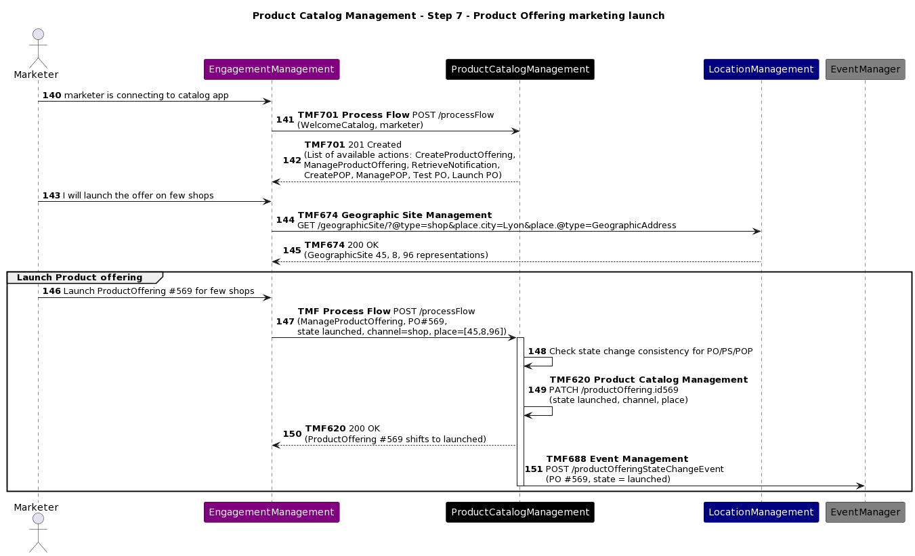

Conclusion

Lessons learned
This use case currently illustrates only a basic view of all that a Product Catalog Management component should cover.
At least it gives an idea about
- how Service Catalog Management and Product Catalog Management can interact
- how different actors in charge of different parts of the global process can also collaborate
- how the Product Catalog Management component can drive the GUI layer, according to the process needs

Further iterations will detail new sets of sequence diagram, and present views of catalog information produced.

Impacts identified
AP-2626 - Introduce allowedAction in Product Catalog resolved
AP-2519 - Manage operation for Catalog entities like productSpec, productOffering, etc... close
to be confirmed:
check if the TMF620 update at allowedAction or operation level is OK.
check if TMF620 published events include Product Specification State and Attribute Value Changes (not listed in TMFC001 ODA Component specification)
add a new Jira item to introduce Product Usage Specification in TMF620, as part of the definition of a Product Specification.
create a new Jira item to add lifecycles in TMF620, as proposed in §4.1
As many APIs will be modified with the V5 transformation, sequence diagrams will need to be checked when the APIs V5 is published.

Administrative Appendix

Document History

Version History
Version Number | Date Modified | Modified by: | Description of changes
2.0.1 | 18-Aug-2023 | Joseph Guei | Initial Release of Document
2.0.2 | 19-Oct-2023 | Joseph Guei | Minor changes on administrative information

Release History
Release Status | Date Modified | Modified by: | Description of changes
Pre-production | 18-Aug-2023 | Joseph Guei | First release using document in new format
Production | 06-Oct-2023 | Adrienne Walcott | Updated to reflect TM Forum Approved status
Pre-production | 19-Oct-2023 | Joseph Guei | Updated to version 2.0.2
Production | 08-Dec-2023 | Adrienne Walcott | Updated to reflect TM Forum Approved status

Acknowledgments
This document was prepared by the members of the TM Forum E2E team.
Acknowledgments
Team Member (@mention) | Company | Role*
Sylvie Demarest | Orange | Author
Ludovic Robert | Orange | Author
olivier arnaud | Orange | Additional Input
Abel Ruiz Huerta | SATEC | Reviewer
Manoj Nair | Netcracker | Reviewer
Elisabeth Andersson | MATRIXX | Reviewer
Jonathan Goldberg | AMDOCS | Reviewer
Dmytro Gassanov | Netcracker | Reviewer

