TM Forum Guidebook

Use Case: Multi Domain B2B2X Contract Management

TMFS020
Maturity Level: General availability (GA) | Team Approved Date:
Release Status: Production | Approval Status: TM Forum Approved
Version 1.1.0 | IPR Mode: RAND

Notice
Copyright © TM Forum 2026. All Rights Reserved.

This document and translations of it may be copied and furnished to others, and derivative works that comment on or otherwise explain it or assist in its implementation may be prepared, copied, published, and distributed, in whole or in part, without restriction of any kind, provided that the above copyright notice and this section are included on all such copies and derivative works. However, this document itself may not be modified in any way, including by removing the copyright notice or references to TM FORUM, except as needed for the purpose of developing any document or deliverable produced by a TM FORUM Collaboration Project Team (in which case the rules applicable to copyrights, as set forth in the TM FORUM IPR Policy, must be followed) or as required to translate it into languages other than English.

The limited permissions granted above are perpetual and will not be revoked by TM FORUM or its successors or assigns.

This document and the information contained herein is provided on an “AS IS” basis and TM FORUM DISCLAIMS ALL WARRANTIES, EXPRESS OR IMPLIED, INCLUDING BUT NOT LIMITED TO ANY WARRANTY THAT THE USE OF THE INFORMATION HEREIN WILL NOT INFRINGE ANY OWNERSHIP RIGHTS OR ANY IMPLIED WARRANTIES OF MERCHANTABILITY OR FITNESS FOR A PARTICULAR PURPOSE.

TM FORUM invites any TM FORUM Member or any other party that believes it has patent claims that would necessarily be infringed by implementations of this TM Forum Standards Final Deliverable, to notify the TM FORUM Team Administrator and provide an indication of its willingness to grant patent licenses to such patent claims in a manner consistent with the IPR Mode of the TM FORUM Collaboration Project Team that produced this deliverable.

The TM FORUM invites any party to contact the TM FORUM Team Administrator if it is aware of a claim of ownership of any patent claims that would necessarily be infringed by implementations of this TM FORUM Standards Final Deliverable by a patent holder that is not willing to provide a license to such patent claims in a manner consistent with the IPR Mode of the TM FORUM Collaboration Project Team that produced this TM FORUM Standards Final Deliverable. TM FORUM may include such claims on its website but disclaims any obligation to do so.

TM FORUM takes no position regarding the validity or scope of any intellectual property or other rights that might be claimed to pertain to the implementation or use of the technology described in this TM FORUM Standards Final Deliverable or the extent to which any license under such rights might or might not be available; neither does it represent that it has made any effort to identify any such rights. Information on TM FORUM's procedures with respect to rights in any document or deliverable produced by a TM FORUM Collaboration Project Team can be found on the TM FORUM website. Copies of claims of rights made available for publication and any assurances of licenses to be made available, or the result of an attempt made to obtain a general license or permission for the use of such proprietary rights by implementers or users of this TM FORUM Standards Final Deliverable, can be obtained from the TM FORUM Team Administrator. TM FORUM makes no representation that any information or list of intellectual property rights will at any time be complete, or that any claims in such list are, in fact, Essential Claims.

Direct inquiries to the TM Forum office:

100 Enterprise Drive
Suite 301 #1649
Rockaway, NJ 070866, USA
Tel No. +1 862 227 1648
TM Forum Web Page: www.tmforum.org

Table of Contents
Notice 2
Table of Contents 4
1. Introduction 5
1.1. Context or Background 6
1.2. Objective of the use case 7
1.3. Scope and assumptions 7
1.3.1. Scope 7
1.3.2. Assumptions 8
1.3.3. References 8
2. Description 10
3. Information View 12
3.1. 3. A Framework Agreement definition between the CSP and its Customer 12
3.2. 3.B Framework Agreement instanciation through Implementation Agreement between CSP and its Customer 13
4. Sequence diagrams 15
4.1. 4.A Step 1 Framework Agreement definition between the CSP and its Customer 15
4.2. 4.B Step 2 Framework Agreement instanciation through Implementation Agreement between CSP and its Customer 17
5. Conclusion 19
5.1. Lessons learned 19
5.2. Impacts identified 19
6. Appendix 20
7. Administrative Appendix 21
7.1. Document History 21
7.1.1. Version History 21
7.1.2. Release History 21
7.2. Acknowledgments 21

Introduction
The B2B2x's set of use cases aim is to propose a consistent approach to design, implement, operate and monetize offers based on / relying on / that consist in partners' assets. The following use cases (from TMFS019 to TMFS024) will illustrate, through several configurations (Partnerings, ProductOfferings) how TMF Frameworks support interaction and digitalization between all stakeholders.
Regarding partnering, several configurations can be proposed
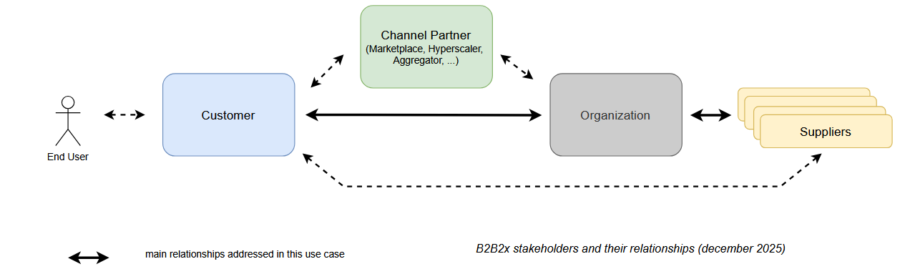

The Organization will provide an Offer (ProductOffering) which is based on its own and Suppliers's assets.
Even if the figure describes here the main relationships (↔), other relationships can exist and / or have to be managed.
B2B2x use cases will illustrate
- Partner On-boarding with Agreement Management (TMFS019)
An Organization will manage Framework Agreement with ad hoc Suppliers (SDWAN Vendors, Cloud Providers, SSE Editors, ...) to be able to provide a SASE solution to its customers
- Multi Party Contract Management for a large enterprise (TMFS020)
An Organization will manage Framework Agreement, Implementation Agreement(s) regarding Customer's Intent (incl. Framework Agreement Implementation with its Suppliers) through SASE Solution.
- Orchestration of a multi party, multi domain, multi tenant Product Offering sold as a solution (TMFS021)
- Cross domain event correlation, event to incident (TMFS022)
- Multi party Usage Management and Charging (TMFS023)
- Settlement with partner for Type 2 marketplaces (TMFS024)

Context or Background
To illustrate Multi Party Contract Management for a large enterprise, we propose to use the following configuration:
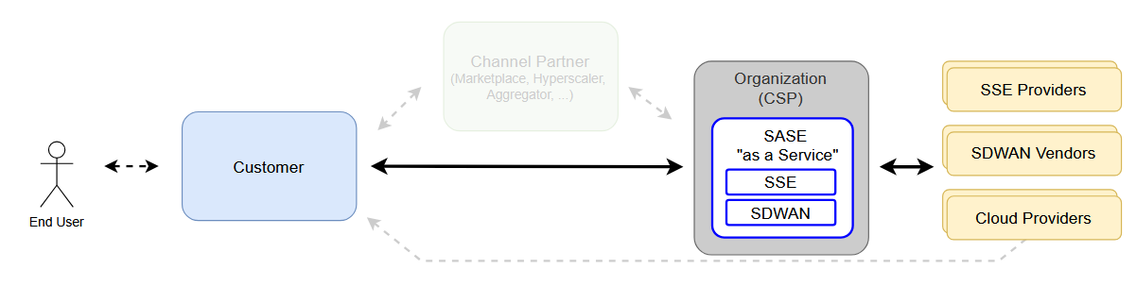
An Organization (a Communication Service Provider aka CSP) provides to its Customers a SASE Solution based on its own assets and some provided by dedicated Suppliers.
To provide such an offer, the CSP define / enrich
- SASE Solution in its catalog that refers to Products provided by Suppliers
- Framework Agreement Specification / Implementation Agreement Specification for its Customers
note: Implementation Agreement Specification can include specific Terms and Conditions linked to Framework Agreement signed with its Suppliers

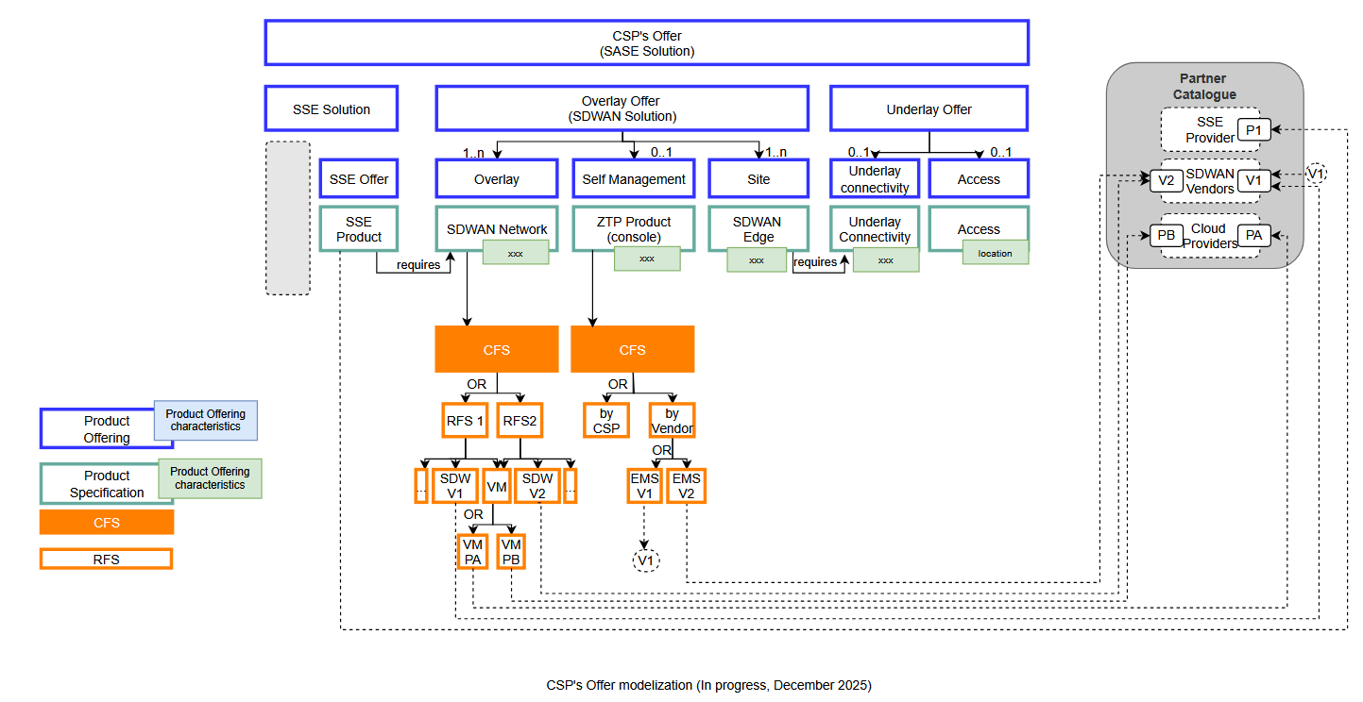 | 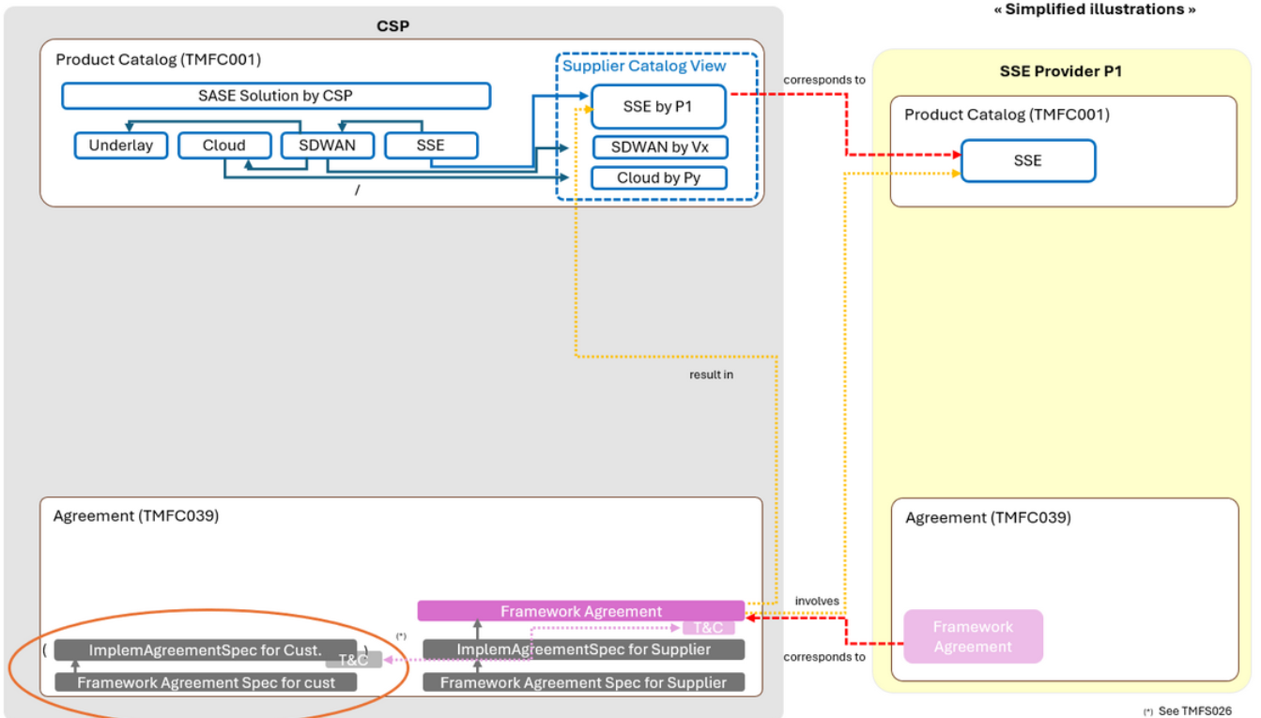
Catalog Modeling illustration | Framework Agreement illustration

Based on those elements, the Organization (aka the CSP) will be able to address Customer's business intent regarding SASE requirements.

Objective of the use case
The objective of the use case is to illustrate how TMF Frameworks support contractualization between an Organization (the CSP) and its Customer based on business intent and relying on Multi Party, Multi Domain assets and contracts.
As a CSP (the Organization), I want
- to manage Customer business Intent
- to be able to propose an ad hoc solution / bundle based on my assets and some provided by my Suppliers
- to manage contractualization with my Customer including Supplier's commitment
As a Customer, I want to find an ad hoc solution regarding my requirements (Secured Network for 300 Sites for next 5 years) and to be able to organise sites deployement regarding my agenda.

Scope and assumptions

Scope
This use case focuses on contractualization between an Organization (the CSP) and its Customer.
This contractualization is based on
- the definition of the scope of the deal, through a Framework Agreement between CSP and its Customer regarding SASE solution
ensuring Customer and CSP (the Organization) from one side and CSP (the Organization) and its Suppliers on the other side clearly agreed on the scope of the commitment
- the instanciation of this Framework Agreement through Implementation Agreement(s) between the CSP and its Customer (and the CSP and its Suppliers regarding CSP's Customer order))
Out of Scope:
Operations are done regarding CSP / Supplier Agreements, meaning if an evolution on Products / Services agreed between CSP and its Suppliers, they will have to update the agreement through TMFS019.
Some call flows have been simplified because described in other use cases

This is the first version of the use case, it will be enriched later (operational models, ...).

Assumptions
It is assumed that this is a happy path and there are no Order errors or fallout.
Pre-Requisites for this use Case:
- The Partner onboarding is completed and a Framework Agreement between the CSP and its Suppliers / Partners has been approved for the Partner Product Offerings (see TMFS019)
- The Customer Account (Party) of the large enterprise is already created and is active
Information View, Sequence diagram, ... will not describe steps linked to Customer management (at organization level nor individuals)

References
SID ABEs:
- Agreement (aligned with GB922 Pattern Domain version 25.1 document)
- ...
ODA components:
- TMFC033 Purchase Management
- TMFC039 Agreement Management
- TMFC050 Product Recommendation Management
- TMFC??? Party Request Management (to be confirmed, see TMFS031)
- TMFC036 Lead and Opportunity Management
- ...

Open APIs:
- TMF??? SupplierOrder (proposed in TMFS007)
- TMF679 ProductOfferingQualification (see proposition / asks described in TMFS018)
- ...
E2E ODA Project
- TMFS007, regarding Supplier Order / Purchase process
- TMFS018, regarding Product Offering Qualification / Product Qualification
- TMFS026, regarding Customer Order Management
- TMFS031, regarding Party Request Management and Intent

B2B2x documentation
This use case is based on elements described in
- TR302 ODA Ecosystem Challenges and Roadmap Proposal v2.0.1
- IG1282 ODA Design Challenges in Applying B2C Solutions to B2B/B2B2X Requirements v1.0.0
- IG1317 ODA DSE Platform Extensions & Patterns for B2B, B2B2X & Partner Ecosystems v1.0.0
https://www.tmforum.org/resources/introductory-guide/ig1317-oda-dse-platform-extensions-patterns-for-b2b-b2b2x-partner-ecosystems-v3-0-0/
- Software marketplaces – a new go to market opportunity for communications service providers v1.2.0 (IG1262)
- TR303A Federated Identity and Authentication Management for Multi-Domain Zero Trust Architecture v4.0.0
- Software Marketplaces Reference Architecture v3.0.0
- GB1034 APPENDIX A - Business Functions
- GB1027C Zero-Touch Partnering Use-Cases v6.0.0
- IG1279 Zero-Touch Partnering Vision & Strategy v3.1.0

Description
A Customer express a Business Intent to the CSP regarding SASE Solution (new Lead).
Step A
Regarding Customer Intent, the CSP will propose a "high level" ProductOffering (via an Opportunity) and the Customer and the CSP will establish a Framework Agreement that will describe the general rules, prices, ... under which the CSP and the Customer will work together. A Framework Agreement can include a set of Framework Agreement Items that may concern, as examples:
- Negotiated Prices of ProductOfferingSpecification (here SASE) according to volumes, examples for SASE:
  - Number of sites: 300 Sites (200 small / 75 medium / 20 large / 5 specific)
  - Commited support for 200 hours a month
  - Support level: Gold for 100 / Silver for 200
  - Restriction on ProductSpecification Characteristics possible values through ProductConfigSpec,
- Restriction on AllowedProductAction,
- Ethic clauses,
- Security clauses,
- Privacy clauses,
- Non disclosure clauses,
- Payment clauses,
- Liquidated damages,
- Responsibility,
- Target geographical areas…

Step B
In accordance with this Framework Agreement, the Customer will order, as many as necessary, SASE Solutions to the CSP leading to Implementation Agreement(s).
For example, an order (via a new Opportunity) could be
- Solution: SASE
- Number of sites: 10 sites (9 Small / 1 Medium)
- Commited support for 20 hours a month
- Support level: Gold (1) / Silver (9)
- ...

At this stage,
- a ProductOffering proposition will be provided by the CSP to its Customer (via a dedicated Opportunity)
In this illustration, the ProductOffering proposition includes Supplier's commitment and 1st quotation.
note: several quotations can be done
- Customer will accept one of the quotes, this acceptance will trigger
  - the production of an Implementation Agreement (according to Implementation Agreement Specification) between the CSP and its Customer,
  - the generation of a Customer Product Order,
  - the generation of ad hoc assets in the ProductInventory,
  - the production of an Implementation Agreement between the CSP and its Suppliers,
  - the generation of Business Partner Product Orders (orders from the CSP to its Suppliers).
Please note that, depending on the CSP's policies, the Customer ProductOrder may be generated before or after the Implementation Agreement approval (signature) by the CSP and the Customer.

Information View

3. A Framework Agreement definition between the CSP and its Customer
This figure illustrates CSP's IT System the definition of the Framework Agreement signed with its Customer (referring to its FrameworkAgreementSpec for Cust / ImplementationAgreementSpec for Cust and its Catalog / FrameworkAgreement with its Supplier).
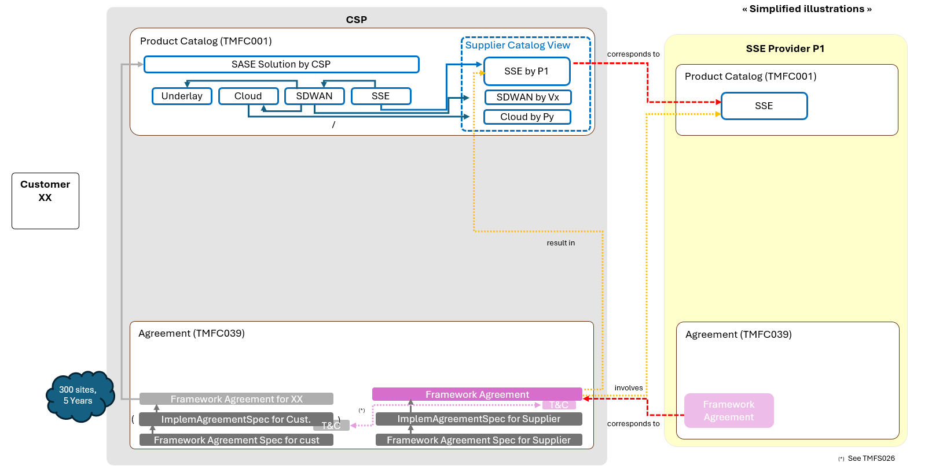

Please see a more detailed illustration (restricted view to CSP's IT System) in SID documentation (abstract from in progress SID 25.5, available in PROLABORATE Tools)
note: this representation includes SalesLead and Sales Opportunity not described above
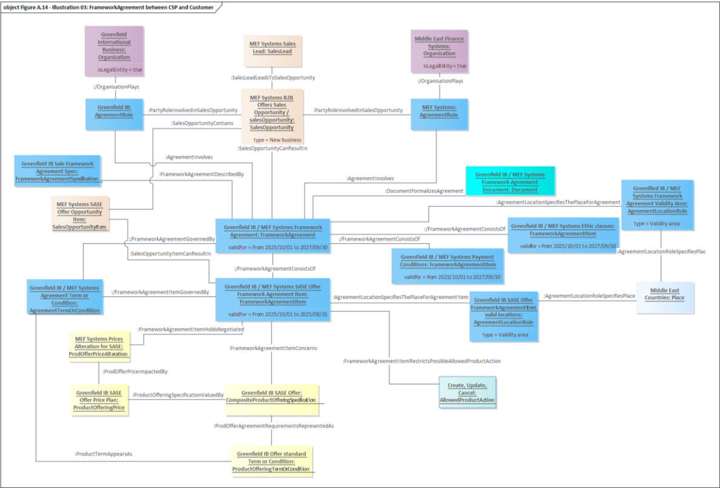 | 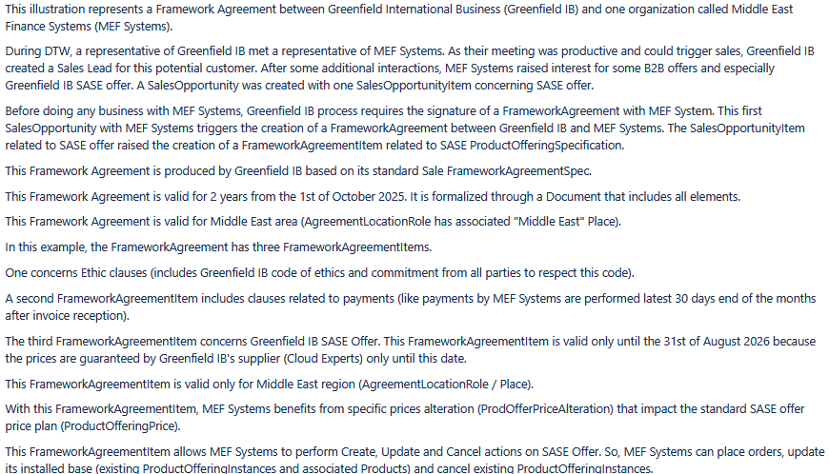

3.B Framework Agreement instanciation through Implementation Agreement between CSP and its Customer

This figure illustrates Framework Agreement instanciation trough
  - the production of an Implementation Agreement (according to Implementation Agreement Specification) between the CSP and its Customer
  - the generation of a Customer Product Order
  - the generation of ad hoc assets in the ProductInventory
  - the production of an Implementation Agreement between the CSP and its Suppliers
  - the generation of Business Partner Product Orders (orders from the CSP to its Suppliers)
Please note that, depending on the CSP's policies, the Customer Product Order may be generated before or after the Implementation Agreement approval (signature) by the CSP and the Customer.

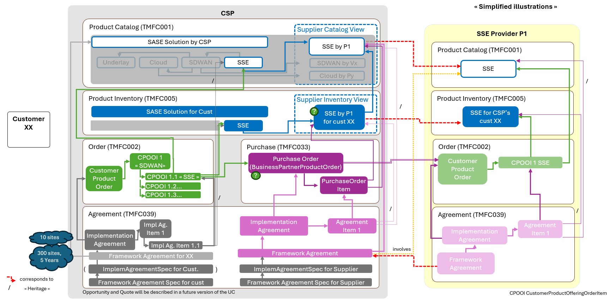

In real life, a lot of situations can be encountered:
- quote can be done with / without qualification with Suppliers,
- Implementation Agreement instanciation can be realised during Order Delivery, after Order Delivery...
- ..
Please see a more detailed illustration (restricted view to CSP's IT System) in SID documentation (asbtract from in progress SID 25.5, available in PROLABORATE Tools)

implementationAgreement between CSP and Customer
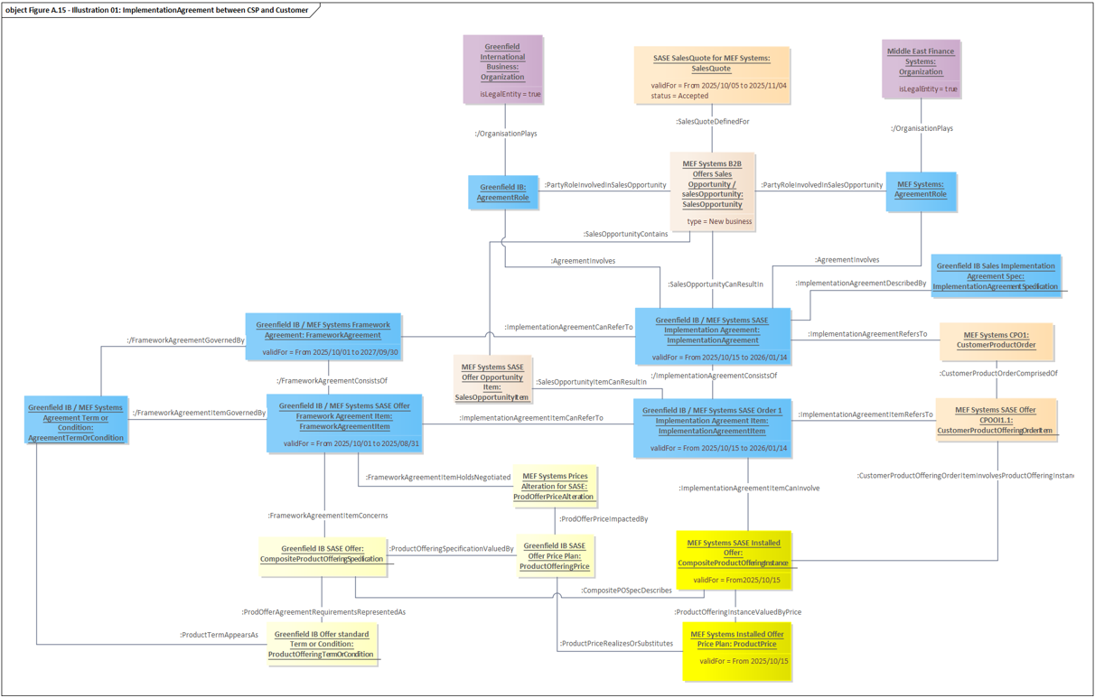 | 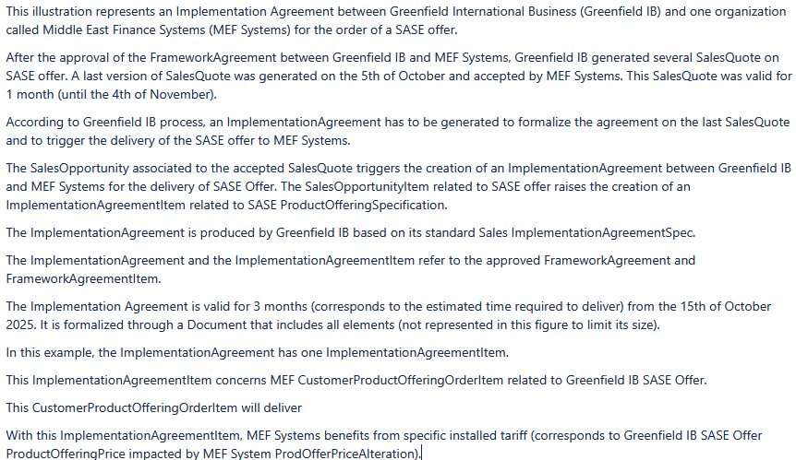
implementationAgreement between CSP and Supplier
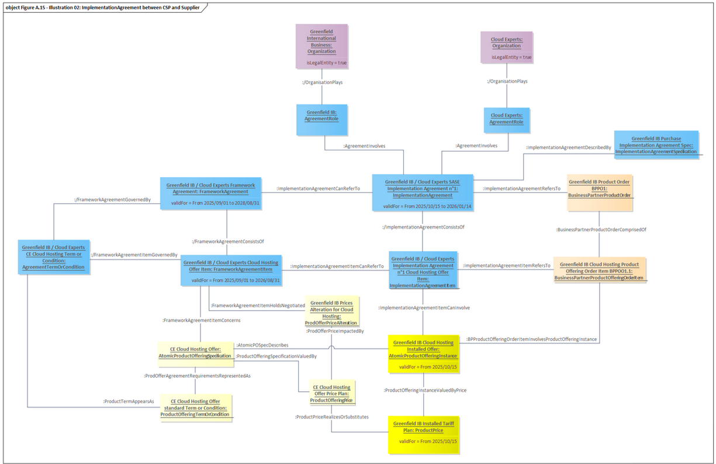 | 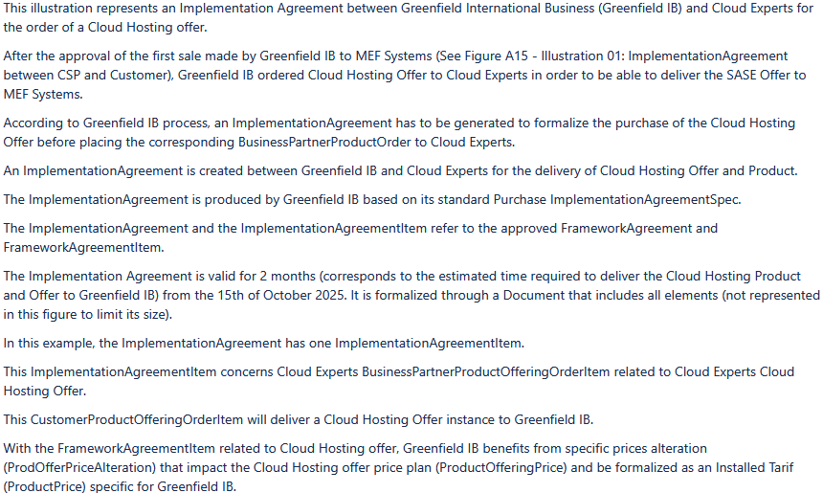

Sequence diagrams

Regarding Customer needs, Customer and CSP will agree on assets that will contribute to SASE Solution, and potentially other solutions, for Customer's context and validate Framework Agreement.

4.A Step 1 Framework Agreement definition between the CSP and its Customer

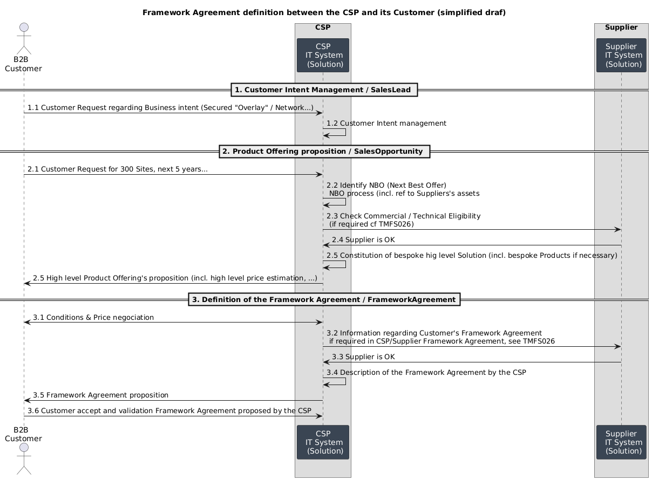

Main ODA Components involved in this process
- At CSP level
  - TMFC001 Product Catalog (incl. Supplier Catalog involved in Framework Agreement
  - TMFC002 Product Order Capture & Validation
  - TMFC039 Agreement Management
  - TMFC050 (Product) Recommendation Management
  - TMFC??? ProductOffering Qualification / TMFC??? Resource Qualification (tbc)
  - TMFC023 Party Interaction Mgt / TMFC??? Party Request Management (to be analysed with TMFS031)
  - TMFC036 Lead and Opportunity Management
- At Supplier level
  - TMFC002 Product Order Capture & Validation

"Opening the box"
note: some elements here are proposition of "in progress" topics linked to enrichment proposed by other UC (TMFS018, ...)
Customer Intent Management / SalesLead
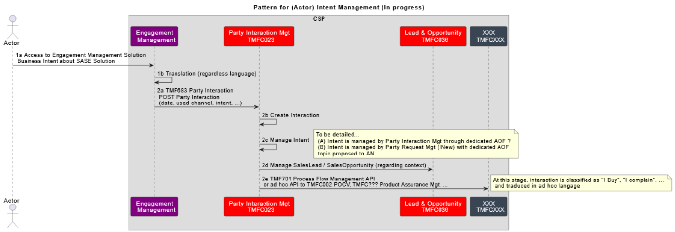 | 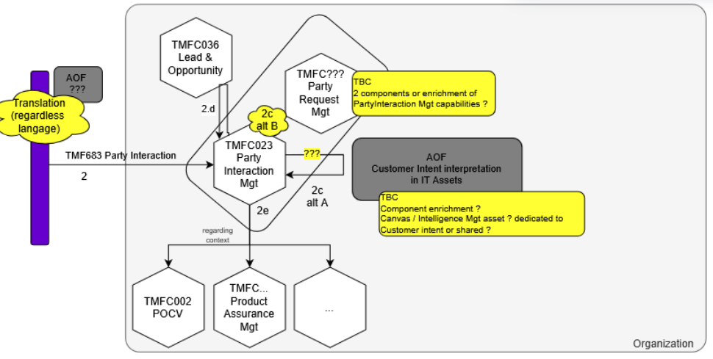
Product Offering proposition / SalesOpportunity
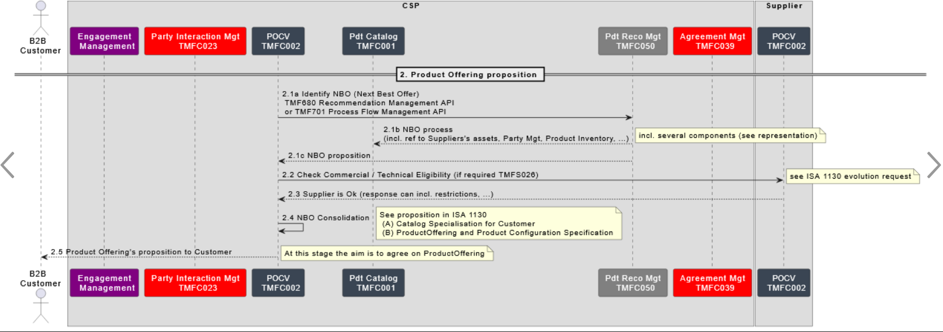 | 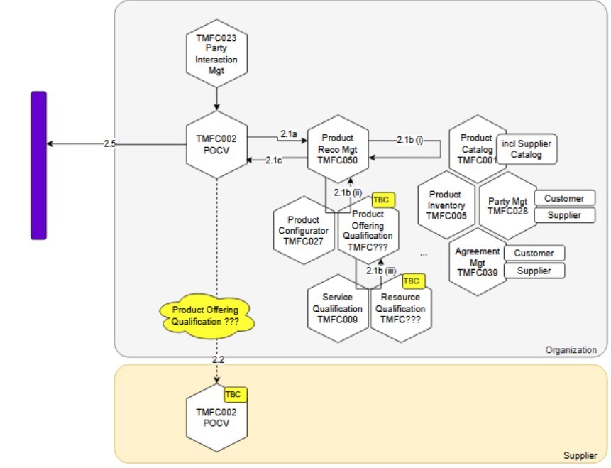
Definition of Framework Agreement / FrameworkAgreement
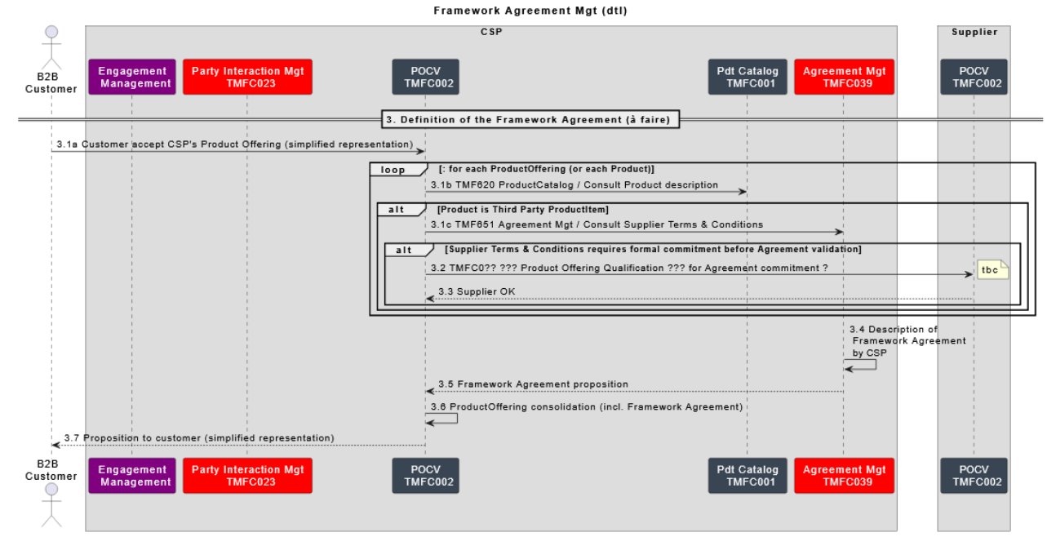 | 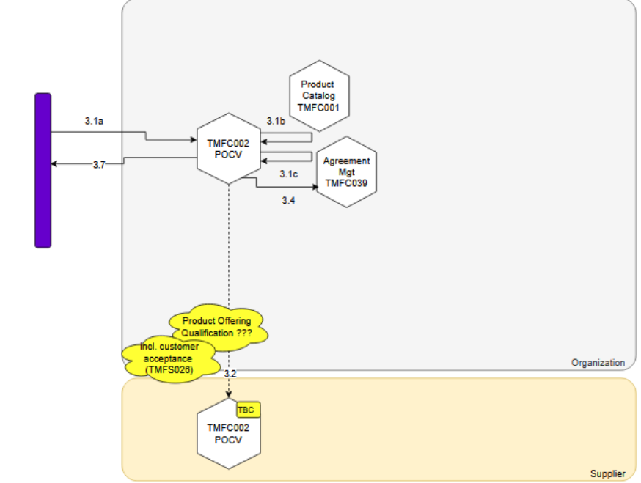

4.B Step 2 Framework Agreement instanciation through Implementation Agreement between CSP and its Customer
(kept for comment consideration, to be removed) 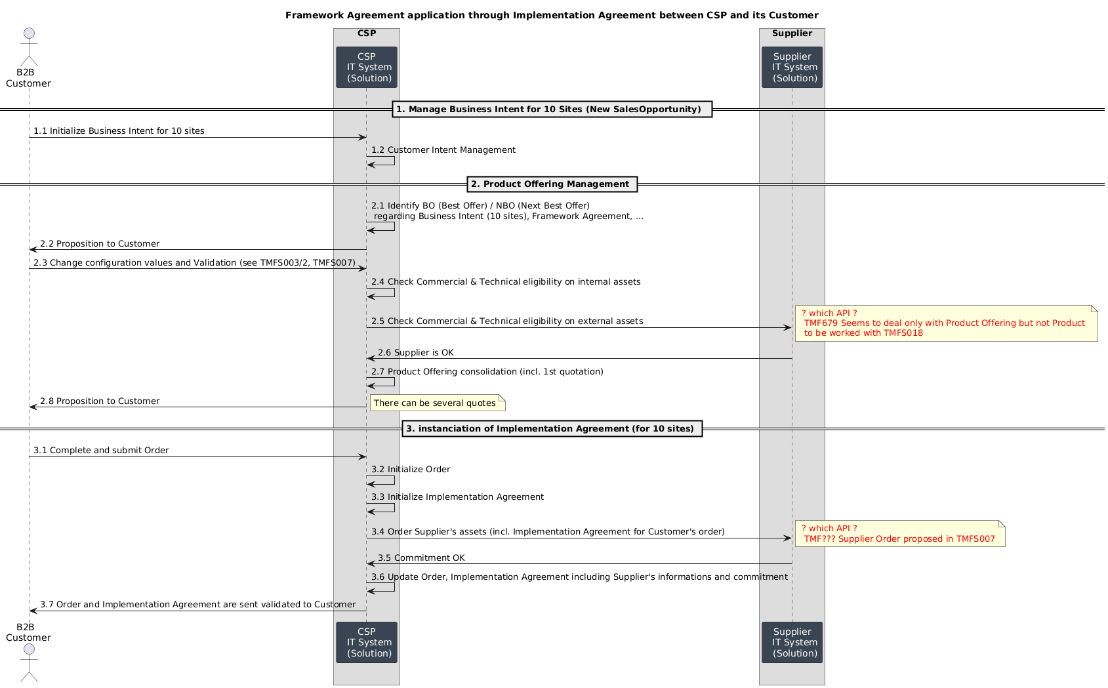
Main ODA Components involved in this process
- At CSP level
  - TMFC001 Product Catalog (incl. Supplier Catalog involved in Framework Agreement
  - TMFC002 Product Order Capture & Validation and / or TMFC??? Party Request Management (to be analysed with TMFS031)
  - TMFC033 Purchase Management
At this level, ODA Component TMFC033 Purchase Management will be in charge of order that will be done by the CSP to its Suppliers regarding its Customer's order.
  - TMFC039 Agreement Management
  - TMFC050 (Product) Recommendation Management
  - TMFC??? ProductOffering Qualification / TMFC??? Resource Qualification (tbc)
  - TMFC023 Party Interaction Mgt / TMFC??? Party Request Management (to be analysed with TMFS031)
  - TMFC036 Lead and Opportunity Management
- At Supplier level
  - TMFC002 Product Order Capture & Validation

"Opening the box"
note: some elements here are proposition of "in progress" topics linked to enrichment proposed by other UC (TMFS018, ...)

Customer Intent Management (10 Sites) / Sales Opportunity
→ see description done for step 1 Framework Agreement definition between the CSP and its Customer
Product Offering proposition
→ not detailed here, see requirements addressed for TMFS018
see description done for step 1 Framework Agreement definition between the CSP and its Customer
regarding step 2.4, how does Commercial and Technical eligibility are done internally at PO/P/S/R level (API, Components) ? (cf TMFS018)
regarding step 2.5, how does Commercial and Technical eligibility are done externally at PO/P level (API) ? (cf TMFS018)
instanciation of Implementation Agreement
focus on purchase order from CSP to its Supplier
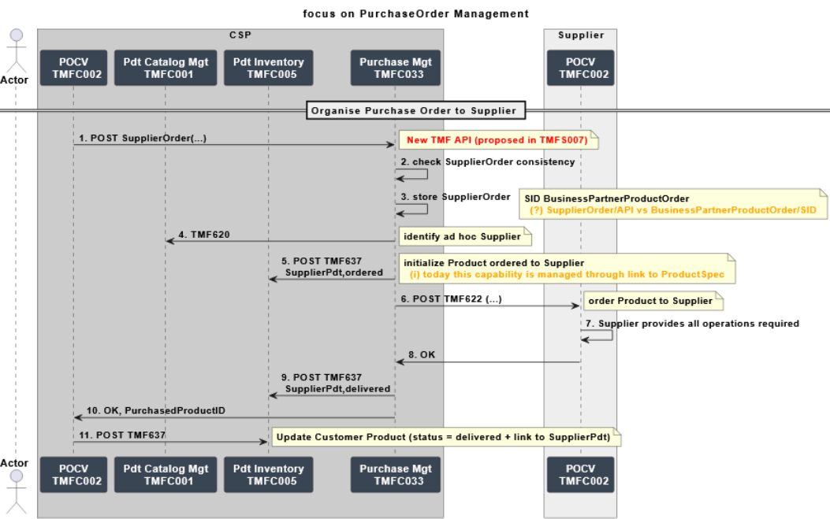 | 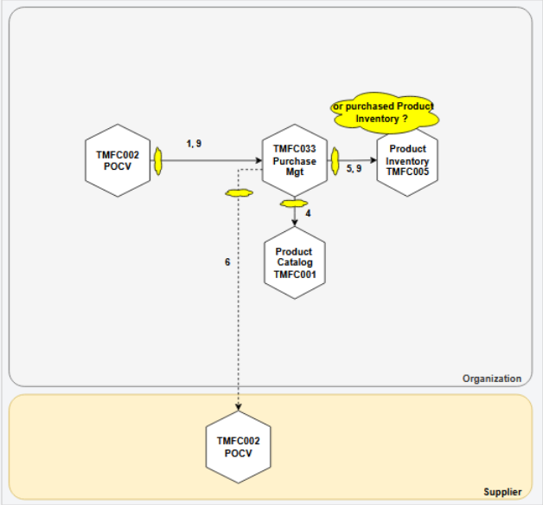

Conclusion

Lessons learned
Even if the use case still needs to be detailed, this version illustrates
- Framework Agreement management between a CSP and its Customer (incl. reference / consistency with Framework Agreements defined between the CSP and its Suppliers)
- Framework Agreement instanciation through Implementation Agreement defintion between a CSP and its Customer (incl. Implementation Agreement between the CSP and its Suppliers regarding CSP's Customer Agreement)
keeping in mind that this is just an illustration, several configuration can occur.

Impacts identified
Some propositions / topics are proposed about
- how Lead / Opportunity / Order can be managed for the different steps
- Intent management, proposition to address with ad hoc teams (cf Autonomous Network UC for ODA / AN convergence, TMFS031 vs TMFC??? Party Request Management)
- ProductOffering / Product / Service / Resource Qualification (internally and with Supplier), proposition to address with ad hoc teams (cf TMFS018)
- ProductOffering / Product Configuration, proposition to address with ad hoc teams
- Purchase Management (sequence flow / interaction diagram) => impact on SID, API, ODA Component Framework
- BO (Best Offer) / NBO (Next Best Offer) Recommandation process, proposition to address with ad hoc teams (cf Autonomous Network UC for ODA / AN convergence)

as 1st proposition to work on

Appendix

Administrative Appendix

Document History

Version History
Version Number¹ | Date Modified | Modified by: | Description of changes
1.0.0 | 04 Dec 2024 | Sri-Jagadish (Jag) Baddukonda | Initial contribution
1.0.0 | 30 Dec 2024 | Rosie Wilson | Final administrative updates
1.1.0 | 22 Jan 2026 | Alan Pope | Final edits prior to publication

Release History
Release Status | Date Modified | Modified by: | Description of changes
Pre-production | 30-Dec-2024 | Rosie Wilson | Release of v1.0.0
Production | 07-Mar-2025 | Adrienne Walcott | Updated to reflect TM Forum Approved status
Pre-production | 22-Jan-2026 | Alan Pope | Updated to v1.1.0
Production | 20-Mar-2026 | Adrienne Walcott | Updated to reflect TM Forum Approved status

Acknowledgments
This document was prepared by the members of the TM Forum End-to-End ODA team.
Team Member (@mention) | Company | Role*
Alix Marès | Orange | Author
Andrew Thomson | Beyond Now | Key Contributor
David Milham | TMForum | Key Contributor
Unknown User | DT | Author
Kamal Maghsoudlou | Ericsson | Key Contributor
Joao Silva | Vodafone | Key Contributor
Abinash Vishwakarma | Netcracker | Reviewer
Surajj Jaggernath | Vodafone | Reviewer
David Richards | CGI | Reviewer
Sai Kishore Tahilianey | IBM | Reviewer
Anh Le | Netcracker | Reviewer
*Select from: Project Chair, Project Co-Chair, Author, Editor, Key Contributor, Additional Input, Reviewer

