TM Forum Guidebook

Use Case: Cloud Native Function Management

TMFS025

Maturity Level: General Availability (GA) | Team Approved Date: 13-Mar-2025
Release Status: Pre-production | Approval Status: TM Forum Approved
Version 1.1.0 | IPR Mode: RAND

Notice
Copyright © TM Forum 2025. All Rights Reserved.

This document and translations of it may be copied and furnished to others, and derivative works that comment on or otherwise explain it or assist in its implementation may be prepared, copied, published, and distributed, in whole or in part, without restriction of any kind, provided that the above copyright notice and this section are included on all such copies and derivative works. However, this document itself may not be modified in any way, including by removing the copyright notice or references to TM FORUM, except as needed for the purpose of developing any document or deliverable produced by a TM FORUM Collaboration Project Team (in which case the rules applicable to copyrights, as set forth in the TM FORUM IPR Policy, must be followed) or as required to translate it into languages other than English.

The limited permissions granted above are perpetual and will not be revoked by TM FORUM or its successors or assigns.

This document and the information contained herein is provided on an “AS IS” basis and TM FORUM DISCLAIMS ALL WARRANTIES, EXPRESS OR IMPLIED, INCLUDING BUT NOT LIMITED TO ANY WARRANTY THAT THE USE OF THE INFORMATION HEREIN WILL NOT INFRINGE ANY OWNERSHIP RIGHTS OR ANY IMPLIED WARRANTIES OF MERCHANTABILITY OR FITNESS FOR A PARTICULAR PURPOSE.

TM FORUM invites any TM FORUM Member or any other party that believes it has patent claims that would necessarily be infringed by implementations of this TM Forum Standards Final Deliverable, to notify the TM FORUM Team Administrator and provide an indication of its willingness to grant patent licenses to such patent claims in a manner consistent with the IPR Mode of the TM FORUM Collaboration Project Team that produced this deliverable.
The TM FORUM invites any party to contact the TM FORUM Team Administrator if it is aware of a claim of ownership of any patent claims that would necessarily be infringed by implementations of this TM FORUM Standards Final Deliverable by a patent holder that is not willing to provide a license to such patent claims in a manner consistent with the IPR Mode of the TM FORUM Collaboration Project Team that produced this TM FORUM Standards Final Deliverable. TM FORUM may include such claims on its website but disclaims any obligation to do so.
TM FORUM takes no position regarding the validity or scope of any intellectual property or other rights that might be claimed to pertain to the implementation or use of the technology described in this TM FORUM Standards Final Deliverable or the extent to which any license under such rights might or might not be available; neither does it represent that it has made any effort to identify any such rights. Information on TM FORUM's procedures with respect to rights in any document or deliverable produced by a TM FORUM Collaboration Project Team can be found on the TM FORUM website. Copies of claims of rights made available for publication and any assurances of licenses to be made available, or the result of an attempt made to obtain a general license or permission for the use of such proprietary rights by implementers or users of this TM FORUM Standards Final Deliverable, can be obtained from the TM FORUM Team Administrator. TM FORUM makes no representation that any information or list of intellectual property rights will at any time be complete, or that any claims in such list are, in fact, Essential Claims.

Direct inquiries to the TM Forum office:

181 New Road, Suite 304
Parsippany, NJ 07054, USA
Tel No. +1 862 227 1648
TM Forum Web Page: www.tmforum.org

Table of Contents
Notice 2
Table of Contents 4
1. Introduction 6
1.1. Context or Background 6
1.2. Objective of the use case 6
1.3. Scope and assumptions 6
1.3.1. Scope 6
1.3.2. Assumptions 6
1.3.3. References 7
2. Description 8
3. Information View 9
3.1. CompoundResource Specification ABE 9
3.1.1. SoftBlackBoxSpecification 9
3.2. Software Resource and Software Specifications ABE 9
3.2.1. SoftwareSpecification 9
3.2.2. ResourceFunctionSpec 9
3.2.3. ConnectionPointSpec 9
3.2.4. SoftConnectionPointSpec 9
3.2.5. APISpecification 9
3.2.6. SoftwareSupportPackageSpec 10
3.2.7. HostingPlatformRequirementSpec 10
3.3. Specifications for CNF Use Case 10
3.3.1. Cloud Native Function 11
3.3.2. Vendor Application 11
3.3.3. Vendor Hosting Platform Requirement 11
3.3.4. Vendor Software Package 11
3.3.5. Vendor Composite Function 11
3.3.6. Vendor Function 11
3.3.7. ODA Component Function 11
3.3.8. Core Function 11
3.3.9. Security Function 11
3.3.10. Management and Operations Function 11
3.3.11. Notification and Reporting Function 12
3.3.12. TMFxxx / other 12
3.4. Resource Order for CNF Use Case 12
3.5. Managed Entities for CNF Use Case 13
4. Sequence diagrams 14
4.1. Step 1 14
4.2. Step 2-3 14
4.3. Step 4-5 14
4.4. Step 6-7 14
4.5. Step 8-9 14
4.6. Step 10-12 14
4.7. Step 13-14 14
4.8. Step 15-16 15
4.9. Step 17 15
4.10. Step 18 15
4.11. Step 19-20 15
4.12. Step 21-22 15
4.13. Step 23-24 15
4.14. Step 25-26 15
4.15. Step 27-28 15
4.16. Step 29-30 16
4.17. Step 31 16
5. Conclusion 17
5.1. Lessons learned 17
5.2. Impacts identified 17
6. Appendix 18
6.1. ODA Component Specification 18
7. Administrative Appendix 27
7.1. Document History 27
7.1.1. Version History 27
7.1.2. Release History 27
7.2. Acknowledgments 27

Introduction
This use case describes managing Cloud Native Functions (CNF) in ODA.

Context or Background
Composable IT & ecosystems are key enablers for telco transformation. TM Forum’s Open Digital Architecture (ODA) is a blueprint for the transformation of telecoms IT and networks, helping telco businesses become agile by enabling composable systems and processes, component parts built by the telco and ecosystem partners, connected with Open APIs. It allows telcos to add and remove components and capabilities as technology evolves without escalating costs.
This document is a product of the ODA Production Modelling team of the Technical Architecture workstream within the Components and Canvas project.
The ODA Production block encompasses Service and Resource domain concerns. Cloud native applications are modeled with the Computing and Software ABE of the Information Framework (SID) and managed with Resource domain Open APIs as described in TMF730. Cloud Native Functions (CNF) may be provisioned by ODA Component TMFC062 Resource Configuration and Activation.

Objective of the use case
As an architect, I need a management continuum across the IT estate so that application lifecycle management is done consistently and harmonized with ODA.
This use case is of interest to strategic planners, designers and operators of the IT estate. It demonstrates how software applications, network and management functions, compute and network resources may be managed with ODA across a multivendor landscape.
Extending the Open Digital Framework (ODF) to cloud native software and networks amortizes investment in ODA. Onboarding and ongoing management of network and management functions, including ODA Components themselves, will enable holistic solutions.

Scope and assumptions

Scope
The initial use case considers the deployment of a cloud native software application onto an infrastructure platform. In this initial version of the document we will consider only Day 1 provisioning.

Assumptions
The target software application realizes a Cloud Native Function (CNF), which for this use case example is assumed to be an ODA Component. This choice allows us to decompose the software application to provide the Core and Supporting functions specified in the ODA Component definition (IG1171).
The target infrastructure platform is assumed to be Kubernetes.

References
The following documents are referenced within this document:
- TMFC062 Resource Configuration and Activation
- TMF730 Software and Compute Management API
- TMF664 Resource Function Activation Management API
- TMF634 Resource Catalog Management API
- TMF639 Resource Inventory Management API

Description
The use case flow begins after a resource order for an ODA Component and ends with a newly created instance on an ODA Canvas.
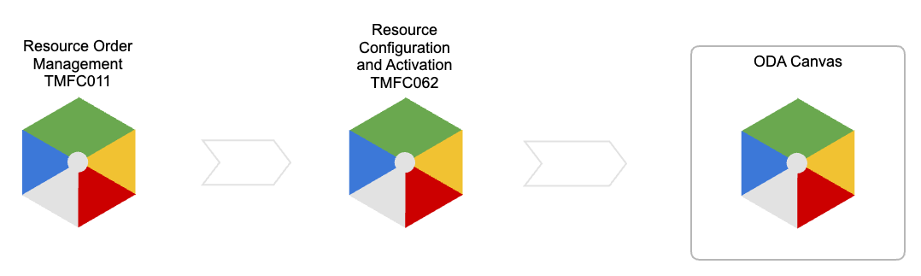

Information View
Software applications may be modeled as Resource domain entities using the TM Forum Information Framework (SID).

CompoundResource Specification ABE
Within the Resource Specification ABE we have the CompoundResource Specification ABE.

SoftBlackBoxSpecification
A Cloud Native Function (CNF) performs a role (e.g. 5GC AMF, ODA TMFC001) in a logical architecture which is independent of its implementation. A SoftBlackBoxSpecification may be used to model a network function with embedded software.

Software Resource and Software Specifications ABE
Within the Logical Resource Specification ABE we find the Software Resource and Software Specifications ABE.

SoftwareSpecification
A software application may be run on a hosting platform. A SoftwareSpecification describes the software including release version, license and requirements on the hosting platform such as operating system, memory and disk space.

ResourceFunctionSpec
Software exists to perform functions, which accept inputs and produce outputs. A ResourceFunctionSpec describes a function provided by the software and its input and output connection points. It may also describe the internal topology of a compound ResourceFunctionSpec.

ConnectionPointSpec
A software function has inputs and outputs. A ConnectionPointSpec describes the information/data which is input/output independently of how it is realized (i.e. a Stage 2 specification).

SoftConnectionPointSpec
A Cloud Native Function (CNF) uses application programming interfaces (API) for it's input/output. A SoftConnectionPointSpec is a realisation of ConnectionPointSpec as an API.

APISpecification
A CNF gets it's input/output through APIs. An APISpecification describes the attribute values shared by all API instances related to it (i.e. Stage 3 specification).

SoftwareSupportPackageSpec
A software application is delivered in one or more files, downloaded or stored on physical media. A SoftwareSupportPackageSpec is a locally managed subclass of PhysicalResourceSpec which defines Characteristics to describe the methods and locations used to retrieve a SoftwareSupportPackage.

HostingPlatformRequirementSpec
A software application, made available by a SoftwareSupportPackage, will have been created with a set of expectations about the runtime environment. An executable compiled for an Intel instruction set won't run on an ARM CPU, a Helm chart requires Kubernetes, a CNF may require hardware acceleration, etc. A HostingPlatformRequirementSpec is used to describe the attributes of a hosting platform required by the software.

Specifications for CNF Use Case
The diagram below provides a Resource Catalog view of our use case example CNF.
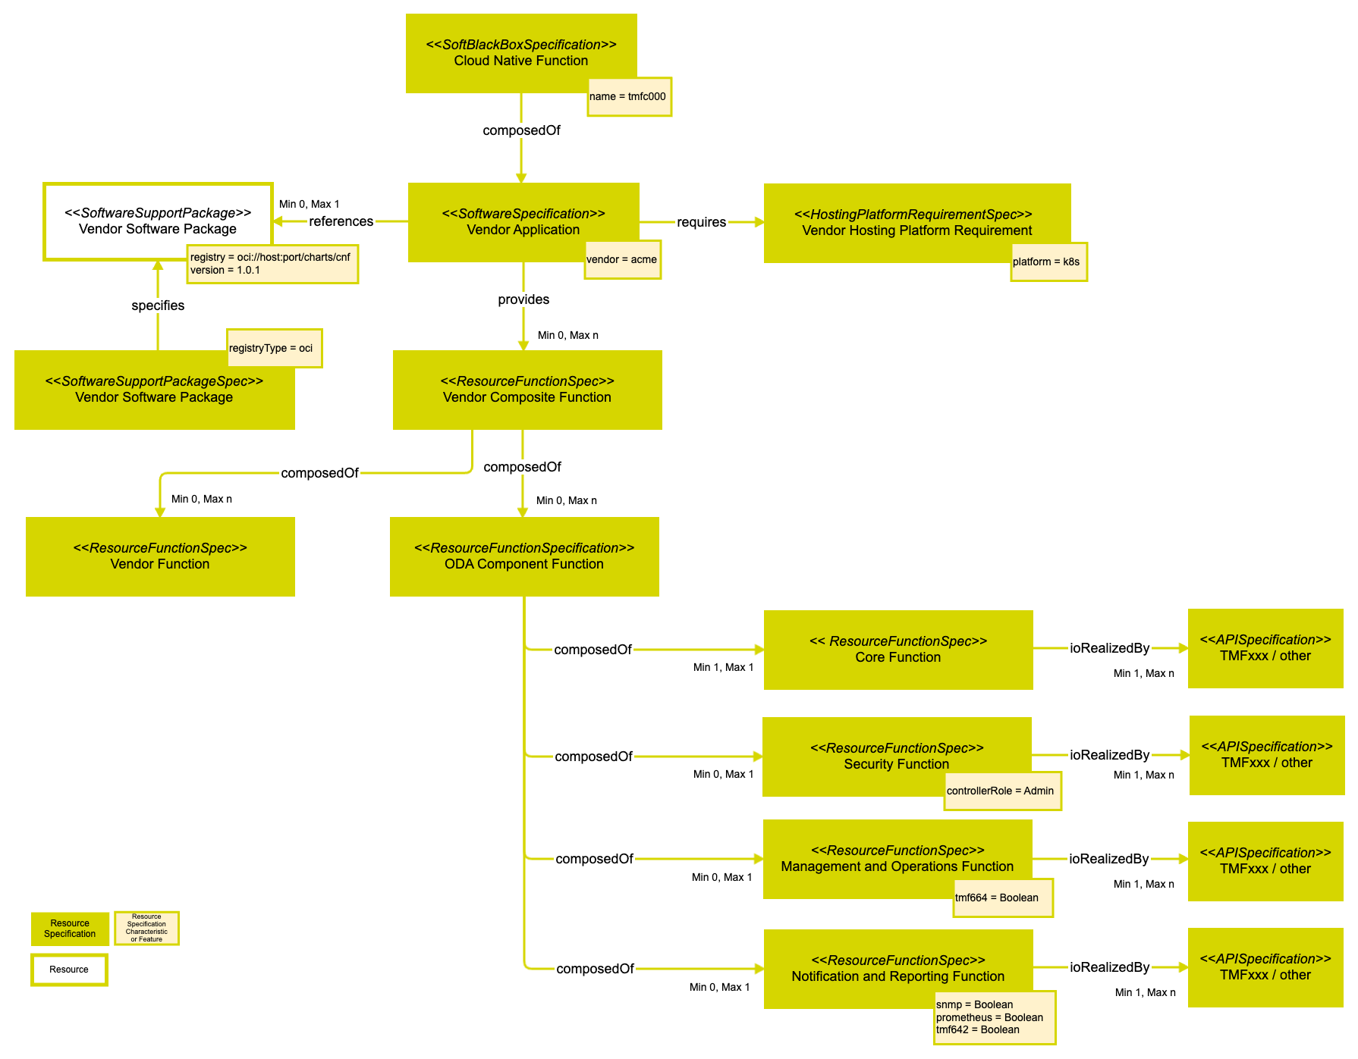

Cloud Native Function
This SoftBlackBoxSpecification describes the CNF as a logical system containing one or more software applications. This can be useful to generalize a role with replaceable software or to describe a role composed of multiple software applications. A SoftBlackBoxSpecification defines characteristics of a SoftBlackBox instance in Resource Inventory.

Vendor Application
This SoftwareSpecification describes the software application provided by the vendor and references the SoftwareSupportPackage in Resource Inventory which delivers it. An instantiation of a SoftwareSpecification in Resource Inventory has type InstalledSoftware.

Vendor Hosting Platform Requirement
This HostingPlatformRequirementSpec places restrictions on target hosting platforms for this software application by defining characteristics of a HostingPlatformRequirement.

Vendor Software Package
This SoftwareSupportPackageSpec defines characteristics of a SoftwareSupportPackage.

Vendor Composite Function
This ResourceFunctionSpec describes a compound ResourceFunction which implements the vendor's CNF.

Vendor Function
This ResourceFunctionSpec describes a ResourceFunction which implements a vendor proprietary function.

ODA Component Function
This ResourceFunctionSpec describes a ResourceFunction which implements an ODA Component.

Core Function
This ResourceFunctionSpec describes a ResourceFunction which implements an ODA Component's Core function.

Security Function
This ResourceFunctionSpec describes a ResourceFunction which implements an ODA Component's Security function.

Management and Operations Function
This ResourceFunctionSpec describes a ResourceFunction which implements an ODA Component's Management and Operations function.

Notification and Reporting Function
This ResourceFunctionSpec describes a ResourceFunction which implements an ODA Component's Notification and Reporting function.

TMFxxx / other
These APISpecifications describe the functions' input/output which. In this example we have no need for independently describing a (Stage 2) ConnectPoint so it is realized directly by an API.

Resource Order for CNF Use Case
The diagram below provides a Resource Order view of our use case example CNF.

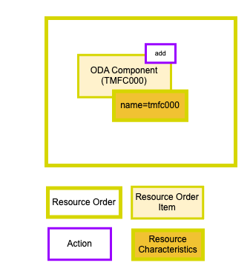

Managed Entities for CNF Use Case
The diagram below provides a Resource Inventory view of our use case example CNF.

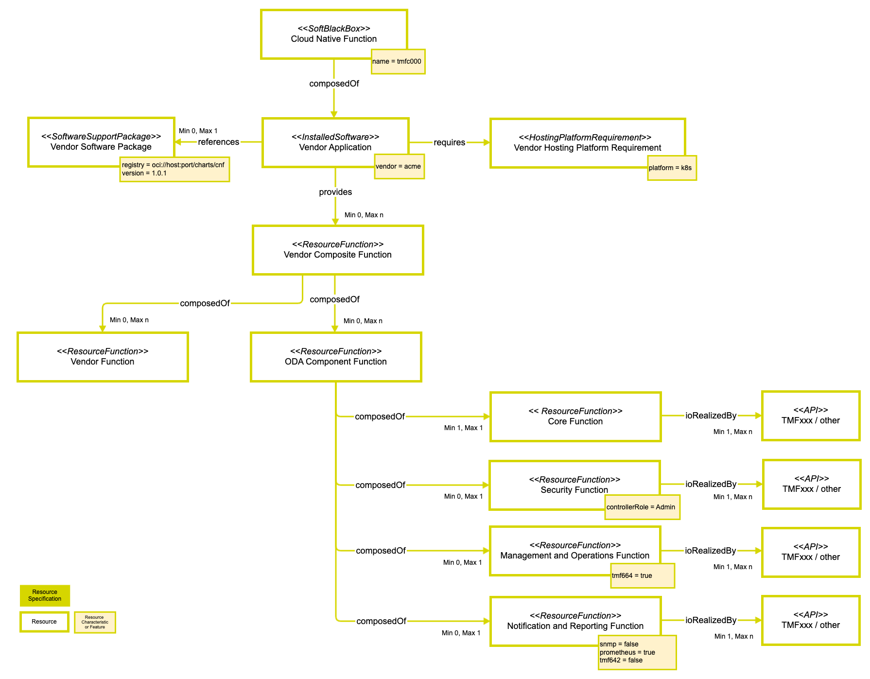

Sequence diagrams
The diagram below depicts an example message sequence for the use case of deploying an instance of a Cloud Native Function (CNF).

Step 1
An operator places a resource order for a new CNF. The name for this instance, and any other required Characteristic values, is provided.

Step 2-3
The Resource Order Component (TMFC011) retrieves specifications referenced in the order from the Resource Catalog Component (TMFC010).

Step 4-5
The Resource Order Component (TMFC011) requests activation of the CNF as a SoftBlackBox from the Resource Configuration and Activation Component (TMFC062).

Step 6-7
The Resource Order Component (TMFC011) subscribes to notification of state changes on the resource order.

Step 8-9
The Resource Configuration and Activation Component (TMFC062) retrieves specifications referenced in the activation request from the Resource Catalog Component (TMFC010).

Step 10-12
The Resource Configuration and Activation Component (TMFC062) requests activation of the CNF in the infrastructure platform. In this Kubernetes example the Vendor Software Package provided a Helm chart which is installed with helm install and parameterized with Values. After this the CNF has been created.

Step 13-14
The Resource Configuration and Activation Component (TMFC062) retrieves resources from the instantiated CNF.

Step 15-16
The Resource Configuration and Activation Component (TMFC062) creates the instantiated resources in the Resource Inventory Component (TMFC012).

Step 17
The Resource Configuration and Activation Component (TMFC062) notifies the Resource Order Component (TMFC011) of resource order state change.

Step 18
Later, in Day 2 operations, an operator places a resource order for a new, or updated, Resource Function in the CNF. For example a supporting Notification & Reporting Function is enabled with TMF642 for alarm reporting.

Step 19-20
The Resource Order Component (TMFC011) retrieves specifications referenced in the order from the Resource Catalog Component (TMFC010).

Step 21-22
The Resource Order Component (TMFC011) requests activation of the CNF Notification & Reporting Function as a ResourceFunction from the Resource Configuration and Activation Component (TMFC062).

Step 23-24
The Resource Order Component (TMFC011) subscribes to notification of state changes on the resource order.

Step 25-26
The Resource Configuration and Activation Component (TMFC062) retrieves the Resource Function Specification referenced in the activation request from the Resource Catalog Component (TMFC010).

Step 27-28
The Resource Configuration and Activation Component (TMFC062) requests activation of the Notification & Reporting Function as a ResourceFunction in the instantiated CNF.

Step 29-30
The Resource Configuration and Activation Component (TMFC062) creates the instantiated ResourceFunction in the Resource Inventory Component (TMFC012).

Step 31
The Resource Configuration and Activation Component (TMFC062) notifies the Resource Order Component (TMFC011) of resource order state change.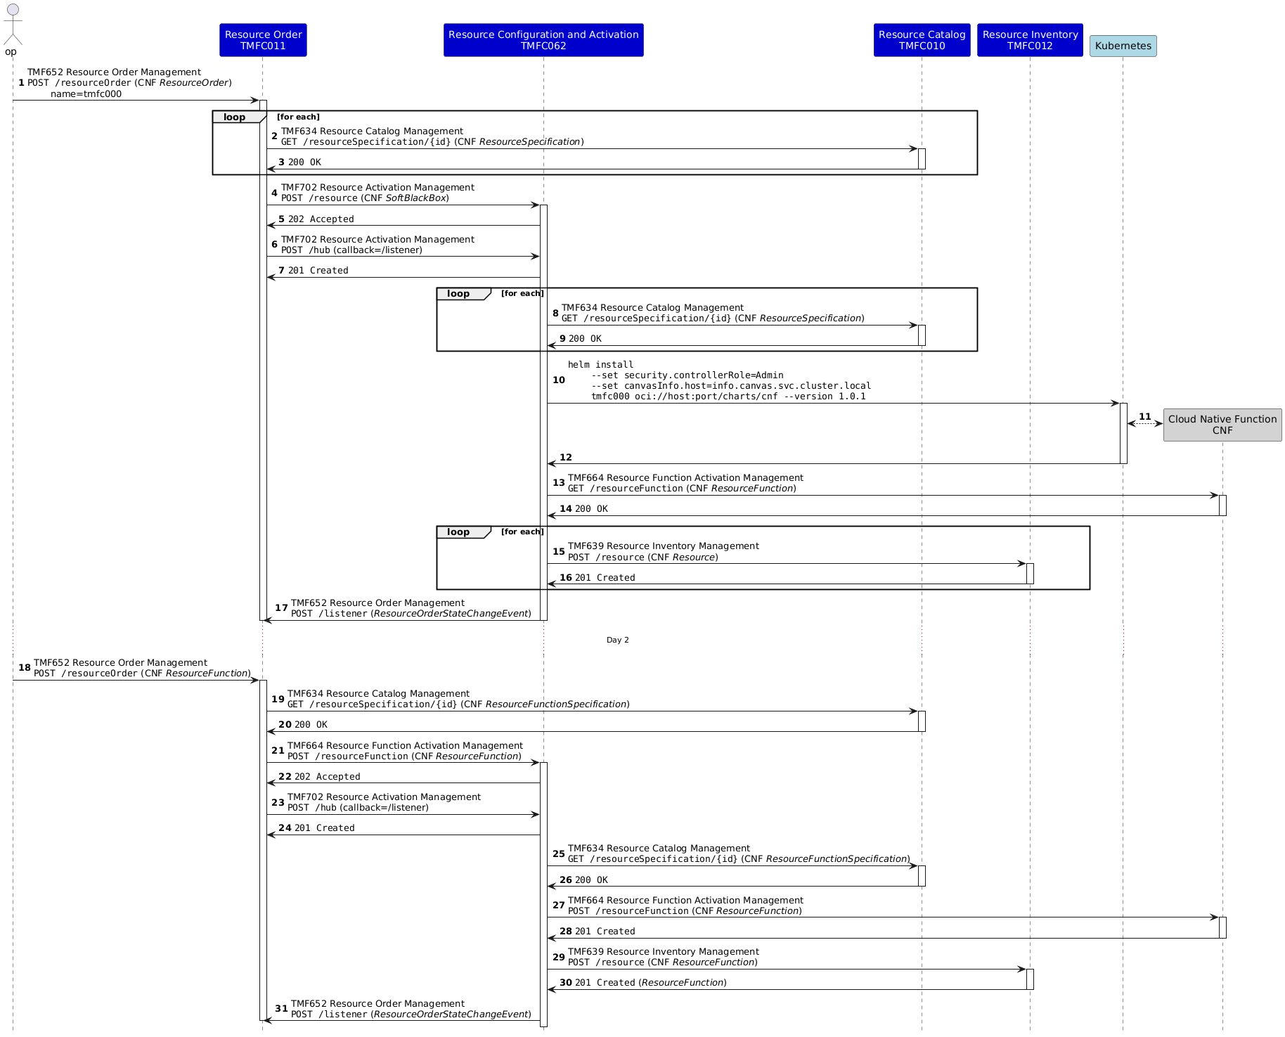

Conclusion

Lessons learned
Any Cloud Native Function (CNF) can be represented, with arbitrary level of specificity, with the Information Framework (SID) models.
Software applications can be decomposed to represent their individual functions as managed entities in a Resource Inventory.
The information managed shouldn't overlap with that of the infrastructure platforms (i.e. k8s) and tooling (i.e. Helm), but should concentrate on the application level, such as describing ODA Component Core and Supporting function behaviour.
The Supporting function Management and Operations should expose TMF664 in order to make the ODA Component's Core and Supporting functions independently managed entities.
An ODA Component for Resource Configuration and Activation (TMFC062) can provide a consistent interface for managing software application lifecycles within the Open Digital Framework (ODF).

Impacts identified
During development of this document the following issues were encountered:
-  ISA-1131 - Software Support Package Specification backlog SoftwareSupportPackageSpec is missing in SID.

Appendix
The JSON in the following code blocks provides an example of specifying an ODA Component using Resource Specifications compatible with TMF730 Software and Compute.

ODA Component Specification
Currently, TM Forum specifies ODA Components with a YAML file which is consumed by a Kubernetes operator in the ODA-CA Canvas reference implementation. We can map the information model of an ODA Component specification onto a SoftBlackBoxSpecification so it can be managed as an entity in a Resource Catalog. This Component specification provides ResourceFunctionSpecifications for the Core and Supporting functions.
The following JSON objects provide an example for specifying an ODA Component (TMFC062).
{
"name": "TMFC062 ODA Component",
"description": "ODA Component Specification of Resource Configuration and Activation (TMFC062)".
"@type": "SoftBlackBoxSpecification",
"@baseType": "ResourceSpecification",
"category": "ODA Production",
"targetResourceSchema": {
"@type": "SoftBlackBox"
},
"lifecycleStatus": "In Study",
"version": "0.0.1",
"lastUpdate": "2024-08-31T13:32:00Z",
"relatedParty": [
{
"name": "Vance Shipley",
"role": "owner"
},
{
"name": "Vance Shipley",
"role": "maintainer"
}
],
"isBundle": true,
"resourceSpecRelationship": [
{
"name": "TMFC062 Core Function",
"role": "Core Function",
"relationshipType": "provides"
},
{
"name": "TMFC062 Security Function",
"role": "Security Function",
"relationshipType": "provides"
},
{
"name": "TMFC062 Management and Operations Function",
"role": "Management and Operations Function",
"relationshipType": "provides"
},
{
"name": "TMFC062 Notification and Reporting Function",
"role": "Notification and Reporting Function",
"relationshipType": "provides"
}
],
"featureSpecification": [
],
"resourceSpecCharacteristic": [
{
"name": "name",
"description": "Name for the installed Helm release",
"valueType": "string",
"configurable": true,
"minCardinality": 1,
"maxCardinality": 1,
"isUnique": true
}
]
}
Code Block 1 TMFC062 ODA Component Specification
{
"name": "TMFC062 Core Function",
"description": "Core Function Specification of Resource Configuration and Activation (TMFC062)".
"@type": "ResourceFunctionSpecification",
"category": "ODA Production",
"targetResourceSchema": {
"@type": "ResourceFunction"
},
"lifecycleStatus": "In Study",
"version": "0.0.1",
"lastUpdate": "2024-08-31T14:17:00Z",
"relatedParty": [
{
"name": "Vance Shipley",
"role": "owner"
},
{
"name": "Vance Shipley",
"role": "maintainer"
}
],
"isBundle": false,
"resourceSpecRelationship": [
{
"name": "TMFC062-TMF702",
"version": "0.0.1",
"relationshipType": "ioRealizedBy"
},
{
"name": "TMF062-TMF664",
"version": "0.0.1",
"relationshipType": "ioRealizedBy"
}
],
"connectionPointSpecification": [
{
"name": "TMFC062-TMF702",
"version": "0.0.1",
"@referredType": "APISpecification"
},
{
"name": "TMF062-TMF66",
"version": "0.0.1",
"@referredType": "APISpecification"
}
],
"connectivitySpecification": [
],
"featureSpecification": [
],
"resourceSpecCharacteristic": [
]
}
Code Block 2 TMFC062 Core Function Specification
{
"name": "TMFC062 Security Function",
"description": "Security Function Specification of Resource Configuration and Activation (TMFC062)".
"@type": "ResourceFunctionSpecification",
"category": "ODA Production",
"targetResourceSchema": {
"@type": "ResourceFunction"
},
"lifecycleStatus": "In Study",
"version": "0.0.1",
"lastUpdate": "2024-08-31T14:17:00Z",
"relatedParty": [
{
"name": "Vance Shipley",
"role": "owner"
},
{
"name": "Vance Shipley",
"role": "maintainer"
}
],
"isBundle": false,
"resourceSpecRelationship": [
{
"name": "TMF062-TMF669",
"version": "0.0.1",
"relationshipType": "ioRealizedBy"
}
],
"connectionPointSpecification": [
{
"name": "TMF062-TMF669",
"version": "0.0.1",
"@referredType": "APISpecification"
}
],
"connectivitySpecification": [
],
"featureSpecification": [
],
"resourceSpecCharacteristic": [
{
"name": "controllerRole",
"description": "Name of a Party Role used by the Security Function",
"valueType": "string",
"configurable": true,
"minCardinality": 1,
"maxCardinality": 1,
"isUnique": true
}
]
}
Code Block 3 TMFC062 Security Function Specification
{
"name": "TMFC062 Management and Operations Function",
"description": "Management and Operations Function Specification of Resource Configuration and Activation (TMFC062)".
"@type": "ResourceFunctionSpecification",
"category": "ODA Production",
"targetResourceSchema": {
"@type": "ResourceFunction"
},
"lifecycleStatus": "In Study",
"version": "0.0.1",
"lastUpdate": "2024-08-31T14:17:00Z",
"relatedParty": [
{
"name": "Vance Shipley",
"role": "owner"
},
{
"name": "Vance Shipley",
"role": "maintainer"
}
],
"isBundle": false,
"resourceSpecRelationship": [
{
"name": "TMF062-TMF664",
"version": "0.0.1",
"relationshipType": "ioRealizedBy"
}
],
"connectionPointSpecification": [
{
"name": "TMF062-TMF664",
"version": "0.0.1",
"@referredType": "APISpecification"
}
],
"connectivitySpecification": [
],
"featureSpecification": [
{
"name": "tmf664",
"isEnabled": true
}
],
"resourceSpecCharacteristic": [
]
}
Code Block 4 TMFC062 Management and Operations Function Specification
{
"name": "TMFC062 Notification and Reporting Function",
"description": "Notification and Reporting Function Specification of Resource Configuration and Activation (TMFC062)".
"@type": "ResourceFunctionSpecification",
"category": "ODA Production",
"targetResourceSchema": {
"@type": "ResourceFunction"
},
"lifecycleStatus": "In Study",
"version": "0.0.1",
"lastUpdate": "2024-08-31T14:17:00Z",
"relatedParty": [
{
"name": "Vance Shipley",
"role": "owner"
},
{
"name": "Vance Shipley",
"role": "maintainer"
}
],
"isBundle": false,
"resourceSpecRelationship": [
{
"name": "TMF062-TMF642",
"version": "0.0.1",
"relationshipType": "ioRealizedBy"
},
{
"name": "TMF062-Prometheus",
"version": "0.0.1",
"relationshipType": "ioRealizedBy"
},
{
"name": "TMF062-SNMP",
"version": "0.0.1",
"relationshipType": "ioRealizedBy"
}
],
"connectionPointSpecification": [
{
"name": "TMF062-TMF642",
"version": "0.0.1",
"@referredType": "APISpecification"
},
{
"name": "TMF062-Prometheus",
"version": "0.0.1",
"@referredType": "APISpecification"
},
{
"name": "TMF062-SNMP",
"version": "0.0.1",
"@referredType": "APISpecification"
}
],
"connectivitySpecification": [
],
"featureSpecification": [
{
"name": "tmf642",
"isEnabled": false
},
{
"name": "prometheus",
"isEnabled": false
},
{
"name": "snmp",
"isEnabled": false
}
],
"resourceSpecCharacteristic": [
]
}
Code Block 5 TMFC062 Notification and Reporting Function Specification
{
"name": "TMFC062-TMF702",
"description": "TMF702 Resource Activation API Specification for TMF062 Core function",
"@type": "APISpecification",
"targetResourceSchema": {
"@type": "API"
},
"apiProtocolType": "REST",
"majorVersion": "4",
"internalSchema": "https://tmf-open-api-table-documents.s3.eu-west-1.amazonaws.com/OpenApiTable/TMF702_Resource_Activation/4.0.0/swagger/TMF702_Resource_Activation_Management_API_v4.0.0_swagger.json",
"internalUrl": "/tmf-api/ResourceActivationAndConfiguration/v4",
"allowedOperations": [
"GET",
"POST",
"PATCH",
"DELETE"
],
"allowedAPIEntities": [
"resource",
"monitor",
"hub",
"listener"
],
"responseTypeFormat": [
"application/json"
]
}
Code Block 6 TMF702 API Specification
{
"name": "TMF062-TMF664",
"description": "TMF664 API Specification",
"@type": "APISpecification",
"targetResourceSchema": {
"@type": "API"
},
"apiProtocolType": "REST",
"majorVersion": "4",
"internalSchema": "https://tmf-open-api-table-documents.s3.eu-west-1.amazonaws.com/OpenApiTable/TMF664_Resource_Function_Activation/4.0.0/swagger/TMF664_Resource_Function_Activation_Management_API_v4.0.0_swagger.json",
"internalUrl": "/tmf-api/resourceFunctionActivation/v4",
"allowedOperations": [
"GET",
"POST",
"PATCH",
"DELETE"
],
"allowedAPIEntities": [
"resourceFunction",
"heal",
"scale",
"migrate",
"monitor",
"hub",
"listener"
],
"responseTypeFormat": [
"application/json"
]
}
Code Block 7 TMF664 API Specification
{
"name": "TMF062-TMF669",
"description": "TMF669 API Specification",
"@type": "APISpecification",
"targetResourceSchema": {
"@type": "API"
},
"apiProtocolType": "REST",
"majorVersion": "4",
"internalSchema": "https://tmf-open-api-table-documents.s3.eu-west-1.amazonaws.com/ODA/TMF669_v4.0.0.swagger.json",
"internalUrl": "/tmf-api/partyRoleManagement/v4",
"allowedOperations": [
"GET",
"POST",
"PATCH",
"DELETE"
],
"allowedAPIEntities": [
"partyRole",
"hub",
"listener"
],
"responseTypeFormat": [
"application/json"
]
}
Code Block 8 TMF669 API Specification
{
"name": "TMF062-Prometheus",
"description": "Prometheus API Specification",
"@type": "APISpecification",
"targetResourceSchema": {
"@type": "API"
},
"apiProtocolType": "REST",
"internalUrl": "/",
"allowedOperations": [
"GET"
],
"allowedAPIEntities": [
"metrics"
],
"responseTypeFormat": [
"text/plain; version=0.0.4"
]
}
Code Block 9 Prometheus API Specification

Administrative Appendix

Document History

Version History
This section records the changes between this and the previous document version as it is edited by the team concerned. Note: this is an incremental number which does not have to match the release number and used for change control purposes only.

Version Number | Date Modified | Modified by: | Description of changes
0.0.1 | 29 Aug 2024 | Vance Shipley | Initial draft from template
1.0.0 | 31 Aug 2024 | Vance Shipley | Completed first draft for discussion
1.0.0 | 30 Dec 2024 | Rosie Wilson | Final Administrative Updates
1.1.0 | 06 Mar 2025 | Vance Shipley | Added resource order and inventory views.
1.1.0 | 13 Mar 2025 | Rosie Wilson | Final Administrative Updates

Release History
Release Status | Date Modified | Modified by: | Description of changes
Pre-production | 30 Dec 2024 | Rosie Wilson | Release of v1.0.0
Production | 07-Mar-2025 | Adrienne Walcott | Updated to reflect TM Forum Approved status
Pre-production | 13 Mar 2025 | Rosie Wilson | Release of v1.1.0
Production | 09-May-2025 | Adrienne Walcott | Updated to reflect TM Forum Approved status

Acknowledgments
This document was prepared by the members of the ODA Production team for approval by the TM Forum End-to-End ODA team.
Team Member (@mention) | Company | Role
Vance Shipley | SigScale | Author
Sylvie Demarest | Orange | Reviewer
Elisabeth Andersson | Matrixx | Reviewer
Dave Milham | TM Forum | Reviewer
*Select from: Project Chair, Project Co-Chair, Author, Editor, Key Contributor, Additional Input, Reviewer

