SNC And Protection

Table of Contents

SNC And Protection 1
Table of Contents 1
Table of Figures 4
Table of Tables 5
1 Introduction 6
2 SNC Properties and Parameters 7
2.1 Service Quality Related Parameters – Protection 7
2.1.1 StaticProtectionLevel [mandatory parameter] 7
2.1.2 ProtectionEffort [mandatory parameter] 9
2.2 Traffic flow into and out of an SNC 9
2.2.1 SNCType overview [mandatory parameter] 9
2.2.2 Network Examples of SNC types 15
2.2.3 Semantic Rules for Aend and Zend 24
2.2.3.1 Implicit SNC Structure Usage 24
2.2.3.2 Explicit SNC Structure 24
2.2.3.3 Usage of ST_EXPLICIT 25
2.3 Cross-Connect 25
2.4 Protection Relationships in an Implicit SNC – ProtectionRole [optional parameter] 25
2.5 Independence of SNCType and StaticProtectionLevel 26
2.6 Network Routed SNCs 26
3 Unidirectional SNCs and Point-to-Multipoint 27
3.1 Models 27
3.1.1 Unidirectional Model 27
3.1.2 Point-to-multipoint Model 28
3.2 Enhanced Capabilities for point-to-multipoint over the interface 29
3.2.1 Creation and modification of Point-to-multipoint configuration 29
3.2.1.1 Preparing the resource for multipoint operation – PotentialFutureSetupIndicator [transmission parameter] 29
3.2.1.2 Indicating the degree of tolerable impact – GradeOfImpact [mandatory parameter] 30
3.2.2 Retrieval of a Point-to-multipoint configuration 30
3.2.3 Migration from point-to-point to point-to-multipoint 30
3.2.4 Comments on deletion 30
3.3 Subnetworks 30
3.3.1 Creating an SNC in a Subnetwork 30
3.3.2 The Mesh Subnetwork 30
3.4 Routing Constraints 31
3.4.1 Exclusion 31
3.4.2 Inclusion 32
3.4.2.1 Request in an inclusion for inappropriate resources 32
3.4.2.2 Request in an inclusion for resources already in use 32
3.4.3 Route Attributes 33
3.4.4 Constraints beyond the span of control of the EMS 33
3.4.5 Interaction between constraints 33
3.4.6 Network Routing 33
3.5 Actual Route Discovery 34
4 SNC modification 35
4.1 Scenarios of Add / Remove Protection Leg 35
4.2 Scenario of SNC Rerouting 36
4.3 Scenario of Add / Remove Backup Route 37
4.4 Impacts on Static Protection Level and SNC type 37
4.5 Modification Behaviors 38
4.5.1 SNC state in case the EMS does not preserve the SNC name 38
4.5.2 SNC state in case the EMS preserves the SNC name 39
4.5.3 TolerableImpact 40
4.5.4 Route Change 41
5 Multiple Route Management 42
6 Call and connection 51
6.1 Control Plane Call 51
6.1.1 Call specific attributes 51
6.1.1.1 Call Identifier 51
6.1.1.2 Call State 52
6.1.1.3 Profile of Call Parameters 52
6.1.1.4 Diversity parameters 53
6.2 Non-Control Plane Call 53
6.3 Multi Layer Routing Area 53
6.3.1 Multi Layer Routing Area specific attributes 55
6.3.1.1 Routing Area Level 55
6.3.1.2 Superior MLRA 55
6.3.1.3 List of Layered Routing Areas 55
6.3.1.4 Supporting ME Name 55
6.3.1.5 SRG 55
6.4 Connection 56
6.4.1 SNC attributes 56
6.4.2 Connection specific attributes 56
6.4.2.1 Maximum Cost 56
6.4.2.2 Route Group Label 56
6.4.2.3 Connection Set Up Type 56
6.4.2.4 Call Id 56
6.4.2.5 Call Name 56
6.4.2.6 Connection Id 56
6.4.2.7 Supported Connection Name 57
6.4.2.8 Connection State 57
6.4.2.9 SRG 57
6.5 Call and Connection discovery in Control Plane context 58
6.5.1 Hierarchy of Multi-Layer Subnetworks 58
6.5.2 Call and Connections Inventory 58
6.5.3 Finding the detailed route of Connections 59
6.6 Version 3.0 operations with restrictions concerning Call and Connections 62
6.7 Version 3.0 operations not affected by Call and Connection management 63
6.8 Version 3.5 new operations 63
7 Administrative Appendix 64
7.1 Document History 64
7.2 Acknowledgments 64
7.3 How to comment on this document 64

Table of Figures
Figure 2-1 - ST_SIMPLE 10
Figure 2-2 - ST_ADD_DROP_A 10
Figure 2-3 - ST_ADD_DROP_Z 11
Figure 2-4 - ST_DOUBLE_ADD_DROP 11
Figure 2-5 - ST_INTERCONNECT 12
Figure 2-6 - ST_DOUBLE_INTERCONNECT 13
Figure 2-7 - ST_OPEN_ADD_DROP 13
Figure 2-8 - ST_EXPLICIT 14
Figure 2-9 - Example Subnetworks Explaining SNC Types ST_ADD_DROP_A, ST_DOUBLE_INTERCONNECT and ST_SIMPLE 15
Figure 2-10 - Example Subnetworks Explaining SNC Types ST_ADD_DROP_A 17
Figure 2-11 - Example Subnetworks Explaining SNC Types ST_DOUBLE_ADD_DROP 19
Figure 2-12 - Example Subnetworks Explaining SNC Types ST_EXPLICIT 21
Figure 2-13 - Example Subnetworks Explaining SNC Types ST_OPEN_ADD_DROP 24
Figure 3-1 –Source and Sink representations 27
Figure 3-2 – Source and Sink PTPs and CTPs 28
Figure 3-3 – Containment 28
Figure 4-1 – ModifySNC: UNPROTECTED <-> FULLY_PROTECTED 35
Figure 4-2 – ModifySNC: ST_SIMPLE <-> ST_ADD_DROP; aEnd is reliable TP 35
Figure 4-3 – ModifySNC: ST_SIMPLE <-> ST_ADD_DROP; aEnd is not the reliable TP 36
Figure 4-4 – ModifySNC: UNPROTECTED <-> PARTIALLY_PROTECTED 36
Figure 4-5 – ModifySNC: simple reroute 36
Figure 4-6 –add new route to an SNC 37
Figure 5-1 - sharing of inactive backup routes, no failures 42
Figure 5-2 - sharing of inactive backup routes, failure on high prio SNC 43
Figure 5-3 - sharing of intended route, no failures 43
Figure 5-4 - sharing of intended route, failure on high prio SNC 44
Figure 5-5 - SNCP protected SNC with backup route, no failures 44
Figure 5-6 - SNCP protected SNC with backup route, failure on main branch 45
Figure 5-7 - Add Drop SNC with backup route, no failures 45
Figure 5-8 - Add Drop SNC with backup route, failure on main branch 46
Figure 6.1 – Three level hierarchy of MLSN/MLRA 53
Figure 6.2 – Two level hierarchy of MLSN/MLRA 54
Figure 6.3 - Route retrieval, untrusted E-NNI 59
Figure 6.4 - Route retrieval, trusted E-NNI 60

Table of Tables
Table 3-1: routing attributes usage 34
Table 4-1: Relationship between SNCType/staticProtectionLevel values 37
Table 4-2: state changes related to the createModifiedSNC() and swapSNC() operations in case of success 39
Table 4-3: state changes related to the createModifiedSNC() and swapSNC() operations in case of failure 39
Table 4-4: state changes related to the createModifiedSNC() and activateSNC() operations in case of success 40
Table 4-5: state changes related to the createModifiedSNC() and activateSNC() operations in case of failure 40
Table 5-1: state changes related to the createModifiedSNC(), modifySNC() and activateSNC() operations in case of successful activation of the SNC 47
Table 5-2: state changes related to the addRoute successful operation 48
Table 5-3: route attribute “intended” 48
Table 5-4: route Actual State 49
Table 5-5: route Administrative State 50

Introduction
The basic create SNC service provided in Phase I of the SSIM (now MTNM) model allows the NMS to create basic SNCs within a limited set of subnetworks applying limited routing constraints.
The MTNM model will advance in these capabilities in Phase II. The following changes are covered in this appendix:
- Increase in the range of subnetworks supported over the interface (adding a mesh subnetwork). The subnetwork topologies are explained in the document
- Enhancements to the SNCs to include a specific SNC type, Static Protection Level and Protection Effort all of which are described in the document
- Improvements in the routing constraint capability to cover inclusions and exclusions:
  - Routing constraints apply to all network topologies other than singleton (e.g. Ring, mesh) where the network operator has effectively chosen to delegate some level of control over the routing to the underlying devices (EMS and NEs) .
  - These constraints may be as extreme as the NMS laying out the entire route or as simple as a single NE inclusion
- Introduction of the cross-connect object
The Version 3 of MTNM features also:
- SNC modification
- SNC multiple route management
Release 3.5 of MTNM features also Call / Connection separation:
- Call establishment, release and modification
- Diversity and Co-routing constraint management
- Navigation considering CP restrictions

Note:
In this Appendix, unless otherwise stated, wherever the term create SNC is used, it is understood that createAndActivateSNC and createSNC both applies and also wherever delete SNC is used, it is understood that deleteAndDeactivateSNC and deleteSNC both apply.

SNC Properties and Parameters
An SNC is defined by a number of parameters. The key parameters to be added/enhanced in this release are justified and described below.

Service Quality Related Parameters – Protection
Aspects of resilience of an SNC are described using StaticProtectionLevel. During the creation of an SNC the NMS will request a particular StaticProtectionLevel but may also offer the EMS some freedom to chose a different StaticProtectionLevel to that requested in the create data; this is achieved via the ProtectionEffort. These parameters are described below.

StaticProtectionLevel [mandatory parameter]
StaticProtectionLevel is a statement of the internal resiliency of the SNC (internal to the subnetwork). The more resilient an SNC is the less the chance of the transmission being interrupted. In general, the more resilient an SNC is the more bandwidth it will consume inside the subnetwork.
The StaticProtectionLevel relates to protection that is provided by using specific dedicated or specific shared resources in the protection path (as opposed to the dynamic protection provided by systems that reroute on failure). The parameter RerouteOnFailure (not covered in this contribution) addresses these dynamic protection capabilities. These augment the other capabilities described in this section. An SNC can be set to any of the values shown below and also set to reroute on failure.
The StaticProtectionLevel will take one of the following values: {PREEMPTIBLE, UNPROTECTED, PARTIALLY_PROTECTED, FULLY_PROTECTED, HIGHLY_PROTECTED}.
The StaticProtectionLevel values are defined as follows:
- PREEMPTIBLE: May have resources taken to recover another SNC.
- UNPROTECTED: An SNC that will fail if any resource in its route fails.
- PARTIALLY_PROTECTED: Protection exists but has at least one shared node, shared link or shared link and node.
- FULLY_PROTECTED: An SNC that will not fail if any single managed resource along its route fails (excluding the originating and terminating nodes for the SNC); for example, an SNC that is diversely routed at any layer.
- HIGHLY_PROTECTED: A higher level of protection than is possible by simple diverse path routing. A highly protected subnetwork should each be able to experience a single failure without affecting traffic. No shared facilities and NEs excluding originating and terminating NEs. Typically this is achieved in a SONET/SDH environment using dual ring interworking, where the proper use of links enhances survivability over that offered by simple diverse path routing. Highly Protected is used when the NMS wishes to request the highest available protection level from the EMS. If a level greater than simple diverse routing is available, it must be provided. If this can be done in multiple ways and is not further specified by the NMS, the choice of highly protected SNC is made by the EMS.
The StaticProtectionLevel does not have any bearing on the externally visible shape and traffic flows of the SNC.
For example an ST_SIMPLE SNC can have a StaticProtectionLevel of FULLY_PROTECTED and an ST_ADD_DROP_A can have a StaticProtectionLevel of PREEMPTIBLE.
The StaticProtectionLevel, an SNC totally contained within a SONET BLSR, that is unprotected at its layer will have its StaticProtectionLevel set to FULLY_PROTECTED.
An SNC contained within a BLSR and is pre-emptible will have StaticProtectionLevel set to PREEMPTIBLE. Although all SNCTypes can take any StaticProtectionLevel, the StaticProtectionLevel that may be selected for an SNC does depend upon the subnetwork that the SNC is to be created in. The following list identifies possible StaticProtectionLevels for each subnetwork type:

Subnetwork | StaticProtectionLevel supported
 | Preemptible | Unprotected | Partially Protected | Fully Protected | Multiply Protected
Singleton | No | Yes | No | No | No
Chain | Yes | Yes | Yes | Yes | Yes
PSR | No | Yes | No | Yes | No
SPRing | Yes | Yes | No | Yes | Yes
OpenPSR | No | Yes | No | No | No
OpenSPRing | Yes | Yes | No | Yes | Yes
Mesh | Yes | Yes | Yes | Yes | Yes

In all cases the EMS will comply with requests that fall within the range of protection that it perceives within the subnetwork. So it is possible that although the interconnectivity between two adjacent NEs when viewed in a subnetwork looks protected, e.g. 1+1 MSP, in the server layers outside the view of the EMS, this protection may be invalidated, e.g. the fiber of the 1+1 MSP may run down the same duct. Similarly it is possible that fibers on either side of a UPSR use the same duct or optical layer bearer. In both of these cases the EMS would provide an optimistic presentation of the level of protection achieved. It is assumed that network planning has been carried out to avoid or at least minimize such occurrences.

ProtectionEffort [mandatory parameter]
The ProtectionEffort is a statement of the requirement of the StaticProtectionLevel to be applied at creation of the SNC. ProtectionEffort will take one of the following values: {WHATEVER, SAME, SAMEORBETTER, SAMEORWORSE}.
The StaticProtectionLevel is ordered from worst to best in the following list: PREEMPTIBLE, UNPROTECTED, PARTIALLY_PROTECTED, FULLY_PROTECTED, HIGHLY_PROTECTED.
The EMS attempts to provide the StaticProtectionLevel requested; if this is not possible it attempts to provide better or worse than the requested protection level according to the ProtectionEffort. However, if the NMS requests StaticProtectionLevel PartiallyProtected with ProtectionEffort SAMEOFBETTER, the EMS may attempt to provide FULLY_PROTECTED first.
For example, if ProtectionEffort of SAMEOFBETTER is specified for a 3-ended ST_ADD_DROP_A to be created in a SPRing Subnetwork and a StaticProtectionLevel of PARTIALLY_PROTECTED is requested, it is acceptable for the EMS to return an ST_ADD_DROP_A SNC that has a StaticProtectionLevel of FULLY_PROTECTED.
If ProtectionEffort WHATEVER is specified, the EMS will attempt to protect at the requested StaticProtectionLevel, and if it cannot do so or chooses not to do so, it is free to choose any other protection level.
Clearly if an SNC is requested with a StaticProtectionLevel of HIGHLY_PROTECTED and a ProtectionEffort of SameOrBetter this is equivalent to a ProtectionEffort of SAME as there is no better protection than HIGHLY_PROTECTED, however, the combination should be allowed and interpreted in this way. Likewise a combination of StaticProtectionLevel PREEMPTIBLE and a ProtectionEffort of SAMEOFWORSE should be allowed and interpreted as StaticProtectionLevel of SAME.

Traffic flow into and out of an SNC

SNCType overview [mandatory parameter]
The SNCType reflects the dataflow from outside the subnetwork. The internal configuration of the SNC is not intended to be expressed via this attribute. Both bidirectional and unidirectional SNCs can be created for each type identified below unless otherwise indicated.
There are 2 types of SNC Types: implicit and explicit. The diagrams that follow show the different implicit SNCTypes: {ST_SIMPLE, ST_ADD_DROP_A, ST_ADD_DROP_Z, ST_DOUBLE_ADD_DROP, ST_INTERCONNECT, ST_DOUBLE_INTERCONNECT, ST_OPEN_ADD_DROP}.

ST_SIMPLE For simple two-ended connection types. This is used in cases where we have one A and one Z.
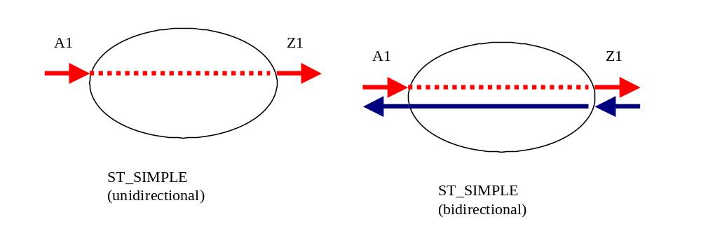
Figure 2-1 - ST_SIMPLE

ST_ADD_DROP_A For connections involving an AddDrop type that have three ends where two incoming signals are switched by a third end-point. In the bidirectional case, one input in the other direction is broadcast to the two outgoing endpoints. In the unidirectional case the Aend always represents ingress of traffic to the SNC and the Zend egress.
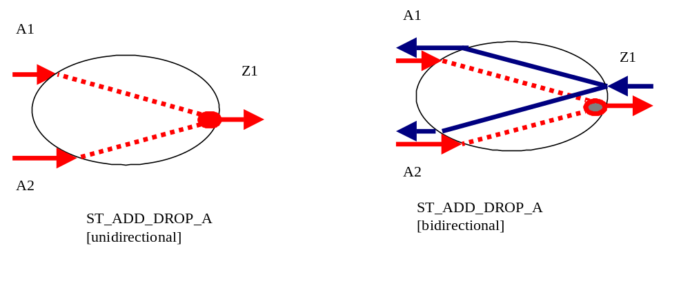
Figure 2-2 - ST_ADD_DROP_A

ST_ADD_DROP_Z Same as ST_ADD_DROP_A, but with Aend as single source, and/or reliable TP.
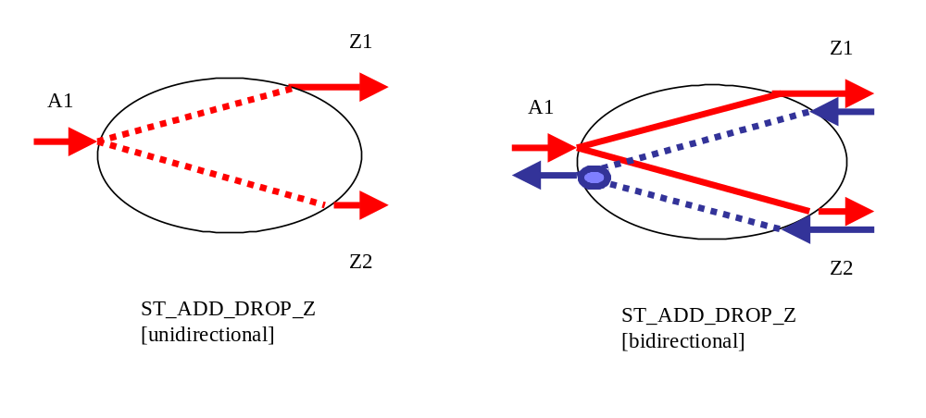
Figure 2-3 - ST_ADD_DROP_Z

ST_DOUBLE_ADD_DROP For connections involving an AddDrop type where the configuration is symmetrical four ended.
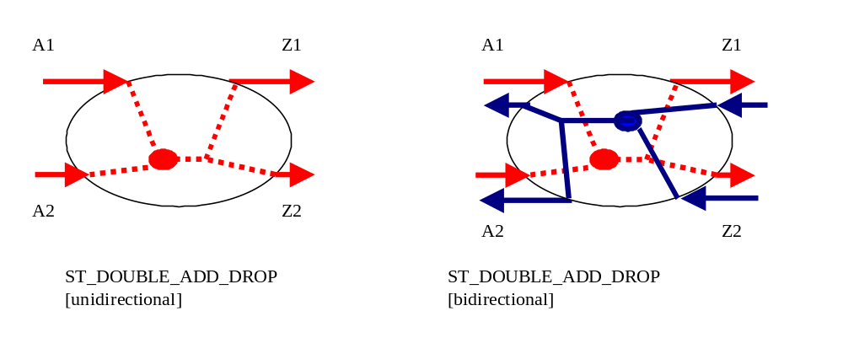
Figure 2-4 - ST_DOUBLE_ADD_DROP

ST_INTERCONNECT For subnetworks performing Drop and Continue in DRI SNCs (See the network examples in 2.2.2 below). In this case the incoming traffic from one Aend is available in the transmit and receive of the second Aend, the third end selects the input from the two Aends. The reverse direction traffic in a unidirectional connection, passes from the Zend to the First Aend.
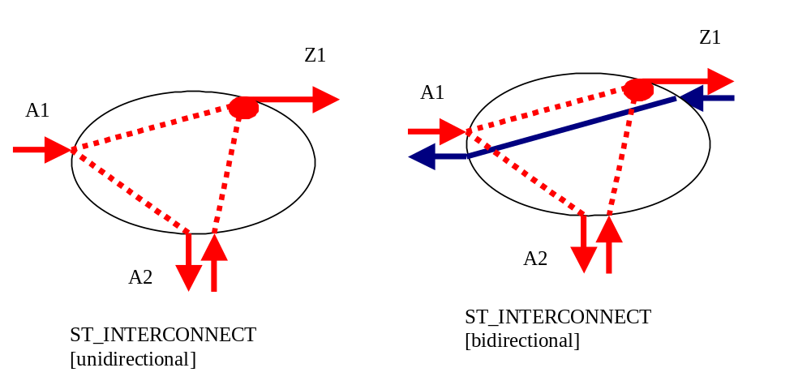
Figure 2-5 - ST_INTERCONNECT

ST_DOUBLE_INTERCONNECT This is a symmetrical form of the ST_INTERCONNECT where a subnetwork provides two interconnect ports, one for the A side traffic and one for the Z side.
Note:
A unidirectional ST_DOUBLE_INTERCONNECT is not valid; instead a unidirectional ST_INTERCONNECT SNC would be used.
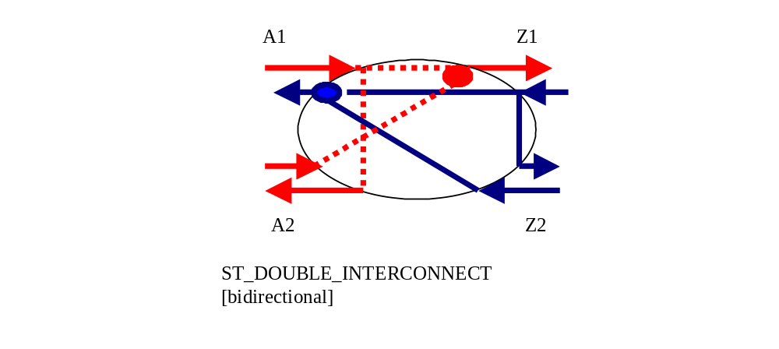
Figure 2-6 - ST_DOUBLE_INTERCONNECT

ST_OPEN_ADD_DROP Used in a double open ring scenario.
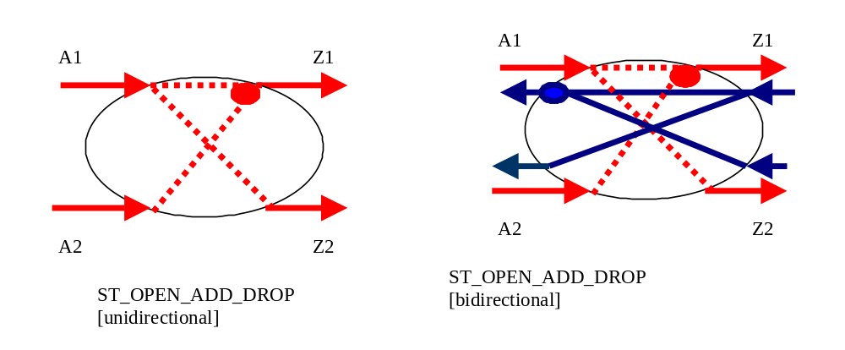
Figure 2-7 - ST_OPEN_ADD_DROP

ST EXPLICIT
- An SNC that may be described using an implicit SNC type may not use the ST_EXPLICIT type. The ST_EXPLICIT is used to describe a complex SNC that cannot be accurately described using the other defined SNC types.
- aEnd and zEnd lists must contain the same number of TPs, e.g. n.
- For every i between 1 and n the ith aEnd entry and the ith zEnd entry form a pair defining an unidirectional traffic flow from the aEnd TP (source) to the zEnd TP (sink).
- A single TP may be used in the aEnd list (i.e. as a source) an arbitrary number of times.
- A single TP must not be used more than twice in the zEnd list (i.e. as a sink).
- If a TP is used twice in the zEnd list, it is assumed that there is a service selector at this TP.
Figure 2-8 shows 2 examples of SNCs that must use ST_EXPLICIT.
Example 1 shows a bidirectional SNC where the Z-endpoint of is source connected and sink connected to different bidirectional CTPs (a single ST_SIMPLE SNC cannot convey the endpoints of this bidirectional SNC).The Aendpoint-Zendpoint pairs for this SNC are A1Z1={J, L1snk}, A2Z2={L2src, J}. Ordering of the pairs is not significant.
Example 2 shows a bidirectional SNC with a protection switch which are connected to source and sink TPs of different bidirectional CTPs at the Z-endpoints (a single ST_ADD_DROP SNC cannot convey the endpoints in this case)
The Aiendpoint-Ziendpoint pairs for this SNC are {L, J1snk}, {L, K1snk}, {J2src, L}, {K2src, L}. Ordering of the pairs is not significant.

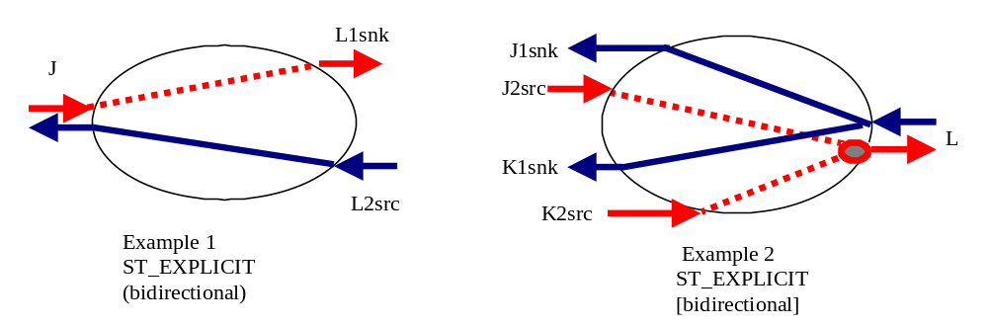
Figure 2-8 - ST_EXPLICIT

Network Examples of SNC types
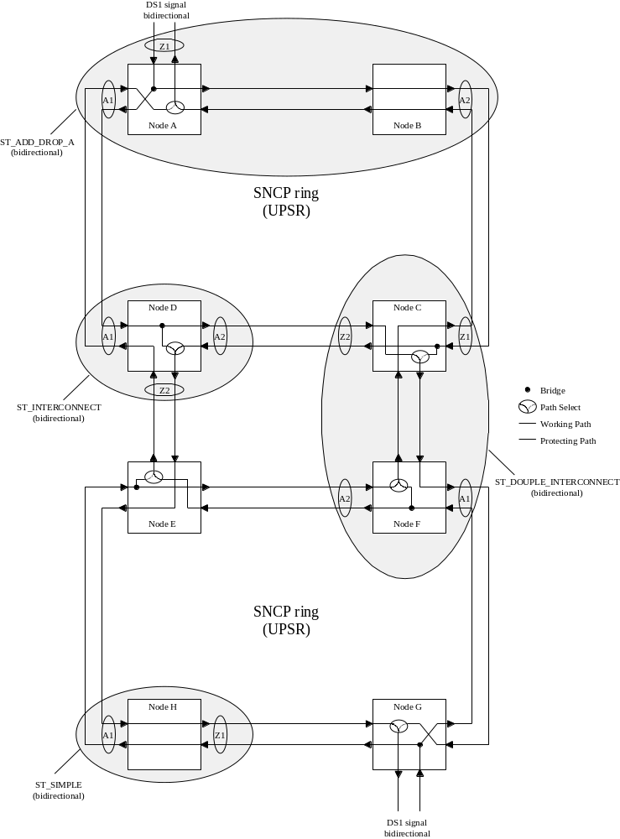
Figure 2-9 - Example Subnetworks Explaining SNC Types ST_ADD_DROP_A, ST_DOUBLE_INTERCONNECT and ST_SIMPLE

To achieve the traffic flow identified with the six subnetworks shown above, the following bidirectional SNCs are required:
- ST_ADD_DROP_A with StaticProtectLevel of Unprotected (and three ports) would be created in the MLSN of nodes A/B, and in node G
- ST_DOUBLE_INTERCONNECT with StaticProtectLevel of Unprotected would be created in the MLSN of nodes C/F
- ST_INTERCONNECT with StaticProtectLevel of Unprotected would be created in node D and node E
- ST_SIMPLE with StaticProtectLevel of Unprotected would be created in node H
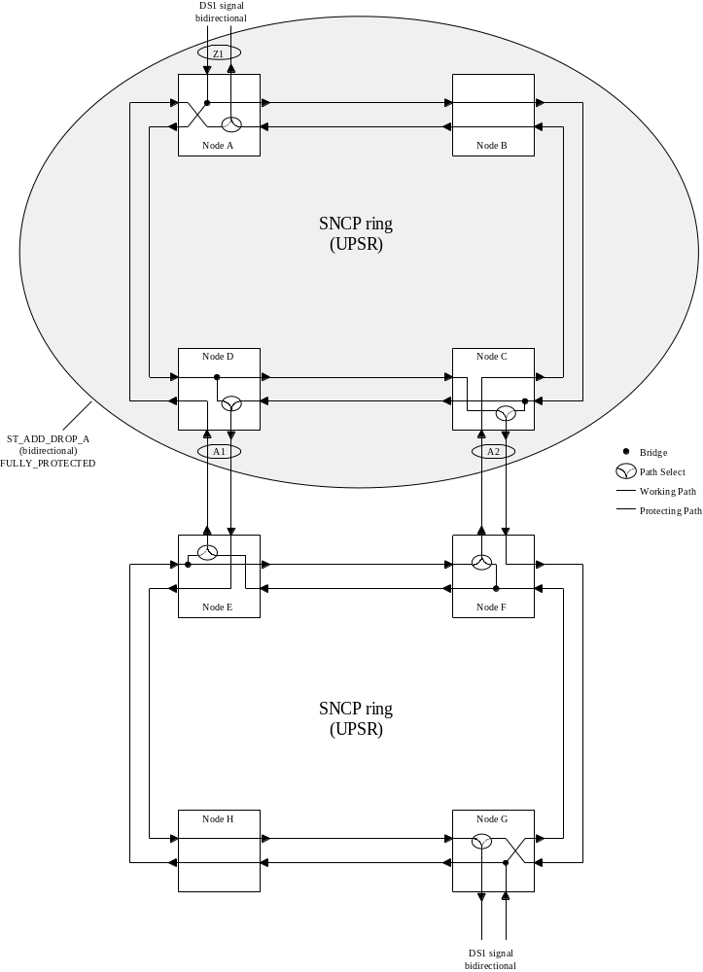
Figure 2-10 - Example Subnetworks Explaining SNC Types ST_ADD_DROP_A

To achieve the traffic flow identified with the five subnetworks shown above, the following bidirectional SNCs are required:
- ST_ADD_DROP_A with StaticProtectLevel of FullyProtected would be created in the MLSN of nodes A/B/C/D.
- ST_INTERCONNECT with StaticProtectLevel of Unprotected would be created in node E and node F
- ST_ADD_DROP_A with StaticProtectLevel of Unprotected (and three ports) would be created in node G
- ST_SIMPLE with StaticProtectLevel of Unprotected would be created in node H
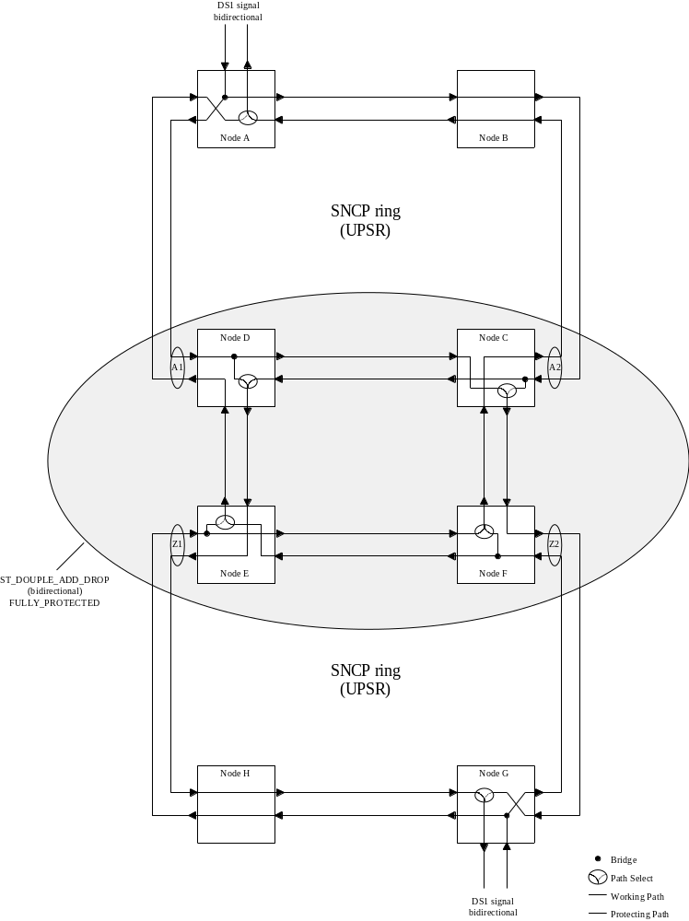
Figure 2-11 - Example Subnetworks Explaining SNC Types ST_DOUBLE_ADD_DROP

To achieve the traffic flow identified with the five subnetworks shown above, the following bidirectional SNCs are required:
- ST_ADD_DROP_A with StaticProtectLevel of Unprotected (and three ports) would be created in node A and node G
- ST_SIMPLE with StaticProtectLevel of Unprotected would be created in node B and node H
- ST_DOUBLE_ADD_DROP with StaticProtectLevel of FullyProtected (and four ports) would be created in the MLSN of C/D/E/F
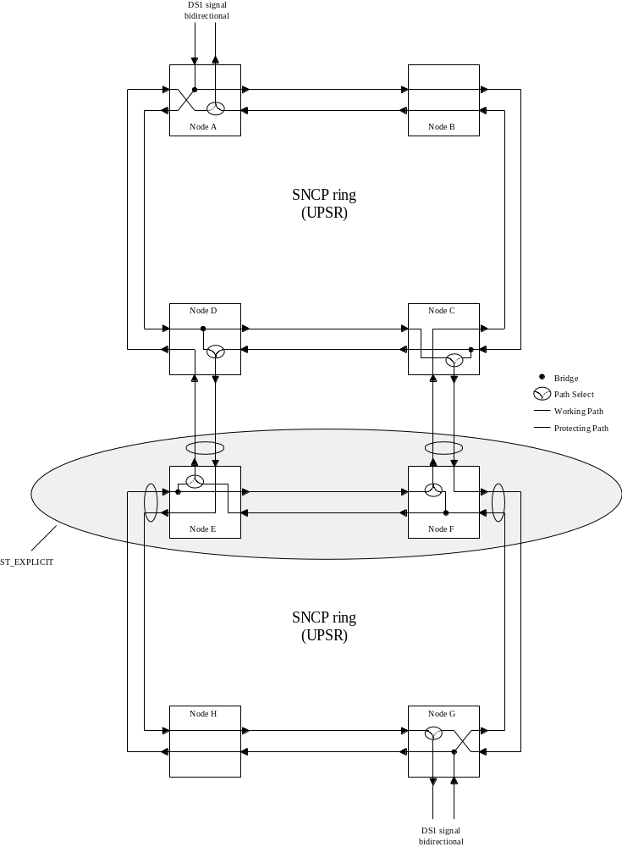
Figure 2-12 - Example Subnetworks Explaining SNC Types ST_EXPLICIT

To achieve the traffic flow identified with the seven subnetworks shown above, the following bidirectional SNCs are required:
- ST_ADD_DROP_A with StaticProtectLevel of Unprotected (and three ports) would be created in node A and node G
- ST_SIMPLE with StaticProtectLevel of Unprotected would be created in node B and node H
- ST_INTERCONNECT with StaticProtectLevel of Unprotected would be created in node C and node D
- ST_EXPLICIT would be created in the MLSN of nodes E/F
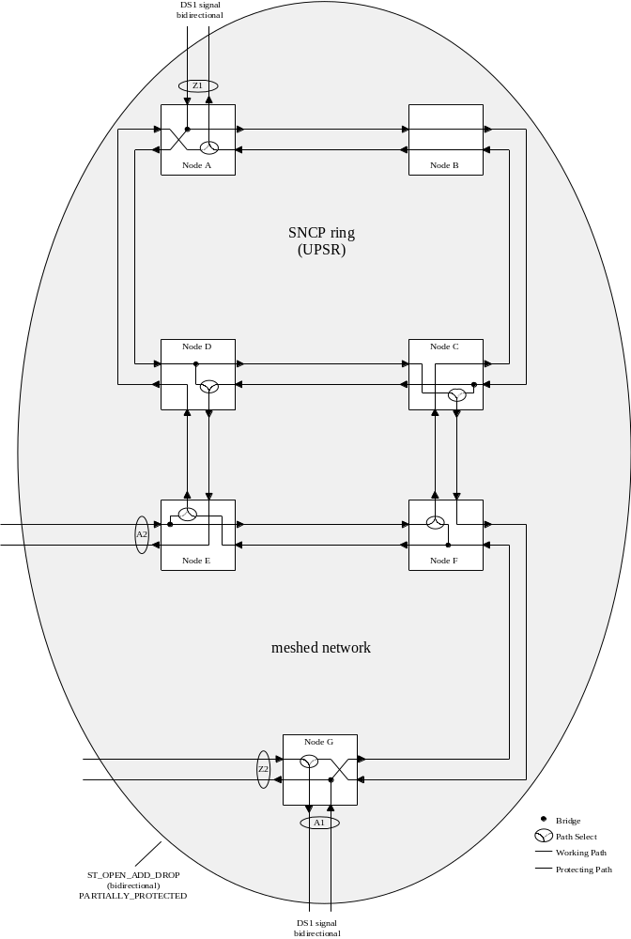
Figure 2-13 - Example Subnetworks Explaining SNC Types ST_OPEN_ADD_DROP

To achieve the traffic flow identified with the subnetwork shown above, the following bidirectional SNC is required:
- ST_OPEN_ADD_DROP with StaticProtectLevel of partially protected would be created in the MLSN of nodes A/B/C/D/E/F/G

Semantic Rules for Aend and Zend
An SNC identifies the TPs that it connects via a pair of lists of points. A single SNC can be described by many A and Zends. There are two distinct styles of SNC, implicit and explicit, that both use the same SNC structure but they use the Aend/Zend lists of the SNC structure in distinctly different ways. The style of SNC is coded into the SNCType value with all but ST_EXPLICIT being implicit in style and structure usage.
For both styles of usage a unidirectional SNCs uses the Aend as the source (transmit) and Zend(s) as the sinks (receive). In bidirectional SNCs the choice of Aend and Zend is determined from the SNC type and in some cases is arbitrary.

Implicit SNC Structure Usage
A number of commonly used SNC external shapes have been identified and each modeled as a specific type that includes a set number of Aend/Zends and that has implicit internal traffic flow semantics (that are documented below).
For the implicit SNC types the Aend and Zend list simply represent the points of entry and exit of traffic on the SNC, the internal flow is conveyed by the type. Some of the SNCs defined as implicit are asymmetric in number of Aends and Zends.
It is expected that these implicit SNCs will cover a majority of the cases of connectivity encountered in the network today. It may be decided in later releases to increase the range of types covered in this way.
The implicit SNCTypes described are:
- ST_SIMPLE
- ST_ADD_DROP_A
- ST_ADD_DROP_Z
- ST_INTERCONNECT
- ST_DOUBLE_INTERCONNECT
- ST_DOUBLE_ADD_DROP
- ST_OPEN_ADD_DROP

Explicit SNC Structure
Unlike the implicit SNC usage, the explicit SNC type has a pairwise matching of the Aends and Zends. The SNC will have an n-entry Aend List and an n-entry Zend List. The tuples are pairwise matched: (A1,Z1), (A2, Z2), ...,(An,Zn). In this manner any arbitrary cross-connect may be described. In some cases, the TP in the Aend List could be a part of the Zend List also.
The SNCType for an explicit SNC is ST_EXPLICIT.

Usage of ST_EXPLICIT
An SNC that may be described using an implicit SNC type may not use the ST_EXPLICIT type. ST_EXPLICIT is to be used to describe all cases of complex SNC that cannot be covered by an implicit type. It is expected that a majority of the cases of use will be complex bi-directional protected SNCs.

Cross-Connect
A cross-connect represents a physical connection within a managed element. A cross-connect is atomic and is identified, similarly to an SNC in a singleton subnetwork, based on its external shape. That is, a cross-connect is identified in this interface by its A end(s) and Z end(s), its “SNC” type, and its directionality.
Other characteristics of SNCs do not apply to CCs. In particular, the static protection level does not apply to CCs, as equipment protection is not modeled by this interface. As well, the SNC state does not apply to CCs as a CC represents a physical connection and not a logical, potential, or reserved set of connections. As such, a CC may only be “active” or “inactive”. A “partial CC” actually corresponds to a different CC in this interface as it has a different external shape (e.g., a “half” bidirectional simple CC is not modeled as a partial CC, but rather as a “complete” unidirectional simple CC).
An “active” CC means that no further intervention on the CC itself is required from the NMS to activate it. The fact that a CC is “active” does not necessarily imply that there is traffic flow on the network.

Protection Relationships in an Implicit SNC – ProtectionRole [optional parameter]
The ProtectionRole parameter is conveyed via the TPParamList (for SNC and cross-connect) and is used to indicate the protection relationship of the Aends and Zends Source TPs.
The ProtectionRole is mandatory for the Source TPs in cases of revertive switch.
The ProtectionRole is optional for the Source TPs in cases of a non-revertive switch. In the non-revertive case the protection role is assigned by the EMS to indicate the Primary from the Secondary TP, where the Primary is the default position of the switch selector.
When applicable, the Source TPs take on one of the following ProtectionRole values:
- PRIMARY The Primary Source TP is where the traffic is switched from.
- BACKUP The Backup Source TP is where the traffic is switched to on failure of the Primary.
In the case when there is no relevant protection role, there will be no ProtectionRole parameter in TPParamList. There is no ProtectionRole for the reliable end (i.e. in case of revertive switch).
The expected usage of ProtectionRole varies with SNCType:
- ST_SIMPLE: No ProtectionRole parameter.
- ST_ADD_DROP_A: Used in Aend.
- ST_ADD_DROP_Z: Used in Zend.
- ST_INTERCONNECT: Used in Aend.
- ST_DOUBLE_INTERCONNECT: Used in Aend and Zend.
- ST_DOUBLE_ADD_DROP: For bi-directional case used in Aend and Zend. For the unidirectional case used in Aend.
- ST_OPEN_ADD_DROP: For this non-symmetrical SNC, the ProtectionRole is used in a mix of Aend and Zend. For bi-directional and unidirectional cases, it is used in the A1 and Z2 ends (that act as the protection for Z1). For bi-directional case, it is also used in the A2 and Z1 ends (that act as the protection for A1).

Independence of SNCType and StaticProtectionLevel

The SNCType describes the externally visible traffic flow from/to the endpoints of the SNC, including how the input signals are combined/selected/broadcasted to generate the output signals.
The StaticProtectionLevel describes how the traffic flow inside the SNC is protected against failures.
These two attributes are independent. For example, an ST_SIMPLE SNC has no externally visible protection (one input goes to one output), but may have a StaticProtectionLevel of FULLY_PROTECTED if the internal path from the input to the output is fully protected. Any single failure inside this subnetwork connection will not result in the failure of the SNC, because, externally, the traffic flow remains the same: one input still goes to one output.
Conversely, an ST_ADD_DROP_A SNC has some built-in “protection functionality” (two inputs go to one selector and the best one is selected as output), but can have a StaticProtectionLevel of UNPROTECTED if the two paths from the two inputs to the output are unprotected. A single failure inside the subnetwork connection will result in the failure of the SNC, because, externally, the traffic flow is affected: one of the input signals is ignored and can not make it to the output signal even if the other input signal has failed.
Note that a failure of an SNC does not necessarily imply failure of the carried traffic, since the SNC may only be a part of a “larger protected connection” that may survive such failures.

Network Routed SNCs
For all subnetwork types other than TOPO_SINGLETON the EMS presents an abstraction of the network that treats a set of NEs as a single manageable entity. When a subnetwork contains more than one NE the EMS (or underlying network components) can perform a routing function to route a requested SNC across the network.

Unidirectional SNCs and Point-to-Multipoint

Models

Unidirectional Model
Both the TP and the SNC support aspects of directionality.
A TP may be unidirectional in function (representing a sink or source) and in addition a bidirectional TP may be solely connected in one of its two directions. Both of these concepts will be represented in the TP.
An SNC may be bidirectional or unidirectional. By convention, the A1 end of the SNC is connected to the source so that the signal flows from A to Z.
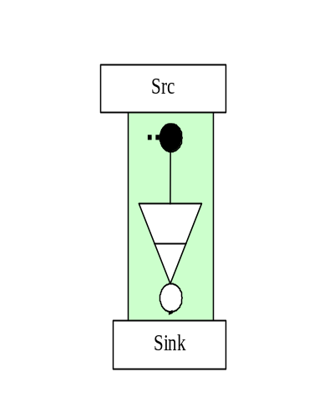
Figure 3-14 –Source and Sink representations
The relationship between the directionality of the PTP and the contained CTPs is shown in the following diagrams.
In the G805 TP model, the Sink and the Src nature of the TP is applicable across the adaptation layers and alternates as we traverse the hierarchy.
In the collapsed model in TMF MTNM Version 2.0, all the layers are not visible. Therefore the Src and the Sink concepts need to be specified as follows:

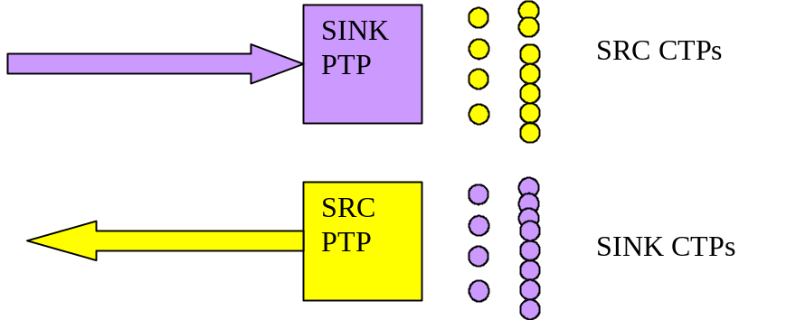
Figure 3-15 – Source and Sink PTPs and CTPs

As shown in Figure 3-15,
A SINK PTP has all of its potential CTPs as SRC CTPs, which can then be used in creating SNCs or to terminate and map.
A SRC PTP has all of its potential CTPs as SINK CTPs, which can then be used in creating SNCs or to terminate and map.
A Bidirectional PTP can have unidirectional CTPs as contained CTPs, but the entire hierarchy below the first unidirectional CTP will have the same directionality. For example, a bidirectional STM4 can have a SRC and SINK VC4 CTP, but all VC12s under the SRC VC4 CTP will be SRC VC12 CTP, and similar relationship between SINK VC4 CTPs and SINK VC12 CTPs.

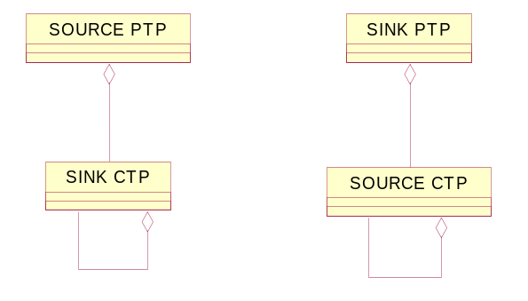
Figure 3-16 – Containment

Point-to-multipoint Model
The point-to-multipoint concept is supported via an overlay model. This model is founded on the recognition that the “legs” of a point-to-multipoint connection are in fact completely independent, the only common aspect being that they share at least the same source. By using individual SNCs to represent the branches of the Point-to-Multipoint connectivity, the issues of sequence of creation and deletion and of migration from a point-point to a point-to-multipoint of other model styles are eliminated. Each SNC is individually managed.

Enhanced Capabilities for point-to-multipoint over the interface
The unidirectional SNC and point-to-multipoint capabilities are supported using the same creation and deletion operations as for bi-directional SNCs.
However, to allow for network environments where point-to-multipoint resources are at a premium, or where the resources benefit pre-connection configuration, a capability to indicate to an EMS that a single point-to-point SNC is the first of many SNCs in a point-to-multipoint configuration will be provided. It should be noted that an EMS should not prevent point-to-multipoint connectivity even if the indication was not provided with the first SNC. This potential future setup indicator capability can be provided in any of the SNC create and delete operations.

Creation and modification of Point-to-multipoint configuration
In order to create point-to-multipoint configurations the existing create SNC operations are used repeatedly to add many uni-directional SNC to a single TP as a source. Uni-directional SNCs may be any of the types listed in this document. In addition, an SNC may be added to any capable TP that is already sourcing one or more SNCs connected at any stage and any of the SNCs involved in a point-to-multipoint may be deleted at any stage.
A single bidirectional TP may be involved as a source in many unidirectional SNCs and as a sink in only one SNC. As a consequence a point-to-multipoint configuration from a bidirectional TP may include one bidirectional SNC.
Setting the transmission parameters at a shared TP of any of the SNCs of a point-to-multipoint configuration will operate on the TP and as a consequence be reflected through all of the SNCs that share that TP.

Preparing the resource for multipoint operation – PotentialFutureSetupIndicator [transmission parameter]
In some cases the network resources may benefit from preparation for point-to-multipoint configuration. To enable the NMS to inform the EMS that an SNC being created is likely to be part of a point-to-multipoint configuration a new transmission parameter has been added (PotentialFutureSetupIndicator). The NMS need not indicate that an SNC is to be part of a point-to-multipoint prior to adding a further SNC, however, not indication the intention to build a point-to-multipoint may cause the EMS/network to have to rearrange resources and potentially hit traffic to satisfy the subsequent requests. The PotentialFutureSetupIndicator transmission parameter is associated with the TPs.

Indicating the degree of tolerable impact – GradeOfImpact [mandatory parameter]
To allow the NMS to indicate to the EMS what level of traffic impact is tolerable when using create&activate to create an SNC or delete&deactivate to delete an SNC and consequently when building/adjusting a point-to-multipoint configuration a new enum has been added GradesOfImpact_T {GOI_HITLESS, GOI_MINOR_IMPACT, GOI_MAJOR_IMPACT}. If the EMS can’t meet the GradesOfImpact requested by the NMS, the operation will fail and an appropriate exception will be raised.

Note: There is no interrelationship between GradeOfImpact and ProtectionLevel.

Retrieval of a Point-to-multipoint configuration
The operation getSubnetworkConnectionsWithTPList populated with the shared point of the point-to-multipoint configuration is used to retrieve all SNCs of a point-to-multipoint configuration that use the TP referenced.

Migration from point-to-point to point-to-multipoint
Assume a Point-to-Point SNC is created, with PotentialFutureSetupIndicator set to "RSU_POINT_TO_POINT" for Source TP. If a second Point-to-Point SNC create&activate operation is sent using the same Source TP, the EMS creates the requested broadcast and changes the value of the Source TP PotentialFutureSetupIndicator to "RSU_BROADCAST". For NEs that do not need any configuration change, the source TP value is set to “RSU_ANY_CONFIG”. No AVC is sent for this parameter.

Comments on deletion
If a point-to-multipoint configuration is applied to a complex subnetwork (such as mesh) it is likely that resources will be shared within the subnetwork between several SNCs of the point-to-multipoint configuration. As a consequence it is the responsibility of the EMS to ensure that deletion of a single SNC does not “damage” other SNCs of the point-to-multipoint configuration. The NMS shall specify the desired GradeOfImpact for this operation.

Subnetworks
A subnetwork is an aggregation of NEs and topological links defined by the EMS. Via the EMS the NMS is able to establish SNCs within the subnetwork.

Creating an SNC in a Subnetwork
An SNC may connect any CTPs in the subnetwork including CTPs that are contained in PTPs that are edgepoints of the subnetwork and also CTPs that are contained in PTPs that are not at the edge of the Subnetwork.

The Mesh Subnetwork
The Mesh subnetwork is used to cover cases where the EMS manages, as a single entity, a number of NEs that are arranged in a complex topology. An EMS may expose multiple MESH subnetworks.

Routing Constraints
A routing constraint can be applied by the NMS and supplied to the EMS during the creation of an SNC.

The routing constraints considered are broken down into three distinct groups:
- Inclusions – to be supported by this release as indicated in the following section
- Exclusions – to be supported by this release as indicated in the following section
- Route Attributes – NOT supported by this release

The constraints identified can be considered for routing of SNCs that are:
- Fully within the span of control of the EMS – to be supported by this release
- Specified with one end outside the span of control of the EMS – NOT supported by this release

In an SNC create operation the NMS may specify inclusion constraints or exclusion constraints but not both inclusion and exclusion.
Routing constraint support is optional in this release. Where an item is indicated as not mandatory, the EMS may throw the exception EXCPT_UNSUPPORTED_ROUTING_CONSTRAINT.

Exclusion
This capability allows the NMS to require the EMS to avoid a particular set of resources when making its routing choices. For example this could allow the NMS to cause an SNC to avoid a PTP that is about to be taken out of service.
As noted above, to be compliant to this interface it is not mandatory for an EMS to support exclusions and an exception has been provided to allow an EMS to reject an SNC create operation that includes exclusion data.

The following exclusions are all optional:
- a list of NEs within the subnetwork
- a list of TPs (PTPs and/or CTPs)
- the resources that are used by a list of previously built SNCs within the subnetwork
- this is clearly qualified to allow the reuse of the resources at the two ends of the SNC within the subnetwork (e.g. same NE and same specified edge PTP).

In this release it is considered sufficient that the resources identified by the NMS to be excluded must not be used by the EMS in the SNC returned, i.e. for an EMS that supports exclusion it is mandatory that all of the items identified in the exclusion list by the NMS must be excluded from the route.

Inclusion
This capability allows the NMS to request that the EMS uses a particular set of resources when making its routing choices. For example this would allow the NMS to prescribe the exact route of an SNC including channels etc.

The following inclusions are all optional:
- A number of lists:
- a list of NEs
- a list of TPs (PTPs and/or CTPs including CTPs of the server layer to SNC being routed)
- a list of specified cross-connects
- additional info
- Giving a degree of description:
- a full route description
- a partial route description
- The NMS will inform the EMS by means of an attribute in the request as to whether the inclusion contains a full route description or a partial route description

The available capacity provided by the direct servers used by an existing SNC (built at the same layer rate as the newly specified SNC) – is NOT SUPPORTED.
In this release it is considered sufficient that the resources identified by the NMS to be included must be used by the EMS in the SNC returned, i.e. the inclusion is mandatory.
It is clearly possible for an NMS to request inclusion of resources that are not necessarily appropriate for use within the requested SNC. The following sections detail cases considered.

Request in an inclusion for inappropriate resources
The following cases should be rejected:
- Resources in the wrong layer
- Resources that do not exist

Request in an inclusion for resources already in use
An NMS may request resources for creation&activation of a bi-directional SNC that are:
- already in use in an existing Active or Partial bi-directional SNC recognized by the EMS
- the request should be rejected if the resource can not be appropriately share by the existing SNC and the new request, for example, a CTP can not be involved in two SNCs at the layer of the CTP, so a request to use the CTP again should be rejected
- involved in a connection in the network but that are not part of an SNC recognized by the EMS
- If the request is for inclusion of a specific cross-connect and the resources in the network are already used in a cross-connect that matches the request exactly (i.e. same points and same SNC type) and the cross-connect in the network is not represented in an SNC known to the EMS, then the EMS shall make use of the cross-connect (i.e. idempotent behavior)
- If the request is for inclusion of a specific cross-connect and the resources in the network are already used in a cross-connect that does not match the request (e.g. wrong SNCType) reject the requested SNC and then produce an SNC including the previously “unknown” cross-connect and provide it to the NMS by normal means (for the NMS to resolve as necessary).

Route Attributes
In addition to the specific individual resources that are used in the routing of an SNC, the overall properties of the SNC also have to be considered. These include the various costs of the route relating to both the quality of the route provided and also to the lost potential for routing other SNCs

Route attributes are:
- Constrain the route cost – NOT SUPPORTED
- equipment cost
- delay
- etc.
Considering that the MTNM model does not include the details of a cost model, it is clearly inappropriate at this stage to include this capability. It has been decided to defer this capability to a later release.

Constraints beyond the span of control of the EMS
Specification of constraints beyond the span of control of the EMS is potentially necessary for Network Routed SNCs. In this document it is considered the multi-route management, useful to provision pre-calculated backup routes by NMS to EMS..

Interaction between constraints
If the inclusion and exclusion list identify the same resources in such a way that the request is effectively invalid, then the request should be rejected.

Network Routing
For SNCs where rerouting is allowed there are a number of cases that need to be considered. These cases are controlled via attributes at the interface.
The following table shows the usage of networkRouted, rerouteAllowed and networkReroute.
Table 3-1: routing attributes usage
Network Routed  Reroute Allowed - Network Reroute | Yes | No | N/A
No (Not allowed to be rerouted from EMS neither the network) | Was last routed in the network | Was last routed by the EMS (or the NMS if full route was specified) | Only valid at creation time (of modification time initiated by modifySNC).  Once the SNC is created, will tell where it was routed
Yes – No (Allowed to be rerouted by the EMS not the network) | SNC was initially routed by the network and no EMS rerouting took place yet | SNC was routed or rerouted by the EMS
Yes – Yes (Allowed to be rerouted by the network only) | SNC was routed or rerouted by the network | SNC was initially routed by the EMS and no network rerouting took place yet
Yes – Not Set (Allowed to be rerouted by either the EMS or the network) | Network Routed indicates who last rerouted the SNC

Actual Route Discovery
Regardless of the routing policy and constraints applied to the network the NMS may choose from time to time to retrieve the route of a particular SNC from the EMS. The EMS shall provide a service to allow the NMS to retrieve the route information for any specified SNC (i.e. it is mandatory that the EMS provides the service and also responds with valid route information. However, it is clearly not mandatory for the NMS to make use of this service).

The route information, in the form of cross-connects, should identify the resources allocated to the SNC at the time of the request and the way in which these resources are used. For example for a resilient SNC that is implemented in the Subnetwork using subnetwork connection protection, all details of the route including normal and alternative paths should be provided. If the SNC is using some form of dynamic rerouting then it is clearly acceptable that only the route includes only the single thread of cross-connects that is supporting the Traffic (as there may be many alternative potential paths that could be selected). Only resources in the layer of the SNC should be identified, so for a VC12 SNC, for example, only cross-connects that deal with passing signals of VC12 characteristic information will be supplied.
A fully detailed explicit route discovery service will be supported in this release.

SNC modification
For this release, the following modification types are foreseen:
- Add / Remove Protection Leg:
the EMS should only try to modify the SNC by applying or removing the legs provided in SNC data. When adding or removing a protection leg, the EMS should compute the differencing of cross connect on the common NE.
- SNC Rerouting:
the EMS should use the routing constraints, if any, to reroute the SNC from end to end.
- Add / Remove Backup Routes:
more routes can be assigned to a given SNC. See related chapter.

Scenarios of Add / Remove Protection Leg

- Change the static protection level from unprotected to fully protected, and vice versa. See Figure 4-17. This configuration is not applicable for singleton subnetworks. The NMS may specify either the full route, a partial route, any routing contraints or nothing.
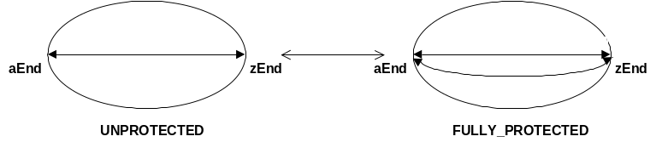
Figure 4-17 – ModifySNC: UNPROTECTED <-> FULLY_PROTECTED

- Change the shape (sncType) from ST_SIMPLE to ST_ADD_DROP and vice-versa with aEnd (or zEnd) as the reliable TP. See Figure 4-18. The NMS may specify either the full route, or only the switch port.
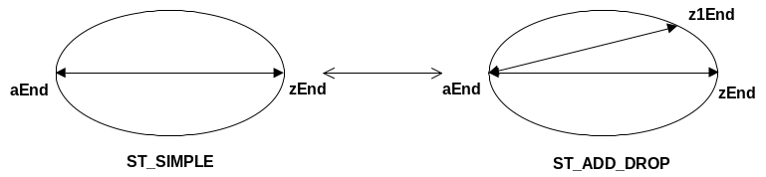
Figure 4-18 – ModifySNC: ST_SIMPLE <-> ST_ADD_DROP; aEnd is reliable TP

- Change the shape (sncType) from ST_SIMPLE to ST_ADD_DROP and vice-versa, where neither aEnd nor zEnd is the reliable TP (the ME with x-conn of type ST_ADD_DROP is ‘in the middle’). See Figure 4-19. This configuration is not applicable for singleton subnetworks. The NMS may specify either the full route, or only the switch port.
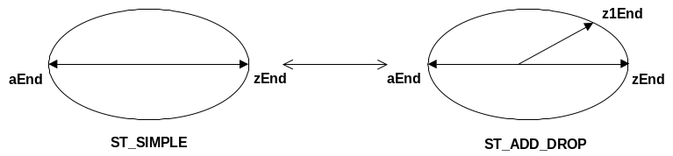
Figure 4-19 – ModifySNC: ST_SIMPLE <-> ST_ADD_DROP; aEnd is not the reliable TP

- Change the static protection level from unprotected to partially protected, and vice versa. See Figure 4-20. This configuration is not applicable for singleton subnetworks. The NMS may specify the full route or just the switch port (in case of add a protection leg) or just the switch cross connect (in case of add and remove a protection leg

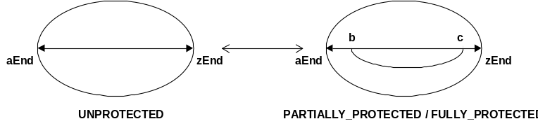
Figure 4-20 – ModifySNC: UNPROTECTED <-> PARTIALLY_PROTECTED

Scenario of SNC Rerouting

The NMS may either specify the full new route or some routing constraints or just invoke reroute without parameters.

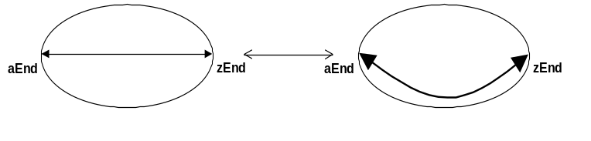
Figure 4-21 – ModifySNC: simple reroute

Scenario of Add / Remove Backup Route

Add/Remove route: one SNC may have more routes, one intended and the others backup. It is possible to add a new route, activate it and deactivate the former route. See also related chapter.

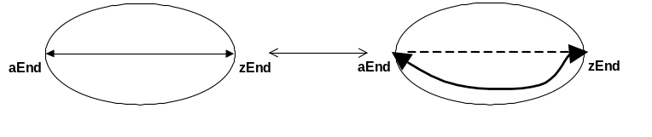
Figure 4-22 –add new route to an SNC

Impacts on Static Protection Level and SNC type
The modification of the SNC’s Static Protection Level does not impact the SNC type. The EMS may support the modification of an unprotected SNC to being a partially, fully or highly protected SNC while maintaining the same SNC type.
Concerning SNC type modifications, the MTNM interface only defines the transitions between ST_SIMPLE and ST_ADD_DROP_A or ST_ADD_DROP_Z to be mandatory.
Note that ST_ADD_DROP_Z bi-directional is new feature of Version 3.
The relation between these four basic modification steps and the corresponding values for SNCType and staticProtectionLevel are shown:

Modification Step |  |  |  | SNCType | staticProtection  Level | ↔ | SNCType | staticProtection  Level
unprotected | ↔ | fully protected |  | ST_SIMPLE | UNPROTECTED | ↔ | ST_SIMPLE | FULLY  PROTECTED
unprotected | ↔ | Y-protected | ↔ | ST_SIMPLE | UNPROTECTED | ↔ | ST_ADD_DROP | UNPROTECTED
Unprotected | ↔ | Y-protected  (‘middle’ branch) |  | ST_SIMPLE | UNPROTECTED | ↔ | ST_ADD_DROP | UNPROTECTED
Unprotected | ↔ | partially protected |  | ST_SIMPLE | UNPROTECTED | ↔ | ST_SIMPLE | PARTIALLY  PROTECTED
Table 4-2: Relationship between SNCType/staticProtectionLevel values

Modification Behaviors
There are two main EMS behaviors when modifying an SNC: preserving or not the SNC name.
If the EMS does not preserve the SNC name, then the EMS will create a new pending SNC from an existing pending or active SNC. It is similar to createSNC but the created SNC is made out an existing one. It is then possible to swap the SNCs, i.e. deactivate the former SNC and activate the new one in one shot.
If EMS supports multiple routes, then it has to preserve SNC name through operations on routes (add/remove and switch).
The nativeEMSName of the new SNC must be the same as the nativeEMSName of the original SNC (the SNC to be modified).

SNC state in case the EMS does not preserve the SNC name
If createModifiedSNC is used:
A new modified SNC will be created in state PENDING. And an Object Creation notification of the newly created (modified) SNC in state PENDING.
The original SNC is left in its original state.
The original SNC to be modified may be in PENDING state or in ACTIVE state.
When swapSNC or modifySNC is used:
SUCCESS:
The original SNC is deleted or moved back to pending depending on the retainOldSNC parameter and the new (modified) SNC is put in state ACTIVE. The following is then notified:
An Object Deletion notification of the original SNC or a SNC state change to partial.
A state change notification of the new (modified) SNC from PENDING to ACTIVE.
The original SNC to be modified must be in ACTIVE state.
FAILURE:
The original SNC could not be removed and/or the new (modified) SNC could not be put in ACTIVE state.
The SNCState for both SNCs will be SNCS_PARTIAL
If the resulting SNC state is PARTIAL, such an SNC can only be set to state ACTIVE by applying operation swapSNC() or modifySNC() again.
During “activation” of an SNC, the TPs of the SNC are configured, and the necessary cross-connects are established for the SNC.
Operation swapSNC() and modifySNC() can be called repeatedly and eventually should succeed (except in conflict cases where the SNC remains in SNCS_PENDING or SNCS_PARTIAL). Should the missing or excess cross-connects be changed in the MEs via a craft interface, for example, prior to communications to those MEs being re-established, the swapSNC() / modifySNC() command ultimately should succeed when communication to the MEs is re-established (even though all cross-connects already exist).

In the following Tables, the state changes related to the operations are shown.
Initial State of SNC to be modified | Operation | Intermediate State | Operation | Final State
PENDING | createModifiedSNC() | PENDING for both | N/A
ACTIVE | createModifiedSNC() | ACTIVE for the old SNC  PENDING for the new SNC | swapSNC() | ACTIVE for the new SNC.  If the retainOldSNC parameter is false, the old SNC has been deleted  If true, the old SNC is left in PENDING
ACTIVE | ModifySNC() | N/A | N/A | ACTIVE
Table 4-3: state changes related to the createModifiedSNC() and swapSNC() operations in case of success

Initial State of SNC to be modified | Operation | Intermediate State of modified SNC | Operation | State of modified SNC
PENDING | createModifiedSNC() | PENDING for the original SNC, N/A for the new one | N/A
ACTIVE | createModifiedSNC() | ACTIVE for the old SNC.  N/A for the new one | swapSNC() | PARTIAL for both
ACTIVE | ModifySNC() | N/A | N/A | PARTIAL for both
Table 4-4: state changes related to the createModifiedSNC() and swapSNC() operations in case of failure

Retaining the old SNC
This parameter in SNCModifyData can be used if the original SNC must be preserved in order to swap back to that SNC at some point in time. It is applicable only in case EMS does not preserve the SNC name.

SNC state in case the EMS preserves the SNC name
If createModifiedSNC is used:
The addressed SNC route is modified. If the SNC was in PENDING or PARTIAL state, then the state is unchanged. If the SNC was in ACTIVE state, then the output state is PARTIAL. In case the SNC has several routes, then the administrative state of the addressed route will always transit to LOCKED state.
If modifySNC is used:
SUCCESS:
SNC state is set to ACTIVE. In case the SNC has several routes, then the administrative state of addressed route is set to UNLOCKED.
This operation cannot be applied to a PENDING SNC .
FAILURE:
SNC state is set to PARTIAL. In case the SNC has several routes, then the addressed route administrative state is anyway set to UNLOCKED.

During “activation” of an SNC, the TPs of the SNC are configured, and the necessary cross-connects are established for the SNC.

Operation activateSNC(), modifySNC(), switchSNC() can be called repeatedly and eventually should succeed (except in conflict cases where the SNC remains in SNCS_PENDING or SNCS_PARTIAL). Should the missing or excess cross-connects be changed in the MEs via a craft interface, for example, prior to communications to those MEs being re-established, the activateSNC()/modifySNC()/switchSNC() command ultimately should succeed when communication to the MEs is re-established (even though all cross-connects already exist).

In the following Table 4-5 and Table 4-6 the state changes related to the operations are shown, in case SNC has only one route.

Initial State of SNC to be modified | Operation | Intermediate State of modified SNC | Operation | Final State of modified SNC
PENDING | createModifiedSNC() | PENDING | activateSNC() | ACTIVE
ACTIVE | createModifiedSNC() | PARTIAL | activateSNC() | ACTIVE
ACTIVE | ModifySNC() | N/A | N/A | ACTIVE
Table 4-5: state changes related to the createModifiedSNC() and activateSNC() operations in case of success

Initial State of SNC to be modified | Operation | Intermediate State of modified SNC | Operation | Final State of modified SNC
PENDING | createModifiedSNC() | PENDING | activateSNC() | PARTIAL
ACTIVE | createModifiedSNC() | PARTIAL | activateSNC() | PARTIAL
ACTIVE | ModifySNC() | N/A | N/A | PARTIAL  If no XCs are activated, the SNC state is not-existing
Table 4-6: state changes related to the createModifiedSNC() and activateSNC() operations in case of failure

An already active SNC can be modifyActivated again; the EMS is allowed to not send the commands to the ME a second time for the cross connect establishment however the commands may be sent for the transmission parameters. While in SNCS_PARTIAL state, it is possible to activate a modified SNC again, this corresponds to a retry.

TolerableImpact
In addition tolerableImpact and tolerableImpactEffort (of type ProtectionEffort_T) for the purpose of qualifying the conditions under which an SNC modification may be performed, are provided as parameters of the operation.
Parameter tolerableImpactEffort is a qualification of the requirement that the tolerableImpact as specified, is met.
The NMS may ask for different grades of impact. The EMS can only verify the intent of whether the grade of impact could be met. In actuality when commands are sent to the network, unforeseen circumstances could make a hitless request to fail, causing some service hit. Other times, NMS could accept a major impact, where the EMS can disconnect and connect if suitable tolerableImpact is requested.

Route Change
A route change is notified using the existing NT_ROUTE_CHANGE notification in case operation createModifiedSNC() does not result in exception.
Field “route” of the route change event may then be set to emptyList. Persistency of the NT_ROUTE_CHANGE notifications are expected to be maintained at the same level as other configuration change notifications.

Multiple Route Management
MTNM V2 definition allows the (implicit) association between a SNC and only one route.
MTNM V3 allows to define, for a given SNC, its NOMINAL or INTENDED route, plus zero, one or more BACKUP routes.
The INTENDED route could be defined as the preferred, or default route for a given service. Practically, the intended route could be simply the first time provisioned route, or the preferred route for a number of factors, from network engineering to intrinsic media reliability.
The BACKUP or ALTERNATIVE route (from now on “bkp route”), which is partly or totally different from intended (but with same end points), is useful mainly for restoration and maintenance purposes.
Concerning the “SNC management mode of operation”, it is considered the case of “pending state supported” and “sharing of cross-connects not supported”. Anyway it is possible to include the case of “pending state not supported”, but EMS shall be able to e.g. create&activate a bkp route in a hitless way – which could also imply the capability of cross connects sharing.

The following figures show some examples of restoration scenarios involving SNCs with 2 routes, the INTENDED and BACKUP ones:

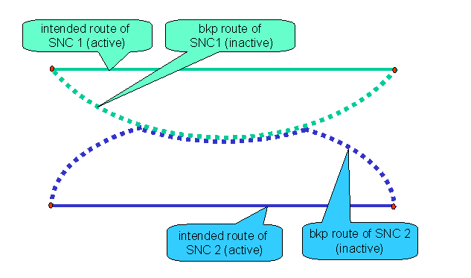
Figure 5-23 - sharing of inactive backup routes, no failures

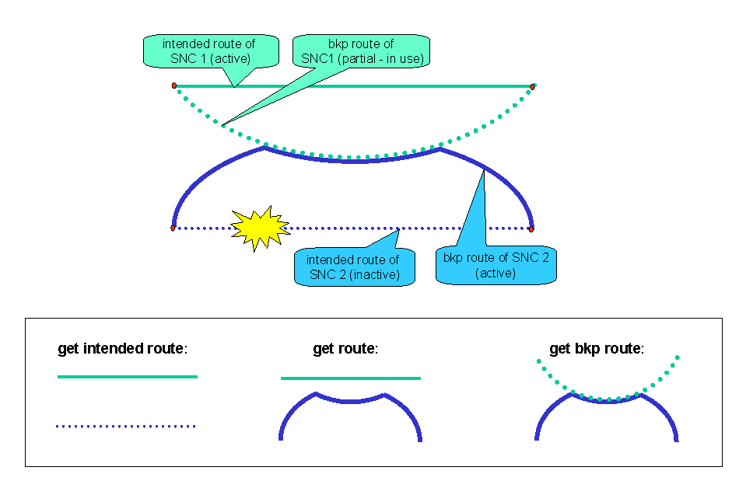
Figure 5-24 - sharing of inactive backup routes, failure on high prio SNC

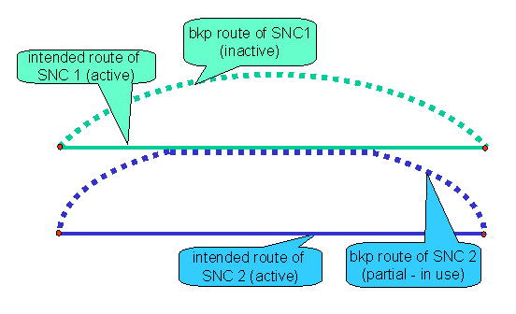
Figure 5-25 - sharing of intended route, no failures

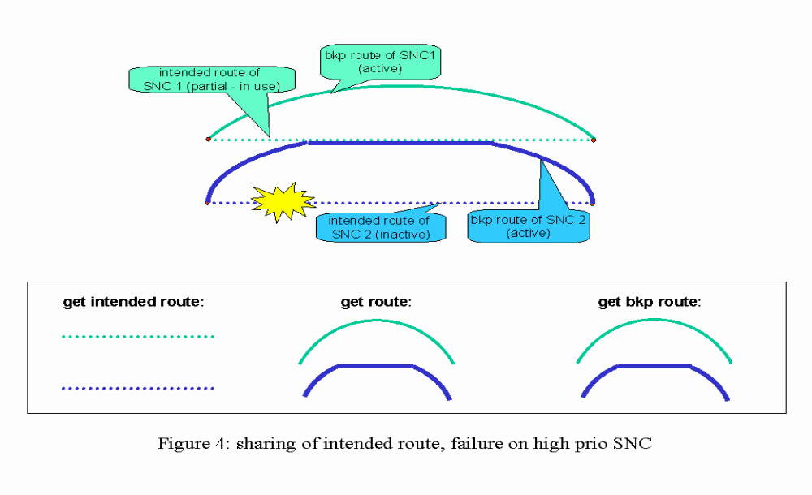
Figure 5-26 - sharing of intended route, failure on high prio SNC

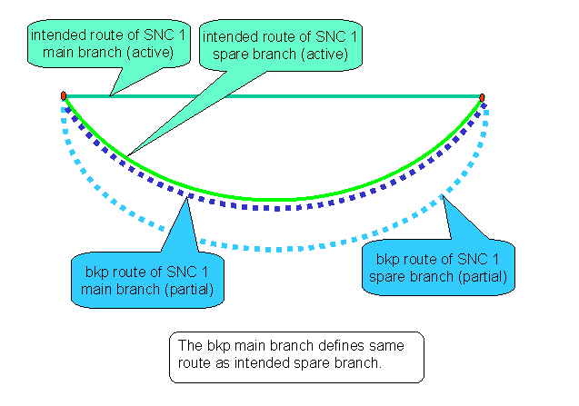
Figure 5-27 - SNCP protected SNC with backup route, no failures

Note that in Figure 5-27 the SNC 1 is an end to end protected SNC via SNCP. According to current definitions, the route retrieved by getRoute() operation includes both the main and spare branches, so both branches are marked as “current”.

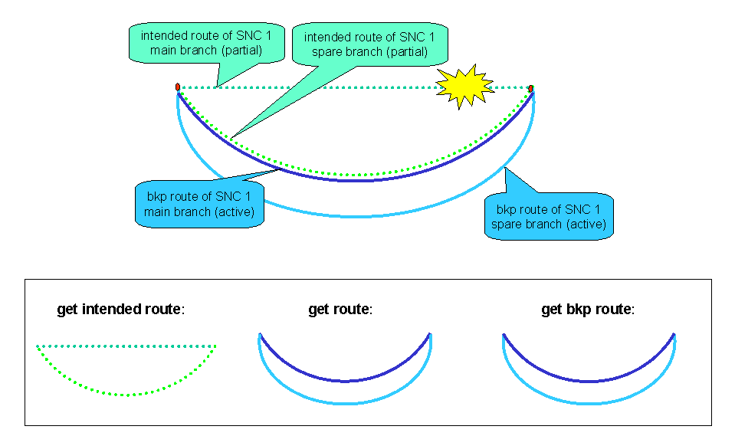
Figure 5-28 - SNCP protected SNC with backup route, failure on main branch

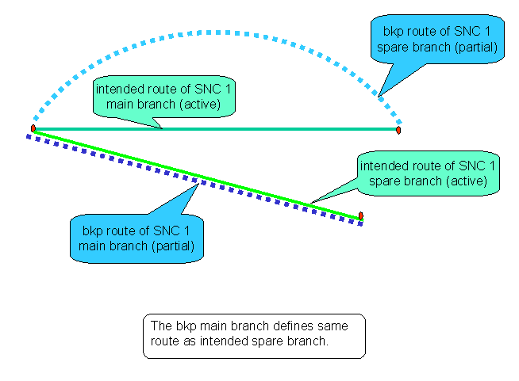
Figure 5-29 - Add Drop SNC with backup route, no failures

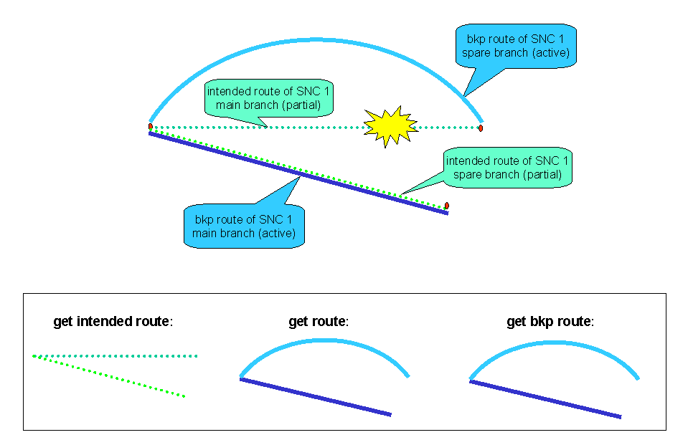
Figure 5-30 - Add Drop SNC with backup route, failure on main branch

In the following table the state changes related to the SNC modifications are shown, in case SNC has more routes.

Initial State of SNC to be modified | Initial State of route to be modified | Operation | Intermediate SNC State | Intermediate route State | Operation | Final State of SNC to be modified | Final State of route to be modified
PENDING | LOCKED | createModifiedSNC()  addressing the intended or bkp route | PENDING | LOCKED | activateSNC() | ACTIVE | UNLOCKED
PARTIAL | UNLOCKED  or LOCKED | createModifiedSNC()  addressing the intended or bkp route | PARTIAL | LOCKED | activateSNC() | ACTIVE  Restoration process may switch the routes so activating the just modified one | UNLOCKED
ACTIVE | UNLOCKED  or LOCKED | createModifiedSNC() | PARTIAL | LOCKED | activateSNC() | ACTIVE | UNLOCKED
ACTIVE | UNLOCKED  or LOCKED | modifySNC() | N/A | N/A | N/A | ACTIVE | UNLOCKED
Table 5-7: state changes related to the createModifiedSNC(), modifySNC() and activateSNC() operations in case of successful activation of the SNC

In the following table the state changes related to the addition and removal of SNC routes are shown.

Initial State of SNC to be modified | Initial State of route to be added | Operation | Intermediate SNC State | Intermediate route State | Operation | Final State of SNC to be modified | Final State of route to be modified
PENDING | Not existing | addRoute() | PENDING | LOCKED | activateSNC()  switchSNC()  is refused | ACTIVE | UNLOCKED
PENDING | Not existing | addRoute() | PENDING | LOCKED | setAdminSt = UNLOCKED  switchSNC() is refused | ACTIVE | UNLOCKED
PARTIAL | Not existing | addRoute() | PARTIAL | LOCKED | activateSNC()  or  setAdminSt = UNLOCKED | ACTIVE  this time activation succeeded | UNLOCKED
ACTIVE | Not existing | addRoute() | ACTIVE | LOCKED | activateSNC()  or  setAdminSt = UNLOCKED | ACTIVE | UNLOCKED
Table 5-8: state changes related to the addRoute successful operation

Next table shows the meaning of route attribute “intended”:

route attribute | meaning | behavior
INTENDED = true | the route is the intended, or nominal, or default one. There can be only one intended route per SNC | In case the SNC is “revertive”, then the restoration process will always switch to this route if possible, i.e. if there are no failures or if the intended route is not locked.
INTENDED = false | the route is a backup one. There could be zero, one or more backup routes per SNC | The route is considered as protection route, available in case of failure.  By means of setIntendedRoute() it is possible to set the addressed route as intended, and so the formerly intended route is now a backup route
Table 5-9: route attribute “intended”

Next table shows the meaning of ACTUAL route states, valid either the PENDING state of SNC is supported or not:

route ActualState | XCs
INACTIVE | None of its XCs is active in the network.
ACTIVE | all its XCs are active in the network. So it is the route where SNC traffic is currently carried.  inUseBy shall be always false
PARTIAL | one or more, but not all the XCs are active in the network.  - If the route was unsuccessfully activated, then inUseBy shall be always false.  - If the route was unsuccessfully deactivated, then inUseBy could be true.
Table 5-10: route Actual State

Note: for efficiency reasons, in some implementations a route can be moved to PARTIAL actual state, so its activation, either by NMS or by restoration process, will be faster.

Next table shows the meaning of ADMINISTRATIVE route states, valid either the PENDING state of SNC is supported or not:

route AdministrativeState | Meaning | Changeable by
LOCKED | The route is not allowed to be active. | setRoutesAdminState()  if all the routes of a given SNC are set to locked, the SNC transits in PENDING state.  - createSNC() creates one locked intended route  - deactivateSNC() locks all routes  - addRoute() creates one locked backup route  - createModifySNC() modifies the addressed route, which transits to locked  Note for createModifySNC(): the SNC will transit to PARTIAL state, because the just modified route was never unlocked/activated before, and the old route is still ACTIVE in the network. So the SNC PARTIAL state means that an activateSNC or route unlock operation is needed.  Moreover, it is not possible to determine the actual route of the SNC in the network once the route was modified.
UNLOCKED | The route is allowed to be active | setRoutesAdminState()  If a route was modified by createModifySNC(), then setting it to unlocked implies the (possible) activation of the new route. It is up to the EMS/network to activate or not the just unlocked route, according to failure scenario, revertive behavior, etc.  If the activation is successful, (route actual state is ACTIVE) then also the SNC will transit to ACTIVE.  If a locked route of a PENDING SNC is set to UNLOCKED, the SNC will transit to either ACTIVE or PARTIAL.  - createAndActivateSNC() creates and unlocks the intended route  - activateSNC() unlocks all routes  - switchRoute() is a “manual” switch, so no route is locked or unlocked.  - modifySNC() modifies and unlocks the addressed route  - deleteSNC() fails if at least one route is unlocked
Table 5-11: route Administrative State

Call and connection

The deployment of the ASON/GMPLS enhanced network is a complex and stepped procedure; in fact a new Network Manager is actually introduced.
Apart from totally “green field” scenarios, it is possible to envisage that:
- existing “legacy” networks will move to ASON only some subnetworks (technology consolidation), hence traditionally managed SNCs and ASON driven Connections would coexist for some significant time.
Such mixing is likely to occur even inside the same Managed Element.
- Existing NMS, EMS will not be obsolete by the new ASON approach.
The above considerations implies that the management interface shall include both “legacy” Subnetworks and “new” Routing Areas, with their SNCs and dynamic Call/Connections.
To minimize the impact to existing software (interface, GUI, data bases, etc.), and to prevent, from the beginning, the risk that real MTNM implementations will diverge, the MultiLayer Subnetwork (MLSN) and the SNC managed object classes have been reused to represent Routing Area and Connection, respectively, in the Solution Set specification.
This section explains also the different usage of the MLSN and the SNC in a Control Plane and non Control Plane environment.
With respect to the Call, a new 2nd class object has been defined, to represent:
- the Call in the Control Plane enhanced networks, i.e. according G.8080 definition. A Call may include zero, one or more Connections.
- the Call as a mean to represent the connectivity supplied by server trail(s) of Ethernet layer network. In other words, the Call is used to represent the virtual topology at Ethernet layer, it is coincident with the Ethernet Topological Link. Also in this case, the Call may include one or more Connections.

Control Plane Call
The call structure is the abstraction of a call. G.8080 defines a call as the association between endpoints that supports an instance of a service.
In the Control Plane environment, an end-to-end call is considered to consist of multiple call segments, depending on whether the call traverses multiple domains (signalling, routing or recovery domains included). For purposes of this interface call and call segments are identical.
Call Operations can only be done by the EMS that controls the call; this is by the EMS that controls the originating points of the call.

Call specific attributes

Call Identifier
This attribute represents the identifier used by Control Plane, according to G.7713 “Call Name” definition. This identifier is only used for control plane signaling.

Call State
The call state has dependency upon the state of the associated connections. This dependency is related to call type and policy.
The state values are:
- IN_PROGRESS: The supporting Connections are currently being created
- ESTABLISHED_IN_SERVICE: All the supporting Connections have been created successfully
- ESTABLISHED_IN_SERVICE_SEARCHING: A Call has been modified through the addition of Connections and not all new Connections have been successfully created.
May not be valid for Calls defined in non-Control Plane context.
- ESTABLISH_OUT_OF_SERVICE: All Connections have failed and they are not being restored
- ESTABLISHED_OUT_OF_SERVICE_SEARCHING: All Connections have failed and they are currently being restored
- ESTABLISHED_IN_SERVICE_DEGRADED: The number of failed connections has reached or exceeded the degraded threshold AND the severely degraded threshold has not been reached or exceeded
- ESTABLISHED_IN_SERVICE_SEVERELY_DEGRADED: The number of failed supporting Connections has reached or exceeded the severely degraded threshold (in case of LCAS support)
- ESTABLISHED_IN_SERVICE_DEGRADED_SEARCHING: At least one supporting Connection has failed (in the case of LCAS support) AND the severely degraded threshold has not been reached or exceeded
- ESTABLISHED_IN_SERVICE_SEVERELY_DEGRADED_SEARCHING: The number of failed supporting Connections has reached or exceeded the severely degraded threshold (in case of LCAS support)

Profile of Call Parameters
This attribute includes conditions and qualifiers to support a class of service for the call. (E.g. qualifiers that describe LCAS based services).

- severelyDegradedThreshold: Indicates the threshold that qualifies the call as severely degraded in a VCAT environment. Default Value is "1", which is to say that if 1 connection supporting the call is failed, then the call transits into ESTABLISHED_IN_SERVICE_SEVERELY_DEGRADED (or / _ SEARCHING) state.
- degradedTreshold: Indicates the threshold that qualifies the call as degraded in a VCAT environment. Default Value is "1".
- classOfService: The class of service of the Call. This parameter applies only to an established call and shall be ignored during call creation in a VCAT environment.
- classOfServiceParameters: Includes parameters specific to Class of Service. They are only relevant to an established call and shall be ignored during Call Creation in a VCAT environment.

Diversity parameters
These attributes provide the information on corouting and diversity (link and node) for the call. A call may have No Diversity or Link Diversity and/or Node Diversity.

Non-Control Plane Call
The Call managed object class has been introduced to model connectivity schemes also outside ASON/GMPLS enhanced networks. In fact it is used to model VCAT schemes, where the actual connectivity is implemented by one or more trails which are concatenated just at the boundary of the layer network.
Furthermore, the Call creates a topological link in the client Ethernet virtual topology. For example, a Call describing an SDH VCAT scheme, which has GFP/Ethernet as supported client, can be considered as an Ethernet topological link.

Multi Layer Routing Area
The MLSN 2nd class object of Solution Set is also used to represent a Multi Layer Routing Area, which is the routing domain managed by proper Control Plane controller. Release 3.5 of this interface foresees two or at most three levels of routing hierarchy, with a unique instance of top-level Routing Area, with its subordinates Routing Areas (three level hierarchy, Figure 6.31) or Routing Nodes (two level hierarchy, Figure 6.32).
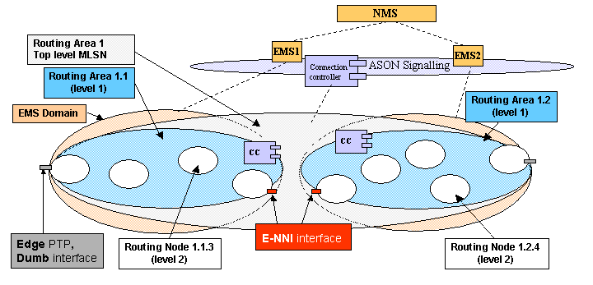

Figure 6.31 – Three level hierarchy of MLSN/MLRA

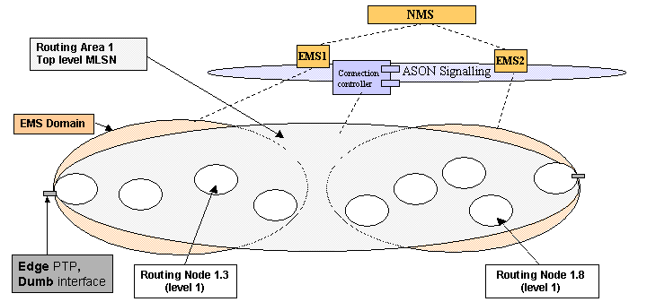

Figure 6.32 – Two level hierarchy of MLSN/MLRA

The top level Routing Area 1 is presented as a unique bubble, as it is from functional point of view, but of course at NMS-EMS interface there is a top level MLSN/RA instance per each EMS domain, i.e. per each interface instance. Then the subordinate MLRAs RA1.1 and RA1.2 (three level hierarchy, Figure 6.31) or just the Routing Nodes (two level hierarchy, Figure 6.32) are shown. Release 3.5 foresees a 1:1 relationship between a Routing Node and a Managed Element.
Through the interface, it is possible to address the top level MLSN/RA to get resources even external to the local EMS domain. This is allowed by the signalling implemented in the Top-level Routing Area, across E-NNIs.
Concerning Transport Plane resources, the EMS domain seen at NMS-EMS1 interface has visibility only within local EMS domain, e.g. it is not possible to get PTPs of an ME within EMS domain 2.

Multi Layer Routing Area specific attributes

Routing Area Level
This attribute allows identifying the level the MLSN instance belongs with respect to routing hierarchy. MTNM Release 3.5 foresees up to three levels, hence the attribute allowed values are:
- RoutingNodeLevel
- IntermediateLevelRA
- TopLevelRA
It is foreseen only one instance of TopLevelRA MultiLayer Subnetwork, given the fact Control Plane is very likely introduced to unify networking capability, allowing to deploy just one mesh subnetwork at top level.

Superior MLRA
This attribute allows identifying the name of superior MLSN/MLRA object instance with respect to routing hierarchy.

List of Layered Routing Areas
This attribute allows identifying the routing areas at each layer network. It is a Name Value Pair List formed by RA Control Plane identifier and Layer.

Supporting ME Name
This attribute is meaningful only when RoutingAreaLevel = “RoutingNodeLevel”, and allows identifying the Managed Element name supporting the Routing Node.

SRG
This attribute lists the Shared Risk Groups the MLRA / MLSN is involved.

Connection
The SNC 2nd class object of Solution Set is also used to represent a connection supporting a call in the Control Plane. The connection represents the relationship between subnetwork points (SNP). A connection may encompass a sequence of connections (or a sequence of SNCs in the non-control plane context) and thus create a recursive relationship across the routing hierarchy. The top level connection represents the connection at the highest level of recursion. Note that a Call may have one or more parallel top-level connection(s).

SNC attributes
aEnd, zEnd attributes of the SNC object provide the list of CTP/FTP/GTP of a non-control plane SNC, while in a control plane connection, these attributes shall represent the end points of the Connection in the control plane name space, i.e., the values shall identify SNPs or SNPPs. Optionally, the connection end points may be also represented by TNA/FTP/CTP values. In the SS these values are provided by the following attributes: aEndTPList, zEndTPList.

Connection specific attributes

Maximum Cost
This attribute represents the maximum link/node cost allowed for routing.

Route Group Label
This attribute shall represent the route group of the connection, for the specification of diversity / corouting constraints.

Connection Set Up Type
This attribute allows identifying if the connection represents a
- Permanent Connection, i.e. a connection provisioned by Management Plane to Data Plane (hence a “traditional” or “legacy” SNC but created in a Control Plane controlled subnetwork),
- Soft Permanent Connection, i.e. a connection provisioned by Management Plane to Control Plane
- Switched Connection, e.g. a connection provisioned by signalling at UNI side.

Call Id
This attribute allows identifying the identifier of the call the connection belongs. Such call identifier is the identifier used by Control Plane, according to G.7713 “Call Name” definition.

Call Name
This attribute indicates the Call Name which the connection is supporting in a non control plane case.

Connection Id
This attribute allows identifying the identifier of the connection, used by Control Plane, according to G.7713 “Connection Name” definition.

Supported Connection Name
This attribute indicates the Connection Name (i.e. its superior connection) which the connection is supporting in a non control plane case. Note that this superior connection must be defined in a top level MLSN – which allows identifying it with a simple string – RDN value..

Connection State
This attribute allows identifying the state of the connection. Note that this state is alternative to the SNC state attribute, and may have one of the following values: “Complete”, “Searching” or “N/A”. A connection is in “Searching” state when Control Plane is building its route in the Data Plane. Once the route of the Connection has been successfully established in the Data Plane (as far as Control Plane declares such successful routing), the state transits to “Complete”.

SRG
This attribute list the Shared Risk Groups the Connection is involved.

Call and Connection discovery in Control Plane context
As far as a Control Plane enhanced network is concerned, the visibility available to EMS may be different from the “legacy” case, where the EMS directly controls, by definition, its whole domain with “white box” view. When CP is deployed, depending on the amount of information signalling is able to provide, and depending on which part of the CP managed network is addressed, detailed or “opaque” information is available to EMS. Hence a new set of management operation has been designed, to cope with the particular scenario where CP acts as mediation OS for the Data Plane management.

Hierarchy of Multi-Layer Subnetworks
Given the unique instance of top-level MLRA, the following operation allows retrieving the subordinate MLRAs, which can be either Routing Areas (subnetworks) (case of three levels hierarchy) or Routing Nodes (case of two levels hierarchy). In other words, with this operation NMS can discover all the Routing Areas (subnetworks) managed by Control Plane.

- Get All Subordinate MLRAs (MLSNs)
The operation will reply the MLSNs (which represent MLRAs) including Routing Nodes that are one level subordinate to the MLSN provided as an input.
The containment hierarchy of MLSNs representing a MLRA is reflected only by the result of this operation, as the containment hierarchy of MLSNs is not reflected in the name of MLSN 2nd class object. The subordinate MLSN(s) are replied, regardless the addressed MLSN is directly managed or not by the EMS (the EMS does not manage the MLSN but it can access the related control plane information).
If the operation is addressed to a MLRA of Routing Node type, which is at the bottom of the routing hierarchy, the result is an empty list.
If the operation is addressed to a non control plane Multi Layer Subnetwork, the operation is rejected and an exception is raised.

Call and Connections Inventory
Given the unique instance of top level MLSN/MLRA, the following operation allows retrieving all the Calls and associated top level Connections:
- get All Calls And Top Level Connections (top level MLRA)
This operation retrieves all details of the Calls and associated Top Level Connections in the scope of a specified MLSN which represents a top level MLRA, Control Plane controlled.
An EMS will only return the Calls and top level Connections that it controls the Originating Point of. By implication this informs the NMS which EMS controls each Call.
Once NMS knows which EMS controls each Call, it is then allowed to perform further operations to retrieve route details.
With reference to the Ethernet scenario, i.e. not controlled by control plane, the following operation is available:
- get All Calls And Top Level Connections And SNCs
which replies all the Calls, top level connections and subordinate SNCs associated with a subnetwork. This operation does not apply to control plane enhanced subnetworks.

Finding the detailed route of Connections
Given the (usually) distributed implementation of Control Plane Components, plus the fact that the EMS domain may be smaller than CP routing domain, the details of connection route may not be always available. For example, little or null information may be available to EMS for the part of connection route which is remote with respect to EMS domain. This because signalling between Routing Domains may support very limited information concerning both the remote topology and then the details of remote route (also called “untrusted E-NNI”). The following figures show the untrusted and trusted E-NNI scenarios.

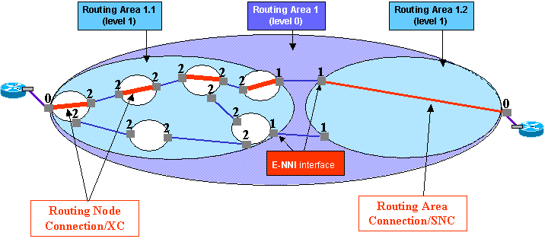
Figure 6.33 - Route retrieval, untrusted E-NNI

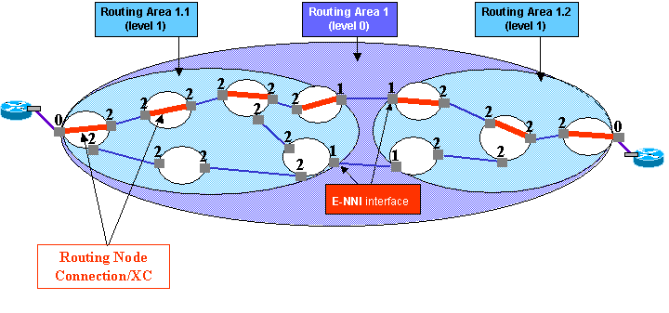
Figure 6.34 - Route retrieval, trusted E-NNI

In Figure 6.33 it is shown Routing Area 1.1, which is fully managed by a given EMS (i.e. EMS domain fully includes RA1.1), and the “opaque” view of the topology of Routing Area 1.2. In fact, E-NNI signalling communicates just the TNAs (reachability information) of RAs 1.2 and 1.3 to the CP Components of RA1.1. Hence the route of a Connection spanning e.g. RA1.1 and RA 1.2 will include all details (XCs) within RA1.1, and just entry/exit points of RA1.2. This of course applies at the management interface of the EMS which fully manages RA1.1. Another EMS, which e.g. fully manages RA 1.2, will not see details of RA1.1 internal topology.
In Figure 6.34 it is shown a trusted E-NNI, where e.g. EMS1 is allowed to communicate to NMS the details of end-to-end Connection, because signalling carries all details of RA1.2 topology and connectivity. Please consider that such two scenarios are the extreme cases, intermediate cases are also possible, i.e. where summarized information is signaled E-NNI side.
The available operations are:
- getAllSubordinateRAidsWithConnection
This operation provides a way for the NMS to retrieve the identifiers of the subordinate routing areas, at the lower partitioning level (N-1 level) and which are known to be involved in the route of a Connection at the level N.This operation allows the NMS to provide a filter input parameter to retrieve the subordinate Routing Areas for only the actual route, or only the home/intended route, or both. This operation result is not recursive.This operation has been designed to operate in a 3 level hierarchy, i.e. where the top level MLRA contains subordinate MLRAs, and such subordinate MLRAs contain Routing Nodes. This operation can only be addressed to a top level routing area. Depending on the signalling used in the network, the EMS will indicate whether the response is a "Full" description of the route or a "Sparce" description:
Full: The control plane component at the originating point of the connection has a full view of all of the ids of the routing area one level subordinate to the top level routing area involved in the connection. In this case the NMS can simply interrogate the EMSs for each routing area returned in any order to find out the detail routes of each routing area.
Sparce: The control plane component at the originating point of the connection can only provide the id of the local routing area, the next neighbour and the destination routing area (and can not provide the identifiers of any other routing areas along the route).
For the "Sparce case" the NMS will follow the route (i.e., starting from the originating routing area and progressing along the route to the subsequent routing areas ) and use "getConnectionsAndRouteDetails()" to find out the detail routes of each routing area. The output of this operation has the following characteristics:
The MLRA List is empty if there is not MLRAs for the requested intended or actual route or if the MLRA is a MLRNode. There may be no Home/Intended route in the case where none was provisioned.There may be no Actual route where the connection is searching or the actual route traverses a different MLRA to the Home/Intended route. For an SNCP connection, the replied Home/Intended route will always include both main and spare legs of the SNCP protection, while the replied actual route may return only one leg, if only such leg is currently active in the network. The route is described in full across the MLRA regardless of sharing of same Routing Node Connections among distinct routes of the same Call.

- get Connections And Route Details (Call, MLRA)
This operation provides the NMS with the routes of the connections that support top level connections of the referenced Call. The request may be tailored by the following allowed input combinations.
In the case of a 2 level routing area hierarchy:
- CallID only: the EMS should return the top level connections supporting the call and their detailed routes.
- CallID and sNPOrSNPPID: The EMS should return the routes for the connection(s) that originate from the referenced SNP or SNPP for the referenced call. If the SNP or SNPP is at the hierarchical level of a routing node, then the response is an empty list.
In the case of a 3 level routing area hierarchy
- CallID only: The EMS should return the routes for all connections that support any top level connection of the referenced call, for all MLRAs directly managed by the EMS.
- CallID and mLRAName: The EMS should return the routes for all connections within the referenced MLRA that support any top level connection of the referenced call (there could be more than one top level connection for the same call passing through an MLRA). If the referenced MLRA is a routing node, then the response is an empty list. If the reference MLRA is the top level MLRA then the response will only include a list of all of the top level connections supporting the call.
- CallID and sNPOrSNPPID: The EMS should return the routes for the connection(s) that originate from the referenced SNP or SNPP of the referenced call. If the SNP or SNPP is at the hierarchical level of a routing node, then the response is an empty list. If the SNP or SNPP is at the top level then the response will only include a list of all of the top level connections, that originate from the specified SNP(P), supporting the call.
In all cases the output is filtered appropriately by routeType. All Routing Node Connections for a particular route will be returned regardless of any sharing of the same Routing Node Connections among distinct routes of the same Call.
Optionally the response may include the edge and internal MLSNPP Links.
Note: given an SNCP scheme, the replied home route will always include both main and spare legs of the SNCP protection, while the replied actual route may return only one leg, if only such leg is currently active in the network. Once the CP routing succeeds to activate the spare leg, then both legs are replied when actual route is asked.

Version 3.0 operations with restrictions concerning Call and Connections
To split the management operation dedicated to “legacy” SNCs from the newly introduced operations for the SNC/Connection management, the following operations are not usable in a Control Plane context.
More precisely, the following operations are rejected if the MLSN represents a MLRA in the control plane:
- getAllTopologicalLinks, getAllTopologicalLinkNames

The following operations are rejected if the MLSN represents a MLRA in either control plane or non control plane:
- getAllEdgePoints, getAllEdgePointNames
- getAllSubnetworkConnections, getAllSubnetworkConnectionNames
- getAllFixedSubnetworkConnections, getAllFixedSubnetworkConnectionNames, getAllFixedSubnetworkConnectionsWithTP, getAllFixedSubnetworkConnectionNamesWithTP
- createSNC, createAndActivateSNC, checkValidSNC
- createTPPool, getAllTPPools, getAllTPPoolNames

The following operations are rejected if the SNC represents a Connection in the Control Plane:
- getroute, getRouteAndTopologicalLinks, getBackupRoutes, switchRoute setIntendedRoute, setRoutesAdminState, getIntendedRoute, addRoute, removeRoute
- getSNCsByUserLabel, activateSNC, swapSNC, deactivateSNC, deleteSNC, deactivateAndDeleteSNC, createModifiedSNC, modifySNC

The following restriction applies to getAllSubnetworkConnectionsWithTP, getAllSubnetworkConnectionNamesWithTP:
- In case the addressed TP is actually included in more than one multi-layer subnetwork, then only SNCs that are in an MLSN that does not represent an MLRA are returned by this operation. For example if a request is made for VC4 and VC12 SNCs in the case where the VC4 layer is controlled by the Control Plane and the VC12 layer is controlled by a traditional NMS then only VC12 SNCs will be returned regardless of the presence of VC4 connectivity

The following restriction applies to getAllManagedElements, getAllManagedElementNames:
- when the MLSN represents a MLRA at bottom level (Routing Node), then the operation returns the Managed Element that support that Routing Node. When the MLSN represents a MLRA at a different level, the operation is rejected

Version 3.0 operations not affected by Call and Connection management

- getMultiLayerSubnetwork, getTopologicalLink, getAssociatedTP, getTPGroupingRelationships, getSNC, deleteTPPool, modifyTPPool, getTPPool
- getEMS, getAllTopLevelSubnetworks, getAllTopLevelSubnetworkNames, getAllTopLevelTopologicalLinks, getAllTopLevelTopologicalLinkNames, getTopLevelTopologicalLink, getAllEMSAndMEActiveAlarms, getAllEMSSystemActiveAlarms, createTopologicalLink, deleteTopologicalLink, acknowledgeAlarms, unacknowledgeAlarms, getAllEMSAndMEUnacknowledgedActiveAlarms, getAllEMSSystemUnacknowledgedActiveAlarms, createASAP, deleteASAP, assignASAP, deassignASAP, modifyASAP, getAllASAPs, getAllASAPNames, getASAP, getASAPbyResource, getASAPAssociatedResourceNames

Version 3.5 new operations

- getAllSubordinateMLSNs, getAllSubordinateRAidsWithConnection, getMLSNPPLink, getAllMLSNPPLinks, getAllInternalMLSNPPLinks, getAllEdgeMLSNPPLinks, getAllMLSNPPs, getAllCallsAndTopLevelConnections, getAllCallsAndTopLevelConnectionsAndSNCs, getAllCallsAndTopLevelConnectionsWithME, getAllCallsAndTopLevelConnectionsAndSNCsWithME, getAllCallsAndTopLevelConnectionsAndSNCsWithTP, getAllCallIdsWithTP, getAllCallIdsWithSNPPOrTNAName, getCallAndTopLevelConnectionsAndSNCs, getCallAndTopLevelConnections, establishCall, modifyCall, releaseCall, getCall, addConnections, removeConnections, getConnectionsAndRouteDetails, modifyDiversityAndCorouting

- getMLSNPP, setTNANameForMLSNPP, getAvailableCapacity, assignSignallingController, deassignSignallingController, setSignallingProtocolAndParameters, setTNANameForMLSNPPLinkEnd, modifySignallingProtocolParameters, enableSignalling, disableSignalling

- getAllMLRAs, getAllMLSNPPLinks, getAllMLSNPPLinksWithTP, getAllMLSNPPLinksWithMLSNs, getAllMLSNPPLinksWithTNAs, getAllMLSNPPs, getAllMLSNPPsWithTP, getAllMLSNPPsWithTNA

Administrative Appendix

Document History

Version | Date | Description of Change
3.0 | April 2005
3.1 | December 2006 | Section on Call and Connection added.

Acknowledgments

First Name | Last Name | Company

How to comment on this document
Comments and requests for information must be in written form and addressed to the contact identified below:

Keith | Dorking | CIENA
Phone: | +1 678 867 5007
Fax: | +1 678 867 5010
e-mail: | Kdorking@ciena.com

Please be specific, since your comments will be dealt with by the team evaluating numerous inputs and trying to produce a single text. Thus we appreciate significant specific input. We are looking for more input than wordsmith” items, however editing and structural help are greatly appreciated where better clarity is the result.

If an EMS supports subnetworks other than Singleton, it is expected to support some degree of network routing. The degree depends upon the type of subnetwork.
In addition ResilienceScheme and ResilienceLayer were discussed, however, for Phase two of the MTNM interface only ProtectionLevel and ResilienceQuality will be fully supported. ResilienceScheme relates to the protection architecture including switch/restoration time being employed (i.e. restoration, UPSR) while ResilienceLayer relates to the layer the protection is applied (i.e. Line, Optical MS).
The singleton does not support any form of network protection and equipment protection is not considered.
Assumes 1:1 point to point system covered supporting extra traffic.
Assumes a chain with some fibers protected and others not protected where the SNC uses some of both types of fibre
Only when it involves two adjacent NEs at the layer of connection and all components (e.g. fibers) are diverse.
Only when it involves two adjacent NEs at the layer of connection and all components (e.g. fibers) are diverse.
Assumes PSR configuration is standard form and therefore always has no extra traffic capability
Assumes PSR configuration is standard form and therefore never supports MSP
Assumes PSR has no MSP and therefore can not support anymore than one layer of protection
Assumes Standard NUT (Non-pre-emptible Unprotected Traffic) capability available in MSSPring
Assumes SPRing configuration is standard and does not support SNC over mix of NUT and protection bandwidth
For example MSSPring ring with four fibers
Assumes PSR configuration is standard form and therefore always has no extra traffic capability
Assumes PSR configuration is standard form and therefore never supports MSP
Assumes PSR configuration is standard form and therefore only offers one layer of protection.
Assumes PSR has no MSP and in this case ring is broken so no complete protection in any layer
Assumes Standard NUT (Non-preemptible Unprotected Traffic) capability available in MSSPring
Assumes SPRing configuration is standard and does not support SNC over mix of NUT and protection bandwidth
For 4 fiber BLSR
I.e. they are created individually and deleted individually, there is no point-multi-point SNC. On this basis each SNC of a point-to-multipoint configuration possesses all of the protection attributes etc.
For ATM, a bi-directional SNC with zero flow of traffic in one direction is considered as unidirectional
This is applicable to any SNC create operation
Other similar but more sophisticated capabilities to support route separacy have not been covered here, but should be considered in a later release.
It was recognized that longer term a best effort and degree of success measure would be beneficial.
This capability removes the need for the SONET specific BLSR direction and timeslot implementation supported in release 1 of the interface and as a consequence these SONET specific items will be deleted from the release 2 interface definition. It should be noted that the East/West aspect of BLSR direction can be recovered from the protection group information.
In situations where the EMS does not support a capability to reroute (e.g. on failure) after the original route set-up has occurred, the response to the request will be the same each time the request is made. However for an EMS that does support a rerouting capability, the route request will yield a snap shot of the current state and information provided may clearly change from one request to the next.
In this release it is assumed that the EMS will not pass back exclusion/inclusion constraint used during the routing.
More precisely, network resources in the Control Plane name space, represented by e.g. SNP, SNPP, SNPP Link managed objects. May include the remote SNC 2 as well.
More precisely, network resources in the Transport Plane name space, represented by e.g. ME, PTP, CTP managed objects.

