MTOSI Object Naming
Abstract
This MTOSI Supporting Document provides a normative and informative description of the MTOSI Object Naming. It should be read in conjunction with:
- The MTNM Supporting document SD1-25 ObjectNaming
- The Framework BA, IA and IIS
Table of Contents

1 Introduction 2
2 Usage of Terms 3
3 XML Representation 4
3.1 Overview 4
3.2 XML Data Structure 4
3.3 Usage Contexts 5
4 Normative Rules 6
5 MTOSI Naming Recommendations 7
5.1 Top-Level Objects 7
5.2 MTNM and MTOSI RDN Type Mapping Table 7
6 Examples 9
7 Appendix: How to use MTOSI names for SubNetworks 10
8 Administrative Appendix 13
8.1 Document History 13
8.2 Acknowledgments 13
8.3 How to comment on this document 13

Introduction
This MTOSI Supporting Document provides:
- Description of the XML data structure used for MTOSI object naming,
- Normative rules applicable to all MTOSI object naming, and
- Informative examples to cover some aspects of the MTOSI object naming
Notes:
- The MTOSI object naming is very similar to the MTNM object naming. References to SD1-25 ObjectNaming are used as much as possible to avoid duplication across the two documents.
- Ideally, this document should be merged with the SD1-25

Usage of Terms
This supporting document use the following terms:

Distinguished Name (DN) | It is the management identifier of the MTOSI object. All MTOSI object instances have a unique DN. Note that the MTOSI DN is based on a sequence of RDNs.  http://www.google.ca/search?q=define:Distinguished+Name&sa=X&oi=glossary_definition&ct=title
Relative Distinguished Names (RDN) | It is a naming component of the DN. Each MTOSI RDN represents the local name of an MTOSI object instance understood in the context of the MTOSI objects hierarchy structure.  The MTOSI RDN is composed of two data:  - The MTOSI object type identifier  - The name of MTOSI object instance

XML Representation

Overview
The XML data structure used for the MTOSI object naming is:
- Very similar to the equivalent data structure found in the MTNM CORBA specifications (TMF814 IDL). See section below on MTOSI & MTNM object naming comparison.
- Generic to be used in many different context of the MTOSI interface specifications
- Loose to support full forward and backward compatibility whenever new objects are introduced.

XML Data Structure
Refer to the XML Schema definitions in XSD artifact found in Framework DDP IIS: NamingDefinitions.xsd.
The namespace for all XML Schema data types defined in this artifact is: http://www.tmforum.org/mtop/fmw/xsd/nam/v1
The following XML fragment provides an example of the naming data structure used by all MTOSI objects:

<mer:getManagedElementRequest xmlns:mer="http://www.tmforum.org/mtop/mri/xsd/mer/v1" xmlns:nam="http://www.tmforum.org/mtop/fmw/xsd/nam/v1">
<mer:meName>
<nam:rdn>
<nam:type>MD</nam:type>
<nam:value>string</nam:value>
</nam:rdn>
<nam:rdn>
<nam:type>ME</nam:type>
<nam:value>string</nam:value>
</nam:rdn>
</mer:meName>
</mer:getManagedElementRequest>

The DN of all MTOSI objects is based on an un-constraint sequence of RDNs, which are themselves based on a un-constraint pair of strings:
- RDN.type This is loosely defined as a string. It defines the specific type of the object instance. All RDN instances must use the MTOSI compliant acronym indicating the object type (See Normative Rules section).
- RDN.value This is also loosely defined as a string. It defines the specific naming name (value) of the object instance. The format is further constraint depending on the object type (See Normative Rules section).

Usage Contexts
The naming structure used to describe MTOSI object instances in MTOSI IIS definitions can have the following forms depending on the usage context:
- A DN
  - The “name” attribute in the CommonObjectInfo, which is the abstract set of attributes common to all MTOSI objects. It is to be used when the object instance is retrieved via a fine-grained operation.
  - An association by reference to another object instance (identified by an object attribute name with the Ref suffix)
- A sequence of DNs
  - A reference to multiple object instances indicating the model association (attribute has the RefList suffix)
- An RDN for a relative name
  - This is the appropriate format used in the data structure associated with coarse-grained inventory operations (Refer to Network Resource Fulfillment DDP SD2-12). Note that the object type is omitted as well as in context too.

Normative Rules
- MTOSI object RDN type MUST comply with Table 1
- The MTOSI Management Domain (MD) object IS a top-level object (See 5.1 for additional guidelines)
- The MTOSI Operations System (OS) object IS a top-level object (See 5.1 for additional guidelines)
- The MTOSI Transmission Descriptor (TMD) object IS a top-level object (See 5.1 for additional guidelines)
- The MTOSI Alarm Severity Assignment Profile (ASAP) object is a top-level object (See 5.1 for additional guidelines)
- All other MTOSI objects MUST comply with all normative rules as defined for each object type in SD1-25
- The DN definition in terms of a sequence of RDNs
- The format of the RDN value for each object type
- The RDN value MUST be
- at most 1024 characters (from ISO8859) long
- with white space character allowed in the value
- with no leading or trailing spaces
Ideally, each MTOSI object should self-described (in BA, IA and IIS) its naming definition with respect to the MTOSI hierarchy by indicating its location with the identification of its parent object type. There will be no need for this type of supporting document.

MTOSI Naming Recommendations

Top-Level Objects
The MTOSI top-level objects are those that have their DN based on a single RDN, which means their RDN value must be globally unique.
An MTOSI recommendation is to set the format of the RDN value of all MTOSI top-level objects as followed: CompanyName/ObjectName, where:
- CompanyName is a unique identifier of the company (vendor) name, and
- ObjectName is a unique identifier of the object instance within the company. In the case
Notes:
- In the case of an OS acting as an EMS, the naming of its MD and OS RDN values can be the same as the EMS RDN described in TMF814, which is CompanyName/EMSName
- The RDN value can be further decomposed such as in the case of profile/template objects (TMD, ASAP) with the following formatted value; CompanyName/ProductName/TemplateName
See example of the XML fragment for the MD below:

<tns:md xmlns:tns="http://www.tmforum.org/mtop/fmw/xsd/md/v1" xmlns:coi="http://www.tmforum.org/mtop/fmw/xsd/coi/v1" xmlns:nam="http://www.tmforum.org/mtop/fmw/xsd/nam/v1" …>
<coi:name>
<nam:rdn>
<nam:type>OS</nam:type>
<nam:value>CompanyName/OsName</nam:value>
</nam:rdn>
</coi:name>
…
</tns:md>

MTNM and MTOSI RDN Type Mapping Table
TMF814 IDL field name values | XML RDN type values
name=”AID” | AID
name=”ASA” | ASA
name=”ASAP” | ASAP
name=”CTP” | CTP
name=”EquipmentHolder” | EH
name=”EPGP” | EPG
name=”Equipment” | EQ
name=”FlowDomain” | FD
name=”FDFr” | FDFR
name=”FTP” | FTP
name=”GTP” | GTP
name=”EMS” | MD
name=”ManagedElement” | ME
name=”MFD” | MFD
name=”MultiLayerSubnetwork” | MLSN
name=”EMS” | OS
name=”PGP” | PG
name=”PMP” | PMP
name=”PTP” | PTP
name=”SubnetworkConnection” | SNC
name=”TCProfile” | TCPROFILE
name=”TCAPP” | TCAPP
name=”TopologicalLink” | TL
name=”TransmissionDescriptor” | TMD
name=”TPPool” | TPPOOL
name=”TCProfile” | TCP
Table 1 MTNM and MTOSI RDN Types Mapping

Examples
An “xml” folder is available in each DDP IIS. In most cases it contains sample XML files populated based on specific XML Schema artifacts found in the given DDP.
Refer to the XML samples in the Manage Resource Inventory DDP has they include details of all MTOSI object naming forms:
- MTOSI object DN
- MTOSI object relative name in inventory data structure

Appendix: How to use MTOSI names for SubNetworks
This appendix shows the flexibility of the MTOSI naming schema by giving examples for the naming of SubNetworks.
A central point in the discussion is the following statement extracted from the TMF518_FMW document:
“The Management Domain object is introduced solely for the purpose of guaranteeing unique names.”
It clearly means that there is no implicit notion of geography associated with a MD object: in no case the objects named as subordinates (immediate or several levels below) of a given MD object must be located in the same physical network. The way objects are organized as subordinates of different MD objects is under the entire responsibility of the Service Provider when deploying MTOSI.
The only constraint is that any object in a MTOSI deployed system must have a unique name.
Consider the following example where the 35 green ellipses represent MEs. The SP may want to organize his inventory by grouping those MEs by vendor: he will then use 5 independent MD objects, each representing a specific vendor, and he will position each ME as subordinate of the appropriate vendor.

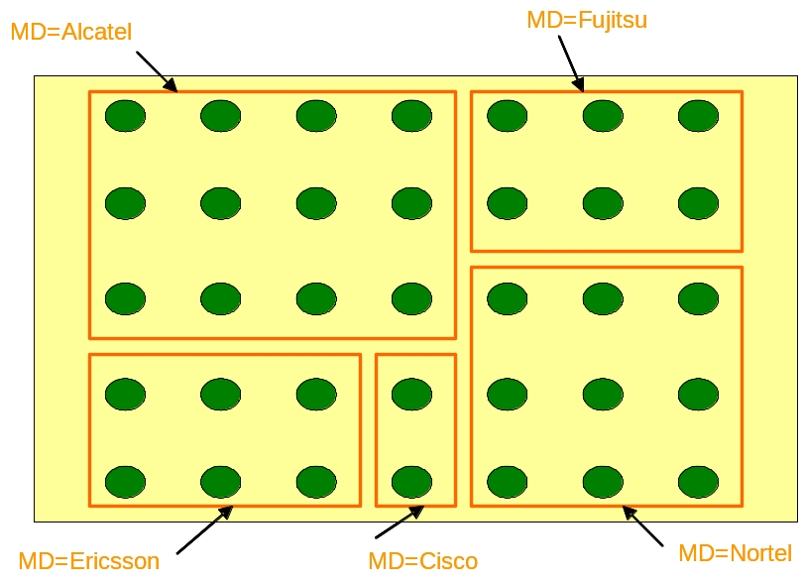

In each of the 5 MDs, the names used for the ME objects must be unique, but indeed the same relative name may be used for different MEs belonging to different MDs. For instance, as shown below, the two ME objects at the upper left corner of the MD=Alcatel and MD=Fujitsu MD objects have the same relative name ME=me1, which does not create any problem because their full name differs by the MD part.
.

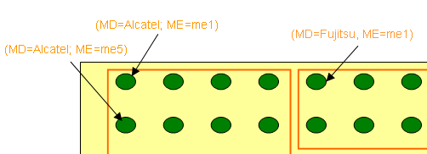

This being said, lets assume that the same SP has installed those different MEs in 5 networks located in 5 different cities in 2 different countries.
It is indeed understandable that he may want to organize the Subnetwork objects into 2 different MDs to reflect the distributed nature of his global network. The mTOP naming scheme offers him this possibility; for this purpose, he can create the additional MDs and Subnetwork objects as illustrated on the picture below:

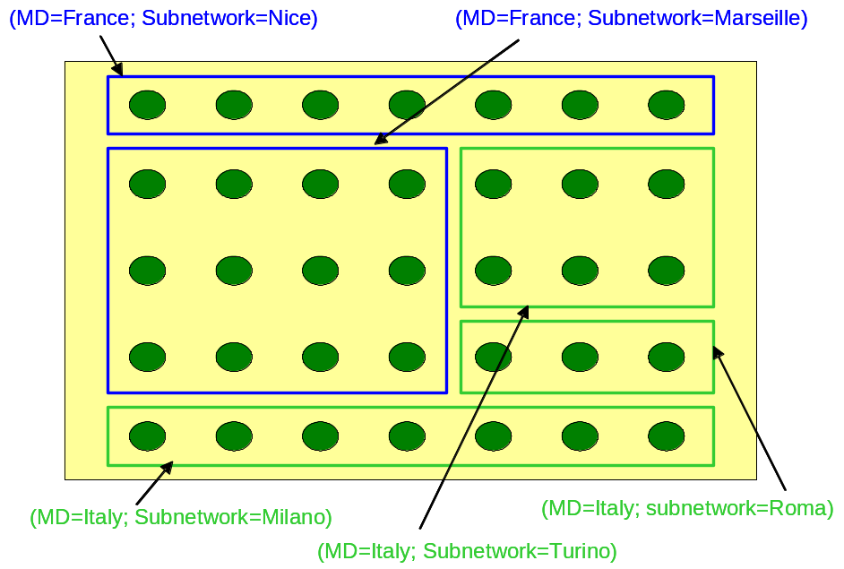

The combination of the two sets of MDs would lead to the following topology tree, where the MEs are named under the “equipment supplier” MDs and not under the “country” MD.

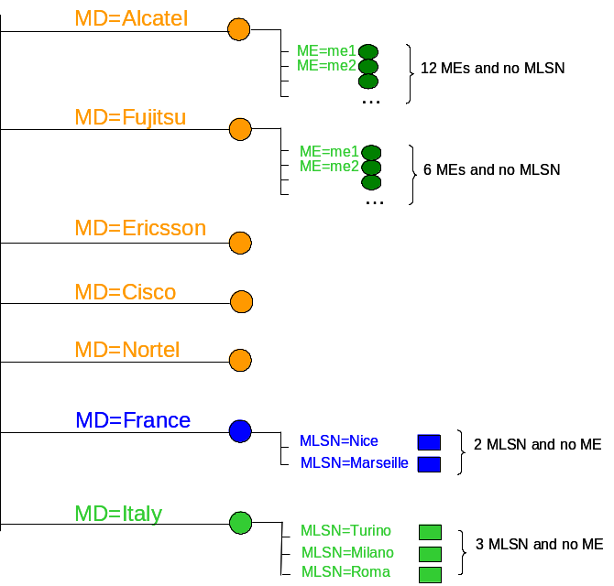

Indeed, our SP may want to “document” in his inventory that some MEs from Alcatel are located in France while some others are located in Italy.
He certainly cannot do this by giving another name to the corresponding MEs, for instance by naming them as subordinates of the MD=France of the MD=Italy Management Domain objects, since any object can have only one single name.
Actually, he may probably want to do more, by “documenting” in his inventory that:
the (MD=Alcatel; ME=me1) “belongs” to the Subnetwork in Nice
and that:
the (MD=Alcatel; ME=me5) “belongs” to the Subnetwork in Milano.

The way to “capture” this information is not by using naming relationships but by using the following reference relationships implemented in the ME MTOSI objects:by the following attributes:
associatedMEList available in the MLSN class
containingSnNameList available in the ME class

as available in the Inventory Layout.

Administrative Appendix

Document History

Version Number | Date Modified | Modified by: | Description of changes
0[1].1.2 | 03/11/2005 | Elisabetta Gardelli | Initial issue
V1.0 | 4/4/2005 | Elisabetta Gardelli | reviewed
V1.1 | 11/29/2005 | Elisabetta Gardelli | No version number in document name; added vendor objects naming section
2.0 | May 2008 | Jérôme Magnet | Simplified/updated based on MTOSI R2 changes

Acknowledgments

First Name | Last Name | Company
Francesco | Caruso | Telcordia Technologies Inc.
Nigel | Davis | Nortel
Steve | Fratini | Telcordia Technologies Inc.

How to comment on this document
Comments and requests for information must be in written form and addressed to the contact identified below:

Jérôme | Magnet | Nortel
Phone: | 1-613-763-1480
Fax:
e-mail: | jeromem@nortel.com

Please be specific, since your comments will be dealt with by the team evaluating numerous inputs and trying to produce a single text. Thus we appreciate significant specific input. We are looking for more input than wordsmith” items, however editing and structural help are greatly appreciated where better clarity is the result.

