This document compares BA, IA and IIS of the Network Resource Basic DDP

References:
BA: TMF518_NRB.doc 1119 16.11.07 besson
IA: NetworkResourceBasic.emx 1386 24.01.08 zeuner
IIS: CommonResourceInfo.xsd 1406 04.02.08 jeromem
ITU-T-Definitions.xsd 1406 04.02.08 jeromem
LayeredParameters.xsd 1406 04.02.08 jeromem
LayerRates.xsd 1406 04.02.08 jeromem
VendorResourceObject.xsd 1406 04.02.08 jeromem
SDs:

Conventions:
yellow marked items are to be corrected (often discussion necessary)
turquoise marked items are to be added/changed

Content:
1 High level UML diagrams 3
1.1 Static Class Diagram 3
1.2 Data Types Class Diagram 4
2 Objects 5
2.1 CommonResourceInfo 5
2.2 VendorResourceObject 9
2.3 new object 10
3 Data Types 10
4 new section 12

Figures:
Figure 1: NRB Class Diagram 3
Figure 2: Data Types Class Diagram 4

History:
Version | Date | Description of Change
0.1 | 26.06.2007 | Initial version.
0.2 | 20.02.2008 | Updated BA and XSDs integrated.
0.3 | 21.02.2008 | Editorial reorganisation.

High level UML diagrams

NRB Class Diagram
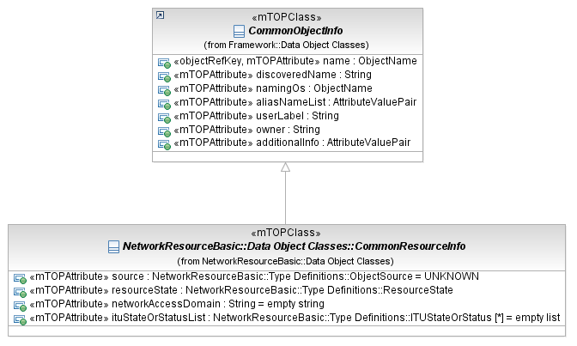
Figure 1: NRB Class Diagram

Data Types Class Diagram
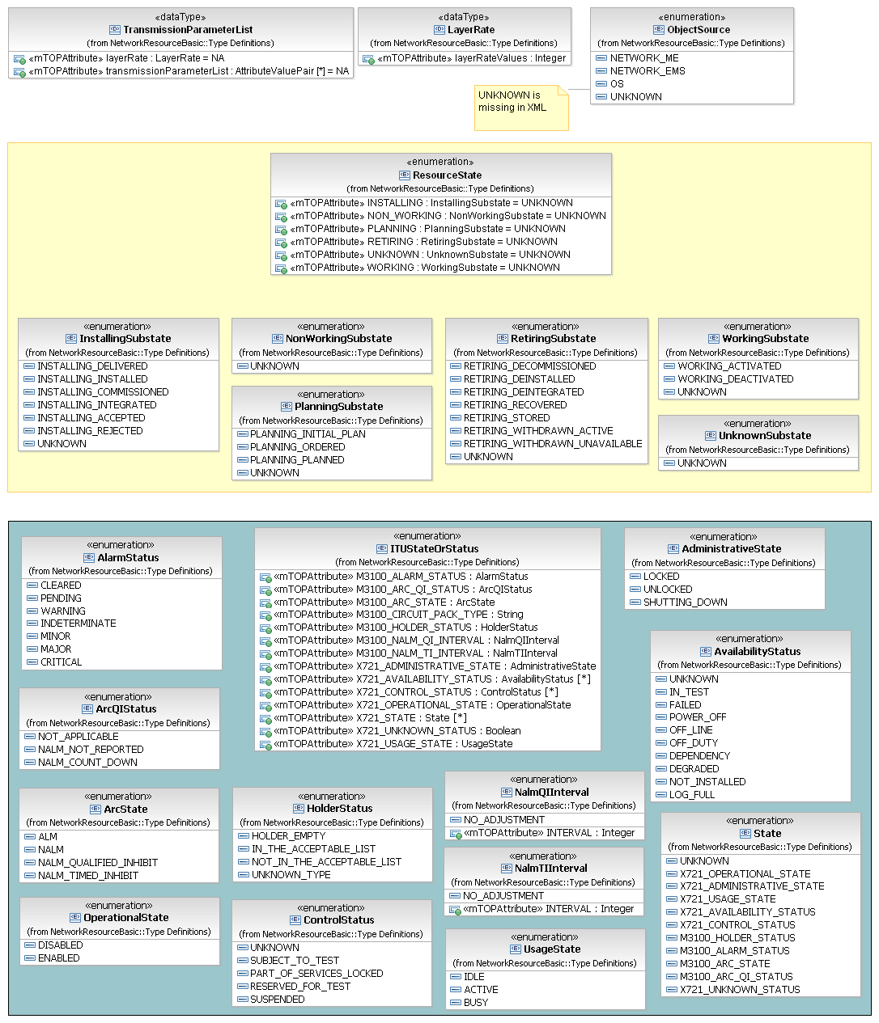
Figure 2: Data Types Class Diagram

Objects

CommonResourceInfo

BA (CommonResourceInfo) | IA | IIS | Comments
R_TMF518_NRB_I_0001  All objects that represent managed resources across the Interface shall have in addition to the attributes defined in requirement TMF518_FMW_I_001 the following attributes:  - source - this attribute shall indicate whether the object was discovered from the network, or was entered into the OS’s inventory. The possible values for this attribute are, i.e.,  - network ME – the object was discovered directly from an NE.  - network OS – the object was discovered from an OS communicating directly with an NE.  - OS – the object was entered into an OS on the CCV, that was not communicating directly with an NE, e.g., OS GUI or file transfer to the OS from some other system.  - Unknown – the source of the object is not available or known by the OS.  - resource state - this attribute shall represent the lifecycle state of a physical resource. The possible values for this attribute are:  - planning – the resource is scheduled for deployment in accordance with a specific plan.  - installing – the resource undergoes a full commissioning process until it is finally ready for work and support services.  - working – the resource has been physically installed and all necessary firmware and software have been installed, all commissioning tests have been performed,  - retiring – the resource undergoes all necessary procedures for its decommissioning and phasing out.  - unknown - the resource state is not known.  Refer to Section 3.1.1 for more information regarding the resource state attribute.  - network access domain – this attribute shall represent the (identifier of) Network Access Domain (NAD) to which the resource has been assigned.  A NAD provides a way for a Network Operator to partition the resources in the network into different administrative domains.  ituStateOrStatusList  meiAttributes | inherited from CommonObjectInfo  This object class defines the attributes that are common to all resource objects.  See R_TMF518_NRB_I_0001.  source  See R_TMF518_NRB_I_0001 and R_TMF518_NRB_I_0002.  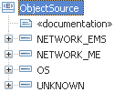  resourceState  See R_TMF518_NRB_I_0001.  See SD2-17_MTOSI_EnhancedResourceStates supporting document.  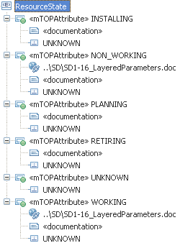  networkAccessDomain  This attribute contains a free-format string used to associate the resource to a Network Access Domain.  ituStateOrStatusList  See R_TMF518_NRB_I_0001?? and R_TMF518_NRB_I_0004.  See supporting document SD1-8_encodingX731M3100 supporting document.  meiAttributes | name="commonResourceInfo"  This aggregate defines attributes common to all mTOP resource objects.  extension base="coi:CommonObjectInfoType"  name="source" type="tns:SourceType"  Indicates whether the object was discovered or entered in OS inventory.  complexType name="SourceType"  This is the definition of the object attribute that indicates whether the object was discovered from the network, or was entered into the OS's inventory.  extension base="tns:SourceEnumType"  attribute name="qualifier" type="xsd:string"  simpleType name="SourceEnumType"  enumeration value="NETWORK_ME"  the object was discovered directly from the ME.  enumeration value="OS"  the object was entered into an OS on the CCV, e.g., OS GUI or file transfer to the OS from some other system.  enumeration value="NETWORK_EMS"  the object was discovered from an EMS.  name="resourceState" type="tns:ResourceStateType"  Containment for all the ITU-T status and state parameters  name="networkAccessDomain" type="gen:NetworkAccessDomainType"  ituStateOrStatusList  name="meiAttributes" type="gen:MultiEventInventoryAttributesType"  This attribute is used when a object instance is embedded in the inventory layout payload of a Multi-Event Inventory (MEI) notification. It provides the time at which the NE detected the inventory change (if available) and an indication of the type of inventory update, e.g., Object Creation.
R_TMF518_NRB_I_0002  The resource state attribute of an object shall be qualified through the use of a number of sub-states. The possible values for these sub-states are in the case of:  - planning:  - initial plan - a requirement for the resource has been identified.  - planned - the characteristics of the resource and its deployment have been completely identified but nothing exists in the network.  - ordered - an order for delivery of the resource has been agreed between the network provider and supplier.  - installing:  - delivered - the resource has been accepted by the network provider as delivered to site by the supplier  - installed - the resource has been unpacked and installed by the supplier/ installer.  - commissioned - the resource has commissioned by the supplier/ commissioner.  - integrated - the resource management has been integrated by the supplier/ integrator.  - accepted - the resource has been accepted by the network provider as ready for network use.  - rejected - the resource was rejected by the network provider and has been returned from site to the supplier  - working:  - activated - the resource is working, has been configured and is available for use.  - deactivated - the resource is working but is not available for use.  - retiring:  - withdrawn-active - the resource is not available to carry any new traffic. Existing traffic is to be removed/offloaded to other resources.  - withdrawn-unavailable – the resource is not available to carry any new traffic. Existing traffic has been removed/offloaded.  - de-integrated - all physical and logical entities in support of the resource are still in place. The resource is still visible to an OS for remote administration.  - decommissioned - the resource no longer visible to an OS for remote administration.  - de-installed - the resource is physically in place but physical and logical entities in support of the resource have been withdrawn.  - stored - the resource has been packed and removed from its location to a designated storage location.  - recovered - the resource has been recovered from site for disposal.  - unknown  - non working | 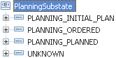  During the Planning phase the resource is scheduled for deployment in accordance with a specific plan. During this phase, the resource is assigned the composite state value of “Planning”. The resource state in the Inventory Management OS provides the other OSs with the information regarding the resources’ planning state.  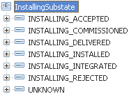  During this phase, the Resource undergoes a full commissioning process until it is finally ready for work and support services. takes the Resource State value of “Installed”. During this phase, the resource is assigned the composite Inventory state value of “Installing”. Resources may also be installed in the network regardless of any specific plan.  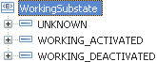  After the resource has been physically installed and all necessary Firmware and Software have been installed, all the commissioning testing has been performed and is running, it enters the working phase.  During this phase, the Resource is assigned the composite state value “Working”.  X.731 and M.3100 state and status information for a Working resource are mapped to the ituStateOrStatusList attribute or to a transmission parameter of a TP layer if a layered approach is needed (see SD1-16_LayeredParameters supporting document).  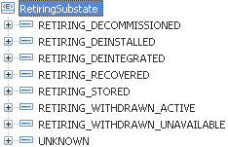  During this phase, the resource undergoes all necessary procedures for its decommissioning and phasing out.  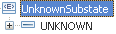    The Non-working phase designates the resource assurance states, namely, all possible states in which the resource is put out of work, either by intrinsic internal reasons, e.g., a resource that becomes faulty, or intentionally by the operator, e.g, for maintenance purposes.  During this phase, the Resource is assigned the composite state value “Non-working”.  X.731 and M.3100 state and status information for a Working resource are mapped to the ituStateOrStatusList attribute or to a transmission parameter of a TP layer if a layered approach is needed (see SD1-16_LayeredParameters supporting document). | complexType name="ResourceStateType"  This is the definition of the object attribute that indicates the state of the resource.  extension base="tns:ResourceStateEnumType"  attribute name="overlap"  attribute name="qualifier"  <!-- ================= -->  simpleType name="ResourceStateEnumType"  enumeration value="PLANNING"  enumeration value="PLANNING_INITIAL_PLAN"  enumeration value="PLANNING_ORDERED"  enumeration value="PLANNING_PLANNED"  enumeration value="INSTALLING"  enumeration value="INSTALLING_ACCEPTED"  enumeration value="INSTALLING_COMMISSIONED"  enumeration value="INSTALLING_DELIVERED"  enumeration value="INSTALLING_INSTALLED"  enumeration value="INSTALLING_INTEGRATED"  enumeration value="INSTALLING_REJECTED"  enumeration value="WORKING"  enumeration value="WORKING_ACTIVATED"  enumeration value="WORKING_DEACTIVATED"  enumeration value="RETIRING"  enumeration value="RETIRING_DECOMMISSIONED"  enumeration value="RETIRING_DEINSTALLED"  enumeration value="RETIRING_DEINTEGRATED"  enumeration value="RETIRING_RECOVERED"  enumeration value="RETIRING_STORED"  enumeration value="RETIRING_WITHDRAWN_ACTIVE"  enumeration value="RETIRING_WITHDRAWN_UNAVAILABLE"  enumeration value="UNKNOWN  enumeration value="NON_WORKING"
R_TMF518_NRB_I_0004  To allow an object that represents a managed resources across the Interface to support the ITU-T state and status values (as defined in the ITU-T X.731 and M.3100) in a consistent manner the attribute names and values have been predefined (refer to SD1-8 for the defined names and values).  If it is required (by an implementer of the Interface) that an object support an ITU-T X.731 or M.3100 state or status value then the attribute identifier and the values to be used shall be those identified in SD1-8. These state and status values would be in used in addition to the resource state attribute. | 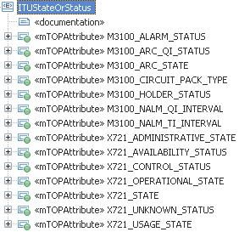  This enumeration contains an ITU state or status together with it's value.  See R_TMF518_NRB_I_0004. | element name="ituParameters"  Containment of all ITU-T state or status parameters supported in mTOP  element name="x721.OperationalState"  element name="x721.AdministrativeState"  element name="x721.UsageState"  element name="x721.AvailabilityStatus"  element name="x721.ControlStatus"  element name="m3100.HolderStatus"  element name="m3100.CircuitPackType"  element name="m3100.AlarmStatus"  element name="m3100.ArcState"  element name="m3100.NALMTIInterval"  element name="m3100.NALMQIInterval"  element name="m3100.ArcQIStatus"  element name="x721.Unkownstatus"  element name="x721.State"

VendorResourceObject

BA (VendorResourceObject) | IA | IDL | Comments
?? | ?? | inherited from CommonResourceInfo  vendorResourceObject (tns:VendorResourceObject_T)  This aggregate defines attributes of the mTOP vendor resource object.
?? | ?? | vendorObjectType (string)  The vendor proprietary definition of an object type.

new object

BA (?) | IA | IDL | Comments

Data Types

Transmission Parameters

BA (Transmission Parameters) | IA | IDL | Comments
R_TMF518_NRB_I_0005  A Transmission Parameter is a characteristic that shall be identified by a name value pair.  Refer to supporting document SD1-16 for the currently identified TP parameters. | 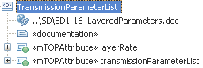  This data structure contains a list of transmission parameters per layer rate. The list of defined parameters can be fond in the SD1-16_LayeredParameters supporting document.  Note: Setting is prohibited for some specific parameters.  See R_TMF518_NRB_I_0005. | complexType name="LayeredParametersListType"  This is used in the TP definition and as a consequence is available for use in a connection specification where a TP is specified.  element name="layeredParameters" type="tns:LayeredParametersType"  <!-- ============== -->  complexType name="LayeredParametersType"  This is a structure that includes the layer rate with the applicable list of transmissions parameters  element name="layer" type="lr:LayerRateType"  Represents the layer to which the parameters apply.  element name="transmissionParameterList" type="nam:NameAndValueStringListType"  element name="vendorExtensions" type="gen:AnyListType"  The specific containment for vendor extensions of the list of tranmission parameters.

Layer Rate

BA (Layer Rate) | IA | IDL | Comments
R_TMF518_NRB_I_0003  Certain objects representing managed resources shall have an attribute that represents the network layer rates that are encapsulated by the resource for the purposes of management.  The values for these layer rate shall be defined in the supporting document SD1-17.  If a layer rate is not defined in SD1-17 then a mechanism shall be defined that enables the definition of proprietary values (refer to SD1-17 for the details of defining proprietary layer rates). | 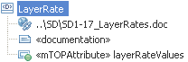  This data structure identifies the layer rate of a resource. There is a standardised list of LayerRates in SD1-17_LayerRates supporting document. LayerRates from this standard list should be used wherever possible. The standardised list will be augmented in subsequent releases through the normal approval process. The LayerRate definition includes a range of layer identifiers for proprietary usage.  The conditions for use of this capability, to augment the list of supported layers between releases, are described in the attached SD1-17_LayerRates supporting document.  See R_TMF518_NRB_I_0003. | complexType name="LayerRateListType"  A list of LayerRates  element name="layerRate" type="tns:LayerRateType"  <!-- ===================== -->  complexType name="LayerRateType"  The LayerRateType value is used to identify:  - the Layer of a PTP/CTP,  - the characteristic information of a PTP/FTP,  - the Layer/Rate of a connection.  Each LayerRateType may be used in conjunction with a CTP/PTP/FTP of that layer. In the SDH definitions, the G.805 CP and G.805 Termination Function layer names differ, for example TU12 is used for the G.805 CP and VC12 for the corresponding G.805 Termination Function. In this interface definition the TU and VC definitions have been combined into a single composite layer and this has been named to include the equivalent SONET layer, e.g. LR_VT2_andTypeU12_VC12.  For more details refer to the following supporting document:  - layering documentfor all layering concepts  - LayerRates document for information about recognized values in MTOSI  All extensions are permitted (VENDOR_EXT and MINOR_EXT).  extension base="tns:LayerRateEnumType"  attribute name="extension" type="xsd:string"

new section

BA (?) | IA | IDL | Comments

