mTOP DDP BA Guidelines
Author: Michel Besson

General
- DDPs BA documents should NOT make use of the mTOP product names, such as MTOSI or MTNM, except to refer to pre-DDP documents.
The reason is that DDP BA features stay at the mTOP level and may be applicable to both MTOSI and MTNM. Alternatively we may want to find a neutral term (e.g. mTOP).

Specifications for Requirements

- There are five categories (TMF labeled) of requirements in addition to the business requirements.
- In each DDP, requirements identifiers must be unique within each category.
- Requirements are defined using the following tabular template

R_TMFXXX_DDD_C_N | Description of the requirement
Source | Source of the requirement

where “C” designates the category of whether it is a business requirement, and is one of:
“BR”, I, II, III, IV, V and
“N” is a 4 digits integer (e.g. 0012)
XXX denotes the type of DDP document e.g., 518 (BA), 612 (IA) or 864 (SS)
DDD denotes the feature area of the DDP document e.g. NRA (NetworkResourceAssurance).
- A requirement is referred to by its identifier “R_TMFXXX_DDD_C_N”

- It must be possible to display the definition of a requirement by a simple mouse click from any of its references.
- When a new BA document is generated, the “N” part of the requirement identifier must be generated in sequence (no “hole” in the requirements definitions) within each category, until the document is made available to the team (editor decides). From this stage the identifier of a given requirement will never change.
Any modification introduced after this stage may break this sequence:
- when a requirement is rejected, its definition is simply removed
- it must be possible to move a requirement within a DDP.
Futher, the requirement number must remain the same when the requirement is moved.
- it must be possible to introduce a new requirement definition at any place in the BA document (indeed a new requirement definition takes the next available “N” in the corresponding category).
- [nice to have] For each DDP, it must be possible to automatically generate or access to the list of requirement identifiers without accessing the BA document itself, with the following status attributes:
- created in version X.Y of the DDP
- rejected during the review process (was then never published)
- modified in version X.Y of the DDP
- removed in version X.Y of the DDP
- [nice to have] list of documents where it is referred and corresponding page number

- Do NOT use the DDP version number as part of the requirement identifier
(e.g. Requirement (1.1)I. 5 )

- Traceability matrices should be generated automatically.

Specifications for Use Cases

- In each DDP, use case identifiers must be unique.

- Use cases are defined using the following tabular template

where “N” is a 4 digits integer

Use Case Id | UC_TMFXXX_DDD_N
Use Case Name
Summary
Actor(s)
Pre-Conditions
Begins When
Description
Ends When
Post-Conditions
Exceptions | Put a reference here to a document or a separate table which lists all the exceptions.  Specific exceptions will be explicitly listed in the Description clause.
Traceability | Hyperlinks to the associated requirements

- A use case is referred to by its identifier “UC_TMFXXX_DDD_N”
- It must be possible to display the definition of a use case by a simple mouse click from any of its references.
- It must be easy to go to “navigate” from a requirement to the Use Cases where this requirement applies and vice versa (within the same document or across BA documents or across BA and non BA document; within he same DDP or across DDPs???)
- When a new BA document is generated, the “N” part of the Use Case identifier must be generated in sequence (no “hole” in the Use Case definitions), until the document is released for official approval. From this stage the identifier of a given Use Case will never change.
Any modification introduced after this stage may break this sequence:
- when a Use Case is rejected, its definition is simply removed
- it must be possible to move the definition of a Use Case (the number must remain the same)
- it must be possible to introduce a new Use Case definition at any place in the BA document (indeed a new Use Case definition takes the next available “I” in the DDP).

- [nice to have] For each DDP, it must be possible to automatically generate or access to the list of use case identifiers without accessing the BA document itself, with the following status attributes:
- created in version X.Y of the DDP
- rejected during the review process (was then never published)
- modified in version X.Y of the DDP
- removed in version X.Y of the DDP
- [nice to have] list of documents where it is referred and corresponding page number
- Traceability matrices should be generated automatically

How to use the “mTOP_BA.dot” Word Template
The “mTOP_BA.dot” Word template (distributed separately) tries to implement most of the specifications presented in the previous sections.

Copy the mTOP_BA.dot under
HomeDir\Application Data\Microsoft\Templates
where HomeDir is your home directory on windows.
It is the directory where the Normal.dot file is already.

To create a new BA file, you can either:
- double click on this mTOP_BA.dot
- or enter Word and then enter the menu File / New and then select the mTOP_BA.dot template on your computer.

A new menu bar (called mTOP main commands) has been created looking as follows:

You will also note the new Boolmarks button in the Standard menu bar:

Creating a New BA Document
When you create a new BA Document, the first thing you must do is to set the value of one standard property and 3 custom properties:
- Setting the Document Title
Go to File / Properties / Summary
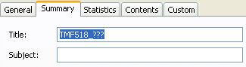
By default the template set the Title to “TMF518_???”.
Change it to the proper name (e.g. “TMF518_NRB” but you may choose any name here).
Then go back to the beginning of the document, click left anywhere in the title and hit the F9 key. It will automatically update the title. The title is also used in the top left Header of the Word document. You may do the same thing to update its value as well.
(to update all the fields in one go, select all the document and hit F9).
- Setting custom properties
Go to File / Properties / Custom
You will see 4 specific properties that have been created by the template.
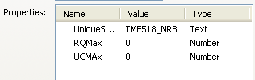
RQMax and UCMax shoud be set to 0 by default. You do not need to change their values.
Those two properties are used to keep trace of the maximum number of requirements and use cases created in the document. They will be automatically updated when you add requirements or use cases. Since those properties are associated to the document, their associated value will be kept between two Word session (closing and re-opening the document, those values will be kept).
UniqueSeed is another property that you need to set. It must be unique for each DDP and it corresponds to the TMFXXX_DDD part of the requirement and use case Ids (see previous sections). Its value must then be something like TMF518_DDD. By default the template proposes TMF518_NRB as an example.
ProductDir is used to indicate a relative path to the mTOP “Product” directory which contains the DDPs (Generally, the value for most of the BA documents is set to “..\..\..\..\”, to the exception of the BA under “ServiceActivation” which have one more level of depth (“..\..\..\..\..\”).

Heading paragraphs

The first 5 buttons (H1 to H5) have been created to make your life easier for Header Numbering.
There are many ways in Word to handle this, most of them may create trouble at some point in time. Using those 5 buttons EXCLUSIVELY to handle Header Numbering should make your life easy.
PLEASE USE THE “H1, H2,… H5” BUTTONS TO CREATE HEADING PARAGRAPHS, AND AVOID USING ANY OTHER METHOD.
(??? In the future I may add buttons for Appendix Headers as well).

How to Create Requirements Automatically Numbered

When you want to create a new requirement, move the cursor where you want to insert the new requirement definition within any of the sections in chapter 3.
Then click on the createRQ button.
A requirement definition table is automatically created.
If you move the cursor and click again on the createRQ button a second requirement definition appears; if you do it again you will get three requirement definition tables as shown below:

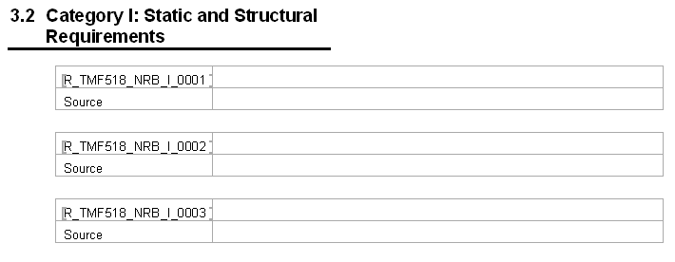

The requirement number is automatically incremented and for each requirement a bookmark is created at the beginning of the requirement number in the first cell of each table.
You can now enter the definition of the requirement and the source fields manually.
The requirement number will always increase (and the RQMax property will be incremented accordingly).

If you want to remove or move a requirement definition you can do it manually. Since the requirement numbers are simple numbers, this will not change the numbering of the other requirements. Indeed, when a requirement definition table is removed its associated bookmark is removed as well.
For instance, if you remove the requirement 0002 and then move the requirement 0003 in first position this will result in the following view:

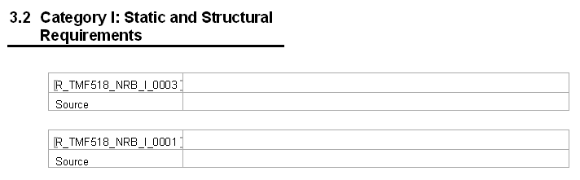

In principle, the bookmarks brackets ([ ]) may not be displayed, except if you have selected the bookmark toggle in Tools / Options / View as follows (Not really very useful; I use it more for debugging the macros):
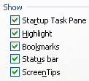

Once you have entered new requirements the list of bookmarks in the Bookmarks popup menu is automatically updated. Then you do NOT need to explicitly select the Bookmarks button and click on the Refresh list item.
This is NOT true when you delete a requirement table (and then delete the associated bookmark as well). In this case you need to update the list of available bookmarks by clicking on the Refresh list item:

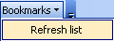

The list updates automatically by the addition of the newly created bookmarks:

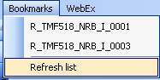

How to Create Use Cases automatically Numbered

To create a use case, move the cursor at the point of insertion and then click on the createUC button.
A use case definition table is automatically created.
A new bookmark is created at the beginning of the use case number in the first cell, as shown in the example below:
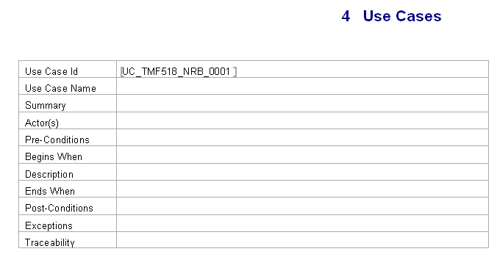
To enter hyperlinks to one or several requirements in the Traceability value field, move the cursor where the hyperlink must be inserted and then click the Bookmarks popup menu. Select the chosen requirement item in this menu. Repeat the operation for each requirement to add:

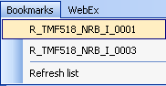

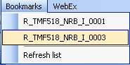

The corresponding hyperlinks are created automatically:

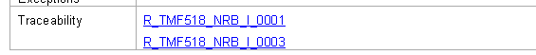

How to Create a Use Case Summary Table Automatically

Another macro called createUCTableSummary can be used to automatically create the Cross Reference table (from use case to requirements)
Just move the cursor to the place you want to create this table and click on the createUCTableSummary button. The table will be generated automatically:

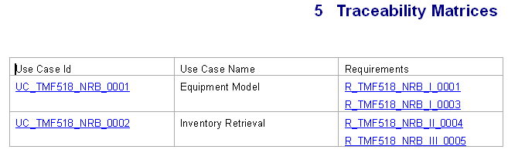
(??? other similar macros will be created in the future to automate the creation of the other cross reference tables).

How to Re-Sequence the Requirements or Use Cases
When you are in “draft” mode, you may often create new requirements tables which you will delete later or move to a different place in the document (same for use case tables). After a while, you will end up with a BA draft document where the requirements (use cases) are randomly sequenced, with possible “holes” as well.
Before releasing the document for review (leaving the draft mode) you may want to re-sequence those requirements (or use case) tables. The two following macros are for this purpose.
When you use those macros, indeed, not only the bookmarks are renumbered but also the hyperlinks pointing to them are updated as well. After the document has been released for review those macros are not supposed to be used anymore (??? should it be enforced?), since the requirements/use cases numbers are not supposed to change anymore (requirements / use cases not accepted will be removed, leaving a “hole” in the sequence, then).

[Also, in case you make a typo when creating a requirement table (e.g. you type a wrong category) or use case, you may also use the macro to fix one bookmark only. You will be invited enter the new bookmark name interactively. ??? I may remove this macro in future versions.]

How to Handle mTOP “Terms”
This section explains how to quickly insert a reference to a term which is defined in the mTOP Dictionary, and display its definition as a screen tip. For instance after having edited the statement “The sole RFS associated to a CFS”, you can very easily replace “RFS” and “CFS” by hyperlinks and at a later stage the definition of the corresponding term is dynamically highlighted by moving the cursor over the hyperlink term, as shown below.

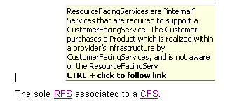
Before using this feature (as an editor or a reader) make sure that:
- you have downloaded a local copy of the “SD2-0_mTOPDictionary.doc” file,
- and that the BA document you are editing has its custom property “ProductDir” set up properly.

mTOP terms are all collected in the “SD2-0_mTOPDictionary.doc” file which is registered within the “Product\trunk\DDPs\Framework\SD” directory.
Each term in this document is defined as an entry in a 2 columns table and is associated with a bookmark (see the two examples below):
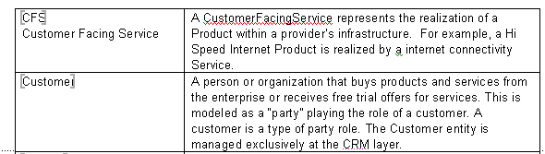
Actually all mTOP terms bookmarks are prefix with “T_”: for instance the bookmark corresponding to the term “CFS” is named “T_CFS”. This is transparent for the user in this file.

BA files show a popup menu called “BookmarksTerms”: 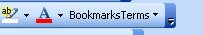.
(??? For the moment this popup is associated with the “Formatting” menu bar; this may be changed in the future, but will have no influence.)
When you open a BA file (to edit it or simply to read it), this popup menu is automatically generated by accessing the “SD2-0_mTOPDictionary.doc” file and by collecting all the bookmarks prefixed with a “T_”. For instance at the time when this Guideline is written the following popup has been automatically generated from the definitions present in the dictionary:
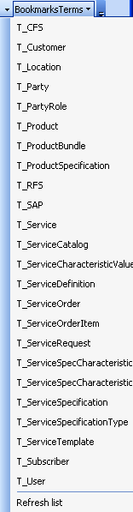
When you edit the BA you can insert a hyperlink representation of a term by simply selecting the appropriate bookmark in this list. The corresponding term will be inserted (without its “T_” prefix).
At a later stage you can display the corresponding definition by simply moving the cursor near the hyperlink word. Clicking on the hyperlink will have no navigating effect.

Caveats
- As I said above, not all the macros allowing automatic generation of cross reference tables have been created yet. This will be added in future versions. So, please do not generate those cross reference tables by hand for now.
- When you create a new requirement table or use case table bookmarks are automatically generated. The template automatically updates the list of bookmarks in the Bookmarks popup menu. Then you do NOT need to explicitly select the Bookmarks button and click on the Refresh list item. This is NOT true when you delete a requirement table or a use case table (and then delete the associated bookmark as well). In this case you need to update the list of available bookmarks by clicking on the Refresh list item.
- When you delete a requirement table or use case table, the hyperlinks which may point to the corresponding bookmarks are NOT modified.
(this will be corrected in future versions).

