
RFx Guide
for Transport Network Management – MTOSI/XML
Release 1.0
Document Number: TR 164
5-November-2010

Notice
No recipient of this document shall in any way interpret this document as representing a position or agreement of TM Forum or its members. This document is a draft working document of TM Forum and is provided solely for comments and evaluation. It is not a Forum Approved Document and is solely circulated for the purposes of assisting TM Forum in the preparation of a final document in furtherance of the aims and mission of TM Forum.
Although it is a copyrighted document of TM Forum:
- Members of TM Forum are only granted the limited copyright waiver to distribute this document within their companies and may not make paper or electronic copies for distribution outside of their companies.
- Non-members of the TM Forum are not permitted to make copies (paper or electronic) of this draft document other than for their internal use for the sole purpose of making comments thereon directly to TM Forum.
- If this document forms part of a supply of information in support of an Industry Group Liaison relationship, the document may only be used as part of the work identified in the Liaison and may not be used or further distributed for any other purposes
Any use of this document by the recipient, other than as set forth specifically herein, is at its own risk, and under no circumstances will TM Forum be liable for direct or indirect damages or any costs or losses resulting from the use of this document by the recipient.
This document is governed, and all recipients shall be bound, by all of the terms and conditions of the Intellectual Property Rights Policy of the TM Forum (http://www.tmforum.org/Bylaws/1094/home.html) and may involve a claim of patent rights by one or more TM Forum members or by non-members of TM Forum.

Direct inquiries to the TM Forum office:

240 Headquarters Plaza,
East Tower – 10th Floor,
Morristown, NJ 07960 USA
Tel No. +1 973 944 5100
Fax No. +1 973 944 5110
TM Forum Web Page: www.tmforum.org

Table of Contents
Notice 2
Table of Contents 3
List of Figures 5
List of Tables 5
Executive Summary 6
1. Introduction 7
2. Coverage 8
2.1. Scenarios 8
2.1.1. NMS-EMS (1) 9
2.1.2. NMS to lower-tier NMS (2) 9
2.1.3. NMS to NMS (Peer to Peer) (3) 9
2.2. Transport Technologies 9
2.2.1. Transmission Parameters 9
2.2.2. Performance Parameters 10
2.2.3. Layer Rates 10
2.2.4. Probable Causes 10
3. Requirements per management topic 11
3.1. General 11
3.2. Document Delivery Package (DDP) structure 11
3.3. Framework 12
3.3.1. Common information and naming 12
3.3.2. Interface versioning 14
3.3.3. Notifications 14
3.3.4. General interface aspects 14
3.3.5. Message Exchange Patterns (MEPs) 14
3.3.6. Extensibility 15
3.3.7. Multiple Action Requests and Transactions 15
3.4. Manage resource inventory 16
3.4.1. Inventory retrieval 16
3.4.2. Inventory notifications 17
3.4.3. Inventory discovery and synchronization 17
3.4.4. Inventory Update 18
3.5. Resource provisioning 19
3.5.1. Connection control 19
3.5.2. Equipment provisioning 19
3.5.3. Flow Domain control 20
3.5.4. Termination Point control 21
3.5.5. Transmission Descriptor (TMD) control 23
3.5.6. Assignment of Transmission Descriptor 23
3.5.7. Topological Link control 23
3.6. Resource trouble management 23
3.6.1. Alarm management 23
3.6.2. Protection management 25
3.6.3. Maintenance and diagnostic test management 26
3.7. Resource Performance Management 26
3.7.1. Monitor Performance Management 26
3.7.2. Performance Management control 28
4. Administrative Appendix 29
4.1. Document History 29
4.2. Acknowledgments 29
4.3. How to comment on this document 29

List of Figures
Figure 2.1: Management system scenarios
Figure 3.1: ‘Location’ of DDPs within the Business Process Framework (eTOM)
Figure 3.2: Common object information

List of Tables
Table 3.1: Common information requirements
Table 3.2: Interface versioning requirements
Table 3.3: Notification requirements
Table 3.4: MART requirements
Table 3.5: Inventory retrieval requirements
Table 3.6: Inventory notifications
Table 3.7: Inventory Discovery and Synchronization
Table 3.8: Inventory update
Table 3.9: Connection control
Table 3.10: Equipment provisioning
Table 3.11: Matrix Flow Domain management
Table 3.12: Flow Domain management
Table 3.13: Traffic Conditioning (TC) profile management
Table 3.14: Flow Domain Fragment (FDFr) management
Table 3.15: Group Termination Point (GTP) Management
Table 3.16: TP Pool management
Table 3.17: TP management
Table 3.18: Transmission Descriptor (TMD) control
Table 3.19: TMD assignment
Table 3.20: Topological Link control
Table 3.21: Alarm management
Table 3.22: Protection management
Table 3.23: Maintenance and diagnostic management
Table 3.24: Retrieval of PM data
Table 3.25: TCA Parameter Profile retrieval
Table 3.26: TCA notifications
Table 3.27: PM control
Table 3.28: TCA control
Table 3.29: TCA Parameter Profile (TCA PP) management

Executive Summary
This supporting document provides some reusable RFx material concerning the management of transport networks intended for reuse by service providers. This version of the document is based on MTOSI (XML solution).

Introduction
This RFx template is meant to be reused by service providers in their various RFPs and RFIs. This RFx template likely covers more requirements than would typically be needed in an RFP or RFI. So, the user of this template is encouraged to make use of the various parts that are useful and simply delete the other parts. In terms scope, it is noted that:
- The requirements here tend to be high level, and so it is expected that the user of the template would add additional detail to suit their needs. In particular, the RFx writer may want to stipulate particular operations, objects and notifications (the tables in MTOSI Release 2.0 Implementation Statement can be used to help here).
- This document only covers the interface aspects of an RFx. Items such as applications, application grouping into systems and non-functional requirements (response time and transactions per second) are out of scope.
This particular template is based on MTOSI Rel. 2.0, which is an OS-OS management interface based on XML and intended to be used to manage transport networks and associated services.
MTOSI covers many transport technologies, including SONET/SDH, PDH, DWDM, ATM, DSL, Frame Relay and Ethernet. It should be emphasized, however, that these technologies are covered by common objects, operations and notifications. So, for example, MTOSI does not have a separate operation for the creation of a SubNetwork Connection (SNC) for each technology but rather a common operation (createSNC). The same is true for the Termination Points; they are technology agnostic. The technology-specific information is "hidden" behind parameter lists to which the operations and termination points refer. There are, for example, lists for technology-specific transmission parameters, performance parameters, layer/rates and probable alarm causes.
It should be noted that each interface has a server side and a client side. (Note that the MTOSI UML model uses ‘Requesting OS’ for the server side and ‘Target OS’ for the client side of an interaction.) Typically, the service side provides a given capability and/or has the ability to send notifications. The client side is able to make requests and understand the responses and/or receive and understand notifications. Further, in the case of notifications, the client side requires the capability to register for notifications. For the most part, the requirements are stated generically without regard to whether the requirement is focused on the server or client side. The users of this template may want to specialize the requirements to suit their needs with regard to whether they need server-side, client-side or both sides of an interfaces to be supported by a given management system.

Coverage

Scenarios
Figure 2.1 shows the various scenarios that are covered in this document. The following subsections provide further explanation for each scenario. The Common Communications Vehicle (CCV) is the transport for the application message. Currently, MTOSI supports Java Message Service (JMS) or HTTP as the CCV technology.
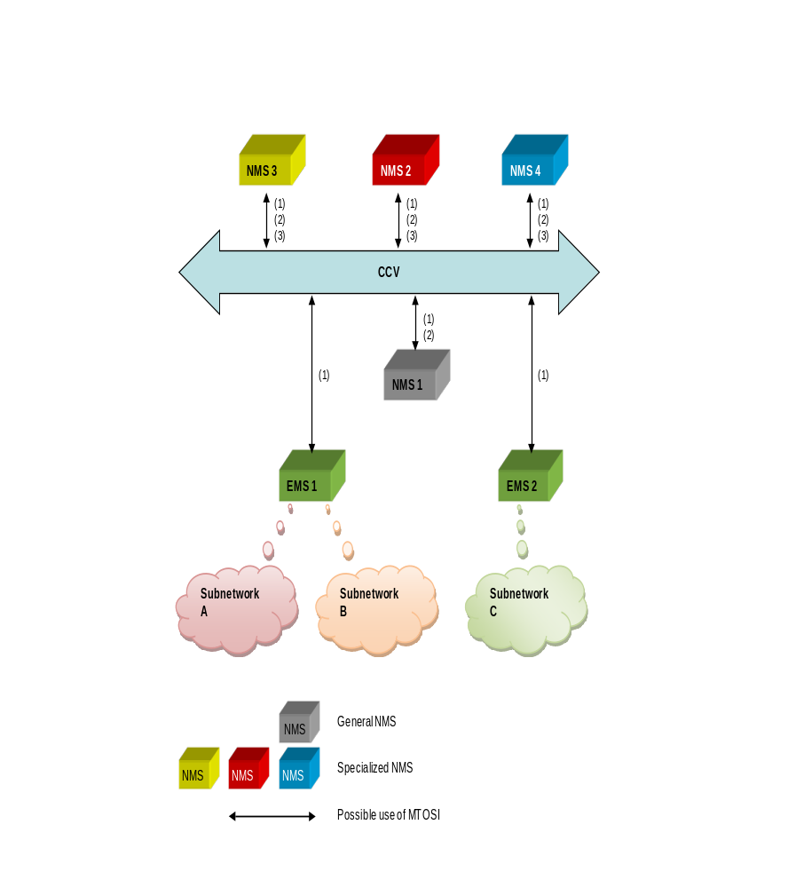
Figure 2.1: Management system scenarios
As the reader will see, not all of the MTOSI requirements apply to all scenarios. In cases where the requirement is specific to a particular scenario, this will be noted.

NMS-EMS (1)
As noted previously, MTOSI is OS-OS communications. However, NMS to EMS is covered as a special case. The EMS and the subnetwork could come from a single equipment supplier (e.g., EMS 2 in Figure 2 1) or it could be a third-party EMS that manages subnetworks from many equipment suppliers (e.g., EMS 1 in Figure 2 1, assuming Subnetwork A and B contain equipment from different suppliers). It should be noted that there can be multiple instances of the NMS-EMS (1) interface for a given EMS or NMS, i.e., one EMS can be managed by several NMSs, and one NMS can manage several EMSs.

NMS to lower-tier NMS (2)
Another possible application of MTOSI is between a higher-tier NMS and a lower-tier NMS. For example, in Figure 2 1, NMS 1 (lower-tier NMS) could be a general NMS, and NMS 2 could be an inventory management NMS. The general NMS relays information about network modifications to the inventory NMS, which shares the information with other NMSs.

NMS to NMS (Peer to Peer) (3)
Yet another case is peer-to-peer communications between two NMSs. In Figure 2 1, an inventory NMS (NMS 2) could use MTOSI to make available inventory information to say a fault management NMS (NMS 3) and a planning system (NMS 4).

Transport Technologies
As noted earlier, MTOSI covers a number of transport technologies. The same set of operations, notifications and objects are used to manage these technologies. The variations in procedures and information are typically embedded in the transmission parameters of the various operations, the layered transmission parameters of the termination points, the various performance management measurements (which of course do vary from technology to technology) and in some cases specialized probable causes (used for fault management). These parameter lists are contained in separate ‘supporting documents’.
It is only allowed to use a proprietary parameter when there is no corresponding parameter specified.

Transmission Parameters
Transmission parameters are defined in supporting document SD1-16_LayeredParameters. The document defines where and how a parameter has to be used. For each parameter, the following properties are specified:
- name of the parameter;
- layers to which the parameter can be applied to;
- object classes to which the parameter can be applied to;
- allowed values that the parameter can have;
- if a notification has to be sent when the value of the parameter changes;
- who (client/server) can potentially set the parameter;
- standard defining the parameter;
- comments and examples explaining the parameter.

Performance Parameters
Performance parameters are defined in supporting document SD1-28_PerformanceParameters. The document defines where and how a parameter has to be used. For each performance parameter, the following properties are specified:
- name of the parameter;
- description of the parameter;
- layers to which the parameter can be applied to;
- standard defining the parameter.

Layer Rates
Layer rates are defined in supporting document SD1-17_LayerRates. The document contains the list of specified layer rates. For each layer rate, the following properties are specified:
- name of the layer rate;
- integer value of the layer rate;
- string of the layer rate when used in object naming;
- description of the layer rate.

Probable Causes
Probable causes are defined in supporting document SD1-33_ProbableCauses. The document contains the list of specified probable causes. For each probable cause, the following properties are specified:
- name of the probable cause;
- description of the probable cause;
- standard defining the probable cause;
- object classes to which the probable cause can be applied.

Requirements per management topic

General
It is not necessary to implement the whole MTOSI interface specification.
The complete functionality required for the system at the server side of the MTOSI interface has to be implemented according to the MTOSI specification. Proprietary additions are only allowed for functions that are currently not manageable by the MTOSI specification.
Proprietary extensions, if necessary, have to be described in detail and have to be contributed to TM Forum for inclusion in a future release of the MTOSI specification.

Document Delivery Package (DDP) structure
The MTOSI specification is divided into Document Delivery Packages (DDPs) based on Business Process Framework (eTOM) Level 2/3 processes.
DDPs are of two basic types:
- Static specification DDPs
- Dynamic specification DDPs
The following DDPs are defined in MTOSI Rel. 2.0:
- Framework (FMW)
- RM&O + RD&M (as defined in the Business Process Framework)
  - Static
    - Network Resource Basic (NRB)
    - Network Resource Fulfillment (NRF)
    - Network Resource Assurance (NRA)
  - Dynamic
    - Manage Resource Inventory (MRI)
    - Resource Provisioning (RP)
    - Resource Trouble Management (RTM)
    - Resource Performance Management (RPM)
- SM&O + SD&M (as defined in the Business Process Framework)
  - Static
    - Service Basic (SB)
  - Dynamic
    - Manage Service Inventory (MSI)
    - Service Activation (SA)
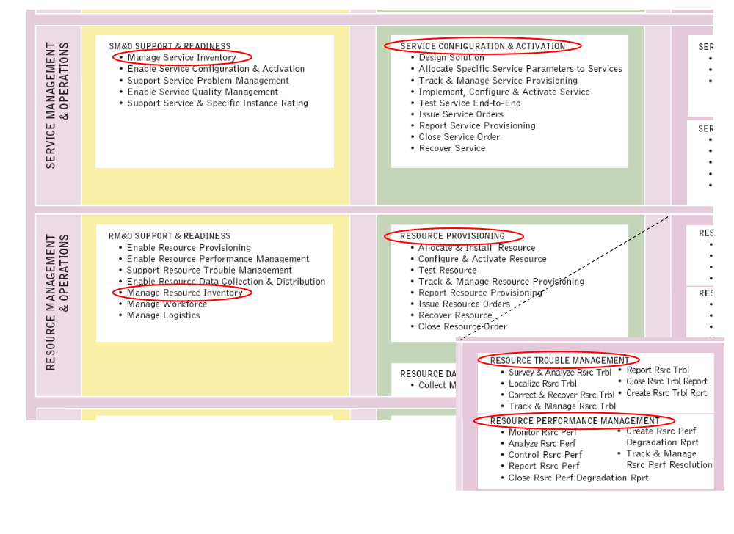
Figure 3.1: ‘Location’ of DDPs within the Business Process Framework (eTOM)

Framework

Common information and naming
The static information contained in all interface objects is defined in a common superclass.
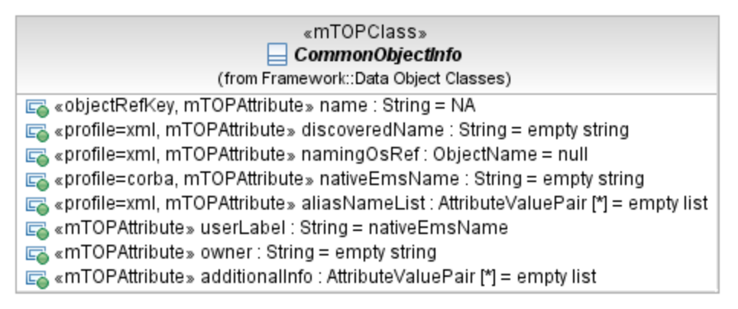
Figure 3.2: Common object information
The attribute ‘nativeEMSName’ (marked by ‘profile=corba’) is not required for the MTOSI interface.
Table 3.1: Common information requirements
Requirements | Source | Comments
The management system shall support the MTOSI common information as shown in Error: Reference source not found above. | TMF518_FMW, Section 3.1.1 | Note that only the ‘name’ attribute is mandatory. The other attributes may be used based on service provider needs.
In cases where the discovering OSS (the OSS that first announces the existence of a given object to other OSSs on the CCV) is not the naming OSS, the discovering OSS shall use the discoveredName, which will be superseded by the name as supplied by the naming OSS. | TMF518_FMW, Section 3.1.1 | Also, see Rationale for Design Decisions Concerning Object Discovery Notification (ODscN) in TMF518_FMW, Section 3.1.6.1
Each object shall be given a unique name in the context of a CCV. However, it is also possible to have aliases for an object (provided in the aliasNameList) | TMF518_FMW, Section 3.1.1
One or more management domains shall be used to represent the managed network of a service provider in the context of a given CCV. Each network resource is contained under exactly one management domain. Each OS on the CCV may store a part or the whole inventory associated with one or more management domains. | TMF518_FMW, Section 3.1.4 (R_TMF518_FMW_I_0004)

Interface versioning
Table 3.2: Interface versioning requirements
Requirements | Source | Comments
The management system shall support backward and forward compatibility for any minor version. | TMF518_FMW, Section 3.1.5 | This is in fact a characteristic of the MTOSI interface design.

Notifications
The MTOSI Framework (as described in TMF518_FMW) covers generic requirements on MTOSI notifications that apply to the more specific notifications defined in the other DDPs.
Table 3.3: Notification requirements
Requirements | Source | Comments
As needed for a given DDP, the management system shall support the MTOSI notifications. | TMF518_FMW, Section 3.1.6 | This requirement needs to be specialized for a given DDP as not all DDPs require all of the MTOSI notification types.  Requirements in subsequent sections of this document help narrow down the required notification types for a given DDP.
The management system shall publish a creation notification for itself and its associated management domain/s when it is first associated with the CCV. | TMF518_FMW, Section 3.1.6

General interface aspects
Sections 3.2.1, 3.2.2 and 3.2.3.1 of TMF518_FMW list some very general requirements that cover basic assumptions for MTOSI. It is not clear that these need to be repeated in an RFP, and we do not attempt to summarize these requirements in this document. However, the RFP writer may choose to reference these requirements as a reminder to their suppliers.

Message Exchange Patterns (MEPs)
MTOSI defines several MEPs such a Synchronous Request/Reply, Iterator, (File) Bulk Transfer and Notification with sync subscription with Asynchronous version for each. This is described in much more detail in the MTOSI supporting document: SD2-5_Communication_Styles, MTOSI Communication Styles.
In all likelihood, the equipment or OSS supplier has to choose a given set of MEPs in advance based on the allowable MEPs for each MTOSI operation, e.g., Asynchronous Request/Reply for simple operations and Asynchronous Bulk Transfer for operations that return a lot of information. This could cause interoperability problems for the service provider if their suppliers have chosen different approaches. So, it is important to indicate a preference well in advance of an RFP if possible (perhaps in an early RFI that has some indication of the service provider’s preference with respect to MEPs).

Extensibility
MTOSI supporting document: SD2-6_VersioningAndExtensibility defines rules for version and extensibility. The advice is given to the RFx writer with respect to MTOSI extensibility:
- Supplier extensions are key differentiators. The RFx writer should ask what extensions the supplier has added to the interface.
- The RFx writer should make sure that none of the supplier extensions are replacements for existing MTOSI functions as this leads to non-interoperability.
- The RFx writer should make sure that the supplier is using the MTOSI extension mechanisms and not their own proprietary extension mechanism.
- The RFx writer should make clear what extensions they need for their company.
- For both supplier and service provider extensions, it is recommended that these extensions eventually be submitted back to TM Forum for inclusion in a future MTOSI release.

Multiple Action Requests and Transactions
The MTOSI Multiple Action Requests and Transaction (MART) capability allows a client OSS to package several operations in a single message.
Some example uses of the MART capability are as follows:
- Apply the same operation to a large number of objects of the same type, e.g., create 500 ATM SNCs, where each action/object pair is regarded as an independent transaction.
- Apply sets of operations to sets of objects as a single transaction. The transactional logic is delegated to the server OS. This is useful in performance tasks such as the configuration of a managed element and all associated equipment and ports.

Table 3.3: MART requirements
Requirements | Source | Comments
The management system shall support the fulfillment of MART requests from the client system. | TMF518_FMW, Section 3.2.6
The management system shall support requests for the status of a given MART request. | TMF518_FMW, Section 3.2.6 (R_TMF518_FMW_II_0026)
The management system shall support requests to terminate an outstanding MART request. | TMF518_FMW, Section 3.2.6 (R_TMF518_FMW_II_0027)
The management system shall support MART requests that have instructions concerning execution sequencing and failure behavior. | TMF518_FMW, Section 3.2.6 (R_TMF518_FMW_II_0031 and R_TMF518_FMW_II_0032)

Manage resource inventory
With respect to the Application Framework (TAM), the interface capabilities in this section would be supported by the Resource Inventory Management application.

Inventory retrieval
This interface capability is part of the Application Framework feature known as Resource Inventory Retrieval.
MTOSI provides both fine-grained and coarse-grained operations for inventory management. The requirements that follow cover both types of inventory operations. However the users of this template may want to request either one or the other in their RFP or RFI documents.
The requirements that follow are based on the following three documents: TMF518_MRI (this contains the requirements and use cases for resource inventory management), TMF612_MRI (this contains the supporting information model for resource inventory management) and TMF864_MRI (this contains the WSDL and XSDs that actually specify the interface itself).
Table 3.5: Inventory retrieval requirements
Requirements | Source | Comments
The management system shall support the MTOSI fine-grained inventory retrieval capabilities for connection oriented technologies. | TMF518_MRI, Section 3.3.2 | Section 3.3.2 provides a rather long list of requirements for various transport-related objects. The user of this template may want to specify requirements and identify a subset consisting of only those object types that are needed for their particular application.
The management system shall support the MTOSI bulk inventory retrieval capability. | TMF518_MRI, Section 3.3.1.3 | This capability supports both connection and connectionless technologies.  As with the previous requirement, the user may want to narrow this requirement to only the specific object types that are needed for their application.

Inventory notifications
This interface capability is related to the Application Framework feature known as Resource Inventory Update Notifications.
Table 3.4: Inventory notifications
Requirements | Source | Comments
The management system shall support the MTOSI fine-grained notifications for object creation, object deletion, attribute value change and state change. | TMF518_NRF, Section 3.1.26  TMF518_FMW, Section 3.1.6.1 | The fine-grained notifications are best for relatively infrequent events. For cases where a new Managed Element or even a new circuit pack is activated, the fine-grained approach may not work well because there would be a flood of notifications in these cases.
The management system shall support the MTOSI fine-grained notification for object discovery. | TMF518_NRF, Section 3.1.26  TMF518_FMW, Section 3.1.6.1 | The object discovery notification is used when the discovering OS does not provide the ‘permanent’ for objects (see TMF518_FMW, Section 3.1.6.6 for more details).
The management system shall support the MTOSI Multi-Entity Inventory (MEI) notification to report inventory changes on multiple inventory objects in one message. | TMF518_NRF, Section 3.1.26.6  TMF518_FMW, Section 3.2.7  Non-functional requirements in Section 3.5 of TMF518_MRI | The MEI approach is helpful in cases where a lot of inventory information needs to be reported at one time, e.g., when a new Managed Element is activated.

Inventory discovery and synchronization
This interface capability is related to the Application Framework feature known as Resource Inventory Reconciliation.
The inventory mechanism provided by MTOSI can be used in a variety of ways to discover and keep inventory in synchronization among several management systems. It is really up to the service provider and their suppliers to decide on how to combine the various capabilities.
Table 3.5: Inventory Discovery and Synchronization
Discovery and Synchronization Approach | Description
Periodic retrievals with fine-grained notifications and suppression of notification floods | In this approach, the client system would retrieve all inventory changes from the server that have occurred over some agreed time period (perhaps one day). In the event of major changes during the day, it is agreed in advance to only report on the container object (e.g. object creation of a Managed Element) and then have the client do a retrieval request on the contained objects within the Management Element.
Periodic retrievals with MEI notifications | In this approach, the client system would retrieve all inventory changes from the server that have occurred over some agreed time period (perhaps one day). However, in the event of major changes during the day, the server would send the notifications in a batch via the MEI mechanism. Fine-grained notifications could still be used here for other situations.
Periodic retrievals with no notifications | Yet another approach is not to use notifications at all. The client systems would do regular retrievals (just the changes) over some agreed time. Further, the client system could be manually instructed to additional retrievals whenever a significant network change is made and the service provider does not want to wait for the next regularly scheduled update.

Inventory Update
This interface capability is related to the Application Framework feature known as Resource Inventory Update.
The MTOSI inventory update mechanism allows one system to tell another system to update its inventory view. One example usage is between a planning system and an inventory system. In this example, the service provider plans a future network view in a planning system and then pushes the view to their inventory system. Subsequently, the network is updated to fit the new view and the inventory system discovers and reconciles the new network with the view that it got from the planning system.
Table 3.6: Inventory update
Requirements | Source | Comments
The management system shall support the MTOSI fine-grained notifications for object creation, object deletion, attribute value change and state change. | TMF518_NRF, Section 3.1.26  TMF518_FMW, Section 3.1.6.6 | The fine-grained notifications are best for relatively infrequent events. For cases where a new Managed Element or even a new circuit pack is activated, the fine-grained approach may not work well because there would be a flood of notifications in these cases.

Resource provisioning

Connection control
Table 3.7: Connection control
Requirements | Source | Comments
The management system shall support requests to create and activate SubNetwork Connections (SNCs). | TMF518_RP, Section 3.3.1 | For a given SNC, create and activate can be done in separate requests or together in a single request.  MTOSI supports point to point as well as point to multi-point connections.  MTOSI supports a variety of complex SNC types. It is recommended that the user of this document decide what SNC types they need for their given situation. The SNC types are defined in SD1-36, SNC Types (this is a supporting document that is packaged with TMF518_FMW).
The management system shall support requests to check the feasibility of creating and activating an SNC. | TMF518_RP, Section 3.3.1
The management system shall support requests to modify an SNC (including modification of the SNC’s route). | TMF518_RP, Section 3.3.1
The management system shall support requests to deactivate and delete an SNC. | TMF518_RP, Section 3.3.1 | For a given SNC, deactivate and delete can be done in separate requests or together in a single request.
The management system shall support requests to deactivate and delete a leg of a point to multi-point connection. | TMF518_RP, Section 3.3.1

Equipment provisioning
Table 3.8: Equipment provisioning
Requirements | Source | Comments
The management system shall support requests to provision and unprovision equipment and equipment holders. | TMF518_RP, Section 3.3.2

Flow Domain control
From R_TMF518_NRF_I_0047 in TMF518_NRF, a Matrix Flow Domain (MFD) is contained within a Managed Element (ME) and represents a grouping of assigned Connectionless Port Termination Point (CPTP). These assigned CPTPs adapt to TPs at a client layer (Flow Points) that support connectionless switching.

Table 3.9: Matrix Flow Domain management
Requirements | Source | Comments
The management system shall support the creation, modification and deletion of Matrix Flow Domains. | TMF518_RP, Section 3.3.3.1
The management system shall support requests to assign and unassign CPTPs to/from a MFD. | TMF518_RP, Section 3.3.3.1
The management system shall support requests OS to associate and disassociate a Transmission Descriptor (TMD) to/from a given Matrix Flow Domain. | TMF518_RP, Section 3.3.3.1 | A TMD is basically a reusable template that defines various transmission characteristics.

From R_TMF518_NRF_I_0049 of TMF518_NRF, a Flow Domain (FD) represents a network grouping of zero or more Matrix Flow Domains (MFDs) and zero or more CPTPs that are assigned to these MFDs.

Table 3.10: Flow Domain management
Requirements | Source | Comments
The management system shall support requests to create, modify and delete Flow Domains. | TMF518_RP, Section 3.3.3.2
The management system shall support requests to associated and disassociate CPTPs to/from a Flow Domain. | TMF518_RP, Section 3.3.3.2
The management system shall support requests to associated and disassociate MFDs to/from a Flow Domain. | TMF518_RP, Section 3.3.3.2

From R_TMF518_NRF_I_0052 of TMF518_NRF, a Traffic Conditioning (TC) Profile contains the parameters that police the traffic at the ingress and or egress (in this version only ingress is supported) of a connectionless layer (e.g., Ethernet) network. The policies can be applied to:
- a UNI/NNI port (CPTP) (e.g. for Ethernet per VLAN-Id, Priority and CoS)
- a point of an Flow Domain Fragment (FDFr) (FP) (e.g., for Ethernet per VLAN-Id, Priority and CoS)
From R_TMF518_NRF_I_0055 of TMF518_NRF, a Matrix Flow Domain Fragment (MFDFr) object shall represent the portion of a Flow Domain (FD) within a Matrix Flow Domain (MFD) inside a Network Element (NE).

Table 3.11: Traffic Conditioning (TC) profile management
Requirements | Source | Comments
The management system shall support requests to create, modify and delete Traffic Conditioning Profiles. | TMF518_RP, Section 3.3.3.3

From R_TMF518_NRF_I_0059 of TMF518_NRF, a Flow Domain Fragment (FDFr) is a logical entity that represents a transparent end-to-end connectivity between two or more Flow Points (FP) (at the same connectionless layer and with compatible directionality) within a Flow Domain (FD).

Table 3.12: Flow Domain Fragment (FDFr) management
Requirements | Source | Comments
The management system shall support requests for the creation, modification and deletion of FDFrs. | TMF518_RP, Section 3.3.3.4
The management system shall support requests to add or remove Flow Points to/from an FDFr. | TMF518_RP, Section 3.3.3.4

Termination Point control
From R_TMF518_NRF_I_0012 in TMF518_NRF, a Group Termination Point (GTP) object shall represent a sequence of Connection Termination Points (CTPs) (with a specific order) in the same Network Element (NE).
GTPs shall have the following behavior:
- The CTPs comprising a GTP need not be contiguous.
- A CTP cannot belong to more than one GTP at a time.
- Once a CTP is included in a GTP, it cannot be cross-connected independent of the GTP.
- All CTPs in a GTP must have the same connection state and be in the same network access domain.
Table 3.13: Group Termination Point (GTP) Management
Requirements | Source | Comments
The management system shall support requests for the creation and deletion of GTPs. | TMF518_RP, Section 3.3.6
The management system shall support requests to add or remove Connection Termination Points (CTPs) to/from a Group Termination Point (GTP). | TMF518_RP, Section 3.3.6

From R_TMF518_NRF_I_0014 in TMF518_NRF, a Termination Point Pool (TP Pool) object shall represent a grouping (without a specific order) of Termination Points (TP) or Group Termination Points (GTP) from the same subnetwork for some administrative management purposes (e.g. bandwidth reservation and common routing).
Table 3.14: TP Pool management
Requirements | Source | Comments
The management system shall support requests for the creation and deletion of TP Pools. | TMF518_RP, Section 3.3.3.6
The management system shall support requests to add or remove Termination Points or Group Termination Points to or from a TP Pool. | TMF518_RP, Section 3.3.3.6

Table 3.15: TP management
Requirements | Source | Comments
The management system shall support requests to terminate and map a Connection Termination Point (CTP).  This request, if successful, will configure the CTP such that it will then be capable of supporting lower rate connections.  The converse capability shall also be supported, i.e., modify the CTP so that it is no longer terminated and map, and can thus support cross connections at the CTP’s layer and rate. | TMF518_RP, Section 3.3.6 | Some examples:  Termination and mapping of an STS1 CTP such that it will support VT1.5 CTPs.  Termination and mapping of a T3 CTP such that it will support T1 CTPs.
The management system shall support requests to provision Termination Point transmission parameters. | TMF518_RP, Section 3.3.6
The management system shall support requests to create and delete Floating Termination Points (FTPs). | TMF518_RP, Section 3.3.6 | An FTP is a TP without a physical layer that behaves both like a Physical Termination Point (PTP) and a Connection Termination Point (CTP):  FTPs (client side) behave like PTPs wherever PTPs are used in the Interface.  FTPs (server side) behave like CTPs wherever CTPs are used in the Interface.

Transmission Descriptor (TMD) control
A TMD is a profile of attributes that can be assigned to one or more TPs.
Table 3.16: Transmission Descriptor (TMD) control
Requirements | Source | Comments
The management system shall support requests to create, modify and delete TMDs. | TMF518_RP, Section 3.3.7

Assignment of Transmission Descriptor
Table 3.17: TMD assignment
Requirements | Source | Comments
The management system shall support requests to associate an ingress and/or egress Transmission Descriptor with a given Termination Point or Matrix Flow Domain. | TMF518_RP, Section 3.3.8

Topological Link control
Table 3.18: Topological Link control
Requirements | Source | Comments
The management system shall support requests to create and delete Topological Links. | TMF518_RP, Section 3.3.9

Resource trouble management

Alarm management
Alarm management is covered by the Application Framework application known as ‘Resource Status Monitoring’.
The requirements for alarm management are discussed in Section 3.3.1 of TMF518_RTM.

Table 3.19: Alarm management
Requirements | Source | Comments
The management system shall support the MTOSI capabilities for the retrieval of Alarm Severity Assignment Profiles (ASAPs) | TMF518_RTM, Section 3.3.1.1 | ASAPs allow a client to tell an alarm generating system the conditions under which an event is assigned a particular alarm severity.  Another approach is to not use ASAPs and make alarms to the desired severity within the client (alarm receiving system).  The ASAP object is defined in TMF518_NRA, Section 3.1.1.
The management system shall allow its clients to create, delete and modify ASAPs. | TMF518_RTM, Section 3.3.1.3
The management system shall allow its clients to assign and de-assigned ASAPs from objects for which alarms can be generated (e.g. TPs and Equipment). | TMF518_RTM, Section 3.3.1.4.4
The management system shall allow its clients to activate or deactivate alarm reporting for a given object instance. | TMF518_RTM, Section 3.3.1.2 | The alarm notification is defined in TMF518_NRA, Section 3.1.1.
The management system shall support alarm administration, which includes alarm subscription (with filters) by interested clients and the subsequent sending of alarms to registered clients. | TMF518_RTM, Section 3.3.1.4.1
The management system shall support the filtered retrieval of active alarms. | TMF518_RTM, Section 3.3.1.4.2 | This is typically needed to synchronize active alarms between the alarm generating system and the clients that receive such alarms.
The management system shall support the acknowledgement and unacknowledgement of alarms.  The management system shall support subscription to events related to alarm acknowledgement and unacknowledgement and the subsequent sending of such events. | TMF518_RTM, Section 3.3.1.4.3
The management system shall support the subscription to and sending of root cause alarms. | TMF518_RTM, Section 3.3.1.4.5
The management system shall be able to indicate that a set of alarms are correlated to a given alarm. | TMF518_RTM, Section 3.3.1.4.6

Protection management
Protection management is not explicitly mentioned in the Application Framework. However, one can say that protection management has two basic aspects, i.e., configuration of the resources that perform the automatic protection and the actual protection management procedures. Configuration of the resources for protection management would be supported by the Resource Order Management application, but it should be emphasized that the order may apply to a non-customer specific need such as establishment of protection groups for a SONET or SDH ring. The actual real-time protection management mechanism would come under the Resource Problem Management application.
Table 3.20: Protection management
Requirements | Source | Comments
The management system shall support retrieval requests for TP protection information such as protection groups. | TMF518_RTM, Section 3.3.2.1 and Section 3.3.2.3 (R_TMF518_RTM_II_0059) | The requirements in the referenced section are at the line level and covered technologies such as MS-SPRING and BLSR.
The management system shall support subscription to and subsequent sending of lifecycle notifications (such as object creation and deletions) concerning protection groups. | TMF518_RTM, Section 3.3.2.1 (R_TMF518_RTM_II_0052)
The management system shall support retrieval requests for equipment protection information. | TMF518_RTM, Section 3.3.2.2 and Section 3.3.2.4 (R_TMF518_RTM_II_0060)
The management system shall support subscription to and subsequent sending of lifecycle notifications concerning equipment protection groups. | TMF518_RTM, Section 3.3.2.2 (R_TMF518_RTM_II_0054)
The management system shall support subscription to and subsequent sending of equipment protection switch events. | TMF518_RTM, Section 3.3.2.4 (R_TMF518_RTM_II_0061)
The management system shall support retrieval requests for trail and subnetwork connection protection information. | TMF518_RTM, Section 3.3.2.3 (R_TMF518_RTM_II_0055, R_TMF518_RTM_II_0056 and R_TMF518_RTM_II_0059))
The management system shall support subscription to and subsequent sending of trail and subnetwork connection protection switch events. | TMF518_RTM, Section 3.3.2.3 (R_TMF518_RTM_II_0057)
The management system shall support requests for the execution of protection switch commands such as “Lockout” and “Force switch”. | TMF518_RTM, Section 3.3.2.3 (R_TMF518_RTM_II_0058)

Maintenance and diagnostic test management
This function may be mapped to the Application Framework application known as ‘Resource Testing Management’.
Table 3.21: Maintenance and diagnostic management
Requirements | Source | Comments
The management system shall support requests to set and release of maintenance commands that are supported by a Termination Point (TP). | TMF518_RTM, Section 3.3.3 (R_TMF518_RTM_II_0062)
The management system shall support requests to determine if any persistent maintenance commands have been invoked. | TMF518_RTM, Section 3.3.3 (R_TMF518_RTM_II_0063)

Resource Performance Management
With respect to the Application Framework, the interface capabilities in this section would be supported by the Resource Performance Monitoring/Management application.
It should be emphasized the MTOSI (as well as MTNM) only allows for Performance Management (PM) with regard to Termination Points (TPs). The next generation of this work will be expanded to entities beyond just TPs.

Monitor Performance Management
The function is related to the Application Framework function known as ‘Resource Performance data collection,’ which is classified under the Performance Monitoring/Management application.
Table 3.22: Retrieval of PM data
Requirements | Source | Comments
The management system shall support requests to determine the set of supported PM measurements for a given Managed Element. | TMF518_RPM, Section 3.3.1.1
The management system shall support requests for the retrieval of current PM parameters for a given set of TPs.  The retrieval request shall support filtering based on some or all of the following criteria: start and end time, PM measurement, PM location (e.g., far end, near end), layer rate, granularity (15-minute or 24-hour) and identified set of TPs. | TMF518_RPM, Section 3.3.1.1 | Two types of responses are defined in MTOSI, i.e., a PM file format or s simple data structure carried. See TMF518_RPM, Section 3.3.1.1 (R_TMF518_RPM_II_0011) for more details.
The management system shall support request for the retrieval of historical PM parameters for a given set of TPs. The measurements shall be stored in 24-hour and 15-minute registers.  The retrieval request shall support filtering based on some or all of the following criteria: start and end time, PM measurement, PM location (e.g., far end, near end), layer rate, granularity (15-minute or 24-hour) and identified set of TPs. | TMF518_RPM, Section 3.3.1.1 | MTOSI only supports 15-minute and 24-hour registers. The next generation of this work will, however, support finer grained intervals.  Two types of responses are defined in MTOSI, i.e., a PM file format or a simple data structure carried. See TMF518_RPM, Section 3.3.1.1 (R_TMF518_RPM_II_0011) for more details.
As defined in requirement R_TMF518_NRA_I_0011 of TMF518_NRA, a Threshold Crossing Alert (TCA) Parameter Profile represents, for a specific layer rate, a set of Threshold Crossing Alert (TCA) Parameters associated with a set of Termination Points (TPs). A TCA Parameter Profile is a simple way to assign the same PM thresholds to a set of TPs.
Table 3.23: TCA Parameter Profile retrieval
Requirements | Source | Comments
The management system shall support requests to retrieve all the TPs associated with a given TCA Parameter Profile. | TMF518_RPM, Section 3.3.1.2
The management system shall support requests to retrieve a given set of one or more TCA Parameter Profiles (TCA PP). The requesting OS may specify a given TCA PP, all TCA PPs associated with a given Managed Element or all TCA PPs managed by a given OS. | TMF518_RPM, Section 3.3.1.2  TMF518_RPM, Section 3.3.2.2 (R_TMF518_RPM_II_0022, R_TMF518_RPM_II_0024 and R_TMF518_RPM_II_0025)
Table 3.24: TCA notifications
Requirements | Source | Comments
The management system shall support subscription to and subsequent sending of TCAs. | TMF518_RPM, Section 3.3.1.3

Performance Management control
This function is covered under the Application Framework application known as “Resource Performance Monitoring/Management”. However, it should be noted that Performance Management control is not specifically mentioned in the Application Framework description.
Table 3.25: PM control
Requirements | Source | Comments
The management system shall support requests to enable and disable PM collection for a given set of TPs. | TMF518_RPM, Section 3.3.2.1
The management system shall support requests to clear (reset) the PM data registers for a given set of TPs. | TMF518_RPM, Section 3.3.2.1
Table 3.26: TCA control
Requirements | Source | Comments
The management system shall support requests to enable and disable the notification of Threshold Crossing Alerts on a given list of TPs or list of Managed Elements. | TMF518_RPM, Section 3.3.2.2
The management system shall support requests to set the value of specific TCA parameters for a Termination Point (TP) as identified by a given TP name, layer rate, granularity and location. | TMF518_RPM, Section 3.3.2.2
Table 3.27: TCA Parameter Profile (TCA PP) management
Requirements | Source | Comments
The management system shall support requests to create, delete and modify TCA PPs. | TMF518_RPM, Section 3.3.2.3
The management system shall support requests to associate a TCA PP with a given TP. | TMF518_RPM, Section 3.3.2.3

Administrative Appendix

Document History

Version Number | Date Modified | Modified by: | Description of changes
1.0 | March 2010

Acknowledgments
- Keith Dorking, Ciena
- Stephen Fratini, Telcordia
- Bernd Zeuner, Deutsche Telekom

How to comment on this document
Comments and requests for information must be in written form and addressed to the contact identified below:
Stephen | Fratini | Telcordia
Phone: | +1 732 699 2226
e-mail: | sfratini@telcordia.com
Please be specific, since your comments will be dealt with by the team evaluating numerous inputs and trying to produce a single text. Thus we appreciate significant specific input. We are looking for more input than ‘wordsmith’ items, however editing and structural help are greatly appreciated where better clarity is the result.

