mTOP Information Agreement Guidelines

Abstract

This document contains the unique design reference for the development of all mTOP Information Agreements (IA).

Table of Content

1 Introduction 3
1.1 Status 3
1.2 Context 3
1.3 Future 3
2 General Guidelines 3
2.1 IA Architecture 3
2.1.1 Overview 3
2.1.2 Logical View 4
2.1.3 Development View 5
2.1.4 Deployment View 10
2.2 Naming Conventions 10
2.3 Versioning 11
2.3.1 Overview 11
2.4 Documentation 11
3 IA Modelling Guidelines 11
3.1 Introduction 11
3.2 General IA Requirements (blue requirements provided by Steve Fratini) 11
3.3 New General IA Requirements (blue requirements provided by Steve Fratini) 12
3.4 General UML Guidelines 12
3.4.1 mTOP Profile 14
3.4.2 Data Type Guidelines 20
3.4.3 Object Class Guidelines 23
3.4.4 Object Class Attribute Guidelines 24
3.4.5 UML Diagram Guidelines 26
3.4.6 Use Case Guidelines 26
3.4.7 Reference Guidelines 26
3.4.8 Relationship Guidelines 26
3.4.9 Traceability Guidelines 27
3.5 Data Model (DM) DDP Guidelines 28
3.5.1 Overview 28
3.5.2 Location 28
3.5.3 Object Class Guidelines 28
3.5.4 Relationship Guidelines 28
3.5.4.1 Naming relationship 28
3.5.4.2 Instance Reference relationship 29
3.5.4.3 Attribute List relationship 31
3.5.5 Dependencies 32
3.6 Operations Model (OM) Guidelines 32
3.6.1 Overview 32
3.6.2 Location 33
3.6.3 Interface Guidelines 34
3.6.4 Operation Guidelines 34
3.6.5 Relationship Guidelines 40
3.6.6 Dependencies 40
3.7 Notification Guidelines 40
3.7.1 Overview 40
3.7.2 Location 40
3.7.3 File/Information Structur 40
3.7.4 Dependencies 41
4 Changes History 41
4.1 IA v3.4 (used in MTNM R3.5) to IA v3.5 (used in MTOSI R2.0) 41
5 References 41
5.1 External References 41
5.2 Internal References 41
Appendix A: mTOP Parameters Supporting Documents 42
Appendix B: mTOP Layered Parameters Domains 43
Appendix C: known issues with RSM 45
Revision History 47
Acknowledgements 47
How to comment on the document 47

Introduction
The purpose of this document is to be the unique design reference for the development of all mTOP Information Agreements (IA).

The Unified Modelling Language (UML) Version 2.1 [Ref 1] will be used as the notation for the IA. The IA will be created with the "Rational Software Modeler" (RSM) tool [Ref 2] provided by IBM.

These guidelines shall ensure that different people can create individual parts of the Information Agreement with the same "look and feel" which can then be combined into an mTOP Release.

Status
This document is an mTOP Guideline document.
Refer to the mTOP Guidelines GForge Usage document [Ref 4] for access and usage procedures of all the mTOP data available through the TMF GForge Subversion (SVN) repository.

Context
The definition of these mTOP IA guidelines is driven by the development of the MTOSI Release 2.0 mTOP product. The writing of these IA guidelines has been made possible based on the experience the mTOP team gained from the previous MTOSI and MTNM releases.

Future
These IA guidelines are not a static document. The following factors will certainly influence the evolution of these guidelines sometime in the future:
- During the creation of the individual IA DDPs the editors become more and more familiar with the RSM tool which may lead to improvements.
- mTOP Methodology: The idea of generating a protocol specific UML which then allows to automatically (tool supported) create the IIS (XML, IDL) is still the targeted goal. The guidelines will therefore have to be adapted to the process/tooling chosen.
- Harmonization/Convergence with the UML models from other standards (SID, OSS/J, 3GPP, etc) will also lead to an evolution of these guidelines.

General Guidelines

IA Architecture

Overview
The purpose of the mTOP IA is to provide a description of the protocol neutral mTOP Information Model based on UML.

The overall mTOP IA is structured along the mTOP DDP partitioning which is based on the eTOM level2/3 processes. All IA definitions must relate to the scope of the mTOP DDP that it is part of. Refer to the mTOP Guidelines DDP Definitions documents [Ref 5] for a rational description of the mTOP DDPs.

Logical View
The complete definition of the mTOP Information Model is based on the use of individual UML Models containing the mTOP DDPs.

The DDPs are grouped into two basic types:
- Data Model DDPs (DM-DDPs) containing the static data entities.
- Operations Model DDPs (OM-DDPs) containing the dynamic (service) interfaces.

The following DDPs will be created for MTOSI Release 2.0:
- Framework (FMW)
- RM&O + RD&M
- Data Model DDPs
- Network Resource Basic (NRB)
- Network Resource Fulfillment (NRF)
- Network Resource Assurance (NRA)
- Operations Model DDPs
- Manage Resource Inventory (MRI)
- Resource Provisioning (RP)
- Resource Trouble Management (RTM)
- Resource Performance Management (RPM)
- SM&O + SD&M
- Data Model DDPs
- Service Basic (SB)
- Operations Model DDPs
- Manage Service Inventory (MSI)
- Service Activation (SA)

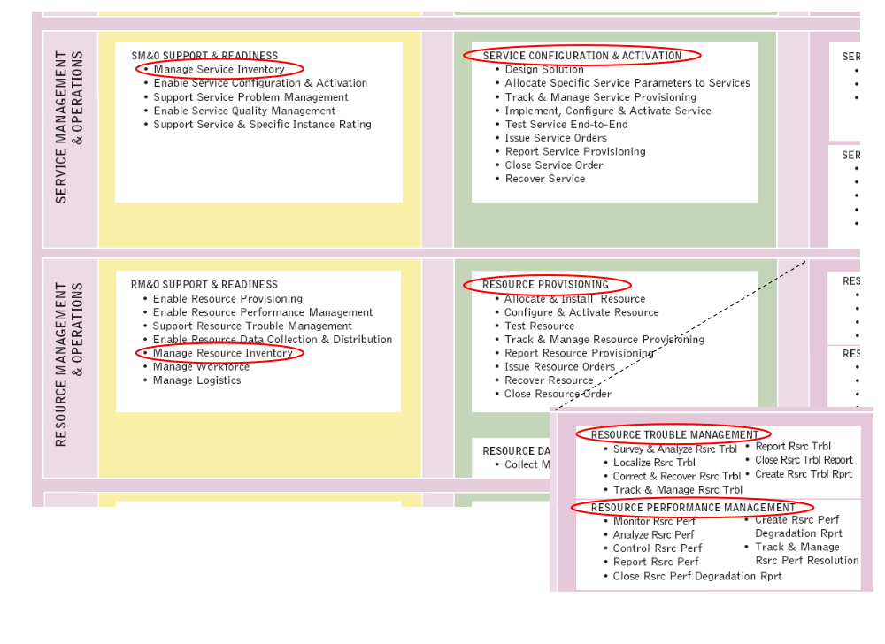
Figure 1: "Location" of the MTOSI Release 2.0 DDPs within eTOM
Note: The development of the Framework DDP will have the highest priority because this DDP is used in all other DDPs.

Development View
The development view of the mTOP IA is maintained and managed through the TMF GForge Subversion repository. Refer to the mTOP Guidelines GForge Usage [Ref 4].
The following steps describe how to add the IA (in fact it adds the complete specification) from the GForge Subversion repository as a new project into RSM.
- A prerequisite is that you have installed the "Subclipse" (an Eclipse Plug-in) Subversion tool into RSM. Section 2.4.3 in the mTOP Guidelines GForge Usage [Ref 4] document describes how to install and configure "Subclipse".
- Creating a new Repository Location (customised based on the "Subclipse" help documentation)
You create and work with your repository locations from the SVN Repository View, which is part of the SVN Repository Exploring Perspective. To create a new repository location, click the Add SVN Repository button or right clicking inside the view and selecting New > Repository Location...
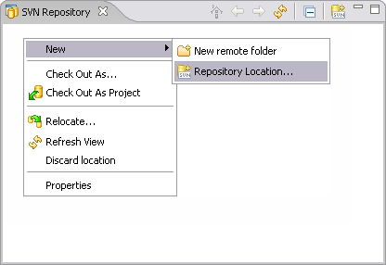
The Add SVN Repository dialog will prompt you for a repository location URL. Enter the URL of the mTOP repository
- svn+ssh://<username>@svn.gforge.tmforum.org/svn/mtop (<username> is your TMF GForge registered username) or
- https://gforge.tmforum.org/svn/mtop/ (Note: https should only be used if svn+ssh is blocked by the firewall).
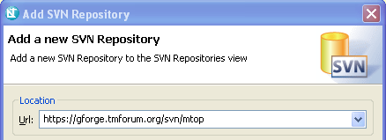
Once you click finish, the wizard will create the location:
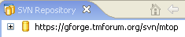
Expand the location to see the contents for the given URL.
- Checking out the draft MTOSI Release 2.0 specification from the GForge repository
Excerpt from "Subclipse" help documentation: Check out is the term used to describe the process of making a copy of a project from a repository into your local workspace. In SVN, the check out process creates a working copy. A working copy is a specially formatted folder structure which contains additional .svn folders that store SVN information, as well as a pristine copy of each item that is checked out.
In the SVN Repository window, select the Product / trunk repository directory and choose Checkout from the context menu:
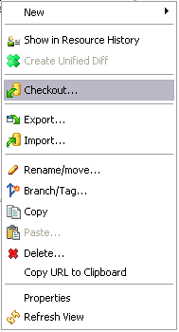
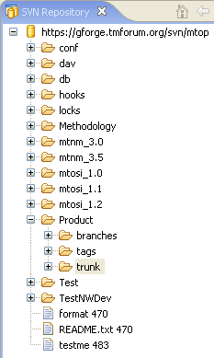

Choose Check out as a project configured using the New Project Wizard and click Next:
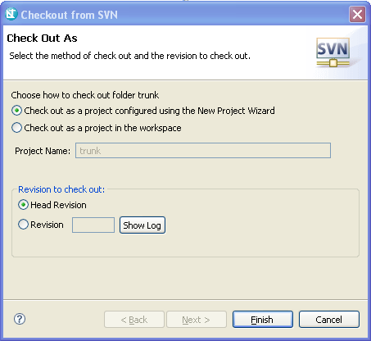

Choose General / Project and click Next:
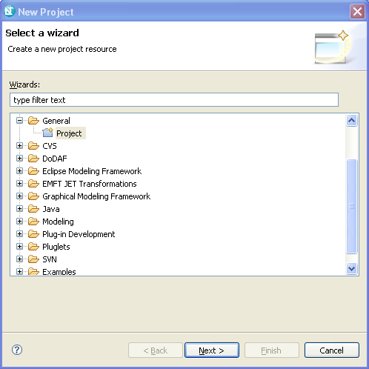

Choose a new project name (e.g., "mTOP_MTOSI_R2.0") and the location for the files and click Next:
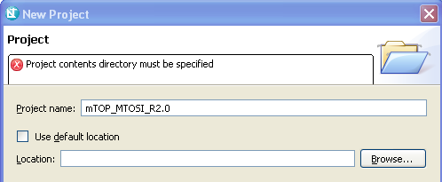

Do not reference a project and click Finish.
Finally, move to the Modeling view in RSM and you will find the new project mTOP_MTOSI_R2.0 in the Project Explorer:
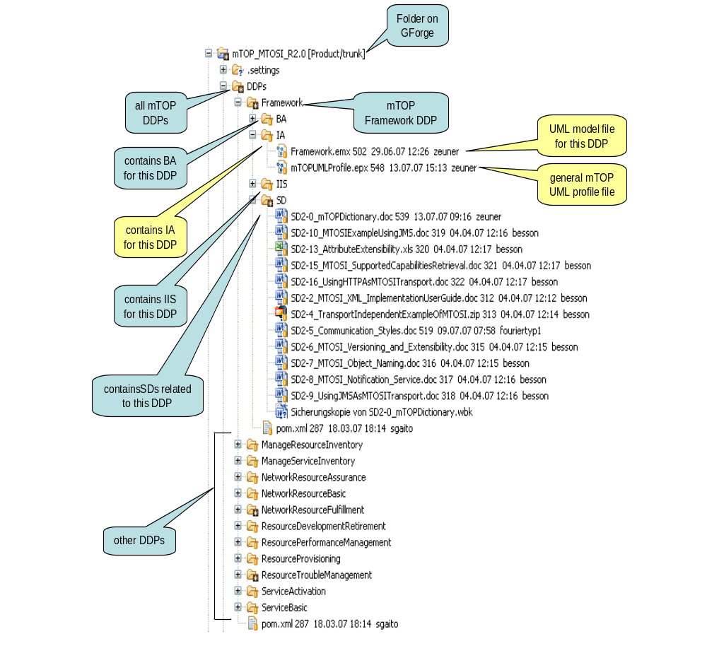
Figure 2: Structure of the IA Model files on GForge during development

Deployment View
to be defined

Naming Conventions
Refer to the mTOP Guidelines NamingConventions document [Ref 6].

mTOP artifacts are the Business Agreement (BA), the Information Agreement (IA) and the Interface Implementation Specification (IIS).

UML artifacts are classes, attributes, operations, parameters and relationships.

In this document the following tags are used as variables:
- <DDP_Full> for the full DDP name
- <DDP> for the short DDP name (acronym)

Versioning

Overview
Editor's note: Should not be a problem because backward compatibility is not required for the IA.

Documentation
The documentation of the mTOP UML IA will be done with the tool "Rational Software Modeler" from IBM. This application can also generate HTML-based documentation of the UML models.

The location for the generated HTML documentation is: to be defined.

IA Modelling Guidelines

Introduction
The information modeling comprises the "analysis" part of the specification. The requirements and use cases defined in the BA are the basis for the analysis.

The purpose of this section is to provide a set of UML design recommendations to promote all mTOP IA editors to specify the IA in a standardized mTOP UML style. The benefits are:
- Readability of the UML specification as they all have the same style.
- Providing the necessary information to distribute the workload between many editors.
- …

General IA Requirements (blue requirements provided by Steve Fratini)
- The UML 2.1 (Unified Modeling Language) is used as a notation for the model.
- The IA shall be protocol-neutral, i.e., not reflect any middleware protocol-specific characteristics (like CORBA, HTTP, JMS).
- The IA shall be map-able to various protocol-specific interfaces.
Until this mapping is automated, it will be necessary to (manually) create an IA to IIS mapping document.
- The requirements and use cases from the BA are converted into the model as object classes (containing attributes or operations) and relationships between the objects.
- For complex attributes state transition diagrams shall be created.
- For complex operations activity diagrams shall be created.
- Traceability from each modeling construct back to the requirements and use cases has to be provided.
- The information model has to provide guidelines on how the UML notation (e.g., relationship stereotypes) is used to model specific requirements.

New General IA Requirements (blue requirements provided by Steve Fratini)
This section provides the requirements which are new wrt. the last mTOP IA version (i.e., TMF608 v3.4).
- The IA shall be documented in UML 2.1 using the “Eclipse dialect”.
- The IA shall be divided into:
- Data entities – represent managed entities specified in the DM-DDPs.
These entities only have attributes and associations.
Notifications are also treated as data entities.
- Service interfaces – specified in the OM-DDPs.
These interfaces only have operations.
- The IA shall be sectionalized based on the DDP separations.
- This will allow for:
- Multiple editors of the IA
- Release of portions of the IA.
- Overlap of information between the BA and IA is allowed, but is strongly recommended that the BA be considered the source and the other document be populated automatically with the redundant information.
- Eventually, the intent is to have UML models for the various protocol-specific interfaces. These UML models will be considered part of the IIS and not the IA.

General UML Guidelines
This section provides the general guidelines (i.e., which are not specific to the Data Model or Operations Model).

Each DDP shall be stored in a separate Model file (xxx.emx file). Each Model shall be structured in the following way:
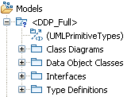
Figure 3: UML Model structure
The Data Model DDPs only have "Data Object Classes" and the Operations Model DDPs only have "Interfaces". The only exception which has both types of classes is the Framework DDP.

Note: RSM creates automatically an additional "Diagrams" folder that contains all the diagrams which are created in the specific Model.
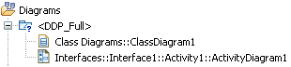
Figure 4: UML Model diagrams structure
The following figure shows the location of the UML artifacts:
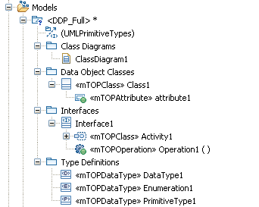
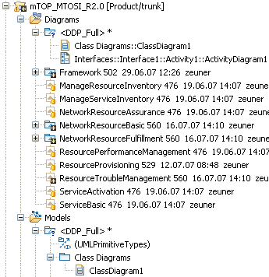
Figure 5: UML artefact structure

mTOP Profile
The RSM tool allows extending the UML core metamodel by using profiles. An mTOP UML Profile has been defined to extent the "class" and "structuralFeature" metaclasses of the core metamodel.

The "class" metaclass has been extended with the capability to specify:
- the creation notifications of the resource object class (NO | YES | NOT_APPLICABLE), default value = NOT_APPLICABLE
- the deletion notifications of the resource object class (NO | YES | NOT_APPLICABLE), default value = NOT_APPLICABLE
- the discovery notifications of the resource object class (NO | YES | NOT_APPLICABLE), default value = NOT_APPLICABLE
- if the order of the attributes is significant at the class level (Boolean), default value = False.

The "structuralFeature" metaclass has been extended with the capability to specify:
- the kind of notification that has to be send when an attribute changes its value (ATTRIBUTE_VALUE_CHANGE | STATE_CHANGE | NO_NOTIFICATION | NOT_APPLICABLE), default value = NOT_APPLICABLE
- the kind of reference that is used between object classes (VALUE | REFERENCE), default value = VALUE; see also 3.5.4.2 and 3.5.4.3.

The "dataType" metaclass and, via inheritance in the metamodel, the enumeration and primitive types have been extended with the capability to specify:
- an extensibility value that allows to plan for evolution of the data structure (OPEN | CLOSED | QUALIFIABLE | EXTENDABLE | OVERLAP), default value = CLOSED.

The "operation" metaclass has been extended with the capability to specify:
- Message Exchange Patterns (MEP) for the operations (SRR | ARR | SIT | ABR | SFB | AFB | SN | AN), default = empty list.

All extensions have been defined as mandatory. For the cases where an additional property makes no sense, the value "NOT_APPLICABLE" has been defined.

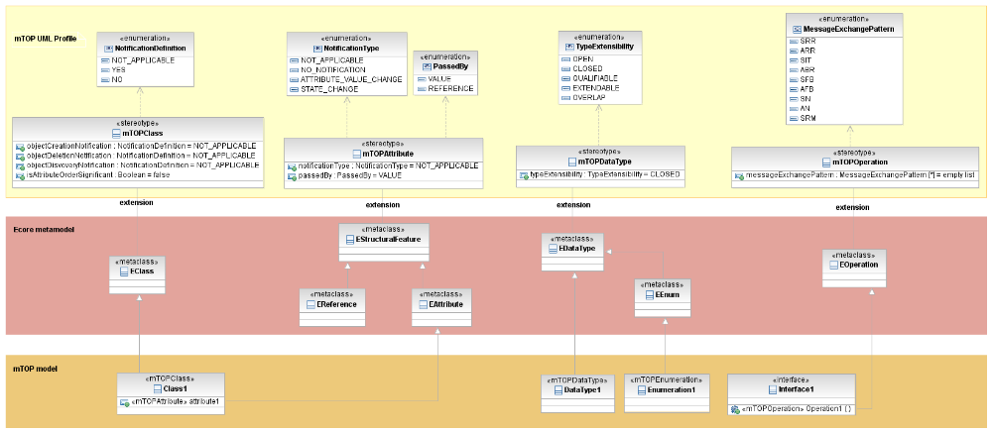
Figure 6: RSM model structure

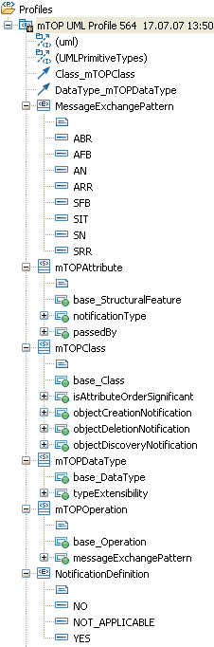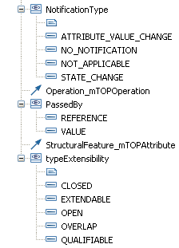
Figure 7: mTOP Profile structure

The mTOP UML Profile has to be added to all UML model files where these additional properties are necessary.
Left click the UML model file that you would like to add the profile to in the Project Explorer (in our example the NetworkResourceBasic model. Go to the Profiles tab within the Properties and click on Add Profile …
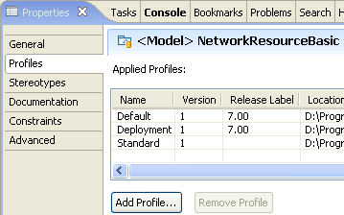

Choose the mTOPUMLProfile.epx file from your RSM workspace in folder: \mTOP_MTOSI_R2.0\DDPs\Framework\IA\.

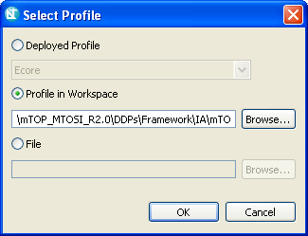

The current Profile has not been released so far because it is not mature enough. Therefore click OK on the next window:
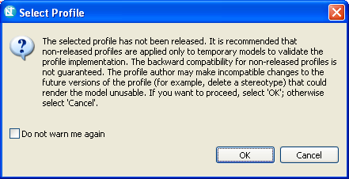

The mTOP UML Profile is now added to the list of profiles:

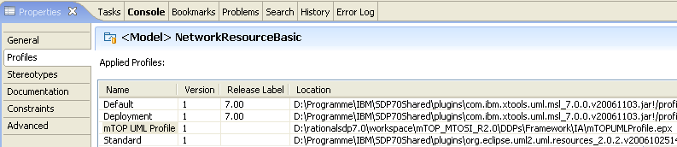

All object classes, attributes, data types, operations and associations contain now the additional properties. This is identified by the stereotypes <<mTOPClass>> for the object classes, <<mTOPAttribute>> for the attributes, <<mTOPDataType>> for the data types and <<mTOPOperation>> for the operations:

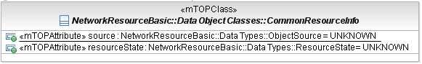
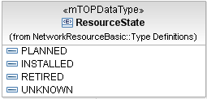
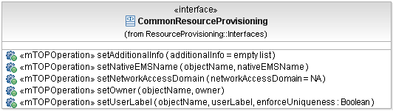

The additional properties are defined as stereotypes as depicted in the following figures:

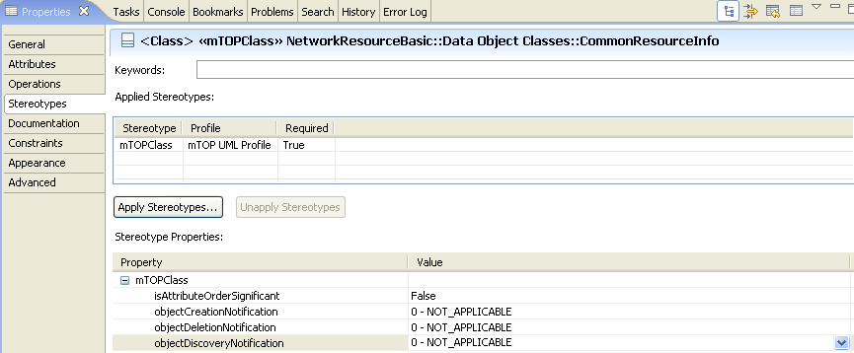

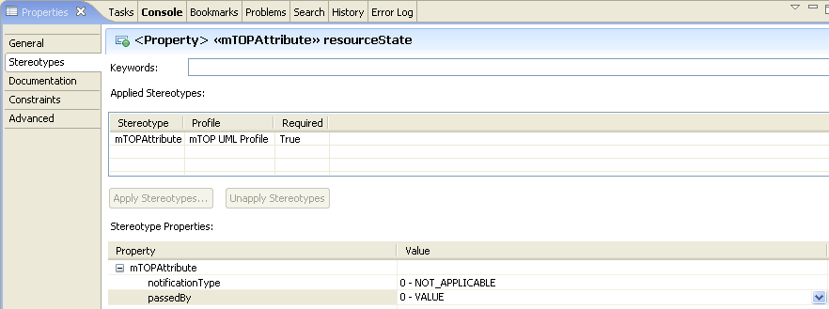

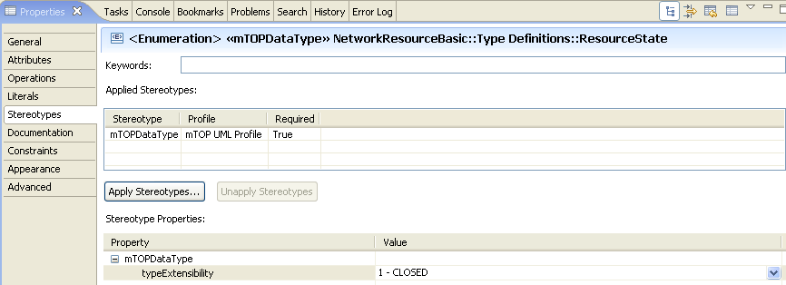

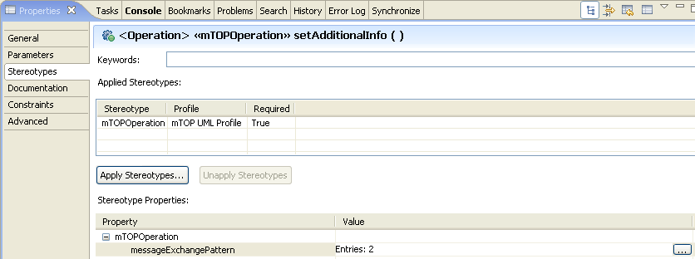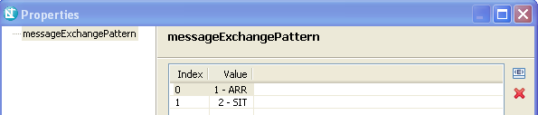

Data Type Guidelines
We distinguish between "basic" and "complex" data types.

The basic data types do not need additional specification. They are provided by the RSM tool as .
Basic data types are Boolean, String, Integer.

Add list of agreed protocol neutral data types here. Contact Steve O.

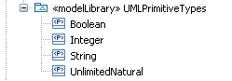
Figure 8: Basic data types
Complex data types are specified for attribute and parameter types when basic data types cannot be used. They are defined as object classes with attributes and are contained in the Type Definitions folder within each UML Model. Complex data types use basic and/or other complex data types for their Type definitions.

Guidelines:
- The category of the data type is identified by a little icon in front of the type name. The RSM meta-model already provides the dataType = , enumeration = and primitive data types (note that these types have been enhanced by the mTOP UML Profile and therefore become <<mTOPDataType>>).
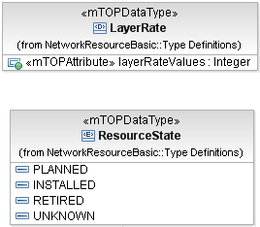
Figure 9: Complex data types (example)
- Parameter lists for creation and modification of resources shall be specified as (dataTypes) in the Type Definitions folder.
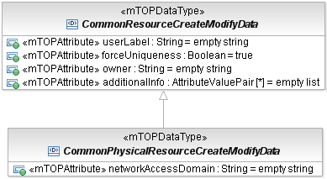
Figure 10: Creation/Modification parameter data types (example)
- Data type names
- follow Upper CamelCase (UCC)
- special definitions are in the mTOP Guidelines NamingConventions document [Ref 6].
- Attribute names within data types
- follow Lower CamelCase (LCC)
- special definitions are in the mTOP Guidelines NamingConventions document [Ref 6].
- Enumeration "value" names of data types
- have only upper case characters
- words are separated by "_"
- examples are in the mTOP Guidelines NamingConventions document [Ref 6].
- Enumeration "values" are specified as literals in the enumeration object classes.
- Data Type extensibility
- the extensibility (OPEN | CLOSED | QUALIFIABLE | EXTENDABLE | OVERLAP) has to be defined for all enumerations; see SD2-6 MTOSI Versioning and Extensibility [Ref 8].

Importing Data Types from Framework DDP

DDPs can use the general Data Types defined in the Framework DDP by importing the "Type Definitions" package which contains all the common Data Types defined:
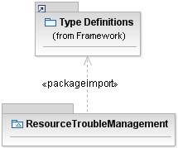
Figure 11: package import (example)

Object Class Guidelines
Object classes are used to model data entities in the DM model or (service) interfaces in the OM model.
Each object class comprises:
- Object Class Name
- follow Upper CamelCase (UCC)
- special definitions are in the mTOP Guidelines NamingConventions document [Ref 6].
- Object Class Documentation
- contains a short summary of usage
- contains "Object Created By?" and "Object Deleted By?" definitions which provides information on who and when the object is created and deleted (e.g., Created and deleted by requesting OS).
- Superclass(es)
- inheritance and multiple inheritance may be used.
- Abstract Object Class
- indicates if the object class can be created or is just used for inheritance.

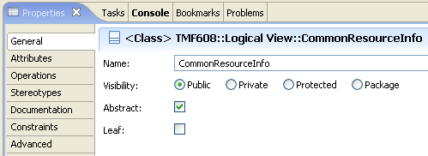
Figure 12: Defining an object class as "abstract" (example)
- Object Notifications (contained in mTOPClass stereotype)
- identifies if creation/deletion notifications have to be send
"objectCreationNotification" <NO | YES | NOT_APPLICABLE>
"objectDeletionNotification" <NO | YES | NOT_APPLICABLE>
"objectDiscoveryNotification" <NO | YES | NOT_APPLICABLE>; see also section 3.4.1.
- Ordered Attribute list
- identifies if the order of the attributes is significant at the class level (Boolean); see also section 3.4.1.

Object Class Attribute Guidelines
Each attribute in an object class comprises:
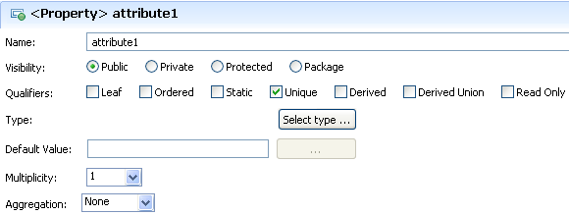
Figure 13: Defining attribute properties (example)
- Attribute Name
- follow Lower CamelCase (LCC)
- special definitions are in the mTOP Guidelines NamingConventions document [Ref 6]
- Boolean typed attributes always start with ‘is’ (e.g., ‘isAbstract’)
- Enumeration typed attributes always end with “Kind” (e.g., ‘AggregationKind’).
- Attribute Documentation
- contains a short summary of usage.
- Visibility
- Public: if the attribute shall be inherited to subclasses
- Private: if the attribute shall not be inherited to subclasses = default value.
- Qualifiers
- Leaf: defines if it is allowed to specialize or redefine the attribute in a subclass; default value is false.
- Ordered: for a multi-valued multiplicity; the order of the values is important
- Static: means invariant
- Unique: for a multi-valued multiplicity, no duplicate attribute values are allowed
- Derived: defines whether the attributes value or values can be computed from other information; default value is false
- Derived Union: defines whether the attributes value or values are derived as the union of all of the values that are constrained to subset it; default value is false
- Read Only: not writeable by Requesting OS.
With respect to the previous TMF608 only "Static" and "Read Only" have to be defined according to Table 1.
Note: For multi-valued attributes like exception in the operations, "Ordered" and Unique" have to be defined.
MTNM R3.5  contains the Attribute properties as contained in the "documentation" field (i.e., not machine readable) in Rational Rose | MTOSI R2.0  contains the Attribute properties as contained in the "Qualifiers" field (i.e., machine readable) in RSM
Readable by NMS? Yes  Writeable by NMS? No  Invariant? No | Static = False  Read Only = True
Readable by NMS? Yes  Writeable by NMS? No  Invariant? Yes | Static = True  Read Only = True
Readable by NMS? Yes  Writeable by NMS? Yes  Invariant? No | Static = False  Read Only = False

Table 1: Attribute access mapping
- Type
- refers to a basic or complex data type.
- Default Value
provides the value that the attribute has to start with in case the value is not provided during creation or already defined because of a system state.
If a default value makes no sense (e.g., if representing state of the system) = "na".
No default value for object identifier = "null".
No default value for String = "empty string".
No default value for Sequence = "empty list".
- Multiplicity
- defines the number of values the attribute can simultaneously have.
- Aggregation
- None: the affect on the attribute is unspecified when the parent is deleted
- Shared: the attribute is not deleted when its parent is deleted
- Composite: the attribute is deleted when its parent is deleted.
- Attribute Notifications (contained in mTOPAttribute stereotype)
- identifies which kind of notification has to be send in case of a value change:
"Changes in the value of the attribute lead to an <AVC | SC> notification." or
"Changes in the value of the attribute will not be notified automatically."
See also section 3.4.1.
- Attribute passedBy (contained in mTOPAttribute stereotype)
- this property can be ignored for attributes
- default value "VALUE" must not be changed.

UML Diagram Guidelines
Objects and their relationships are added to class diagrams. It is recommended to create an overview class diagram containing all object classes from the DDP. Additional class diagrams may be established to show specific parts of the DDP in detail.

State diagrams shall be created for complex attributes.

Activity diagrams\Sequence Diagrams (possibly use cases) shall be created for complex operations.

The class name compartment shall contain the "Qualified Name"

The class attributes and operation shall show the "Signature".

Use Case Guidelines
Use Cases are only specified in the BA. Add reference to use case specification template.

Reference Guidelines
Where appropriate, a UML artifact should reference external (wrt. UML) documentations (e.g., supporting documents) by a URL .

Relationship Guidelines
Relationships between the object classes are derived from the dynamic and static requirements in the BA. Each relationship comprises:
We need to define and add a catalog of mTOP relationship stereotypes.
- Relationship Name
- follow Upper CamelCase (UCC)
- Relationship Type
- e.g., inheritance, composition, association, dependency, aggregation.
- Role Names
- identifies the role that the object plays at this end of the relationship
- follow Lower CamelCase (LCC)
- only navigable relationships have role names.
- Granularity
- identifies the number of objects that can have this relationship.
- Constraint(s)
- list the constraint(s) under which the relationship can exist.

It is recommended to create relationships which are just for explanation to the reader of the model. These relationships are not navigable and have no role names. They will therefore not be taken into account in the protocol specific specification. This can for example be used to show the relationship to the object which is retrieved by a get-operation in another DDP.

Example:
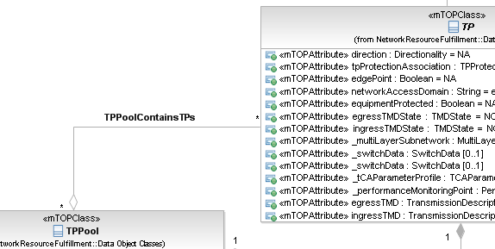
Figure 14: "No Role" relationship (example)

Traceability Guidelines
Not required for MTOSI 2.0; we will add it once it can be automated.

The following traceability matrices shall be provided:
- mapping from object classes to requirements
- mapping from object class attributes to requirements
- mapping from object class operations to requirements
- mapping from object classes to use cases.

Data Model (DM) DDP Guidelines

Overview
There is an mTOP UML Model for each mTOP DM DDP; see section 2.1.2.

Location
An mTOP IA UML data model file corresponds to an mTOP DM DDP and is contained in the IA folder of this DDP; see section 2.1.3.

Object Class Guidelines
DM Model object classes are derived from the static requirements (i.e., category I requirements) in the BA.

Relationship Guidelines

Naming relationship
Naming relationships are defined using the composition association with:
- a private role name at the subordinate class
- a stereotype of <<naming>>
- no relationship name.
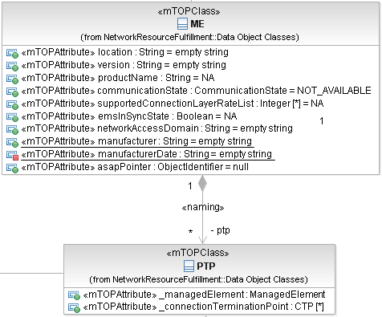
Figure 15: Naming relationship (example)

Instance Reference relationship
An object instance (name) is referenced in another object by either using the aggregation association or the simple association with:
- a relationship name
- a public role name at the referenced class side
- a default value of NA
- a notificationType of ATTRIBUTE_VALUE_CHANGE or NO_NOTIFICATION
- a passedBy value = REFERENCE.

Example 1:
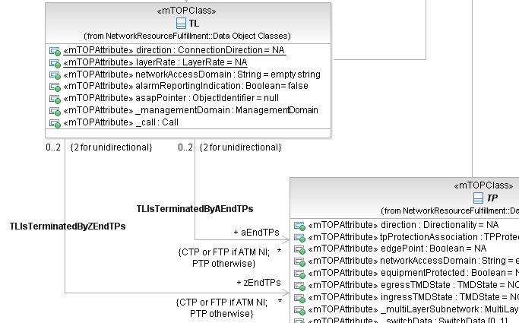
Figure 16: Unidirectional relationship using simple association (example 1)

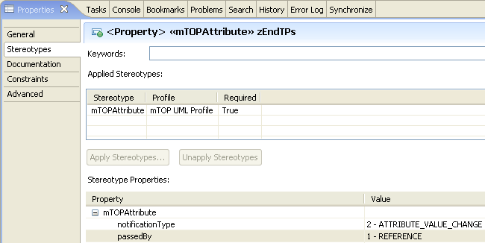
Figure 17: Additional properties of role attribute in example 1
In example 1, the name of the Termination Point (TP) shall be part of the information that is provided when the Topological Link (TL) is retrieved via the interface using the role name as the identifier (e.g., name of TP shall be implemented as an attribute of TL).

Attribute List relationship
The attribute list (complete information) of a referenced object can be used in the referencing object by using the composition association with:
- a relationship name
- a public role name at the referenced class
- a default value of NA
- notificationType = ATTRIBUTE_VALUE_CHANGE or NO_NOTIFICATION
- passedBy = VALUE.

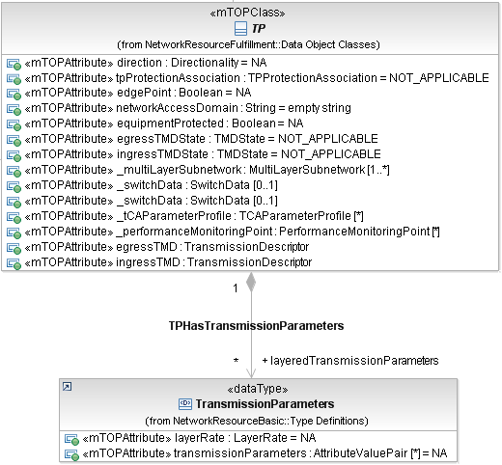
Figure 20: Attribute List relationship 1 (example)
In this example, sequences (at least one) of the attributes contained in TransmissionParameters shall be part of the information when the TP is retrieved via the interface (e.g., attributes of TransmissionParameters shall be retrieved together with attributes of TP).

Dependencies
to be added

Service Interface Guidelines
Service Interfaces are specified in the OM-DDPs.

Overview
There is an mTOP UML Model for each mTOP OM DDP; see section 2.1.2.
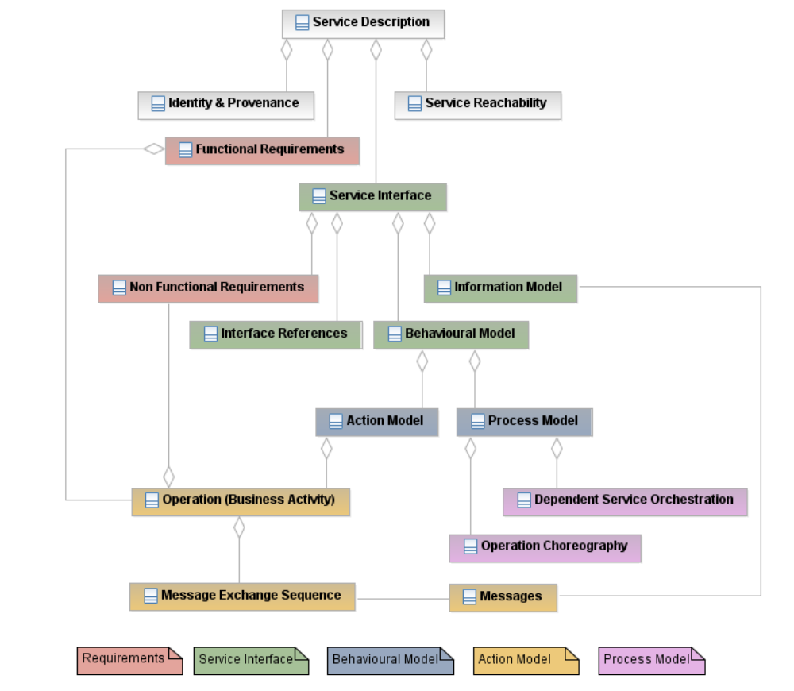
Figure 21 - OM Service description structure
However we should start with a simplified version.
Key attributes are:
- Business activities (operations)
- Message Exchange Patterns

Location
An mTOP IA UML operations model file corresponds to an mTOP OM DDP and is contained in the IA folder of this DDP; see section 2.1.3.

Interface Guidelines
OM Model Interfaces are derived from the dynamic requirements (i.e., category II requirements) in the BA. The Interfaces are modelled as object classes (i.e., the service interfaces).

Operation Guidelines
Operations (within the Interfaces) are derived from the dynamic requirements and use cases in the BA. Each operation comprises:

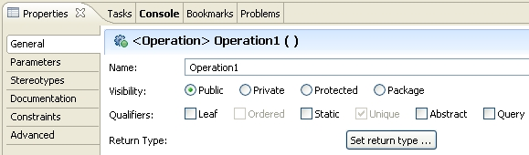
Figure 22: Defining operation properties (example)
- Operation Name
- follow Lower CamelCase (LCC)
- special definitions are in the mTOP Guidelines NamingConventions document [Ref 6].
- Visibility
- Public: if the operation shall be inherited to subclasses
- Private: if the operation shall not be inherited to subclasses = default value.
- Qualifiers
- Leaf: defines if it is allowed to specialize or redefine the operation in a subclass; default value is false.
- Static: ??
- Abstract: If true, then the behavioral feature does not have an implementation, and one must be supplied by a more specific element. If false, the behavioral feature must have an implementation in the classifier or one must be inherited from a more general element. Default value is false.
- Query: defines whether an execution of the BehavioralFeature leaves the state of the system unchanged (= true) or whether side effects may occur (= false); default value is false.
- Return Type : always "void".
- Message Exchange Pattern (MEP) (contained in mTOPOperation stereotype)
- the MEP fully identifies the messages and the choreography (sequencing and cardinality) of the messages independently from a business activity (SRR | ARR | SIT | ABR | SFB | AFB | SN | AN) ; see also section 3.4.1 and SD2-5 Communication Styles [Ref 7].
- Operation Documentation
- contains a short summary of usage.
- Pre-condition(s)
Pre-condition(s) are modeled as Constraints. They list the conditions that have to be true before the operation can be started (i.e., if not true, the operation will not start at all).

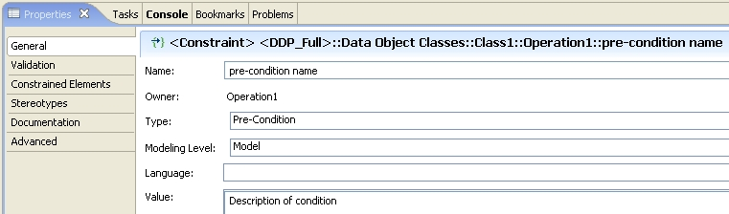

Note: It is also possible to define the pre-condition in OCL.
Figure 23: Defining operation pre-conditions
- Parameter(s)
see below.
- Post-condition(s)
Post-condition(s) are modeled as Constraints. They describe the state of the system after the operation has been successfully executed.
- Operation Exceptions
List the allowed exceptions (together with a failure reason) for the operation.
- ACCESS_DENIED - Raised when the requesting OS is not permitted to perform the operation.
- CAPACITY_EXCEEDED - Raised when the request will result in resources being created or activated beyond the capacity supported by the NE or target OS.
- ENTITY_NOT_FOUND - Raised when the specified object instance does not exist.
- INTERNAL_ERROR - Raised in case of non-specific target OS internal failure.
- INVALID_INPUT - Raised when the operation contains an input parameter that is syntactically incorrect or identifies an object of the wrong type or is out of range.
- NE_COMM_LOSS - Raised when communication to the managed element is lost.
- NOT_IMPLEMENTED - Raised when the target OS does not support this operation.
- NOT_IN_VALID_STATE - Raised when the state of the specified object is such that the target OS cannot perform the operation.
- OBJECT_IN_USE - Raised when the object identified in the request is currently in use.
- PROTECTION_EFFORT_NOT_MET - Raised when the level of protection effort in the request cannot be met by the target OS.
- TIMESLOT_IN_USE - Raised when a requested timeslot is already in use.
- TP_INVALID_ENDPOINT - Raised when the specified TP does not exist or cannot be created.
- UNABLE_TO_COMPLY - Raised when the target OS cannot respond to the request.
- UNSUPPORTED_ROUTING_CONSTRAINTS - Raised when the target OS is unable to satisfy the requested routing constraints.
- USERLABEL_IN_USE - Raised when the user label uniqueness constraint is not met; the specified user label is currently being used.

The exceptions are contained in the folder "Operation Exceptions" in the Framework DDP.
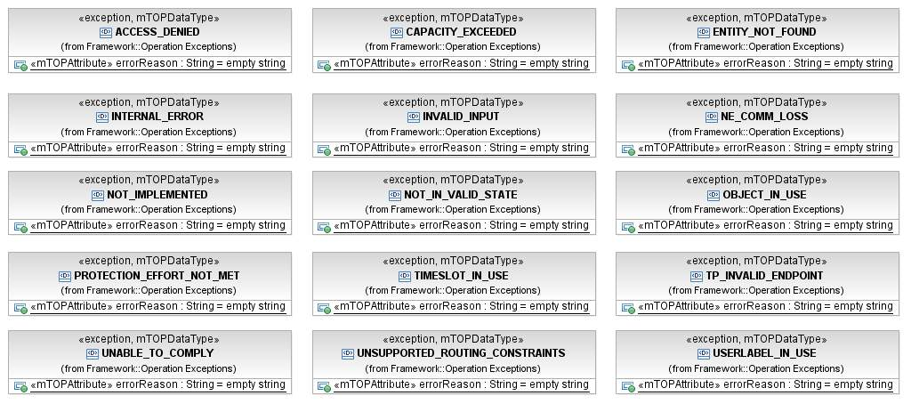
Figure 24: Operation Exceptions Class Diagram
The relevant exceptions can be added to an operation by right click on the operation, choose UML Properties …, choose RaisedException and browse to the exception class via the "…" button on the right:

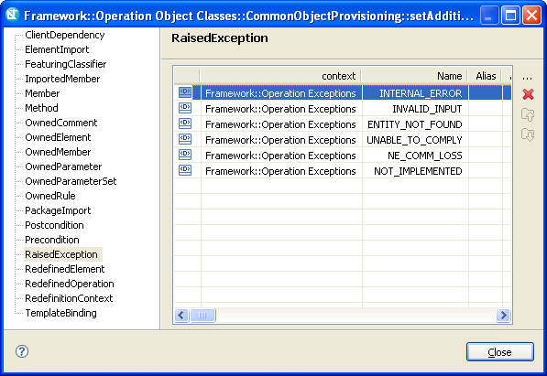
Figure 25: Raised exception window

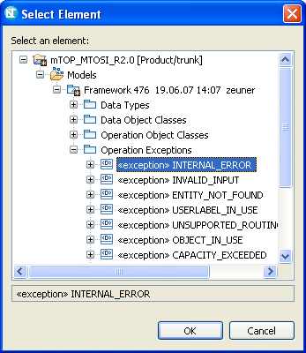
Figure 26: Select exception window
Each parameter in an operation comprises:

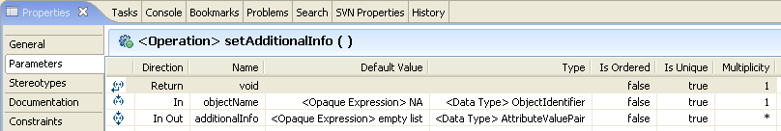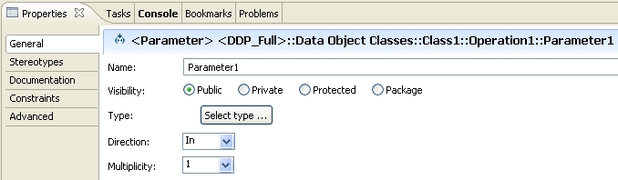
Figure 27: Defining operation parameters
- Name
- follow Lower CamelCase (LCC)
- special definitions are in the mTOP Guidelines NamingConventions document [Ref 6].
- Visibility
- Public: if the attribute shall be inherited to subclasses
- Private: if the attribute shall not be inherited to subclasses = default value.
- Type
refers to a basic or complex data type.
- Direction
- In | In Out | Out | Return .
- Default Value
provides the value that the parameter has to start with in case the value is not provided.
- Is Ordered
for a multivalued parameter; the order of the values is important.
- Is Unique
for a multivalued parameter, no duplicate values are allowed.
- Multiplicity
defines the number of values the parameter can simultaneously have.
- parameter Documentation
contains a short summary of usage.

Relationship Guidelines
It is recommended to use the dependency relationship to associate input or output parameter lists to the operations in an object. These relationships are just for explanation to the reader of the model. No special care has to be taken in the protocol specific part; they are usually modelled in operations of the dependent class.

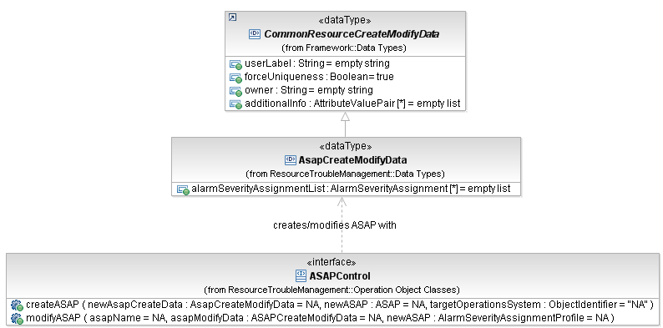
Figure 28: Depiction of operation parameter classes (example)

Dependencies
to be added

Notification Guidelines

Overview
to be added

Location
to be added

File/Information Structur
The content of the mTOP IA package typically consists of the following subfolders:
to be added

Dependencies
to be added

Changes History
The purpose of this section is to summarize the evolution/changes of mTOP IA guidelines / best-practices between product releases.

IA v3.4 (used in MTNM R3.5) to IA v3.5 (used in MTOSI R2.0)
The following list includes all the important new or updated features introduced into the development of MTOSI R2.0 IA:
- IA for MTOSI R2.0 is based on the new mTOP DDPs.
- Tool change from "Rational Rose" to "Rational Software Modeler".

References

External References
Ref 1 OMG Unified Modeling Language (UML) – http://www.uml.org/
Ref 2 IBM Rational Software Modeler (RSM) –
http://www-306.ibm.com/software/awdtools/modeler/swmodeler/index.html

Internal References
Ref 3 mTOP Wiki (GForge) – http://gforge.tmforum.org/plugins/wiki/index.php?id=12&type=g
Ref 4 mTOP GForge (Subversion) Usage Guidelines – mTOP_Guidelines_GForgeUsage.doc
Ref 5 mTOP DDP Guidelines – mTOP_Guidelines_DDP_Definitions.doc, mTOP_Guidelines_DDP_Maps.xls
Ref 6 mTOP Naming Convention Guidelines – mTOP_Guidelines_NamingConventions.doc
Ref 7 SD2-5 Communication Styles – SD2-5 Communication Styles
Ref 8 SD2-6 MTOSI Versioning and Extensibility supporting document – SD2-6 MTOSI Versioning and Extensibility

Appendix A: mTOP Parameters Supporting Documents
The latest versions of these SDs are available on the CWS
Location: Multi-Technology OSS Program / Supporting Documents / SD1 Series

Supporting Document | Version | Comments
SD 1-8 encodingX731M3100 | 3.1.1
SD1-16 Layered Parameters | 3.2.3 (*)
SD 1-17 Layer Rates | 3.2.3
SD1-28 Performance Parameters | 3.1.2
SD 1-29 PGP Parameters | 3.0.1
SD 1-33 Probable Causes | 4.1.2
Table 2: Supporting Documents containing Parameters
(*) See Appendix B for all layered parameters applicable domains

Appendix B: mTOP Layered Parameters Domains
Generally Applicable Parameters

Connection-oriented Technology Parameters

General parameters for Inverse Multiplexing
SDH/SONET/PDH specific parameters
ATM specific parameters
ATM parameters relevant only to ATM Network Interfaces supporting PNNI
IMA (Inverse Multiplexing for ATM) specific parameters
ATM specific Traffic Descriptor parameters
WDM specific parameters
Protection specific parameters
TCM related parameters for SDH/SONET
TCM related parameters for DWDM/OTN
Radio specific parameters
Frame Relay specific parameters
DSL (Digital Subscriber Line/Loop) specific parameters

Connectionless Technology Parameters

Ethernet specific Parameters
Spanning Tree Protocol (STP) related parameters
VLAN related parameters
Traffic conditioning parameters
Resilient Packed Ring (RPR) related parameters
Class of Service parameters
Ethernet MAU parameters
Link Aggregation Parameters

Note: Model elements referenced in this table have a different name between version 1.4 and version 2.0 of UML; if a model element is not listed, assume it has the same name as in UML 1.4.

Table extracted from RSM help documentation:

UML 1.4 model element name | UML 2.0 model element name
Association end | Member end and Property
Object (when used in activity diagrams) | Object node
Object (when used in sequence diagrams) | Lifeline
Collaboration diagrams | Communication diagrams
Swimlane (or partition) | ActivityPartition
Activity | Structured activity node
Decision | Decision node or merge node
Final State or end state | Final Activity Node
Initial state or start state | Initial node
Object Instance (in activity diagrams) | Central buffer node
State | Structured activity node
State machine | Structured activity node
Synchronization bar (synch bar) | Fork node or Join node
Transition (on an activity diagram) | Control flow
Transition condition (guard condition) | Control flow guard
Formal Arguments (collection of Formal Arguments) | Template Binding
Three-tiered diagrams | Class diagrams
Class Instance | Lifeline
Self-link | Message pathway
Connection relationship | Communication Path
Process (in a deployment diagram) | Artifact
Processor | Execution environment
Destruction marker | Stop node
Focus of Control | Execution Occurrence
Action | UML activity
State diagram | Statechart diagram
Table 3: UML 1.4 - UML 2.0 mapping

Appendix C: known issues with RSM
This section contains all known open issues with regard to the RSM tool.
Note: Finally this section will be (hopefully) deleted.

Revision History

Version | Date | Description of Change
0.1 | 20 July 2007 | Initial version based on mTOP_Guidelines_IA.doc in Methodology folder (20 July 2007; revision 585).
0.2 | 24 July 2007 | Updated based on discussion during TAW Boston.

Acknowledgements

How to comment on the document
Comments and requests for information must be in written form and addressed to the contact identified below:

Name | Bernd Zeuner
Organization | T-Systems
Phone: | + 49 6151 937 3709
Fax:
e-mail: | bernd.zeuner@t-systems.com

Please be specific, since your comments will be dealt with by the team evaluating numerous inputs and trying to produce a single text. Thus we appreciate significant specific input. We are looking for more input than wordsmith” items, however editing and structural help are greatly appreciated where better clarity is the result.

