README

Configuration of the JAVA DB database

The database used is JAVA DB which comes bundled with Sun Application Server.

- Create a new connection pool with
  - DataSource = org.apache.derby.jdbc.ClientConnectionPoolDataSource.

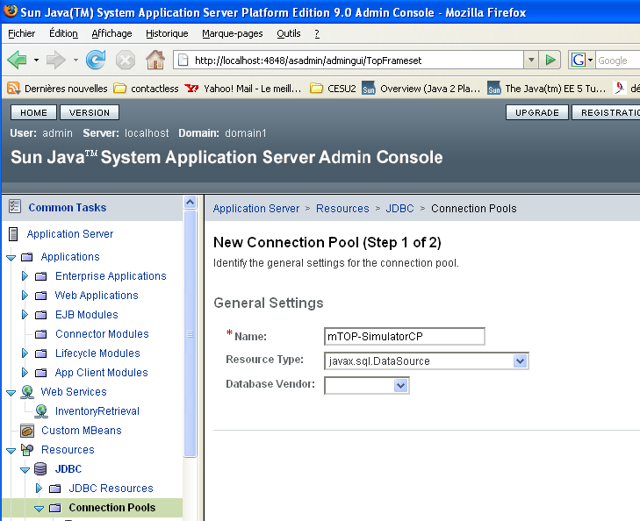

- Datasource Classname = org.apache.derby.jdbc.ClientDataSource
- Resource Type = javax.sql.DataSource
- The following properties

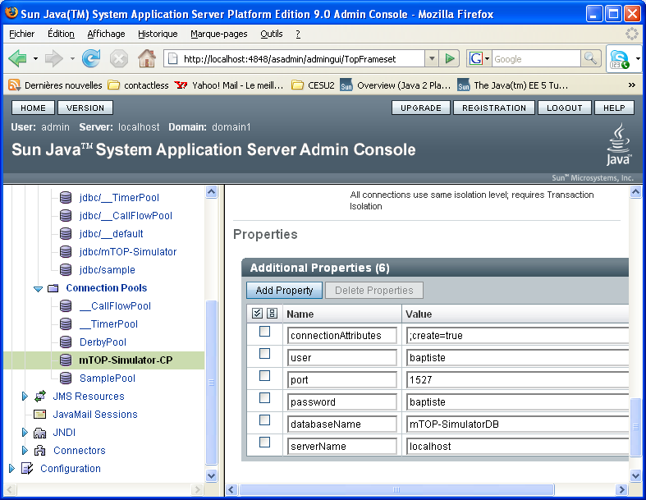

- Create a new JNDI name jdbc/mTOP-Simulator and set it to point at the connection pool
mTOP-SimulatorCP

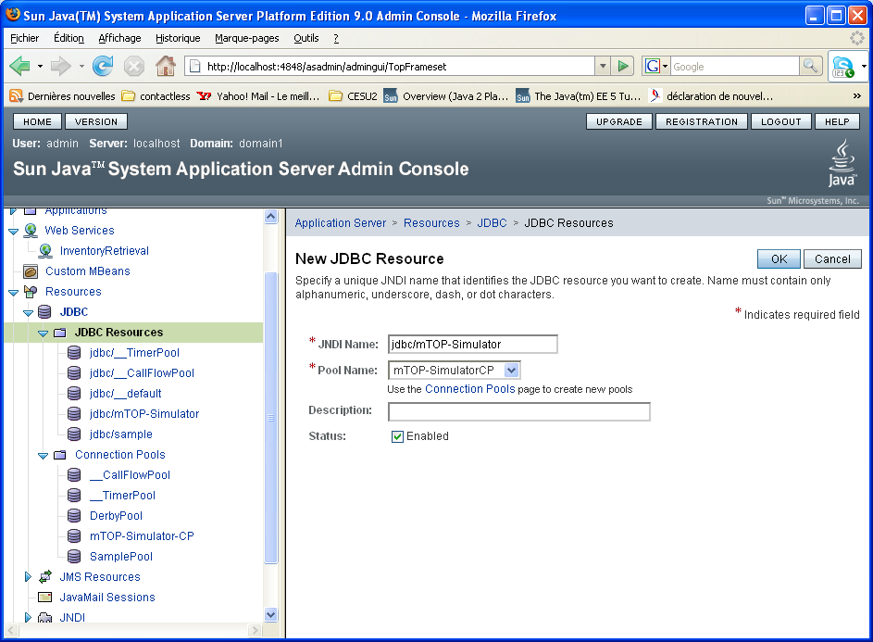

Start the Java DB database
Run asadmin start-database.

Start the Java DB Server
Run asadmin start-domain domain1

Before running the application

Maven configuration

The two applications PopulateDatabase and mTOP-Simulator are made to run with maven 2.0 and jdk 1.6.
download jdk 1.6 here: http://java.sun.com/javase/downloads/index.jsp
download maven 2.0 here: http://maven.apache.org/
Once maven is installed copy the util\mvn-artifacts\me repository in maven groupId repository ( default is C:\Documents and Settings\baptiste\Application Data\.m2\repository

Persitence.xml checking
The JNDI name given when the database was created must be the same as the name which appears under <jta-data-source> tag the in persistence.xml files of the applications.
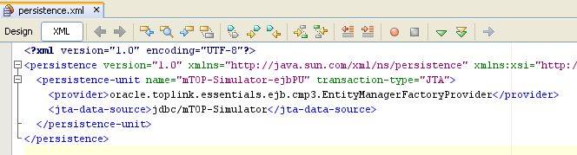

If you didn’t give the same name as the one given on screenshots (ie jdbc/mTOP-Simulator) you need to update the files
PopulateDatabase\ejb\src\main\resources\META-INF\persistence.xml and
mTOP-Simulator\ejb\src\main\resources\META-INF\persistence.xml

Run the PopulateDatabase Application

- Compile and Package the application

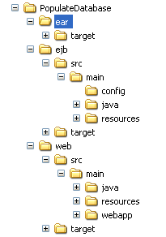

Run mvn install under
  - ejb directory
  - web directory
  - ear directory
in that exact order (due to dependencies).

- Deploy PopulateDatabase on the server

The file to deploy is PopulateDatabase-ear-1.0.ear and is located under ear\target directory.

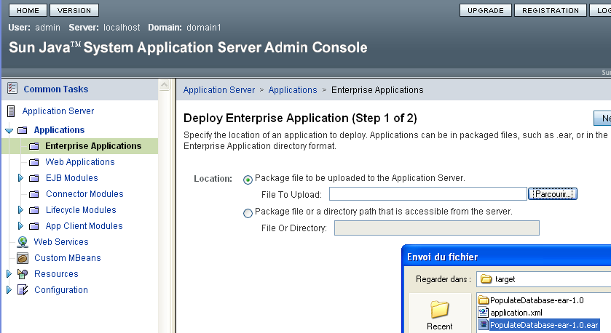

- Populate the database with example.xml

Open a web browser and go to http://localhost:8080/PopulateDatabase
Upload example.xml under ear\PopulateDatabase directory

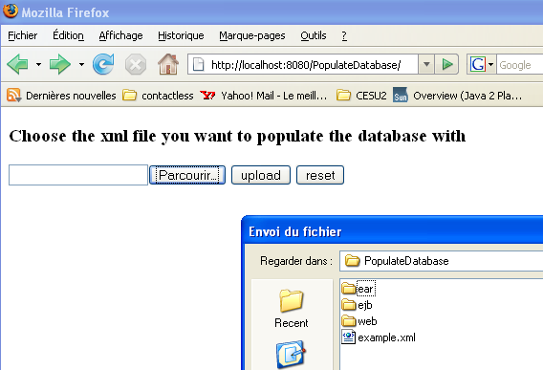

If the database has been well populated you should get the following window

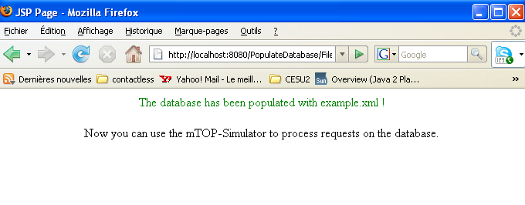

Run mTOP-Simulator Application

To deploy the application follow the same steps 1 and 2 described for PopulateDatabase Application.
Then go on http://localhost:8080/mTOP-Simulator/ to see the thin client of mTOP-Simulator.
Please don’t use it for the moment as some bugs still have to be fixed

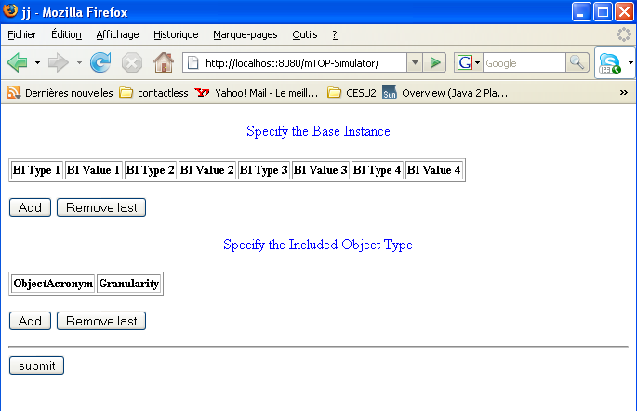

Run the Application Client

The application client will access the remote InventoryRetrieval web Service. To do so it first has to import the stubs classes from the wsdl file.
Go under mTOP-Simulator-AppClient.

- Import the stubs

>wsimport -d build\classes -s gen-src http://localhost:8080/InventoryRetrievalService/InventoryRetrieval?WSDL
Some warnings still have to be removed

- Run the gui

>ant run.

How to Use the GUI Application Client
Please just do a simple test for now just to check if you can access the web service

- Example of GetInventoryRequest: BI = { (MD=md1) } IOT ={ (MD, ATTRS) }

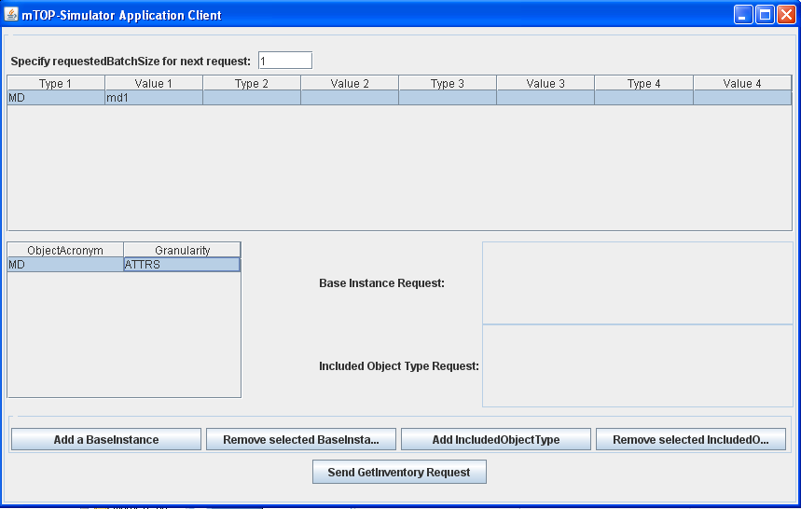

- Click on Send GetInventory Request

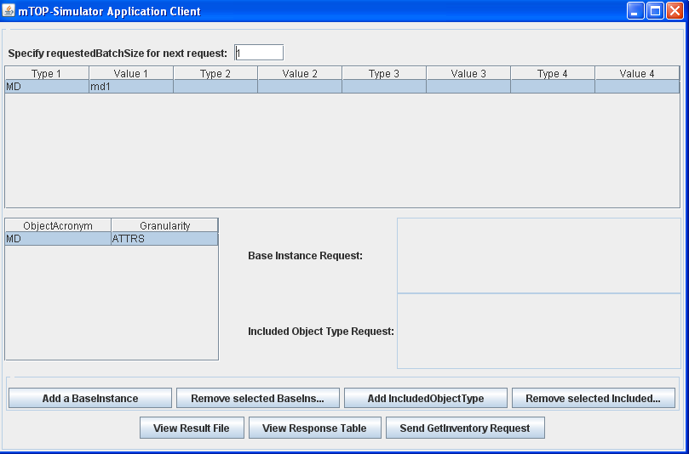

A new file has been created under mTOP-Simulator-AppClient: getInventory-response.xml.
If the client is running on windows clicking on View Result File will edit the file in Internet Explorer.

How to Use the thin client
To be completed

