MTOSI 2.0 editorial bug fixes list
The following bug fixes have been executed in the Resource area of the MTOSI model contained in https://collab.tmforum.org/svn/repos/mtop/Product/trunk.

General
- HTML tags deleted from all documentations in all Resource related DDPs.

Framework
- Interfaces::CommonObjectProvisioning::setUserLabel
Duplicate return parameter deleted.
- Type Definitions::State
attribute1 deleted.

ManageResourceInventory
- Type Definitions::ManagedElementFilter::resourceState
Default value UNKNOWN re-set.
- Interfaces::FlowDomainRetrievalService::getConnectivityAwareness::Documentation
"R_TMF518_MRI_II_0154" replaced by "R_TMF518_MRI_V_0154"
- Interfaces::TerminationPointRetrievalService::getTerminationPointGroupingRelationships
"and GTPs" added to the documentation in "- the names of all TP Pools << and GTPs>> associated to a provided TP".

NetworkResourceAssurance
- Type Definitions::PerformanceMonitoringParameter::pmThresholdList
Attribute pmThresholdList re-created.
- Type Definitions::correlatedNotifications
"correlatedNotifications" replaced by "CorrelatedNotifications".
- NetworkResourceFulfillment model imported.
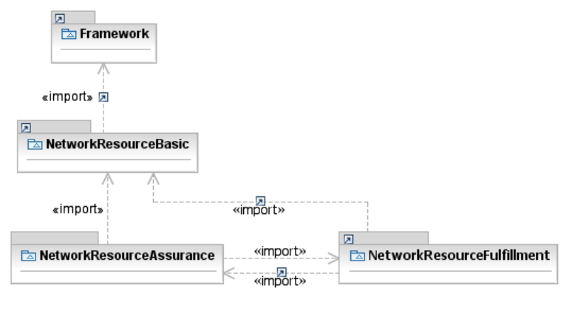
- The "illustrative" association TpContainsPmps has been marked as abstract.
- Type Definitions::ItuArcStateOrStatus: Enumeration converted into a Data Type; name replaced by "ItuArcStateAndStatusList"; multiplicity of all attributes defined as [0..1]; type of attributes NalmQIInterval and NalmTIInterval changed to Integer.
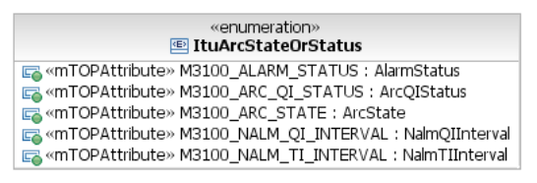 → 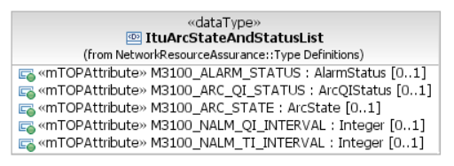
- Type Definitions::NalmQIInterval and Type Definitions::NalmTIInterval: deleted.
- Data Object Classes::EquipmentProtectionGroup::ituArcStateAndStatusList,
Data Object Classes::ProtectionGroup::ituArcStateAndStatusList:
multiplicity changed from [*] to [0..1]; default value deleted.

NetworkResourceBasic
- Enumeration Type Definitions::ResourceState
All resource state sub states copied directly into ResourceState enumeration; all sub states deleted.
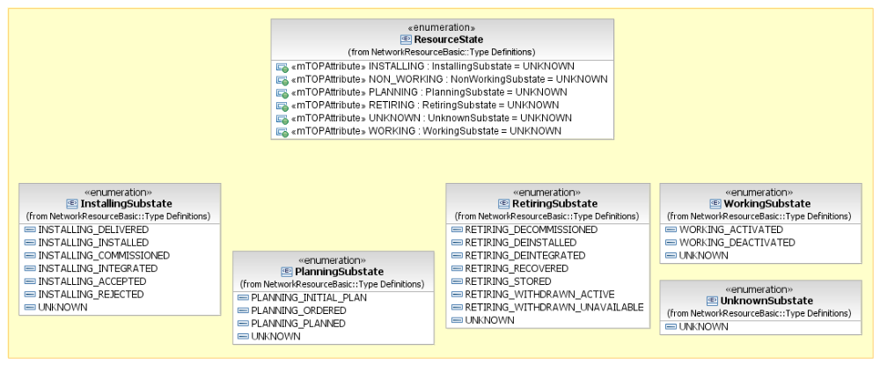→
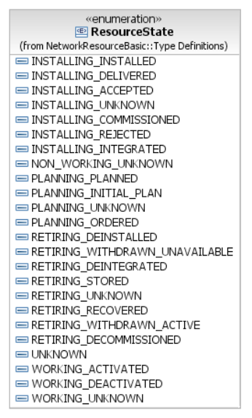
- Type Definitions::ItuStateOrStatus
Enumeration converted into a Data Type; name replaced by "ItuStateAndStatusList"; multiplicity of all non list attributes changed to [0..1].
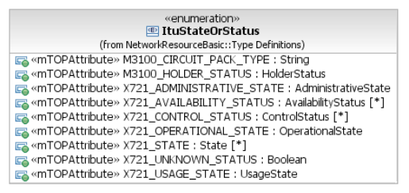 → 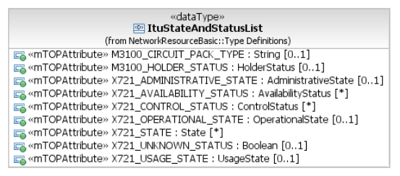
- Data Object Classes::CommonResourceInfo::ituStateAndStatusList
Multiplicity changed from [*] to [0..1]; default value deleted.
- Type Definitions::ItuStateOrStatusNameValuePair
Deleted; since was never used.
- Type Definitions::ItuStateOrStatusName
Deleted; since was never used.

NetworkResourceFulfillment
- Data Object Classes::Associations::HasSubordinate
Made the subordinateOS side of the relationship navigable.
- Data Object Classes::Associations::SncHasZEndGtps
Made the GroupTerminationPoint (zEndTpList) side of the relationship navigable.
- Associations::RouteChangeNotificationHasRoute
Relationship moved to Notifications::Associations and missing Route object class added.
- Data Object Classes::Equipment::ituArcStateAndStatusList,
Data Object Classes::EquipmentHolder::ituArcStateAndStatusList,
Data Object Classes::FlowDomain::ituArcStateAndStatusList;
Data Object Classes::FlowDomainFragment::ituArcStateAndStatusList,
Data Object Classes::GroupTerminationPoint::ituArcStateAndStatusList,
Data Object Classes::OperationsSystem::ituArcStateAndStatusList,
Data Object Classes::ManagedElement::ituArcStateAndStatusList,
Data Object Classes::MatrixFlowDomain::ituArcStateAndStatusList,
Data Object Classes::MultiLayerSubNetwork::ituArcStateAndStatusList,
Data Object Classes::SubNetworkConnection::ituArcStateAndStatusList,
Data Object Classes::TerminationPoint::ituArcStateAndStatusList,
Data Object Classes::TopologicalLink::ituArcStateAndStatusList:
multiplicity changed from [*] to [0..1]; default value deleted.
- Associations::CcHasZEndGtps
Relationship added.
- Data Object Classes::SubNetworkConnection::correlationIdentifier
Text "Changes in the value of this attribute lead to an AVC notification." deleted from documentation.
- Data Object Classes::Associations::GtpContainsCtps
Made listOfTps public.
Renamed listOfTps to "containedTpRefList".
Made relationship non-abstract.
- Data Object Classes::Associations::GtpIsMemberOfTpPool
Made relationship name compliant to upper camel case.
Made tpPoolRef non-navigable and removed the role name.
- Data Object Classes::TrafficConditioningProfile
Inheritance relationship added between TrafficConditioningProfile and CommonResourceInfo.
- Type Definitions::CrossConnect::connectionId::Documentation
Current documentation "This attribute represents the identifier of the associated Connection." replaced by "This attribute represents the control plane identifier. It corresponds to the Connection Name attribute in G.7713. Note that also the Cross Connection points to its superior Connection." To align it with the IIS description.
- Data Object Classes::FlowDomainFragment::a/zEndTpDataList
TerminationPointData associated as type to aEndTpDataList and zEndTpDataList.
- Data Object Classes::SubNetworkConnection::a/zEndTpDataList
TerminationPointData associated as type to aEndTpDataList and zEndTpDataList.

ResourceProvisioning
- Documentation deleted from DDP.

ResourceTroubleManagement
- Documentation deleted from DDP.
- Interfaces::AlarmControlService::setResourceAlarmReportingOff
Deleted the exceptions from the documentation.

