GUI Cut-Through

Client-Launch Configuration Sequence
NMS
GCT Client
GCT Server
EMS
getGCTProfileInfo() invoked
return of getGCTProfileInfo()
system call
Launch display application

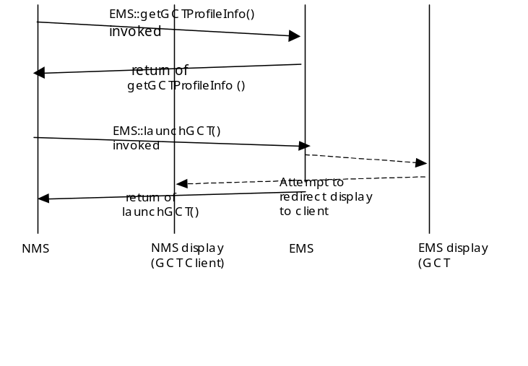

Server Launch Sequence

Note that it is not required for the NMS to reobtain the GCT profile info before every launchGCT request

Conventions for the Client-Launch

The following placeholders are used whenever an EMS command requires specific information from the NMS. These placeholders are used as required by the EMS to retrieve the object name, such as ManagedElement required for ME scope GUI Cut-Through windows. The following conventions are used (and should be noted in the IDL solution set):

<EMS> the value of “EMS” from the NameAttribute name of the EMS
<ManagedElement> the value of “ManagedElement” from the NameAttribute name of the ME

The minimal scope that shall be implemented is the EMS scope. The only mandatory window is the EMS top level window. The recommended implementation would include the ME scope. However, there is no limit of scoping that is mandated by the interface. The NMS implementation shall ignore GCT scopes that are supported by the EMS which it does not require.

<GCTDisplay> Address for GCT display
<userId> userid
<password> password associated with the userid; may be encrypted with pairwise agreement between NMS and EMS
<capability> capability that is assigned to the given user within the GCT application. Suggested values are: “READ_WRITE”, “READ_ONLY”
\> used to escape the > character
\< used to escape the < character
\\ used to escape the \ character

Additional parameters can be added as required such as resolution data. These additional parametersrequire bilateral agreement between the EMS and the NMS. For example to extend the scope to objects beyond the EMS and ME object the following templates might be used: <PTP> , <CTP> or <Equipment>
NMS launches the GCT by executing the command line with the placeholders replaced with the corresponding data.

For example, for the following “command” value that is returned from the getGCTProfileInfo operation:
“/opt/bin/invoke_GCT -display <GCTDisplay> -desc EMSTop –ems <EMS>"
The expanded command that is launched could be:
/opt/bin/invoke_GCT -display 2.3.4.5:0.0 -desc EMSTop -ems myEMS

and, if the NMS were using remote shell on a Unix platform (based on the emsGCTPlatform value returned in the getGCTProfileInfo), it would execute the following:

remsh 200.300.400.500 -n “export DISPLAY=2.3.4.5:0.0; /opt/bin/invoke_GCT -display 2.3.4.5:0.0 –desc EMSTop –ems myEMS”
where “200.300.400.500” is the emsGCTHostname returned in the getGCTProfileInfo.

The launch mechanism itself and security issues are addressed outside of this interface.

There is no error returned from the GCT command. This approach provides consistency for all commands executed since not all commands can return errors.

Revision History
Version | Date | Description of Change
3.0 | November 2006 | Conversion to new template.

Acknowledgements
<FirstName> | <LastName> | <Company>

How to comment on the document
Comments and requests for information must be in written form and addressed to the contact identified below:

Keith | Dorking | Ciena
Phone: | +1 678 867 5007
Fax: | +1 678 867 5010
e-mail: | kdorking@ciena.com

Please be specific, since your comments will be dealt with by the team evaluating numerous inputs and trying to
produce a single text. Thus we appreciate significant specific input. We are looking for more input than wordsmith” items, however editing and structural help are greatly appreciated where better clarity is the result.

