Equipment Model

Equipment Model Overview
The equipment model represents the various manageable physical components of the Network Element (circuit packs or field replaceable units or also, fan, fuse panel, power supply, etc.).
The Equipment Holder Class represents an abstraction of Rack, Shelf, Subshelf, Slot and Subslot.
Figure 1 describes the containment and support/supporting relationship of the equipment model.
Note that an equipment is always a leaf in the containment tree. See also examples in Figure 3, Figure 4 and Figure 5 for further explanation of the model.
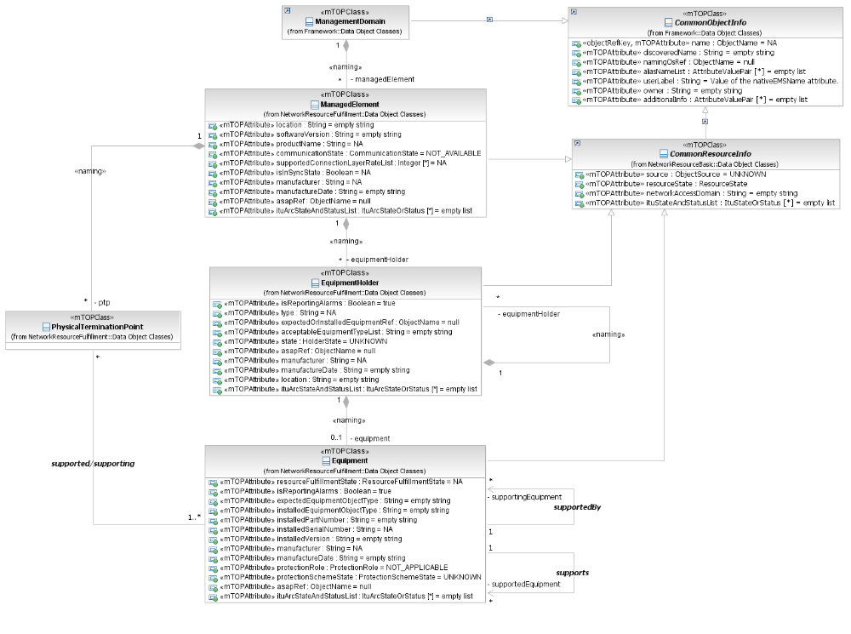
Figure 1: Equipment Model overview

Naming Attribute Structure
The naming attribute structure follows the containment hierarchy of the equipment model. When the Equipment Holder object is named by the Managed Element, the Equipment Holder objects are named recursively, (Rack, Shelf, Subshelf, Slot, and Subslot) and the Equipment objects are named by the Equipment Holder object directly containing it. See supporting document SD2-7_ObjectNaming for further details and examples on equipment naming.

Equipment Protection
The modeling of the equipment protection scheme is shown in Figure 2.
The management of the equipment protection is done through the ProtectionRetrievalService interface (not shown in the diagram).
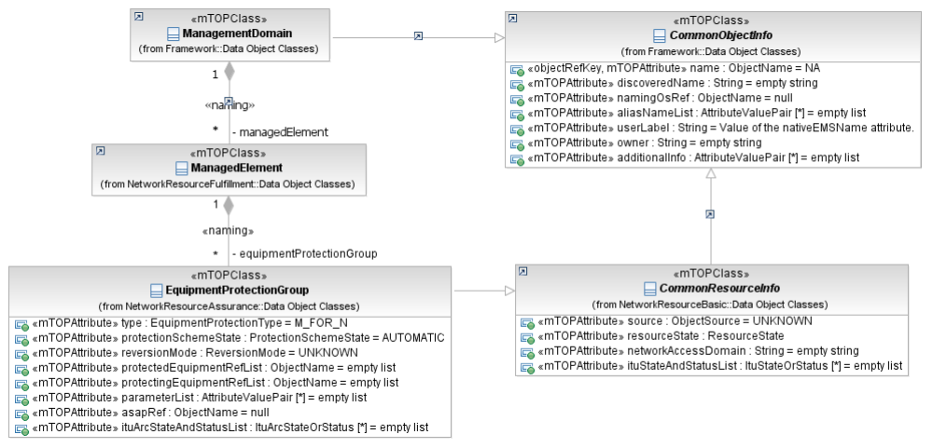
Figure 2: Equipment Protection Model overview

Equipment Model Examples
The following diagrams illustrate the model and show how to apply it.
Figure 3 and Figure 4 show a Managed Element with a shelf that is composed of four slots. Slot #2 shows a slot containing a card with sub-slots where only the sub-slot on the top is equipped with circuitry.

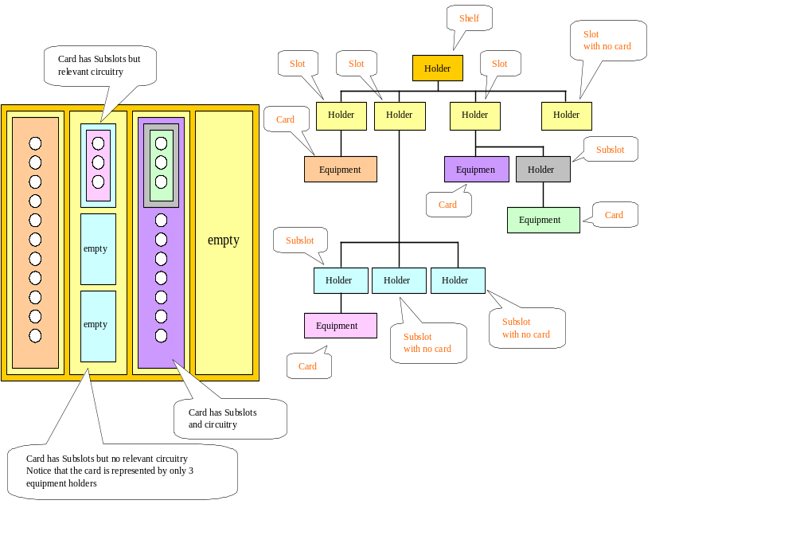
Figure 3: Example equipment configuration

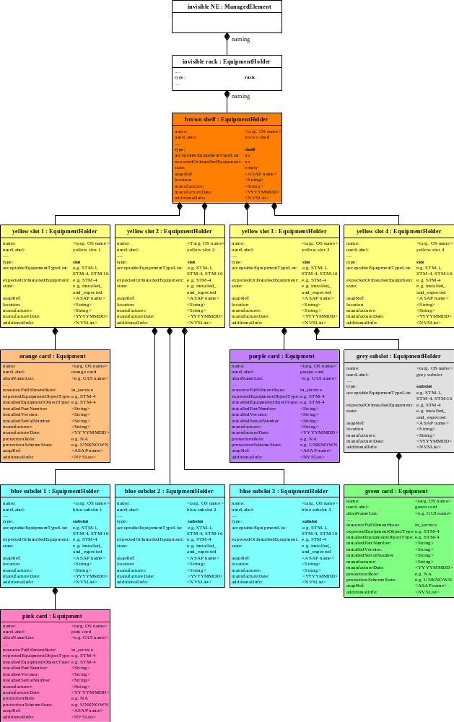
Figure 4: Object model for example equipment configuration
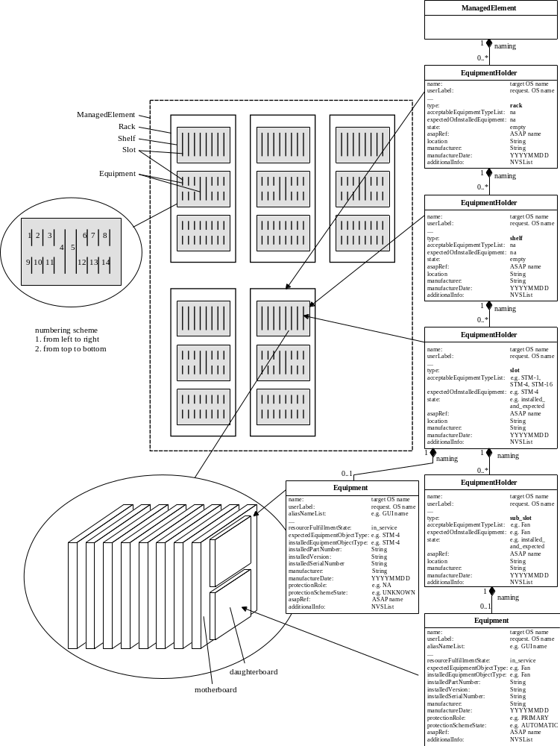
Figure 5: Example explaining object model #2

The interface will allow the requesting OS to determine for each equipment holder:
- the card that has been physically installed in a holder
- the card that was provisioned (i.e. set as Expected) to be in the specific equipment holder.
Note: the term card refers to any equipment that may be installed and or provisioned (i.e. set as Expected).

Modelling of DSL modems as virtual equipment holders (see also SD1-7_DSLOverview)
The DSLAM contains a virtual equipment holder (TU-R shelf) that contains virtual equipment holders (slots) each containing a TU-R as virtual equipment. In this case "internal" Topological Links (TLs) are used to represent the DSL lines between the TU-C/O PTPs on PIUs of the main shelf and the TU-R PTPs on PIUs of the TU-R shelf.
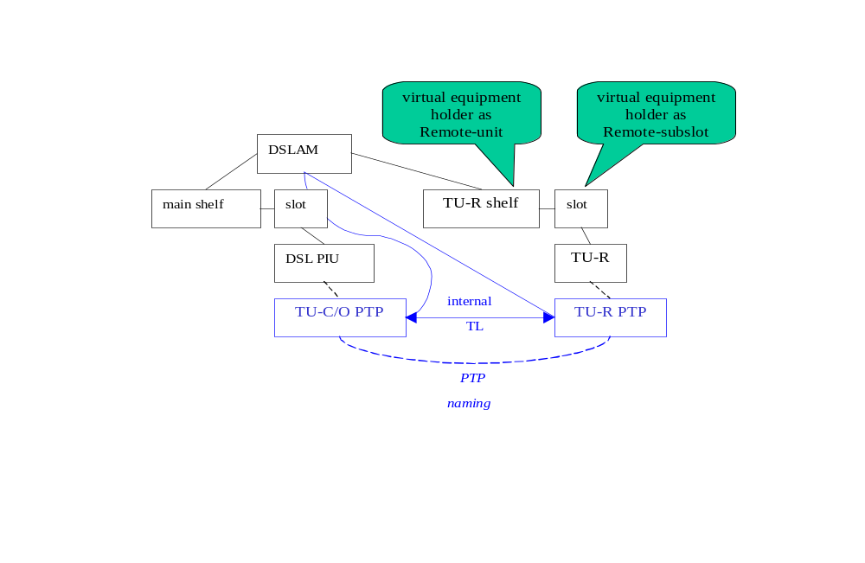
Figure 6: Modeling of external equipment as Remote-Units

Equipment Holder State Machine
There exists a state machine (see Figure 7) for the values of the holder state:
- Empty – no equipment is installed and no expected equipment has been identified
- Installed & not expected – physically inserted in the ME but not expected
- Expected & not Installed – expected but not currently installed
- Installed & Expected – expected and currently installed
- Mismatch of Installed & Expected – there is an inconsistency between the expected equipment and the installed equipment
- Unavailable –this holder cannot accept the installation or provisioning of equipment (this is typically caused by a double width card installed next to this slot)
- Unknown – the EMS does not know the state of the equipment

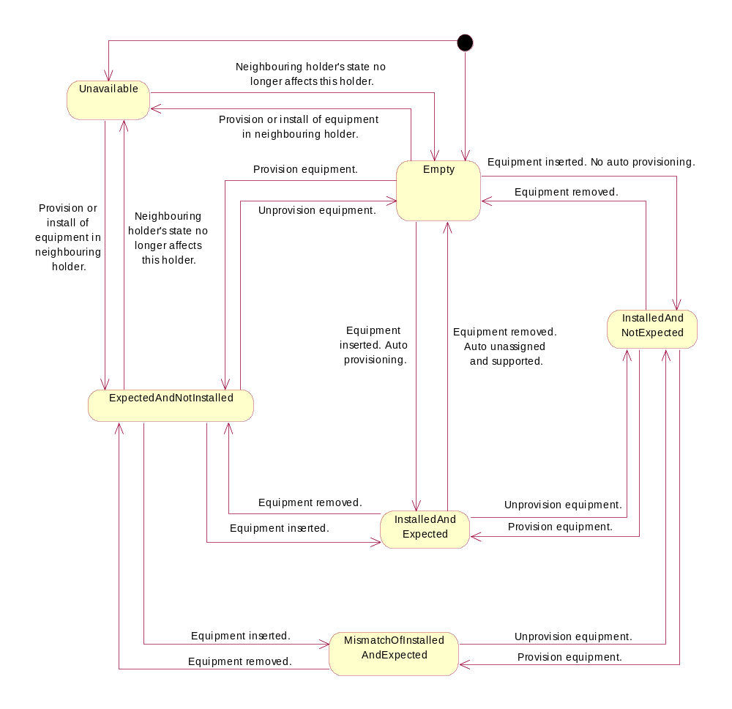
Figure 7: State Chart Diagram of Equipment Holder State

Administrative Appendix

Document History
Version | Date | Description of Change
1.0 | May 2008 | Initial version based on SD1-10

Acknowledgments

First Name | Last Name | Company

How to comment on this document
Comments and requests for information must be in written form and addressed to the contact identified below:

Michel | Besson | Amdocs OSS Division
Phone: | +44 (0) 7717 69 21 78
Fax:
e-mail: | michel.besson@amdocs.com

Please be specific, since your comments will be dealt with by the team evaluating numerous inputs and trying to produce a single text. Thus we appreciate significant specific input. We are looking for more input than wordsmith” items, however editing and structural help are greatly appreciated where better clarity is the result.

