Service Activation - DDP BA - Part 1: Overview



TMF518_SA_1

Version 1.0 November 2006

©TeleManagement Forum 2006

Notice
The TeleManagement Forum (“TM Forum”) has made every effort to ensure that the contents of this document are accurate. However, no liability is accepted for any errors or omissions or for consequences of any use made of this document.
This document is a draft working document of TM Forum and is provided to its members solely for formal comments and evaluation. It is not a Forum Approved Document and is solely circulated for the purposes of assisting TM Forum in the preparation of a final document in furtherance of the aims and mission of TM Forum. Any use of this document by the recipient is at its own risk. Under no circumstances will TM Forum be liable for direct or indirect damages or any costs or losses resulting from the use of this document by the recipient.
Members of TM Forum are granted limited copyright waiver to distribute this document within their companies. They may not make paper or electronic copies for distribution outside their companies. The only purpose of the provision of this draft document to members is for making formal comments thereon to TM Forum.
This document may involve a claim of patent rights by one or more TM Forum members, pursuant to the agreement on Intellectual Property Rights between TM Forum and its members, and by non-members of TM Forum.
Direct inquiries to the TM Forum office:
240 Headquarters Plaza
East Tower – 10th Floor,
Morristown, NJ 07960 USA
Tel No. +1 973 944 5100
Fax No. +1 973 944 5110
TM Forum Web Page www.tmforum.org

Table of Contents
Notice 2
Table of Contents 3
List of Figures 5
List of Tables 6
Executive Summary 7
1 Introduction 8
1.1 Document Overview 8
1.2 Document Structure 8
1.2.1 Requirements 8
1.2.2 Use Cases 8
1.2.3 Traceability 8
1.2.4 Appendices 8
1.3 Terminology Used In This Document 9
2 Business Problem Description, Project Scope 11
2.1 Project Scope 11
2.2 Supported Business scenarios 12
2.2.1 Service Activation Interface 12
2.2.2 Service Component Activation Interface 13
2.3 Benefits 14
2.4 Future Study 14
3 Business Processes 16
3.1 Process Definition and Issues 16
3.2 Mapping of Processes to eTOM Business Framework 16
3.2.1 The SM&O Layer 16
3.2.2 Issues with the eTOM Decomposition 17
3.3 Business Requirements 18
3.4 Category I: Static and Structural Requirements 20
3.5 Category II: Normal Sequences, Dynamic Requirements 20
3.5.1 Service States 20
3.5.2 Service State Requirement 21
3.6 Category III: Abnormal or Exception Conditions, Dynamic Requirements 22
3.7 Category IV: Expectations and Non-Functional Requirements 22
3.8 Category V: System Administration Requirements 24
4 Use Cases 25
5 Traceability Matrices 26
6 Summary and Open Issues 27
6.1 Summary 27
6.2 Open Issues 27
7 Terms and Abbreviations Used within this Document 28
7.1 Terminology 28
7.2 Abbreviations and Acronyms 28
8 References 29
8.1 References 29
8.2 Source or use 29
8.3 IPR Releases and Patent Disclosure 29
9 Contacts 30
10 Administrative 31
10.1 About this document 31
10.1.1 Document Template 31
10.1.2 TM Forum Business Agreements 31
10.1.3 Use and Extension of a TM Forum Business Agreement 31
10.2 Document Life Cycle 31
10.3 Document History 31
10.3.1 Version History 31
10.4 Acknowledgments 31
About TeleManagement Forum 32

List of Figures
Figure 2-1 MTOSI Service Activation Interface 12
Figure 2-2 Service Activation Interface 13
Figure 2-3 Service Activation Interface - [Order aware] 13
Figure 2-4 Service Component Activation 14
Figure 3-1 eTOM Layer 3 Decomposition 17
Figure 3-2 MTOSI-SA Service Interfaces and th eTOM 18
Figure 3-3 MTOSI Service State Transition Diagram 21

List of Tables

Executive Summary
The TM Forum’s Multi-Technology Operations System Interface (MTOSI) Service Management team has been tasked with defining a set of unified open interfaces to be used between Operations Systems (OS) whereby the functionality implemented supports a subset of the eTOM Service Management and Operations (SM&O) processes. These interfaces include:
- The Service Activation interface between the CRM and SM&O layers
  - Interactive Service Activation - The following modes are supported :
    - Best-effort Transaction interface – Service requests entail multi-task transaction execution. In this type of interface, the entire transaction execution is completed despite single task failures. We assume failed tasks are reported and later resolved by any external means, either manually or automatically. This is a best-effort type of interface, i.e., the service request will be executed as soon as possible but no delivery time is guaranteed, nor is there any roll-back capability.
    - Atomic Transaction interface - This interface has the same operations as the previous one; however, the failure of any single task will incur the termination of the transaction execution and will invoke a roll-back of the preceding task.
    - Service Order Management interface - Add-on interface to both the Best-effort Transaction or Atomic Transaction interfaces. Provides full exposure and control of the service order associated with the service request over the interface. It depends on the functions provided by the previous interfaces.

- The Service Component Activation interface is an internal SM&O layer interface.
This document specifies common definitions, architecture aspects and functional requirements for the MTOSI Service Activation feature. The primary focus of both interfaces is service activation exclusively. Although there are dependencies between service activation and other processes described in the SM&O layer, they are considered to be outside the scope of this document.
The MTOSI Service Activation sub-team has worked extensively with key contributors to the TMF SID with the goal of being closely aligned with SID service object definitions as described in GB922_Addendum_4SO_V2-1. The resulting service object model is an extension of the model defined in the SID, and is included in TMF608. The corresponding XML-based specification is part of MTOSI Release 2.0 that can be found in the TMF854 solution set.
* Note: It should be emphasized that NGOSS contracts are defined in terms of functional and non-functional aspects (see TMF 053B). Non-functional part of the contract contains “obligations (required behavior), prohibitions (disallowed behavior), restrictions (limits on behavior) and permissions (allowed behavior) on the capabilities defined in the functional part of the contract.”

Introduction

Document Overview
This document covers the Multi Technology Operations System Interface (MTOSI) Service Activation (SA) Business Agreement. As a primary goal of the TM Forum’s MTOSI effort is to define unified, open interfaces between Operations Systems (OS) at the network AND service management layers, this document focuses on the latter, and in particular on service activation. The resulting interfaces are defined in such a way as to be technology and service agnostic, and capable of being implemented by any service provider.

Document Structure
The document has been structured in the following way:
Section 1 Introduction: Provides overview of this the document, outlines its structure, and defines essential terms used in the document.

Requirements
Section 2 Business Problem Description and Project Scope: Defines the general business problem to be solved, the scope of the project, and relevant business scenarios
Section 3 Business Processes: Lists the functional requirements to be fulfilled by each interface for each business scenario as described in the problem statement.

Use Cases
Section 4 Use Cases: Presents Use Case descriptions and diagrams to define the interactions across each of the process interfaces covered in the Business Agreement.

Traceability
Section 5 Matrix: Provides traceability between the requirements and the use cases.

Appendices
Section 6 Summary and Issues: Reviews the work of the project and identifies open issues.
Section 7 Terminology & Abbreviations: Frequently used terms in the project and their abbreviations.
Section 8 References: List of documents referenced
Section 9 Contacts: People involved in the writing of this document
Section 10 Administrative: TMF related information

Terminology Used In This Document
Customer: A person or organization that buys products and services from the enterprise or receives free trial offers for services. This is modeled as a “party” playing the role of a customer. A customer is a type of party role. The Customer entity is managed exclusively at the CRM layer.
Location: According to the SID, location is “a defined place”. It is further decomposed into a geographic place that relates to world-centric places and local location that relates to locally defined coordinate systems.
Party Role: The part played by a party in a given context with any characteristics, such as expected pattern of behavior, attributes, and/or associations that it entails.
Product: An offering that is externally focused representation of a service and/or resource procured by the market.
Service: Services are tightly bound to the “products” that are sold by a service provider in the “Business” domain. They exist in the “Service Management and Operations” (SM&O) domain of the eTOM and represent instantiations of product offerings. According to the SID, a Service is further subclassed into “customer facing service” (CFS) and “resource facing service” (RFS). A CFS is an abstraction that defines the characteristics and behavior of a particular service in its relationship to a Product. An RFS can be seen as an internal service that is associated with resources and that supports a CFS.
Service Access Point: A service activation request requires specific information about the resource upon which the service is accessed. This information is basically resource oriented (such as a physical Termination Point, a Customer Premises Equipment, Mobile Terminal or Set-top Box).
Service Order: A type of Request that represents a Customer Order's products decomposed into the services through which the products are realized. Service Orders are generated within the confines of the SM&O layer.
Service Order Item: The purpose for the ServiceOrder expressed in terms of a ServiceSpecification or a Service.
Service Request: A request made by the CRM layer to the SM&O layer as defined in the TMF eTOM to take an action on one or more CFS instances given a product identifier and a related set of characteristics.
Service Template: A type of Service Specification (from the SID) introduced for the purposes of Service Activation. It defines invariant service specification characteristics and values that can be dynamically referenced by multiple service instances during their lifecycle span.. Each of these service instances will have the same invariant characteristics. In order not to descend into sub-classing, the service template is considered to be generic such that it serves as a framework for defining technology or service specific templates. Other TMF groups, or service providers, may use the service template as a foundation for building or populating service templates.
Service Definition: A contract by which the SM&O is committed to providing a service. It regulates the generation of service templates by defining the valid service specification characteristics and Service Access Points for a given service.
Service Characteristic: Represents a feature or attribute of a service. For example, bandwidth is a characteristic of many types of services. It is considered to be variable, and is passed along or referenced with other service information at activation time.
Service SpecCharacteristic: Represents features of the service template. The Service SpecCharacteristic, along with its’ counterpart Service SpecCharacteristic Value, is used to define a set of {name, value} pairs for invariant data that is passed or referenced when a service is activated.
Subscriber: A Subscriber is an entity (associated with one or more users) that is engaged in a service subscription with a service provider. The subscriber is allowed to subscribe and unsubscribe services, to register a user or a list of users authorized to use these services, and also to set the limits relative to the use that associated users make of these services.
User: A user is a Person, Organization, Service, or Resource that employs one or more Products, Services, and/or Resources that are provided by a business for some purpose. Human users include different types of users, such as an end-user or an administrative user.

Business Problem Description, Project Scope

Project Scope
The Multi-Technology Operations Systems Interface (MTOSI) Service Activation project (SA) is focused on end-to-end service activation. The objective is to define standardized, service-oriented interfaces that are involved in the activation process at various places within the eTOM map. Note:
The first interface is an SM&O northbound Service Activation interface (SAI) that allows a CRM (OS), such as an Order Entry system, to request via a service request the activation of a given service, or set of services, that instantiate a given product based upon product related information. This interface links the product related information, such as the product specification, to the service domain via the service request.
In this current release, the Service Activation Interface supports only an interactive or on-line service requests. Batch mode service requests are not currently supported. The interactive mode is specified further decomposed into three different types:
Best-effort Transaction Interface
- Supports single service request
- Best-effort transaction server implementation, no rollback support
- Coarse-grained operations, only internal Service Order state is exposed over the interface
- Priorities supported
- No troubleshooting support, failed tasks areproblems are automatically escalated to other SM&O processes
- The CRM application submits a Service Request and monitors the Customer Facing Service (CFS) states associated with the requested Product instance
Atomic TransactionEnhanced Interface
- Same operations as in previous interface
- A failed task in the associated Service Order incurs in transaction execution termination and the inititation of a roll-back or cancellation of preceding tasks
Adds roll-back capabilities to the Best-effort Interface
The CRM application submits a Service Request and monitors the CFS states associated with the requested Product instance
Service Order Management Interface
- Add-on interface to either the Best-effort or the Atomic Transaction interface
- Provides full control and exposure of Service Order over the interface
The Service Activation batch mode is not supported in the current release.
The following figure depicts the Service Activation interfaces. In this diagram, the Service Order Management interface is implicitly bundled in the SAI interface. It may be made visible or not by the specific implementation. For clients that support the asynchronous notification capability, they may receive reports containing status about the service request and its associated information.
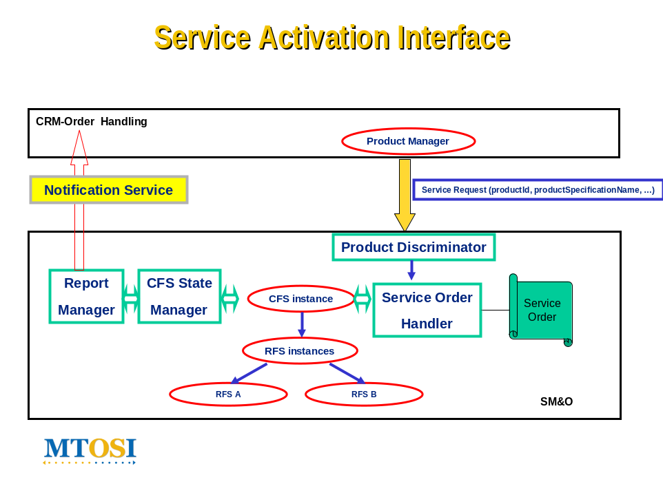
Figure 2-1 MTOSI Service Activation Interface

The second interface, the Service Component Activation Interface (SCAI) is internal in the SM&O layer and allows for the activation of service component (RFSs) instances given specific service related information defined in a service template.
The SCAI, contrary to the SAI, has no knowledge of the product domain. The server OS in this case provides RFS service templates to the client that describe the invariant service characteristics of the services support by the SCAI. These templates are referenced by the client OS when activating a given service over the SCAI. The client OS is responsible for the mapping of the product from the CRM domain to the service.

Supported Business scenarios
The MTOSI Release 2.0 service activation interfaces support the functions as described in this section. Although MTOSI in general does not define or mandate the usage of specific OS types, it is assumed that SM&O layer functionality offered by an interface is implemented by an OS capable of performing such functions. For example, while an EML OS may be capable of offering a Service Component Activation interface, it is highly unlikely that it would expose a Service Activation interface to a BML layer OS. Likewise, an SML OS would not expose a Service Activation interface to another SML or EML OS.

Service Activation Interface
The SAI interfaces allow a CRM application to place a service request to a Service Activation OS to perform an action (create, activate, modify, retire, etc.) on one or more services, given product and subscriber related information from the business management layer. The service upon which this interface is making service requests is viewed as a “customer facing service”. The interface also allows, for clients with an asynchronous notification detection capability the option of receiving notifications when service requests have completed, as well as monitoring service request progress via a corresponding CFS lifecycle state transitions.

Service ActivationOS

Notification Service (ASYNCH)

CCV
CRM Order Handling OS

Figure 2-2 Service Activation Interface

Figure 2-2 above shows an example of one Order Entry OS sending requests to a Service Activation OS. In the case of clients with asynchronous notification mechanisms, a Notification Service sends notifications back to the Order Entry OS to inform the OS about the status of Service Requests.
The Service Order Management interface allows an OS to perform operations on service orders (SO) such as stop, suspend, resume, cancel, and suspend. It also has the ability to retrieve a list of service orders from a service order processing OS.
Service Order OS

CCV
CRM Order Handling SOS
Figure 2-3 Service Activation Interface - [Order aware]

Service Component Activation Interface
This capability allows an OS to request to another OS that a service component be activated based upon service specific information found in a service template. A service component, or resource facing service, may be viewed as a discrete entity involved in the end-to-end delivery of a customer facing service.
The interface exists solely within the SM&O layer, and has no knowledge of associated products. Although a service component activation request may reference a resource for activation purposes, it is assumed that all resource configuration and activation occurs at the network activation interface, or within the OS exposing the service component activation interface.

Element ManagementOS

Network ManagementOS

CCV
Service Activation OS
Content ManagementOS

Figure 2-4 Service Component Activation

Figure 2-4 shows an example of one Service Activation OS sending requests to multiple Network and Element Management OS’s to complete end-to-end activation for a given service.

Benefits
The MTOSI-SA is intended to provide the following benefits to customers, service providers and suppliers:
- Open OS-OS interface allowing service providers to more easily “mix-and-match” OSs from different suppliers;
- Ability to perform end-to-end service activation using a standardized framework, technologies and operations;
- Abstracted service interfaces keep the knowledge “where it needs to be”. Service management layer can focus on service related functions without having to have in-depth knowledge of resource layer details.
- Reduced integration times between OSs from different suppliers and thus quicker time to market for new services and increased REVENUE;
- Reduced integration costs between OSs from different suppliers results in reduction of OPEX.
- Reduced integration risk between OSSs from different suppliers.

Future Study
The following areas have been identified as requiring future study for possible inclusion in later releases of MTOSI:
- Associated to any given subscriber there may be a user profile, or set of profiles, that describe service usage specific parameters. This concept is defined in the 3GPP “Generic User Profile”, and needs to be aligned the the user profile defined as a “service access profile” in MTOSI-SA. This concept is also being elaborated in the SID, under the security management context.
- The role of Policy based Management in MTOSI service activation.
- MTOSI currently doesn’t define “Profile Configuration” capabilities which are required in order to build Service Templates. This may be the object of a resource configuration interface, but is tightly coupled to the service template operations in MTOSI-SA.
- Communication between peer-to-peer SM&O applications.

Business Processes

Process Definition and Issues
This section defines the business process issues to be addressed in this document. It provides a business process view of the requirements to be satisfied through the implementation of the MTOSI Service Activation interfaces. Given the focus on “Service Activation”, the processes addressed will be primarily those in the eTOM SM&O layer and how they interact with the upper CRM layer and the lower RM&O layer.

Mapping of Processes to eTOM Business Framework

The SM&O Layer
The eTOM is a business process framework, or model, that provides the enterprise processes required for a service provider. There are various levels of granularity, or decomposition, of processes that have been defined. The MTOSI-SM work has considered a Level 3 decomposition of the eTOM SM&O layer in order to fully evaluate the process flow for service configuration and activation.
The eTOM Level 3 decomposition takes the process called “Service Configuration & Activation” found at Level 2 and breaks it down into the following sub-processes:
- Design Solution Develop an end-end specific service design which complies with a particular customer's requirement
- Allocate Service Specific Parameters Issue service identifiers for new services.
- Track & Manage Service Provisioning Launch all the operational tasks needed to fix each solution requirement.
- Implement, Configure & Activate Service Ensure service provisioning activities are assigned, managed and tracked efficiently.
- Test Service End-to-End Test specific services to ensure all components are operating within normal parameters, and that the service is working to agreed performance levels
- Issue Service Orders Issue correct and complete service orders
- Report Service Provisioning Monitor the status of service orders, provide notifications of any changes and provide management reports.
- Close Service Order Close a service order when the service provisioning activities have been completed
- Recover Service Recover specific services that are no longer required by customers.
These processes are illustrated below in the context of their relationship with the CRM and the RM&O layers. The identified interfaces include: A) Service Activation interface, B) Resource Activation interface, C) Service Inventory interface, and D) Resource Inventory Interface
Note: Not all Layer 3 processes are shown, in particular those that would not be part of the MTOSI-SM interfaces.

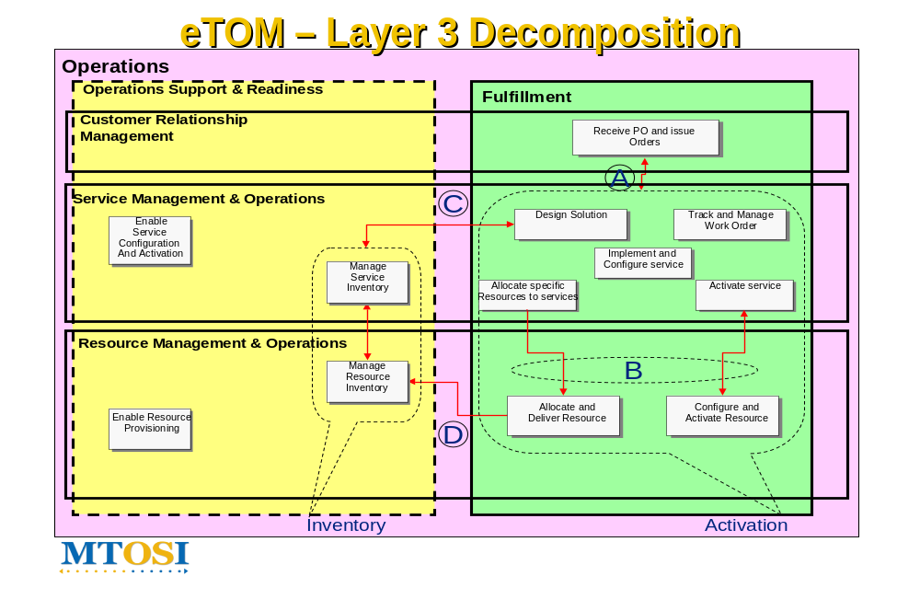
Figure 3-5 eTOM Layer 3 Decomposition

Issues with the eTOM Decomposition
The MTOSI-SM team has identified a number of issues with the eTOM in regards to specifying service interfaces:
- The eTOM’s current specification does not define an interface that supports the network resource-oriented operations (e.g., MTNM NMS-EMS interface). The eTOM considers the EMS as a specific implementation of the RM&O processes.
- The eTOM also does not support a split at the SM&O layer that has been identified as being necessary to implement “Service Configuration Activation”. Only the top layer interface between the CRM & the SM&O layer and the lower layer interface towards RM&O are defined.
The team has had numerous discussions with the eTOM team in an effort to ensure that the two groups are aligned. In regards to the first issue, the general response from the eTOM representative was:
“This is a long standing issue, and one that was intended for consideration several times. I don't believe there has ever been any real detail on the mapping to NMS/EMS in the eTOM - it was visible in the old TOM, but eTOM abstracted the network handling to the more general resource management, and it has always been anticipated that any specific concerns relative to network resources would emerge below the current level of detail...”
The MTOSI-SM team has defined the following “service interfaces” and will continue to work with the eTOM and SID members to further align the models: Service Activation, Service Component Activation, Resource Activation, and Network Activation. Only the first two Service Interfaces are within the scope of the MTOSI-SM business agreement.
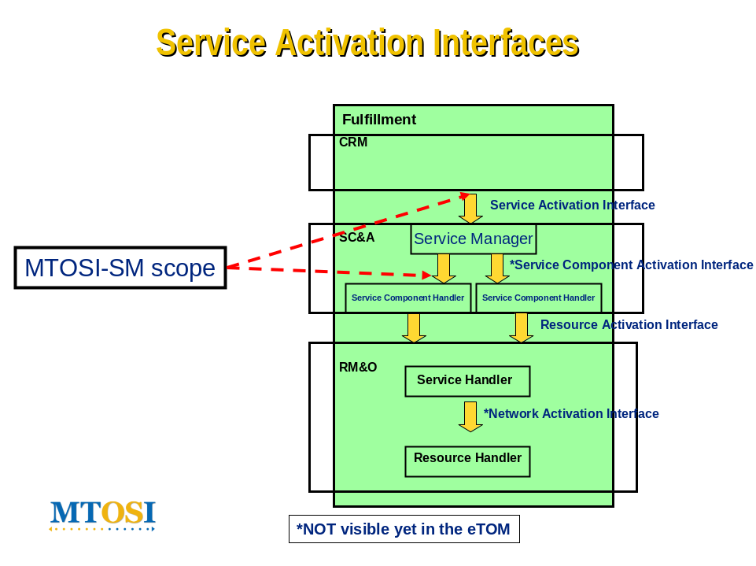
Figure 3-6 MTOSI-SA Service Interfaces and th eTOM

Business Requirements
R_TMF518_SA_1_BR_0001 | The MTOSI-SM interfaces shall be used between Operations Systems (OSs) for service activation within the same administration (i.e., service provider).
Source | New

R_TMF518_SA_1_BR_0002 | MTOSI-SM interfaces shall be technology and service agnostic and thus allow for implementation by any type of service provider.  Example of such services include (amongst others):  - Network Transport Services: DSL, VPN, E-Line, E-LAN, FR, ATM, etc.  - Signaled Services: VoIP, Voice (Mobile and Fixed), VoD  - Application Services : Email, SMS, Voice Mail, etc.  - Triple Play Services: VoIP, IPTV, and HSI
Source | New

R_TMF518_SA_1_BR_0003 | MTOSI-SM interfaces shall support end-to-end template based service activation across the CRM, SMO and RMO layers.
Source | New

R_TMF518_SA_1_BR_0004 | The MTOSI-SM interfaces shall support the activation of single services, composite services, and in the future bundled services. A single service requires activation of only one component, a composite service requires activation of multiple components for one service, and bundled services, such as Triple Play, require activation of multiple services via multiple components.
Source | New

R_TMF518_SA_1_BR_0005 | The MTOSI-SM object model shall keep traceability with the TMF SID, to the extent possible, without compromising the functionality, efficiency, and flexibility, and performance required.
Source | New

R_TMF518_SA_1_BR_0006 | MTOSI-SM interfaces shall allow for service template versioning.
Source | New

R_TMF518_SA_1_BR_0007 | Service Activation interfaces shall allow for the interruption of traffic for a given service, or component service, and the resumption of traffic at a later date/time.
Source | New

R_TMF518_SA_1_BR_0008 | All MTOSI-SA operations shall be secure, whereby a requesting OS must be authorized and authenticated before before performing any activation operations on a given service. This implies that security is implemented on a per service basis, and that a client OS may have the authority to activate one, some, or all services provided by a target.
Source | New

Category I: Static and Structural Requirements

Category II: Normal Sequences, Dynamic Requirements

Service States
The MTOSI-SM interfaces introduce the notion of “service activation states” associated with either the global service, or individual component services that make up the end-to-end service. This “service activation state” is not to be confused with the existing MTNM service state that may take on such values as “in service” (IS), “out of service”, (OOS) “out of service for maintenance” (OOS-M), and “not available”. The MTNM service states are associated with resources, whereas the MTOSI-SM service states are associated with services.
The service activation state describes its lifecycle span as it goes through several stages of processing within the Service Configuration and Activation process until it becomes fully activated and eventually retired in the end. Some of these states depend on the states of their supporting resources.
The global service state for an end-to-end service depends on the service states of the individual components. These service states in turn depend on the underlying states of the resources supporting the component services. Hence, there is a strict dependency between the resource layer and the service layer “service states”.
A Global Service’s state value may change due to some composing service’s state value change, or due to some interface explicit request such as a deactivation request. Likewise, a composing service’s state value may change due to some supporting Resource’s state value change or due to an interface explicit request.
This inter-dependent relationship between the global service state, component service states, and resource “service states” is depicted in the following diagram:

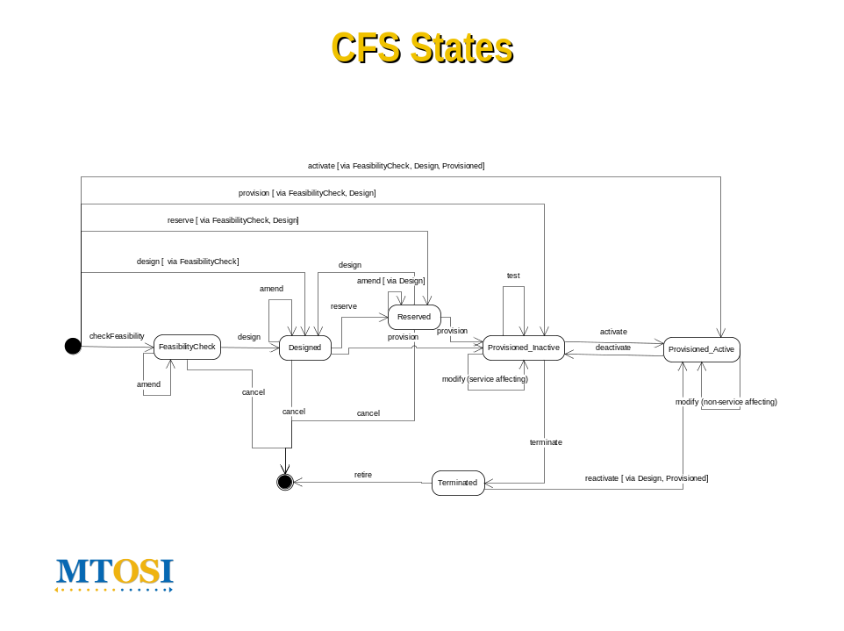
Figure 3-7 MTOSI Service State Transition Diagram

Service State Requirement
R_TMF518_SA_1_II_0009 | The MTOSI-SA service activation interface shall support eight global service states that are options in the serviceState attribute of the Customer Facing Service object:  - DesignedCreated: The service instance and its underlying component (if any) services are in a “DesignedCreated” state and all resources required for end-to-end delivery of the service haven’t been requested yet and are still available  - Reserved: All the underlying components/resources to support the service instance have been allocated, but not provisioned nor activated  - Provisioned: All the underlying components/resources to support the service instance have been allocated and provisioned, but not activated yet  - ProcessingExecutionWaiting for components: The service request is being executed. This process execution may take a considerable time. Resources required for at least one component have yet to be activated.  - Activated: All underlying components/resources service states are in a working state “activated” which implies that all required resources have been activated also.  - Deallocated: All underlying components/resources service states have been “deactivated”, which implies all underlying resources have been freed, and are no longer allocated to the service. This state value reverses the “reserved” value  - DeactivatedSuspended: All underlying components/resources services have been “suspended”, or locked, and traffic is stopped for all subscriber(s). This state value reverses the “activated” value.  - Retired: The service instance and its underlying component services (if any) have been taken out of service and are no longer available for activation.
Source | New

R_TMF518_SA_1_II_0010 | The MTOSI-SA service component activation interface shall support six service component states that are options in the serviceState attribute of the Resource Facing Service object:  - Created: All resources required for the delivery of the component service are available. (They have yet to be allocated and reserved).  - Waiting for components: At least one resource required for the service component activation has yet to be fully activated.  - Activated: All required resources for the component service have been successfully activated and traffic is flowing. This implies the subscriber is able to use the service.  - Deactivated: The service “connection” is deactived and all underlying resources have been freed, and are no longer allocated to the service.  - Suspended: A component service has been “suspended”, or locked, and traffic is stopped for all subscriber(s).  - Retired: A component service has been taken out of service and all required resources are no longer available.
Source | New

R_TMF518_SA_1_II_0011 | The MTOSI-SA service access point shall support six service states that are options in the serviceState attribute of the service access point object:  - Created: All resources required for the delivery of a component service to a subscriber and his/her associated service access point are available. (They have yet to be allocated and reserved).  - Waiting for components: At least one resource required for the service component activation for a particular subscriber and his/her associated service access point has yet to be fully activated.  - Activated: All required resources for the component service for a particular subscriber and his/her associated service access point have been successfully activated and a service “connection” has been established.  - Deactivated: The service “connection” for a particular subscriber and his/her associated service access point is deactived and all underlying resources have been freed, and are no longer allocated to the service.  - Suspended: A component service has been “suspended”, or locked for a particular subscriber.  - Retired: A component service has been taken out of service for a particular subscriber.
Source | New

R_TMF518_SA_1_II_0012 | The MTOSI-SA service objects shall be named in accordance with the general MTOSI naming conventions and shall reside under the MD (Management Domain). These include: Service Definition, Service Template, Customer Facing Service, and Resource Facing Service.
Source | New

Category III: Abnormal or Exception Conditions, Dynamic Requirements

Category IV: Expectations and Non-Functional Requirements

Category V: System Administration Requirements

Use Cases

Traceability Matrices

Summary and Open Issues

Summary

Open Issues

Terms and Abbreviations Used within this Document
This section identifies the important terms, abbreviations and acronyms introduced by the project and those terms applied from external sources

Terminology

Abbreviations and Acronyms

Term | Definition
CCV | Common Communication Vehicle
HTTP | Hyper Text Transfer Protocol
JMS | Java Message Service
MEP | Message Exchange Pattern
SOAP | Simple Object Access Protocol
XML | eXtended Markup Language
XSD | XML Schema Document
WSDL | Web Service Description Language
SID | Shared Information Data
eTOM | Enhanced Telecommunications Operation Map
SE | Service
SET | Service Template
SD | Service Definition
SAP | Service Access Point
MTOSI | Multi-technology Operations System Interface
OS | Operations System
RFS | Resource Facing Service
CFS | Customer Facing Service
OCN | Object Creation Notification
ODN | Object Deletion Notification
AVC | Attribute Value Change Notification
EXCPT | Exception
SCAI | Service Component Activation Interface
SAI | Service Activation Interface

References

References

Source or use

IPR Releases and Patent Disclosure

Contacts
Editor
Name: Jessie JEWITT Alcatel- Lucent
Phone: 707 480-6418
email: Jessie.Jewitt@alcatel-lucent.com

Administrative

About this document

Document Template
This document has been generated from the mTOP_V01.dot Word template,
which itself is based on Version 5.10 of the TMF 402, BA Template.

TM Forum Business Agreements

Use and Extension of a TM Forum Business Agreement

Document Life Cycle

Document History

Version History

Version Number | Date Modified | Modified by: | Description of changes
0.1 | 1/21/2007 | Jessie JEWITT | Original document

Acknowledgments

About TeleManagement Forum
TeleManagement Forum is an international consortium of communications service providers and their suppliers. Its mission is to help service providers and network operators automate their business processes in a cost- and time-effective way. Specifically, the work of the TM Forum includes:
- Establishing operational guidance on the shape of business processes.
- Agreeing on information that needs to flow from one process activity to another.
- Identifying a realistic systems environment to support the interconnection of operational support systems.
- Enabling the development of a market and real products for integrating and automating telecom operations processes.
The members of TM Forum include service providers, network operators and suppliers of equipment and software to the communications industry. With that combination of buyers and suppliers of operational support systems, TM Forum is able to achieve results in a pragmatic way that leads to product offerings (from member companies) as well as paper specifications.

