SD2-6 MTOSI Versioning And Extensibility
Abstract
This supporting document addresses versioning and extendibility mechanisms adopted by MTOSI.
Through the versioning mechanism it is possible to evolve the interfaces in a controlled manner maintaining backward and forward compatibility for a class of changes considered minor.
The extendibility mechanism allows a vendor (and\or an MTOSI architect) to tailor the specification to deal with future or specific concerns not addressed in the most current MTOSI release (latest version of the service interfaces).
Table of Contents

The Title 1
Abstract 1
Table of Contents 1
1 Introduction 2
2 Administrative Appendix 3
2.1 Document History 3
2.2 Acknowledgments 3
2.3 How to comment on this document 3

Introduction
Versioning entails rules and conventions for updating and supporting the MTOSI XML from one version to the next. Two classes of versions are identified each with different compatibility implications: minor and major versions. This contribution describes the mechanism for MTOSI versioning in order to guarantee the compatibility of minor versions and the possible migration strategies between major versions.
Extensibility mechanism is also addressed in order to allow a vendor (and/or an MTOSI architect) to extend the MTOSI specification with structures needed in any future or specific MTOSI deployment.
Detailed XML Interface Design aspects of versioning and extensions are covered in the Framework SD0-5_mTOPGuidelines_WebServices.

Forward and Backward Compatibility
MTOSI defines a set of interfaces exposed as services. As MTOSI specifications, these interfaces are called as “service interfaces”.
An interface consists of a set of operations, which in turn consist of a set of messages
E.g., getTerminationPoint operation in the TerminationPointRetrieval service interface of the ManagedResourceInventory DDP has:
- getTerminationPointRequest, the request message
- getTerminationPointResponse, the response message
All service interface messages are XML instance documents with associated XSDs (XML Schema Definition) for validation.
A Service exposes one or more service interfaces (wsdl:portType and related bindings). A message processor processes an XML instance. In Client-Server architectures both Client and Server or Sender and Receiver in a Request/Response business activity will be processing an XML instance. For this reason Backward and Forward compatibility is defined in relation to the processor role in which a sender or a receiver is acting [ORC01].
Backward compatibility – The message processor works correctly when receiving an old version of a message.
Forward compatibility – The message processor works correctly when receiving a new version of a message.
Service interfaces versions are fully compatible if the versions are both backward and forward compatible.

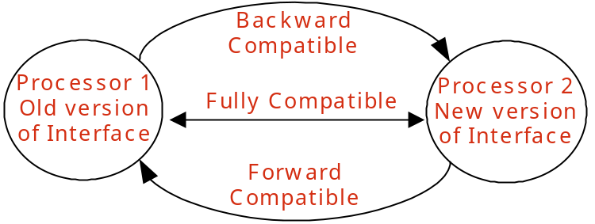
Figure 1 - Backward and Forward Compatibility

A major update is a change for which no meaningful communication between Sender and Receiver is possible with respect to the change, where the Sender and Receiver are using different versions. A message processor will not be able to natively process a message after a major update. After a major update the service will loose its backward compatibility (by definition).
A minor update is a change after which it is still possible for a processor to natively process a message. After a minor change the service will still be backward compatible.

Minor and Major Version Compatibility

Version Identifiers
Version identifiers are of the form “N.x”, where “N” represents the major version number and “x” represents the minor version string.
“N” must be a number
“x” must start with a number, but may also contain additional periods and numbers, e.g., “0”, “0.1”, “1.1”
Starting with version 1.0, each time a minor change is applied to the service interface the minor string is changed. The new minor version string should be lexically greater than the previous.
Each time a major change is introduced in a service interface, its major version number should be incremented.

Service Interface Versioning
In MTOSI, service interfaces and data models support both major and minor versioning as defined in the previous section.

Only the addition of new optional elements or optional structures in the XML Schema is both forward and backward compatible

Considering that compatible versions are classified as minor versions, the above axiom has the following implications:
- Adding a new optional interface to an MTOSI release is considered a minor change.
- Adding a new optional operation/notification to an interface is considered a minor change.
- Adding a new optional formal argument in an operation is considered a minor change.
- Adding a new optional element or structure to an MTOSI network object (TMF608) is considered a minor change.
- Adding or refining enumeration values as a minor change in a new release may be achieved by introducing an optional enumeration variable that specializes the base variable. Adding a new enumeration value directly in the enumeration set will result in a major version.
- Adding mandatory artifacts will result in a major version.
- Deleting artifacts by deprecating them will result in a minor version
- Deleting mandatory artifacts by removing them will result in a major version
- Deleting optional artifacts by removing them will result in a minor version

All minor versions of a service interface within a major version are defined to be compatible with each other
- E.g., 1.0, 1.0.1, 1.1, 1.2 are compatible with each other.
It should be noted that minor versions of a service interface are generally NOT identical but just compatible. Version 1.8 has different capabilities than 1.1. These differences make them different even though the addition of minor updates is still compatible. Any business activity supported by V1.1 should be supported by V1.8 with reasonable behaviors. The vice versa is also true. Note that the adjective “reasonable” refers to a contained semantic difference that can be tolerated in the context of a business activity.
This document includes the details on how to achieve interoperability between two MTOSI services implemented from two different minor versions of the same service interfaces major version (See ).

Different major versions of a service interface are not compatible with each other
- E.g., 1.x and 2.x are not compatible versions
Although not normative, this document highlights several possible migration strategies to bridge MTOSI services implemented from two different major versions of the same service interface (See ).
Refer to [SD0-5] for the details about the MTOSI XML specifications design requirements regarding versioning of the MTOSI service interfaces and data modules.

MTOSI Releases and Service Interface Versions
Each MTOSI service interface and data module has a distinct version number. All MTOSI service interfaces and data modules that are offered in MTOSI Release 2.0 have their version number set to 1.0 (See [SD0-5]). This independence of versioning allows each specification unit to evolve without impacting all the others.
It is important to note that:
- The versioning mechanism of the MTOSI service interfaces and data modules is not related to the MTOSI Release number.
- The MTOSI Document Delivery Packages (DDPs), which are specification components of an MTOSI Release, are not versioned.
The following example provides a simulation of the evolution of MTOSI Releases and their contents in the future:
- MTOSI R2.0 has the following DDPs and service interfaces:
  - RTM DDP:
    - AlarmRetrieval Version 1.0
    - AlarmControl Version 1.0
  - MRI DDP:
    - ResourceInventoryRetrieval Version 1.0
    - TerminationPointRetrieval Version 1.0

- Future MTOSI R2.1 may have (example only):
  - RTM DDP:
    - AlarmRetrieval Version 1.0 (unchanged)
    - AlarmControl Version 1.1 (minor change – new optional operations/attributes/parameters)
  - MRI DDP: (unchanged)
    - ResourceInventoryRetrieval Version 1.0
    - TerminationPointRetrieval Version 1.0

- Future MTOSI R3.0 may have (example only):
  - RTM DDP:
    - AlarmRetrieval Version 2.0 (major change)
    - AlarmControl Version 1.1 (unchanged)
  - MRI DDP: (unchanged)
    - ResourceInventoryRetrieval Version 2.0 (major change)
    - TerminationPointRetrieval Version 1.0 (unchanged)

Achieving Minor Version Interoperability
A Message processor knows and supports a specific version of the service interface (major and minor number).
All messages with the same major version as the processor are compatible regardless of the minor version.
In this section we address the mechanism to achieve backward and forward compatibility in a minor version release.

Backward compatibility
By only adding optional element in an XML Schema (minor version change), the XML instances are backward compatible. A new version of a message processor will by default ignore any missing optional element in an old message instance.

Forward compatibility
Forward compatibility is exercised when an old processor receives a new version message. There are two main mechanisms to achieve forward compatibility: planning for extensions and Validation by projection.

Versioning Mechanism Options

Planned extensions
The XSD has a construct “ANY” that allows extending a schema maintaining forward compatibility. Nevertheless this construct has some side effects: it often introduces additional complexity (wrappers, namespaces) to deal with the intrinsic non-determinism, and it is often not realistic to know where and how an interface will be extended in the future. The “ANY” mechanism is best suited for well planned extensions such as the customer extensions under the UML vendorExtensions attribute.

Validation by projection
This technique advocates removing (projecting) all the unknown elements and structures not recognized in the message processor version, prior to validate and process the XML remains. [BAU04][ORC04 ].
In this way all the optional future tags added in minor release will be silently ignored by a current or earlier version message processor. While some of the current tools in the market allows this relax validation (e.g. Java XMLbeans), we can always achieve forward compatibility by pre-processing the XML instances before they reach the message processor. For example, an XSLT can be defined to pass through only those elements valid for a version of an interface. The same result can be achieved by materializing the XML message it a generic DOM structure and using for example XPATH to process the XML and only reference known elements. The implementation particulars of the above mentioned techniques are beyond the scope of MTOSI.

MTOSI Minor Version Mechanism
In MTOSI we adopt the “planned extensions” to address the vendor extensibility dimension and the “validation by projection” technique to address the forward compatibility of MTOSI service interfaces with the same major version.
In a nutshell, if a message minor version of an incoming message is greater than the processor’s supported minor version, the processor MUST silently ignore extra elements it does not know (as note previously, these must be optional elements).
Refer to the “Advanced versioning features” section (not normative in MTOSI) in this document for some thoughts on how to modify this default behavior. Alternatively, the processor could add to the response message a list of all ignored tag elements in a warning containment.
If a service interface message (request, response, or fault) is validated against the associated MTOSI XML Schema, the XSLT mapping must be used prior to the validation step.

<soap:envelope>
<soap:body>
<tns:myRequest xmlns:tns=”myServiceInterface/v1”>
<tns:a>…</tns:a>
<tns:b>…</tns:b>
<tns:c minorVersion=”2”>…</tns:c>
</tns:myRequest>
</soap:body>
</soap:envelope>
<soap:envelope>
<soap:body>
<tns:myRequest xmlns:tns=”myServiceInterface/v1”>
<tns:a>…</tns:a>
<tns:b>…</tns:b>
</tns:myRequest>
</soap:body>
</soap:envelope>
Message pre-processed by Target OS to MTOSI myServiceInterface version 1.0
myServiceInterface XSLT v1.0
Keep a & b elements of myRequest message
Message generated by Requesting OS using MTOSI myServiceInterface version 1.2
Figure 2 - Filtering the unknown elements
Refer to examples captured in Framework DDP in IIS/xml folder:
- Md.xml – an XML document instance based on MTOSI MD object version 1.0 (See Md.xsd in xsd folder)
- Md1-1.xsd – an example of the XML Schema for MTOSI MD object version 1.1
- Md1-1.xml – an XML document instance based on MTOSI MD object version 1.1 (see above XML Schema module example Md1-1.xsd)

Use Cases
Figure 3 shows a request/reply flow in the case both the client and processor support the exact same version.

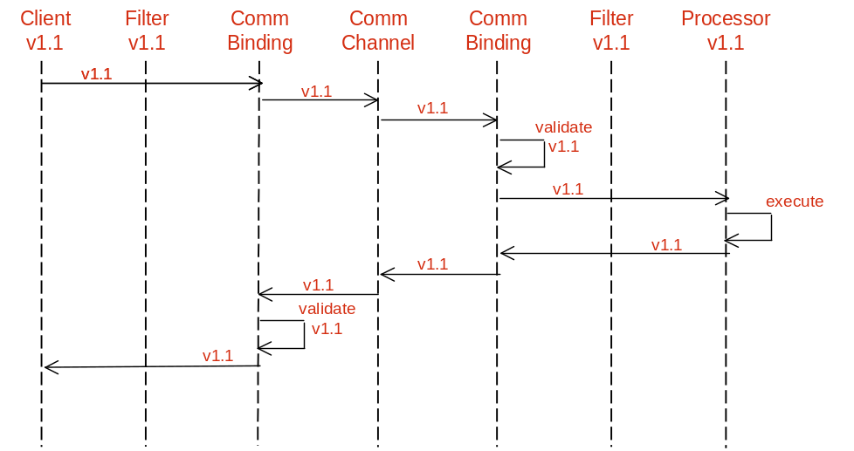
Figure 3 - Versions supported by client and processor match

Figure 4 shows a request/reply flow when the processor support a latter minor version than the client. Note that the filter on the client side transforms the v1.2 response into a v1.1 message, and the Communication Binding function on the processor side validates the v1.1 message against the v1.2 specification.
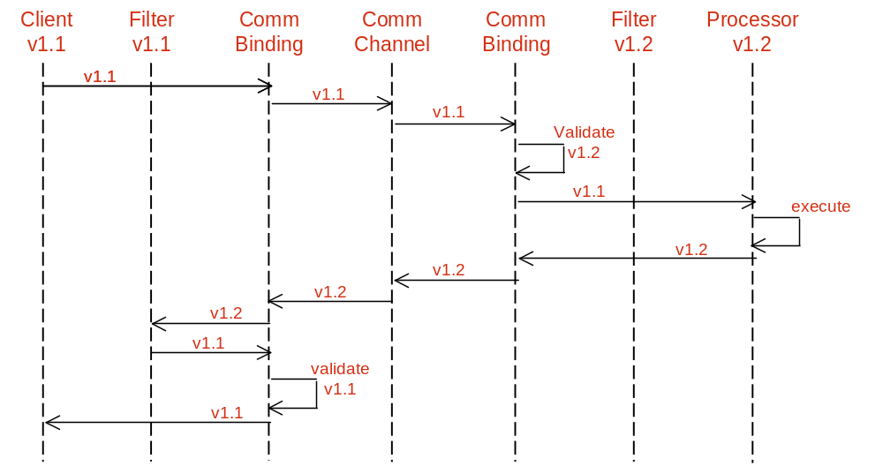
Figure 4 - Version supported by client older than that of processor

Figure 5 shows a request/reply flow when the client has a latter minor version than the processor. The filter on the processor side maps the message to v1.1 message and then the message is validated against the v1.1 XML and sent onto the processor. On the other side, the v1.1 message is validated against the v1.2 XML and then sent onto the client.

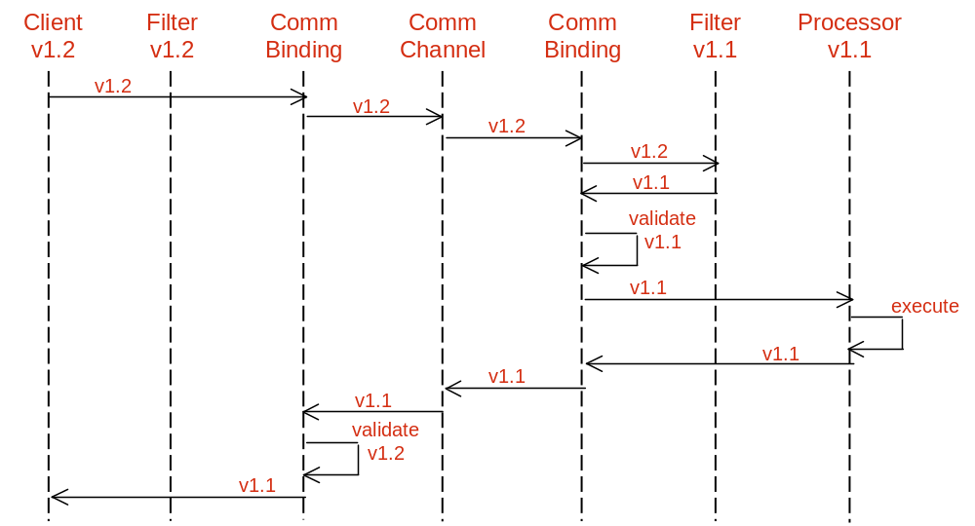
Figure 5 - Version supported by client newer than that of processor

The flows suggested in this section are not normative. They simply are meant to suggest a method for dealing with interoperability between MTOSI minor versions.

Major Version Interoperability Transition
All content in this section is not normative, but can be used as guidelines to dealing with interoperability of MTOSI clients and servers that implement an MTOSI service interface with two different major versions.
Both Client and Server processors should have some degree of independence when upgrading. When a client or server upgrades to a new major version of an interface, the previous major version should also be supported. A major version of an interface supported by a client must be available from a server.
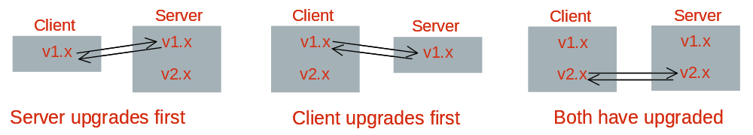
Figure 6 - Configurations showing multiple interface endpoints in clients and applications

Transition can be also accomplished through a mediation layer.
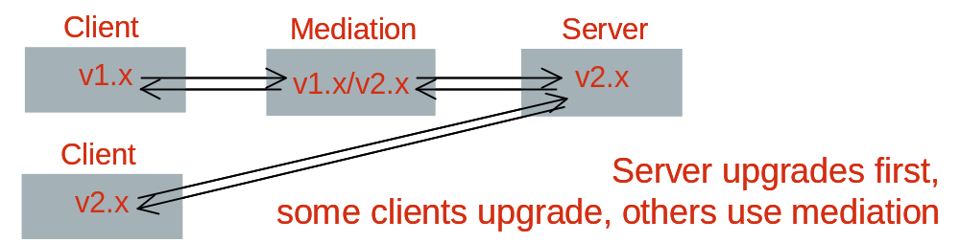
Figure 7 - Transition through a mediation layer

Notifications must be published in the major interface versions expected by subscribers.
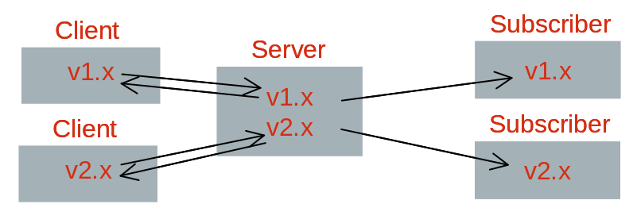
Figure 8 - Example of transition configuration with clients and subscribers on different major versions

If a server cannot support multiple major versions, mediation will also be required to generate notifications.
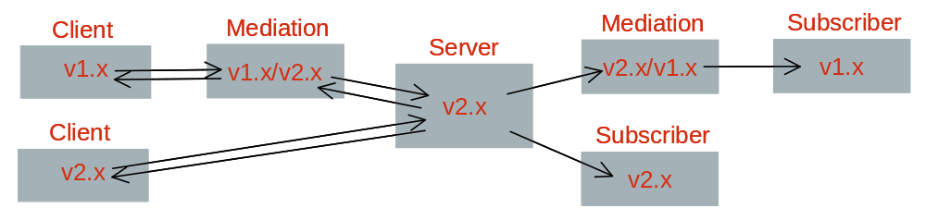
Figure 9 - Mediation layer for notifications

Use Cases
The following diagram in Figure 10 shows how a Server may support two major versions with two interface endpoints offered through a common communication binding stack. Both old and new clients can access the proper service by routing the request to the proper communication channel.
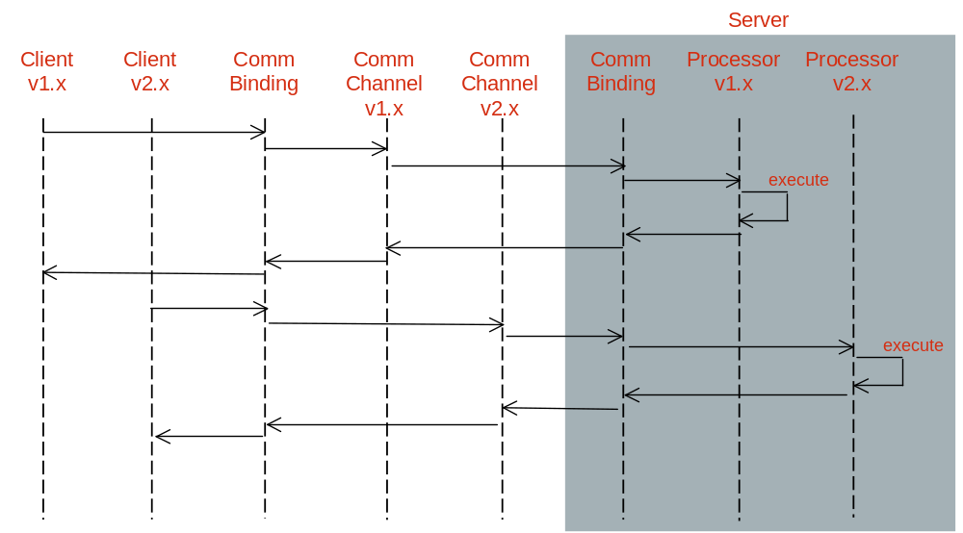
Figure 10 - Server supports two major versions with two interface endpoints, both old and new clients (Filters and validation not shown)

In the following diagram (Figure 11) a Server supports only one major version and uses a mediator layer during transition (Communication Binding not shown).
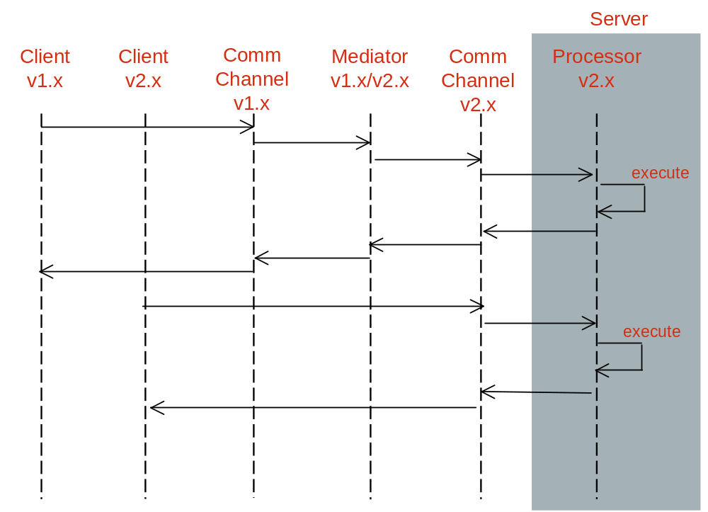
Figure 11 - Server supports only one major version, requires mediator during transition

The following diagram (Figure 12) shows how different communication channels and notification channels may be used during a transition from different major versions.
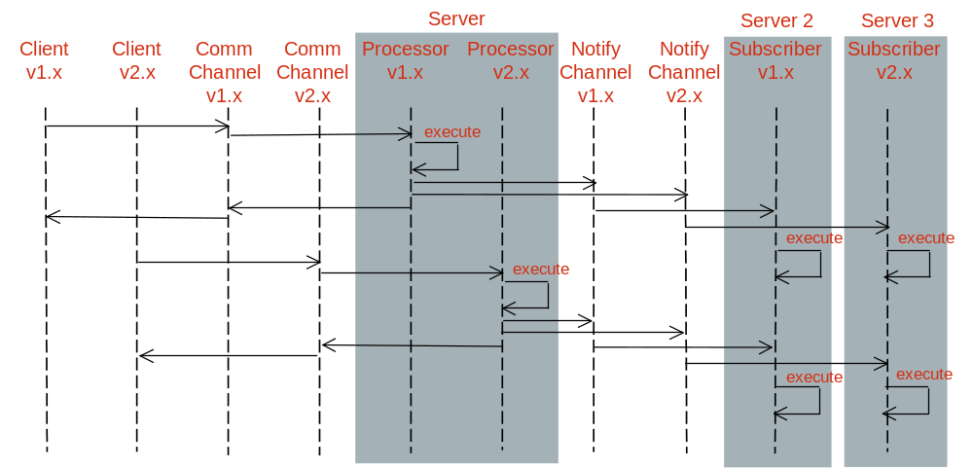
Figure 12 - Notification when there are subscribers on different major versions. Publication and subscription to Notify channels v1.x and v2.x is configurable

XML Schema Extensions
Extensibility is one of the essential design characteristics that are applied in the definition of the MTOSI XML Schema. Extensibility requirements are captured in the framework BA. The design of extension handlers in the MTOSI XML Schema is based on the following two considerations:

- Allow vendor to customize by extension the interface definitions, and
- Allow evolution of the interface definitions with minimal impact on compatibility.
The MTOSI XML Schema extension capabilities are covered in the following three sections:

- Complex Type Extension such as MTOSI objects and notifications (events)
- Simple Type Extensions such as MTOSI object attributes and parameters
- Vendor objects and notifications
Additionally, some XML examples are provided in the DDPs IIS XML directory.

XML Complex Type Extension
This section describes the adopted extension mechanism of all MTOSI XML data based on XML Schema complex types such as the definitions of objects and notifications (events).

Design Guidelines
Any release of the MTOSI XSD should be customizable to fit the need of a specific solution. Note that the UML model names this extensibility placeholder to allow customer extensions: additionalInfo.
The customer extension mechanism should allow a processor to accept additional custom elements needed in a specific solution while maintaining syntactical compatibility with any processor outside the solution. In other words, a processor should be able to process the known extensions or silently ignore them if not known.
Refer to [SD0-5] for the analysis of the extensibility mechanisms of XML entities, which are based on an XML Schema complex type.

Usage Guidelines
All XML elements found in the vendorExtensions element of an MTOSI XML instance complex entity:
- MUST be associated with a namespace. This is a mandatory XML condition of a valid XML instance.
- Any namespaces can be used including anyone of the MTOSI XML Schema module namespaces. For example, one may re-use the XML definition of the list of name and value string pairs (nvsList) from the Framework GeneralDefinitions.xsd (http://www.tmforum.org/mtop/fmw/xsd/gen/v1)
- If a vendor specific namespace is used, it is recommended that its naming definition be globally distinguishable to avoid any conflict with definitions from other vendors. For example, a namespace using URN notation could use this format: urn:com:<company>:<context>:<version> where:
  - <company> is the name of the company that owns the vendor definition
  - <context> is a unique distinguishable context within the company such as a product name
  - <version> is the version of the definitions associated with the namespace
- Refer to the XML samples of managed objects, which are captured in the various MTOSI DDP (Framework and DM DDPs).

XML Simple Type Extensions
This section describes the definitions used in the MTOSI schema to allow for extension of the MTOSI attributes of the MTOSI objects and notifications (events).

Patterns Overview
MTOSI identifies and supports the following XML simple type extensibility patterns:

- Open - the MTOSI team has not specified any specific values for this attribute. The value set is left as decision for the software vendor. Many of the name related attributes are of this type, e.g., the name attribute for managed element.
- Closed - the MTOSI team has defined a discrete set of possible values for this attribute. For this type of attribute, no vendor extensions are allowed and the MTOSI team does not plan any extensions either. This is used for very stable attributes (a Boolean might be a good example).
- Qualifiable - the MTOSI team has determined that this attribute may need further qualification by the vendor. This means that for a given value of an attribute, the vendor may specify sub-values. For example, resourceState was determined to qualifiable. So, a vendor can further qualify the value "Planned" with the sub-values Planned-ordered, Planned-received, Planned-tested.
- Extendable - the MTOSI team has determined that the value set for this attribute can be extended by a vendor (i.e., an implementer of the MTOSI) or by the MTOSI team itself (in going from one version to the next). In this case, the additional values for the attribute do not overlap in meaning with the existing values defined for the attribute. Extendable-Vendor means only extendable for the vendor, Extendable-MTOSI means only extendable by the MTOSI team within a minor version update, and Extendable means both.
- Overlap - the MTOSI team has determined that the value set for this attribute can be extended by a vendor. In this case, the additional values overlap partially or completely with the MTOSI provided values for the attribute. Also, the vendor must provide a mapping between the overlapping values for the attribute and the MTOSI defined values.

Design Guidelines
Each type of extension needs to be handled with a specific schema design pattern. The first two types can easily be associated with a simple schema definition. The other types are more challenging as they require a very special arrangement of their constraint settings.
Attributes can be extended by the MTOSI vendor in order to customize a deployment or by an MTOSI Interface editor in the context of a new release. A vendor should be able to extend (customize) the private MTOSI Interface while maintaining syntactic compatibility with the base MTOSI release.
When possible, it is important to adopt schema design patterns that allow an evolution of the object/event attribute constraint definition in the scope of a minor version. Any changes that imply a major version update are a significant impact to the MTOSI version compatibility scheme. As specified in section 3, the release of a major version interface is not backward compatible with any previous versions [ENUM].
The next sections will define how the various attribute extension are modeled in MTOSI.
See SD2-13 for a map of what is extendable.

Open Type Extension
Definition: Attribute is defined without any constraints.
This is only applicable to attribute that extend from following datatypes; string or any numerical. Booleans are excluded as they can be associated with a simple form of enumeration.

XSD:
- Type: <simpleType> any of the xsd:string or numericals datatypes.
- Constraint: None
- Extension: Free as it has no constraints.
- Caution: Adding to the schema some constraint settings (changing to another extension form) in the future can only be handled as a major version update! Backward compatibility would not work as the XML schema validation would be failing.

Example:
We identify that (EquipmentObjectType_T)Equipment.expectedEquipmentObjectType is Open

<xsd:simpleType name ="EquipmentObjectType_T">
<xsd:restriction base="xsd:string">
</xsd:restriction>
</xsd:simpleType>

But, changing it to the following is a Major version update (change to a Closed extension type)

<xsd:simpleType name ="EquipmentObjectType_T">
<xsd:restriction base="xsd:string">
<xsd:minLength value="1"/>
<xsd:maxLength value="1024"/>
</xsd:restriction>
</xsd:simpleType>

Consequently, an open attribute should be restricted (specialized) by an MTOSI vendor by introducing business rules rather than restricting the XSD in order to maintain syntactical compatibility with the base MTOSI release.

Closed
Closed Attributes cannot be extended by an MTOSI vendor and will trigger a Major release if extended by an MTOSI editor in the context of a new release.

Qualifiable Type Extension
Definition: Constraint is not relevant - But, sub-definition of values shall be offered to vendor.
This is only applicable to simple type attribute.

XSD:
- Type: <simpleType> any of the xsd base types.
- Constraint: Can be Open or Closed (enum).
- Extension: Another attribute of the same XSD type is required to allow carrying the sub-values.
  - Naming convention: "Qualifier"
  - Constraint: Must be Open.

Example:
We identify that (String)Common.resourceState is Qualifiable.
The following object attribute must be available as well: (String)qualifier
<ME>
<resourceState qualifier="IS_ACTIVE" > <!--note the extension here-->
INSTALLED
</resourceState>
</ME>

Extendable Type Extension
Definition: Schema can be extended by MTOSI team or vendor (as a minor version update)
This is applicable to the two possible types of attribute; simple and complex.

XSD:
Two scenarios based on the type of the attribute:
Simple Type Element:
- Type: <simpleType> of any of the xsd base types.
- Constraint: Applicable to Closed and Qualifiable types only.
- Extension: It is a limitation of XML schema. Changing the constraints breaks the validation of the schema, which would normally be handled as a major version update.

The following approach is suitable to handling vendor extensions as well as MTOSI extensions, as users are free to create as many customized values as long as they comply with the value prefix naming convention: “PROP_“ for vendor Extensions and MINOR_ for MTOSI editors.

Here is a brief description of the schema:
- Include all the initial (MTOSI) possible definitions with the schema enumeration constraint (same as with the Closed type)
- Use the pattern constraint style to allow any other values starting with PROP_ based on value pattern matching

Example:
<xsd:simpleType name="ColorType">
<xsd:union>
<xsd:simpleType>
<xsd:restriction base="xsd:string">
<xsd:enumeration value="BLUE" />
<xsd:enumeration value="WHITE" />
<xsd:enumeration value="RED" />
</xsd:restriction>
</xsd:simpleType>
<xsd:simpleType>
<xsd:restriction base="xsd:string">
<xsd:pattern value="PROP_([a-z]|[A-Z]|[0-9]|(_-))*" />
</xsd:restriction>
</xsd:simpleType>
</xsd:union>
</xsd:simpleType>

These values are valid: “WHITE”, “BLUE”, and “PROP_GREEN”

An enhanced version of this option is to include in the attribute definition union a third definition that is reserved to capture the vendor specific extended set of values. That third definition could be externalized to a specific schema file available in the vendorExtensions area of the local schema structure. This is also the pattern used for managing vendor extension of MTOSI Objects/Events. Vendor could replace the local vendor extension definition with there

The same mechanism is used with the prefix MINOR_ to allow MTOSI editors to add additional values within the same major version.

Complex Type Element:
- Type: <complexType> of any form.
- Extension: A special vendorExtension containment that can take any elements of any namespace can be used. The definition comes from an individual schema file (xsd) that the vendor can modify (extend) locally with its deployed systems. Same pattern as for extension of MTNM objects/events.

Any unplanned structural change in a complex type will trigger a major release.

Overlap Type Extension
Definition: Schema can be extended by the vendor. It is the most complex extension type as the vendor is allowed a complete re-definition of the scope and distribution of the possible values based on a mapping mechanism.
This is only applicable to simple type attribute.

XSD:
- Type: <simpleType> of any of the xsd base types.
- Constraint: Applicable to Closed type only (enum).
- Extension: A similar pattern as the one adopted for the Qualifable extension type can be used here. Another attribute is defined to hold the vendor value that is mapped from the initial MTOSI value.
Refer to the following convention:
  - Naming convention: "Overlap" attribute
  - Constraint: Must be Open.

Example: the same example proposed for the qualifiable extension applies replaving the attribute name “qualifier” with “overlap”.

Examples
SD2-13 defines the following forms of attribute extensibility in the Overview sheet: Qualifiable, Extendable-Vendor, Extendable-MTOSI and Overlap. We use the resourceState attribute to provide examples for these four types of attribute extensibility.
First, we not that the resourceState has the following possible values:
- planned (without any supporting network resources)
- installed (supported by network resources)
- retired (no more supported by network resources)
- unknown is available for resources when other values are not applicable.
As that a service provider would like to extend these values as follows:
- The state “retired” is further qualified as retired-removed and retired-storedAway.
- New states “present” and “notPresent” are used instead of “planned” and “installed” but the semantics of the values are not the same. For example, let’s say the present means the equipment is in the service provider’s possession and notPresent has the opposite meaning.
- A new state “sold” is used to indicate the equipment has been sold. For the sake of argument, assume that the meaning of “sold” does not overlap any of the other MTOSI-defined values for resourceState.
The “retired” state is extended via qualification. The resourceStateQualifier would be set to retired-removed or retired-storedAway whenever the resourceState has the value “retired”.
The “planned” and “installed” states are extended (actually overlapped) by the present and notPresent states. In such cases, the resourceState would typically be populated with the value “unknown” and the resourceStateOverlap attribute would be set to present or notPresent.
The new state “sold” is used as a value of resourceState. The vendor uses the prefix PROP_ to denote that the value is vendor-defined. In particular, the value PROP_sold would be used. Now if the vendor took their new state to the MTOSI team and the team approved, the set of valid states for resourceState would be expanded. This can happen in one of two ways:
- The MTOSI team may only want to make a minor update (backward compatible). In this case the new value would be listed as MINOR_sold.
- On the other hand, the MTOSI team may decide to make a major update (not backward compatible). In this case, the new value would be just “sold”.

It should be noted that the difference between the two above mentioned options is that while in the first case, there is no “type checking” on the value, i.e., MINOR_xxx could be anything and message processor would pass it, in the second case, there is type checking and a valid value must be used or a validation exception will be raised.

MTOSI Vendor Objects and Notifications
This section describes the following other extensibility patterns, which are offered in the MTOSI Framework to allow for the management of vendor specific objects and/or notifications.

MTOSI Vendor Object Specifications

Element Definitions
Define a generic vendor object element (no global type visible): VendorObject with following elements:
- name (mandatory) the object instance name based on NamingAttributes_T (See naming below)
- vendorObjectType (mandatory) free string. However, it is recommended that vendors use following format convention: <vendorName>/<objectType> where:
  - <vendorName> is the string uniquely identifying a vendor
  - <objectType> is the string uniquely identifyin the vendor object type
- vendorExtensions All vendor object specific attributes must be embedded inside that generic vendor object element. The element type is externally defined. It can take any elements from any namespace. Emphasize that these extensions must have the vendor namespace to avoid conflict with other vendor object extensions (See example below).

The reason for having this vendor object base definition is to ensure that all vendor extensions are encapsulated in an MTOSI container (confinement to control vendor extensions). The element definition must use final=”#all” to ensure that no redefinitions are of the elements are possible.

Naming Usage
Naming of the VendorObject is optional (See above definition). Naming rules are as followed:

- Use the propNm RDN tag from NamingAttributes_T
- Name is absolute. The propNm must always be last component in the naming hierarchy. VendorObject SHALL NOT be the parent of any MTOSI object.
- Hierarchy of VendorObjects is allowed using the value separator “/” such as in ehNm or ctpNm RDN tags.

Example of an absolute name of VendorObjectB contained in VendorObjectA, which is directly contained in ManagementDomain myDomain.
<name>
<mdNm>myDomain</mdNm>
<propNm>VendorObjectA/VendorObjectB</propNm>
</name>

Notifications Usage
Notifications of the VendorObject are supported on the basis of a VendorObject instance name and the VendorObject class type (ObjectType_T definition). For example, the ObjectCreation notification attributes are set as followed:

- objectName is the absolute name of the VendorObject instance (see example above).
- objectType is always OT_VENDOR_OBJECT based on ObjectType_T. Note that on receiving a notification with objectType set to OT_VENDOR_OBJECT, the receiving OS needs has to check the vendorObjectType attribute of the object instance based on the objectName to determine the vendor object type.

Inventory Retrieval Usage
Inventory retrieval coarse-grained operation getInventory only supports the query for the VendorObject MTOSI object type as for any other MTOSI object types. The includedObjectType filter attribute does not support the specific setting of a vendorObjectType instance. And, for the same reason as stated above, the filter can only specify the enumerated value associated with an MTOSI object type. So, all of the VendorObject instances are returned for a given filter baseInstance context setting.
All the VendorObject instances are encapsulated in a specific list of the inventory layout data structure. There is no context retrieval for the VendorObject instances matching the filter criteria. The list is readily available from the InventoryData XML element. Consequently, the name of these VendorObject instances is absolute.

Example
The example below is a simple XML VendorObject instance found directly under the domain “myDomain”. It is assigned a vendor object type “NortelObjectA”. And, the vendorExtensions encapsulates an instance of ObjectA element, which is defined from the vendor namespace; nortel.v1 with schema definitions in nortelDefinitions.xsd.

<?xml version="1.0" encoding="UTF-8"?>
<!--Sample XML file generated by XMLSpy v2005 rel. 3 U (http://www.altova.com)-->
<VendorObject xmlns="tmf854.v1" xmlns:nt1="nortel.v1" xmlns:xsi="http://www.w3.org/2001/XMLSchema-instance" xsi:schemaLocation="tmf854.v1 ..\..\xsd\networkResources\vendorObject.xsd nortel.v1 nortelDefinitions.xsd" extAuthor="jm" tmf854Version="1.0" extVersion="1.1">
<name>
<mdNm>myDomain</mdNm>
<propNm>myObjectA</propNm>
</name>
<vendorObjectType>NortelObjectA</vendorObjectType>
<vendorExtensions>
<nt1:ObjectA>
<nt1:attribute1>value1</nt1:attribute1>
<nt1:attribute2>
<nt1:attribute2-1>21</nt1:attribute2-1>
<nt1:attribute2-1>22</nt1:attribute2-1>
</nt1:attribute2>
</nt1:ObjectA>
</vendorExtensions>
</VendorObject>

MTOSI Vendor Notification Specifications

Element Definitions
Define a generic vendor notification element as one of the supported event types. The definition of VendorNotification has the following elements:

- notificationId (mandatory)
- vendorNotificationType (mandatory) free string
Question: shall we constraint with pattern <vendorName>_* where <vendorName> must be a name selected by the vendor to ensure uniqueness of the definition
- vendorExtensions based on externally defined type which can take any elements from any namespace. Emphasize that these extensions must have the vendor namespace to avoid conflict with other vendor notification extensions (See example)

The reason for having this vendor notification base definition is the same as for the VendorObject.

Notification Topic Usage
To support the vendor notifications, they must be associated with an MTOSI topic. So, the following changes are to be made:
- A VendorNotification is supported in the Inventory and Fault MTOSI topics.
- A new VendorNotification MTOSI topic is created. Its capabilities are described through the DiscoveryServicethe same way as for the other MTOSI topics.

Example
The following example describes the instance of a VendorNotification with the vendor notification type value “NortelNotificationA”. The entire structure of this notification is defined in vendor schema nortelDefinitions.xsd with the vendor namespace; nortel.v1.

<?xml version="1.0" encoding="UTF-8"?>
<event xmlns="tmf854.v1" xmlns:nt1="nortel.v1" extAuthor="jm" tmf854Version="1.0" extVersion="1.1">
<VendorNotification>
<notificationId>notifID</notificationId>
<vendorNotificationType>NortelNotificationA</vendorNotificationType>
<vendorExtensions>
<nt1:NotificationA>
<nt1:attribute1>value1</nt1:attribute1>
<nt1:attribute2>
<nt1:attribute2-1>21</nt1:attribute2-1>
<nt1:attribute2-1>22</nt1:attribute2-1>
</nt1:attribute2>
<nt1:attribute3>
<nt1:attribute3-1>false</nt1:attribute3-1>
<nt1:attribute3-2>string</nt1:attribute3-2>
</nt1:attribute3>
</nt1:NotificationA>
</vendorExtensions>
</VendorNotification>
</event>

MTOSI Extensions Usage Recommendations
The MTOSI schema is designed to provide maximum extension capabilities in order to allow a complete and successful integration of various OS solutions. However, the following sections suggest some usage recommendations. These recommendations should all be understood by any implementers who are designing proprietary schema that is going to be used in these MTOSI vendor extensions.
Finally, as a general recommendation, all vendor specific definitions of interest to the MTOSI user community should be presented to the MTOSI team as potential contributions for additions to the standard interface definitions.

Extending an MTOSI Object vs. Using Vendor Object
Extension of an MTOSI object/notification is usually preferable to the use of an MTOSI vendor object/notification.
It is recommended to use the MTOSI object/notification extension method if the characteristics of the extension can be associated with one of the existing MTOSI objects/notifications. Extending the definition of an MTOSI object/notification with additional specific attributes has the following advantages:
- Simpler implementation effort (no specific naming handling)
- Greater management controls (retrieval, data lifecycle)
- Easier integration (the object/notification is a known entity)

For instance, if a network entity concept can be related to an MTOSI Physical Termination Point (PTP), the recommended option is to extend the schema definition of the PTP with specific additional attributes in the vendorExtension element.

Otherwise, a specific vendor object can be defined (as seen in 4.3.1) to describe that network entity concept, which cannot be mapped to any of the MTOSI objects.

Examples of XML Messages with Extensions
MTOSI comes with some XML examples within each XML directory of the DDP that can be used to support the various MTOSI extension techniques.

All the extension examples are based on a vendor schema, which can be found in xml\vendorSchema\vendorDefinitions.xsd

The following XML messages have extensions:
- getInventory_response.xml with
  - one PTP object extension, and
  - one vendor object
- objectCreation.xml extension of the ObjectCreation notification
- vendorNotification.xml a specific vendor notification

Advanced Versioning Features

Summary
This supporting document classifies the changes to a release in two main categories: minor and major. Any minor change will result in a minor version increment in the Interfaces and will still guarantee full compatibility.
Three prerequisite must be met in order to implement the MTOSI versioning mechanism:
- Mark the XSDs with comments including the major and minor version number.
- Mark the XML messages with the major and minor version number (both header and body)
- Maintain the same major XSD namespace across the set of minor releases
By adding only optional elements or structures in a minor release, the MTOSI minor releases will be backward compatible.
By adopting the “validation by projection” all the minor releases will also be forward compatible.
It is strongly advised to keep all the MTOSI modification in this class of versioning since it will minimize the migration activities.
A major change (even if only semantic) will not preserve the native service compatibility and will require a mechanism (described in section 3.5) to allow a smooth release transition.
A vendor extensibility mechanism has also been introduced to address any proprietary extension a vendor may require in a particular deployment of MTOSI.

References
[SD0-5] – Framework DDP SD0-5_mTOPGuidelines_WebServices
[BAU04] – “Theory of Compatibility (Part 3)” – David Bau, http://davidbau.com/archives/2004/01/15/theory_of_compatibility_part_3.html
[ORC04] – “Providing Compatible Schema Evolution” - David Orchard, http://www.pacificspirit.com/Authoring/Compatibility/ProvidingCompatibleSchemaEvolution.html
[ORC01] – “Versioning XML Languages” - David Orchard, Norman Walsh, http://www.w3.org/2001/tag/doc/versioning-20031003-diff.html
[ENUM] - Managing Enumerations in W3C XML Schemas http://www.xml.com/lpt/a/2003/02/05/wxs-enum.html
[SD2-9] Using JMS as an MTOSI Transport

Administrative Appendix

Document History

Version Number | Date Modified | Modified by: | Description of changes
1.0 | MM/DD/YY |  | 1.0
1.1 | November 2005 | Included comments from ME review | 1.1
2.0 | April, 2008 | Jérôme Magnet | Simplified/updated based on MTOSI R2 changes

Acknowledgments

First Name | Last Name | Company
Tom | Kelley | Telcordia Technologies Inc.
Josephine | Micallef | Telcordia Technologies Inc.

How to comment on this document
Comments and requests for information must be in written form and addressed to the contact identified below:

Francesco | Caruso | Telcordia Technologies Inc.
Phone: | +1 732 699 3072
Fax: | +1 732 336 7026
e-mail: | caruso@research.telcordia.com

Jérôme | Magnet | Nortel
Phone: | 1-613-763-1480
Fax:
e-mail: | jeromem@nortel.com

Please be specific, since your comments will be dealt with by the team evaluating numerous inputs and trying to produce a single text. Thus we appreciate significant specific input. We are looking for more input than wordsmith” items, however editing and structural help are greatly appreciated where better clarity is the result.

