Location Identification

Introduction
The following kinds of parameters in the MTNM specification need exact identification of the signal direction or signal location to which they apply to:
- Performance Parameters
- Probable Causes
- Layered Parameters

Performance Parameters
The location identification for the performance parameters is modelled with the additional attribute "pmLocation" which is attached to every parameter.
The attribute pmLocation is used to identify three different items:
- the physical direction of the monitored signal (i.e. which bitstream is supervised), identified by "Contra"/""
- the logical direction of the monitored signal (i.e. to which direction the information of the supervised bits of the physical bitstream refer to), identified by "Near_End"/"Far_End"
- the type (i.e. sink or source) of atomic function that measures the signal, identified by "Rx"/"Tx".
Refer to Figure 1 for clarification.
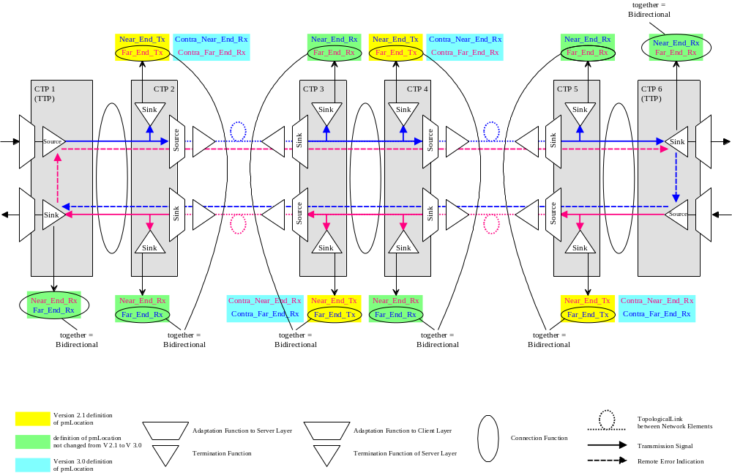
Figure 1: Measurement points identified by pmLocation

The attribute pmLocation can contain seven values to define the location of the measurement:
- Bidirectional
Identifies a bidirectional measurement (i.e. both directions of the signal are taken into account for this measure)
- Near_End_Rx
Identifies a unidirectional measurement provided by a sink monitoring function that supervises the signal which is related to the sink atomic function of this TP. The direction of the supervised signal is measured.
- Far_End_Rx
Identifies a unidirectional measurement provided by a sink monitoring function that supervises the signal which is related to the sink atomic function of this TP. The opposite direction of the supervised signal is measured.
- Contra_Near_End_Rx
Identifies a unidirectional measurement provided by a sink monitoring function that supervises the signal which is related to the source atomic function of this TP. The direction of the supervised signal is measured.
- Contra_Far_End_Rx
Identifies a unidirectional measurement provided by a sink monitoring function that supervises the signal which is related to the source atomic function of this TP. The opposite direction of the supervised signal is measured.
- Near_End_Tx
Identifies a unidirectional measurement provided by a source monitoring function of this TP. The direction of the supervised signal is measured.
- Far_End_Tx
Identifies a unidirectional measurement provided by a source monitoring function of this TP. The opposite direction of the supervised signal is measured.

Probable Causes
Termination Points can detect alarms on both directions of the signal. The definition of the direction is done with respect to the type of the atomic function that processes that direction of the signal. The identification of the direction is modelled in the Name of the probable cause.
All probable causes defined (see ProbableCauses supporting document) identify alarms detected on the signal which is related to the sink atomic function. For alarms detected on the signal which is related to the source atomic function, the prefix "Contra_" has to be used (e.g. SSF → Contra_SSF or TCM_AIS → Contra_TCM_AIS).
Refer to Figure 2 depicting a 2 Mbit/s port as an example.

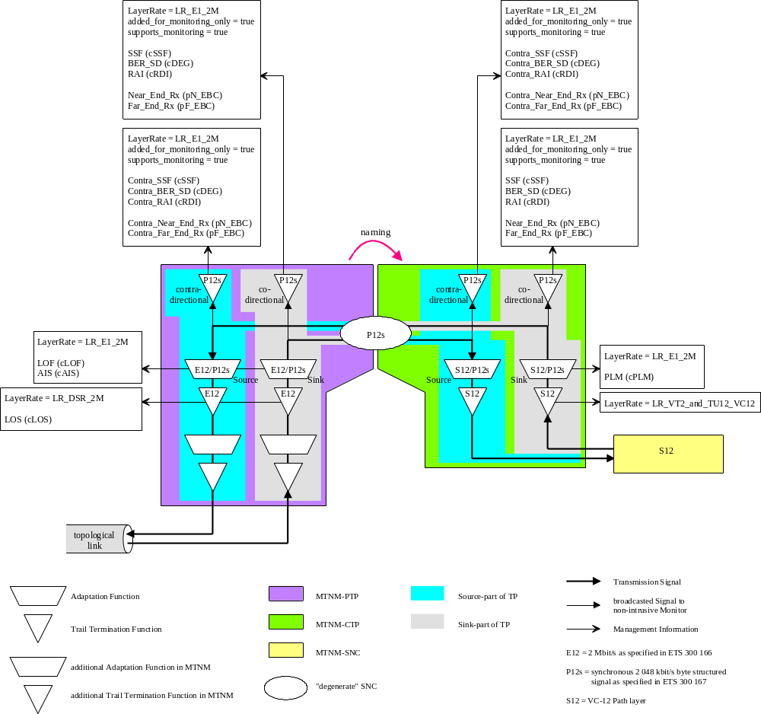
Figure 2: Parameters associated to a 2 Mbit/s Port

In addition it is also possible, that one Termination Point is physically located in two distinct located network elements (refer to DSL modelling as an example). This TP may detect the same probable cause in the local and in the remote network element.
In order to differentiate these two probable causes, an additional prefix "RU_" (RU for Remote Unit) has to be used in the Name of the probable cause.
e.g. SSF → RU_SSF or Contra_TCM_AIS → RU_Contra_TCM_AIS

Layered Parameters
In some cases one layered parameter is defined for each direction of the signal.
In order to differentiate these two parameters, the direction of the signal will be defined by the terms Codirectional and Contradirectional. For the Codirectional case no additional identification is necessary. For the Contradirectional case an additional inter-syllable "Contra" has to be used in the Name of the parameter (refer to TCM related parameters as an example).
e.g. TCMTrailTraceActualRx → TCMContraTrailTraceActualRx

Definition of both terms:
- Codirectional transmission functions mean those which work in the same direction as the direction of the port, i.e.
  - sink functions related to information which is mapped from the signal received by the containing PTP
  - source functions related to the information which is mapped to the signal transmitted by the containing PTP.
- Contradirectional transmission functions mean those which work in the opposite direction as the direction of the port, i.e.
  - sink functions related to information which is mapped to the signal transmitted by the containing PTP
  - source functions related to the information which is mapped from the signal received by the containing PTP.

Refer to Figure 3 (below) for an example of a TCM function.

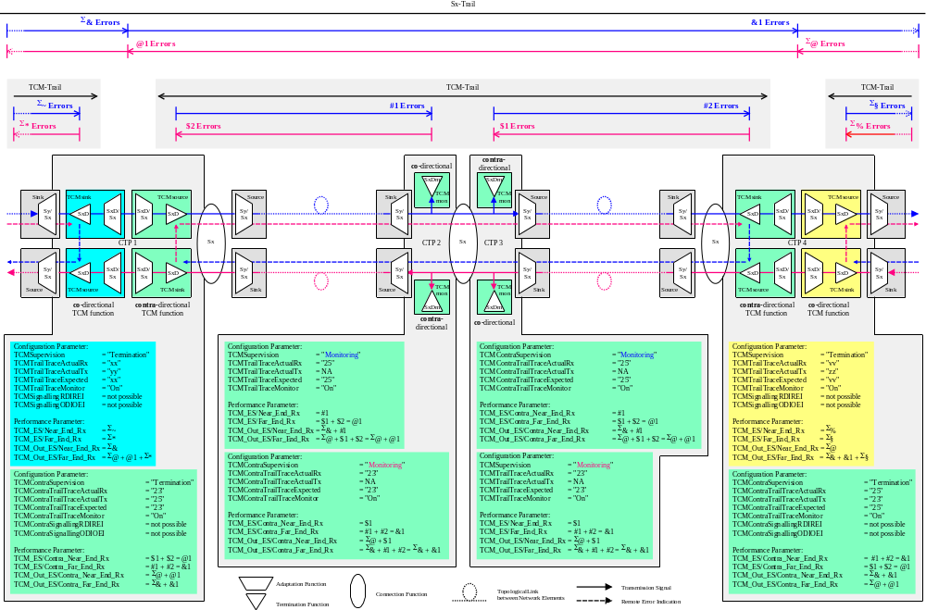

Revision History
Version | Date | Description of Change
3.0 | April 2005

Acknowledgements
<FirstName> | <LastName> | <Company>

How to comment on the document
Comments and requests for information must be in written form and addressed to the contact identified below:

Keith | Dorking | CIENA
Phone: | +1 678 867 5007
Fax: | +1 678 867 5010
e-mail: | Kdorking@ciena.com

Please be specific, since your comments will be dealt with by the team evaluating numerous inputs and trying to produce a single text. Thus we appreciate significant specific input. We are looking for more input than wordsmith” items, however editing and structural help are greatly appreciated where better clarity is the result.

