Submission No. |  | 276 | Date of Request: |  | Nov 28, 2007
Submitter Details:
mTOP Team,
represented by
Michel Besson, Amdocs (MTOSI 2.0 Release Manager)
email: Michel.Besson@Amdocs.com
tel: +44 7717 692178
Submission Details:
All Submission artifacts have been agreed on by the above NGOSS team
Artifact Nr | Artifact Title |  |  | Artifact Version |  | CRs implemented in artifact
Refer to table 1 in the Release Notes document: “TMF521_MTOSI_Release2.0BA.doc”
IPR Details
Is there any IPR associated with this contribution YES / NO (indicate as appropriate)
The author must declare any IPR that their company owns with respect to this contribution. Note that if the contribution is accepted by the team an IPR declaration form will be required. This may be downloaded from the TMF web site at: http://www.tmforum.org/browse.asp?catID=2211
CCB Action Details:
Accepted/Rejected. |  | accepted | Authority |  | Dave Raymer
Reason for Rejection of Submission:
not rejected

Artifact Release notes:
See attached “MTOSI 2.0 BA Release Notes” located in the attached file “TMF521_MTOSI_Release2.0BA.doc”

Artifact Nr | Artifact Title | Artifact Version | CRs implemented in artifact
Release Notes:
See attached “MTOSI 2.0 BA Release Notes” located in the attached file “TMF521_MTOSI_Release2.0BA.doc”

Artifact Processing and Posting information.

Submission Type <select as appropriate>
Document Suite __X__ Single Document ____ Model ___

Contents Business Agreements for next MTOSI release.
URL where document(s) parked:
http://www.tmforum.org/cws/view_folder.aspx?SelectedIndex=1&team_ID=6
MTOSI CWS area | Document workspace | Submitted Documents | Release 2.0

Outstanding Action Items:
none

Suite / Document Valid until: until full MTOSI 2.0 release (i.e., this release only contains the BA part of MTOSI Rel. 2.0. The IA and IIS part will be release at a future date)

Evaluation Period:
- Member Evaluation: 90 days

Suite/Document Release Date: immediate

Suite / Document Pricing: members only

Marketing Web notification input -

Team Name:

Multi-Technology Operations Systems Interface (MTOSI)

Short Description – The TM Forum’s Multi-Technology Operations Systems Interface (MTOSI) is committed to the development of NGOSS-based contracts for managing network resources and connectivity and the associated services in the following areas of the Business Process Framework (eTOM).
- Resource Management & Operations (RM&O)
  - Resource Trouble Management (RTM)
  - Managed Resource Inventory (MRI)
  - Resource Provisioning (RP)
  - Resource Performance Management (RPM)
- Service Management & Operations (SM&O)
  - Service Configuration & Activation (SA)
    - Service Activation Interface (SAI)
    - Service Component Activation Interface (SCAI)
Note that the SAI and SCAI represent a further level of decomposition than is now present in the eTOM.

Full Description –

Multi-Technology Operations Systems Interface (MTOSI): Scope

The TM Forum’s Multi-Technology Operations Systems Interface (MTOSI) is committed to the development of NGOSS-based contracts for managing network resources and connectivity, and the associated services.

The MTOSI Interface model (which is shared with the Multi-Technology Network Management (MTNM) interface) consists of a generic view which is derived and developed at different abstraction levels with different interactions patterns, in order to cover both the OS-OS fine grained interactions and the coarse grained services, focusing on network resources management as well as on services management. Note that an OS in this context is any management system that exhibits Element Management Layer (EML), Network Management (NML) and/or Service Management Layer (SML) functionality. Such innovative modelling concepts allow for a the single interface using one model and consistent operations paradigm to manage many disparate network technologies (SDH/SONET, WDM, ATM, DSL, Ethernet, Wireless, etc.) even where intertwined within single network devices.

MTOSI Supported Business Processes

The MTOSI Release 2.0 product is intended to provide a unified set of management interfaces in support of the following areas of the Business Process Framework (eTOM).
- Resource Management & Operations (RM&O)
  - Resource Trouble Management (RTM) - This set of capabilities covers resource fault management, protection management and maintenance and diagnostics. In terms of fault management, the focus is on alarm subscription, active alarm synchronization, the control of alarm reporting and the predetermined assignment of severities to given alarm types. The protect management requirements and use cases entail the retrieval of protection related information such as protection groups and subscription to protect switch events. The maintenance and diagnostics aspect focuses on the sending of maintenance commands and the determination of active (still running) maintenance actions. This capability is supported by means of the interface that both allows an OS to send alarms to a set of interested OSs and allows an OS (alarm requesting OS) to request some or all of the active alarms known to another OS (target OS). In order to receive alarms from a given OS, an alarm consuming OS must first subscribe to receive the alarms of the given OS. A single OS could play both roles.
  - Managed Resource Inventory (MRI) - This capability is supported by means of the interface that both allows an OS to retrieve all or part of the inventory known to another OS, and also allows an OS to send inventory update notifications to a set of interested OSs.
  - Resource Provisioning (RP) - This capability allows for creating, modifying and deleting network resource entities handling control of connections, flow domains (for connectionless technologies), software, termination points, transmission descriptors, topological links, the provisioning of equipment and the management of traffic conditioning profiles and flow domain fragments.
  - Resource Performance Management (RPM) - This capability covers resource performance monitoring and control:
    - Monitor Performance Management
      - PM Retrieval – this includes the retrieval of both current and historical PM data
      - Threshold Crossing Alert (TCA) Notifications
    - Control Performance Management
      - PM Control – this includes, for example, the enabling and disabling of PM collection
      - TCA Control – this includes, for example, the enabling and disabling of TCA generation.
- Service Management & Operations (SM&O)
  - Service Configuration & Activation (SA)
    - Service Activation Interface (SAI) – an activation interface between an OS support the Customer Relationship Management (CRM) capability and another OS supporting the Service Configuration and Activation (SC&A) capability.
    - Service Component Activation Interface (SCAI) - an activation interface between two OSs supporting the SA capability (above).

Release Structure: DDPs

In order to allow for more efficient release delivery, the monolithic BA, IA and SS documents from MTOSI Release 1.1 have been partitioned into smaller self-contained (though not independent) units called Document Delivery Packages (DDPs). This is similar to the 3GPP concept of Integration Reference Point (IRP). The basic idea is that the Interface, which is specified by the entire document set (of a release), is partitioned into DDPs where each DDP specifies “a certain aspect” of the Interface, which needs to be very clearly scoped.

There are three kinds of DDPs:
- The Framework DDP (FMW) – this DDP contains the generic artefacts that are applicable to all the other DDPs.
- Data Model DDP (DM-DDP) – a DDP that concerns a data model (entities, data structures including notifications, attributes, state, but no operations)
- Operation Model DDP (OM-DDP) – a DDP that concerns a computational model (operations, notifications, transactions) for a given functional area (such as resource inventory management)
The unified deliverables structure for each DDP is as follows:
- Business Agreements (BAs): a business view specification including requirements and use cases
- Information Agreements (IAs): a system view specification
- Interface Implementation Specifications (ISSs): implementation and deployment view specification for XML (WSDL, XSD, bindings…)
- Supporting Documentation: normative and informative supporting documents.
Note that in this MTOSI 2.0BA release, only the Business Agreements and their associated Supporting Documentation have been provided. The Information Agreements and Interface Implementation Specifications (IISs) will be added in the full MTOSI 2.0 release.

MTOSI 2.0 DDPs
The MTOSI 2.0 Release is constituted of several DDPs which names are presented in the table below. For The MTOSI 2.0 BA release (this release), only the documents relating to the BA aspects are delivered.

 | DDP long name | DDP short name
General
 | Framework | FMW
RM related
 | DM-DDPs
 | NetworkResourceBasic | NRB
 | NetworkResourceFulfilment | NRF
 | NetworkResourceAssurance | NRA
 | OM-DDPs
 | ManageResourceInventory | MRI
 | ResourceProvisioning | RP
 | ResourceTroubleManagement | RTM
 | ResourcePerformanceManagement | RPM
SM related
 | DM-DDPs
 | ServiceBasic | SB
 | OM-DDPs
 | ServiceActivation | SA

The OM-DDPs reflect business scenarios as highlighted above.

Releationships between DDPs

It may happen that artefacts defined in one DDP use artefacts defined in one or several other DDPs.
The figure below shows the DDP dependency graph along with the Supporting Documents associated with each DDP:
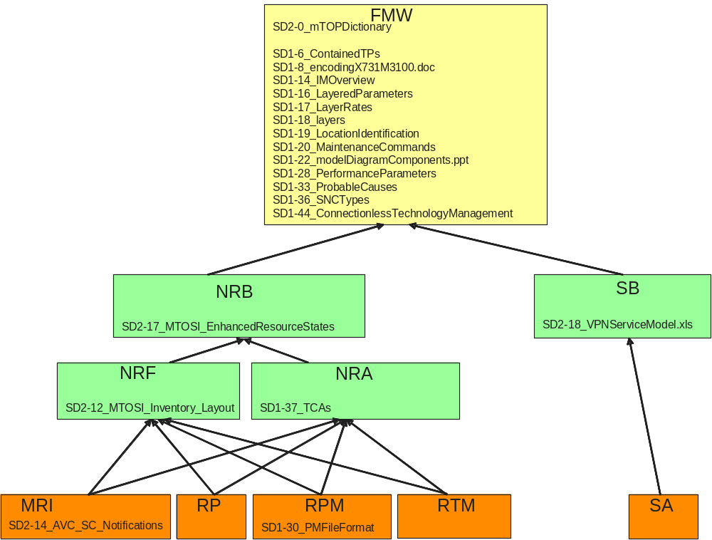

Special Instructions for Web:
These documents (zip files) should be posted to the Document library, to the team page and should have a News central announcement sent out. These documents (zip files) SHOULD appear in the document library and team pages in the order presented below.

SUITE BREAKDOWN details

Individual Document Description(s) (NOTE: these documents should appear on the website in the FOLLOWING ORDER).

Document Number, Name & Version:

TMF521_MTOSI_ReleaseNotes, MTOSI 2.0 BA Release Notes, Release 2.0BA, (TMF521_MTOSI_Release2.0BA.pdf)

Short –
The Multi-Technology Operations Systems Interface (MTOSI) provides a set of NGOSS-based contracts for managing network resources and connectivity and the associated services. This document constitutes the Release Note of the MTOSI 2.0 BA Release. It presents an overview of the Release 2.0BA of the MTOSI product and it shows the complete list of all the different documents constituting this Release.

Full Description –
The Multi-Technology Operations Systems Interface (MTOSI) provides a set of NGOSS-based contracts for managing network resources and connectivity and the associated services. This document constitutes the Release Note of the MTOSI 2.0 BA Release. It presents an overview of the Release 2.0BA of the MTOSI product and it shows the complete list of all the different documents constituting this Release.
Release 2.0 of the MTOSI product is a major release. It means that it does contain new features compared to the previous MTOSI 1.x releases.
Many modifications have been introduced in this release. They are summarized below:
- Service activation management
- Resource provisioning and activation
- Management of connectionless networks
- Performance management and maintenance commands
- Inventory updates, multi-event inventory notifications and enhanced inventory retrieval (attribute value matching)
- Enhanced model for resource states
- Multi-action and request transactions
- Division of deliverables into Document Delivery Packages (DDPs) as shown in the next subsection.

Document Number, Name & Version:

TMF518_FMW, Framework - DDP BA, Release 2.0BA, (mtosi-fwk-2_0ba.zip)

Short Description –
The Multi-Technology Operations Systems Interface (MTOSI) Framework Business Agreement covers requirements and use cases concerning both the interface communication mechanisms and the general network resources aspects.

Full Description –
The Multi-Technology Operations Systems Interface (MTOSI) Framework Business Agreement covers requirements and use cases concerning both the interface communication mechanisms and the general network resources aspects.
The following items are covered:
- Resource identification
- Functional modelling
- Resources data retrieval mechanisms
- Notification mechanisms

Document Number, Name & Version:

TMF518_NRB, Network Resource Basic - DDP BA, Release 2.0BA, (mtosi-nrb-2_0ba.zip)

Short & Full Description –
The Multi-Technology Operations Systems Interface (MTOSI) Network Resource Basic Business Agreement covers the static requirements for the general aspects of the network resources (Data Model).

Document Number, Name & Version:

TMF518_NRF, Network Resource Fulfilment - DDP BA, Release 2.0BA, (mtosi-nrf-2_0ba.zip)

Short & Full Description –
The Multi-Technology Operations Systems Interface (MTOSI) Network Resource Fulfilment Business Agreement addresses the Data Model (DM) aspects of resource fulfilment and as such it defines all resource related managed entities visible across the Interface that are used in support of resource fulfilment.

Document Number, Name & Version:

TMF518_NRA, Network Resource Assurance - DDP BA, Release 2.0BA, (mtosi-nra-2_0ba.zip)

Short & Full Description –
The Multi-Technology Operations Systems Interface (MTOSI) Network Resource Assurance Business Agreement addresses the Data Model (DM) aspects of resource assurance and as such it defines all resource related managed entities visible across the Interface that are used in support of resource assurance.

Document Number, Name & Version:

TMF518_MRI, Manage Resource Inventory - DDP BA, Release 2.0BA, (mtosi-mri-2_0ba.zip)

Short Description –
The Multi-Technology Operations Systems Interface (MTOSI) Manage Resource Inventory Business Agreement covers requirements and use cases concerning the management of resource inventory.

Full Description –
The Multi-Technology Operations Systems Interface (MTOSI) Manage Resource Inventory Business Agreement covers requirements and use cases concerning the management of resource inventory.
The following management capabilities are covered:
- General Management such as (among others):
- Bulk inventory retrieval (retrieving selected information in a single operation)
- Multi-Object Inventory Update
- Inventory Management of Connection Oriented Technologies
- Inventory Management of Connectionless Technologies
- Inventory Notifications

Document Number, Name & Version:

TMF518_RP, Resource Provisioning - DDP BA, Release 2.0BA, (mtosi-rp-2_0ba.zip)

Short Description –
The Multi-Technology Operations Systems Interface (MTOSI) Resource Provisioning Business Agreement covers requirements and use cases concerning the provisioning of network resources.

Full Description –
The Multi-Technology Operations Systems Interface (MTOSI) Resource Provisioning Business Agreement covers requirements and use cases concerning the provisioning of network resources.
The following management capabilities are covered:
- Connection Control
- Equipment Provisioning
- Flow Domain Control
- Gui Cut-Through Control
- Software and Data Control
- Termination Point Control
- Transmission Descriptor Control
- Assignment of Transmission Descriptors
- Topological Link Control

Document Number, Name & Version:

TMF518_RTM, Resource Trouble Management (RTM) - DDP BA, Release 2.0BA, (mtosi-rtm-2_0ba.zip)

Short –
The Multi-Technology Operations Systems Interface (MTOSI) Resource Trouble Management Business Agreement covers requirements and use cases for the following aspects of RTM: resource fault management, protection management, and maintenance and diagnostics control.

Full Description –
The Multi-Technology Operations Systems Interface (MTOSI) Resource Trouble Management Business Agreement covers requirements and use cases for the following aspects of RTM: resource fault management, protection management, and maintenance and diagnostics control.
In terms of fault management, the focus is on alarm subscription, active alarm synchronization, the control of alarm reporting and the predetermined assignment of severities to given alarm types.
The protect management requirements and use cases entail the retrieval of protection related information such as protection groups and subscription to protect switch events.
The maintenance and diagnostics aspect focuses on the sending of maintenance commands and the determination of active (still running) maintenance actions
This capability is supported by means of the interface that both allows an OS to send alarms to a set of interested OSs and allows an OS (alarm requesting OS) to request some or all of the active alarms known to another OS (target OS). In order to receive alarms from a given OS, an alarm consuming OS must first subscribe to receive the alarms of the given OS. A single OS could play both roles.

Document Number, Name & Version:

TMF518_RPM, Resource Performance Management - DDP BA, Release 2.0BA, (mtosi-rpm-2_0ba.zip)

Short Description –
The Multi-Technology Operations Systems Interface (MTOSI) Resource Performance Management Business Agreement covers requirements and use cases concerning resource performance management.

Full Description –
The Multi-Technology Operations Systems Interface (MTOSI) Resource Performance Management Business Agreement covers requirements and use cases concerning resource performance management.
The following management capabilities are covered:
- Monitor Performance Management
- PM Retrieval – this includes the retrieval of both current and historical PM data
- Threshold Crossing Alert (TCA) Notifications
- Control Performance Management
- PM Control – this includes, for example, the enabling and disabling of PM collection
- TCA Control – this includes, for example, the enabling and disabling of TCA generation

Document Number, Name & Version:

TMF518_SB, Service Basic - DDP BA, Release 2.0BA, (mtosi-sb-2_0ba.zip)

Short & Full Description –
The Multi-Technology Operations Systems Interface (MTOSI) Service Management Business Agreement presents the service Management technology neutral data model. It initiates from the SID service management information model with several extensions and adaptations introduced to fit the business needs for service activation and inventory (those modifications will be proposed to the SID team as suggestion for improvement).
It defines the static and structural requirements of the managed objects that are visible across the Service Activation Interface(s) and the Service Component Activation Interface.

Document Number, Name & Version:

TMF518_SA, Service Activation - DDP BA, Release 2.0BA, (mtosi-sa-2_0ba.zip)

Short Description –
The Multi-Technology Operations Systems Interface (MTOSI) Service Activation Business Agreement covers the two interfaces:
- The Service Activation interface between the CRM and SM&O layers
- The Service Component Activation interface is an internal SM&O layer interface.

Full Description –
The Multi-Technology Operations Systems Interface (MTOSI) Service Activation Business Agreement covers the two interfaces:
- The Service Activation interface between the CRM and SM&O layers
- The Service Component Activation interface is an internal SM&O layer interface.
This Business Agreement is split into the following three parts:

Part 1: Overview: The Multi-Technology Operations Systems Interface (MTOSI) Service Activation Business Agreement (BA) Overview specifies common definitions, architecture aspects and functional requirements for the MTOSI Service Activation feature.
It introduces two interfaces:
- The Service Activation interface between the CRM and SM&O layers
- The Service Component Activation interface is an internal SM&O layer interface.
The primary focus of both interfaces is service activation exclusively.

Part 2: Service Activation Interface (SAI): The MTOSI Service Activation BA Service Activation Interface covers requirements and use cases for a service activation interface where it is assumed that one side of the interface supports and understands the eTOM’s Customer Relationship Management (CRM) concepts, e.g., product and customer, and the other side of the interface supports and understands the eTOM Service Management & Operations (SM&O) concepts, e.g., customer facing service and service order. This interface also allows for the management of service orders that are created as a result of a service activation request.

Part 3: Service Component Activation: The MTOSI Service Activation BA Service Component Activation covers requirements and use cases for a service component activation interface (SCAI). This interface is entirely within the eTOM SM&O layer. As such, it receives activation requests from another SM&O application that is normally responsible for the orchestration of end-to-end service activation.
The interfaces exposed by the SCAI hide the complexity of the underlying resource activation process through the use of service templates and references to service access points.

Miscellaneous Items: none

