"Reference" relationships

Introduction
In the past, the IA (UML) has defined two kinds of "Reference" relationships:
- a reference to the name of an object; called "Instance Reference" relationship
- a reference to an attribute list; called "Attribute List" relationship.
Chris Hartley went through the IA Guideline document (SD0-4) and discovered that we have used these two relationships not in accordance with the UML specification. I.e., a "standardised" transformation tool which converts these relationships into a specific protocol (e.g., IDL, XML) would not produce the intended result.
Problem with the "Instance Reference" relationship is that we do not specify the attribute that is used for the object name. The relationship points to the class. Everyone (human) knows that this is the "name" attribute of the object, but a machine do not know this; e.g., it could also be the userLabel attribute.
Problem with the "Attribute List" relationship is: [Chris Hartley] → "Surely, the data type is an attribute (with a multiplicity of *) rather than being composed. Since a dataType doesn’t have an identity, it can’t be associated to."
The following two sections lists examples for the two relationships and contains the BA requirements, the intended IDL and XML implementations and the current UML modelling which is against the UML specification.
Goal: A new UML modelling pattern which fills the gap between BA and IIS needs to be created.
One proposal could be to convert these relationships into "abstract" relationships (i.e., will not be taken into account by a transformation tool) and add the necessary attributes directly to the referencing classes.

"Instance Reference" relationship
Example:
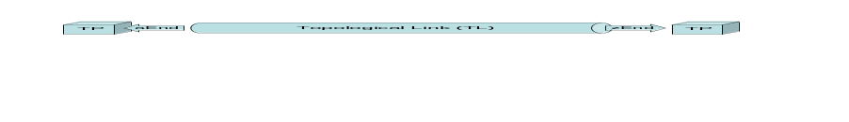
BA Requirement:
A TL object shall have, in addition to the attributes identified in R_TMF518_NRB_I_0001, the following attributes:
- …
- aEnd Termination Point (TP) - this attribute shall represent the name of the A end TP.
- zEnd Termination Point (TP) - this attribute shall represent the name of the Z end TP.
- …

IDL Implementation:
struct TopologicalLink_T
{
globaldefs::NamingAttributes_T name;
string userLabel;
string nativeEMSName;
string owner;
globaldefs::ConnectionDirection_T direction;
transmissionParameters::LayerRate_T rate;
globaldefs::NamingAttributes_T aEndTP;
globaldefs::NamingAttributes_T zEndTP;
globaldefs::NVSList_T additionalInfo;
};

XML Implementation:
<xsd:complexType name="TopologicalLink_T">

<xsd:element name="aEndTP" type="nam:NamingAttributes_T" minOccurs="0">
<xsd:annotation>
<xsd:documentation>
<p>Name of A end TP (PTP/CTP/FTP). The termination point name must be explicit (a generic endpoint
specification may not be used in this case).</p>
</xsd:documentation>
</xsd:annotation>
</xsd:element>
<xsd:element name="zEndTP" type="nam:NamingAttributes_T" minOccurs="0">
<xsd:annotation>
<xsd:documentation>
<p>Name of Z end TP (PTP/CTP/FTP). The termination point name must be explicit (a generic
endpoint specification may not be used in this case).</p>
</xsd:documentation>
</xsd:annotation>
</xsd:element>

</xsd:complexType>
<!-- ================= -->
<xsd:complexType name="NamingAttributes_T">
<xsd:annotation>
<xsd:documentation>
<p>This is the definition of the name attribute, which represents a unique identifier for the MTOSI object on
the CCV. Once set by the naming OS, the name is invariant for the life of the object and should be used
when referring to the object over the CCV. Name attribute of an object instance shall always be
assigned a value, unless the object instance is first discovered by an OS that is not the naming OS for
the object instance. In such a case, the discovering OS shall provide a value for the Discovered Name
attribute of the object. The naming OS shall provide a value for the Name attribute of the object once it
becomes aware of the new object.</p>
</xsd:documentation>
</xsd:annotation>
<xsd:sequence>
<xsd:element name="object" maxOccurs="unbounded">
<xsd:complexType>
<xsd:sequence>
<xsd:element name="type" type="gen:ObjectType_T">
<xsd:annotation>
<xsd:documentation>
<p>the object type acronym.</p>
</xsd:documentation>
</xsd:annotation>
</xsd:element>
<xsd:element name="name" type="xsd:string">
<xsd:annotation>
<xsd:documentation>
<p>the object instance name.</p>
</xsd:documentation>
</xsd:annotation>
</xsd:element>
</xsd:sequence>
</xsd:complexType>
</xsd:element>
</xsd:sequence>
</xsd:complexType>
<!-- ================= -->

IA Modelling: An object instance name (here: the name attribute of the TP class) is referenced in another object (here: the TL) by using the simple association with:
- a relationship name (here: TLIsTerminatedByAEndTPs)
- navigable in the direction to the referenced class (here: TP)
- a public role name at the referenced class side (here: + aEndTPs)
- a default value = NA
- a notificationType = ATTRIBUTE_VALUE_CHANGE or NO_NOTIFICATION
- a passedBy value = REFERENCE.

Current UML modelling:
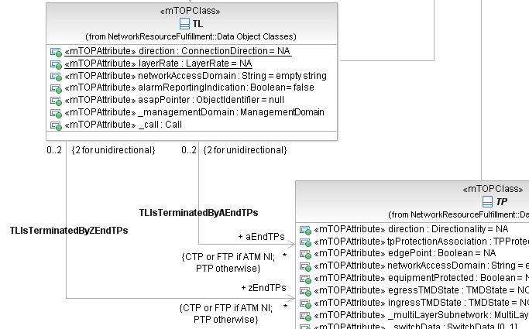
Figure 1: Unidirectional Instance Reference relationship using simple association

Question: What would be the right (according to UML 2.0 specification) IA modelling for the IDL and XML implementations?

"Attribute List" relationship
BA Requirement:
A TP object shall have, in addition to the attributes identified in R_TMF518_NRB_I_0001, the following attributes:
- …
- layered transmission parameters - this attribute shall represent the transmission parameters associated with the different layers that are encapsulated within the TP. Refer to the supporting document LayeredParameters.pdf for details of the currently defined transmission parameters.
- …

IDL Implementation:
struct TerminationPoint_T
{
globaldefs::NamingAttributes_T name;

transmissionParameters::LayeredParameterList_T transmissionParams;

};

typedef sequence<LayeredParameters_T> LayeredParameterList_T;

struct LayeredParameters_T
{
LayerRate_T layer;
globaldefs::NVSList_T transmissionParams;
};

XML Implementation:
<xsd:complexType name="PhysicalTerminationPoint_T">

<xsd:element name="transmissionParams" type="lp:LayeredParametersList_T" nillable="true" minOccurs="0">
<xsd:annotation>
<xsd:documentation>
<p>A list of transmission parameters which can be set and/or retrieved on the TP at a specified layer. This
attribute must contain the complete set of layer rates represented by a PTP - even if they have no
parameters associated with them. The layerRates are listed in the order of their client-server
relationship (see layering for more details).</p>
</xsd:documentation>
</xsd:annotation>
</xsd:element>

</xsd:complexType>
<!-- ================= -->
<xsd:complexType name="LayeredParametersList_T">
<xsd:annotation>
<xsd:documentation>
This is used in the TP definition and as a consequence is available for use in a connection specification
where a TP is specified.
</xsd:documentation>
</xsd:annotation>
<xsd:sequence>
<xsd:element name="layeredParameters" type="tns:LayeredParameters_T" minOccurs="0" maxOccurs="unbounded"/>
</xsd:sequence>
</xsd:complexType>
<!-- ============== -->
<xsd:complexType name="LayeredParameters_T">
<xsd:annotation>
<xsd:documentation>
This is a structure that includes the layer rate with the applicable list of transmissions parameters
</xsd:documentation>
</xsd:annotation>
<xsd:sequence>
<xsd:element name="layer" type="lr:LayerRate_T">
<xsd:annotation>
<xsd:documentation>
Represents the layer to which the parameters apply.
</xsd:documentation>
</xsd:annotation>
</xsd:element>
<xsd:element name="transmissionParams">
</xsd:element>
<xsd:element name="vendorExtensions" minOccurs="0">
<xsd:annotation>
<xsd:documentation>
The specific containment for vendor extensions of the list of tranmission parameters.
</xsd:documentation>
</xsd:annotation>
<xsd:complexType>
<xsd:sequence>
<xsd:any namespace="##other" processContents="lax" minOccurs="0" maxOccurs="unbounded"/>
</xsd:sequence>
</xsd:complexType>
</xsd:element>
</xsd:sequence>
</xsd:complexType>

IA Modelling:
The attribute list (i.e., the complete information) of a referenced data type (here: all attributes of the TransmissionParameters data type) can be "imported" to the referencing object (here: TP) by using the composition association with:
- a relationship name (here: TPHasTransmissionParameters)
- navigable in the direction to the referenced data type (here: TransmissionParameters)
- a public role name at the referenced data type (here: + layeredTransmissionParameters)
- a default value = NA
- a notificationType value = ATTRIBUTE_VALUE_CHANGE or NO_NOTIFICATION
- a passedBy value = VALUE.

Current UML modelling:
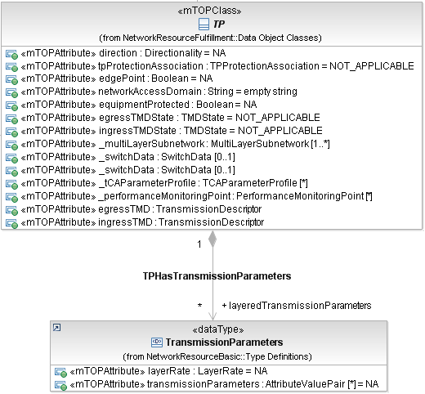
Figure 2: Attribute List relationship
In this example, sequences of the attributes contained in TransmissionParameters shall be part of the information when the TP is retrieved via the interface (e.g., attributes of TransmissionParameters shall be retrieved together with attributes of TP).

Question: What would be the right (according to UML 2.0 specification) IA modelling for the IDL and XML implementations?

