This document compares BA, IA and IIS of the Framework DDP
Top Issues:
- IIS does not have any Log events. Should we add them?
References:
BA: TMF518_FMW.doc 1719 besson
IA: not distributed
IIS SVN Logs:
- Revision: 1695 Author: jeromem Date: 12:30:01 PM, Wednesday, May 07, 2008 Message: Updated the HTML for all DDP IIS

SDs:

Conventions:
yellow marked items need discussion
turquoise marked items are obvious (from my point of view) and need to be added/changed/deleted
green marked items are postponed after MTOSI 2.0; i.e to TIP

Content:
1 High level UML diagrams 4
1.1 3 Common Object Provisioning Class Diagram 4
2 Object Classes 5
2.1 CommonObjectInfo 5
2.2 ManagementDomain 11
3 Notifications 13
3.1 CommonEventInformation 14
3.2 EventInformation 15
3.3 ObjectCreationNotification 17
3.4 ObjectDeletionNotification 18
3.5 ObjectDiscoveryNotification 19
3.6 AttributeValueChangeNotification 20
3.7 StateChangeNotification 21
3.8 FileTransferStatusNotification 22
3.9 HeartbeatNotification 25
3.10 SoftwareBackupStatusNotification 25
3.11 LogAttributeValueChangeNotification 27
3.12 LogCapacityThresholdAlarmNotification 28
3.13 LogProcessingErrorAlarmNotification 29
3.14 LogStateChangeNotification 30
3.15 EventLossClearedNotification 30
3.16 EventLossOccurredNotification 32
4 Interfaces 34
4.1 CommonObjectInfoProvisioning 34
4.2 MART Service 40
4.2.1 doProcess 42
4.2.2 getProcessState 44
4.2.3 terminateProcess 45
5 Data Types 47
5.1 SingleDoProcessRequestData 47
5.2 SingleDoProcessResponseData 51
5.3 OperationSetState 53
5.4 SingleTerminateProcessResponseData 55

Figures:
Figure 1: Common Object Class Diagram 5
Figure 2: Notifications Class Diagram 13
Figure 3: Common Object Provisioning Class Diagram 34
Figure 4: FMW MART Service Interface Diagram 41

History:
Version | Date | Description of Change
0.0.1 | 27.06.2007 | Initial version.
0.0.2 | 02.07.2007 | Updated TMF518_FMW.doc (R506) from Michel incorporated.
0.0.3 | 14.09.2007 | Updated TMF518_FMW.doc (R680) from Srini incorporated.
0.04 | 07.05.2008 | Review between IA and IIS
0.05 | 18.06.2008 | Updated based on BA Revision 1719.
0.06 | 15.01.2009 | MART service added.

High level UML diagrams

Object Classes

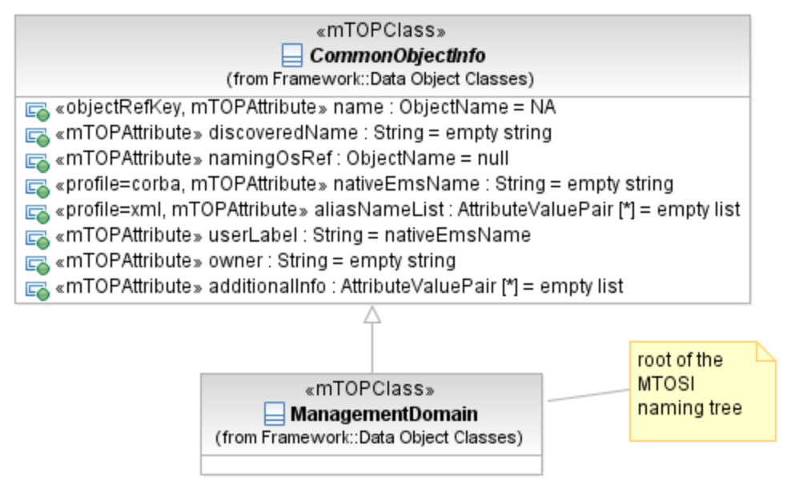
Figure 1: Common Object Class Diagram

CommonObjectInfo

BA | IA (CommonObjectInfo) | IIS (CommonObjectInfoType) | Comments
The requirements for the management of network or service resources have been specified in terms of the entities that are visible across the interface and the service requests that may be invoked across the interface. The data model detailing these entities and the associated service requests is detailed in the relevant IA DDP sections, while the BA DDP sections contain the requirements for the visible data entities and the associated service requests.  Among its functions, the Common Communications Vehicle (CCV) is used to publish new entities. In the following paragraphs, it should be noted that the OS managed entity can be used to represent an EMS, NMS or SMS. A top-level OS has direct access to the CCV. Subordinate OSs access the CCV indirectly via the top-level OS.  For each entity instance published on the CCV, there is a publishing OS and a naming OS. The publishing OS first announces the existence of the entity instance on the CCV. The naming OS stores and names the entity instance. The “name” of the entity could be the same as the “discovered name” (the name used to announce the entity) but it does not have to be.  For any particular entity, the discovering OS and the naming OS need not be the same OS. Furthermore, an entity may be stored by more than one OS. Note that the use of the word “store” is used to distinguish from the concept of “steward” (or owner).The usage of “store” in this context means that the OS has information about an entity. Multiple OSs on the CCV may store information (maybe even the same exact set of information) about the same network entity. However, it may be desirable to have a single steward for each network or service resource.  Note: An attribute is mandatory unless otherwise stated, therefore it shall always be found at the interface within relevant resources, independently from its value set (i.e., an empty value could be allowed). When an attribute is described as optional, this means that the attribute need not be present at the interface within the relevant resource.  R_TMF518_FMW_I_0001  All entities visible across the Interface shall have the following attributes: | This object class defines the common attributes for all addressable object classes.  Traceability: R_TMF518_FMW_I_0001.  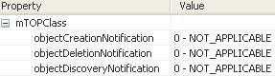 | CommonObjectInfoType  The aggregate of all common object attributes.
• name - this attribute represents a unique identifier for the entity instance on the CCV. Once set by the naming OS, the value of the name is invariant for the life of the entity and should be used when referring to the entity over the CCV. The name attribute of an entity instance shall always be assigned a value, unless the entity instance is first discovered by an OS that is not the naming OS for the entity instance. In such a case, the discovering OS shall provide a value for the Discovered Name attribute of the entity. The naming OS shall provide a value for the Name attribute of the entity once it becomes aware of the new entity instance.  R_TMF518_FMW_I_0002  Network resource names shall be unique across the name spaces of all the top-level OSs associated with a particular instance of a CCV.  R_TMF518_FMW_I_0003  Each entity on the CCV is given a unique name (represented by the value of the “name” attribute) by exactly one OS. This OS is referred to as the “naming OS” for the entity. | «objectRefKey» name : ObjectName = NA  This attribute represents a unique identifier of the object on the CCV within the context of the OS that creates the object.  For object naming see also attached supporting document SD2-7_ObjectNaming.  Traceability: R_TMF518_FMW_I_0002, R_TMF518_FMW_I_0003.  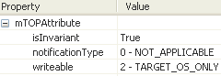 | element name="name" type="nam:NamingAttributeType"  This attribute represents a unique name/identifier for the object on the CCV. Consult the SD2-7 about object naming for additional normative references.
• discovered name - this is the name of the entity when its existence is first published on the CCV, but only in the case where the OS that publishes the entity on the CCV is not the naming OS. If the naming OS first publishes the entity on the CCV, this attribute may be left empty. The discovered name is assumed to be unique from the perspective of the publishing OS. The discovered name published on the CCV does not necessarily need to be the name of the entity as discovered by the OS from the subtending network. There are no specific rules concerning the relationship between the “name” attribute and “discovered name” attribute of the entity. They could be set to the same value or they could be different. | discoveredName : String = empty string  This attribute contains the name of the object when its existence is first published on the CCV but only in the case where the OS that publishes the object on the CCV is not the naming OS.  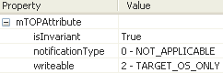 | element name="discoveredName" type="gen:DiscoveredNameType"  +++++++++++++++++  simpleType name="DiscoveredNameType"  This is the definition of the name of the object when its existence is first published on the CCV but only in the case where the OS that publishes the object on the CCV is not the naming OS. If the naming OS first publishes the object on the CCV, this attribute may be left empty.  The discovered name is assumed to be unique from the perspective of the publishing OS.  The discovered name published on the CCV does not necessarily need to be the name of the object as discovered by the OS from the subtending network..  There are no specific rules concerning the relationship between the "name" and "discovered name" of the object. They could be set to the same value or they could be different.  restriction base="xsd:string"
• namingOS - this attribute represents an identifier for the steward of the entity, intended as the OS that sets the name of the entity. The namingOS attribute is set by the OS that is responsible for setting the “name” of the entity. It is assumed that each entity (that is published on the CCV) has a unique naming OS. This attribute is optional in a point to point NML-EML paradigm. | namingOsRef : ObjectName = null  This attribute represents an identifier for the steward of the object, intended as the OS that sets the name of the object. The namingOS attribute is set by the OS that is responsible for setting the "name" of the object.  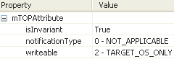 | element name="namingOsRef" type="xsd:string"  This is the object attribute definition to identify the name of the OS that provided the unique MTOSI name for the object. It is assumed that each object (that is published on the CCV) has a unique naming OS. This attribute is optional in a point to point NMS-EMS paradigm. | JM: This is a string as the OS DN has a single RDN
• aliasNameList - this attribute contains a list of aliases for the entity. The attribute is a list of name-value pairs. The name refers to the type of alias (e.g., nativeEMSname) and the value component holds the alias itself. There are a number of other names that can be applied to a network entity, such as nativeEMSname, intended as the name of the entity as presented on an EMS GUI, or the nativeNEname, intended as the name of the resource as displayed on a (possibly remote) terminal connection to an NE. Another case could be the Transport Network Assigned Address (TNA), intended as the name of an access point as represented to a client of a control planed based network. It allows users to identify UNI interfaces for call setup without the service provider exposing the internal addresses of the network. Some or all of these names may need to be associated with an MTOSI entity, in the aliasNameList. | «profile=xml» aliasNameList : AttributeValuePair [*] = empty list  This attribute contains a list of aliases for the object.  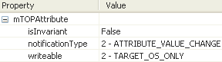 | element name="aliasNameList" type="gen:AliasNameListType"  +++++++++++++++++  complexType name="AliasNameListType"  This is the definition of the object attribute that contains the list of aliases for the network entity. The attribute is a name-value list. The name refers to the type of alias (e.g., nativeEMSname) and the value component holds the alias itself.  sequence  element name="alias"  complexType  sequence  element name="aliasName" type="xsd:string"  element name="aliasValue" type="xsd:string"
• user label - this attribute represents the “user friendly” name for the entity. The user label is filled by the naming OS. This attribute is optional. | userLabel : String = nativeEmsName  This attribute represents a provisionable, user friendly name for the object. The userLabel attribute is owned and may be set by the requesting OS or the naming OS.  The difference between the userLabel and the name is that the userLabel is an attribute of the object that may be "set" by the requesting OS or the naming OS.  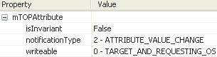 | element name="userLabel" type="gen:UserLabelType"  +++++++++++++++++  simpleType name="UserLabelType"  This is the definition of the object attribute that represents a provisionable, "user friendly" name for the object. The user label is filled by the naming OS.  restriction base="xsd:string"
• owner: this attribute represents an identifier for the owner of the entity. This attribute is optional. | owner : String = empty string  This attribute represents an identifier for the owner of the object.  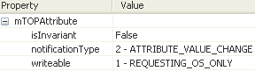 | element name="owner" type="gen:OwnerType"  +++++++++++++++++  simpleType name="OwnerType"  This is the definition of the object attribute that represents an identifier for the owner of the object.  restriction base="xsd:string"
• additionalInfo/vendorExtensions – this attributes allows vendors to further qualify and extend an entity’s characteristics. The use of this attribute is detailed in Section 3.4.3. | additionalInfo : AttributeValuePair [*] = empty list  This is a vendor specific attribute that contains additional specific information about the object. This list can be empty.  The attribute, when present, can be used to convey information from the target OS to the requesting OS, and vice versa, of additional information that isn't explicitly modelled, except that some parameter names and values may be predefined.  Any information encoded in the additionalInfo is optional: the target OS need not fill out this information and the requesting OS need not interpret this information.  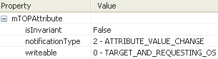 | element name="vendorExtensions" type="gen:AnyListType"  This is a container for all vendor extensions.  +++++++++++++++++  complexType name="AnyListType"  A generic list of any type of elements. Used for vendor Extensions or loose element encapsulation from other namespaces.  sequence  xsd:any namespace="##any" | .
?? | «profile=corba» nativeEmsName : String [1] = empty string  This attribute contains the native EMS Name of the object. It represents how an EMS user addresses an object on the EMS GUI. Its aim is to provide a "nomenclature bridge" for relating information presented on NMS displays and EMS displays (via GUI cut through).  The EMS may or may not support changing this value.  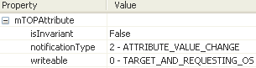 |  | JM See aliasNameList.  keep nativeEMSName for CORBA only

ManagementDomain

BA | IA (ManagementDomain) | IIS (ManagementDomainType) | Comments
R_TMF518_FMW_I_0004  One or more management domains are used to represent the managed network of a service provider in the context of a given CCV. Each network resource is contained under exactly one management domain. Each OS on the CCV may store a part or the whole inventory associated with one or more management domains. | This object class is used to represent the managed network of a service provider (i.e., a portion of a network) in the context of a given CCV. Each network resource is contained under exactly one Management Domain. Each OS on the CCV may store a part or the whole inventory associated with one or more Management Domains.  A top-level OS may manage part or all of one or more Management Domains.  Traceability: R_TMF518_FMW_I_0004, R_TMF518_FMW_I_0006.  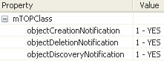 | ManagementDomainType  This aggregate defines the Management Domain mTOP network resource object attributes.  extension base="coi:CommonObjectInfoType"  This element entails the attributes common to all mTOP network resource objects.  <xsd:sequence>  </xsd:sequence>
R_TMF518_FMW_I_0005  Network Access Domain. It represents a domain to which the Management Domain resources are associated. |  |  | JM: This is in NRB  BZ: In MTOSI 1.1 the ManagementDomain has the attribute networkAccessDomain

Notifications

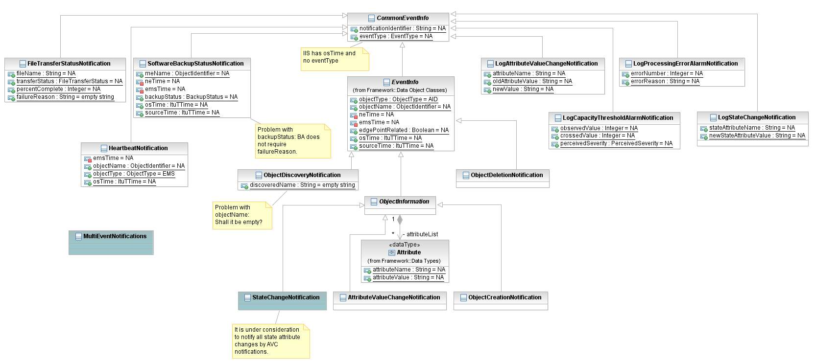
Figure 2: Notifications Class Diagram

BA (Notifications) | IA | IIS | Comments
R_TMF518_FMW_I_0009
The Interface shall support a reliable mechanism for an OS to distribute notifications.

CommonEventInformation

BA | IA (CommonEventInformation) | IIS (CommonEventInformationType) | Comments
R_TMF518_FMW_I_0010  All event notifications shall have the following attributes: | CommonEventInformation  This object class represents the information common to all event Notifications.  Traceability: R_TMF518_FMW_I_0010.  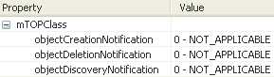 | CommonEventInformationType  The type definition of the common set of attributes used for all events. | JM: We should not define the EventType as an enumeration.  The same for the ObjectType. Those two should be based on string (open)  All event and object types are not known in Framework
• Identifier – this attribute shall represent an identifier for the event. The value of this identifier is not guaranteed to be unique. | notificationId : String = NA  This attribute contains the identifier of the Event Notification. The uniqueness and the sequence of the Notification Identifier are not guaranteed.  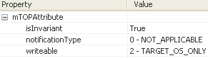 | element name=" notificationId" type="gen:NotificationIdentifierType"  The uniqueness and the sequence of the notificationId are not guaranteed.
• Source Time – this attribute shall represent the time at which the event occurred at its source. | sourceTime : ItuTTime = NA  This attribute represents the time at which the event occurred at its source (typically the network element).  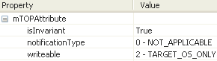 | element name="sourceTime" type="xsd:dateTime"  The time at which the event was reported by the source system (NE, EMS or OS).
additionalInfo/vendorExtensions | additionalInfo : AttributeValuePair [*] = empty list  This attribute is a vendor specific attribute that is used by the OS supplier to append additional parameters to the Event Notification.  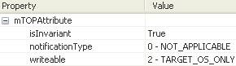 | element name="vendorExtensions" type="gen:AnyListType"  Containment for all vendor extensions.

EventInformation

BA | IA (EventInformation) | IIS (EventInformationType) | Comments
R_TMF518_FMW_I_0011  In addition to those attributes identified in R_TMF518_FMW_I_0010 a number of notifications may also have the following attributes: | EventInformation  This object class represents the information common to a number of Event Notifications. Environmental Alarms are to be mapped to its containing object (i.e. parent). Additional information can be specified to provide further details of the Environmental Alarm.  Traceability: R_TMF518_FMW_I_0011.  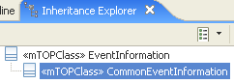  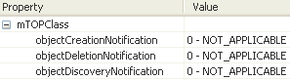 | EventInformationType extends from CommonEventInformationType  The type definition of the event information set of attributes.
• Object Name – this attribute shall represent the name of the entity against which the event notification is generated | objectName : ObjectName = NA  This attribute represents the name of the object against which the event notification is generated.  Note that this attribute is not applicable for Protection Switch Notifications.  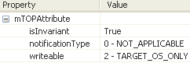 | - objectName (NamingAttributeType)  Identifies the name of the object associated with the event.
• Object Type – this attribute shall represent the type of the entity against which the event notification is generated | objectType : String = NA  This attribute identifies the type of the object associated with the event. The attribute is needed to allow simple notification filtering based on the object type.  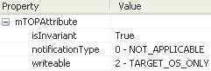 | - objectType (xsd:string)  Identifies the type of the object associated with the event. This attribute is needed to allow simple notification filtering based on the object type.
• OS Time – this attribute shall represent the time at which the event occurred at the notifying OS. | osTime : ItuTTime = NA  This attribute represents the time at which the event occurred at the reporting OS.  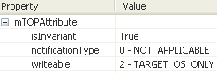 | - osTime (xsd:dateTime)  The time at which the event was reported by the OS (EMS).

ObjectCreationNotification

BA | IA (ObjectCreationNotification) | IIS (ObjectCreationType) | Comments
R_TMF518_FMW_I_0012  An Object Creation Notification is an event used across the Interface to indicate that an object has been created. | ObjectCreationNotification  This notification provides the complete details of an object which has been created.  Traceability: R_TMF518_FMW_I_0012.  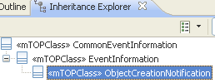  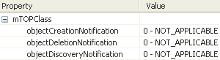 | complexType name="Object CreationType" abstract="true"  The abstract type definition of the ObjectCreation event. The resource (NRB) or service (SB) event instances shall be used.  ObjectCreationType extends from EventInformationType | JM: inherit from EventInformationType
?? | object (????) | object (gen:AnyListType)  This definition allows for the full XML object to be inserted here.

ObjectDeletionNotification

BA | IA (ObjectDeletionNotification) | IIS (ObjectDeletionType) | Comments
R_TMF518_FMW_I_0012  An Object Deletion Notification is an event used across the Interface to indicate that an object has been deleted. | ObjectDeletionNotification  This notification provides information on an object which has been deleted.  Traceability: R_TMF518_FMW_I_0012.  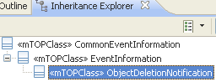  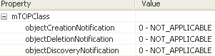 | complexType name="ObjectDeletionType" abstract="true"  The type definition of the ObjectDeletion event. The resource (NRB) or service (SB) event instances shall be used.  ObjectDeletionType extends from EventInformationType | JM: Same as ObjectCreation

ObjectDiscoveryNotification

BA | IA (ObjectDiscoveryNotification) | IIS (ObjectDiscoveryType) | Comments
R_TMF518_FMW_I_0012  An Object Discovery Notification is an event used across the interface to indicate that an object has been discovered (but not yet named). | ObjectDiscoveryNotification  An Object Discovery Notification (ODscN) is an event used to indicate that an object has been discovered but not yet named by the naming OS, in case the discovery and naming OS are different OSs.  Traceability: R_TMF518_FMW_I_0012.  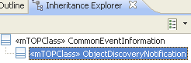  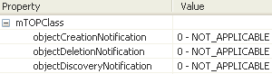 | complexType name="ObjectDiscoveryType" abstract="true"  The type definition of the ObjectDiscovery event. The resource (NRB) or service (SB) event instances shall be used.  ObjectDiscoveryT extends from CommonEventInfoType | BZ: BA not in line with ObjectDiscoveryNotification defined in MTOSI R1.1.
 | discoveredName : String = empty string  This attribute serves as an identifier for the object against which the event notification is generated. The naming OS for this object will in due course provide a unique name for this object. | element name="discoveredName" type="gen:DiscoveredNameType"  Identifies the name of the object associated with the event.
element name="osTime" type="xsd:dateTime"
The time at which the event was reported by the OS (EMS).

AttributeValueChangeNotification

BA | IA (AttributeValueChangeNotification) | IIS (AttributeValueChangeType) | Comments
R_TMF518_FMW_I_0012  An Attribute Value Change (AVC) Notification is an event used across the Interface to indicate that one or more of the attribute values of an object have changed. | AttributeValueChangeNotification  This notification provides the new value of an attribute that has been changed.  Traceability: R_TMF518_FMW_I_0012.  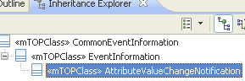  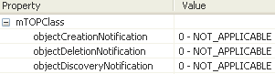 | complexType name="AttributeValueChangeType" abstract="true"  AttributeValueChangeType extends from EventInformationType  The type definition of the AttributeValueChange event. The resource (NRB) or service (SB) event instances shall be used.
?? | attributeList : AttributeValuePair [*] = empty list  This attribute lists all attributes (names and their new values) of the object which changed its value.  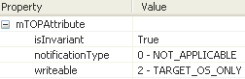 | attributeList (sequence ##any)  This container encapsulates the object element populated with the attributes which value changed.  Refer to the SD2-14_AVC_SC_Notifications.doc for a description of all object attributes supported by the AVC event

StateChangeNotification

BA | IA (StateChangeNotification) | IIS (StateChangeType) | Comments
R_TMF518_FMW_I_0012  A State Change Notification is an event used across the Interface to indicate that a state transition has occurred. | StateChangeNotification  inherited from CommonEventInfo  inherited from EventInfo  inherited from ObjectInformation  This notification provides the new value of a state attribute that has been changed.  Object Lifecycle: Created by the reporting OS  Object Creation Notification Issued? NA  Object Deletion Notification Issued? NA | stateChange (tns:StateChangeypeT)  substitutionGroup="cei:commonEventInfo"  The element definition of the StateChange event.  +++++++++++++++++++++++++++++++++++  StateChangeType extends from EventInformationType  The type definition of the StateChange event. | BZ: It is under consideration to notify all state attribute changes by AVC notifications.
attributeList (cei:AnyListType)
This container only encapsulates the new values of the state attributes that have changed for the specified object. Each top-level children of this container shall match the state attribute schema of the designated object.

FileTransferStatusNotification

BA | IA (FileTransferStatusNotification) | IIS (FileTransferStatusType) | Comments
R_TMF518_FMW_I_0012  A File Transfer Status Notification is an event used across the Interface to indicate the status of file transfer. | FileTransferStatusNotification  This event holds details of PM historical PM data file being transferred including transfer status, percent complete and failure reason.  The number of events indicating InProgress that will be transferred is target OS dependent, however, at least one event indicating Completed with percentComplete = 100, or Failed with failureReason filled in is mandatory.  Traceability: R_TMF518_FMW_I_0012.  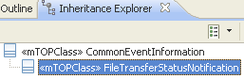  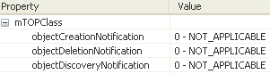 | name="fileTransferStatus" type="tns:FileTransferStatusType" substitutionGroup="cei:commonEventInformation"  The element definition of the file transfer status event.  +++++++++++++++++++++++++++++++++++  FileTransferStatusType extends from CommonEventInformationType  The type definition of the file transfer status event. | BZ: osTime is in IIS but not required by BA.
?? | fileName : String = NA  This attribute represents the name of the file being transferred (this shall include the path name).  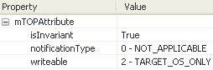 | element name="fileName" type="xsd:string"  Name of the file being transferred (this will include the path name) as provided in the file Location URI input parameter of a bulk retrieval operation.
?? | transferStatus : FileTransferStatus = NA  This attribute represents the current state of the transfer (in progress, failed or completed).  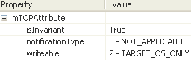  +++++++++++++++++++++++++++++++++++  FileTransferStatus  COMPLETED  FAILED  IN_PROGRESS | element name="transferStatus" type="tns:FileTransferStatusEnumType"  Indicates the file transfer status.  +++++++++++++++++++++++++++++++++++  FileTransferStatusEnumType (xsd:string)  Describe the transfer status type. This is used for file transfer protocol notifications.  xsd:enumeration value=FT_IN_PROGRESS  xsd:enumeration value=FT_FAILED"  xsd:enumeration value=FT_COMPLETED
?? | percentComplete : Integer = NA  This attribute indicates the percent complete of the file transfer. It must be in the range 0...100. Only applies if transferStatus is InProgress or Completed.  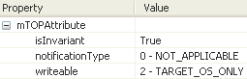 | element name="percentComplete" type="xsd:unsignedInt"  Indicates percent of file transfer complete must be in the range 0..100. Only applies if transferStatus is FT_IN_PROGRESS or FT_COMPLETED. This field is optional otherwise.
?? | failureReason : String = empty string  This attribute represents, in the event of a failure, the reason for the failure. Only applies if transferStatus is Failed.  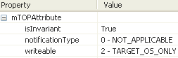 | element name="failureReason" type="xsd:string"  This string will contain the failure reason. Only applies if transferStatus is FT_FAILED.  This field is optional otherwise.

HeartbeatNotification

BA | IA (HeartbeatNotification) | IIS (HeartbeatType) | Comments
R_TMF518_FMW_I_0012  A Heartbeat Notification is an event used across the Interface to indicate the state of the notification delivery mechanism between the sending and receiving OSs. | HeartbeatNotification  This Notification is used to indicate the state of the notification delivery mechanism between the sending and receiving OSs.  The sending OS shall send out heartbeat notifications to the receiving OS on a regular basis so that the receiving OS can conclude that it is out of sync (regarding events) if it doesn't receive any heartbeat notifications for some time.  Traceability: R_TMF518_FMW_I_0012.  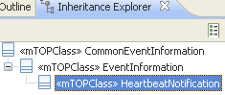  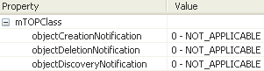 | element name="heartbeat" type="tns:HeartbeatType" substitutionGroup="cei:commonEventInformation"  The element definition of the heartbeat event.  +++++++++++++++++++++++++++++++++++  HeartbeatType extends from EventInformationType  The type definition of the heartbeat event.
 | emsTime = NA

SoftwareBackupStatusNotification

BA | IA (SoftwareBackupStatusNotification) | IIS (SoftwareBackupStatusType) | Comments
R_TMF518_FMW_I_0012  A Software Backup Status Notification is an event used across the Interface to indicate that status of the backup of Managed Element (ME) data. | SoftwareBackupStatusNotification  inherited from CommonEventInfo  This notification indicates the status of the backup of Managed Element (ME) data.  Note: The operation backupME defined in the SoftwareManager object class is an asynchronous operation.??  Object Lifecycle: Created by the reporting OS  Object Creation Notification Issued? NA  Object Deletion Notification Issued? NA  meName : ObjectIdentifier = NA  This attribute represents the name of the Managed Element for which the backup status is reported.  neTime  emsTime  backupStatus : BackupStatus = NA  This attribute represents the current status of the software backup transfer (idle. in progress, completed, aborted or failed) of the Managed Element.  osTime : ItuTTime = NA  This attribute represents the time at which the event occurred at the reporting OperationsSystem.  sourceTime : ItuTTime = NA  This attribute represents the time at which the event occurred at the source (typically the NetworkElement).  ??Issues: This is suggested generalization to “NE time”.  Further, note that TMF854 uses osTime and neTime, and that TMF513 uses, EMS Timestamp and NE Timestamp. |  | This is event is in ResourceProvisioning DDP as it is specific to the SoftwareAndBackup service interface

LogAttributeValueChangeNotification

BA | IA (LogAttributeValueChangeNotification) | IIS (LogAttributeValueChangeType) | Comments
R_TMF518_FMW_I_0013  The Log functionality support implies the following notification types definitions:  Log Attribute Value Change Notification | LogAttributeValueChangeNotification  inherited from CommonEventInfo  This notification is a special type of Attribute Value Change Notification used to indicate that the following Log attributes have changed:  - capacity alarm threshold  - log full action  - maximum log size  - start time  - stop time  - week mask  - changing the discrimnator constraint  - max record life.  Object Lifecycle: Created by the reporting OS  Object Creation Notification Issued? NA  Object Deletion Notification Issued? NA | ??
attributeName : String = NA
The attribute indicates the name of attribute being changed.

oldAttributeValue : String = NA
This attribute contains the old attribute value.

newValue : String = NA
This attribute contains the new attribute value.

LogCapacityThresholdAlarmNotification

BA | IA (LogCapacityThresholdAlarmNotification) | IIS (LogCapacityThresholdAlarmType) | Comments
R_TMF518_FMW_I_0013  The Log functionality support implies the following notification types definitions:  Log Capacity Threshold Alarm Notification | LogCapacityThresholdAlarmNotification  inherited from CommonEventInfo  This notification is a special type of Threshold Crossing Alert (TCA) Notification used to indicate that the Log capacity alarm threshold attribute has been crossed.  Object Lifecycle: Created by the reporting OS  Object Creation Notification Issued? NA  Object Deletion Notification Issued? NA | ??
observedValue : Integer = NA
This attribute represents the current Log size, as a percentage of the maximum Log size.

crossedValue : Integer = NA
This attribute represents the threshold level that has been crossed.

perceivedSeverity : PerceivedSeverity = NA
This attribute represents the severity of the alarm. The perceived severity is minor if the Log is not full and critical otherwise.

LogProcessingErrorAlarmNotification

BA | IA (LogProcessingErrorAlarmNotification) | IIS (LogProcessingErrorAlarmType) | Comments
R_TMF518_FMW_I_0013  The Log functionality support implies the following notification types definitions:  Log Processing Error Alarm Notification | LogProcessingErrorAlarmNotification  inherited from CommonEventInfo  This notification is a special type of Alarm Notification used to indicate that a processing error has occurred (associated with the Log functionality).  Object Lifecycle: Created by the reporting OS  Object Creation Notification Issued? NA  Object Deletion Notification Issued? NA | ??
errorNumber : Integer = NA
This attribute represents the error number associated with the problem.

errorReason : String = NA
This attribute represents a textual description of the problem.

LogStateChangeNotification

BA | IA (LogStateChangeNotification) | IIS (LogStateChangeType) | Comments
R_TMF518_FMW_I_0013  The Log functionality support implies the following notification types definitions:  Log State Change Notification. | LogStateChangeNotification  inherited from CommonEventInfo  This notification is a special type of State Change Notification used to indicate a change in the state of the Log.  Object Lifecycle: Created by the reporting OS  Object Creation Notification Issued? NA  Object Deletion Notification Issued? NA | ??
stateAttributeName : String = NA
This attribute represents the name of the state attribute that has changed its value.

newStateAttributeValue : String = NA
This attribute represents the new state attribute value.

EventLossClearedNotification

BA | IA (EventLossCleared Operation) | IIS (EventLossClearedType) | Comments
?? | NmsSession: operation eventLossCleared  The EMS invokes this operation to indicate that the event or alarm loss period is over, and that it is now capable of providing relevant notifications.  After invoking this operation on the NmsSession instances, the EMS clears the internal flag set by alarmLossOccured() or/and eventLossOccurred. If event or alarm loss occurs again, alarmLossOccurred() or eventLossOccurred() will be called.  How and when the EMS decides to invoke eventLossCleared() is an EMS implementation detail. The actual algorithm that the EMS uses may be as simple as a timer-based mechanism or a complicated one which monitors the current rate at which the EMS pushes events.  Operation Exceptions: None  Traceability: R_TMF518_FMW_I_00xx. | element name="eventLossCleared" type="tns:EventLossClearedType" substitutionGroup="cei:commonEventInformation"  The element definition of the EventLossCleared event.  +++++++++++++++++++++++++++++++++++  complexType name="EventLossClearedType"  The type definition of the EventLossCleared event.  extension base="cei:CommonEventInformationType"
 | ?? | name="objectType" type="gen:ObjectTypeType"  Identifies the type of the object associated with the event. This attribute is needed to allow simple notification filtering based on the object type.
 | ?? | element name="objectName" type="nam:NamingAttributeType"  Identifies the name of the object associated with the event.
 | (in) endTime (ItuTTime) = NA  This parameter contains the time of the end of the event loss period, as determined by the EMS. | element name="endTime" type="xsd:dateTime"  The time of the end of the event loss period, as determined by the notification producer OS.

EventLossOccurredNotification

BA | IA (EventLossOccurred Operation) | IIS (EventLossOccurredType) | Comments
?? | NmsSession: operation eventLossOccurred  When an EMS fails to push an event, it can notify all connected NMSs by invoking this method on every active NmsSession instance. This method should also be invoked on any new NmsSession instance set up during the event loss period.  Once the EMS invokes this method on the NmsSession instances, it sets an internal flag to indicate that it has already informed NMSes of event loss. As long as this flag is set, the EMS will not invoke this method again.  When this method is invoked on a NmsSession instance, the NMS comes to know that the EMS has failed to push one or more events that may be of interest to it. The NMS should consider itself to be potentially out-of-sync with the EMS. It should wait until the EMS calls eventLossCleared() before resynchronizing with the EMS.  Operation Exceptions: None  Traceability: R_TMF518_FMW_I_00xx. | element name="eventLossOccured" type="tns:EventLossOccuredType" substitutionGroup="cei:commonEventInformation"  The element definition of the EventLossOccured event.  +++++++++++++++++++++++++++++++++++  complexType name="EventLossOccuredType"  The type definition of the EventLossOccured event.  extension base="cei:CommonEventInformationType"
 | ?? | element name="objectType" type="gen:ObjectTypeType"  Identifies the type of the object associated with the event. This attribute is needed to allow simple notification filtering based on the object type.
 | ?? | element name="objectName" type="nam:NamingAttributeType"  Identifies the name of the object associated with the event.
 | (in) startTime (ItuTTime) = NA  This parameter contains the time of the first Notification lost. | element name="startTime" type="xsd:dateTime"  The time of the first notification lost.
 | (in) notificationId (String) = NA  This parameter contains the Notification Identifier of the first Notification lost. | element name="firstEventLostNotificationId" type="gen:NotificationIdentifierType"  The notificationId of the first notification lost.

Interfaces

CommonObjectInfoProvisioning

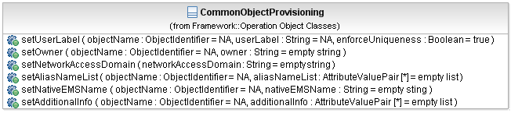
Figure 3: Common Object Provisioning Class Diagram

BA (CommonObjectInfoProvisioning) | IA | IIS | Comments
?? | CommonObjectProvisioning:setAliasNameList  This operation sets the alias names of the specified object.  As an input only the alias names to be changed, removed, or added shall be provided. If a name is to be removed, "-" shall be specified as a value. If a name is specified that is currently not part of the aliasNameList attribute of the object, the name is added by the target OS with the specified value.  The output contains all current alias names.  [in] objectName : ObjectIdentifier = NA  This parameter identifies the name of the object whose alias names have to be changed.  [inout] aliasNameList : AttributeValuePair [*] = empty list  The input parameter contains the list of alias names to be changed, added, or removed.  The output parameter contains all current alias names.  Operation Exceptions:  1. NOT_IMPLEMENTED - Raised when the target OS does not support this operation.  2. INTERNAL_ERROR - Raised in case of non-specific target OS internal failure.  3. INVALID_INPUT - Raised when the operation contains an input parameter that is syntactically incorrect or identifies an object of the wrong type or is out of range.  4. ENTITY_NOT_FOUND - Raised when objectName references an object that does not exist.  5. UNABLE_TO_COMPLY - Raised when the alias names can not be set for the specified object.  6. NE_COMM_LOSS - Raised when communication to managed element is lost. | setAliasNames
?? | CommonObjectProvisioning:setUserLabel  This operation sets the user label of an object.  Once an object is created, the userLabel may only be changed by a requesting OS through this operation.  [in] enforceUniqueness : Boolean = true  This parameter specifies whether or not the userLabel should be checked for uniqueness amongst objects of the same class within the target OS.  If true, then the operation will fail if provided userLabel is already in use.  [in] objectName : ObjectIdentifier = NA  This parameter identifies the name of the object whose userLabel has to be changed.  [in] userLabel : String = NA  This parameter identifies the new userLabel of the object.  Operation Exceptions:  1. NOT_IMPLEMENTED - Raised when the target OS does not support this operation.  2. INTERNAL_ERROR - Raised in case of non-specific target OS internal failure.  3. INVALID_INPUT - Raised when the operation contains an input parameter that is syntactically incorrect or identifies an object of the wrong type or is out of range.  4. ENTITY_NOT_FOUND - Raised when objectName references object which does not exist.  5. USERLABEL_IN_USE - Raised when the userLabel uniqueness constraint is not met.  6. UNABLE_TO_COMPLY - Raised when the userLabel can not be set for the specified object.  7. NE_COMM_LOSS - Raised when communication to managed element is lost. | setUserLabel
?? | CommonObjectProvisioning:setOwner  This operation sets the owner attribute of the specified object.  [in] objectName : ObjectIdentifier = NA  This parameter identifies the name of the object whose owner has to be changed.  [in] owner : String = empty string  This parameter identifies the new owner of the object.  Operation Exceptions:  1. NOT_IMPLEMENTED - Raised when the target OS does not support this operation.  2. INTERNAL_ERROR - Raised in case of non-specific target OS internal failure.  3. INVALID_INPUT - Raised when the operation contains an input parameter that is syntactically incorrect or identifies an object of the wrong type or is out of range.  4. ENTITY_NOT_FOUND - Raised when objectName references an object that does not exist.  5. UNABLE_TO_COMPLY - Raised when the owner can not be set for the specified object.  6. NE_COMM_LOSS - Raised when communication to managed element is lost. | setOwner
?? | CommonObjectProvisioning:  setNetworkAccessDomain  The operation allows the requesting OS to change the association of the resource (which contains a networkAccessDomain attribute) to a Network Access Domain.  [in] networkAccessDomain : String = empty string  This parameter identifies the new Network Access Domain name.  Operation Exceptions:  1. NOT_IMPLEMENTED - Raised when the target OS does not support this operation.  2. INTERNAL_ERROR - Raised in case of non-specific target OS internal failure.  3. UNABLE_TO_COMPLY - Raised when the network Access Domain attribute is not present in the object.  4. NE_COMM_LOSS - Raised when communication to the managed element is lost. | setNetworkAccessDomain
?? | CommonObjectProvisioning:setNativeEMSName  The nativeEMSName is owned by the EMS. It represents how an EMS user addresses an object on the EMS GUI. The EMS may or may not support changing this value.  When an object is created by the EMS, the EMS selects the nativeEMSName for the object.  When an object is created by an NMS, the NMS specifies the userLabel for the object. If the EMS supports setting of nativeEMSNames, the nativeEMSName should be set to the same value as the userLabel. If the EMS does not support setting of nativeEMSNames, or if the nativeEMSName has constraints that the userLabel does not satisfy, the EMS selects the nativeEMSName for the object.  After an object has been created, the nativeEMSName may be changed by the NMS, if the EMS supports this functionality, using the setNativeEMSName operation.  If there has been a change in the native EMS name, then the EMS forwards an AVC notification.  [in] nativeEMSName : String = empty sting  This parameter identifies the new nativeEMSName of the object.  [in] objectName : ObjectIdentifier = NA  This parameter identifies the name of the object whose nativeEMSName has to be changed.  Operation Exceptions:  1. NOT_IMPLEMENTED - If EMS does not support this operation.  2. INTERNAL_ERROR - Raised in case of non-specific EMS internal failure.  3. INVALID_INPUT - Raised when objectName is incorrectly formed.  4. ENTITY_NOT_FOUND - Raised when objectName references an object which does not exist.  5. UNABLE_TO_COMPLY - Raised when the nativeEMSName can not be set for the specified object.  6. NE_COMM_LOSS - Raised when communication to managed element is lost. | ??
?? | CommonObjectProvisioning:setAdditionalInfo  This operation sets the additional info attribute of the object (i.e. resource).  As an input only the list of parameters to be changed, removed, or added shall be provided. If an entry is to be removed, "-" shall be specified as a value. If a parameter is specified that is currently not part of the additionalInfo attribute of the resource that parameter is added by the target OS with the specified value.  The operation is best effort.  The output specifies the values which were actually set.  [in] objectName : ObjectIdentifier = NA  This parameter identifies the name of the object whose additional info attribute has to be changed.  [inout] additionalInfo : AttributeValuePair [*] = empty list  The input parameter contains the list of parameters to be changed, added, or removed.  The output parameter contains the actually updated, changed or added parameters.  Operation Exceptions:  1. NOT_IMPLEMENTED - Raised when the target OS does not support this operation.  2. INTERNAL_ERROR - Raised in case of non-specific target OS internal failure.  3. INVALID_INPUT - Raised when input parameter are syntactical incorrect and raised when a parameter is identified as only "settable" using a "specific operation"; i.e. the whole list of parameters will be rejected if one of the parameters indicates that it should be set via a specific operation other than setAdditionalInfo.  4. ENTITY_NOT_FOUND - Raised when objectName references an object that does not exist.  5. UNABLE_TO_COMPLY - Raised when the target OS is unable to execute the request because at least one of the parameters although valid can not be set and that parameter is identified as "not best effort"; i.e. the whole list of parameters will be rejected if one fails that must be set. This is potentially usable for cases where two parameters interact and must both be set at once for the operation to be valid.  6. NE_COMM_LOSS - Raised when communication to the ME is lost.

MART Service

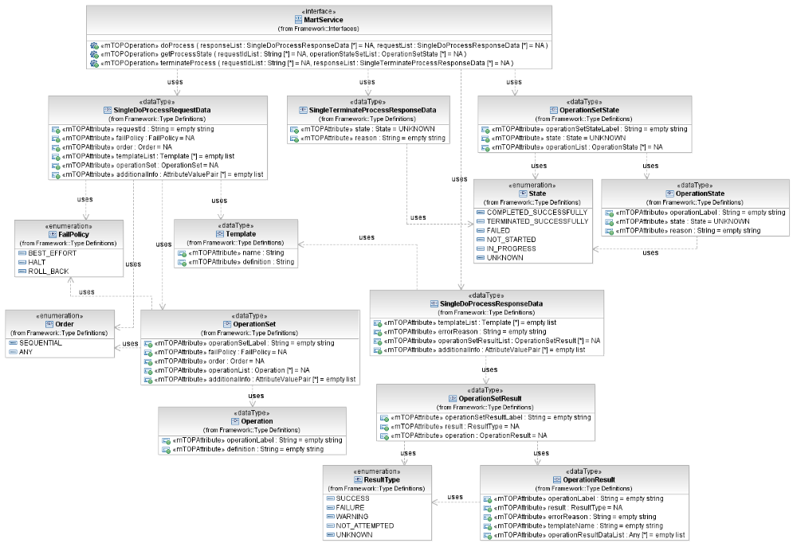
Figure 4: FMW MART Service Interface Diagram

doProcess

BA | IA (doProcess) | IIS | Comments
R_TMF518_FMW_II_0028  The Interface shall support a message exchange pattern (ref to SD2-5) that shall allow for a MART request to take several hours to complete.  The maximum time allowed for any single MART request shall be 24 hours.  R_TMF518_FMW_II_0030  The Interface shall support a message based request and response message exchange pattern (ref to SD2-5). | This operation sends bulk operations to a target OS.  Traceability: R_TMF518_FMW_II_0028, R_TMF518_FMW_II_0030, UC_TMF518_FMW_0005. | This operation allows the Client OS to send bulk operations to a Target OS.
?? | (in) requestList (*) (SingleDoProcessRequestData)  This parameter contains the request message structure of the doProcess compound operation.  Traceability: R_TMF518_FMW_II_00??.  +++++++++++++++++  see SingleDoProcessRequestData Type in section 5.1 | (in) <xsd:complexType>  <xsd:sequence>  element name="requestId" type="xsd:string"  <!-- requestId is used to further query the process state of a request -->  element name="failPolicy" type="tns:FailPolicyType"  element name="order" type="tns:OrderType"  element name="templateList" type="tns:TemplateListType"  element name="operationSet" type="tns:OperationSetType"  element name="vendorExtensions" type="gen:AnyListType"  </xsd:sequence>  </xsd:complexType>
R_TMF518_FMW_II_0025  The Interface shall allow a server OS that receives a MART request from a client OS to report the results of each operation within a MART response to the client OS.  The client will be informed of the outcome of each individual contained operation within a MART request.  R_TMF518_FMW_II_0029  The Interface shall support the out of band (e.g. file transfer) message exchange pattern (ref to SD2-5). | (out) responseList (*) (SingleDoProcessResponseData)  This parameter contains the response message structure of the doProcess compound operation.  Traceability: R_TMF518_RP_II_0091.  +++++++++++++++++  see SingleDoProcessResponseData Type in section 5.2 | (out) <xsd:complexType>  <xsd:sequence>  element name="errorReason" type="xsd:string"  element name="templateList" type="tns:TemplateListType"  element name="operationSetResult" type="tns:OperationSetResultType"  element name="vendorExtensions" type="gen:AnyListType"  </xsd:sequence>  </xsd:complexType>
UC_TMF518_FMW_0005  Pre-Conditions:  Both OSs have successfully executed UC_TMF518_FMW_0002 | None
UC_TMF518_FMW_0005  Post-Conditions:  The client OS knows the outcome of each operation. | ??
UC_TMF518_FMW_0005  Exceptions:  See Table 4 1. | 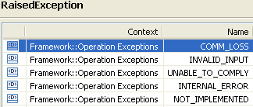 | restriction base="msg:AllExceptionsType"  element ref="msg:commLoss"  element ref="msg:internalError"  element ref="msg:invalidInput"  element ref="msg:notImplemented"  element ref="msg:unableToComply"

getProcessState

BA | IA (getProcessState) | IIS | Comments
R_TMF518_FMW_II_0026  The Interface shall allow uniquely identifying and referring to a MART request.  The Interface shall allow a client OS to query a server OS for the current status of a request. | This operation returns the current status of a list of provided processes.  Traceability: R_TMF518_FMW_II_0026, UC_TMF518_FMW_0007. | This operation allows the Client OS to query a server OS for the current status of a request. | bz:  One or more requests?
 | (in) requestIdList (*) (string)  This parameter provides the identifiers of the processes whose states are requested. | (in)  <xsd:sequence>  element name="requestId" type="xsd:string"  </xsd:sequence>
 | (out) operationStateSetList (*) (OperationSetState)  This parameter returns the current states of the processes.  +++++++++++++++++  see OperationSetState Type in section 5.3 | (out)  <xsd:sequence>  element name="operationStateSet" type="tns:OperationSetStateType"  </xsd:sequence>  +++++++++++++++++  see OperationSetStateType Type in section 5.3
UC_TMF518_FMW_0007  Pre-Conditions:  The client OS has one or more MART requests which have been accepted by the server OS. The requests have not completed in the requested timeframe. | The client OS has one or more MART requests which have been accepted by the server OS. The requests have not completed in the requested timeframe.
UC_TMF518_FMW_0007  Post-Conditions:  The Cclient OS knows the state of progress at the time of requesting. | No changes in the system.
UC_TMF518_FMW_0007  Exceptions:  See Table 4 1. | 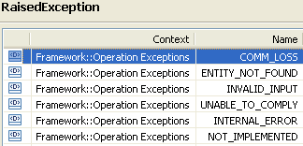 | restriction base="msg:AllExceptionsType"  element ref="msg:commLoss"  element ref="msg:internalError"  element ref="msg:invalidInput"  element ref="msg:notImplemented"  element ref="msg:unableToComply"  element ref="msg:entityNotFound"

terminateProcess

BA | IA (terminateProcess) | IIS | Comments
R_TMF518_FMW_II_0027  The Interface shall support the ability to allow an OS to request that an outstanding MART operation be terminated. The resulting situation could be separately retrieved. | This operation terminates bulk operations under processing at a target OS.  Traceability: R_TMF518_FMW_II_0027, UC_TMF518_FMW_0008. | This operation allows the Client OS to terminate bulk operations under processiing at a Target OS.
 | (in) requestIdList (*) (string)  This parameter provides the identifiers of the processes that shall be terminated. | (in)  <xsd:sequence>  element name="requestId" type="xsd:string"  </xsd:sequence>
 | (out) responseList (*) (SingleTerminateProcessResponseData)  This parameter returns the state and an optional reason of the MART terminate request.  +++++++++++++++++  see SingleTerminateProcessResponseData Type in section 5.4 | (out)  <xsd:sequence>  element name="state" type="tns:StateType"  element name="reason" type="xsd:string"  </xsd:sequence> | bz:  It seems that the structure is not in line with the description in the Use Case:  "The server OS returns the state of the MART terminate request as known at the time of terminating. …"
UC_TMF518_FMW_0008  Pre-Conditions:  The client OS has one or more MART requests which have been accepted by the server OS. The requests have not completed and the time out has not yet been reached. | The client OS has one or more MART requests which have been accepted by the server OS. The requests have not completed and the time out has not yet been reached.
UC_TMF518_FMW_0008  Post-Conditions:  Even if some, all or none of the operations have been completed, the Server OS is no longer processing the MART request. | Even if some, all or none of the operations have been completed, the Server OS is no longer processing the MART request.
UC_TMF518_FMW_0008  Exceptions:  See Table 4 1. | 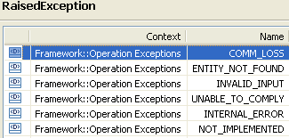 | restriction base="msg:AllExceptionsType"  element ref="msg:commLoss"  element ref="msg:internalError"  element ref="msg:invalidInput"  element ref="msg:notImplemented"  element ref="msg:unableToComply"  element ref="msg:entityNotFound"

Data Types

SingleDoProcessRequestData

BA | IA (SingleDoProcessRequestData) | IIS | Comments
?? | This data type contains a single response structure of the compound doProcess operation.  Traceability: R_TMF518_FMW_II_00??.  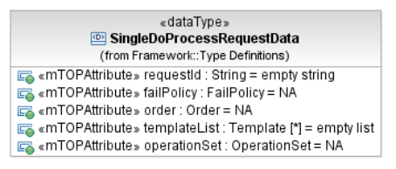 | (in) <xsd:complexType>  <xsd:sequence>  …  </xsd:sequence>  </xsd:complexType>
 | requestId (String)  This attribute contains the identifier of the process whose state is requested. | element name="requestId" type="xsd:string"  <!-- requestId is used to further query the process state of a request -->
R_TMF518_FMW_II_0032  The Interface shall allow in a MART request to let the client define the failure behavior (halt, rollback or continue) for each operation and sets of operations. | failPolicy (FailPolicy)  This attribute contains the failure behaviour for the operation.  Traceability: R_TMF518_FMW_II_0032.  +++++++++++++++++  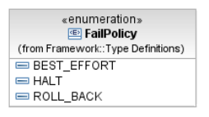 | element name="failPolicy" type="tns:FailPolicyType"  +++++++++++++++++  name="FailPolicyType"  enumeration value="BEST_EFFORT"  enumeration value="HALT"  enumeration value="ROLL_BACK"
R_TMF518_FMW_II_0031  The Interface shall allow in a MART request to let the client define the execution order of subsets of operations. This may be execution sequential in a specified order or delegate order and concurrency decisions to the server. | order (Order)  This attribute contains the execution order of subsets of the operation.  Traceability: R_TMF518_FMW_II_0031.  +++++++++++++++++  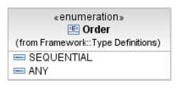 | element name="order" type="tns:OrderType"  +++++++++++++++++  name="OrderType"  enumeration value="SEQUENTIAL"  enumeration value="ANY"
 | templateList (*) (Template)  This attribute …  +++++++++++++++++  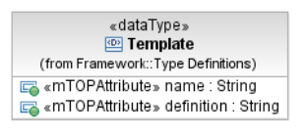  Templates have the same structure as the operations for which they are templates. | element name="templateList" type="tns:TemplateListType"  +++++++++++++++++  xsd:complexType name="TemplateListType"  Templates have the same structure as the operations for which they are templates.  <xsd:sequence>  element name="template"  <xsd:complexType>  <xsd:sequence>  element name="name" type="xsd:string"  element name="definition" type="tns:OperationType"  </xsd:sequence>  </xsd:complexType>  </xsd:element>  </xsd:sequence>  </xsd:complexType> | bz:  Do we need a strong typed definition for the operation names in the IA?
 | operationSet (OperationSet)  This attribute …  +++++++++++++++++  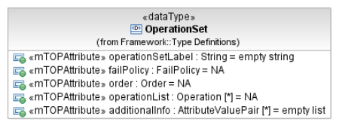  This data type contains the definition of a set of operations with their controls.  operationSetLabel (String)  This attribute re-associates the results in the response with the operations set.  failPolicy (FailPolicy)  This attribute defines the operation execution fail over control.  order (Order)  Operation execution ordering control.  operationList (*) (Operation)  This attribute contains the list of operations.  additionalInfo (*) (AttributeValuePair)  This Parameter allows the communication from the requesting OS to the target OS of additional information which is not explicitly modelled.  +++++++++++++++++  +++++++++++++++++  +++++++++++++++++  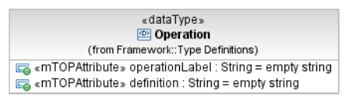  Templates have the same structure as the operations for which they are templates.  operationLabel (String)  This attribute reassociates the results in the response with the request.  failPolicy  isResultDataRequested  templateName  operationData  definition (String)  This parameter defines the label of the owner of the new/modified object. | element name="operationSet" type="tns:OperationSetType"  +++++++++++++++++  complexType name="OperationSetType"  Definition of a set of operations with their controls.  <xsd:sequence>  element name="operationSetLabel" type="xsd:string"  lLabel which is used to re-associate the results in the response with the operations set.  element name="failPolicy" type="tns:FailPolicyType"  Operation execution fail over control.  element name="order" type="tns:OrderType"  Operation execution ordering control.  element name="operation" type="tns:OperationType"  List of operations.  element name="vendorExtensions" type="gen:AnyListType"  </xsd:sequence>  </xsd:complexType>  +++++++++++++++++  complexType name="OperationType"  <xsd:sequence>  element name="operationLabel" type="xsd:string"  lLabel which is used to re-associate the results in the response with the request.  element name="failPolicy" type="tns:FailPolicyType"  oOperation level controls.  element name="isResultDataRequested" type="xsd:boolean"  fFlag used to indicate if the result should contain the operationResultData or not.  element name="templateName" type="xsd:string"  An operation can optionally name a template which will provide values for any element not explicitly included here.  element name="operationData"  <xsd:complexType>  <xsd:sequence>  <xsd:any namespace="##any" processContents="lax"  </xsd:sequence>  </xsd:complexType>  </xsd:sequence>  </xsd:complexType>
 | additionalInfo (*) (AttributeValuePair)  This Parameter allows the communication from the requesting OS to the target OS of additional information which is not explicitly modelled. | element name="vendorExtensions" type="gen:AnyListType"

SingleDoProcessResponseData

BA | IA (SingleDoProcessResponseData) | IIS () | Comments
?? | This data type contains a single response structure of the compound doProcess operation.  Traceability: R_TMF518_FMW_II_00??.  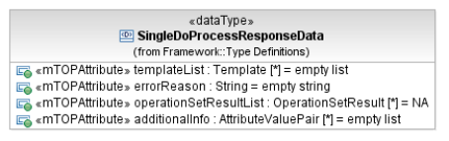 | (out) <xsd:complexType>  <xsd:sequence>  …  </xsd:sequence>  </xsd:complexType>
 | errorReason (String)  This attribute contains the operation execution error reason(s); if any. | element name="errorReason" type="xsd:string"
 | templateList (*) (Template)  This attribute …  +++++++++++++++++  Templates have the same structure as the operations for which they are templates. | element name="templateList" type="tns:TemplateListType"
 | operationSetResultList (*) (OperationSetResult)  This attribute …  +++++++++++++++++  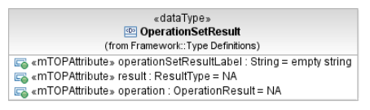  This data type contains the definition of a set of operation results with their controls.  operationSetResultLabel (String)  This attribute reassociates the results in the response with the operations set.  result (ResultType)  This attribute defines the operation set execution result.  operation (OperationResult)  This attribute contains the list of operations.  additionalInfo (*) (AttributeValuePair)  This Parameter allows the communication from the requesting OS to the target OS of additional information which is not explicitly modelled.  +++++++++++++++++  ResultType  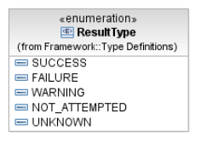  +++++++++++++++++  OperationResult  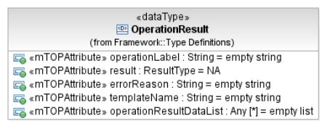  operationLabel (String)  This attribute contains the operation label.  result (ResultType)  This attribute defines the operation execution result.  errorReason (String)  This attribute contains the operation execution error reason; if any.  templateName (String)  This attribute optionally name a template which will provide values for any element not explicitly included here.  operationResultDataList (*) (Any)  This attribute contains the MTOSI fine-grained operation response. It is a loosely type definition - Refer to the unused (for reference only) strongly typed definition; OperationEnumType. | element name="operationSetResult" type="tns:OperationSetResultType"  +++++++++++++++++  complexType name="OperationSetResultType"  Definition of a set of operations results with their controls.  <xsd:sequence>  element name="operationSetResultLabel" type="xsd:string"  label which is used to reassociate the results in the response with the operations set.  element name="result" type="tns:ResultType"  Operation set execution result.  element name="operation" type="tns:OperationResultType"  List of operations.  element name="vendorExtensions" type="gen:AnyListType"  </xsd:sequence>  </xsd:complexType>  +++++++++++++++++  name="ResultType"  enumeration value="SUCCESS"  enumeration value="FAILURE"  enumeration value="WARNING"  enumeration value="NOT_ATTEMPTED"  enumeration value="UNKNOWN  +++++++++++++++++  complexType name="OperationResultType"  <xsd:sequence>  element name="operationLabel" type="xsd:string"  Operation label.  element name="result" type="tns:ResultType"  Operation execution result.  element name="errorReason" type="xsd:string"  Operation execution error reason.  element name="templateName" type="xsd:string"  An operation result can optionally name a template which will provide values for any element not explicitly included here.  element name="operationResultData"  MTOSI fine-grained operation response  This is a loosely type definition - Refer to the unused (for reference only) strongly typed definition; OperationEnumType.  <xsd:complexType>  <xsd:sequence>  <xsd:any namespace="##any" processContents="lax"  </xsd:sequence>  </xsd:complexType>  </xsd:sequence>  </xsd:complexType> | bz:  Do we need a strong typed definition for the operation names in the IA?
 | additionalInfo (*) (AttributeValuePair)  This Parameter allows the communication from the requesting OS to the target OS of additional information which is not explicitly modelled. | element name="vendorExtensions" type="gen:AnyListType"

OperationSetState

BA | IA (OperationSetState) | IIS | Comments
?? | This data type contains the definition of a set of operations results with their controls.  Traceability: R_TMF518_FMW_II_00??.  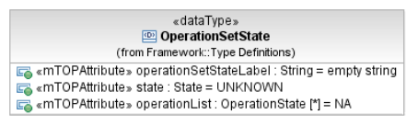 | complexType name="OperationSetStateType"  Definition of a set of operations results with their controls  <xsd:sequence>  …  </xsd:sequence>  </xsd:complexType>
 | operationSetStateLabel (String)  This attribute contains the label which is used to re-associate the states in the response with the operations set. | element name="operationSetStateLabel" type="xsd:string"  lLabel which is used to re-associate the states in the response with the operations set.
 | state (State)  This attribute contains the operation set execution state.  +++++++++++++++++  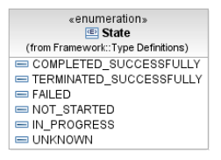 | element name="state" type="tns:StateType"  Operation set execution state.  +++++++++++++++++  name="StateType"  enumeration value="COMPLETED_SUCCESSFULLY"  enumeration value="TERMINATED_SUCCESSFULLY"  enumeration value="FAILED"  enumeration value="NOT_STARTED"  enumeration value="IN_PROGRESS"  enumeration value="UNKNOWN"
 | operationList (*) (OperationState)  This attribute contains the list of operations.  +++++++++++++++++  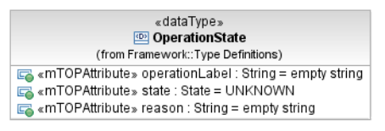  operationLabel (String)  This attribute contains the operation label.  state (State)  This attribute contains the operation process state.  reason (String)  This attribute contains an explanation about the process state. | element name="operation" type="tns:OperationStateType"  List of operations.  +++++++++++++++++  complexType name="OperationStateType"  <xsd:sequence>  element name="operationLabel" type="xsd:string"  Operation label.  element name="state" type="tns:StateType"  Operation process state.  element name="reason" type="xsd:string"  Explanation about the process state.  </xsd:sequence>  </xsd:complexType> | bz:  "<!-- ============== -->" is missing between OperationSetStateType and OperationStateType.

SingleTerminateProcessResponseData

BA | IA (SingleTerminateProcessResponseData) | IIS | Comments
?? | This data type contains a single response structure of the terminateProcess operation.  Traceability: R_TMF518_FMW_II_00??.  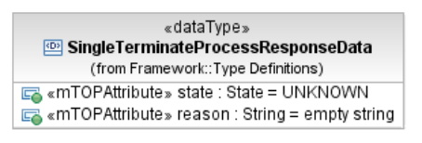 | (out)  <xsd:sequence>  …  </xsd:sequence>
 | state (State)  This attribute contains the operation set execution state. | element name="state" type="tns:StateType"
 | reason (String)  This attribute contains the operation execution error reason; if any. | element name="reason" type="xsd:string"

