This document compares BA, IA and IIS of the Manage Resource Inventory DDP

References:
BA: TMF518_MRI.doc 1927 30.12.08 besson
IA: ManageResourceInventory.emx 1944 26.01.09 zeuner
IIS: ConnectionRetrievalMessages.xsd 1574 08.04.08 jeromem
EquipmentInventoryRetrievalMessages.xsd 1574 08.04.08 jeromem
FlowDomainRetrievalMessages.xsd 1574 08.04.08 jeromem
ManagedElementRetrievalMessages.xsd 1574 08.04.08 jeromem
ManagementDomainRetrievalMessages.xsd 1574 08.04.08 jeromem
MultiLayerSubnetworkRetrievalMessages.xsd 1574 08.04.08 jeromem
OperationsSystemRetrievalMessages.xsd 1574 08.04.08 jeromem
ResourceInventoryRetrievalMessages.xsd 1574 08.04.08 jeromem
ResourceInventoryUpdateMessages.xsd 1574 08.04.08 jeromem
TerminationPointRetrievalMessages.xsd 1574 08.04.08 jeromem
TopologicalLinkRetrievalMessages.xsd 1574 08.04.08 jeromem
TrafficConditioningProfileRetrievalMessages.xsd 1574 08.04.08 jeromem
TransmissionDescriptorRetrievalMessages.xsd 1574 08.04.08 jeromem
SDs:

Conventions:
yellow marked items need discussion
turquoise marked items are obvious (from my point of view) and need to be added/changed/deleted
green marked items are postponed after MTOSI 2.0; i.e to TIP
grey marked items identify a separate defined data type.

Content:
1 High level UML diagrams 6
1.1 MRI Interface Diagram 6
1.2 MRI DDP Relationship Diagram 8
2 Connection Retrieval Service 9
2.1 getAllCrossConnections 10
2.2 getAllFixedCrossConnections 11
2.3 getAllFixedSubnetworkConnections 12
2.4 getAllFixedSubnetworkConnectionsWithTp 14
2.5 getAllSubnetworkConnections 16
2.6 getAllSubnetworkConnectionsWithTp 18
2.7 getBackupRoutes 20
2.8 getIntendedRoute 22
2.9 getPotentialFixedCrossConnections 24
2.10 getRoute 26
2.11 getSubnetworkConnection 28
2.12 getSubnetworkConnectionModeOfOperation «profile=xml» 29
2.13 getSubnetworkConnectionsByUserLabel 30
2.14 Data Types 31
2.14.1 GetCrossConnectionsRequest Type 31
2.14.2 GetSubnetworkConnectionsRequest Type 32
2.14.3 GetSubnetworkConnectionsWithTpRequest Type 32
2.14.4 MultipleCrossConnectionObjectsResponse Type 33
2.14.5 MultipleSubnetworkConnectionObjectsResponse Type 33
3 Equipment Inventory Retrieval Service 35
3.1 getAllEquipment 36
3.2 getAllSupportingEquipment 37
3.3 getContainedEquipment 39
3.4 getEquipment 40
3.5 getSupportedEquipment 41
3.6 getSupportingEquipment 42
3.7 Data Types 43
3.7.1 GetSupportEquipmentRequest Type 44
3.7.2 EquipmentOrEquipmentHolder Type 44
4 Flow Domain Retrieval Service 45
4.1 getAllAssociatedMatrixFlowDomains 46
4.2 getAllFlowDomainFragments 47
4.3 getAllFlowDomains 48
4.4 getAllSupportedMatrixFlowDomains 49
4.5 getAssigningMatrixFlowDomain 51
4.6 getAssociatingFlowDomain 51
4.7 getConnectivityAwareness «profile=xml» 52
4.8 getFlowDomain 54
4.9 getFlowDomainFragment 54
4.10 getFlowDomainFragmentRoute 55
4.11 getFlowDomainFragmentsByUserLabel 57
4.12 getFlowDomainFragmentsWithTp 57
4.13 getFlowDomainsByUserLabel 59
4.14 getMatrixFlowDomain 60
5 Managed Element Retrieval Service 61
5.1 getAllManagedElements 62
5.2 getAllManagedElementsPassingFilter 63
5.3 getAllManagedElemetsWrtOs 65
5.4 getManagedElement 66
5.5 Data Types 67
5.5.1 ManagedElementFilter Type 67
5.5.2 MultipleMeObjectsResponse Type 68
5.5.3 SingleMeObjectResponse Type 68
6 Management Domain Retrieval Service 70
6.1 getAllManagementDomains 71
6.2 getManagementDomain 71
7 Multi Layer Subnetwork Retrieval Service 73
7.1 getAllMultiLayerSubnetworksWrtOs 74
7.2 getAllTopLevelMultiLayerSubnetworks 75
7.3 getContainingMultiLayerSubnetworkNames 76
7.4 getMultiLayerSubnetwork 77
7.5 Data Types 78
7.5.1 MultipleObjectsResponse Type 78
8 Operations System Retrieval Service 80
8.1 getAllOperationsSystems 81
8.2 getOperationsSystem 81
8.3 getSubordinateOperationsSystem 82
8.4 Data Types 83
8.4.1 SingleObjectResponse Type 83
9 Resource Inventory Retrieval Service 84
9.1 getInventory 85
9.2 Data Types 88
9.2.1 SimpleFilter Type 88
9.2.2 InventoryData Type 94
10 Resource Inventory Update Service 98
10.1 updateInventory 99
10.2 Data Types 104
10.2.1 EffortMode Type 104
10.2.2 IntegrationMode Type 105
11 Termination Point Retrieval Service 107
11.1 getAllAssignableConnectionlessPortTerminationPoints 108
11.2 getAllAssignedConnectionlessPortTerminationPoints 109
11.3 getAllConnectionlessPortTerminationPoints 110
11.4 getAllEdgePoints 111
11.5 getAllFloatingTerminationPoints 113
11.6 getAllGroupTerminationPoints 116
11.7 getAllPhysicalTerminationPoints 117
11.8 getAllPhysicalTerminationPointsWithoutFtps 120
11.9 getAllSupportedPhysicalTerminationPoints 122
11.10 getAllTerminationPointPools 124
11.11 getAssociatedGroupTerminationPoint 125
11.12 getAssociatedTerminationPoints 126
11.13 getAssociatedTerminationPointsWrtTmd 128
11.14 getContainedCurrentConnectionTerminationPoints 130
11.15 getContainedInUseConnectionTerminationPoints 131
11.16 getContainedPotentialConnectionTerminationPoints 134
11.17 getContainingTerminationPoints 136
11.18 getGroupTerminationPoint 138
11.19 getTerminationPoint 138
11.20 getTerminationPointGroupingRelationships 140
11.21 getTerminationPointPool 141
11.22 getTrafficConditioningProfileAssociatedTps 142
11.23 Data Types 143
11.23.1 GetAllTerminationPoints Type 144
11.23.2 GetAllConnectionTerminationPoints Type 144
11.23.3 MultipleTerminationPointObjectsResponse Type 145
11.23.4 SingleGroupTerminationPointObjectResponse Type 145
11.23.5 RequestProfile2 Type 146
11.23.6 RequestProfile4 Type 146
12 Topological Link Retrieval Service 147
12.1 getAllTopLevelTopologicalLinks 148
12.2 getAllTopologicalLinks 149
12.3 getAllTopologicalLinksBetweenMds 150
12.4 getAllTopologicalLinksOfFd 150
12.5 getAllTopologicalLinksWrtOs 151
12.6 getRouteAndTopologicalLinks 153
12.7 getTopLevelTopologicalLink 156
12.8 getTopologicalLink 157
12.9 Data Types 158
12.9.1 MultipleTlObjectsResponse Type 158
13 Traffic Conditioning Profile Retrieval Service 160
13.1 getAllTrafficConditioningProfiles 161
13.2 getTrafficConditioningProfile 162
14 Transmission Descriptor Retrieval Service 163
14.1 getAllTransmissionDescriptors 164
14.2 getAllTransmissionDescriptorsWrtOs 165
14.3 getTransmissionDescriptor 167
14.4 getTransmissionParameters 168
14.5 Data Types 171
14.5.1 MultipleTmdObjectsResponse Type 171

Figures:
Figure 1: MRI Interface Diagram 7
Figure 2: MRI DDP Relationship Diagram 8
Figure 3: MRI Connection Retrieval Service Interface Diagram 9
Figure 4: MRI Equipment Inventory Retrieval Service Interface Diagram 35
Figure 5: MRI Flow Domain Retrieval Service Interface Diagram 45
Figure 6: MRI Managed Element Retrieval Service Interface Diagram 61
Figure 7: MRI Management Domain Retrieval Service Interface Diagram 70
Figure 8: MRI Multi Layer Subnetwork Retrieval Service Interface Diagram 73
Figure 9: MRI Operations System Retrieval Service Interface Diagram 80
Figure 10: MRI Resource Inventory Retrieval Service Interface Diagram 84
Figure 11: MRI Resource Inventory Update Service Interface Diagram 98
Figure 12: MRI Termination Point Retrieval Service Interface Diagram 107
Figure 13: MRI Topological Link Retrieval Service Interface Diagram 147
Figure 14: MRI Traffic Conditioning Profile Retrieval Service Interface Diagram 160
Figure 15: MRI Transmission Descriptor Retrieval Service Interface Diagram 163

History:
Version | Date | Description of Change
0.1 | 30.04.2008 | Initial version.
0.2 | 5.5.2008 | Corrected all the BA blue comments (to the exception of the Traceability Matrices have no head line.).
0.3 | 15.12.2008 | Jerome: Completed update of the MTOSI R2 MRI based on comments
0.4 | 13.01.2009 | Operations ConnectionRetrievalService:getSubnetworkConnectionModeOfOperation() and FlowDomainRetrievalService:getConnectivityAwareness() added.
0.5 | 23.01.2009 | Traceability for ConnectionRetrievalService::getSubnetworkConnectionModeOfOperation() added.  Traceability for FlowDomainRetrievalService::getConnectivityAwareness() added.
General:
BA: R_TMF518_MRI_II_0063 (PhysicalTerminationPoint::getContainingPGNames) belong to MRI or RTM?
BA: 3.3.4 Inventory Notifications not contained in IA and IIS; should be moved to the DM DDPs..
BA: Some requirements refer to "TMF 513 Version 3.5"; Version 3.5 does not exist, should be Version 3.1.
corrected
BA: Traceability Matrices have no head line.

High level UML diagrams

MRI Interface Diagram
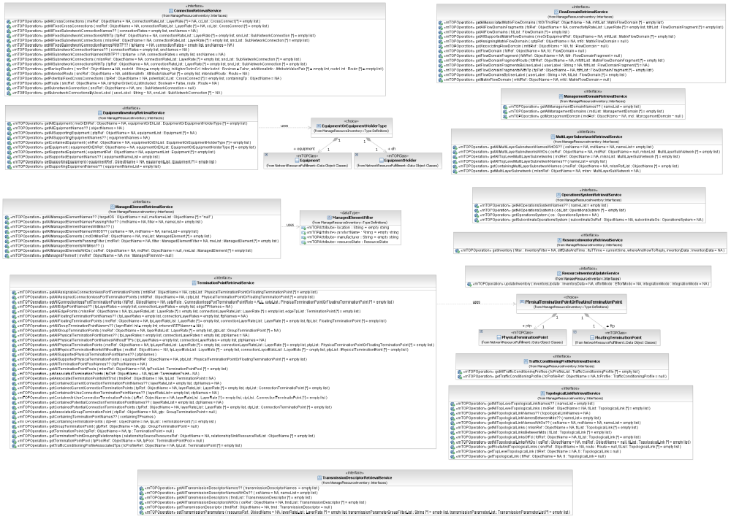
Figure 1: MRI Interface Diagram

MRI DDP Relationship Diagram
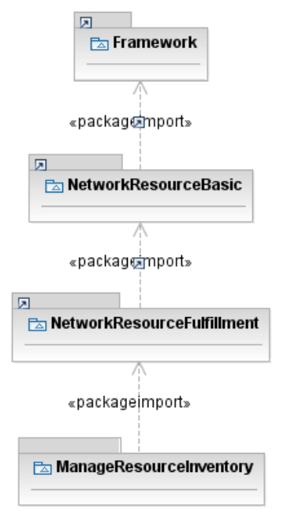
Figure 2: MRI DDP Relationship Diagram

Connection Retrieval Service
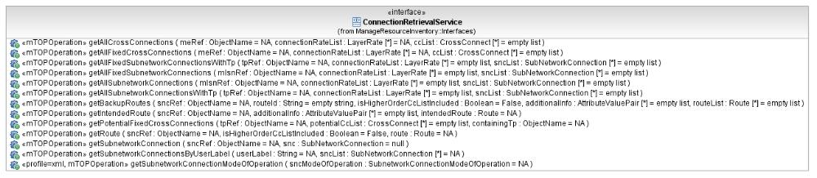
Figure 3: MRI Connection Retrieval Service Interface Diagram

getAllCrossConnections

BA (getAllCrossConnections) | IA | IIS | Comments
R_TMF518_MRI_II_0099  The Interface shall allow the requesting OS to retrieve the attributes of all of the Cross Connects given a Managed Element name specified by the requesting OS. | This operation retrieves the list of the Cross-Connects for the specified Managed Element at the specified Layer Rates.  The operation will also return Cross-Connections between GTPs.  Traceability: R_TMF518_MRI_II_0099. | This operation retrieves the list of the Cross-Connects for the specified Managed Element at the specified Layer Rates.  This operation returns cross-connects between CTPs/FTPs.
 | meRef (ObjectName)  This parameter provides the name of the Managed Element whose Cross-Connections are in scope. | GetCrossConnectionsRequestType  element name="meRef" type="nam:NamingAttributeType"  Name of the Managed Element for which to retrieve CCs.
?? | connectionRateList (*) (LayerRate)  This parameter provides the list of Layer Rates for which to retrieve the Cross-Connections.  This must not be an empty list. In this case an INVALID_INPUT exception is thrown. | GetCrossConnectionsRequestType  element name="connectionRateList" type="lay:LayerRateListType"  List of rates for which to retrieve CCs. This must not be an empty list. In this case an INVALID_INPUT exception is thrown.
 | ccList (*)  This parameter returns the Cross-Connections matching the specified Layer Rate(s). | MultipleCrossConnectionObjectsResponseType  element name="ccList" type="cc:CrossConnectListType"  The list of CCs.
 | 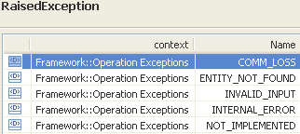 | restriction base="msg:AllExceptionsType"  element ref="msg:commLoss"  element ref="msg:entityNotFound"  element ref="msg:internalError"  element ref="msg:invalidInput"  element ref="msg:notImplemented"  element ref="msg:tooManyOpenIterators"

getAllFixedCrossConnections

BA (getAllFixedCrossConnections) | IA | IIS | Comments
R_TMF518_MRI_II_0100  The Interface shall allow the requesting OS to retrieve the attributes of all the fixed Cross Connect (CC)s given a Managed Element (ME) name specified by the requesting OS. | This operation retrieves the list of the fixed Cross-Connects for the specified Managed Element at the specified Layer Rates.  The operation will also return fixed Cross-Connections between GTPs.  Traceability: R_TMF518_MRI_II_0100. | This operation has exactly the same behaviour as getAllCrossConnections(), but instead returns only fixed Cross Connection object structures.  See Subnetwork Connection Types for an explanation of fixed SNCs.  A cross connection is identified as fixed using additional information.  See Additional Information Usage for detail on additional information for SNCs, cross connections and TPs. | bz:  SD1-36_SNCTypes does not say much about "fixed" CCs.  bz:  This is only true for IDL.
 | meRef (ObjectName)  This parameter provides the name of the Managed Element whose Cross-Connections are in scope. | GetCrossConnectionsRequestType  element name="meRef" type="nam:NamingAttributeType"  Name of the Managed Element for which to retrieve CCs.
?? | connectionRateList (*) (LayerRate)  This parameter provides the list of Layer Rates for which to retrieve the fixed Cross-Connections.  This must not be an empty list. In this case an INVALID_INPUT exception is thrown. | GetCrossConnectionsRequestType  element name="connectionRateList" type="lay:LayerRateListType"  List of rates for which to retrieve CCs. This must not be an empty list. In this case an INVALID_INPUT exception is thrown.
 | ccList (*)  This parameter returns the fixed Cross-Connections matching the specified Layer Rate(s). | MultipleCrossConnectionObjectsResponseType  element name="ccList" type="cc:CrossConnectListType"  The list of CCs.
 | 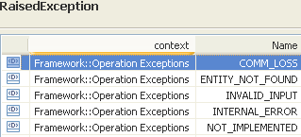 | restriction base="msg:AllExceptionsType"  element ref="msg:commLoss"  element ref="msg:internalError"  element ref="msg:entityNotFound"  element ref="msg:invalidInput"  element ref="msg:notImplemented"  element ref="msg:tooManyOpenIterators"

getAllFixedSubnetworkConnections

BA (getAllFixedSubnetworkConnections) | IA | IIS | Comments
R_TMF518_MRI_II_0038  The Interface shall allow the requesting OS to retrieve the attributes of all the fixed Subnetwork Connections contained within a Subnetwork specified by the requesting OS.  R_TMF518_MRI_II_0039 | This operation retrieves the filtered list of fixed Subnetwork Connections contained within the specified Multi Layer Subnetwork.  The operation also returns bundled SNCs, if any.  Traceability: R_TMF518_MRI_II_0038. | This operation has exactly the same behaviour as getAllSubnetworkConnections(), but instead returns only fixed SNCs object structures. See Subnetwork Connection Types for an explanation of fixed SNCs.  The operation also returns bundled SNCs, if any. | bz:  SD1-36_SNCTypes does not say much about "fixed" SNCs.
 | mlsnRef (ObjectName)  This parameter provides the name of the Multi Layer Subnetwork whose fixed Subnetwork Connections are in scope. | GetSubnetworkConnectionsRequestType  element name="mlsnRef" type="nam:NamingAttributeType"  Name of the subnetwork.
?? | connectionRateList (*) (LayerRate)  This parameter provides the list of Subnetwork Connection Layer Rates used to scope the request.  If the list is empty, all fixed Subnetwork Connections contained in the Multi Layer Subnetwork are returned. | GetSubnetworkConnectionsRequestType  element name="connectionRateList" type="lay:LayerRateListType"  List of rates of the SNC names to be reported. If an empty list is specified, then all SNC names of all rates are to be reported.
 | sncList (*)  This parameter returns the list of fixed Subnetwork Connections contained within the Multi Layer Subnetwork for the provided Layer Rates or an empty list. | MultipleSubnetworkConnectionObjectsResponseType  element name="sncList" type="snc:SubnetworkConnectionListType"  The list of SNCs.
 | 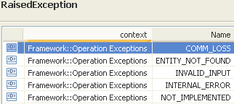 | restriction base="msg:AllExceptionsType"  element ref="msg:commLoss"  element ref="msg:entityNotFound"  element ref="msg:internalError"  element ref="msg:invalidInput"  element ref="msg:notImplemented"  element ref="msg:tooManyOpenIterators"

getAllFixedSubnetworkConnectionsWithTp

BA (getAllFixedSubnetworkConnectionsWithTp) | IA | IIS | Comments
R_TMF518_MRI_II_0040  The Interface shall allow the requesting OS to retrieve the attributes of all the fixed Subnetwork Connections that contain the Termination Point and connection rate(s) specified by the requesting OS.  1) If a Physical Termination Point is specified, then all SNC(s) that pass through the contained Connection Termination Point (CTP)s are returned. The SNCs returned include the CTPs at either end or as part of their route.  2) If a CTP is specified, then all the SNC(s) that pass through the specified CTP are returned. The SNCs returned include the CTPs at either end or as part of the route.  If the CTP provides the source of a point-to-multipoint SNC then all the SNCs of that multipoint configuration that connect to that CTP will be returned.  R_TMF518_MRI_II_0041 | This operation retrieves the list of fixed Subnetwork Connections (SNCs) which contain the specified Termination Point (TP) constrained by the specified connection rate.  A TP may be a PTP in which case a full list of fixed SNCs using any of its contained CTPs is required. A TP may be a CTP, in which case only fixed SNCs using that CTP or any of its contained CTPs are required.  Both end CTPs and intermediate CTPs at the same layer are considered. In all cases, only fixed SNCs that also match the specified connection rate filter are returned.  All legs of a broadcast system can be retrieved using this operation where the source TP of the broadcast system is used as input to the operation. The output will be the list of individual fixed SNCs that make up the broadcast system.  This operation also works if a Group Termination Point (GTP) is supplied rather than a CTP. In this case, the Layer Rate is set to LR_Not_Applicable. If the GTP is part of a Cross-Connection, the target OS returns the set of bundled SNCs that use the provided GTP or contained GTP (if a CTP that is associated with a GTP is provided) as either an end point or an interior point.  Traceability: R_TMF518_MRI_II_0040. | This operation has exactly the same behaviour as getAllSubnetworkConnectionsWithTP(), but instead returns only fixed SNCs object structures. See Subnetwork Connection Types for an explanation of fixed SNCs.  An SNC is identified as fixed using additional information. See Additional Information Usage for detail on additional information for SNCs, cross connections and TPs.. | bz:  SD1-36_SNCTypes does not say much about "fixed" SNCs.
 | tpRef (ObjectName)  This parameter provides the name of the Termination Point whose associated fixed Subnetwork Connections are in scope. It is also possible to provide a GTP. | GetSubnetworkConnectionsWithTpRequestType  element name="tpRef" type="nam:NamingAttributeType"  Termination point for which to report SNCs. The termination point name must be explicit (a generic endpoint specification may not be used in this case). See Object Naming for further detail on FTP naming.
 | connectionRateList (*) (LayerRate)  This parameter provides the list of Subnetwork Connection Layer Rates used to scope the request.  If the list is empty, all fixed Subnetwork Connections using the specified Termination Point are returned. | GetSubnetworkConnectionsWithTpRequestType  element name="connectionRateList" type="lay:LayerRateListType"  List of rates of the SNC names to be reported. If an empty list is specified, then all SNC names of all rates are to be reported.
 | sncList (*)  This parameter returns the list of fixed Subnetwork Connections containing the provided TP for the provided Layer Rates or an empty list. | MultipleSubnetworkConnectionObjectsResponseType  element name="sncList" type="snc:SubnetworkConnectionListType"  The list of SNCs.
 | 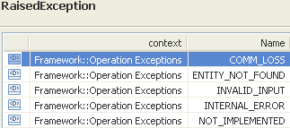 | restriction base="msg:AllExceptionsType"  element ref="msg:commLoss"  element ref="msg:entityNotFound"  element ref="msg:internalError"  element ref="msg:invalidInput"  element ref="msg:notImplemented"  element ref="msg:tooManyOpenIterators"

getAllSubnetworkConnections

BA (getAllSubnetworkConnections) | IA | IIS | Comments
R_TMF518_MRI_II_0030  The Interface shall allow the requesting OS to retrieve the attributes of all the Subnetwork Connection (SNC)s that are contained within a Subnetwork specified by the requesting OS.  R_TMF518_MRI_II_0031  R_TMF518_MRI_II_0032  The Interface shall allow the requesting OS to retrieve the attributes of all the Subnetwork Connection (SNC)s that are contained within a Subnetwork and for specific SNC layer rate(s) specified by the requesting OS.  R_TMF518_MRI_II_0033 | This operation retrieves the filtered list of Subnetwork Connections (SNCs) contained within the Multi Layer Subnetwork.  This operation also returns bundled SNCs, if any.  Traceability: R_TMF518_MRI_II_0030, R_TMF518_MRI_II_0032. | This operation retrieves the filtered list of Subnetwork Connections (SNCs) contained within the Multi Layer Subnetwork. This operation also returns bundled SNCs, if any (see Bundled SNC overview for further details). | bz:  R_TMF518_MRI_II_0030 necessary?
 | mlsnRef (ObjectName)  This parameter provides the name of the Multi Layer Subnetwork whose Subnetwork Connections are in scope. | GetSubnetworkConnectionsRequestType  element name="mlsnRef" type="nam:NamingAttributeType"  Name of the subnetwork.
 | connectionRateList (*) (LayerRate)  This parameter provides the list of Subnetwork Connection Layer Rates used to scope the request.  If the list is empty, all Subnetwork Connections contained in the Multi Layer Subnetwork are returned. | GetSubnetworkConnectionsRequestType  element name="connectionRateList" type="lay:LayerRateListType"  List of rates of the SNC names to be reported. If an empty list is specified, then all SNC names of all rates are to be reported.
 | sncList (*)  This parameter returns the list of Subnetwork Connections contained within the Multi Layer Subnetwork for the provided Layer Rates or an empty list. | MultipleSubnetworkConnectionObjectsResponseType  element name="sncList" type="snc:SubnetworkConnectionListType"  The list of SNCs.
 | 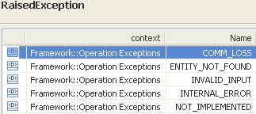 | restriction base="msg:AllExceptionsType"  element ref="msg:commLoss"  element ref="msg:entityNotFound"  element ref="msg:internalError"  element ref="msg:invalidInput"  element ref="msg:notImplemented"  element ref="msg:tooManyOpenIterators"

getAllSubnetworkConnectionsWithTp

BA (getAllSubnetworkConnectionsWithTp) | IA | IIS | Comments
R_TMF518_MRI_II_0034  The Interface shall allow the requesting OS to retrieve the attributes of all the Subnetwork Connection (SNC)s that contain a Termination Point (TP) and for specific connection rates(s) specified by the requesting OS .  1. If a Physical Termination (PTP) is specified, then all SNC(s) that pass through the contained Connection Termination Point (CTP)s are returned. The SNCs returned include the CTPs at either end or as part of their route.  2. If a CTP is specified, then all the SNC(s) that pass through the specified CTP are returned. The SNCs returned include the CTPs at either end or as part of the route.  If the CTP provides the source of a point-to-multipoint SNC then all the SNCs of that multipoint configuration that connect to that CTP will be returned.  R_TMF518_MRI_II_0035 | This operation retrieves the list of Subnetwork Connections (SNCs) using the specified Termination Point at the specified connection rates.  An SNC is using the specified TP if any of its routes, intended and/or backup, in any state, use this TP.  A TP may be a PTP in which case a full list of SNCs using any of its contained CTPs is required. A TP may be a CTP, in which case only SNCs using that CTP or any of its contained CTPs are required.  Both end CTPs and intermediate CTPs at the same layer are considered. In all cases, only SNCs that also match the specified connection rate filter are returned.  All legs of a broadcast system can be retrieved using this operation where the source TP of the broadcast system is used as input to the operation. The output will be the list of individual SNCs that make up the broadcast system.  This operation also works if a GTP is supplied rather than a CTP. In this case, the layerRate is set to LR_Not_Applicable. If the GTP is part of a Cross-Connection, the target OS returns the set of bundled SNCs that use the provided GTP or contained GTP (if a CTP that is associated with a GTP is provided) as either an end point or an interior point.  Traceability: R_TMF518_MRI_II_0034. | This operation retrieves the list of Subnetwork Connections (SNCs) using the specified Termination Point at the specified connection rates.  An SNC is using the specified TP if any of its routes, intended and/or backup, in any state, use this TP.  A TP may be a PTP in which case a full list of SNCs using any of its contained CTPs is required. A TP may be a CTP, in which case only SNCs using that CTP or any of its contained CTPs are required.  Both end CTPs and intermediate CTPs at the same layer are considered. In all cases, only SNCs that also match the specified connection rate filter are returned.  All legs of a broadcast system can be retrieved using this operation where the source TP of the broadcast system is used as input to the operation. The output will be the list of individual SNCs that make up the broadcast system.  This operation also works if a GTP is supplied rather than a CTP. In this case, the layerRate is set to LR_Not_Applicable. If the GTP is part of a Cross-Connection, the target OS returns the set of bundled SNCs that use the provided GTP or contained GTP (if a CTP that is associated with a GTP is provided) as either an end point or an interior point. | bz:  Descriptions should be aligned.
 | tpRef (ObjectName)  This parameter provides the name of the Termination Point whose associated Subnetwork Connections are in scope. It is also possible to provide a GTP. | GetSubnetworkConnectionsWithTpRequestType  element name="tpRef" type="nam:NamingAttributeType"  Termination point for which to report SNCs. The termination point name must be explicit (a generic endpoint specification may not be used in this case). See Object Naming for further detail on FTP naming.
 | connectionRateList (*) (LayerRate)  This parameter provides the list of Subnetwork Connection Layer Rates used to scope the request.  If the list is empty, all Subnetwork Connections using the specified Termination Point are returned. | GetSubnetworkConnectionsWithTpRequestType  element name="connectionRateList" type="lay:LayerRateListType"  List of rates of the SNC names to be reported. If an empty list is specified, then all SNC names of all rates are to be reported.
 | sncList (*)  This parameter returns the list of Subnetwork Connections containing the provided TP for the provided Layer Rates or an empty list. | MultipleSubnetworkConnectionObjectsResponseType  element name="sncList" type="snc:SubnetworkConnectionListType"  The list of SNCs.
 | 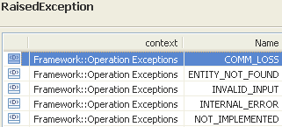 | restriction base="msg:AllExceptionsType"  element ref="msg:commLoss"  element ref="msg:entityNotFound"  element ref="msg:internalError"  element ref="msg:invalidInput"  element ref="msg:notImplemented"  element ref="msg:tooManyOpenIterators"

getBackupRoutes

BA (getBackupRoutes) | IA | IIS | Comments
R_TMF518_MRI_II_0044  The Interface shall allow the requesting OS to retrieve the attributes of the backup Route given a Subnetwork Connection (SNC) name and Route identifier specified by the requesting OS.  R_TMF518_MRI_II_0045  The Interface shall allow the requesting OS to retrieve the attributes of all the Routes (intended and backup) given a Subnetwork Connection (SNC) name specified by the requesting OS. | This operation retrieves the specified Route of a Subnetwork Connection (SNC). If the Route is not specified, the operation returns all the Routes of the SNC, intended and backup ones. The rest of the behavior is the same as the getRoute() operation.  Note: The relationship between Bundled SNC service and the SNC with Multiple Routes feature requires further study.  Traceability: R_TMF518_MRI_II_0044, R_TMF518_MRI_II_0045. | The operation returns the requested route for the SNC whose name is specified as a parameter. If the input route is not specified (empty string), the operation replies all the routes of the SNC, intended and backup ones. The rest of the behavior is same as getRoute(). | bz:  Does R_TMF518_MRI_II_0045 apply here?
 | sncRef (ObjectName)  This parameter provides the name of the Subnetwork Connection whose Routes are in scope. | (in) element name="sncRef" type="nam:NamingAttributeType"  The name of the subnetwork connection.
 | routeId (String)  This parameter provides the identifier of the Route. | (in) element name="routeId" type="xsd:string"  The id of the route.
?? | isHigherOrderCcListIncluded (Boolean)  This parameter specifies whether the higher order Cross-Connections of other SNCs used to carry the queried SNC have to be included in addition to the Cross-Connections of the queried SNC; false otherwise. | (in) element name="isHigherOrderCcListIncluded" type="xsd:boolean"  Specifies whether the higher order CCs of other SNCs used to carry the queried SNC route have to be included in addition to the CCs of the queried SNC route.
?? | additionalInfo (inout) (*) (AttributeValuePair)  This parameter allows the communication of additional information which is not explicitly modelled. | (in) element name="additionalInfo" type="gen:NameAndValueStringListType"  to allow the communication of additional information which is not explicitly modelled. | bz:  I thought the IIS uses "Any"?
 |  | (out) element name="additionalInfo" type="gen:NameAndValueStringListType"  to allow the communication of additional information which is not explicitly modelled. | bz:  I thought the IIS uses "Any"?
 | routeList (*)  This parameter returns the Route(s) of the SNC. | (out) element name="routeList" type="rt:RouteListType"  The route(s) of the SNC..
 | 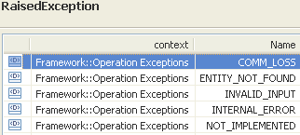 | restriction base="msg:AllExceptionsType"  element ref="msg:commLoss"  element ref="msg:entityNotFound"  element ref="msg:internalError"  element ref="msg:invalidInput"  element ref="msg:notImplemented"

getIntendedRoute

BA (getIntendedRoute) | IA | IIS | Comments
R_TMF518_MRI_II_0046  The Interface shall allow the requesting OS to retrieve the attributes of the intended Route given a Subnetwork Connection (SNC) name specified by the requesting OS. | This operation retrieves the intended Route of a Subnetwork Connection (SNC).  Note: The relationship between Bundled SNC service and the SNC with Multiple Routes feature requires further study.  Traceability: R_TMF518_MRI_II_0046. | The operation returns the intended route for the SNC whose name is specified as a parameter. The behavior is essentially the same as getRoute().
 | sncRef (ObjectName)  This parameter provides the name of the Subnetwork Connection whose intentended Route is requested. | (in) element name="sncRef" type="nam:NamingAttributeType"  The name of the subnetwork connection.
(in) element name="routeId" type="xsd:string"
The id of the route.

(in) element name="isHigherOrderCcListIncluded" type="xsd:boolean"
Specifies whether the higher order CCs of other SNCs used to carry the queried SNC route have to be included in addition to the CCs of the queried SNC route.

 | additionalInfo (inout) (*) (AttributeValuePair)  This parameter allows the communication of additional information which is not explicitly modelled. | (in) element name="additionalInfo" type="gen:NameAndValueStringListType"  to allow the communication of additional information which is not explicitly modelled.
(out) element name="additionalInfo" type="gen:NameAndValueStringListType"
to allow the communication of additional information which is not explicitly modelled.

 | intendedRoute (Route)  This parameter returns the intended Route of the Subnetwork Connection. | (out) element name="route" type="rt:RouteType"  The route of the SNC.
 | 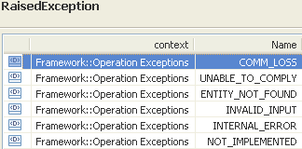  UNABLE_TO_COMPLY - Raised when the EMS is unable to execute the request because at least one of the parameters although valid can not be set and that parameter is identified as "not best effort" in additionalInfo. If the EMS cannot determine the reason it could not comply, it is also allowed to throw UNABLE_TO_COMPLY. | restriction base="msg:AllExceptionsType"  element ref="msg:commLoss"  element ref="msg:entityNotFound"  element ref="msg:internalError"  element ref="msg:invalidInput"  element ref="msg:notImplemented"

getPotentialFixedCrossConnections

BA (getPotentialFixedCrossConnections) | IA | IIS | Comments
R_TMF518_MRI_II_0101  The Interface shall allow the requesting OS to retrieve the attributes of all the potentially fixed Cross Connect (CC)s that are associated with the Termination Point (TP) name specified by the requesting OS. | This operation retrieves the attributes of all the potentially fixed Cross Connects (CCs) that are associated with the provided Termination Point (TP). I.e. the operation is able to retrieve fixed multiplexing and fixed inverse multiplexing schemes.  If the provided TP may be or is involved in a multiplexing or inverse multiplexing scheme, it will report:  1) the TP containing the fixed Layer  2) the list of potential fixed Cross-Connects that will exist if the containing TP's clientConnectivity or serverConnectivity is set to "Connected" (i.e. if the containing TP is currently multiplexing or inverse multiplexing).  If the clientConnectivity (resp. serverConnectivity) of the TP is currently set to "Connected", the potentialCcList matches the list of active fixed Cross-Connects that are involved in its client TPs (resp. server TPs).  If the TP client Layer (resp. server Layer) is always fixed cross connected (hard-wired), the potentialCcList always matches the list of active fixed Cross-Connects that are involved in the client TPs (resp. server TPs).  Traceability: R_TMF518_MRI_II_0101. | The operation is used to retrieve fixed connection schemes related to normal and inverse multiplexing.  See Subnetwork Connection Types for an explanation of fixed SNCs.  The operation takes as an input a TP and if this TP may be or is involved in a multiplexing or inverse multiplexing scheme, it will report:  - The TP containing the fixed layer.  - the list of potential fixed cross connects that will exist if the containing TP's clientConnectivity or serverConnectivity is set to "Connected" (i.e. If the containing TP is set to multiplexing or inverse multiplexing).  If the clientConnectivity (resp. serverConnectivity) of the TP is currently set to "Connected", the potentialCcList matches the list of active fixed cross connects that involve its client TPs (resp. server TPs).  If the TP client layer (resp. server layer) is always fixed cross connected (hard-wired), the potentialCcList always matches the list of active fixed cross connects that involve the client TPs (resp. server TPs).
 | tpRef (ObjectName)  This parameter provides the name of the Termination Point whose potential fixed Cross-Connects shall be retrieved.  The input TP may be either the containing TP or one of the end TPs of the portentialCcList. | (in) element name="inputTp" type="nam:NamingAttributeType"  Any TP name of the ME. The operation will return the multiplexing or inverse multiplexing scheme in which this TP is involved.  The input TP may be either the containing TP or one of the end TPs of the portentialCcList.
 | containingTp (ObjectName)  This parameter returns the TP supporting the attribute clientConnectivity or serverConnectivity. | (out) element name="containingTp" type="nam:NamingAttributeType"  The TP supporting the attribute clientConnectivity or serverConnectivity.
 | potentialCcList (*) (CrossConnect)  This parameter returns the list of all fixed Cross-Connects of that multiplexing scheme, i.e. the list of Cross-Connects that will exist when the containing TP clientConnectivity or serverConnectivity is set to "Connected". The A_end TPs of the Cross-Connects should be the low order TPs that can be flexibly cross connected, and the Z_end TPs the TP clients of the high order TP. The list of Cross-Connects does not have to be ordered. | (out) element name="potentialCcList" type="nam:NamingAttributeType"  The list of fixed Cross Connect of that multiplexing scheme, i.e. the list of cross connects that will exist when the containing TP clientConnectivity or serverConnectiivty is set to "Connected". The A_end TPs of the cross connects should be the low order TPs that can be flexibly cross connected, and the Z_end TPs the TP client of the high order TP. The list of cross connect does not take any specific order. If there are no potential fixed cross connects and empty list is returned.
 | 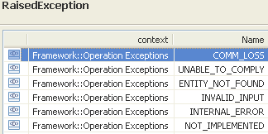 | restriction base="msg:AllExceptionsType"  element ref="msg:commLoss"  element ref="msg:entityNotFound"  element ref="msg:internalError"  element ref="msg:invalidInput"  element ref="msg:notImplemented"  element ref="msg:tooManyOpenIterators"  element ref="msg:unableToComply"

getRoute

BA (getRoute) | IA | IIS | Comments
R_TMF518_MRI_II_0042  The Interface shall allow the requesting OS to retrieve the attributes of a Route given a Subnetwork Connection (SNC) name specified by the requesting OS.  If the SNC has alternative routes, then the Interface shall allow the requesting OS to retrieve the intended route (if the SNC is the Pending or Partial state), the active route otherwise. | This operation retrieves the Route for a Subnetwork Connection (SNC). The Route information, in the form of Cross-Connections, should identify the resources allocated to the SNC at the time of the request and the way in which these resources are used.  If the SNC has more alternative Routes, then it retrieves the intended Route if the SNC is in Pending or Partial state, otherwise it retrieves the active Route. This because there can be more partial Routes and no active Route, in such case the intended Route is replied, as it is not known which of the partial Routes is the candidate for becoming the active Route.  The requesting OS specifies if it wants to retrieve only resources in the layer of the SNC (the Cross-Connections that belong to the SNC), or higher order Cross-Connections also (the Cross-Connections of other SNCs that are used to carry the traffic of the queried SNC).  All Cross-Connections allocated to the SNC must be returned, even if they are not active in the managed elements. This allows the requesting OS to query the Route that will be used before activating an SNC.  The operation also works for bundled SNCs. In the case of a bundled SNC, the target OS returns a set of Cross-Connections betweens GTPs.  In case of an SNC that represents a trail (to be identified by the roles of its end points) the operation getRouteAndTopologicalLinks() shall be used to facilitate the delivery of the Topological Links that support the trail termination inclusions of the SNC.  Traceability: R_TMF518_MRI_II_0042. | This operation retrieves the Route for a Subnetwork Connection (SNC). The Route information, in the form of Cross-Connections, should identify the resources allocated to the SNC at the time of the request and the way in which these resources are used.  If the SNC has more alternative Routes, then it retrieves the intended Route if the SNC is in Pending or Partial state, otherwise it retrieves the active Route. This because there can be more partial Routes and no active Route, in such case the intended Route is replied, as it is not known which of the partial Routes is the candidate for becoming the active Route.  The requesting OS specifies if it wants to retrieve only resources in the layer of the SNC (the Cross-Connections that belong to the SNC), or higher order Cross-Connections also (the Cross-Connections of other SNCs that are used to carry the traffic of the queried SNC).  All Cross-Connections allocated to the SNC must be returned, even if they are not active in the managed elements. This allows the requesting OS to query the Route that will be used before activating an SNC.  The operation also works for bundled SNCs. In the case of a bundled SNC, the target OS returns a set of Cross-Connections betweens GTPs.  In case of an SNC that represents a trail (to be identified by the roles of its end points) the operation getRouteAndTopologicalLinks() shall be used to facilitate the delivery of the Topological Links that support the trail termination inclusions of the SNC.
 | sncRef (ObjectName)  This parameter provides the name of the Subnetwork Connection whose Route shall be returned. | (in) element name="sncRef" type="nam:NamingAttributeType"  The name of the SNC.
?? | isHigherOrderCcListIncluded (Boolean)  This parameter specifies whether the higher order Cross-Connections of other SNCs used to carry the queried SNC have to be included in addition to the Cross-Connections of the queried SNC; false otherwise. | (in) element name=" isHigherOrderCcListIncluded" type="xsd:boolean"  Specifies whether the higher order CCs of other SNCs used to carry the queried SNC have to be included in addition to the CCs of the queried SNC.
 | route (Route)  This parameter returns the Route object containing the sequence of CTPs that comprise the working and protected (if applicable) Route of the Subnetwork Connection. | (out) element name="route" type="rt:RouteType"  The route of the SNC.
 | 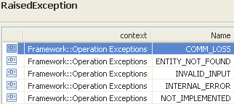 | restriction base="msg:AllExceptionsType"  element ref="msg:commLoss"  element ref="msg:entityNotFound"  element ref="msg:internalError"  element ref="msg:invalidInput"  element ref="msg:notImplemented"  element ref="msg:tooManyOpenIterators"  element ref="msg:unableToComply"

getSubnetworkConnection

BA (getSubnetworkConnection) | IA | IIS | Comments
R_TMF518_MRI_II_0036  The Interface shall allow the requesting OS to retrieve the attributes of a Subnetwork Connection (SNC)s given a SNC name specified by the requesting OS. | This operation retrieves the Subnetwork Connection and its associated distinguishing information.  The operation will return a bundled SNC structure if the name provided is that of a bundled SNC.  Traceability: R_TMF518_MRI_II_0036. | This operation will return the SubnetworkConnection structure for the SNC whose name is supplied as a parameter. This operations will provide a bundled SNC structure if the name provided is that of a bundled SNC (see Bundled SNC overview for further details).
 | sncRef (ObjectName)  This parameter provides the name of the Subnetwork Connection to be retrieved. | (in) element name="sncRef" type="nam:NamingAttributeType"  The name of the SNC.
 | snc (SubNetworkConnection)  This parameter returns the requested Subnetwork Connection object. | (out) element name="snc" type="snc:SubnetworkConnectionType"  The SNC.
 | 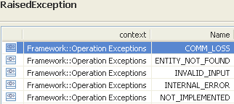 | restriction base="msg:AllExceptionsType"  element ref="msg:commLoss"  element ref="msg:entityNotFound"  element ref="msg:internalError"  element ref="msg:invalidInput"  element ref="msg:notImplemented"

getSubnetworkConnectionModeOfOperation «profile=xml»

BA | IA  («profile=xml, mTOPOperation»  getSubnetworkConnectionModeOfOperation()) | IIS (getSubnetworkConnectionModeOfOperation) | Comments
R_TMF518_MRI_II_0153  The Interface shall allow the requesting OS to retrieve the subnetwork connection management mode of operation. | The operation returns the supported subnetwork connection management mode of operation. The defined modes are contained in the attached Supporting Document SD1-23_ModesOfOperation.  Traceability R_TMF518_MRI_II_0153 | to be added
[out] sncModeOfOperation (SubnetworkConnectionModeOfOperation)
This parameter returns the supported SNC mode of operation.
Default value: NA
+++++++++++++++++
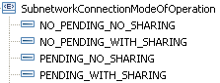

 | 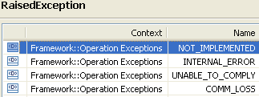

getSubnetworkConnectionsByUserLabel

BA (getSubnetworkConnectionsByUserLabel) | IA | IIS | Comments
R_TMF518_MRI_II_0037  The Interface shall allow the requesting OS to retrieve the attributes of a Subnetwork Connection (SNC)s given a SNC user label specified by the requesting OS. | This operation returns the Subnetwork Connections whose userLabel is supplied as a parameter.  The operation also works for bundled SNCs.  Traceability: R_TMF518_MRI_II_0037. | This operation will return the SubnetworkConnection structures for the SNCs whose userLabel is supplied as a parameter. This operation will provide a bundled SNC structure if the name provided is that of a bundled SNC (see Bundled SNC overview for further details).
 | userLabel (String)  This parameter provides the User Label of the Subnetwork Connections to be retrieved. | (in) element name="userLabel" type="xsd:string"  The userLabel of the SNCs to retrieve.
 | sncList (*)  This parameter returns the list of Subnetwork Connections matching the provided User Label. | MultipleSubnetworkConnectionObjectsResponseType  element name="sncList" type="snc:SubnetworkConnectionListType"  The list of SNCs.
 | 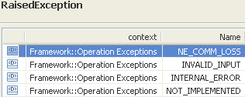 | restriction base="msg:AllExceptionsType"  element ref="msg:commLoss"  element ref="msg:internalError"  element ref="msg:invalidInput"  element ref="msg:notImplemented"

Data Types

GetCrossConnectionsRequest Type

BA | IA | IIS (GetCrossConnectionsRequestType) | Comments
Request message structure for a set of CC object names
(in) element name="meRef" type="nam:NamingAttributeType"
Name of the Managed Element for which to retrieve CCs.
(in) element name="connectionRateList" type="lay:LayerRateListType"
List of rates for which to retrieve CCs. This must not be an empty list. In this case an INVALID_INPUT exception is thrown.

GetSubnetworkConnectionsRequest Type

BA | IA | IIS (GetSubnetworkConnectionsRequestType) | Comments
element name="mlsnRef" type="nam:NamingAttributeType"
Name of the subnetwork.
element name="connectionRateList" type="lay:LayerRateListType"
List of rates of the SNC names to be reported. If an empty list is specified, then all SNC names of all rates are to be reported.

GetSubnetworkConnectionsWithTpRequest Type

BA | IA | IIS (GetSubnetworkConnectionsWithTpRequestType) | Comments
element name="tpRef" type="nam:NamingAttributeType"
Termination point for which to report SNCs. The termination point name must be explicit (a generic endpoint specification may not be used in this case). See Object Naming for further detail on FTP naming.
element name="connectionRateList" type="lay:LayerRateListType"
List of rates of the SNC names to be reported. If an empty list is specified, then all SNC names of all rates are to be reported.

MultipleCrossConnectionObjectsResponse Type

BA | IA | IIS (MultipleCrossConnectionObjectsResponseType) | Comments
element name="ccList" type="cc:CrossConnectListType"
The list of CCs.

MultipleSubnetworkConnectionObjectsResponse Type

BA | IA | IIS (MultipleSubnetworkConnectionObjectsResponseType) | Comments
element name="sncList" type="snc:SubnetworkConnectionListType"
The list of SNCs.

Equipment Inventory Retrieval Service
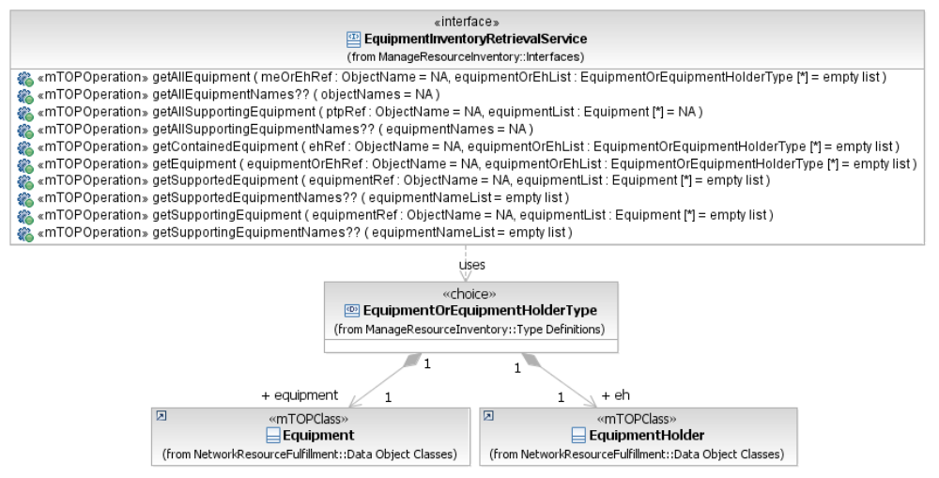
Figure 4: MRI Equipment Inventory Retrieval Service Interface Diagram

getAllEquipment

BA (getAllEquipment) | IA | IIS | Comments
R_TMF518_MRI_II_0085  The Interface shall allow the requesting OS to retrieve the attributes of all the Equipments given a Managed Element (ME) name specified by the requesting OS.  R_TMF518_MRI_II_0086  R_TMF518_MRI_II_0088  The Interface shall allow the requesting OS to retrieve the attributes of all the Equipments and Equipment Holders given an Equipment Holder name specified by the requesting OS.  The target OS shall return all Equipments and Equipment Holders at all levels of containment beneath the specified Equipment Holders.  R_TMF518_MRI_II_0089 | This operation returns all Equipment and Equipment Holders that are contained in a provided Managed Element or Equipment Holder.  Traceability: R_TMF518_MRI_II_0085, R_TMF518_MRI_II_0088. | This operation returns all Equipment and Equipment Holders that are contained in a provided Managed Element or Equipment Holder.
 | meOrEhRef (ObjectName)  This parameter provides the name of the Managed Element or Equipment Holder for which to retrieve the contained Equipment and Equipment Holders. | type="tns:GetAllEquipmentRequestType"  element name="meOrEhRef" type="nam:NamingAttributeType"  This parameter provides the name of the Managed Element or Equipment Holder for which to retrieve the contained Equipment and Equipment Holders.
 | equipmentOrEhList (*) (EquipmentOrEquipmentHolderType)  This parameter returns the list of all Equipment and/or Equipment Holder objects.  +++++++++++++++++  see EquipmentOrEquipmentHolder Type in section 3.7.2 | type="ei:EquipmentOrHolderListType"  +++++++++++++++++  see EquipmentOrEquipmentHolder Type in section 3.7.2
 | 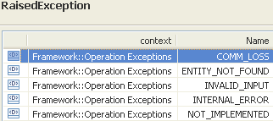 | restriction base="msg:AllExceptionsType"  element ref="msg:commLoss"  element ref="msg:entityNotFound"  element ref="msg:internalError"  element ref="msg:invalidInput"  element ref="msg:notImplemented"  element ref="msg:tooManyOpenIterators"

getAllSupportingEquipment

BA (getAllSupportingEquipment) | IA | IIS | Comments
R_TMF518_MRI_II_0083  The Interface shall allow the requesting OS to retrieve the attributes of all the Equipment(s) that support the Physical Termination Point (PTP) identified by the PTP name specified by the requesting OS.  R_TMF518_MRI_II_0084 | This operation returns all Equipment that supports a provided Physical Termination Point (PTP) or Floating Termination Point (FTP).  For a PTP, the Equipment that are returned are those which support the physical layer of the PTP (i.e. implements the port or are connected by a fibre, wire, etc.).  For an FTP, the Equipment returned are those which support the physical circuitry implementing the FTP and will include the Equipment from which the FTP is named (the FTPs will depend upon the presence of that Equipment for their most basic operation).  For a particular PTP/FTP the Tx port/function and Rx port/function may be on different cards and in this case both should be returned. Equipment that are used by the PTPs/FTPs, but that do not support them directly (such as a shared DEMUX card) are not reported.  In case of Equipment Protection, the operation reports the primary Equipment only; i.e., the protecting Equipment will not be returned.  Traceability: R_TMF518_MRI_II_0083. | This operation returns all Equipment that supports a provided Physical Termination Point (PTP) or Floating Termination Point (FTP).  For a PTP, the Equipment that are returned are those which support the physical layer of the PTP (i.e. implements the port or are connected by a fibre, wire, etc.).  For an FTP, the Equipment returned are those which support the physical circuitry implementing the FTP and will include the Equipment from which the FTP is named (the FTPs will depend upon the presence of that Equipment for their most basic operation).  For a particular PTP/FTP the Tx port/function and Rx port/function may be on different cards and in this case both should be returned. Equipment that are used by the PTPs/FTPs, but that do not support them directly (such as a shared DEMUX card) are not reported.  In case of Equipment Protection, the operation reports the primary Equipment only; i.e., the protecting Equipment will not be returned. | bz:  BA does not mention FTP.
 | ptpRef (ObjectName)  This parameter provides the name of the PTP/FTP for which to retrieve the supporting Equipment.  The Termination Point name must be explicit (a generic endpoint specification may not be used in this case). | type="tns:GetAllEquipmentWithPtpRequestType"  (in) element name="ptpRef" type="nam:NamingAttributeType"  This parameter provides the name of the PTP/FTP for which to retrieve the supporting Equipment.  The Termination Point name must be explicit (a generic endpoint specification may not be used in this case).
 | equipmentList (*) (Equipment)  This parameter returns the list of all supporting Equipment objects. | type="ei:EquipmentOrHolderListType"  +++++++++++++++++  see EquipmentOrEquipmentHolder Type in section 3.7.2
 | 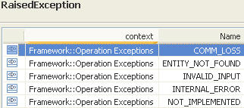 | restriction base="msg:AllExceptionsType"  element ref="msg:commLoss"  element ref="msg:entityNotFound"  element ref="msg:internalError"  element ref="msg:invalidInput"  element ref="msg:notImplemented"

getContainedEquipment

BA (getContainedEquipment) | IA | IIS | Comments
R_TMF518_MRI_II_0087  The Interface shall allow the requesting OS to retrieve the attributes of all the Equipment contained directly in the Equipment Holder identified by a Equipment Holder name specified by the requesting OS. | This operation returns the Equipment and Equipment Holders directly contained by a provided Equipment Holder.  The operation differs from getAllEquipment() in that it only looks at the next level of the containment hierachy.  Traceability: R_TMF518_MRI_II_0087. | This operation returns the Equipment and Equipment Holders directly contained by a provided Equipment Holder.  The operation differs from getAllEquipment() in that it only looks at the next level of the containment hierarchy.
 | ehRef (ObjectName)  This parameter provides the name of the Equipment Holder for which to retrieve the directly contained Equipment and Equipment Holders. | (in) element name="ehRef" type="nam:NamingAttributeType"  This parameter provides the name of the Equipment Holder for which to retrieve the directly contained Equipment and Equipment Holders.
 | equipmentOrEhList (*) (EquipmentOrEquipmentHolderType)  This parameter returns the list of all Equipment and/or Equipment Holder objects.  +++++++++++++++++  see EquipmentOrEquipmentHolder Type in section 3.7.2 | type="ei:EquipmentOrHolderListType"  +++++++++++++++++  see EquipmentOrEquipmentHolder Type in section 3.7.2
restriction base="msg:AllExceptionsType"
element ref="msg:commLoss"
element ref="msg:entityNotFound"
element ref="msg:internalError"
element ref="msg:invalidInput"
element ref="msg:notImplemented"

getEquipment

BA (getEquipment) | IA | IIS | Comments
?? | This operation returns an Equipment or Equipment Holder object.  Traceability: R_TMF518_MRI_II_00??. | This operation returns an Equipment or Equipment Holder object. | bz:  TMF513v3.1 associates R_TMF518_MRI_II_0085 to this operation.
 | equipmentOrEhRef (ObjectName)  This parameter provides the name of the Equipment or Equipment Holder to be retrieved. | (in) element name="equipmentOrEhRef" type="nam:NamingAttributeType"  This parameter provides the name of the Equipment or Equipment Holder to be retrieved.
 | equipmentOrEhList (*) (EquipmentOrEquipmentHolderType)  This parameter returns the list of all Equipment and/or Equipment Holder objects.  +++++++++++++++++  see EquipmentOrEquipmentHolder Type in section 3.7.2 | (out) element name=" equipmentOrEhList" type="ei:EquipmentOrHolderType"  This parameter returns the list of all Equipment and/or Equipment Holder objects.  +++++++++++++++++  see EquipmentOrEquipmentHolder Type in section 3.7.2
restriction base="msg:AllExceptionsType"
element ref="msg:commLoss"
element ref="msg:entityNotFound"
element ref="msg:internalError"
element ref="msg:invalidInput"
element ref="msg:notImplemented"

getSupportedEquipment

BA (getSupportedEquipment) | IA | IIS | Comments
R_TMF518_MRI_II_0092  The Interface shall allow the requesting OS to retrieve the attributes of all the Equipments that are supported by an Equipment identified by an Equipment name specified by the requesting OS.  R_TMF518_MRI_II_0093 | This operation returns all Equipment that are supported by the provided Equipment, e.g., a power pack might support many circuit packs.  Traceability: R_TMF518_MRI_II_0092. | This operation returns all Equipment that are supported by the provided Equipment, e.g., a power pack might support many circuit packs.
 | equipmentRef (ObjectName)  This parameter provides the name of the Equipment for which to retrieve the supported Equipment object list. | type="tns:GetSupportEquipmentRequestType"  +++++++++++++++++  see GetSupportEquipmentRequestType Type in section 3.7.1
 | equipmentList (*) (Equipment)  This parameter returns the list of all supported Equipment objects. | type="ei:EquipmentOrHolderListType"  +++++++++++++++++  see EquipmentOrEquipmentHolder Type in section 3.7.2
 | 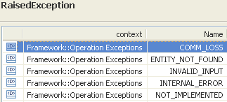 | restriction base="msg:AllExceptionsType"  element ref="msg:commLoss"  element ref="msg:entityNotFound"  element ref="msg:internalError"  element ref="msg:invalidInput"  element ref="msg:notImplemented"

getSupportingEquipment

BA (getSupportingEquipment) | IA | IIS | Comments
R_TMF518_MRI_II_0090  The Interface shall allow the requesting OS to retrieve the attributes of all the Equipments that support an Equipment identified by an Equipment name specified by the requesting OS.  R_TMF518_MRI_II_0091 | This operation returns all Equipment that supports the provided Equipment, e.g., the power pack and synchronization card that support a given piece of Equipment.  Traceability: R_TMF518_MRI_II_0090. | This operation returns all Equipment that supports the provided Equipment, e.g., the power pack and synchronization card that support a given piece of Equipment.
 | equipmentRef (ObjectName)  This parameter provides the name of the Equipment for which to retrieve the supporting Equipment object list. | type="tns:GetSupportEquipmentRequestType"  +++++++++++++++++  see GetSupportEquipmentRequestType Type in section 3.7.1
 | equipmentList (*) (Equipment)  This parameter returns the list of all supporting Equipment objects. | type="ei:EquipmentOrHolderListType"  +++++++++++++++++  see EquipmentOrEquipmentHolder Type in section 3.7.2
restriction base="msg:AllExceptionsType"
element ref="msg:commLoss"
element ref="msg:entityNotFound"
element ref="msg:internalError"
element ref="msg:invalidInput"
element ref="msg:notImplemented"

Data Types

GetSupportEquipmentRequest Type

BA | IA | IIS (GetSupportEquipmentRequestType) | Comments
element name="equipmentRef" type="nam:NamingAttributeType"
the name of the equipment for which to retrieve the supported/supporting equipment list.

EquipmentOrEquipmentHolder Type

BA | IA | IIS (EquipmentOrHolderType) | Comments
 | EquipmentOrEquipmentHolderType  This data type contains either an Equipment or an Equipment Holder object.  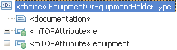  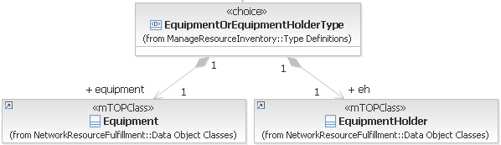 | defined in NRF  EquipmentOrEquipmentHolderType"  This data type contains either an Equipment or an Equipment Holder object .  choice  element ref="eq:eq"  element ref="eh:eh"  </xsd:choice>

Flow Domain Retrieval Service
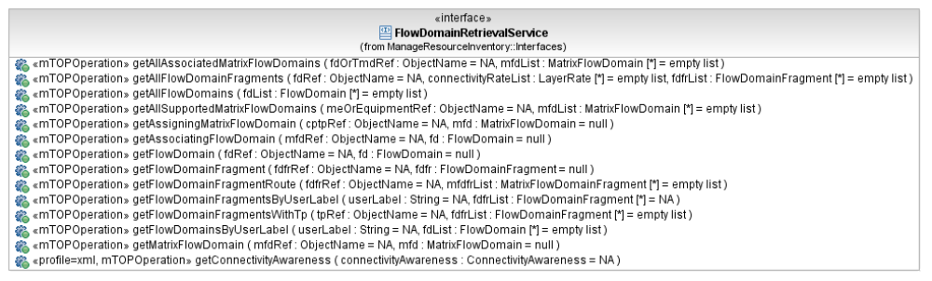
Figure 5: MRI Flow Domain Retrieval Service Interface Diagram

getAllAssociatedMatrixFlowDomains

BA (getAllAssociatedMatrixFlowDomains) | IA | IIS | Comments
R_TMF518_MRI_II_0113  The Interface shall allow the requesting OS to retrieve all the Matrix Flow Domain (MFD)s that are associated with a specified Transmission Descriptor (TMD).  R_TMF518_MRI_II_0119  The Interface shall allow the requesting OS to retrieve the attributes of all Matrix Flow Domain (MFD)s associated with a specified Flow Domain (FD). | This operation retrieves the details of all Matrix Flow Domains (MFDs) that are associated with the provided Flow Domain or Transmission Descriptor.  Traceability: R_TMF518_MRI_II_0113, R_TMF518_MRI_II_0119. | This operation allows an OS to request a list of matrix flow domains that are contained by a specified managed element or associated with a specified equipment, transmission descriptor or flow domain. | bz:  Equipment supports MFDs.
 | fdOrTmdRef (ObjectName)  This parameter provides the name of the Flow Domain or Transmission Descriptor for which to retrieve the associated Matrix Flow Domains. | (in) element name="fdOrTmdRef " type="nam:NamingAttributeType"  This parameter provides the name of the Flow Domain or Transmission Descriptor for which to retrieve the associated Matrix Flow Domains. | bz:  Equipment and ME supports MFDs.
 | mfdList (*) (MatrixFlowDomain)  This parameter returns the list of all Matrix Flow Domain objects associated with the provided Flow Domain or Transmission Descriptor. | (out) element name="mfdList" type="mfd:MatrixFlowDomainListType"  This parameter returns the list of all Matrix Flow Domain objects associated with the provided Flow Domain or Transmission Descriptor.
restriction base="msg:AllExceptionsType"
element ref="msg:commLoss"
element ref="msg:entityNotFound"
element ref="msg:internalError"
element ref="msg:invalidInput"
element ref="msg:notImplemented"
element ref="msg:tooManyOpenIterators"

getAllFlowDomainFragments

BA (getAllFlowDomainFragments) | IA | IIS | Comments
R_TMF518_MRI_II_0126  The Interface shall allow the requesting OS to retrieve the attributes of all the Flow Domain Fragment (FDFr)s contained within a specified Flow Domain (FD). It shall be possible to filter the FDFrs to be retrieved based on their connectivity rates. | This operation retrieves the details of all the Flow Domain Fragments (FDFrs) contained in the provide Flow Domain (FD) by using a filter that is based on the Connectivity Rates.  Traceability: R_TMF518_MRI_II_0126. | This operation retrieves the details of all the Flow Domain Fragments (FDFrs) contained in the provide Flow Domain (FD) by using a filter that is based on the Connectivity Rates.
 | fdRef (ObjectName)  This parameter provides the name of the Flow Domain whose Flow Domain Fragments are in scope. | (in) element name="fdRef" type="nam:NamingAttributeType"  Name of the flow domain.
 | connectivityRateList (*) (LayerRate)  This parameter indicates the Connectivity Rates of the Flow Domain Fragments which are used to scope the request.  If the list is empty, then all Flow Domain Fragments contained in the Flow Domain are to be returned. | (in) element name="connectivityRateList" type="lay:LayerRateListType"  List of rates of the flow domain fragments to be reported. If an empty list is specified, then all flow domain fragments of all rates are to be reported.
 | fdfrList (*) (FlowDomainFragment)  This parameter returns the list of Flow Domain Fragment objects contained in the Flow Domain selected by the given Connectivity Rates. | (out) element name="fdfrList" type="fdfr:FlowDomainFragmentListType"  This parameter returns the list of Flow Domain Fragment objects contained in the Flow Domain selected by the given Connectivity Rates.
 | 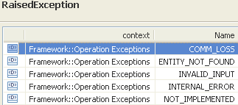 | restriction base="msg:AllExceptionsType"  element ref="msg:commLoss"  element ref="msg:entityNotFound"  element ref="msg:internalError"  element ref="msg:invalidInput"  element ref="msg:notImplemented"  element ref="msg:tooManyOpenIterators"

getAllFlowDomains

BA (getAllFlowDomains) | IA | IIS | Comments
R_TMF518_MRI_II_0117  The Interface shall allow the requesting OS to retrieve the attributes of all Flow Domain (FD)s managed by the target OS. | This operation retrieves the details of all Flow Domains managed by the target OS.  Traceability: R_TMF518_MRI_II_0117. | This operation allows an OS to request a list of the flow domains that exist under the given MD.
?? | ?? | (in) element name="mdRef" type="nam:NamingAttributeType"  The name of the Management Domain whose contained FDs are being requested.
 | fdList (*) (FlowDomain)  This parameter returns the list of all Flow Domain objects managed by the target OS. | (out) element name="fdList" type="fd:FdListType"  List of FlowDomains.
 | 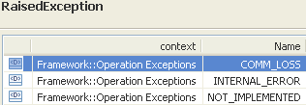 | restriction base="msg:AllExceptionsType"  element ref="msg:commLoss"  element ref="msg:entityNotFound"  element ref="msg:internalError"  element ref="msg:invalidInput"  element ref="msg:notImplemented"  element ref="msg:tooManyOpenIterators"

getAllSupportedMatrixFlowDomains

BA (getAllSupportedMatrixFlowDomains) | IA | IIS | Comments
R_TMF518_MRI_II_0109  The Interface shall allow the requesting OS to retrieve the attributes of all Matrix Flow Domain (MFD)s supportedcontained within a specified Managed Element (ME).  It is irrelevant whether or not the MFDs are actually associated to a Flow Domain (FD).  R_TMF518_MRI_II_0112  The Interface shall allow the requesting OS to retrieve the attributes of the Matrix Flow Domain (MFD)s that are supported by a specific Equipment; given a specified Equipment name. | This operation retrieves the details of all Matrix Flow Domains (MFDs) that are supported by the provided Managed Element or Equipment.  Traceability: R_TMF518_MRI_II_0109, R_TMF518_MRI_II_0112. | This operation retrieves the details of all Matrix Flow Domains (MFDs) that are supported by the provided Managed Element or Equipment.
 | meOrEquipmentRef (ObjectName)  This parameter provides the name of the Managed Element or Equipment for which to retrieve the supported Matrix Flow Domains. | (in) element name= meOrEquipmentRef " type="nam:NamingAttributeType"  This parameter provides the name of the Managed Element or Equipment for which to retrieve the supported Matrix Flow Domains. | bz:  TMD and FD are associated to MFDs.
 | mfdList (*) (MatrixFlowDomain)  This parameter returns the list of all Matrix Flow Domain objects supported by the provided Managed Element or Equipment. | (out) element name="mfdList" type="mfd:MatrixFlowDomainListType"  This parameter returns the list of all Matrix Flow Domain objects supported by the provided Managed Element or Equipment.
 | 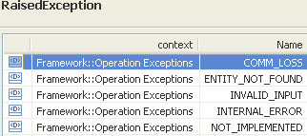 | restriction base="msg:AllExceptionsType"  element ref="msg:commLoss"  element ref="msg:entityNotFound"  element ref="msg:internalError"  element ref="msg:invalidInput"  element ref="msg:notImplemented"  element ref="msg:tooManyOpenIterators"

getAssigningMatrixFlowDomain

BA (getAssigningMatrixFlowDomain) | IA | IIS | Comments
R_TMF518_MRI_II_0108  The Interface shall allow the requesting OS to retrieve the attributes of the Matrix Flow Domain (MFD) that is assigned to a requesting OS specified Connectionless Port TP (CPTP). | This operation retrieves the details of a Matrix Flow Domain (MFD) that is assigned to a given Connectionless Port Termination Point (CPTP).  Traceability: R_TMF518_MRI_II_0108. | This operation returns the matrix flow domain to which is assigned a given "CPTP" termination point.
 | cptpRef (ObjectName)  This parameter provides the name of the CPTP to which the MFD to be retrieved is assigned to. | (in) element name="cptpRef" type="nam:NamingAttributeType"  Name of the CPTP termination point to which the MatrixFlowDomain is assigned.
 | mfdList (MatrixFlowDomain)  This parameter returns the assigning Matrix Flow Domain object. | (out) element name="mfd" type="mfd:MatrixFlowDomainType"  Matrix flow domain structure returned.
 | 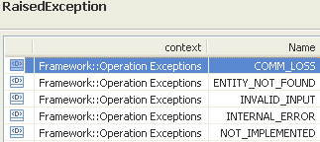 | restriction base="msg:AllExceptionsType"  element ref="msg:commLoss"  element ref="msg:entityNotFound"  element ref="msg:internalError"  element ref="msg:invalidInput"  element ref="msg:notImplemented"

getAssociatingFlowDomain

BA (getAssociatingFlowDomain) | IA | IIS | Comments
R_TMF518_MRI_II_0115  The Interface shall allow the requesting OS to retrieve the attributes of the Flow Domain (FD) that is associated to a specified Matrix Flow Domain (MFD). | This operation retrieves the details of the Flow Domain that a provided Matrix Flow Domain is associated to.  Traceability: R_TMF518_MRI_II_0115. | This operation returns the flow domain structure for the (single) flow domain that the Matrix Flow Domain that is supplied as a parameter is associated to.
 | mfdRef (ObjectName)  This parameter provides the name of the Matrix Flow Domain whose associating Flow Domain is requested. | (in) element name="mfdRef" type="nam:NamingAttributeType"  Name of the MatrixFlowDomain.
 | fd (FlowDomain)  This parameter returns the associating Flow Domain object. | (out) element name="fd" type="fd:FlowDomainType"  The flow domain that the Matrix Flow Domain is associated to.
 | 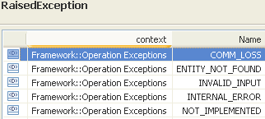 | restriction base="msg:AllExceptionsType"  element ref="msg:commLoss"  element ref="msg:entityNotFound"  element ref="msg:internalError"  element ref="msg:invalidInput"  element ref="msg:notImplemented"

getConnectivityAwareness «profile=xml»

BA | IA  («profile=xml, mTOPOperation»  getConnectivityAwareness()) | IIS (getConnectivityAwareness) | Comments
R_TMF518_MRI_V_0154  The NML-EML Interface shall allow the NMS to retrieve the connectivity awareness capability (with regard to the connectionless technologies) provided by the EMS.  The EMS works either in the “connectivity-aware” or in the “connectivity-unaware” mode:  • “connectivity aware” indicates that the EMS has some capability to detect the connectivity between the MFDs within an FD  • “connectivity-unaware” indicates that the EMS has no capability at all to detect connectivity between the MFDs within an FD. | This operation returns the supported connectivity awareness capability (with regard to the connectionless technologies) provided by the target OS.  The target OS works either in the “connectivity-aware” or in the “connectivity-unaware” mode:  - “connectivity aware” indicates that the target OS has some capability to detect the connectivity between the MFDs within an FD  - “connectivity-unaware” indicates that the target OS has no capability at all to detect connectivity between the MFDs within an FD.  Traceability R_TMF518_MRI_II_0154 | to be added
[out] connectivityAwareness (ConnectivityAwareness)
This parameter returns the supported connectivity awareness capability.
Default value: NA
+++++++++++++++++
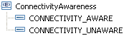

getFlowDomain

BA (getFlowDomain) | IA | IIS | Comments
R_TMF518_MRI_II_0121  The Interface shall allow the requesting OS to retrieve the attributes of a Flow Domain (FD) given a specified FD name | This operation retrieves the details of a Flow Domain given its Name.  Traceability: R_TMF518_MRI_II_0121. | This operation allows an OS to request a flow domain.
 | fdRef (ObjectName)  This parameter provides the name of the Flow Domain to be retrieved. | (in) element name="fdRef" type="nam:NamingAttributeType"  Name of the FlowDomain.
 | fd (FlowDomain)  This parameter returns the Flow Domain object selected by the given name. | (out) element name="fd" type="fd:FlowDomainType"  Flow Domain Structure returned.
restriction base="msg:AllExceptionsType"
element ref="msg:commLoss"
element ref="msg:entityNotFound"
element ref="msg:internalError"
element ref="msg:invalidInput"
element ref="msg:notImplemented"

getFlowDomainFragment

BA (getFlowDomainFragment) | IA | IIS | Comments
R_TMF518_MRI_II_0128  The Interface shall allow the requesting OS to retrieve the attributes of a Flow Domain Fragment (FDFr) given a specified FDFr name. | This operation retrieves the details of the Flow Domain Fragment (FDFr) given its Name.  Traceability: R_TMF518_MRI_II_0128. | This operation returns the flow domain fragment structure for the flow domain fragment whose name is supplied as a parameter.
 | fdfrRef (ObjectName)  This parameter provides the name of the Flow Domain Fragment to be retrieved. | (in) element name="fdfrRef" type="nam:NamingAttributeType"  Name of the FDFr to retrieve.
 | fdfr (FlowDomainFragment)  This parameter returns the Flow Domain Fragment object selected by the given name. | (out) element name="fdfr" type="fdfr:FlowDomainFragmentType"  Retrieved FDFr with the name as specified in input.
 | 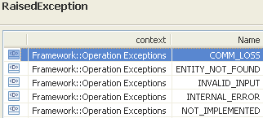 | restriction base="msg:AllExceptionsType"  element ref="msg:commLoss"  element ref="msg:entityNotFound"  element ref="msg:internalError"  element ref="msg:invalidInput"  element ref="msg:notImplemented"

getFlowDomainFragmentRoute

BA (getFlowDomainFragmentRoute) | IA | IIS | Comments
R_TMF518_MRI_II_0131  The Interface shall allow the requesting OS to retrieve the Matrix Flow Domain Fragment (MFDFr)s of a Flow Domain Fragment (FDFr) given a specified FDFr name. | This operation retrieves the Route (i.e., the list of Matrix Flow Domain Fragments) of the Flow Domain Fragment.  It is only used for systems where the Route is provisioned by the OS (e.g., it is not useful for Ethernet networks using GVRP).  Traceability: R_TMF518_MRI_II_0131. | This operation returns the route for the FdFr whose name is specified as a parameter. It is only used for systems where the route is provisioned by the OS (e.g., it is not useful for Ethernet networks using GVRP).
 | fdfrRef (ObjectName)  This parameter provides the name of the Flow Domain Fragment whose Route is to be retrieved. | (in) element name="fdfrRef" type="nam:NamingAttributeType"  The name of the FDFr.
 | mfdfrList (*) (MatrixFlowDomainFragment)  This parameter returns the list of Matrix Flow Domain Fragment objects forming the Route of the provided Flow Domain Fragment. | (out) element name="route" type="fdfrr:FlowDomainFragmentRouteType"  The route of the FDFr.  +++++++++++++++++  name="FlowDomainFragmentRouteType"  A route for an FDFr is defined as a partially ordered list of MFDFr.  <xsd:sequence>  <xsd:element ref="mfdfr:mfdfr" minOccurs="0" maxOccurs="unbounded"/>  </xsd:sequence> | 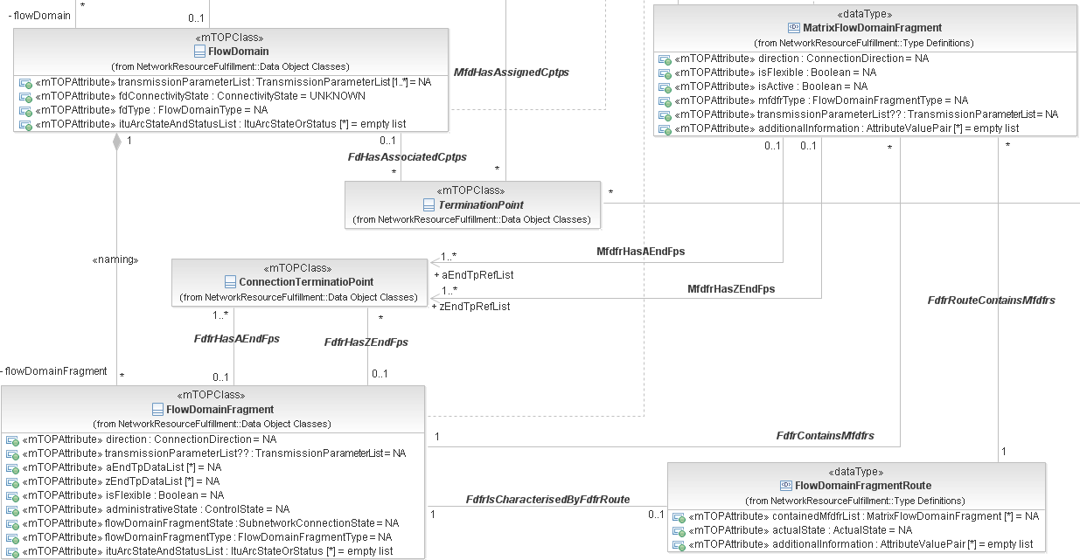
 | 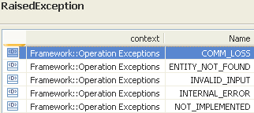 | restriction base="msg:AllExceptionsType"  element ref="msg:commLoss"  element ref="msg:entityNotFound"  element ref="msg:internalError"  element ref="msg:invalidInput"  element ref="msg:notImplemented"

getFlowDomainFragmentsByUserLabel

BA (getFlowDomainFragmentsByUserLabel) | IA | IIS | Comments
R_TMF518_MRI_II_0129  The Interface shall allow the requesting OS to retrieve the attributes of all the Flow Domain Fragment (FDFr) given a specified FDFr user label. | This operation retrieves the details of all Flow Domain Fragments contained in the Flow Domain which have the provided User Label.  Traceability: R_TMF518_MRI_II_0129. | This operation returns the flow domain fragment structures for the flow domain fragments whose userLabel is supplied as a parameter.
 | fdRef (Objectname)
 | userLabel (String)  This parameter provides the User Label of the Flow Domain Fragments to be retrieved. | (in) element name="userLabel" type="xsd:string"  The user label of the flow domain fragments to retrieve. | bz:  Why does the IIS need an extra UserLabelType?
 | fdfrList (*) (FlowDomainFragment)  This parameter returns the list of Flow Domain Fragment objects selected by the given User Label. | (out) element name="fdfrList" type="fdfr:FlowDomainFragmentListType"  Retrieved FDFrList with the userLabel as specified in input.
 | 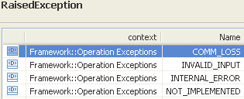 | restriction base="msg:AllExceptionsType"  element ref="msg:commLoss"  element ref="msg:internalError"  element ref="msg:invalidInput"  element ref="msg:notImplemented"

getFlowDomainFragmentsWithTp

BA (getFlowDomainFragmentsWithTp) | IA | IIS (getFlowDomainFragmentsWithTp) | Comments
R_TMF518_MRI_II_0127  The Interface shall allow the requesting OS to retrieve the attributes of all the Flow Domain Fragment (FDFr)s that connect or pass through client Flow Point (FP)s of the specified Connectionless Port TP (CPTP).  R_TMF518_MRI_II_0130  The Interface shall allow the requesting OS to retrieve the attributes of the Flow Domain Fragment (FDFr) connecting a Flow Point (FP) given a specified FP name. | This operation retrieves the details of all the Flow Domain Fragments (FDFrs) that connects or passes through  - client Flow Points of the provided Connectionless Port Termination Point (CPTP) or  - the provided Flow Point.  In case a Flow Point is provided, not more than one FDFr will be returned.  Traceability: R_TMF518_MRI_II_0127, R_TMF518_MRI_II_0130. | This operation retrieves the details of all the Flow Domain Fragments (FDFrs) that connects or passes through  - client Flow Points of the provided Connectionless Port Termination Point (CPTP) or  - the provided Flow Point.  In case a Flow Point is provided, not more than one FDFr will be returned.
 | tpRef (ObjectName)  This parameter provides either the Name of an FP or the Name of a server layer CPTPfor which the connecting FDFr shall be returned. | (in) element name="tpRef" type="nam:NamingAttributeType"  The name of the flow point or CPTP for which the connected flow domain fragments shall be returned.
 | fdfrList (*) (FlowDomainFragment)  This parameter returns the list of Flow Domain Fragment objects that connects or passes through the provided Flow Point or client Flow Points of the provided CPTP. | (out) element name="fdfrList" type="fdfr:FlowDomainFragmentListType"  This parameter returns the list of Flow Domain Fragment objects that connects or passes through the provided Flow Point or client Flow Points of the provided CPTP.
 | 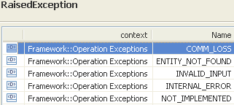 | restriction base="msg:AllExceptionsType"  element ref="msg:commLoss"  element ref="msg:entityNotFound"  element ref="msg:internalError"  element ref="msg:invalidInput"  element ref="msg:notImplemented"  element ref="msg:tooManyOpenIterators"

getFlowDomainsByUserLabel

BA (getFlowDomainsByUserLabel) | IA | IIS | Comments
R_TMF518_MRI_II_0120  The Interface shall allow the requesting OS to retrieve the attributes of all the Flow Domain (FD)s given a specified FD user label.  Note:  The user label may or may not be unique within the target OS domain. Non-unique user labels can be used by the Requesting OS for example to associate several FDs from the same target OS, typically to indicate that those FDs participate in the same service provider's application (corporate customer, etc.). This situation may occur for example in case the Target OS supports only singleton FDs. | This operation retrieves the details of all Flow Domains which have the provided User Label.  Traceability: R_TMF518_MRI_II_0120. | This operation retrieves the details of all Flow Domains which have the provided User Label.
 | userLabel (String)  This parameter provides the User Label of the Flow Domains to be retrieved. | (in) element name="userLabel" type="xsd:string"  UserLabel of the FlowDomain. | bz:  Why does the IIS need an extra UserLabelType?
 | fdList (*) (FlowDomainFragment)  This parameter returns the list of Flow Domain objects selected by the given User Label. | (out) element name="fdList" type="fd: FlowDomain ListType"  List of FlowDomains.
 | 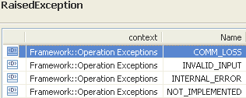 | restriction base="msg:AllExceptionsType"  element ref="msg:commLoss"  element ref="msg:internalError"  element ref="msg:invalidInput"  element ref="msg:notImplemented"

getMatrixFlowDomain

BA (getMatrixFlowDomain) | IA | IIS | Comments
R_TMF518_MRI_II_0110  The Interface shall allow the requesting OS to retrieve the attributes of a Matrix Flow Domain (MFD) given a specified MFD name | This operation retrieves the details of a Matrix Flow Domain given its name.  Traceability: R_TMF518_MRI_II_0110. | This operation returns a matrix flow domain given a matrix flow domain name.
 | mfdRef (ObjectName)  This parameter provides the name of the Matrix Flow Domain to be retrieved. | (in) element name="mfdRef" type="nam:NamingAttributeType"  Name of the matrix flow domain to retrieve.
 | mfd (MatrixFlowDomain)  This parameter returns the Matrix Flow Domain object selected by the given name. | (out) element name="mfd" type="mfd:MatrixFlowDomainType"  Matrix flow domain structure returned.
restriction base="msg:AllExceptionsType"
element ref="msg:commLoss"
element ref="msg:entityNotFound"
element ref="msg:internalError"
element ref="msg:invalidInput"
element ref="msg:notImplemented"

Managed Element Retrieval Service
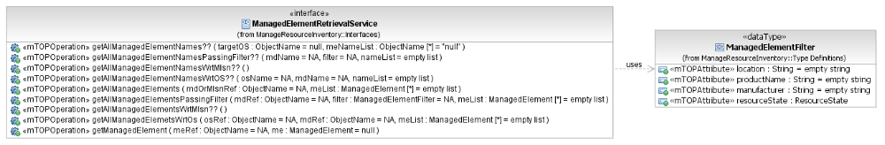
Figure 6: MRI Managed Element Retrieval Service Interface Diagram

getAllManagedElements

BA (getAllManagedElements) | IA | IIS | Comments
R_TMF518_MRI_II_0015  The Interface shall allow the requesting OS to retrieve the attributes of all the Managed Elements (ME)s that are contained in a management domain.  R_TMF518_MRI_II_0016  R_TMF518_MRI_II_0017  The Interface shall allow the requesting OS to retrieve the attributes of all the Managed Elements (ME)s that are contained within a Subnetwork specified by the requesting OS.  R_TMF518_MRI_II_0018 | This operation returns all the Managed Elements contained by a provided Management Domain or Multi Layer Subnetwork.  Traceability: R_TMF518_MRI_II_0015, R_TMF518_MRI_II_0017. | This operation returns all the Managed Elements contained by a provided Management Domain or Multi Layer Subnetwork.
 | mdOrMlsnRef (ObjectName)  This parameter provides the name of the Management Domain or Multi Layer Subnetwork for which to retrieve the contained Managed Elements. | (in) element name=" mdOrMlsnRef " type="nam:NamingAttributeType"  This parameter provides the name of the Management Domain or Multi Layer Subnetwork for which to retrieve the contained Managed Elements.
 | meList (*) (ManagedElement)  This parameter returns the list of all contained Managed Element objects. | type="tns:MultipleMeObjectsResponseType"  +++++++++++++++++  see MultipleMeObjectsResponse Type in section 5.5.2
restriction base="msg:AllExceptionsType"
element ref="msg:commLoss"
element ref="msg:entityNotFound"
element ref="msg:internalError"
element ref="msg:invalidInput"
element ref="msg:notImplemented"
element ref="msg:tooManyOpenIterators"

getAllManagedElementsPassingFilter

BA (getAllManagedElementsPassingFilter) | IA | IIS | Comments
R_TMF518_MRI_II_0001  The Interface should support requests to retrieve MEs based on any combination of location, manufacturer, productName and (if supported) resourceState. For example, an OS should be able to request all MEs at “locationA”, from “manufacturerB”, of type “productC” and with resourceState equal to Planning (or vice versa equal to Installing). | This operation returns all Managed Elements (MEs) contained by a specific Management Domain (MD) that pass a given filter condition.  The filter condition should test for equality based on any combination of location, manufacturer, productName and resourceState. The matching is based in "AND", i.e., all the supplied filter conditions must be met. If the filter is left empty, then all the MEs contained by the given MD are returned.  The operation can only be directed to a top-level OS and not to a subordinate OS.  Traceability: R_TMF518_MRI_II_0001. | This operation returns all ManagedElements (MEs) contained by a specific Management Domain that pass a given filter condition. The filter condition should test for equality based on any combination of location, manufacturer, productName and resourceState. The matching is based in "AND", i.e., all the supplied filter conditions must be met. If the filter is left empty, then all the MEs contained by the given MD are returned.  The operation can only be directed to a top-level OS and not to a subordinate OS.
 | mdRef (ObjectName)  This parameter provides the name of the Management Domain whose contained Managed Elements are in scope of the request. | (in) element name="mdRef" type="nam:NamingAttributeType"  The name of the Management Domain whose contained MEs are being requested.
 | filter (ManagedElementFilter)  This parameter provides the filter. I.e., a list of any combination of a location, manufacturer, productName and resourceState. The matching is based in "AND", i.e., all the supplied filter conditions must be met.  +++++++++++++++++  see ManagedElement Type in section 5.5.1 | (in) element name="filter" type="tns:FilterType"  A list of any combination of a location, manufacturer, productName and resourceState. The matching is based on "AND", i.e., all the supplied filter conditions must be met.  +++++++++++++++++  see MeFilter Type in section 5.5.1
 | meList (*) (ManagedElement)  This parameter returns the list of all Managed Element objects contained by the provided MD that match the provided filter. | type="tns:MultipleMeObjectsResponseType"  +++++++++++++++++  see MultipleMeObjectsResponse Type in section 5.5.2
 | 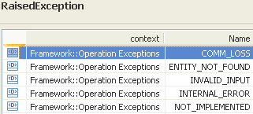 | restriction base="msg:AllExceptionsType"  element ref="msg:commLoss"  element ref="msg:entityNotFound"  element ref="msg:internalError"  element ref="msg:invalidInput"  element ref="msg:notImplemented"  element ref="msg:tooManyOpenIterators"

getAllManagedElemetsWrtOs

BA (getAllManagedElemetsWrtOs) | IA | IIS | Comments
R_TMF518_MRI_II_0007  The Interface shall support requests to retrieve the objects instances that are named (contained) under a given management domain. The possible object types include the following: subnetwork, topological link and managed element.  R_TMF518_MRI_II_0013  The Interface shall support request to retrieve all the managed elements, topological links and subnetworks to which a given subordinate OS has a “manages” relationship. Note that there will not be any “manages” relationships with subnetworks unless the top-level and subordinate OSs uses the same subnetwork partitioning. | This operation returns all Managed Elements (MEs) managed by the provided subordinate OS AND contained by the provided Management Domain (MD).  If no MD is provided all MEs managed by the provided subordinate OS are returned.  Note that "Wrt" in the name of the operation stands for "with respect to".  Traceability: R_TMF518_MRI_II_0007, R_TMF518_MRI_II_0013, UC_TMF518_MRI_0012. | This operation returns the data structure for each ManagedElement (ME) managed by a given subordinate OS AND contained by a specific Management Domain.  Note that Wrt in the name of the operation stands for "with respect to".
 | osRef (ObjectName)  This parameter provides the name of the subordinate OS whose contained Managed Elements are in scope of the request. | (in) element name="osRef" type="nam:NamingAttributeType"  The name of the subordinate OS whose contained MEs are being requested.
 | mdRef (ObjectName)  This parameter provides the name of the Management Domain whose contained Managed Elements are in scope of the request. | (in) element name="mdRef" type="nam:NamingAttributeType"  The name of the Management Domain whose contained MEs are being requested.
 | meList (*) (ManagedElement)  This parameter returns the list of all Managed Element objects managed by the provided subordinate OS and contained by the provided MD. | type="tns:MultipleMeObjectsResponseType"  +++++++++++++++++  see MultipleMeObjectsResponse Type in section 5.5.2
see use case in section 14.2 | 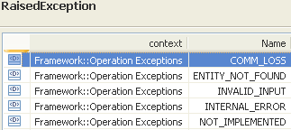 | restriction base="msg:AllExceptionsType"  element ref="msg:commLoss"  element ref="msg:entityNotFound"  element ref="msg:internalError"  element ref="msg:invalidInput"  element ref="msg:notImplemented"  element ref="msg:tooManyOpenIterators"

getManagedElement

BA (getManagedElement) | IA | IIS | Comments
R_TMF518_MRI_II_0019  The Interface shall allow the requesting OS to retrieve the attributes of a Managed Elements (ME)s which name is specified by the requesting OS. | This operation retrieves the details of a Managed Element identified by its name.  Traceability: R_TMF518_MRI_II_0019. | This operation returns the Managed Element for the given managed element name.
 | meRef (ObjectName)  This parameter provides the name of the Managed Element to be retrieved. | (in) element name="meRef" type="nam:NamingAttributeType"  The name of the Managed Element requested.
 | me (ManagedElement)  This parameter returns the Managed Element object selected by the given name. | type="tns:SingleMeObjectResponseType"  +++++++++++++++++  see SingleMeObjectResponse Type in section 5.5.3 | bz:  Don't understand why a special type is defined here. E.g., getMatrixFlowDoamin does not have this special type.
 | 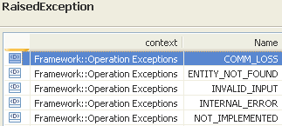 | restriction base="msg:AllExceptionsType"  element ref="msg:commLoss"  element ref="msg:entityNotFound"  element ref="msg:internalError"  element ref="msg:invalidInput"  element ref="msg:notImplemented"

Data Types

ManagedElementFilter Type

BA | IA (ManagedElementFilter) | IIS (MeFilterType) | Comments
R_TMF518_MRI_II_0001  The Interface should support requests to retrieve MEs based on any combination of location, manufacturer, productName and (if supported) resourceState. For example, an OS should be able to request all MEs at “locationA”, from “manufacturerB”, of type “productC” and with resourceState equal to Planning (or vice versa equal to Installing). | This data type contains the criterias for filtering Managed Element retrieval operations.  Traceability: R_TMF518_MRI_II_0001.  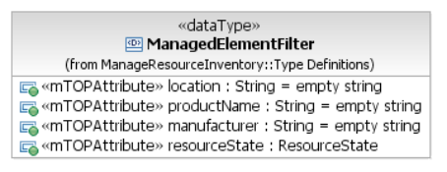 | Me Filter.
 | location (String)  This attribute identifies the location of the Network Element represented by the Managed Element. | element name="location" type="xsd:string"  The location is the geographical location of the Managed Element. | bz:  Why does the IIS need an extra LocationType?
 | manufacturer (String)  This attribute identifies the Managed Element manufacturer name. | element name="manufacturer" type="xsd:string"  The manufacturer attribute identifies the managed element manufacturer name. | bz:  Why does the IIS need an extra ManufacturerType?
 | productName (String)  This attribute identifies the Managed Element vendor's name/designation for the product. | element name="productName" type="xsd:string"  The productName identifies the managed element product/type name. | bz:  Why does the IIS need an extra ProductNameType?
 | resourceState (ResourceState)  See R_TMF518_NRB_I_0001.  See SD2-17_MTOSI_EnhancedResourceStates supporting document. | element name="resourceState" type="cri:ResourceStateType"  See SD2-17_MTOSI_EnhancedResourceStates supporting document.

MultipleMeObjectsResponse Type

BA | IA | IIS (MultipleMeObjectsResponseType) | Comments
element name="meList" type="me:ManagedElementListType"
The list of MEs.

SingleMeObjectResponse Type

BA | IA | IIS (SingleMeObjectResponseType) | Comments
element name="me" type="me:ManagedElementType"
The retrieved ME.

Management Domain Retrieval Service
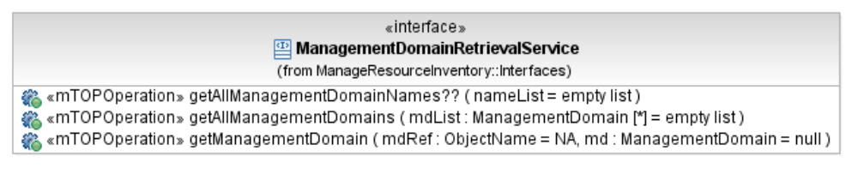
Figure 7: MRI Management Domain Retrieval Service Interface Diagram

getAllManagementDomains

BA (getAllManagementDomains) | IA | IIS | Comments
R_TMF518_MRI_II_0009  R_TMF518_MRI_II_0010  The Interface shall support requests to retrieve all the Management Domains to which the top-level OS has a “manages” relationship. | This operation returns the details of all Management Domains (MDs) associated with a top-level OS.  The operation can only be directed to a top-level OS and not to a subordinate OS.  Traceability: R_TMF518_MRI_II_0010. | This operation returns the data structure for each Management Domain (MD) associated with a top-level OS.  This operation can only be directed to a top-level OS and not to a subordinate OS.
 | mdList (*) (ManagementDomain)  This parameter returns the list of all Management Domain objects associated to the top-level OS to which the request is directed. | type="tns:MultipleObjectsResponseType"  +++++++++++++++++  element name="mdList" type="md:ManagementDomainListType"  The list of MD objects.
 | 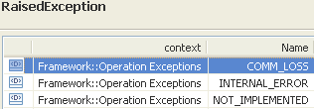 | restriction base="msg:AllExceptionsType"  element ref="msg:commLoss"  element ref="msg:internalError"  element ref="msg:notImplemented"

getManagementDomain

BA (getManagementDomain) | IA | IIS | Comments
R_TMF518_MRI_II_0006  The Interface shall support requests to retrieve all the attributes of a given Management Domain. | This operation returns the details of a Management Domain (MD) identified by its name.  The operation can only be directed to a top-level OS and not to a subordinate OS.  Traceability: R_TMF518_MRI_II_0006. | This operation returns the data structure associated with a given Management Domain (MD) identified by the provided mdName.  This operation can only be directed to a top-level OS and not to a subordinate OS.
 | mdRef (ObjectName)  This parameter provides the name of the Management Domain to be retrieved. | mdRef (ObjectName)  This parameter provides the name of the Management Domain to be retrieved.
 | md (ManagementDomain)  This parameter returns the Management Domain object selected by the given name. | type="tns:SingeObjectResponseType"  +++++++++++++++++  element name="md" type="md:ManagementDomainType"  The MD object.
restriction base="msg:AllExceptionsType"
element ref="msg:commLoss"
element ref="msg:entityNotFound"
element ref="msg:internalError"
element ref="msg:invalidInput"
element ref="msg:notImplemented"

Multi Layer Subnetwork Retrieval Service
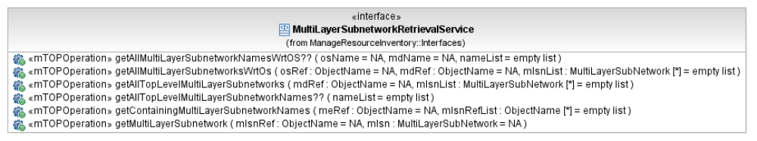
Figure 8: MRI Multi Layer Subnetwork Retrieval Service Interface Diagram

getAllMultiLayerSubnetworksWrtOs

BA (getAllMultiLayerSubnetworksWrtOs) | IA | IIS | Comments
R_TMF518_MRI_II_0007  The Interface shall support requests to retrieve the objects instances that are named (contained) under a given management domain. The possible object types include the following: subnetwork, topological link and managed element.  R_TMF518_MRI_II_0013  The Interface shall support request to retrieve all the managed elements, topological links and subnetworks to which a given subordinate OS has a “manages” relationship. Note that there will not be any “manages” relationships with subnetworks unless the top-level and subordinate OSs uses the same subnetwork partitioning. | This operation returns all Multi Layer Subnetworks (MLSNs) managed by the provided subordinate OS AND contained by the provided Management Domain (MD).  If no MD is provided all MLSNs managed by the provided subordinate OS are returned.  Note that "Wrt" in the name of the operation stands for "with respect to".  Traceability: R_TMF518_MRI_II_0007, R_TMF518_MRI_II_0013, UC_TMF518_MRI_0012. | This operation returns all Multi Layer Subnetworks (MLSNs) managed by the provided subordinate OS AND contained by the provided Management Domain (MD).
 | osRef (ObjectName)  This parameter provides the name of the subordinate OS whose managed Multi Layer Subnetworks are in scope of the request. | (in) element name="osRef" type="nam:NamingAttributeType"  This parameter provides the name of the subordinate OS whose managed Multi Layer Subnetworks are in scope of the request.
 | mdRef (ObjectName)  This parameter provides the name of the Management Domain whose contained Multi Layer Subnetworks are in scope of the request. | (in) element name="mdRef" type="nam:NamingAttributeType"  This parameter provides the name of the Management Domain whose contained Multi Layer Subnetworks are in scope of the request.
 | mlsnList (*) (MultiLayerSubnetwork)  This parameter returns the list of all Multi Layer Subnetwork objects managed by the provided subordinate OS and contained by the provided MD. | type="tns:MultipleObjectsResponseType"  +++++++++++++++++  see MultipleObjectsResponse Type in section 7.5.1
see use case in section 14.2 | 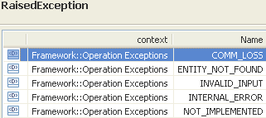 | restriction base="msg:AllExceptionsType"  element ref="msg:commLoss"  element ref="msg:entityNotFound"  element ref="msg:internalError"  element ref="msg:invalidInput"  element ref="msg:notImplemented"  element ref="msg:tooManyOpenIterators"

getAllTopLevelMultiLayerSubnetworks

BA (getAllTopLevelMultiLayerSubnetworks) | IA | IIS | Comments
R_TMF518_MRI_II_0022  R_TMF518_MRI_II_0023  The Interface shall allow the requesting OS to retrieve the attributes of all the top level Subnetwork (s) | This operation returns all top level Multi Layer Subnetworks contained by a provided Management Domain.  Traceability: R_TMF518_MRI_II_0023. | This operation returns all top level Multi Layer Subnetworks contained by a provided Management Domain.
 | mdRef (ObjectName)  This parameter provides the name of the Management Domain for which to retrieve the contained Multi Layer Subnetworks. | (in) element name="mdRef" type="nam:NamingAttributeType"  The name of the Management Domain whose contained MLSNs are being requested.
 | mlsnList (*) (MultiLayerSubnetwork)  This parameter returns the list of all contained Multi Layer Subnetwork objects. | type="tns:MultipleObjectsResponseType"  +++++++++++++++++  see MultipleObjectsResponse Type in section 7.5.1
 | 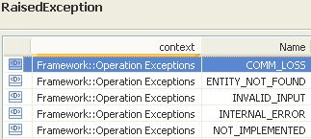 | restriction base="msg:AllExceptionsType"  element ref="msg:commLoss"  element ref="msg:entityNotFound"  element ref="msg:internalError"  element ref="msg:invalidInput"  element ref="msg:notImplemented"  element ref="msg:tooManyOpenIterators"

getContainingMultiLayerSubnetworkNames

BA (getContainingMultiLayerSubnetworkNames) | IA | IIS | Comments
R_TMF518_MRI_II_0021  The Interface shall allow the requesting OS to retrieve the names of the containing Subnetwork(s) given a Managed Element name specified by the requesting OS. | This operation retrieves the names of all Multi Layer Subnetworks containing a provided Managed Element.  Traceability: R_TMF518_MRI_II_0021. | This operation returns the list of MLSN names that the Managed Element supplied as an input parameter belongs to.
 | meRef (ObjectName)  This parameter provides the name of the Managed Element whose containing Multi Layer Subnetwork names are requested. | (in) element name="meRef" type="nam:NamingAttributeType"  The name of the ME for which to retrieve the containing MLSN names
 | mlsnRefList (*) (ObjectName)  This parameter returns the list of the containing Multi Layer Subnetwork names. | type="tns:MultipleObjectNamesResponseType"  element name="mlsnRefList" type="nam:NamingAttributeListType"  The list of object names.
restriction base="msg:AllExceptionsType"
element ref="msg:commLoss"
element ref="msg:entityNotFound"
element ref="msg:internalError"
element ref="msg:invalidInput"
element ref="msg:notImplemented"

getMultiLayerSubnetwork

BA (getMultiLayerSubnetwork) | IA | IIS | Comments
R_TMF518_MRI_II_0020  The Interface shall allow the requesting OS to retrieve the attributes of a Subnetwork, given a Subnetwork name specified by the requesting OS. | This operation retrieves the details of a Multi Layer Subnetwork given its name.  Traceability: R_TMF518_MRI_II_0020. | This operation retrieves the details of a Multi Layer Subnetwork given its name.
 | mlsnRef (ObjectName)  This parameter provides the name of the Multi Layer Subnetwork to be retrieved. | (in) element name="mlsnRef" type="nam:NamingAttributeType"  The name of the MLSN to retrieve.
 | mlsn (MultiLayerSubnetwork)  This parameter returns the Multi Layer Subnetwork object selected by the given name. | type="tns:SingleObjectResponseType"  +++++++++++++++++  element name="mlsn" type="mlsn:MultiLayerSubnetworkType"  The retrieved MLSN.
 | 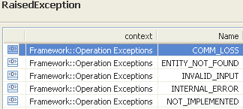 | restriction base="msg:AllExceptionsType"  element ref="msg:commLoss"  element ref="msg:entityNotFound"  element ref="msg:internalError"  element ref="msg:invalidInput"  element ref="msg:notImplemented"

Data Types

MultipleObjectsResponse Type

BA | IA | IIS (MultipleObjectsResponseType) | Comments
element name="mlsnList" type="mlsn:MultiLayerSubnetworkListType"
The list of MLSNs.

Operations System Retrieval Service
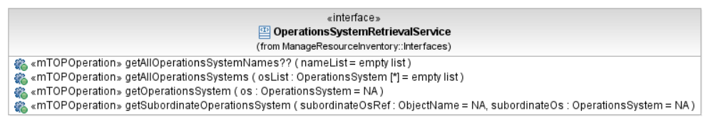
Figure 9: MRI Operations System Retrieval Service Interface Diagram

getAllOperationsSystems

BA (getAllOperationsSystems) | IA | IIS | Comments
R_TMF518_MRI_II_0011  R_TMF518_MRI_II_0012  The Interface shall support requests to retrieve all the subordinate Operations Systems to which the top-level OS has a “manages” relationship. | This operation returns the details of all Operations Systems known to the top-level OS to which the operation is directed. The data structure corresponding to the top-level OS is also returned.  The operation can only be directed to a top-level OS and not to a subordinate OS.  Traceability: R_TMF518_MRI_II_0012. | This operation returns the data structure for each OS known to the top-level OS to which the operation is directed. The data structure corresponding to the top-level OS is also returned. This operation can only be directed to a top-level OS and not to a subordinate OS.
 | osList (*) (OperationsSystem)  This parameter returns the list of all Operations System objects known to the top-level OS to which the request is directed. | type="tns:MultipleObjectsResponseType"  +++++++++++++++++  element name="osList" type="os:OperationsSystemListType"  The list of OS objects.
restriction base="msg:AllExceptionsType"
element ref="msg:commLoss"
element ref="msg:internalError"
element ref="msg:notImplemented"
element ref="msg:tooManyOpenIterators"

getOperationsSystem

BA (getOperationsSystem) | IA | IIS | Comments
R_TMF518_MRI_II_0008  The Interface shall support requests to retrieve all the attributes of a given Operations System. | This operation returns the details of the addessed top-level Operations System (OS).  The operation can not be directed to a subordinate OS.  Traceability: R_TMF518_MRI_II_0008. | This operation returns the data structure associated with the addessed OS.  This operation may only be directed to a top-level OS and not to a subordinate OS.
 | os (OperationsSystem)  This parameter returns the top-level Operations System object to which the request is directed. | type="tns:SingleObjectResponseType"  +++++++++++++++++  see SingleObjectResponse Type in section 8.4.1
 | 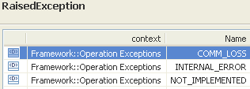 | restriction base="msg:AllExceptionsType"  element ref="msg:commLoss"  element ref="msg:internalError"  element ref="msg:notImplemented"

getSubordinateOperationsSystem

BA (getSubordinateOperationsSystem) | IA | IIS | Comments
R_TMF518_MRI_II_0008  The Interface shall support requests to retrieve all the attributes of a given Operations System. | This operation returns the a subordinate Operations System (OS) given its name.  The operation can only be directed to a top-level OS and not to a subordinate OS.  Traceability: R_TMF518_MRI_II_0008. | This operation returns the data structure associated with a given subordinate OS identified by the provided subordinateOSName. The operation can only be directed to a top-level OS and not to a subordinate OS.
 | subordinateOsRef (ObjectName)  This parameter provides the name of the subordinate OS to be retrieved. | (in) element name="osRef" type="nam:NamingAttributeType"  The name of a top-level OS.
 | subordinateOs (OperationsSystem)  This parameter returns the subordinate OS object selected by the given name. | type="tns:SingleObjectResponseType"  +++++++++++++++++  see SingleObjectResponse Type in section 8.4.1
 | 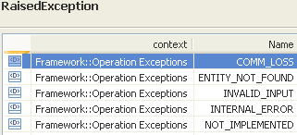 | restriction base="msg:AllExceptionsType"  element ref="msg:commLoss"  element ref="msg:entityNotFound"  element ref="msg:internalError"  element ref="msg:invalidInput"  element ref="msg:notImplemented"

Data Types

SingleObjectResponse Type

BA | IA | IIS (SingleObjectResponseType) | Comments
element name="os" type="os:OperationsSystemType"
The OS object.

Resource Inventory Retrieval Service
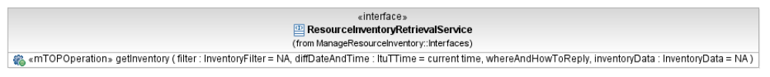
Figure 10: MRI Resource Inventory Retrieval Service Interface Diagram

getInventory

BA (getInventory) | IA | IIS | Comments
R_TMF518_MRI_II_0002  The Interface shall support the capability for a requesting OS to retrieve the inventory from a target OS via bulk inventory retrieval.  The retrieved inventory information may be partitioned in any manner provided that:  • Individual object instances (but not necessarily the fully containment hierarchy) are completely contained in a single partition  • The full details of an object instance may only appear in one partition but to set context, it may be necessary to include the object instance with just its name in several partitions.  • The receiver can reconstruct the document as the various partitions are received. So, for example, if the hierarchy of an ME is to be sent in multiple partitions, the context of each partition needs to be present: in this example, the MD and ME objects with just their names and whatever part of the ME hierarchy that is to be transported in the given partition.  See also the requirement R_TMF518_MRI_IV_0149 which specifies different retrieval styles. | This operation returns a specified portion of the inventory data from the OS to which the request is directed (i.e., the target OS). The target OS returns all objects (in batches) satisfying the scope and filter constraints of the requesting OS that have a modification date equal to or later than the Diff Date and Time.  The operation can only be directed to a top-level OS and not to a subordinate OS.  Traceability: R_TMF518_MRI_II_0002, R_TMF518_MRI_II_0003, R_TMF518_MRI_II_0004, UC_TMF518_MRI_0011. | This operation returns a specified portion of the inventory data from the OS to which the request is directed (i.e., the target OS). The target OS returns all objects satisfying the scope and filter constraints of the requesting OS that have a modification date equal to or later than the Diff Date and Time.  The operation can only be directed to a top-level OS and not to a subordinate OS.
R_TMF518_MRI_II_0004  Each of the bulk inventory mechanisms listed in R_TMF518_MRI_II_0002 shall support the ability to provide a subset of the inventory known to the target OS. The subset is defined by a filter provided by the requesting OS.  …  +++++++++++++++++  see InventoryFilter Type in section 9.2.1 | filter (InventoryFilter)  This parameter defines the subset of the total inventory to be returned.  Traceability: R_TMF518_MRI_II_0004.  +++++++++++++++++  see InventoryFilter Type in section 9.2.1 | (in) element name="filter" type="tns:SimpleFilterType"  This parameter defines the subset of the total inventory to be returned.  +++++++++++++++++  see SimpleFilterType in section 9.2.1
R_TMF518_MRI_II_0003  Each of the bulk inventory mechanisms listed in R_TMF518_MRI_II_0002 may optionally support the ability to retrieve only the inventory that has been modified after a Diff Date and Time provided by the requesting OS. | diffDateAndTime (ItuTTime)  This parameter allows to constraint the inventory retrieval by a modification date and time. I.e., all objects with a modification date equal to or greater than this value are in scope of this operation. | (in) element name="diffDateAndTime" type="xsd:dateTime"  This parameter allows to constraint the inventory retrieval by a modification date and time. I.e., all objects with a modification date equal to or greater than this value are in scope of this operation.
?? | whereAndHowToReply (??)  This parameter contains the necessary information (including where and how) the target OS needs to send the response. The information provided in this parameter depends on the scenario (i.e., type of communication style) used for retrieving the network inventory. The individual information to be provided by the requesting OS is described in the following Use Cases:  - UC_TMF518_MRI_0011: Bulk Inventory Retrieval - Scenario 1: Coarse grained approach, batched response, message communication style  - UC_TMF518_MRI_0012: Bulk Inventory Retrieval - Scenario 2: Coarse grained approach, RPC communication style  - UC_TMF518_MRI_0013: Bulk Inventory Retrieval - Scenario 3: Coarse grained approach, file transfer. | ??
 | inventoryData (InventoryData)  This parameter returns the the requested inventory data. | (out) element name="inventoryData" type="invdata:InventoryDataType"  The inventory data which may vary based on the MEP. Also, note that the atomic elements of the inventory data XML representation are all the following top-level objects: MD, ME, MLSN, OS, TL, and TMD. It means that all top-level object instances must be fully encapsulated in one batch when the MEP involves multiple responses.  +++++++++++++++++  see InventoryData Type in section 9.2.2 | bz:  Isn't this part of TMF 854 XML Solution Set?
UC_TMF518_MRI_0011  Pre-Conditions:  All OSs involved in the use case have successfully executed the Use Case 0001 OS (Re) Starts as defined in the TMF518_FMW BA document. | None
UC_TMF518_MRI_0011
Post-Conditions:
In case of success:
The requesting OS has the requested inventory information from the target OS.
In case of failure:
The requesting OS does not have the entire requested inventory information from the target OS.

UC_TMF518_MRI_0011  Exceptions:  1. Not implemented: The target OS does not support this service.  2. Invalid input: An input parameter is invalid (e.g., invalid filter syntax)  3. Processing failure: The requested operation could not be performed.  4. Communications failure: The target OS has lost communications with an entity that is needed to help fulfill the request. | 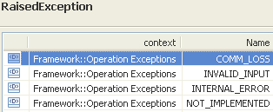 | restriction base="msg:AllExceptionsType"  element ref="msg:commLoss"  element ref="msg:internalError"  element ref="msg:invalidInput"  element ref="msg:tooManyOpenIterators"  element ref="msg:unsupportedCompressionFormat"  element ref="msg:unsupportedPackingFormat" | bz:  The Exceptions clause is not in line with mTOP_Guidelines_BAs.doc: It shall only contain a list of all necessary exceptions. The specific exceptions have to be explicitly listed in the Description clause.  bz:  Exceptions are not part of the exception list in the BA Guidelines.

Data Types

SimpleFilter Type

BA | IA (InventoryFilter) | IIS (SimpleFilterType) | Comments
R_TMF518_MRI_II_0004  Each of the bulk inventory mechanisms listed in R_TMF518_MRI_II_0002 shall support the ability to provide a subset of the inventory known to the target OS. The subset is defined by a filter provided by the requesting OS.  The filter shall contain two parts: | This data type contains the Inventory Filter structure used for the getInventory() operation.  Traceability: R_TMF518_MRI_II_0004. | The data structure of the Inventory Retrieval filter. Some examples are listed in the following table.  See table in Comments column.
  Filter Constraint | Simple Filter
  Given an ME name (e.g., md1/ME123), get all the EHs and Equipment Attributes | BaseInstanceList: { (MD=md1;ME=ME123)}  IncludedObjectTypes: { (EH, ATTRS), (EQ, ATTRS) }
  Given an ME name (e.g., md1/ME123), get all the contained Ehs Attributes and the ME attibutes | BaseInstanceList: { (MD=md1;ME=ME123) }  IncludedObjectTypes: { (ME, ATTRS), (EH, ATTRS) }
  Get all MEs and associated attributes (within the entire inventory known to the target OS) | BaseInstanceList: { }  IncludedObjectTypes { (ME, ATTRS) }
  Get all ME, OS and MD names (within the entire inventory known to the target OS) | BaseInstanceList: { }  IncludedObjectTypes: { (ME, NAME), (MD, NAME), (OS, NAME) }
  Given an EH name (e.g., md1/ME123/ACME7), get all the contained Equipment (and relationship pointers) | BaseInstanceList: { (MD=md1;ME=ME123;EH=ACME7) }  IncludedObjectTypes: { (EQ,FULL)}
  Given a PTP name (e.g., md1/ME123/PTPxyz), get the PTP Attributes | BaseInstanceList: { (MD=md1;ME=ME123;PTP=PTPxyz) }  IncludedObjectTypes: { (PTP, ATTRS) }
Base Instances List:  It is a list of names of instances present in the inventory repository, used to determine a set of disjoint sub-trees of instances which they are the roots of. | baseInstanceList (String)  This attribute identifies a list of base object instances for the subtrees to be retrieved. It is a list of serialized MTOSI names. If the list is left empty then all the nodes at the top of the MTOSI instance tree are selected (i.e., all MDs, TMDs, inter-MD-TLs, and OSs are selected). Specification of the baseInstanceList does not select any objects in and of itself. In order to select specific objects, one needs to specify the IncludedObjectTypes.  The ";" is used as a separator, and "=" is used to associate a value with a type of object. For example, MD=md1;ME=ME123;EH=ACME7 identifies an equipment holder within managed element ME123 within management domain md1. The relative name of the equipment holder is ACME7.  The following abbreviations are used for the object type names:  MD - management domain  ME - managed element  EH - equipment holder  EQ - equipment  PTP - physical termination point  FTP - floating termination point  CTP - connection termination point  TPPool - termination point pool  EPGP - equipment protection group  PGP - protection group  SNC - subnetwork connection  MLSN - multi layer subnetwork  TL - topological link  OS - operations system  TMD - transmission descriptor. | element name="baseInstance" type="nam:NamingAttributeType"  This attribute identifies a list of base object instances for the subtrees to be retrieved. BaseInstanceList is a list of serialized MTOSI names. If the BaseInstanceList is left empty then all the nodes at the top of the MTOSI instance tree are selected (i.e., all MDs, TMDs, and OSs are selected). Specification of the BaseInstanceList does not select any objects in and of itself. In order to select specific objects, one needs to specify the IncludedObjectTypes.
?? | This option is not in the IA. | <xsd:choice>  Two options to identify the scope of the objects to be retrieved:  <xsd:sequence>  element name="queryExpression" type="gen:QueryExpressionType"  Specify an attribute matching query expression to be applied to the sub-tree of the inventory layout document targeted by the baseInstance. This expression is based on a standard specification query language (Xpath, ansi-92).  Refer to the Business Agrrement (BA) requirement description for details of the minimum set of supported query operations.  element name="granularity" type="tns:GranularityType"  Specify the granularity of the inventory report based.  </xsd:sequence>
(Scope Qualifier, Selection Qualifer) pairs list:  ○ Scope Qualifier  Not all the instances present in the set of disjoint sub-trees determined by the list of Base Instances should be considered to construct the bulk retrieval response.  A Scope Qualifier designates, within this set of sub-trees, those instances which should be considered in the scope of the bulk retrieval response.  It can be of four kinds which are mutually exclusive:  1. empty:  in this case all the instances of all the sub-trees are considered.  2. an Included Object Type:  in this case all the instances of all the sub-trees which correspond to this object type are considered;  the list of valid object types is given after this requirement table.  3. an attribute matching filter:  it is a logical expression conformant to the requirements R_TMF518_FMW_II_0023 and R_TMF518_FMW_II_0024 from the TMF518_FMW BA.  All the instances of all the sub-trees matching this logical expression are considered.  4. an object name:  it will determine the unique instance among all the instances of all the sub-trees that needs to be considered;  note that this case is also covered by the item 3 above; reason to keep it in this requirement is for backward compatibility. | includedObjectTypeList (*) (IncludedObjectType)  This attribute identifies the type of objects contained under the selected base object instances that are to be included in the returned inventory file. The requesting OS always have to provide at least one object. The base object itself may also be included.  For each included object type, one needs to indicate whether  a. just the name,  b. all the associated attributes (including the name), or  c. the associated attributes and relationship pointers  are to be returned for each instance.  The includedObjectTypes need to be picked such that each selected base class has a single (connected) subtree below it.  The following abbreviations are used for the object type names:  MD - management domain  ME - managed element  EH - equipment holder  EQ - equipment  PTP - physical termination point  FTP - floating termination point  CTP - connection termination point  TPPool - termination point pool  EPGP - equipment protection group  PGP - protection group  SNC - subnetwork connection  RT - route  CC - cross connection  MLSN - multi layer subnetwork  TL - topological link  OS - operations system  TMD - transmission descriptor.  +++++++++++++++++  See next row. | <xsd:sequence>  element name="includedObjectType"  This attribute identifies the type of objects contained under the selected base object instances that are to be included in the returned inventory file. The base object itself is included only if the type of the base instance appears in the IncludedObjectTypes list. If no included object types are listed, then the entire subtree under the base object instance is returned.  For each included object type, one needs to indicate whether.  - just the name,  - all the associated attributes (including the name), or  - the associated attributes and relationship pointers are to be returned for each instance.  The IncludedObjectTypes need to be picked such that each selected base class has a single (connected) subtree below it.  For example, if all the EHs under a given MD where needed, the requesting OS would need to list the given MD as a base instance and put ME and EH in the IncludedObjectTypes list. The requesting OS could just request the names of the MEs to reduce the size of the returned file.  +++++++++++++++++  See next row.
* if “empty” is used as a Scope Qualifier there must be a single (Scope Qualifier, Selection Qualifier) pair in the list;  * no two different pairs in the list should have the same Scope Qualifier.  * in case when the different Scope Qualifiers in the list are in mutual contradiction, the return result may be inconsistent (e.g. contradiction in two matching filter expressions).  * the Scope Qualifiers in the list of pairs (case of the “included object type”) need to be picked such that each selected base class has a single (connected) sub-tree below it.  For example, if all the EHs under a given MD where needed, the requesting OS would need to list the given MD as a base instance and put ME and EH in the Included Object Types list.  ○ Selection Qualifier  The information to return from each instance in the scope is determined from the Selection Qualifier that can be one of the three kinds:  - NAME: the name attribute only  - ATTRS: all the non-relationship pointers attributes (including the name)  - FULL: all the attributes (including the name) and the relationship pointers attributes  Note that there is one Selection Qualifier per Scope Qualifier. | IncludedObjectType  This data type defines a single object type and the associated kind of information to be included in the InventoryFilter data type.  objectType (String)  This attribute defines the object type to be returned.  The following abbreviations are used for the object type names:  MD - management domain  ME - managed element  EH - equipment holder  EQ - equipment  PTP - physical termination point  FTP - floating termination point  CTP - connection termination point  TPPool - termination point pool  EPGP - equipment protection group  PGP - protection group  SNC - subnetwork connection  RT - route  CC - cross connection  SN - subnetwork  TL - topological link  OS - operations system  TMD - transmission descriptor.  include (Include)  This attribute indicates whether  a. just the name,  b. all the associated attributes (including the name), or  c. the associated attributes and relationship pointers  are to be returned for each instance.  If include is "NAME" then just the name of each object instance is returned, if include is "ATTRS" all the associated attributes (including the name) for each instance are returned, and if include is "FULL" then the associated attributes (including the name) and the relationship pointers are returned for each instance.  +++++++++++++++++  Include (Enum)  NAME  ATTRS  FULL | element name="objectType" type="gen:ObjectTypeType"  Specify the object type acronym.  element name="granularity" type="tns:GranularityType"  Specify the granularity of the inventory report based.  +++++++++++++++++  name="GranularityType">  Filter attribute used to select the granularity of the Inventory report.  restriction base="xsd:string"  enumeration value="NAME"  Retrieve the name only.  enumeration value="ATTRS"  Retrieve the name and the other object attributes.  enumeration value="FULL"  Retrieve the name, the object attributes adn all the relationsship object pointers.  </xsd:sequence>  </xsd:choice>

InventoryData Type

BA | IA | IIS (InventoryDataType) | Comments
 | IA contains just a pointer to SD2-12_MTOSI_Inventory_Layout | defined in NRF  element name="mdList"  The list of Management Domain inventories.  element name="md" type="tns:ManagementDomainInventoryType"  +++++++++++++++++  name="ManagementDomainInventoryType"  The data structure of the Management Domain as returned in inventory report.  Refer to the InventoryLayout supporting document.  element name="mdNm" type="xsd:string"  The name of the MD.  element name="mdAttrs" type="md:ManagementDomainType"  The specific attributes of the MD.  element name="supportingOsRefList" type="nam:NamingAttributeListType"  List of OS names supporting this MD.  element name="meList"  List of ME inventories contained in this MD.  <xsd:sequence>  element name="meInv" type="tns:ManagedElementInventoryType"  </xsd:sequence>  element name="mlsnList"  List of MLSN inventories contained in this MD.  <xsd:sequence>  element name="mlsnInv" type="tns:MultiLayerSubnetworkInventoryType"  </xsd:sequence>  element name="fdList"  List of FD inventories contained in this MD.  <xsd:sequence>  element name="fdInv" type="tns:FlowDomainInventoryType"  </xsd:sequence>  element name="tlList"  List of TL inventories contained in this MD.  <xsd:sequence>  element name="tlInv" type="tns:TopologicalLinkInventoryType"  </xsd:sequence>  element name="qualityIndicator" type="tns:DataQualityIndicatorType"  The quality indicator used to report exception information on MD data retrieval.
 | IA contains just a pointer to SD2-12_MTOSI_Inventory_Layout | element name="tmdList"  The list of top level TMD inventories.  element name="tmd" type="tns:TransmissionDescriptorInventoryType"  +++++++++++++++++  name="TransmissionDescriptorInventoryType"  The data structure of the Transmission Descriptor as returned in inventory report.  Refer to the InventoryLayout supporting document.  element name="tmdNm" type="xsd:string"  The name of the TMD.  element name="tmdAttrs" type="tmd:TransmissionDescriptorType"  The specific attributes of the TMD.  element name="qualityIndicator" type="tns:DataQualityIndicatorType"  The quality indicator used to report exception information on TMD data retrieval.
 | IA contains just a pointer to SD2-12_MTOSI_Inventory_Layout | element name="osList"  The list of OS inventories.  element name="os" type="tns:OperationsSystemInventoryType"  +++++++++++++++++  name="OperationsSystemInventoryType"  The data structure of the Operations System as returned in inventory report.  Refer to the InventoryLayout supporting document.  element name="osNm" type="xsd:string"  The name of the OS.  element name="osAttrs" type="os:OperationsSystemType"  The specific attributes of the OS.  element name="subordinateOsRefList" type="nam:NamingAttributeListType"  The list of the subordinate OS names.  element name="managesMdRefList" type="nam:NamingAttributeListType"  The list of all the MD names wrt OS.  element name="managesMeRefList" type="nam:NamingAttributeListType"  The list of all the ME names wrt OS.  element name="managesTlRefList" type="nam:NamingAttributeListType"  The list of all the TL names wrt OS.  element name="offersTmdRefList" type="nam:NamingAttributeListType"  The list of the TMD names associated with this OS.  element name="managesMlsnRefList" type="nam:NamingAttributeListType"  The list of all the MLSN names wrt OS.  element name="qualityIndicator" type="tns:DataQualityIndicatorType"  The quality indicator used to report exception information on OS data retrieval.
 | IA contains just a pointer to SD2-12_MTOSI_Inventory_Layout | element name="voList" type="vro:VendorResourceObjectListType"  The list of Vendor Objects.  +++++++++++++++++  name="VendorResourceObjectType"  This aggregate defines attributes of the mTOP vendor resource object.  extension base="cri:CommonResourceInfoType"  element name="vendorObjectType" type="xsd:string"  The vendor proprietary definition of an object type.

Resource Inventory Update Service
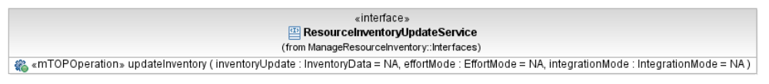
Figure 11: MRI Resource Inventory Update Service Interface Diagram

updateInventory

BA (updateInventory) | IA | IIS | Comments
R_TMF518_MRI_II_0005  The Interface shall support the ability for one OS (Requesting OS) to request that another OS (Target OS) update its inventory.  • Only the data kept by the Target OS is affected. There is not expectation that the underlying network is modified.  R_TMF518_MRI_III_0146  The Multi-Object Inventory Update request shall support the following behavior:  • In the case of failure when the effort mode is set to “atomic”, the target OS shall indicate the reason for failure using the exceptions described in Table 3 3. In this case, the target OS may stop processing when it encounters the first problem that causes the request to fail.  • In the case of failure when the effort mode is set to “best effort”, the target OS shall indicate the reason for failure (on a per object basis) using the exceptions described in Table 3 3. In this case, the target OS needs to be to exhaustive in reporting failed aspects of the request. It is possible, however, to use some shortcuts. In particular, the target OS may report that it could not update a given object instance as well as all childern of the object instance. | This operation allows an OS to request that another OS (i.e., the target OS) update its inventory. The expectation is that the target OS update its inventory as requested, but no other side-effects are expected (e.g., creating an SNC in the network).  This is a key point concerning this capability. The update may entail object creations, attribute modifications and/or object deletions. The requesting OS provides an inventoryData structure that describes the desired updates to be made by the target OS. The operation can only be directed to a top-level OS and not to a subordinate OS.  Rather than having an indicator for each object in the inventory layout (in the inventory update request) concerning the type of update desired, e.g., create, modify, delete or noChange. It was decided that the target OS shall determine the desired update by simply comparing the inventory layout to its current inventory, with the following rules:  If an object is included in the inventory layout that was not known to the target OS before, this is to be treated as a creation request.  Deletions are indicated by setting the resourceState to RETIRING_WITHDRAWN_UNAVAILABLE.  Modifications are determined by comparing each existing object in the inventory layout (provided in the update request) to the object as currently known to the target OS. This is the same convention that was used for the getInventory operation. In this case, the information is being pushed rather than pulled.  In the case of effortMode="bestEffort", this operations uses Multi-Object Exceptions. In the case of effortMode="atomic" the first encountered exception is returned.  Traceability: R_TMF518_MRI_II_0005, R_TMF518_MRI_III_0146, UC_TMF518_MRI_0015. | This operation allows an OS to request that another OS (i.e., the Target OS) update its inventory. The expectation is that the target OS update its inventory as requested, but no other side-effects are expected (e.g., creating an SNC in the network).  This is a key point concerning this capability. The update may entail object creations, attribute modifications and/or object deletions. The requesting OS provides an inventoryData structure that describes the desired updates to be made by the Target OS. The operation can only be directed to a top-level OS and not to a subordinate OS.  Rather than having an indicator for each object in the inventory layout (in the inventory update request) concerning the type of update desired, e.g., create, modify, delete or noChange. It was decided that the target OS shall determine the desired update by simply comparing the inventory layout to its current inventory, with the following rules:  If an object is included in the inventory layout that was not known to the target OS before, this is to be treated as a creation request.  Deletions are indicated by setting the resourceState to â€œRetiring/unavailableâ€.  Modifications are determined by comparing each existing object in the inventory layout (provided in the update request) to the object as currently known to the target OS. This is the same convention that was used for the getInventory operation. In this case, the information is being â€œpushedâ€ rather than â€œpulledâ€.  In the case of effortMode="bestEffort", this operations uses Multi-Object Exceptions. In the case of effortMode="atomic" the first encountered exception is returned.
R_TMF518_MRI_II_0005  • The update request may apply to multiple objects of possibly different types.  • The update request may involve a combination of object additions, object modifications and object deletions. | inventoryUpdate (InventoryData)  This parameter defines the requested inventory update.  Note that the same data structure is used as in the response to the getInventory operation.  +++++++++++++++++  see InventoryData Type in section 9.2.2 | (in) element name="inventoryUpdate" type="invdata:InventoryDataType"  This attribute defines the requested inventory update. Note that the same data structure is used as in the response to the getInventory operation.  +++++++++++++++++  see InventoryData Type in section 9.2.2
+++++++++++++++++  see EffortMode Type in section 10.2.1 | effortMode (EffortMode)  This parameter indicates the effort level for the updateInventory operations. The two possible values are "bestEffort" and "atomic". Either effort mode can be applied to any of the integration modes.  +++++++++++++++++  see EffortMode Type in section 10.2.1 | (in) element name="effortMode" type="tns:EffortModeType"  This attribute is used to indicate the effort level for the updateInventory operations. The two possible values are "bestEffort" and "atomic". Either effort mode can be applied to any of the integration modes.  +++++++++++++++++  see EffortMode Type in section 10.2.1
+++++++++++++++++  see IntegrationMode Type in section 10.2.2 | integrationMode (IntegrationMode)  This parameter describes how the requested inventory update should be integrated into the existing inventory of the receiving OS.  +++++++++++++++++  see IntegrationMode Type in section 10.2.2 | (in) element name="integrationMode" type="tns:IntegrationModeType"  This attribute describes how the requested inventory update should be integrated into the existing inventory of the receiving OS.  +++++++++++++++++  see IntegrationMode Type in section 10.2.2
UC_TMF518_MRI_0015  Pre-Conditions:  The requesting OS and target OS have been authenticated and have access to a CCV. | None
UC_TMF518_MRI_0015  Post-Conditions:  In case of success:  The inventory of the target OS has been updated as requested (for atomic, and best effort when all updates succeed) or partially updated (best effort when not all the updates succeed).  In case of failure:  The inventory of the target OS remains unchanged as a result of the request from the requesting OS. | The inventory of the target OS has been updated as requested.
UC_TMF518_MRI_0015  Exceptions:  See Table 3 3. | 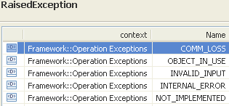 | restriction base="msg:AllExceptionsType"  The updateInventory operation allows for multiple exceptions for a single request. This is explained further in TMF518_MRI.  choice minOccurs="1" maxOccurs="unbounded"  element ref="msg:internalError"  element ref="msg:notImplemented"  <!-- == Object does not exist == -->  element name="invalidInputObjectDoesNotExist" type="msg:BaseExceptionMessageType"  element name="nonExistentContainingObject" type="nam:NamingAttributeType"  If while attempting to create an object whose containing object (possibly several layers up) does not exist, the target OS should raise an exception and supply the name of the containing object that it claims does not exist. The "reason" parameter of the exception should state "containing object does not exist".  <!-- == Unsupported object types == -->  element name="invalidInputUnsupportedObjectTypes" type="msg:BaseExceptionMessageType"  element name="objectType" type="gen:ObjectTypeType"  If the requesting OS is trying to create instance of one or more object types that are unsupported by the target OS, the target OS should raise an exception and list the unsupported object types.  <!-- == Unsupported attributes or attribute values == -->  element name="invalidInputUnsupportAttributesOrValues" type="msg:BaseExceptionMessageType"  element name="objectType" type="gen:ObjectTypeType"  If the requesting OS is trying to modify an unsupported attribute type or set an attribute to a not allowed value (either because the value is not supported or because the current situation does not allow the value to be set as requested, e.g., trying to reuse the name of an existing object), the target OS should raise an exception and list the problem attributes types.  Depending on the situation, the reason parameter should state either "unsupported attribute type" or "attempted to set attribute to not allowed value."  <!-- == Objects in use == -->  element name="objectInUse" type="msg:BaseExceptionMessageType"  element name="objectName" type="nam:NamingAttributeType"  If requesting OS is trying to modify an object that is in use (this may depend on the policies of the target OS), the target OS should raise an exception and provide the type and name of the object instances in question that are already in use.  If the requesting OS is attempting to delete an object when an associated object (possibly several layers up) is currently in use (e.g., attempting to delete a CTP when an associated SNC is still in use may violate a policy of the target OS) then the target OS should raise an exception and supply the name of the containing object that is in use. The "reason" parameter of the exception should say "Containing object is in use".  <!-- == Policy violation == -->  element name="policyViolation" type="msg:BaseExceptionMessageType"  element name="objectName" type="nam:NamingAttributeType"  If creation of a given object violates a policy of the target OS, the target OS should raise an exception, identify the object (can leave the relative name empty if not provided by the requesting OS) and indicate the specific policy that has been violated in the "reason" parameter of the exception.  If modification or deletion of a given object violates a policy of the target OS, the target OS should raise an exception, identify the object and indicate the specific policy that has been violated in the "reason" parameter of the exception.

Data Types

EffortMode Type

BA | IA | IIS (EffortModeType) | Comments
R_TMF518_MRI_II_0005  • In addition to the integration modes of operation stated above, it is also possible to stipulate that an inventory update request be “best effort” or “atomic” (these are referred to as effort modes). “Best effort” means that the target OS shall make as many of the requested updates as possible and report on the ones that failed. “Atomic” means that the target OS must make all the requested updates or completely roll back the operation. Either effort mode can be applied to any of the integration modes. | This enumeration indicates the effort level for the updateInventory operations.  Traceability: R_TMF518_MRI_II_0005. | This parameter is used to indicate the effort level for the updateInventory operations.
 | enumeration value="BEST_EFFORT"  This value means that the target OS shall make as many of the requested updates as possible and report on the ones that failed. | enumeration value="BEST_EFFORT"  The value "bestEffort" means that the target OS shall make as many of the requested updates as possible and report on the ones that failed.
 | enumeration value="ATOMIC"  This value means that the target OS must make all the requested updates or completely roll back the operation. | enumeration value="ATOMIC"  The value "atomic" means that the target OS must make all the requested updates or completely roll back the operation.

IntegrationMode Type

BA | IA | IIS (IntegrationModeType) | Comments
R_TMF518_MRI_II_0005  • One of the following integration modes shall be associated with each update request: | This enumeration describes how the requested inventory update should be integrated into the existing inventory of the receiving OS.  The behavior associated with this data type is further described in TMF518_MRI.  Traceability: R_TMF518_MRI_II_0005. | This parameter describes how the requested inventory update should be integrated into the existing inventory of the receiving OS.  The behavior associated with this parameter is further described in TMF518_MRI.  TMF518_MRI also provides an example concerning the desired behavior associated with this parameter.
o Replace – for each proposed subtree update, everything from the root and below in the target OS’s inventory is replaced by the proposed subtree update. | enumeration value="REPLACE"  For each proposed subtree update, everything from the root and below in the target OS's inventory is replaced by the proposed subtree update. | enumeration value="REPLACE"  For each proposed subtree update, everything from the root and below in the target OS's inventory is replaced by the proposed subtree update.
o Merge without Overwrite – each proposed subtree update is merged with the associated subtree in the target OS’s inventory. For each proposed subtree update, branches and leaves are added to the associated subtree in the target OS’s inventory to achieve alignment with the proposed update. In the case of overlapping objects (in the proposed update and in the target OS’s inventory), the object in the target OS remains unchanged. | enumeration value="MERGE_WITHOUT_OVERWRITE"  Each proposed subtree update is merged with the associated subtree in the target OS's inventory. For each proposed subtree update, additional branches and leaves are added to the associated subtree in the target OS's inventory to achieve alignment with the proposed update. In the case of overlapping objects (in the proposed update and in the target OS's inventory), the objects in the target OS remains unchanged. | enumeration value="MERGE_WITHOUT_OVERWRITE"  Each proposed subtree update is merged with the associated subtree in the target OS's inventory. For each proposed subtree update, additional branches and leaves are added to the associated subtree in the target OS's inventory to achieve alignment with the proposed update. In the case of overlapping objects (in the proposed update and in the target OS's inventory), the objects in the target OS remains unchanged.
o Merge with Overwrite – this is the same as Merge without Overwrite except for the treatment of overlapping objects. In this case, the proposed object replaces its associated object instance in the target OS’s inventory. | enumeration value="MERGE_WITH_OVERWRITE"  This is the same as MERGE_WITHOUT_OVERWRITE except for the treatment of overlapping objects. In this case, the proposed object replaces its associated object instance in the target OS's inventory. | enumeration value="MERGE_WITH_OVERWRITE"  This is the same as Merge without Overwrite except for the treatment of overlapping objects. In this case, the proposed object replaces its associated object instance in the target OS's inventory.

Termination Point Retrieval Service
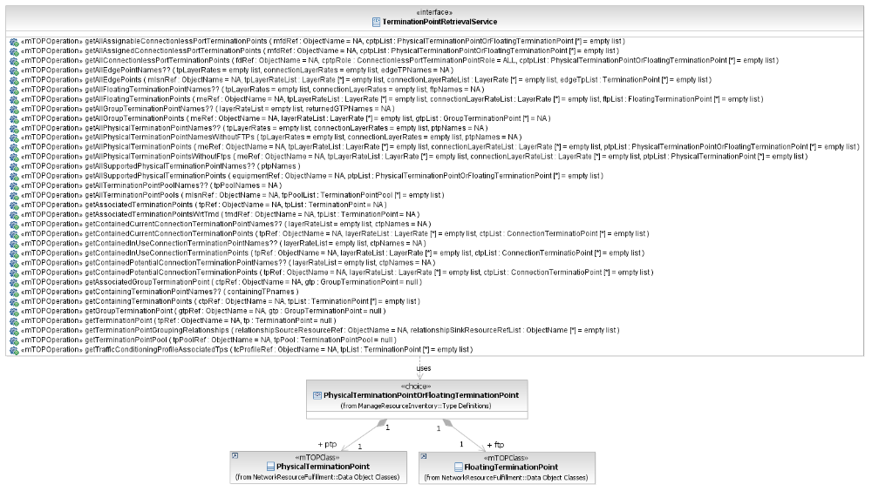
Figure 12: MRI Termination Point Retrieval Service Interface Diagram

getAllAssignableConnectionlessPortTerminationPoints

BA (getAllAssignableConnectionlessPortTerminationPoints) | IA | IIS | Comments
R_TMF518_MRI_II_0116  The Interface shall allow the requesting OS to retrieve the attributes of all Connectionless Port TP (CPTP)s which are potentially able to be assigned to a specified Matrix Flow Domain (MFD).  Notes:  Potentially means: The CPTPs are on the same equipment or same rack with backplane connectivity as the specified MFD.  It is irrelevant whether the CPTPs are already assigned to an MFD or not. | This operation retrieves the details of all Connectionless Port Termination Points (CPTPs) which are potentially able to be assigned to the provided Matrix Flow Domain (MFD).  Potentially means: The CPTPs are on the same Equipment or same Rack with backplane connectivity as the MFD. It is irrelevant whether the CPTPs are already assigned to an MFD or not.  Traceability: R_TMF518_MRI_II_0116. | This operation retrieves the details of all Connectionless Port Termination Points (CPTPs) which are potentially able to be assigned to the provided Matrix Flow Domain (MFD).  Potentially means: The CPTPs are on the same Equipment or same Rack with backplane connectivity as the MFD. It is irrelevant whether the CPTPs are already assigned to an MFD or not.
 | mfdRef (ObjectName)  This parameter provides name of the Matrix Flow Domain whose potential CPTPs shall be returned. | (in) element name="mfdRef" type="nam:NamingAttributeType"  This parameter provides name of the Matrix Flow Domain whose potential CPTPs shall be returned.
 | cptpList (*) (PhysicalTerminationPointOrFloatingTerminationPoint)  This parameter returns the list of Connectionless Port Termination Point objects (i.e., Physical Termination Points and Floating Termination Points) assignable to the provided Matrix Flow Domain. | (out) element name="cptpList" type="tp:TerminationPointListType"  This parameter returns the list of Connectionless Port Termination Point objects (i.e., Physical Termination Points and Floating Termination Points) assignable to the provided Matrix Flow Domain.
 | 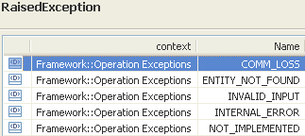 | restriction base="msg:AllExceptionsType"  element ref="msg:commLoss"  element ref="msg:entityNotFound"  element ref="msg:internalError"  element ref="msg:invalidInput"  element ref="msg:notImplemented"  element ref="msg:tooManyOpenIterators"

getAllAssignedConnectionlessPortTerminationPoints

BA (getAllAssignedConnectionlessPortTerminationPoints) | IA | IIS | Comments
R_TMF518_MRI_II_0111  The Interface shall allow the requesting OS to retrieve the attributes of all ConnectionLess Port TP (CPTP)s assigned to a given Matrix Flow Domain (MFD). | This operation retrieves the details of all Connectionless Port Termination Points assigned to the provided Matrix Flow Domain.  Traceability: R_TMF518_MRI_II_0111. | This operation retrieves the details of all Connectionless Port Termination Points assigned to the provided Matrix Flow Domain .
 | mfdRef (ObjectName)  This parameter provides name of the Matrix Flow Domain whose assigned CPTPs shall be returned. | (in) element name="mfdRef" type="nam:NamingAttributeType"  This parameter provides name of the Matrix Flow Domain whose assigned CPTPs shall be returned.
 | cptpList (*) (PhysicalTerminationPointOrFloatingTerminationPoint)  This parameter returns the list of Connectionless Port Termination Point objects (i.e., Physical Termination Points and Floating Termination Points) assigned to the provided Matrix Flow Domain. | (out) element name="cptpList" type="tp:TerminationPointListType"  This parameter returns the list of Connectionless Port Termination Point objects (i.e., Physical Termination Points and Floating Termination Points) assigned to the provided Matrix Flow Domain.
 | 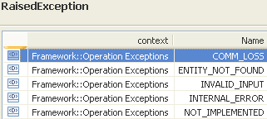 | restriction base="msg:AllExceptionsType"  element ref="msg:commLoss"  element ref="msg:entityNotFound"  element ref="msg:internalError"  element ref="msg:invalidInput"  element ref="msg:notImplemented"  element ref="msg:tooManyOpenIterators"

getAllConnectionlessPortTerminationPoints

BA (getAllConnectionlessPortTerminationPoints) | IA | IIS | Comments
R_TMF518_MRI_II_0118  The Interface shall allow the requesting OS to retrieve the attributes of all Connectionless Port TP (CPTP)s associated to the Flow Domain (FD). It shall be possible to filter this request to retrieve only “fdEdge” (UNI and E-NNI sides), only “fdInternal” or all CPTPs. | This operation retrieves the details of all Connectionless Port Termination Points (CPTPs) associated to the provided Flow Domain. It is possible to filter the request to retrieve only fdEdge (UNI and E-NNI sides), only fdInternal or all CPTPs.  Traceability: R_TMF518_MRI_II_0118. | This operation retrieves the details of all Connectionless Port Termination Points (CPTPs) associated to the provided Flow Domain. It is possible to filter the request to retrieve only fdEdge (UNI and E-NNI sides), only fdInternal or all CPTPs.
 | fdRef (ObjectName)  This parameter provides name of the Flow Domain whose associated CPTPs are in scope. | (in) element name="fdRef" type="nam:NamingAttributeType"  This parameter provides name of the Flow Domain whose associated CPTPs are in scope .
 | cptpRole (NRF::ConnectionlessPortTerminationPointRole)  This parameter provides the kind of CPTPs to be returned (only fdEdge, only fdInternal, or all). | (in) element name="cptpRole" type="com:ConnectionlessPortTerminationPointRoleType"  This parameter provides the kind of CPTPs to be returned (only fdEdge, only fdInternal, or all).
 | cptpList (*) (PhysicalTerminationPointOrFloatingTerminationPoint)  This parameter returns the filtered list of Connectionless Port Termination Point objects (i.e., Physical Termination Points and Floating Termination Points) associated to the provided Flow Domain. | (out) element name="cptpList" type="tp:TerminationPointListType"  This parameter returns the filtered list of Connectionless Port Termination Point objects (i.e., Physical Termination Points and Floating Termination Points) associated to the provided Flow Domain.
restriction base="msg:AllExceptionsType"
element ref="msg:commLoss"
element ref="msg:entityNotFound"
element ref="msg:internalError"
element ref="msg:invalidInput"
element ref="msg:notImplemented"
element ref="msg:tooManyOpenIterators"

getAllEdgePoints

BA (getAllEdgePoints) | IA | IIS | Comments
R_TMF518_MRI_II_0064  The Interface shall allow the requesting OS to retrieve the attributes of all the Edge Termination Point (Edge TP)s (ports) given a Subnetwork name and one or more layer rate(s) specified by the requesting OS.  R_TMF518_MRI_II_0065  R_TMF518_MRI_II_0066  The Interface shall allow the requesting OS to retrieve the attributes of all the Edge Termination Point (Edge TP)s (ports) given a Subnetwork name and that are capable of supporting connection layer rate(s) specified by the requesting OS.  R_TMF518_MRI_II_0067 | This operation retrieves a filtered list of all Termination Points (TPs) that are at the edge of the provided Multi Layer Subnetwork (MLSN) which  - contain one or more of the provided TP Layer Rates and  - are capable of containing CTPs that can be connected at one or more of the also provided connection Layer Rates.  The operation considers the capability/flexibility of the PTPs, not their current states.  Traceability: R_TMF518_MRI_II_0064, R_TMF518_MRI_II_0066. | This operation retrieves a filtered list of all Termination Points (TPs) that are at the edge of the provided Multi Layer Subnetwork (MLSN) which  - contain one or more of the provided TP Layer Rates and  - are capable of containing CTPs that can be connected at one or more of the also provided connection Layer Rates.  The operation considers the capability/flexibility of the PTPs, not their current states.
 | mlsnRef (ObjectName)  This parameter provides the name of the Multi Layer Subnetwork whose edge TPs are in scope. | GetAllEdgePointsType  element name="mlsnRef" type="nam:NamingAttributeType"  Name of the subnetwork.
 | tpLayerRateList (*) (LayerRate)  This parameter provides the list of TP Layer Rates used to scope the request. If the list is empty, all TPs that are at the edge of the Multi Layer Subnetwork are returned. | GetAllEdgePointsType  (in) element name="tpLayerRateList" type="lr:LayerRateListType"  List of TP layer rates for which the edge points are to be fetched. An edge point must contain at least one of the layer rates specified to be reported. If the list is empty then edge points of all rates are returned.
 | connectionLayerRateList (*) (LayerRate)  This parameter provides the list of connection Layer Rates from which the containing CTPs of the reported edge TPs must support at least one. If the list is empty then all edge TPs are returned. | GetAllEdgePointsType  (in) element name="connectionLayerRateList" type="lr:LayerRateListType"  List of connection layer rates for which the edge points are to be fetched. An edge point must support connections for at least one of the layer rates specified to be reported. If the list is empty then edge points for all connection rates are returned.
 | edgeTpList (*) (TerminationPoint)  This parameter returns the list of TPs that are at the edge of the provided Multi Layer Subnetwork for the provided TP Layer Rates and that are capable of containing CTPs that can be connected at one or more of the specified connection Layer Rates. | type="tns:MultipleTerminationPointObjectsResponseType"  +++++++++++++++++  see MultipleTerminationPointObjectsResponse Type in section 11.23.3
restriction base="msg:AllExceptionsType"
element ref="msg:commLoss"
element ref="msg:entityNotFound"
element ref="msg:internalError"
element ref="msg:invalidInput"
element ref="msg:notImplemented"
element ref="msg:tooManyOpenIterators"

getAllFloatingTerminationPoints

BA (getAllFloatingTerminationPoints) | IA | IIS | Comments
R_TMF518_MRI_II_0076  The Interface shall allow the requesting OS to retrieve the attributes of all the Floating Termination Point (FTP)s given a Managed Element (ME) name and one or more layer rate(s) specified by the requesting OS.  The Interface shall allow the requesting OS to specify one or more layer rates to set the scope of the retrieval of FTPs from the target OS.  R_TMF518_MRI_II_0077  R_TMF518_MRI_II_0078  The Interface shall allow the requesting OS to retrieve the attributes of all the Floating Termination Point (FTP)s given a Managed Element (ME) name that are capable of supporting the connection layer rate(s) specified by the requesting OS.  R_TMF518_MRI_II_0079 | This operation returns a filtered list of all Floating Termination Points (FTPs) within a Managed Element (ME) which  - contain one or more of the provided TP Layer Rates and  - are capable of containing CTPs that can be connected at one or more of the provided connection Layer Rates.  The operation considers the capability/flexibility of the FTPs, not their current states.  Traceability: R_TMF518_MRI_II_0076, R_TMF518_MRI_II_0078. | This operation has exactly the same behaviour as getAllPhysicalTerminationPoints(), but instead of returning both PTPs and FTPs it returns solely FTPs.
 | meRef (ObjectName)  This parameter provides the name of the Managed Element whose FTPs are in scope. | type="tns:GetAllTerminationPointsType"  +++++++++++++++++  see GetAllTerminationPoints Type in section 11.23.1
tpLayerRateList (*) (LayerRate)
This parameter provides the list of TP Layer Rates used to scope the request. An FTP must contain at least one of the Layer Rates specified to be reported. If the list is empty then all FTPs (of all rates) are returned.

connectionLayerRateList (*) (LayerRate)
This parameter provides the list of connection Layer Rates used to scope the request. An FTP must support connections for at least one of the Layer Rates specified to be reported. If the list is empty then all FTPs (for all connection rates) are returned.

 | ftpList (*) (FloatingTerminationPoint)  This parameter returns the list of FTP objects. | type="tns:MultipleTerminationPointObjectsResponseType"  +++++++++++++++++  see MultipleTerminationPointObjectsResponse Type in section 11.23.3
 | 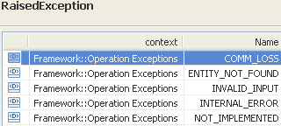 | restriction base="msg:AllExceptionsType"  element ref="msg:commLoss"  element ref="msg:entityNotFound"  element ref="msg:internalError"  element ref="msg:invalidInput"  element ref="msg:notImplemented"  element ref="msg:tooManyOpenIterators"

getAllGroupTerminationPoints

BA (getAllGroupTerminationPoints) | IA | IIS | Comments
R_TMF518_MRI_II_0102  The Interface shall allow the requesting OS to retrieve the attributes of all the Group Termination Point (GTP)s that are managed by the target OS.  R_TMF518_MRI_II_0103 | This operation returns the details of all Group Termination Points (GTPs) within the provided ManagedElement (ME) that contain one or more TPs at the provided Layer Rates.  If there are no GTPs that match the layer constraints, an empty list is returned.  Traceability: R_TMF518_MRI_II_0102. | This operation allows an OS to request all of the GTPs (on the given Managed Element) that contain one or more TPs at the specified layer rates. If there are no GTPs that match the layer constraints, an empty list is returned (see SD1-3 Bundled SNC overview for further information on GTP usage).
 | meRef (ObjectName)  This parameter provides the name of the Managed Element whose GTPs are in scope. | GetAllGroupTerminationPointsType  element name="meRef" type="nam:NamingAttributeType"  The name of the Managed Element for which to retrieve the GTPs.
 | tpLayerRateList (*) (LayerRate)  The GTPs to be returned must contain CTPs that have at least one of the Layer Rates identified by this parameter. If the list is empty then all GTPs supported by the ME are returned. | GetAllGroupTerminationPointsType  (in) element name="tpLayerRateList" type="lr:LayerRateListType"  The GTPs to be returned must contain CTPs that have at least one of the Layer Rates identified by this parameter. If the list is empty then all GTPs supported by the ME are returned.
 | gtpList (*) (GroupTerminationPoint)  This parameter returns the list of GTP objects. | MultipleGroupTerminationPointObjectsResponseType  (out) element name="gtpList" type="gtp:GroupTerminationPointListType"  This parameter returns the list of GTP objects.
 | 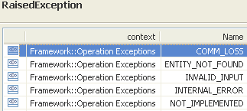 | restriction base="msg:AllExceptionsType"  element ref="msg:commLoss"  element ref="msg:entityNotFound"  element ref="msg:internalError"  element ref="msg:invalidInput"  element ref="msg:notImplemented"  element ref="msg:tooManyOpenIterators"

getAllPhysicalTerminationPoints

BA (getAllPhysicalTerminationPoints) | IA | IIS | Comments
R_TMF518_MRI_II_0059  The Interface shall allow the requesting OS to retrieve the attributes of all the Physical Termination Point (PTP)s (ports) and Floating Termination Point (FTP)s given a Managed Element (ME) name and one or more layer rate(s) specified by the requesting OS.  The Interface shall allow the requesting OS to specify one or more layer rates to set the scope of the retrieval of PTPs and FTPs from the requesting OS.  R_TMF518_MRI_II_0060  R_TMF518_MRI_II_0061  The Interface shall allow the requesting OS to retrieve the attributes of all the Physical Termination Point (PTP)s (ports) and Floating Termination Point (FTP)s given a Managed Element (ME) name that are capable of supporting the connection layer rate(s) specified by the requesting OS.  R_TMF518_MRI_II_0062 | This operation retrieves a filtered list of all Physical Termination Points (PTPs) and Floating Termination Points (FTPs) within a provided Managed Element (ME) which  - contain one or more of the provided TP Layer Rates and  - are capable of containing CTPs that can be connected at one or more of the provided connection Layer Rates.  The operation considers the capability/flexibility of the PTPs/FTPs, not their current states.  Traceability: R_TMF518_MRI_II_0059, R_TMF518_MRI_II_0061. | This operation allows an OS to request all of the PTPs and FTPs on the specified Managed Element, that contain one or more of the OS-specified PTP/FTP layer rates, and that are capable of supporting one or more of the OS-specified connection layer rates. If there are no PTPs/FTPs that match the layer constraints, an empty list is returned.  A PTP/FTP will be returned regardless of connectivity to other managed elements and regardless of position in the subnetwork (both edgepoints of the subnetwork and the PTPs/FTPs that are internal to the subnetwork are reported).
 | meRef (ObjectName)  This parameter provides the name of the Managed Element whose PTPs and FTPs are in scope. | type="tns:GetAllTerminationPointsType"  +++++++++++++++++  see GetAllTerminationPoints Type in section 11.23.1
tpLayerRateList (*) (LayerRate)
This parameter provides the list of PTP/FTP Layer Rates used to scope the request. A PTP/FTP must contain at least one of the Layer Rates specified to be reported. If the list is empty then all PTPs/FTPs (of all rates) are returned.

connectionLayerRateList (*) (LayerRate)
This parameter provides the list of connection Layer Rates used to scope the request. A PTP/FTP must support connections for at least one of the Layer Rates specified to be reported. If the list is empty then all PTPs/FTPs (for all connection rates) are returned.

 | ptpList (*) (PhysicalTerminationPointOrFloatingTerminationPoint)  This parameter returns the list of PTP and FTP objects. | type="tns:MultipleTerminationPointObjectsResponseType"  +++++++++++++++++  see MultipleTerminationPointObjectsResponse Type in section 11.23.3
restriction base="msg:AllExceptionsType"
element ref="msg:commLoss"
element ref="msg:entityNotFound"
element ref="msg:internalError"
element ref="msg:invalidInput"
element ref="msg:notImplemented"
element ref="msg:tooManyOpenIterators"

getAllPhysicalTerminationPointsWithoutFtps

BA (getAllPhysicalTerminationPointsWithoutFtps) | IA | IIS | Comments
R_TMF518_MRI_II_0055  The Interface shall allow the requesting OS to retrieve the attributes all the Physical Termination Point (PTP)s (ports) given a Managed Element (ME) name and one or more layer rate(s) specified by the requesting OS.  The Interface shall allow the requesting OS to specify one or more layer rates to set the scope of the retrieval of PTPs from the requesting OS.  Example physical TP layer rates covering SONET and SDH are: Electrical STS1 / STM0; Electrical STS3 / STM1; Optical OC1 / STM0; Optical OC3 / STM1  R_TMF518_MRI_II_0056  R_TMF518_MRI_II_0057  The Interface shall allow the requesting OS to retrieve the attributes of all the Physical Termination Point (PTP)s (ports) given a Managed Element (ME) name and connection layer rate(s) specified by the requesting OS.  R_TMF518_MRI_II_0058 | This operation retrieves a filtered list of all Physical Termination Points (PTPs) (no Floating Termination Point (FTP) subclasses) within a provided Managed Element (ME) which  - contain one or more of the provided TP Layer Rates and  - are capable of containing CTPs that can be connected at one or more of the provided connection Layer Rates.  This operation considers the capability/flexibility of the PTPs, not their current states.  Traceability: R_TMF518_MRI_II_0055, R_TMF518_MRI_II_0057. | This operation retrieves a filtered list of all Physical Termination Points (PTPs) (no Floating Termination Point (FTP) subclasses) within a provided Managed Element (ME) which  - contain one or more of the provided TP Layer Rates and  - are capable of containing CTPs that can be connected at one or more of the provided connection Layer Rates.  This operation considers the capability/flexibility of the PTPs, not their current states.
 | meRef (ObjectName)  This parameter provides the name of the Managed Element whose PTPs are in scope. | type="tns:GetAllTerminationPointsType"  +++++++++++++++++  see GetAllTerminationPoints Type in section 11.23.1
tpLayerRateList (*) (LayerRate)
This parameter provides the list of TP Layer Rates used to scope the request. A PTP must contain at least one of the Layer Rates specified to be reported. If the list is empty then all PTPs (of all rates; no FTP subclasses) are returned.

connectionLayerRateList (*) (LayerRate)
This parameter provides the list of connection Layer Rates used to scope the request. A PTP (no FTP subclasses) must support connections for at least one of the Layer Rates specified to be reported. If the list is empty then all PTPs (for all connection rates) are returned.

 | ptpList (*) (PhysicalTerminationPoint)  This parameter returns the list of PTP objects. | type="tns:MultipleTerminationPointObjectsResponseType"  +++++++++++++++++  see MultipleTerminationPointObjectsResponse Type in section 11.23.3
 | 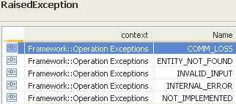 | restriction base="msg:AllExceptionsType"  element ref="msg:commLoss"  element ref="msg:entityNotFound"  element ref="msg:internalError"  element ref="msg:invalidInput"  element ref="msg:notImplemented"  element ref="msg:tooManyOpenIterators"

getAllSupportedPhysicalTerminationPoints

BA (getAllSupportedPhysicalTerminationPoints) | IA | IIS | Comments
R_TMF518_MRI_II_0081  The Interface shall allow the requesting OS to retrieve the attributes of all of the Physical Termination Point (PTP)s that are supported by the Equipment identified by the Equipment name specified by the requesting OS.  R_TMF518_MRI_II_0082 | This operation retrieves all Physical Termination Points (PTPs) and Floating Termination Points (FTPs) that are directly supported by a provided Equipment.  The PTPs that are returned are those that share their physical layer with the primary Equipment (i.e. that represent a Port on the Equipment or are connected by a fibre, wire, etc.).  The FTPs that are returned are those which are implemented by the physical circuitry supported by the Equipment and will include FTPs that are named from the provided Equipment (the FTPs will depend upon the presence of that Equipment for their most basic operation).  When there is Equipment Protection, the operation reports PTPs/FTPs for the primary Equipment only. That is, when called on a protecting Equipment (as opposed to the primary Equipment), the operation returns an empty list, irrespective of the current switch status.  Traceability: R_TMF518_MRI_II_0081. | This operation allows an OS to request the PTPs/FTPs that are directly supported by a given equipment. The PTPs that are returned are those that share their physical layer with the primary equipment (i.e. that represent a port on the equipment or are connected by a fibre, wire, etc.). The FTPs that are returned are those which are implemented by the physical circuitry supported by the equipment and will include FTPs that are named from the specified equipment (the FTPs will depend upon the presence of that equipment for their most basic operation).  When there is equipment protection, this operation reports PTPs/FTPs for the primary equipment only. That is, when called on a protecting equipment (as opposed to the primary equipment), this operation returns an empty list, irrespective of the current switch status.
 | equipmentRef (ObjectName)  This parameter provides the name of the Equipment whose PTPs and FTPs are to be returned. | RequestProfile3Type  element name="equipmentRef" type="nam:NamingAttributeType"  Name of the equipment for which to retrieve supported PTPs/FTPs.
 | ptpList (*) (PhysicalTerminationPointOrFloatingTerminationPoint)  This parameter returns the list of PTP and FTP objects implemented on the Equipment. | type="tns:MultipleTerminationPointObjectsResponseType"  +++++++++++++++++  see MultipleTerminationPointObjectsResponse Type in section 11.23.3
 | 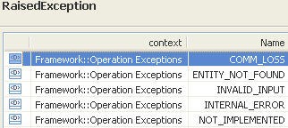 | restriction base="msg:AllExceptionsType"  element ref="msg:commLoss"  element ref="msg:entityNotFound"  element ref="msg:internalError"  element ref="msg:invalidInput"  element ref="msg:notImplemented"  element ref="msg:tooManyOpenIterators"

getAllTerminationPointPools

BA (getAllTerminationPointPools) | IA | IIS | Comments
R_TMF518_MRI_II_0052  The Interface shall allow the requesting OS to retrieve the attributes of all the Termination Point Pool (TP Pool)s given a Subnetwork name specified by the requesting OS.  R_TMF518_MRI_II_0053 | This operation retrieves all Termination Point Pools (TP Pools) contained by a provided Multi Layer Subnetwork (MLSN).  Traceability: R_TMF518_MRI_II_0052. | This operation retrieves all Termination Point Pools (TP Pools) contained by a provided Multi Layer Subnetwork (MLSN).
 | mlsnRef (ObjectName)  This parameter provides the name of the Multi Layer Subnetwork whose TP Pools are to be returned. | RequestProfile1Type  name="mlsnRef" type="nam:NamingAttributeType"  Name of the subnetwork.
 | tpPoolList (*) (TerminationPointPool)  This parameter returns the list of TP Pool objects contained by the MLSN. | MultipleTerminationPointPoolObjectsResponseType  element name="tpPoolList" type="tpp:TerminationPointPoolListType"  The list of TerminationPointPool objects.
restriction base="msg:AllExceptionsType"
element ref="msg:commLoss"
element ref="msg:entityNotFound"
element ref="msg:internalError"
element ref="msg:invalidInput"
element ref="msg:notImplemented"
element ref="msg:tooManyOpenIterators"

getAssociatedGroupTerminationPoint

BA (getAssociatedGroupTerminationPoint) | IA | IIS | Comments
R_TMF518_MRI_II_0105  The Interface shall allow the requesting OS to retrieve the attributes of a Group Termination Point (GTP) that contains a Connection Termination Point (CTP) name specified by the requesting OS. | This operation retrieves the details of the Group Termination Point (GTP) containing the provided Connection Termination Point (CTP).  Traceability: R_TMF518_MRI_II_0105. | This operation retrieves the details of the Group Termination Point (GTP) containing the provided Connection Termination Point (CTP).
 | ctpRef (ObjectName)  This parameter provides the name of the Connection Termination Point whose containing GTP is to be returned. | ctpRef (ObjectName)  This parameter provides the name of the Connection Termination Point whose containing GTP is to be returned.
 | gtp (GroupTerminationPoint)  This parameter returns the GTP object containing the provided CTP. | gtp (GroupTerminationPoint)  This parameter returns the GTP object containing the provided CTP.
 | 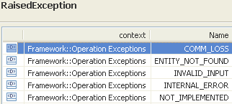

getAssociatedTerminationPoints

BA (getAssociatedTerminationPoints) | IA | IIS | Comments
R_TMF518_MRI_II_0080  The Interface shall allow the requesting OS to retrieve the attributes of all the Termination Point (TP)s associated with a given TP identified a TP name specified by the requesting OS.  Some examples of associated TPs to be returned by the target OS:  In the case of an open Path Switched Ring (PSR) topology, if the requesting OS specifies a CTP (timeslot) on one end of the open PSR, the target OS shall return the CTP on the other end of the open PSR corresponding to the specified timeslot, associated with relationship (as illustrated in the figure below showing the associated CTP relationship in an open ring)  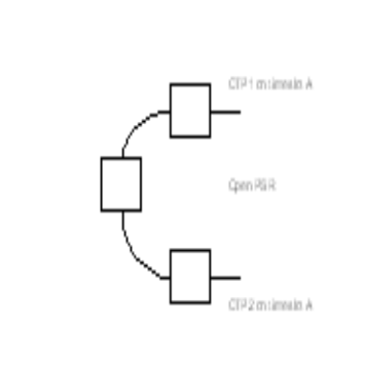 | This operation retrieves a list of PSR (UPSR or SNCP) associated Termination Points (TPs) for the TP whose name is provided.  The operation retrieves the associated CTP of a given CTP or the associated PTP of a given PTP. The timeslot of the TPs will be the same in case of an OPEN_PSR Multi Layer Subnetwork, but the names of the two TPs will be different.  The operation is symmetric on the associated TPs. Given a working TP, the associated TP will be the protecting TP.  When the operation is invoked with a TP that is not an edge point, the returned TPs will be on the same Managed Element.  Traceability: R_TMF518_MRI_II_0080. | This operation returns a list of PSR (UPSR or SNCP) associated termination points for the TP whose name is passed as a parameter.  Note: The termination point name must be explicit (a generic endpoint specification may not be used in this case). See Object Naming for further detail on FTP naming.  When this service is invoked with a TP that is not an edge point, the returned TPs will be on the same Managed Element
 | tpRef (ObjectName)  This parameter provides the name of the Termination Point whose associated TPs are to be returned. | type="tns:RequestProfile2Type"  +++++++++++++++++  see RequestProfile2 Type in section 11.23.5
 | tpList (*) (TerminationPoint)  This parameter returns the list of TP objects associated to the provided TP. | type="tns:MultipleTerminationPointObjectsResponseType"  +++++++++++++++++  see MultipleTerminationPointObjectsResponse Type in section 11.23.3
 | 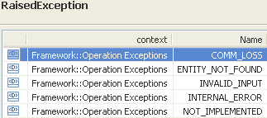 | restriction base="msg:AllExceptionsType"  element ref="msg:commLoss"  element ref="msg:entityNotFound"  element ref="msg:internalError"  element ref="msg:invalidInput"  element ref="msg:notImplemented"  element ref="msg:tooManyOpenIterators"

getAssociatedTerminationPointsWrtTmd

BA (getAssociatedTerminationPointsWrtTmd) | IA | IIS | Comments
R_TMF518_MRI_II_0048  The Interface shall allow the requesting OS to retrieve the attributes of all the Connection Termination Point (CTP) that are associated with a Traffic Descriptor (TD) name specified by the requesting OS.  R_TMF518_MRI_II_0050  The Interface shall allow the requesting OS to retrieve the attributes of all the Termination Point (TP)s that are associated with a Transmission Descriptor (TMD) name specified by the requesting OS. | This operation retrieves the list of Termination Points (TPs) that are associated with a provided Transmission Descriptor (TMD).  Traceability: R_TMF518_MRI_II_0048, R_TMF518_MRI_II_0050. | This operation allows an OS to request all of the TPs associated with the specified Transmission Descriptor.  If there are no TPs which are associated with the specified Transmission Descriptor, then an empty list is returned.
 | tmdRef (ObjectName)  This parameter provides the name of the Transmission Descriptor whose associated TPs are to be returned. | (in) element name="tmdRef" type="nam:NamingAttributeType"  This parameter provides the name of the Transmission Descriptor whose associated TPs are to be returned.
 | tpList (*) (TerminationPoint)  This parameter returns the list of TP objects associated to the provided TMD. | type="tns:MultipleTerminationPointObjectsResponseType"  +++++++++++++++++  see MultipleTerminationPointObjectsResponse Type in section 11.23.3
 |  | element name="getAssociatedTerminationPointsWrtTmdException" type="tns:RequestProfile1Type"

getContainedCurrentConnectionTerminationPoints

BA (getContainedCurrentConnectionTerminationPoints) | IA | IIS | Comments
R_TMF518_MRI_II_0070  The Interface shall allow the requesting OS to retrieve the attributes of all the currently cross-connectible or cross-connected Termination Point (TP)s that are contained by (served by) a given TP identified by a specified TP name and layer rate specified by the requesting OS.  Some examples:  If the requesting OS specifies an OC3 physical TP (port) name that can be mapped to STS1s or VT1.5s, then  ▪ If none of the STS1 CTPs are terminated and mapped the target OS response would include only the 3 STS1 TPs (CTPs).  ▪ If all 3 STS1 CTPs are terminated and mapped, then 84 VT1.5 TPs (CTPs), are returned.  If the requesting OS specifies a STS1 TP name (physical or logical TP, i.e., a physical port or a logical channel (CTP) that can be mapped to VT1.5s), then the target OS response would include:  ▪ 28 VT1.5 TPs (CTPs) if the STS1 TP is terminated and mapped.  ▪ No TPs if the STS1 TP is neither terminated nor mapped.  R_TMF518_MRI_II_0071 | This operation retrieves the "current" Connection Termination Points (CTPs) which  - are contained within the provided Termination Point (PTP or CTP) and  - contain one or more of the provided Layer Rates.  A "current" CTP is defined as a CTP that is either cross-connectible or cross-connected, in the current mapping configuration.  Examples for contained Current TPs in different states of usage are contained in the associated supporting document SD1-6_ContainedTPs.  Traceability: R_TMF518_MRI_II_0070. | This operation is used to retrieve the "current" CTPs that are contained within a specific PTP, FTP or CTP, at specific layer rates. A "current" CTP is defined as a CTP that is either cross-connectable or cross-connected, in the current mapping configuration.
 | tpRef (ObjectName)  This parameter provides the name of the Termination Point whose contained current CTPs are in scope. | type="tns:GetAllConnectionTerminationPointsType"  +++++++++++++++++  see GetAllConnectionTerminationPoints Type in section 11.23.2
layerRateList (*) (LayerRate)
This parameter provides the list of Layer Rates used to scope the request. A CTP must contain at least one of the Layer Rates specified to be reported. If the list is empty then all current CTPs (of all rates) are returned.

 | ctpList (*) (ConnectionTerminationPoint)  This parameter returns the list of CTP objects. | type="tns:MultipleTerminationPointObjectsResponseType"  +++++++++++++++++  see MultipleTerminationPointObjectsResponse Type in section 11.23.3
 | 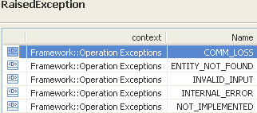 | restriction base="msg:AllExceptionsType"  element ref="msg:commLoss"  element ref="msg:entityNotFound"  element ref="msg:internalError"  element ref="msg:invalidInput"  element ref="msg:notImplemented"  element ref="msg:tooManyOpenIterators"

getContainedInUseConnectionTerminationPoints

BA (getContainedInUseConnectionTerminationPoints) | IA | IIS | Comments
R_TMF518_MRI_II_0072  The Interface shall allow the requesting OS to retrieve the attributes of all the “in use” (actual) Termination Point (TP)s that are contained by (served by) a given TP identified by a TP name and layer rate specified by the requesting OS.  This operation will be used when there are a large number of potential TPs (e.g., in ATM). All of the potential TPs are not returned. The TPs can be scoped on layer rate. If no layer rate is specified, then actual TP at all the contained layers are returned. If layer rate(s) are specified, then only actual TPs at the specified layer rates are returned.  R_TMF518_MRI_II_0073 | This operation retrieves the "in use" Connection Termination Points (CTPs) which  - are contained within the provided Termination Point (PTP or CTP) and  - contain one or more of the provided Layer Rates.  An "in use" CTP is defined as a CTP that is used by a Subnetwork Connection (SNC) in any state (including pending), either as a CM end point or as an intermediate connection point, or a CTP that is terminated and mapped.  The operation can be used when there are a large number of potential CTPs (e.g., in ATM).  Examples for contained InUse TPs in different states of usage are contained in the associated supporting document SD1-6_ContainedTPs.  Traceability: R_TMF518_MRI_II_0072. | This operation is used to retrieve the "in use" CTPs that are contained within a specific PTP, FTP or CTP, at specific layer rates. An "in use" CTP is defined as a CTP that is used by an SNC in any state (including pending), either as a CM end point or as an intermediate connection point, or a CTP that is terminated and mapped. This operation will be used when there are a large number of potential CTPs (e.g., in ATM).  Example of usage with respect to ATM:  To retrieve all actual ATM Network Interfaces associated with a PTP, this operation will be invoked using the PTP name as the tpName and LR_ATM_NI as the only layer rate in the layerRateList. The VPI and VCI ranges that are specified in the returned ATM Network Interface transmissionParams (i.e., Max_VPI_Bits and Max_VCI_Bits) can then be used to determine the potential VPI/VCI range. A subsequent invocation of this operation using an ATM Network Interface CTP as input can be used to determine which VPIs/VCIs are actually in use (with LR_ATM_VP and LR_ATM_VC included in the connectionRateList).  Example of usage with respect to SONET/SDH:  Consider an STM4 PTP with layerRate: LR_Optical_OC12_and_STM4. Assume that the set of CTPs returned by operation getContainedPotentialTPs() contains one CTP with layerRate LR_STS3c_and_AU4_VC4 that is terminating an SNC (layerRate LR_STS3c_and_AU4_VC4), and another CTP with layerRate LR_STS3c_and_AU4_VC4 that is terminated and mapped (attribute tpMappingMode is set to TMTypeERMINATED_AND_AVAILABLE_FOR_MAPPING). The CTP with layerRate LR_STS3c_and_AU4_VC4 that is terminated and mapped contains one CTP with layerRate LR_VT2_andTypeU12_VC12 that is involved in an SNC. None of the other contained CTPs have attribute tpMappingMode set to TMTypeERMINATED_AND_AVAILABLE_FOR_MAPPING, or are involved in an SNC.  Operation getContainedInUseTPs then returns three CTPs:  - The CTP with layerRate LR_STS3c_and_AU4_VC4 that is terminating an SNC.  - The CTP with layerRate LR_STS3c_and_AU4_VC4 that has attribute tpMappingMode set to TMTypeERMINATED_AND_AVAILABLE_FOR_MAPPING.  - The CTP with layerRate LR_VT2_andTypeU12_VC12 that is terminating an SNC. | bz:  Shall the enhanced XML description be copied to the IA?
 | tpRef (ObjectName)  This parameter provides the name of the Termination Point whose contained in-use CTPs are in scope. | type="tns:GetAllConnectionTerminationPointsType"  +++++++++++++++++  see GetAllConnectionTerminationPoints Type in section 11.23.2
layerRateList (*) (LayerRate)
This parameter provides the list of Layer Rates used to scope the request. A CTP must contain at least one of the Layer Rates specified to be reported. If the list is empty then all in-use CTPs (of all rates) are returned.

 | ctpList (*) (ConnectionTerminationPoint)  This parameter returns the list of CTP objects. | type="tns:MultipleTerminationPointObjectsResponseType"  +++++++++++++++++  see MultipleTerminationPointObjectsResponse Type in section 11.23.3
 | 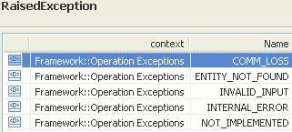 | restriction base="msg:AllExceptionsType"  element ref="msg:commLoss"  element ref="msg:entityNotFound"  element ref="msg:internalError"  element ref="msg:invalidInput"  element ref="msg:notImplemented"  element ref="msg:tooManyOpenIterators"

getContainedPotentialConnectionTerminationPoints

BA (getContainedPotentialConnectionTerminationPoints) | IA | IIS | Comments
R_TMF518_MRI_II_0068  The Interface shall allow the requesting OS to retrieve the attributes of all the potentially present Termination Point (TP)s contained by (served by) a given TP identified by a TP name and layer rate specified by the requesting OS.  Some examples:  If the requesting OS specifies an OC3 physical TP (port) name that can be mapped to STS1s or VT1.5s, then the target OS response would include 3 STS1 TPs (CTPs) and 84 VT1.5 TPs (CTPs), respectively.  If the requesting OS specifies an STS1 TP name (physical or logical TP, i.e., a physical port or a logical channel (CTP) that can be mapped to VT1.5s), then the target OS response would include 28 VT1.5 TPs (CTPs).  R_TMF518_MRI_II_0069 | This operation retrieves the "potential" Connection Termination Points (CTPs) which  - are contained within the provided Termination Point (PTP or CTP) and  - contain one or more of the provided Layer Rates.  Potential CTPs are all CTPs supported by all possible mapping configurations. If the layerRateList is empty then contained CTPs at all flexible and/or static LayerRates are returned.  Examples for contained Potential TPs in different states of usage are contained in the associated supporting document SD1-6_ContainedTPs.  Note that in any case, this operation returns the complete object information for all contained CTPs, not just those CTPs that are directly contained by the provided TP.  Traceability: R_TMF518_MRI_II_0068. | This operation an OS to request all of the CTPs that it is potentially capable of supporting in all possible mapping configurations, at the specified rates and that are contained by the specified termination point.  This operation returns all potential contained CTPs for a given TP. The TP may be a PTP, an FTP or a CTP. If the layerRateList is empty then contained CTPs at all flexible and/or static LayerRates are returned.  For an OC3 PTP that has the potential of mapping to VT1.5 the response would contain 3 STS1 CTPs and 84 VT1.5 CTPs; on a T1 PTP, the contained TPs would be one T1 CTP; for an STS1 CTP the response would contain 28 VT1.5 CTPs. In the case where an OC3 PTP supports mapping to T1s and VT1.5, then the contained list for the OC3 PTP could be 1 STS3c, 3 STS1, 84 VT1.5 and 84 T1 CTPs; if a VT1.5 CTP is provided, 1 T1 CTP is returned; if a T1 CTP is provided, the result is an empty list.  Whenever a protection group is involved, the behaviour of this service is described below:  Scenario 1: Before the Protection Group is created:  - Query On Worker TPs returns list of all CTPs  - Query On Protection TPs returns list of all CTPs.  Scenario 2: After ProtectionGroup is created, if extra (preemptible/non-pre-emptible) traffic is allowed.:  - Query On Worker TPs returns list of all CTPs  - Query On Protection TPs returns list of all CTPs.  Scenario 3: After ProtectionGroup is created, if extra (preemptible/non-pre-emptible) traffic is not allowed:  - Query On Worker TPs returns list of CTPs that allow protected traffic  - Query On Protection TPs returns an empty list (regardless of the switch status).  In case the protection group is created after a query is made, no object delete notification is made, the NMS is expected to query the ports in the protection group to find the list of contained CTPs.  When ATM, this operation needs to be used with caution. The reason for this is that, in ATM, there can be a prohibitively large number of potential VP and VC CTPs returned by this operation. For retrieving ATM CTPs, the getContainedInUseTPs() operation should be considered.  If DWDM, SONET and/or SDH is combined with ATM, it is advisable that this operation be used with the appropriate DWDM, SONET and/or SDH layer rates entered into the layerRateList. Otherwise, ATM CTPs will be returned and the resulting list of contained TPs could get prohibitive. | bz:  Shall the enhanced XML description be copied to the IA?
 | tpRef (ObjectName)  This parameter provides the name of the Termination Point whose contained potential CTPs are in scope. | type="tns:GetAllConnectionTerminationPointsType"  +++++++++++++++++  see GetAllConnectionTerminationPoints Type in section 11.23.2
layerRateList (*) (LayerRate)
This parameter provides the list of Layer Rates used to scope the request. A CTP must contain at least one of the Layer Rates specified to be reported. If the list is empty then all potential CTPs (of all rates) are returned.

 | ctpList (*) (ConnectionTerminationPoint)  This parameter returns the list of CTP objects. | type="tns:MultipleTerminationPointObjectsResponseType"  +++++++++++++++++  see MultipleTerminationPointObjectsResponse Type in section 11.23.3
 | 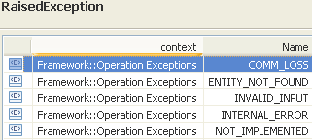 | restriction base="msg:AllExceptionsType"  element ref="msg:commLoss"  element ref="msg:entityNotFound"  element ref="msg:internalError"  element ref="msg:invalidInput"  element ref="msg:notImplemented"  element ref="msg:tooManyOpenIterators"

getContainingTerminationPoints

BA (getContainingTerminationPoints) | IA | IIS | Comments
R_TMF518_MRI_II_0074  The Interface shall allow the requesting OS to retrieve the attributes of all the Termination Point (TP)s that contain (serves) the TP identified by a TP name specified by the requesting OS.  Some examples:  a. If the requesting OS specifies an STS1 TP (CTP) name that is a channel of an OC3, then the target OS would respond with the OC3 physical TP.  b. If the requesting OS specifies an OC3 physical TP (port) name, then the target OS would respond with no containing TPs.  R_TMF518_MRI_II_0075 | This operation retrieves the containing Physical Termination Point (PTP) and any containing Connection Termination Points (CTPs) of the provided CTP.  Traceability: R_TMF518_MRI_II_0074. | This operation returns a list of the containing TPs given a CTP. This will return an PTP or FTP where there is only one level of containment. In a case of deeper containment this will return a list of CTPs and a PTP or FTP.  Using the UPSR OC3 example used in getContainedPotentialTps, getContainingTps on the working T1 CTP will return a working STS1 CTP and a working OC3PTP. If the OC3 was in APS, then getContainingTps on the T1 CTP would return an STS1 CTP, an OC3 working PTP and an OC3 protect PTP.
 | ctpRef (ObjectName)  This parameter provides the name of the Connection Termination Point whose containing TPs are to be returned. | type="tns:RequestProfile4Type"  +++++++++++++++++  see RequestProfile4 Type in section 11.23.6
 | tpList (*) (TerminationPoint)  This parameter returns the list of containing TP objects. | type="tns:MultipleTerminationPointObjectsResponseType"  +++++++++++++++++  see MultipleTerminationPointObjectsResponse Type in section 11.23.3
restriction base="msg:AllExceptionsType"
element ref="msg:commLoss"
element ref="msg:entityNotFound"
element ref="msg:internalError"
element ref="msg:invalidInput"
element ref="msg:notImplemented"

getGroupTerminationPoint

BA (getGroupTerminationPoint) | IA | IIS | Comments
R_TMF518_MRI_II_0104  The Interface shall allow the requesting OS to retrieve the attributes of a Group Termination Point (GTP) for a GTP name specified by the requesting OS. | This operation retrieves the details of a Group Termination Point given its name.  Traceability: R_TMF518_MRI_II_0104. | This operation retrieves the details of a Group Termination Point given its name.
 | gtpRef (ObjectName)  This parameter provides the name of the Group Termination Point to be retrieved. | (in) element name="gtpRef" type="nam:NamingAttributeType"  Name of the GTP.
 | gtp (GroupTerminationPoint)  This parameter returns the Group Termination Point object selected by the given name. | type="tns:SingleGroupTerminationPointObjectResponseType"  +++++++++++++++++  see SingleGroupTerminationPointObjectResponse Type in section 11.23.4
 | 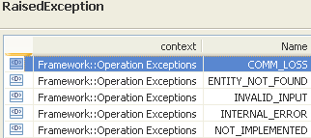 | restriction base="msg:AllExceptionsType"  element ref="msg:commLoss"  element ref="msg:entityNotFound"  element ref="msg:internalError"  element ref="msg:invalidInput"  element ref="msg:notImplemented"

getTerminationPoint

BA (getTerminationPoint) | IA | IIS | Comments
R_TMF518_MRI_II_0047  The Interface shall allow the requesting OS to retrieve the attributes of a Termination Point (TP) given a TP name specified by the requesting OS. | This operation retrieves the details of a Termination Point given its name.  Traceability: R_TMF518_MRI_II_0047. | This operation returns the termination point structure for the given TP name (CTP, FTP or PTP). The termination point name must be explicit (a generic endpoint specification may not be used in this case). See SD1-25_objectNaming.pdf for further detail on FTP naming.  The termination point structure contains SD1-16_LayeredParameters.pdf. The transmission parameters returned will be the parameters in place on the actual termination point on the NE. If there are no transmission parameters or the TP does not actually exist on the NE, then transmissionParams will be empty. The field transmissionParams will also be empty for "potential" ATM VP/VC CTPs.
 | tpRef (ObjectName)  This parameter provides the name of the Termination Point to be retrieved. | type="tns:RequestProfile2Type"  +++++++++++++++++  see RequestProfile2 Type in section 11.23.5
 | tp (TerminationPoint)  This parameter returns the Termination Point object selected by the given name. | SingleTerminationPointObjectResponseType  element name="tp" type="tp:TerminationPointType"  The TP object.
restriction base="msg:AllExceptionsType"
element ref="msg:commLoss"
element ref="msg:entityNotFound"
element ref="msg:internalError"
element ref="msg:invalidInput"
element ref="msg:notImplemented"

getTerminationPointGroupingRelationships

BA | IA | IIS (getTerminationPointGroupingRelationships)  covers only R_TMF518_MRI_II_0049 and R_TMF518_MRI_II_0054  R_TMF518_MRI_II_0106 not covered | IIS (getContainingGroupTerminationPoint)  covers R_TMF518_MRI_II_???
R_TMF518_MRI_II_0049  The Interface shall allow the requesting OS to retrieve the names of all the Termination Point Pool (TP Pool)s that are associated with a Termination Point (TP) specified by the requesting OS.  Descriptions of the associations can be obtained from the respective TPPool attributes for the description of use.  In case of ATM VP TP Pool administration the specified TP is an ATM NI CTP representing a real user network interface that gets partitioned into virtual user network interfaces represented by TP pools. Each TP pool contains ATM VP CTPs that are clients of the specified ATM NI CTP.  R_TMF518_MRI_II_0054  The Interface shall allow the requesting OS to retrieve the names of all the Termination Point (TP)s and Group Termination Point (GTP)s that have been grouped by the Termination Point Pool (TP Pool) specified by the requesting OS.  R_TMF518_MRI_II_0106  The Interface shall allow the requesting OS to retrieve the names of all the Termination Point Pool (TP Pool)s that are associated with the Group Termination Point (GTP) name specified by the requesting OS. | This operation queries the grouping associations between Termination Points (TPs), Termination Point Pools (TP Pools) and Group Termination Points (GTPs).  It allows to retrieve:  - the names of all TP Pools associated to a provided TP; (R_TMF518_MRI_II_0049)  - the name of the TP Pool containing a provided GTP; (R_TMF518_MRI_II_0106)  - the names of all TPs and GTPs contained in a provided TP Pool; (R_TMF518_MRI_II_0054).  Note: A TP can be a member of at most one TP Pool. A TP is associated to a TP Pool (TP --> TP Pool) by admission as a member (TP is a member of TP Pool). The association of a TP Pool to a TP (TP Pool --> TP) can be, but need not be, the reversal of the membership association of a TP to a TP Pool (TP Pool contains TP). Therefore several TP Pools can be associated to a TP.  Descriptions of the associations can be obtained from the respective TP Pool attributes for the description of use.  An example for an association, that is not the containment of the TP itself in a TP Pool, is the partitioning of the set of potential client CTPs of an ATM NI CTP (real user network interface) into a set of ATM VP TP pools (virtual user network interfaces). See attached supporting document SD1-41_TPPoolRelationship.  Traceability: R_TMF518_MRI_II_0049, R_TMF518_MRI_II_0054, R_TMF518_MRI_II_0106. | This operation allows the query of the associations between TPPool and TP.  If a TPPool name is supplied, the method will return the names of all the TPs and GTPs that have been grouped to the supplied TPPool.  If a TP name is supplied, the method will return the names of any associated TPPools. An empty list is returned if no associated TP pools exist for the input TP, or if no TPs have been grouped to the input TP pool.  Note 1. Any termination point name must be explicit (a generic endpoint specification must not be used in this case). See Object Naming for further detail on FTP naming and for details on general TP and TP pool naming.  Note 2. A TP can be a member of at most one TPPool. A TP is associated to a TPPool (TP -- TPPool) by admission as a member (TP is a member of TPPool). | This operation returns the GTP object containing a given CTP (see SD1-3 Bundled SNC overview for further information on GTP usage). If the CTP is not contained in a GTP, the gtp output parameter is left empty.
 | relationshipSourceResourceRef (ObjectName)  This parameter provides the name of the Resource whose grouping relationship peer(s) is (are) to be returned. | type="tns:RequestProfile2Type"  +++++++++++++++++  see RequestProfile2 Type in section 11.23.5 | type="tns:RequestProfile4Type"  +++++++++++++++++  see RequestProfile4 Type in section 11.23.6
 | relationshipSinkResourceRefList (*) (ObjectName)  This parameter returns the names of the Resources that are peers in the grouping relationship with the provided source Resource. | MultipleObjectNamesResponseType  element name="nameList" type="nam:NamingAttributeListType"  The list of object names. | type="tns:SingleGroupTerminationPointObjectResponseType"  +++++++++++++++++  see SingleGroupTerminationPointObjectResponse Type in section 11.23.4
 | 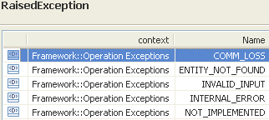 | restriction base="msg:AllExceptionsType"  element ref="msg:commLoss"  element ref="msg:entityNotFound"  element ref="msg:internalError"  element ref="msg:invalidInput"  element ref="msg:notImplemented" | restriction base="msg:AllExceptionsType"  element ref="msg:commLoss"  element ref="msg:entityNotFound"  element ref="msg:internalError"  element ref="msg:invalidInput"  element ref="msg:notImplemented"

getTerminationPointPool

BA (getTerminationPointPool) | IA | IIS | Comments
R_TMF518_MRI_II_0051  The Interface shall allow the requesting OS to retrieve the attributes of a Termination Point Pool (TP Pool) given a TP Pool name specified by the requesting OS. | This operation retrieves the details of a Termination Point Pool (TP Pool) given its name.  Traceability: R_TMF518_MRI_II_0051. | This operation retrieves the details of a Termination Point Pool (TP Pool) given its name.
 | tpPoolRef (ObjectName)  This parameter provides the name of the Termination Point Pool to be retrieved. | (in) element name="tpPoolRef" type="nam:NamingAttributeType"  This parameter provides the name of the Termination Point Pool to be retrieved.
 | tpPool (TerminationPointPool)  This parameter returns the Termination Point Pool object selected by the given name. | SingleTerminationPointPoolObjectResponseType  element name="tpPool" type="tpp:TerminationPointPoolType"  The TerminationPointPool.
restriction base="msg:AllExceptionsType"
element ref="msg:commLoss"
element ref="msg:entityNotFound"
element ref="msg:internalError"
element ref="msg:invalidInput"
element ref="msg:notImplemented"

getTrafficConditioningProfileAssociatedTps

BA (getTrafficConditioningProfileAssociatedTps) | IA | IIS | Comments
R_TMF518_MRI_II_0125  The Interface shall allow the requesting OS to retrieve the attributes of all the Termination Point (TP)s that are associated with a specified Traffic Conditioning (TC) Profile name. | The operation retrieves the details of all Termination Points (TPs) that are associated with the provided Traffic Conditioning Profile (TC Profile).  Traceability: R_TMF518_MRI_II_0125. | The operation retrieves the details of all Termination Points (TPs) that are associated with the provided Traffic Conditioning Profile (TC Profile).
 | tcProfileRef (ObjectName)  This parameter provides the name of the Traffic Conditioning Profile whose associated TPs are to be retrieved. | (in) element name="tcProfileRef" type="nam:NamingAttributeType"  The name of the TC Profile.
 | tpList (*) (TerminationPoint)  This parameter returns the list of Termination Point objects associated with the provided Traffic Conditioning Profile. | MultipleTerminationPointObjectsResponseType
restriction base="msg:AllExceptionsType"
element ref="msg:commLoss"
element ref="msg:entityNotFound"
element ref="msg:internalError"
element ref="msg:invalidInput"
element ref="msg:notImplemented"
element ref="msg:tooManyOpenIterators"

Data Types

GetAllTerminationPoints Type

BA | IA | IIS (GetAllTerminationPointsType) | Comments
element name="meRef" type="nam:NamingAttributeType"
The name of the Managed Element.

(in) element name="tpLayerRateList" type="lr:LayerRateListType"
List of TP layer rates for which the TPs are to be fetched. A TP must contain at least one of the layer rates specified to be reported. If the list is empty then all TPs (of all rates) are returned.

(in) element name="connectionLayerRateList" type="lr:LayerRateListType"
List of connection layer rates for which the TPs are to be fetched. A TP must support connections for at least one of the layer rates specified to be reported. If the list is empty then all TPs (for all connection rates) are returned.

GetAllConnectionTerminationPoints Type

BA | IA | IIS (GetAllConnectionTerminationPointsType) | Comments
element name="tpRef" type="nam:NamingAttributeType"
The name of the PTP, FTP or CTP for which to get CTPs. The termination point name must be explicit (a generic endpoint specification may not be used in this case). See Object Naming for further detail on FTP naming.

(in) element name="layerRateList" type="lr:LayerRateListType"
List of TP layer rates for which the TPs are to be fetched. A TP must contain at least one of the layer rates specified to be reported. If the list is empty then all TPs (of all rates) are returned.

MultipleTerminationPointObjectsResponse Type

BA | IA | IIS (MultipleTerminationPointObjectsResponseType) | Comments
element name="tpList" type="tp:TerminationPointListType"
The list of TP objects.

SingleGroupTerminationPointObjectResponse Type

BA | IA | IIS (SingleGroupTerminationPointObjectResponseType) | Comments
element name="gtp" type="gtp:GroupTerminationPointType"
The GTP object.

RequestProfile2 Type

BA | IA | IIS (RequestProfile2Type) | Comments
element name="tpRef" type="nam:NamingAttributeType"
Name of the TP.

RequestProfile4 Type

BA | IA | IIS (RequestProfile4Type) | Comments
element name="ctpRef" type="nam:NamingAttributeType"
Name of the contained CTP.

Topological Link Retrieval Service
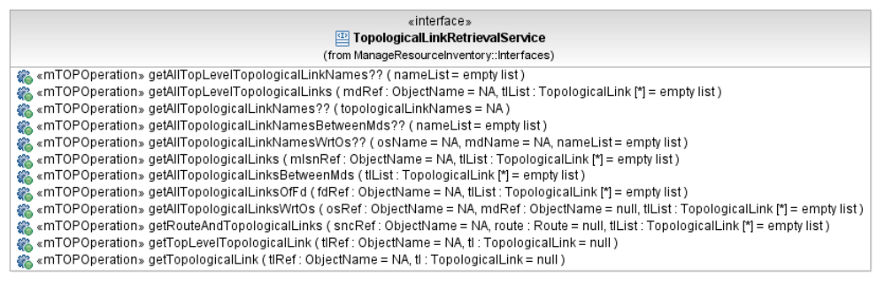
Figure 13: MRI Topological Link Retrieval Service Interface Diagram

getAllTopLevelTopologicalLinks

BA (getAllTopLevelTopologicalLinks) | IA | IIS | Comments
R_TMF518_MRI_II_0024  The Interface shall allow the requesting OS to retrieve the attributes of all the top level Topological Links between the Subnetwork (s).  R_TMF518_MRI_II_0025 | This operation returns all top level (i.e., between Multi Layer Subnetworks) Topological Links (TLs) that are managed by the provided Management Domain (MD).  Traceability: R_TMF518_MRI_II_0024. | This operation returns the TL objects between the subnetworks contained by the MD to which the operation is directed.
 | mdRef (ObjectName)  This parameter provides the name of the Management Domain whose Topological Links are to be returned. | (in) element name="mdRef" type="nam:NamingAttributeType"  The name of the MD for which associated top level TLs are being requested.
 | tlList (*) (TopologicalLink)  This parameter returns the list of top level Topological Link objects. | type="tns:MultipleTlObjectsResponseType"  +++++++++++++++++  see MultipleTlObjectsResponse Type in section 12.9.1
 | 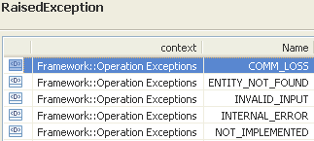 | restriction base="msg:AllExceptionsType"  element ref="msg:commLoss"  element ref="msg:entityNotFound"  element ref="msg:internalError"  element ref="msg:invalidInput"  element ref="msg:notImplemented"  element ref="msg:tooManyOpenIterators"

getAllTopologicalLinks

BA (getAllTopologicalLinks) | IA | IIS | Comments
R_TMF518_MRI_II_0027  The Interface shall allow the requesting OS to retrieve the attributes of all the Topological Links between NEs and internal to NEs given a Subnetwork specified by the requesting OS.  R_TMF518_MRI_II_0028 | This operation retrieves all Topological Links (TLs) (i.e., between or internal to Managed Elements) that are contained within the provided Multi Layer Subnetwork (MLSN).  For singleton MLSNs, no Topological Links will be returned. The target OS reports Topological Links at the "lowest" layer (i.e. closest to physical) about which it has accurate knowledge.  Traceability: R_TMF518_MRI_II_0027. | This operation returns a list of TopologicalLinks which exist inside the Subnetwork whose name is passed as a parameter.  For singleton MLSNs, no Topological Links will be returned. The target OS reports Topological Links at the "lowest" layer (i.e. closest to physical) about which it has accurate knowledge.
 | mlsnRef (ObjectName)  This parameter provides the name of the Multi Layer Subnetwork whose Topological Links are to be returned. | (in) element name="mlsnRef" type="nam:NamingAttributeType"  Name of the subnetwork.
 | tlList (*) (TopologicalLink)  This parameter returns the list of Topological Link objects. | type="tns:MultipleTlObjectsResponseType"  +++++++++++++++++  see MultipleTlObjectsResponse Type in section 12.9.1
restriction base="msg:AllExceptionsType"
element ref="msg:commLoss"
element ref="msg:entityNotFound"
element ref="msg:internalError"
element ref="msg:invalidInput"
element ref="msg:notImplemented"
element ref="msg:tooManyOpenIterators"

getAllTopologicalLinksBetweenMds

BA (getAllTopologicalLinksBetweenMds) | IA | IIS | Comments
?? | This operation returns all TopologicalLinks (TLs) which have end points in two different Management Domains (MDs) which are managed by the addressed top-level OS.  The operation can only be directed to a top-level OS and not to a subordinate OS.  Traceability: R_TMF518_MRI_II_00??. | This operation returns all TopologicalLinks (TL) with end points in two different ManagementDomains (MDs) which are managed by the addressed top-level OS.
 | tlList (*) (TopologicalLink)  This parameter returns the list of all Topological Link objects having end points in two different Management Domains. | type="tns:MultipleTlObjectsResponseType"  +++++++++++++++++  see MultipleTlObjectsResponse Type in section 12.9.1
 | 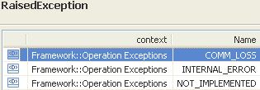 | restriction base="msg:AllExceptionsType"  element ref="msg:commLoss"  element ref="msg:internalError"  element ref="msg:notImplemented"  element ref="msg:tooManyOpenIterators"

getAllTopologicalLinksOfFd

BA (getAllTopologicalLinksOfFd) | IA | IIS | Comments
R_TMF518_MRI_II_150 (TMF513 v3.1 {Requirement II. 380})  The Interface shall allow the requesting OS to retrieve the attributes of all Topological Links (TLs) that are terminated at a specific Flow Domain (FD) given by the requesting OS.  Note:  This also includes the internal Topological Links. | This operation retrieves the details of all the Topological Links (including also the internal Topological Links) that are terminated at the provided Flow Domain (FD).  Traceability: R_TMF518_MRI_II_0???. | This operation retrieves the details of all the Topological Links (including also the internal Topological Links) that are terminated at the provided Flow Domain (FD).
 | fdRef (ObjectName)  This parameter provides the name of the Flow Domain whose Topological Links are to be returned. | (in) element name="fdRef" type="nam:NamingAttributeType"  The name of the Flow Domain.
 | tlList (*) (TopologicalLink)  This parameter returns the list of Topological Link objects. | type="tns:MultipleTlObjectsResponseType"  +++++++++++++++++  see MultipleTlObjectsResponse Type in section 12.9.1
 | 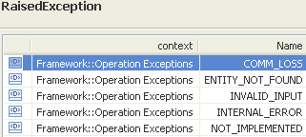 | restriction base="msg:AllExceptionsType"  element ref="msg:commLoss"  element ref="msg:entityNotFound"  element ref="msg:internalError"  element ref="msg:invalidInput"  element ref="msg:notImplemented"  element ref="msg:tooManyOpenIterators"

getAllTopologicalLinksWrtOs

BA (getAllTopologicalLinksWrtOs) | IA | IIS | Comments
R_TMF518_MRI_II_0007  The Interface shall support requests to retrieve the objects instances that are named (contained) under a given management domain. The possible object types include the following: subnetwork, topological link and managed element.  R_TMF518_MRI_II_0013  The Interface shall support the request to retrieve all the managed elements, topological links and subnetworks to which a given subordinate OS has a “manages” relationship. Note that there will not be any “manages” relationships with subnetworks unless the top-level and subordinate OSs uses the same subnetwork partitioning. | This operation returns all Topological Links (TLs) managed by the provided subordinate OS AND contained by the provided Management Domain (MD).  If no MD is provided all TLs managed by the provided subordinate OS are returned.  Note that "Wrt" in the name of the operation stands for "with respect to".  Traceability: R_TMF518_MRI_II_0007, R_TMF518_MRI_II_0013, UC_TMF518_MRI_0012. | This operation returns all Topological Links (TL) managed by a given subordinate OS AND contained by a specific Management Domain.  Note that Wrt in the name of the operation stands for "with respect to".
 | osRef (ObjectName)  This parameter provides the name of the subordinate OS whose managed Topological Links are in scope of the request. | (in) element name="osRef" type="nam:NamingAttributeType"  The name of the subordinate OS whose associated TLs requested.
 | mdRef (ObjectName)  This parameter provides the name of the Management Domain whose contained Topological Links are in scope of the request. | (in) element name="mdRef" type="nam:NamingAttributeType"  The name of the Management Domain whose contained TLs are requested.
 | tlList (*) (TopologicalLink)  This parameter returns the list of Topological Link objects. | type="tns:MultipleTlObjectsResponseType"  +++++++++++++++++  see MultipleTlObjectsResponse Type in section 12.9.1
see use case in section 14.2 | 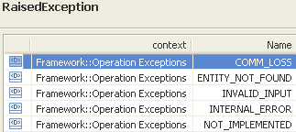 | restriction base="msg:AllExceptionsType"  element ref="msg:commLoss"  element ref="msg:entityNotFound"  element ref="msg:internalError"  element ref="msg:invalidInput"  element ref="msg:notImplemented"  element ref="msg:tooManyOpenIterators"

getRouteAndTopologicalLinks

BA (getRouteAndTopologicalLinks) | IA | IIS | Comments
R_TMF518_MRI_II_0043  The Interface shall allow the requesting OS to retrieve the attributes of a Route and the attributes of all the Topological Link (TL)s given a Subnetwork Connection (SNC) name specified by the requesting OS.  If the SNC has alternative routes, then the Interface shall allow the requesting OS to retrieve the intended route (if the SNC is the Pending or Partial state), the active route otherwise. | This operation returns (like the operation getRoute) the Route, in terms of Cross-Connections, for the provided Subnetwork Connection (SNC). It also returns the list of Topological Links that are used in the Route.  If the SNC has more alternative Routes, then it retrieves the intended Route if the SNC is pending or partial state, otherwise it retrieves the active Route. This because there can be more partial Routes and no active Route, in such case the intended Route is replied, as it is not known which of the partial Routes is the candidate for becoming the active Route.  The Route information, in the form of Cross-Connections, identifies the Resources allocated to the SNC at the time of the request and the way in which these Resources are used. For example, for a resilient SNC that is implemented in the Multi Layer Subnetwork (MLSN) using Subnetwork Connection Protection, all details of the Route including normal and alternative paths should be provided. If the SNC is using some form of dynamic rerouting then it is clearly acceptable that the Route include only the single thread of Cross-Connections that is supporting the traffic (as there may be many alternative potential paths that could be selected).  The list of Topological Links can be used in conjunction with the Cross-Connections to lay out the entire Route through the MLSN.  Unlike the operation getRoute, this operation always retrieves Resources in all layers that support the Route. This includes all Cross-Connections of the SNC (i.e. the Cross-Connections that are in the layer of the SNC) and all higher order Cross-Connections (i.e. the Cross-Connections of server SNCs that are used to carry the traffic of the queried SNC). It also includes all Topological Links (at any layer) that any traffic of the SNC passes across.  All Cross-Connections allocated to the SNC must be returned, even if they are not active in the Managed Elements. This allows the target OS to query the Route that will be used before activating the SNC.  The operation also applies to bundled SNCs.  Traceability: R_TMF518_MRI_II_0043. | This operation returns (like the operation getRoute) the Route, in terms of Cross-Connections, for the provided Subnetwork Connection (SNC). It also returns the list of Topological Links that are used in the Route.  If the SNC has more alternative Routes, then it retrieves the intended Route if the SNC is pending or partial state, otherwise it retrieves the active Route. This because there can be more partial Routes and no active Route, in such case the intended Route is replied, as it is not known which of the partial Routes is the candidate for becoming the active Route.  The Route information, in the form of Cross-Connections, identifies the Resources allocated to the SNC at the time of the request and the way in which these Resources are used. For example, for a resilient SNC that is implemented in the Multi Layer Subnetwork (MLSN) using Subnetwork Connection Protection, all details of the Route including normal and alternative paths should be provided. If the SNC is using some form of dynamic rerouting then it is clearly acceptable that the Route include only the single thread of Cross-Connections that is supporting the traffic (as there may be many alternative potential paths that could be selected).  The list of Topological Links can be used in conjunction with the Cross-Connections to lay out the entire Route through the MLSN.  Unlike the operation getRoute, this operation always retrieves Resources in all layers that support the Route. This includes all Cross-Connections of the SNC (i.e. the Cross-Connections that are in the layer of the SNC) and all higher order Cross-Connections (i.e. the Cross-Connections of server SNCs that are used to carry the traffic of the queried SNC). It also includes all Topological Links (at any layer) that any traffic of the SNC passes across.  All Cross-Connections allocated to the SNC must be returned, even if they are not active in the Managed Elements. This allows the target OS to query the Route that will be used before activating the SNC.  The operation also applies to bundled SNCs.
 | sncRef (ObjectName)  This parameter provides the name of the Subnetwork Connection whose Route and Topological Links are to be returned. | sncRef (ObjectName)  This parameter provides the name of the Subnetwork Connection whose Route and Topological Links are to be returned.
 | route (Route)  This parameter returns the Route object representing the sequence of Cross-Connections that comprise the working and protecting (if applicable) Route for the provided SNC. | route (Route)  This parameter returns the Route object representing the sequence of Cross-Connections that comprise the working and protecting (if applicable) Route for the provided SNC.
 | tlList (*) (TopologicalLink)  This parameter returns the list of Topological Link objects that comprise the working and protecting (if applicable) Route for the provided SNC. | tlList (*) (TopologicalLink)  This parameter returns the list of Topological Link objects that comprise the working and protecting (if applicable) Route for the provided SNC.
restriction base="msg:AllExceptionsType"
element ref="msg:commLoss"
element ref="msg:entityNotFound"
element ref="msg:internalError"
element ref="msg:invalidInput"
element ref="msg:notImplemented"
element ref="msg:tooManyOpenIterators"

getTopLevelTopologicalLink

BA (getTopLevelTopologicalLink) | IA | IIS | Comments
R_TMF518_MRI_II_0026  The Interface shall allow the requesting OS to retrieve the attributes of a top level Topological Link, given a top level TL name specified by the requesting OS. | This operation returns the details of a top-level Topological Link (TL) given its name.  Traceability: R_TMF518_MRI_II_0026. | This operation returns the details of a top-level Topological Link (TL) given its name.
 | tlRef (ObjectName)  This parameter provides the name of the top-level Topological Link to be retrieved. | tlRef (ObjectName)  This parameter provides the name of the top-level Topological Link to be retrieved.
 | tl (TopologicalLink)  This parameter returns the top-level Topological Link object selected by the given name. | tl (TopologicalLink)  This parameter returns the top-level Topological Link object selected by the given name.
 | 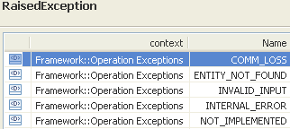 | restriction base="msg:AllExceptionsType"  element ref="msg:commLoss"  element ref="msg:entityNotFound"  element ref="msg:internalError"  element ref="msg:invalidInput"  element ref="msg:notImplemented"  element ref="msg:tooManyOpenIterators"

getTopologicalLink

BA (getTopologicalLink) | IA | IIS | Comments
R_TMF518_MRI_II_0029  The Interface shall allow the requesting OS to retrieve the attributes of a Topological Link, given a TL name specified by the requesting OS. | This operation returns the details of a Topological Link (TL) given its name.  Traceability: R_TMF518_MRI_II_0029. | This operation returns the details of a Topological Link (TL) given its name.
 | tlRef (ObjectName)  This parameter provides the name of the Topological Link to be retrieved. | tlRef (ObjectName)  This parameter provides the name of the Topological Link to be retrieved.
 | tl (TopologicalLink)  This parameter returns the Topological Link object selected by the given name. | tl (TopologicalLink)  This parameter returns the Topological Link object selected by the given name.
 | 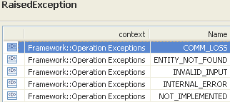 | restriction base="msg:AllExceptionsType"  element ref="msg:commLoss"  element ref="msg:entityNotFound"  element ref="msg:internalError"  element ref="msg:invalidInput"  element ref="msg:notImplemented"  element ref="msg:tooManyOpenIterators"

Data Types

MultipleTlObjectsResponse Type

BA | IA | IIS (MultipleTlObjectsResponseType) | Comments
element name="tlList" type="tl:TopologicalLinkListType"
The list of TL objects.

Traffic Conditioning Profile Retrieval Service
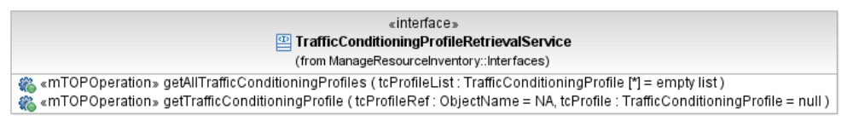
Figure 14: MRI Traffic Conditioning Profile Retrieval Service Interface Diagram

getAllTrafficConditioningProfiles

BA (getAllTrafficConditioningProfiles) | IA | IIS | Comments
R_TMF518_MRI_II_0123  The Interface shall allow the requesting OS to retrieve the attributes of all the Traffic Conditioning (TC) Profiles that are managed by the target OS. | This operation retrieves the details of all Traffic Conditioning (TC) Profiles that are being managed by the target OS.  Traceability: R_TMF518_MRI_II_0123. | This operation retrieves the details of all Traffic Conditioning (TC) Profiles that are being managed by the target OS.
 | ?? | (in) element name="mdRef" type="nam:NamingAttributeType"  The name of the Management Domain whose contained MDs are being requested.
 | tcProfileList (*) (TrafficConditioningProfile)  This parameter returns the list of Traffic Conditioning Profile objects. | MultipleObjectsResponseType  element name="tcProfileList" type="tcp:TrafficConditioningProfileListType"  The list of TC Profiles.
 | 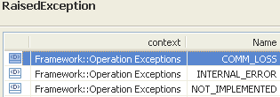 | restriction base="msg:AllExceptionsType"  element ref="msg:commLoss"  element ref="msg:internalError"  element ref="msg:entityNotFound"  element ref="msg:invalidInput"  element ref="msg:notImplemented"  element ref="msg:tooManyOpenIterators"

getTrafficConditioningProfile

BA (getTrafficConditioningProfile) | IA | IIS | Comments
R_TMF518_MRI_II_0124  The Interface shall allow the requesting OS to retrieve the attributes of a Traffic Conditioning (TC) Profile for a specified TC Profile name | This operation retrieves the details of a Traffic Conditioning (TC) Profile given its name.  Traceability: R_TMF518_MRI_II_0124. | This operation retrieves the details of a Traffic Conditioning (TC) Profile given its name.
 | tcProfileRef (ObjectName)  This parameter provides the name of the Traffic Conditioning Profile to be retrieved. | (in) element name="tcProfileRef" type="nam:NamingAttributeType"  The name of the TC Profile.
 | tcProfile (TrafficConditioningProfile)  This parameter returns the Traffic Conditioning Profile object selected by the given name. | (out) element name="tcProfile" type="tcp:TrafficConditioningProfileType"  The returned Traffic Conditioning Profile.
 | 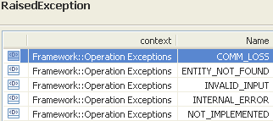 | restriction base="msg:AllExceptionsType"  element ref="msg:commLoss"  element ref="msg:entityNotFound"  element ref="msg:internalError"  element ref="msg:invalidInput"  element ref="msg:notImplemented"

Transmission Descriptor Retrieval Service
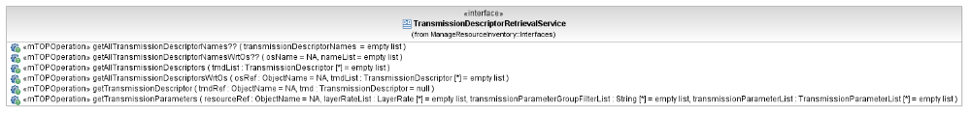
Figure 15: MRI Transmission Descriptor Retrieval Service Interface Diagram

getAllTransmissionDescriptors

BA (getAllTransmissionDescriptors) | IA | IIS | Comments
R_TMF518_MRI_II_0094  The Interface shall allow the requesting OS to retrieve the attributes of all the Traffic Descriptors that are managed by the target OS.  R_TMF518_MRI_II_0095  R_TMF518_MRI_II_151 (TMF513 v3.1 {Requirement II. 187})  The Interface shall allow the requesting OS to retrieve the attributes of all the Transmission Descriptors (TMDs) that are being managed by the target OS.  R_TMF518_MRI_II_0097 | This operation retrieves the details of all Transmission Descriptors (TMDs).  This operation may only be directed to a top-level OS and not to a subordinate OS.  Traceability: R_TMF518_MRI_II_0049, R_TMF518_MRI_II_0???. | This operation returns the list of existing TransmissionDescriptors and their associated distinguishing information.  This operation may only be directed to a top-level OS and not to a subordinate OS.
 | tmdList (*) (TransmissionDescriptor)  This parameter returns the list of Transmission Descriptor objects. | type="tns:MultipleTmdObjectsResponseType"  +++++++++++++++++  see MultipleTmdObjectsResponse Type in section 14.5.1
 | 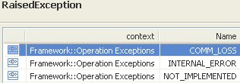 | restriction base="msg:AllExceptionsType"  element ref="msg:commLoss"  element ref="msg:entityNotFound"  element ref="msg:internalError"  element ref="msg:invalidInput"  element ref="msg:notImplemented"  element ref="msg:tooManyOpenIterators"

getAllTransmissionDescriptorsWrtOs

BA (getAllTransmissionDescriptorsWrtOs) | IA | IIS | Comments
R_TMF518_MRI_II_0014  The Interface shall support requests to retrieve all the TMDs to which a given OS (top-level or subordinate) has an “offers” relationship. | This operation returns the details of all Transmission Descriptors (TMDs) associated with a given subordinate OS.  Note that Wrt in the name of the operation stands for "with respect to".  Traceability: R_TMF518_MRI_II_0014, UC_TMF518_MRI_0012. | This operation returns the data structure for each Transmission Descriptor (TMD) associated with a given subordinate OS. Note that Wrt in the name of the operation stands for "with respect to".
 | osRef (ObjectName)  This parameter provides the name of the subordinate OS whose managed Topological Links are to be returned. | (in) element name="osRef" type="nam:NamingAttributeType"  The name of the OS whose associated TMDs are being requested.
 | tmdList (*) (TransmissionDescriptor)  This parameter returns the list of all Transmission Descriptor objects managed by the provided subordinate OS. | MultipleTmdObjectsResponseType
UC_TMF518_MRI_0012  Pre-Conditions:  1. The requesting OS and target OS have been authenticated and have access to a CCV.  2. The requesting OS has no direct knowledge of the inventory held by the target OS. However, the requesting OS may already know about some or all or part of the inventory held by the target OS (this may be via manual entry, for example). The intent is for the requesting OS to verify or match its inventory with that the target OS has. | None
UC_TMF518_MRI_0012  Post-Conditions:  In case of success:  The requesting OS has collected all the requested inventory information from the target OS.  In case of failure:  The requesting OS has not collected all the inventory information that it requested.  Although not mandated by this use case, the requesting OS may want to start receiving inventory updates from the target OS when discovery process maintenance takes place. Once the requesting OS has received responses to all the inventory queries, the requesting OS can analyze the inventory update notifications that it received during the discovery process (if any) and maintain its inventory accordingly. | No change in the system.
UC_TMF518_MRI_0012  Exceptions:  1) Communication failure between the requesting OS and the target OS.  2) The requesting OS may include incorrect or unknown information in its queries to the target OS.  3) Entity not found: when an input parameter references an object that does not exist.  4) Query unknown or not supported.  5) Unable to comply. |  | restriction base="msg:AllExceptionsType"  element ref="msg:commLoss"  element ref="msg:entityNotFound"  element ref="msg:internalError"  element ref="msg:invalidInput"  element ref="msg:notImplemented"  element ref="msg:tooManyOpenIterators" | bz:  The Exceptions clause is not in line with mTOP_Guidelines_BAs.doc: It shall only contain a list of all necessary exceptions. The specific exceptions have to be explicitly listed in the Description clause.

getTransmissionDescriptor

BA (getTransmissionDescriptor) | IA | IIS | Comments
R_TMF518_MRI_II_0096  The Interface shall allow the requesting OS to retrieve the attributes of a Traffic Descriptors given a TD name specified by the requesting OS.  R_TMF518_MRI_II_0098  The Interface shall allow the requesting OS to retrieve the attributes of a Transmission Descriptor for a TMD name specified by the requesting OS. | This operation retrieves the details of a Transmission Descriptor (TMD) given its name.  Traceability: R_TMF518_MRI_II_0096, R_TMF518_MRI_II_0098. | This operation returns the transmission parameters of a flow domain, matrix flow domain, flow domain fragment or transmission descriptor, given the name of the object. A set of groups of transmission parameters to be returned may be specified. | bz:  It seems that the IIS description is for the getTransmissionParameters() operation.
 | tmdRef (ObjectName)  This parameter provides the name of the Transmission Descriptor to be retrieved. | (in) element name="tmdRef" type="nam:NamingAttributeType"  This parameter provides the name of the Transmission Descriptor to be retrieved.
 | tmd (TransmissionDescriptor)  This parameter returns the Transmission Descriptor object selected by the given name. | SingleTmdObjectResponseType  This parameter returns the Transmission Descriptor object selected by the given name.  element name="tmd" type="tmd:TransmissionDescriptorType"  The retrieved TMD.
restriction base="msg:AllExceptionsType"
element ref="msg:commLoss"
element ref="msg:entityNotFound"
element ref="msg:internalError"
element ref="msg:invalidInput"
element ref="msg:notImplemented"
element ref="msg:tooManyOpenIterators"

getTransmissionParameters

BA (getTransmissionDescriptor) | IA | IIS | Comments
R_TMF518_MRI_II_0107  The Interface shall allow the requesting OS to retrieve the layered transmission parameters of a Termination Point (TP) by using a filter that is based on the Layer Rates and the groupings defined in the supporting document SD1-16_LayeredParameters.  It shall also be possible to retrieve all layered transmission parameters defined in the TP.  For a list of the currently defined set of supported TPtransmission parameters refer also to the supporting document SD1-16_LayeredParameters.  R_TMF518_MRI_II_0114  The Interface shall allow the requesting OS to retrieve the layered transmission parameters of a Matrix Flow Domain (MFD) by using a filter that is based on the Layer Rate and the groupings defined in the supporting document SD1-16_LayeredParameters.  It shall also be possible to retrieve all layered transmission parameters defined in the MFD.  For a list of the currently defined set of supported MFD transmission parameters refer also to the supporting document SD1-16_LayeredParameters.  R_TMF518_MRI_II_0122  The Interface shall allow the requesting OS to retrieve the layered transmission parameters of a Flow Domain (FD) by using a filter that is based on the layer rates and the groupings defined in the supporting document SD1-16_LayeredParameters.  It shall also be possible to retrieve all layered transmission parameters defined in the FD.  For a list of the currently defined set of supported FD transmission parameters refer also to the supporting document SD1-16_LayeredParameters.  R_TMF518_MRI_II_0132  The Interface shall allow the requesting OS to retrieve the layered transmission parameters of a Flow Domain Fragment (FDFr) by using a filter that is based on the groupings defined in the supporting document SD1-16_LayeredParameters.  It shall also be possible to retrieve all layered transmission parameters defined in the FDFr.  For a list of the currently defined set of supported FDFr transmission parameters refer also to the supporting document SD1-16_LayeredParameters.  R_TMF518_MRI_II_0152 (TMF513 v3.1 {Requirement II. 352})  The Interface shall allow the requesting OS to retrieve the layered transmission parameters of a Transmission Descriptor (TMD) by using a filter that is based on the layer rates and the groupings defined in the supporting document SD1-16_LayeredParameters.pdf.  It shall also be possible to retrieve all layered transmission parameters defined in the TMD.  For a list of the currently defined set of supported transmission parameters refer to the supporting document SD1-16_LayeredParameters.pdf. | This operation retrieves the layered Transmission Parameters of a  - Termination Point (TP)  - Matrix Flow Domain (MFD)  - Flow Domain (FD)  - Flow Domain Fragment (FDFr) or  - Transmission Descriptor (TMD)  given the name of the object and providing a filter that is based on the Layer Rates and the groupings (i.e., headings) defined in the attached supporting document SD1-16_LayeredParameters.  It is also possible to retrieve all layered Transmission Parameters defined in the Resource.  For a list of the currently defined set of supported Transmission Parameters refer also to the attached supporting document SD1-16_LayeredParameters.  Traceability: R_TMF518_MRI_II_0107, R_TMF518_MRI_II_0114, R_TMF518_MRI_II_0122, R_TMF518_MRI_II_0132, R_TMF518_MRI_II_0??? | This operation retrieves the layered Transmission Parameters of a  - Termination Point (TP)  - Matrix Flow Domain (MFD)  - Flow Domain (FD)  - Flow Domain Fragment (FDFr) or  - Transmission Descriptor (TMD)  given the name of the object and providing a filter that is based on the Layer Rates and the groupings (i.e., headings) defined in the attached supporting document SD1-16_LayeredParameters.  It is also possible to retrieve all layered Transmission Parameters defined in the Resource.  For a list of the currently defined set of supported Transmission Parameters refer also to the attached supporting document SD1-16_LayeredParameters. | bz:  This operation is not in MTOSI_R2-0_DDP_Maps.xls.
 | resourceRef (ObjectName)  This parameter provides the name of the Resource whose Transmission Parameters are to be retrieved. | resourceRef (ObjectName)  This parameter provides the name of the Resource whose Transmission Parameters are to be retrieved.
 | layerRateList (*) (LayerRate)  This parameter provides the Layer Rates of the Transmission Parameters that have to be returned.  If no Layer Rate is provided, all Layer Rates supported by the Resource are in scope. | layerRateList (*) (LayerRate)  This parameter provides the Layer Rates of the Transmission Parameters that have to be returned.  If no Layer Rate is provided, all Layer Rates supported by the Resource are in scope.
 | transmissionParameterGroupFilterList (*) (String)  This parameter provides the Transmission Parameter Groups that have to be returned by providing a list of headings (1st and 2nd level) that are used to structure the Transmission Parameters defined in supporting document SD1-16_LayeredParameters.  If no Group is provided, all Transmission Parameters supported by the Resource are in scope. | transmissionParameterGroupFilterList (*) (String)  This parameter provides the Transmission Parameter Groups that have to be returned by providing a list of headings (1st and 2nd level) that are used to structure the Transmission Parameters defined in supporting document SD1-16_LayeredParameters.  If no Group is provided, all Transmission Parameters supported by the Resource are in scope. | bz:  May be the name of the input parameter is a little bit too long ☺
 | transmissionParameterList (*) (TransmissionParameterList)  This parameter returns the requested Transmission Parameters of the provided Resource. | transmissionParameterList (*) (TransmissionParameterList)  This parameter returns the requested Transmission Parameters of the provided Resource. | 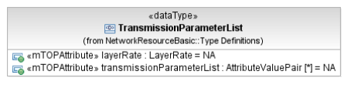
restriction base="msg:AllExceptionsType"
element ref="msg:commLoss"
element ref="msg:entityNotFound"
element ref="msg:internalError"
element ref="msg:invalidInput"
element ref="msg:notImplemented"

Data Types

MultipleTmdObjectsResponse Type

BA | IA | IIS (MultipleTmdObjectsResponseType) | Comments
Response message structure for a set of TMD objects
element name="tmdList" type="tmd:TransmissionDescriptorListType"
The list of TMDs.

