Manage Service Inventory - DDP BA

TMF518_MSI
Version 1.0


September 2007

©TM Forum 2007
Notice
No recipient of this document shall in any way interpret this document as representing a position or agreement of the TeleManagement Forum (TM Forum) or its members. This document is a draft working document of TM Forum and is provided solely for comments and evaluation. It is not a Forum Approved Document and is solely circulated for the purposes of assisting TM Forum in the preparation of a final document in furtherance of the aims and mission of TM Forum.
Although it is a copyrighted document of TM Forum:
- Members of TM Forum are only granted the limited copyright waiver to distribute this document within their companies and may not make paper or electronic copies for distribution outside of their companies.
- Non-members of the TM Forum are not permitted to make copies (paper or electronic) of this draft document other than for their internal use for the sole purpose of making comments thereon directly to TM Forum.
- If this document forms part of a supply of information in support of an Industry Group Liaison relationship, the document may only be used as part of the work identified in the Liaison and may not be used or further distributed for any other purposes
Any use of this document by the recipient, other than as set forth specifically herein, is at its own risk, and under no circumstances will TM Forum be liable for direct or indirect damages or any costs or losses resulting from the use of this document by the recipient.
This document is governed by all of the terms and conditions of the Agreement on Intellectual Property Rights between TM Forum and its members, and may involve a claim of patent rights by one or more TM Forum members or by non-members of TM Forum.
Direct inquiries to the TM Forum office:
240 Headquarters Plaza,
East Tower – 10th Floor,
Morristown, NJ 07960 USA
Tel No. +1 973 944 5100
Fax No. +1 973 944 5110
TM Forum Web Page: www.tmforum.org
Table of Contents

Notice 3
Table of Contents 4
List of Requirements 6
List of Use Cases 7
List of Figures 9
List of Tables 10
Executive Summary 11
1 Introduction 12
1.1 mTOP DDP Structure 12
1.2 Document Structure 12
1.3 Terminology Used In This Document 13
2 Business Problem Description, Project Scope 14
2.1 Project Scope 14
2.2 Benefits 15
2.2.1 Service Provider Benefits 15
2.2.2 Supplier Benefits 15
3 Business Processes 17
3.1 Business Requirements 17
3.2 Category I: Static and Structural Requirements 17
3.3 Category II: Normal Sequences, Dynamic Requirements 17
3.3.1 Service Inventory Retrieval 19
3.3.2 Service Inventory Update 21
3.4 Category III: Abnormal or Exception Conditions, Dynamic Requirements 23
3.5 Category IV: Expectations and Non-Functional Requirements 24
3.6 Category V: System Administration Requirements 24
4 Use Cases 25
5 Traceability Matrices 26
6 Future Directions 27
7 References 28
7.1 References 28
7.2 IPR Releases and Patent Disclosure 28
8 Administrative Appendix 29
8.1 About this document 29
8.2 Use and Extension of a TM Forum Business Agreement 29
8.3 Document History 29
8.4 Company Contact Details 30
8.5 Acknowledgments 30
8.6 About TM Forum 30
List of Requirements
R_TMF518_MSI_II_0001 19
R_TMF518_MSI_II_0002 19
R_TMF518_MSI_II_0003 19
R_TMF518_MSI_II_0004 21
R_TMF518_MSI_II_0005 21
R_TMF518_MSI_II_0006 21
R_TMF518_MSI_II_0007 22
R_TMF518_MSI_II_0008 22
R_TMF518_MSI_II_0009 22
R_TMF518_MSI_II_0010 22
R_TMF518_MSI_II_0011 23
R_TMF518_MSI_II_0012 23
List of Figures
Figure 2-1. mTOP program 12
Figure 2. Service Inventory Layout 16

List of Tables
Executive Summary

Introduction

mTOP DDP Structure
In order to allow for more efficient release delivery, the previous monolithic BA, IA and SS documents have been partitioned into smaller self-contained (though not independent) units called Document Delivery Packages (DDPs).
This is similar to the 3GPP concept of Integration Reference Point (IRP). The basic idea is that the Interface, which is specified by the entire document set (of a release), is partitioned into DDPs where each DDP specifies “a certain aspect” of the Interface, which needs to be very clearly scoped.
There are three kinds of DDPs:
  - Data Model DDP (DM-DDP) – a DDP that concerns a data model (entities, data structures, attributes, state, but no operations)
  - Operation Model DDP (OM-DDP) – a DDP that concerns a computational model (operations, notifications, transactions) for a given functional area (such as resource inventory management)
  - the FrameWork DDP (FMW) – this DDP contains the generic artifacts that are applicable to all the other DDPs.
The unified deliverables structure for any given mTOP product release is as follows:
  - Product Release Notes:
    - a scope specification for the type and extent of the delivered product,
    - the partitioning of the release into DDPs (i.e., definitions of various aspects of the release),
    - and an overview of the release’s (delta) deliverables;
  - For each DDP:
    - Business Agreements (BAs): a business view specification
    - Information Agreements (IAs): a system view specification
    - Interface Implementation Specifications (ISSs): implementation and deployment view specification per supported enabling technology (mapping of the IA to either CORBA (IDL, services usage) or XML (WSDL, XSD, bindings…)
    - Supporting Documentation: normative and informative supporting documents.
  - Reference Implementation (optional) of core IIS fragments for selected interfaces and enabling technologies.

Document Structure
The following sections are included in this document:
- Section Error: Reference source not found is this introduction.
- Section 2 defines the business problem and project scope
- Section Error: Reference source not found has the requirements and associated descriptive text.
- Section Error: Reference source not found contains the use cases.
- Section Error: Reference source not found has traceability matrices between the use cases and the requirements.
- Section Error: Reference source not found provides a list of open issues to be considered in later versions of this document.
- Section Error: Reference source not found lists references and states IPR claims, if any.
- Section 8 provides administrative details such as document history and acknowledgements

Terminology Used In This Document
This DM DDP document introduces many terms for which a definition is presented. For those terms, the same definitions are also available in the SD2-0_mTOPDictionary supporting document with many other terms commonly used in the mTOP products.

Business Problem Description, Project Scope

Project Scope
The TM Forum’s mTOP program consists of two projects, i.e., resource management and service management, and four coordination teams, i.e., product planning council (the mTOP PPC), architecture, methodology and implementation.

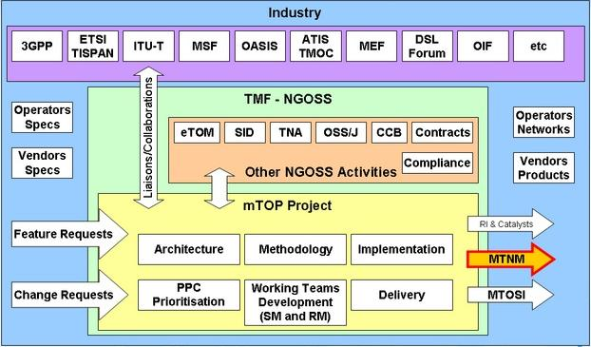
Figure 2-1. mTOP program

The scope of mTOP (with respect to the eTOM) is within Service Management and Operations (SM&O) and Resource Management and Operations (RM&O) with respect to Fulfillment, Assurance and some limited aspects of Operations Support and Readiness (OS&R). It should be emphasized that mTOP does not cover every aspect within these areas.
The goal of this program is to provide a unified set of specifications for both an OS-OS interface and an NML-EML interface covering assurance and fulfillment for all transmission/network technologies via G.805/G.809 while using enabling technologies such as JMS, HTTP, and CORBA to transport the management messages themselves.
The projects within this program are intended to provide rigorous specifications for the implementation of interfaces concerning the management of connection oriented and connectionless based networks. Both service and resource level management are within scope.

Benefits
mTOP provides a set of Interface specifications that allow for resource and service management.
These specifications are intended to lower design, implementation, Verification Validation & Testing (VVT), and maintenance costs for management interfaces which are supported by a concrete data model. The mTOP Interfaces are intended for use by service providers, suppliers of equipment and OSS suppliers. The intention is to also encourage system integrator usage of management systems that make use of the mTOP Interfaces.
In particular, the followed approach tends to minimize cost of integration, provide access to all necessary information and control, and support all vendor/operator differentiation as well as any mixes of vintages of interface capability.

Service Provider Benefits
The service provider benefits are as follows:
- One stop shopping concerning feature requests for much of the TM Forum contract specification work. The mTOP PPC handles and prioritizes all requests for new features. So, by making use of the mTOP PPC processes, a service provider can proactively plan in advance for their OSS interface needs.
- The technical deliverables are also of high value to the service provider. The mTOP interface specifications lower risk, allow for an open, multi-supplier environment, shorten delivery times and lower integration costs.
- The mTOP products provide an integrated, multi-technology interface with support for most key layer 1 and layer 2 transport technologies. This is in contrast to earlier approaches where each technology-specific forum provided a single-technology management interface. The service provider was faced with having to use many different, uncoordinated management interfaces. mTOP has resolved this issue for layer 1 and 2 technologies and layer 3 (IP) is being planned for a future release.
- The mTOP products are not bound to any one middleware, transport or computing language. So, the service provider will be able to evolve to new technologies as they arise.

Supplier Benefits
The supplier benefits are as follows:
- Fewer Adapters leads to Lower Costs – in as much as mTOP gains market penetration (and there has already been significant market acceptance of the mTOP products), the supplier is faced with the need to build fewer adapters between their products and the products of their partners. A supplier can also directly see cost savings in the use of the mTOP Interfaces among its own products (as the need for an open interface arises).
- Lower Middleware Transitions Costs – the mTOP products are defined to be middleware and transport independent. So, the supplier can migrate from one middleware or transport technology to another without changing the supporting business logic in the code.
- Increase Usage by System Integrators (SIs) – a supplier’s support of their own “open” interfaces goes only so far to encourage SIs. Clearly, an SI would like to make use of supplier products (both equipment and OSS suppliers) that make use of well supported standard interfaces rather than supplier specific interfaces. The latter case forces the SI into a situation characterized by many pair-wise negotiations between various suppliers.
- Lower Training Cost – in as much as a supplier re-uses the mTOP Interfaces for multiple products and for multiple customers, the various training costs are lower because the designers, system engineers, developers and testers are using the same (mTOP) Interfaces over and over again.

Business Processes

Business Requirements

Category I: Static and Structural Requirements
Related static requirements can be found in TMF518_SB, Service Basic - DDP BA

Category II: Normal Sequences, Dynamic Requirements
A Service Inventory OS handles objects which are identified by their unique name on the CCV.
In addition, a Service Inventory OS has knowledge of the name (only) of objects of the following classes from the CRM domain:
  - Product
  - ProductSpecification
  - ProductOffering
  - ProductSpecificationCharacteristic
  - Subscriber
  - User
or from the RM&O domain:
  - Resource

Some of the attributes specified in the objects handled by a Service Inventory OS are used to make reference to another object by using its name. References are used to represent associations between objects:
  - for example, the association between a ServiceTemplate instance and a ServiceDefinition instance - both SM&O objects -
  - or the association between a ServiceDefinition instance and a ProductSpecification instance (this latter object belongs to the CRM domain and his known only by its name)

As opposed to the Inventory for Network Resoures (cf. TMF518_MRI and SD2-12_MTOSI_Inventory_Layout) the objects in the Service Inventory OS are not organized in a hierarchical way and there is no containment tree. Service Inventory Objects do not have a superior and do not have subordinates. However, objects relate together through associations represented by specific reference attributes which values contain the name of the associated object.
All the objects handled by a Service Inventory OS are shown on Figure 2
  - The objects belonging to the CRM or the RM&O layers are represented in brown. Recall that only their name is known by the Service Inventory OS, and always in association with another object.
  - The objects belonging to the SM&O layer are represented in yellow. Those objects are structured as requested in the TMF518_SB BA document.
  - the solid lines between objects represent associations (a.k.a. references attributes)

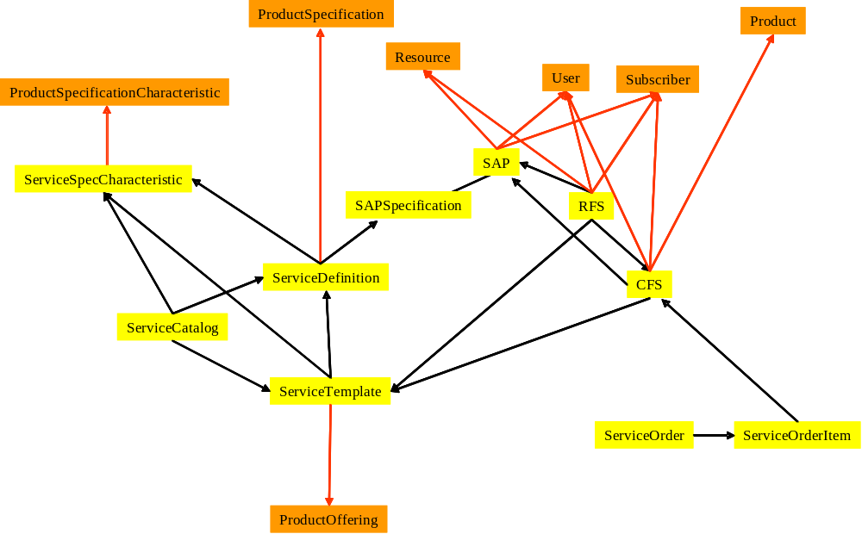

Figure 2. Service Inventory Layout

In the following requirements, the OS sending a request over the Interface is called the “requesting OS” and the OS receiving the request is called the “target OS”.

The operations related to the Service Inventory API must be organized into two separate interfaces with clear distinct objectives:
- Service Inventory Retrieval
- Service Inventory Update
Note that, in the present version, there is no exposed API to create/update/modify the following objects: ServiceSpecCharacteristic, ServiceDefinition, ServiceTemplate, ServiceCatalog, SAPSpecification.
The reason is that the Service Inventory API has been conceived, in a first step, to support the Service Activation stage (the client is typically a Service Activation OS).
New interfaces will be created in future releases to also support the Service Design and the Service Deployment stages (typical client being a Planning OS).

Service Inventory Retrieval

R_TMF518_MSI_II_0001 | The Service Inventory Interface shall support the capability for a requesting OS to retrieve the inventory from a target OS only via bulk inventory retrieval. Support for bulk inventory retrieval can be done in any of the following ways:  - Batched responses – in this approach the server (target OS) sends the requested information back to the client (requesting OS) in a series of responses (batches). For example, using asynchronous communication over JMS.  - Batched retrieval – in this approach the client (requesting OS) retrieves the requested information from the server (target OS) via a series of requests using an iterator approach. For example, using http/s with synchronous communication.  - Batched File transfer – in this approach the requested inventory is delivered in the form of file(s). The approach allows the client (requesting OS) to designate the location of the file(s) (by providing a URI). For example, using FTP.  All of the above bulk inventory retrieval methods shall support the same Inventory output data structure schema, as well as, its batching capabilities.
Source | Similar to the requirement R_TMF518_MRI_II_0002

R_TMF518_MSI_II_0002 | Each of the bulk inventory mechanisms listed in R_TMF518_MSI_II_0001 may optionally support the ability to retrieve only the inventory that has been modified or added after a Diff Date and Time provided by the requesting OS.
Source | Similar to the requirement R_TMF518_MRI_II_0003

R_TMF518_MSI_II_0003 | Each of the bulk inventory mechanisms listed in R_TMF518_MSI_II_0001 shall support the ability to retrieve a subset of the inventory known by the target OS. This subset is defined by a filter provided by the requesting OS.  A filter is constituted of a list of  {scope qualifier, selection qualifier} pair.  The scope qualifyer is used to designate the entities present in the Service Inventory OS that must be returned.  The scope qualifyer shall be one of the following kinds:  - A SM&O object name:  it will determine a unique object present in the Service Inventory OS.  - One of the 8 object class names:  “CFS”,  “RFS”,  “SAP”,  “SAPSpecification”,  “ServiceCatalog”,  “ServiceDefinition”,  “ServiceTemplate”,  “ServiceSpecCharacteristic”  In this case, all the object instances of the selected class present in the Service Inventory OS must be returned.  - An attribute matching filter:  it is a logical expression conformant to the requirements R_TMF518_FMW_II_0022 and R_TMF518_FMW_II_0023 from the TMF518_FMW BA.  All the instances matching this logical expression are considered.  In particular, this filter can specify a reference attribute.  The selection qualifier is used to designate which information contained in the objects of the scope or related to those objects must be returned.  The selection qualifier shall be one of the following values:  - NAME  Used to indicate that only the value of the name attribute of the entities in the scope must be returned.  - FULL  Used to indicate that the values of the specific attributes (including the name) and of the reference attributes of the objects in the scope must be returned  - REFERENCES  Used to indicate that:  - all the attributes of the objects in the scope must be returned (as in FULL above)  - also must return the objects indicated by the reference attributes of the objects in the scope; for those pointed objects, the values of the specific attributes and the reference attributes must returned.
Source | Inspired from the requirement R_TMF518_MRI_II_0004

Service Inventory Update

R_TMF518_MSI_II_0004 | The Interface shall allow the requesting OS to create a CFS instance given its specific attributes (including its name) and its reference attributes supplied by the requesting OS.
Source | Created in Version 1.0

R_TMF518_MSI_II_0005 | The Interface shall allow the requesting OS to modify an existing CFS instance. The requesting OS must supply the specific attributes and the reference attributes that need to be modified (the attributes that do not need to be modified may not be supplied).  Not all the CFS attributes are modifiable.  The following CFS attributes are modifiable:  - hasStarted  - isMandatory  - startMode  - isStateful  - adminState  - serviceState  - operationalState  - userReferenceList  - sapReferenceList  - describedByList  The following CFS attributes are NOT modifiable:  - serviceTemplateReference (??? check with the team)  - productReference  - subscriberReference
Source | Created in Version 1.0

R_TMF518_MSI_II_0006 | The Interface shall allow the requesting OS to delete one or more existing CFS instance(s) given its / their name(s) as specified by the requesting OS.  ??? what happens to the objects pointing to it (RFS, ServiceOrderItem?) do we sweep them out?
Source | Created in Version 1.0

R_TMF518_MSI_II_0007 | The Interface shall allow the requesting OS to create an RFS instance given its specific attributes (including its name) and its reference attributes supplied by the requesting OS.
Source | Created in Version 1.0

R_TMF518_MSI_II_0008 | The Interface shall allow the requesting OS to modify an existing RFS instance. The requesting OS must supply the specific attributes and the reference attributes that need to be modified (the attributes that do not need to be modified may not be supplied).  Not all the RFS attributes are modifiable.  The following RFS attributes are modifiable:  - hasStarted  - isMandatory  - startMode  - isStateful  - adminState  - serviceState  - operationalState  - cFSReference  - userReferenceList  - sapReferenceList  - resourceReference  - describedByList  The following RFS attributes are NOT modifiable:  - serviceTemplateReference (??? check with the team)  - productReference  - subscriberReference
Source | Created in Version 1.0

R_TMF518_MSI_II_0009 | The Interface shall allow the requesting OS to delete one or several existing RFS instance(s) given its / their name(s) as specified by the requesting OS.
Source | Created in Version 1.0

R_TMF518_MSI_II_0010 | The Interface shall allow the requesting OS to create a SAP instance given its specific attributes (including its name) and its reference attributes supplied by the requesting OS.
Source | Created in Version 1.0

R_TMF518_MSI_II_0011 | The Interface shall allow the requesting OS to modify an existing SAP instance. The requesting OS must supply the specific attributes and the reference attributes that need to be modified (the attributes that do not need to be modified may not be supplied).  Not all the SAP attributes are modifiable.  The following SAP attributes are modifiable:  - adminState  - serviceState  - operationalState  - userReferenceList  - resourceReference  The following SAP attributes are NOT modifiable:  - type  - subscriberReference  - sAPSpecReference
Source | Created in Version 1.0

R_TMF518_MSI_II_0012 | The Interface shall allow the requesting OS to delete one or several existing SAP instance(s) given its / their name(s) as specified by the requesting OS.  ??? what happens to the objects pointing to it (RFS, ServiceOrderItem?) do we sweep them out?
Source | Created in Version 1.0

ServiceOrder??? TBD
ServiceOrderItem??? TBD

Category III: Abnormal or Exception Conditions, Dynamic Requirements
None have been identified thus far.

Category IV: Expectations and Non-Functional Requirements
None have been identified thus far.

Category V: System Administration Requirements
None have been identified thus far.

Use Cases
???

Traceability Matrices
??? You MUST start with the UCs Matrix (use the createUCsMatrix)
??? Then you will create the Rqs Matrix (use the createRqsMatrix)

Future Directions

References

References
- TMF518_FMW, Framework DDP BA, Version 1.0
- TMF518_SB, Service Basic DDB BA, Version 1.0
- TMF517, Multi-Technology Operations System Interface (MTOSI) Business Agreement, Version 1.2, December 2006

IPR Releases and Patent Disclosure
There are no known IPR claims on the material in this document. As per the TM Forum bylaws, any TM Forum member company that has IPR claims on this or any TM Forum specification needs to make the claims known to the TM Forum membership immediately.

Administrative Appendix
This Appendix provides additional background material about the TM Forum and this document.

About this document
This document has been generated from the SD0-3_mTOPTemplate_BA.dot Word template,
which itself is based on Version 6.0 of the TMF 402, BA Template.

Use and Extension of a TM Forum Business Agreement
This document defines the business problem and requirement model for Service Management. The Business Agreement is used to gain consensus on the business requirements for exchanging information among processes and systems in order to solve a specific business problem. The Business Agreement should feed the development of Information Agreement(s), which is a technology-neutral model of one or more interfaces. While the Business Agreement contains sufficient information to be a “stand alone” document, it is better read together with the Information Agreement document TMF612_SB when the Information Agreement is available. Reviewing the two documents together helps in gaining a full understanding of how the technology neutral information model solution is defined for this requirement model. An initial Business Agreement may only deal with a subset of the requirements. It is acceptable for subsequent issues of the document to add additional requirements not addressed by earlier releases of the BA. Business Agreements are the basis for requirement traceability for information models.
It is expected that this document will be used:
- As the foundation for a TM Forum Information Agreement(s)
- To facilitate requirement agreement between Service Providers and vendors
- As input to a service Provider’s Request for Information / Request for Proposal (RFI/RFP—RFX)
- As input for vendors developing COTS products
- As a source of requirements for other bodies working in this area

Document History
Version | Date Modified | Description of changes
1.0 | October 2007 | This is the first version of the document and as such, there are no changes to report.

Company Contact Details
Document Contact
Michel Besson
Cramer > Amdocs OSS division
Email: sfratini@telcordia.com
Phone: +1 732 699 2226

Acknowledgments
This document was prepared by the members of the TM Forum <<team name>> team…
- Name, Company, Editor
- Name, Company, position if appropriate (e.g. team leader)
Additional input was provided by the following people:
- Name, Company

About TM Forum
TM Forum is an international consortium of communications service providers and their suppliers. Its mission is to help service providers and network operators automate their business processes in a cost- and time-effective way. Specifically, the work of the TM Forum includes:
- Establishing operational guidance on the shape of business processes.
- Agreeing on information that needs to flow from one process activity to another.
- Identifying a realistic systems environment to support the interconnection of operational support systems.
- Enabling the development of a market and real products for integrating and automating telecom operations processes.
The members of TM Forum include service providers, network operators and suppliers of equipment and software to the communications industry. With that combination of buyers and suppliers of operational support systems, TM Forum is able to achieve results in a pragmatic way that leads to product offerings (from member companies) as well as paper specifications.

