Manage Service Inventory - DDP BA

TMF518_MSI
Version 1.1


September, 2011

Notice
No recipient of this document and code shall in any way interpret this material as representing a position or agreement of TM Forum or its members. This material is draft working material of TM Forum and is provided solely for comments and evaluation. It is not “Forum Approved” and is solely circulated for the purposes of assisting TM Forum in the preparation of final material in furtherance of the aims and mission of TM Forum.
Although it is copyrighted material of TM Forum:
- Members of TM Forum are only granted the limited copyright waiver to distribute this material within their companies and may not make paper or electronic copies for distribution outside of their companies.
- Non-members of the TM Forum are not permitted to make copies (paper or electronic) of this draft material other than for their internal use for the sole purpose of making comments thereon directly to TM Forum.
- If this material forms part of a supply of information in support of an Industry Group Liaison relationship, the document may only be used as part of the work identified in the Liaison and may not be used or further distributed for any other purposes
Any use of this material by the recipient, other than as set forth specifically herein, is at its own risk, and under no circumstances will TM Forum be liable for direct or indirect damages or any costs or losses resulting from the use of this material by the recipient.
This material is governed, and all recipients shall be bound, by all of the terms and conditions of the Intellectual Property Rights Policy of the TM Forum (http://www.tmforum.org/Bylaws/1094/home.html) and may involve a claim of patent rights by one or more TM Forum members or by non-members of TM Forum.
Direct inquiries to the TM Forum office:
240 Headquarters Plaza,
East Tower – 10th Floor,
Morristown, NJ 07960 USA
Tel No. +1 973 944 5100
Fax No. +1 973 944 5110
TM Forum Web Page: www.tmforum.org
Table of Contents

Notice 2
Table of Contents 3
List of Requirements 5
List of Figures 6
List of Tables 7
Executive Summary 8
1 Introduction 9
1.1 DDP Structure 9
1.2 Document Structure 9
1.3 Terminology Used In This Document 10
2 Business Problem Description, Project Scope 11
2.1 Project Scope 11
2.2 Benefits 12
2.2.1 Service Provider Benefits 12
2.2.2 Supplier Benefits 13
3 Business Processes 14
3.1 Business Requirements 14
3.2 Category I: Static and Structural Requirements 14
3.3 Category II: Normal Sequences, Dynamic Requirements 14
3.3.1 Service Inventory Retrieval 16
3.3.2 Service Inventory Update 18
3.4 Category III: Abnormal or Exception Conditions, Dynamic Requirements 18
3.5 Category IV: Expectations and Non-Functional Requirements 18
3.6 Category V: System Administration Requirements 18
4 Use Cases 19
5 Traceability Matrices 20
6 Future Directions 21
7 References 22
7.1 References 22
7.2 IPR Releases and Patent Disclosure 22
8 Administrative Appendix 23
8.1 About this document 23
8.2 Use and Extension of a TM Forum Business Agreement 23
8.3 Document History 23
8.4 Company Contact Details 24
8.5 Acknowledgments 24
List of Requirements
R_TMF518_MSI_II_0001 16
R_TMF518_MSI_II_0002 16
R_TMF518_MSI_II_0003 16

List of Figures
Figure 2-1. Inputs to the TM Forum Integration Program 11
Figure 2-2. TM Forum Integration Program 12
Figure 3-1. Service Inventory Layout 15

List of Tables
Executive Summary
This document entails the Business Agreement (BA) aspect of the MTOSI / MTNM Manage Service Inventory (MSI) Document Delivery Package (DDP). As it name indicates, it covers requirements and use cases (for further study) concerning the management of service inventory.
The following management capabilities are covered:
- Bulk inventory retrieval (retrieving selected information in a single operation).

Introduction

DDP Structure
In order to allow for more efficient release delivery, the previous monolithic BA, IA and SS documents have been partitioned into smaller self-contained (though not independent) units called Document Delivery Packages (DDPs).
This is similar to the 3GPP concept of Integration Reference Point (IRP). The basic idea is that the Interface, which is specified by the entire document set (of a release), is partitioned into DDPs where each DDP specifies “a certain aspect” of the Interface, which needs to be very clearly scoped.
There are three kinds of DDPs:
  - the FrameWork DDP (FMW) – this DDP contains the generic artifacts that are applicable to all the other DDPs.
  - Data Model DDP (DM-DDP) – a DDP that concerns a data model (entities, data structures, attributes, state, but no operations)
  - Operation Model DDP (OM-DDP) – a DDP that concerns a computational model (operations, notifications, transactions) for a given functional area (such as resource inventory management)
The unified deliverables structure for any given MTNM / MTOSI product release is as follows:
  - Product Release Notes:
    - a scope specification for the type and extent of the delivered product,
    - the partitioning of the release into DDPs (i.e., definitions of various aspects of the release),
    - and an overview of the release’s (delta) deliverables;
  - For each DDP:
    - Business Agreements (BAs): a business view specification
    - Information Agreements (IAs): a system view specification
    - Interface Implementation Specifications (ISSs): implementation and deployment view specification per supported enabling technology (mapping of the IA to either CORBA (IDL, services usage) or XML (WSDL, XSD, bindings…)
    - Supporting Documentation: normative and informative supporting documents.
  - Reference Implementation (optional) of core IIS fragments for selected interfaces and enabling technologies.

Document Structure
The following sections are included in this document:
- Section 1 is this introduction.
- Section 2 defines the business problem and project scope
- Section 3 has the requirements and associated descriptive text.
- Section 4 contains the use cases.
- Section 5 has traceability matrices between the use cases and the requirements.
- Section 6 provides a list of open issues to be considered in later versions of this document.
- Section 7 lists references and states IPR claims, if any.
- Section 8 provides administrative details such as document history and acknowledgements

Terminology Used In This Document
This DM DDP document introduces many terms for which a definition is presented. For those terms, the same definitions are also available in [4] with many other terms commonly used in the MTOSI / MTNM products.

Business Problem Description, Project Scope

Project Scope
The TM Forum Integration Program is responsible for all of the interface and business services work within the TM Forum. In some cases, interface work is delegated to other teams but the final verification for technical uniformity and integrity is the responsibility of the TM Forum Integration Program.
Initially, the TM Forum Integration Program was formed to coordinate the various existing TM Forum interfaces activities (as shown in Figure 2-1). In particular, the responsibility for maintaining MTOSI and MTNM is now covered by the MTOSI-MTNM Users Group which is a team within the TM Forum Integration Program. The long term plan (which is already well under progress) is to migration the various input work to a single harmonized suite of interfaces.

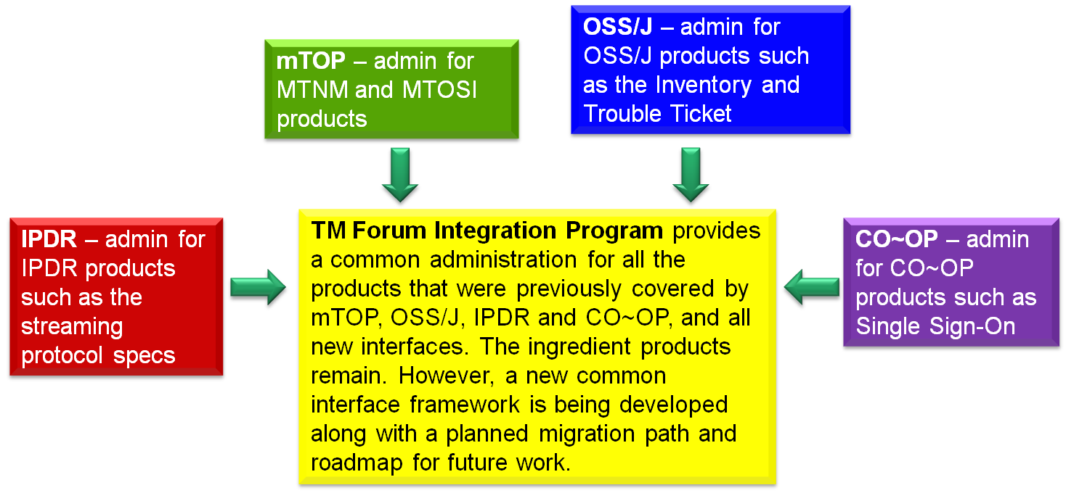
Figure 2-1. Inputs to the TM Forum Integration Program

Figure 2-2 provides a summary of the team within the TM Forum Integration Program as well as a few teams outside of the program but which also do some interface work. In terms of MTOSI and MTNM, the main input for updates come from the Resource and Service Management Team.

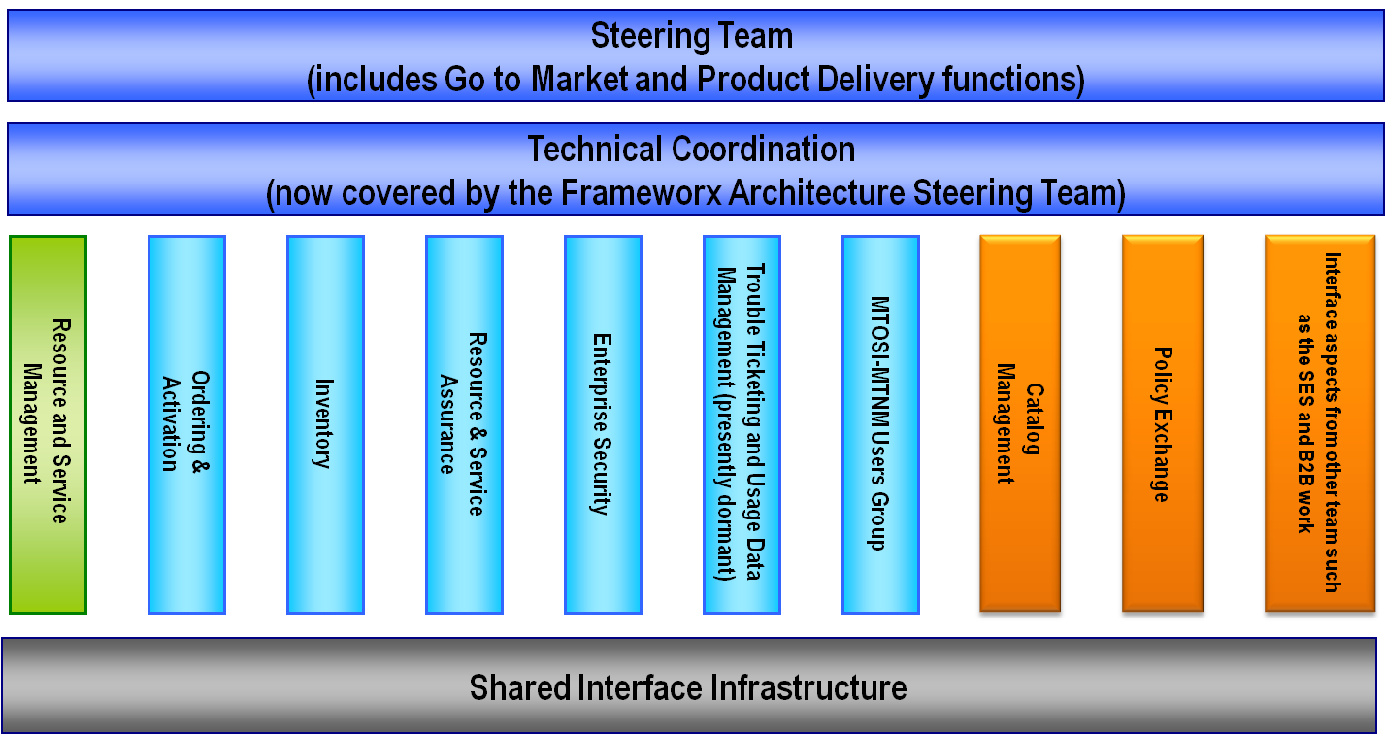
Figure 2-2. TM Forum Integration Program

Benefits
MTOSI and MTNM provide a set of Interface specifications that allow for resource and service management (with only MTOSI covering service management, but with MTOSI and MTNM both covering resource management, using very much the same information model).
These specifications are intended to lower design, implementation, Verification Validation & Testing (VVT), and maintenance costs for management interfaces. These Interfaces are intended for use by service providers, suppliers of equipment and OSS suppliers. The intention is to also encourage system integrator usage of management systems that make use of the Interfaces.
In particular, the followed approach tends to minimize the cost of integration, provide access to all necessary information and control, and support all vendor/operator differentiation. The intent of the interface is to provide compatibility among different version, for a detailed description see SD2-6_VersioningAndExtensibility.

Service Provider Benefits
The service provider benefits are as follows:
- One stop shopping concerning feature requests for much of the TM Forum contract specification work is part of the defined Change Control Group (CCG) process that TM Forum makes available in order to control the interface.
- The technical deliverables are also of high value to the service provider. The Interface specifications allow for an open, multi-supplier environment, shorten delivery times and lower integration costs.
- The MTOSI and MTNM products provide an integrated, multi-technology interface with support for most key layer 1 and layer 2 transport technologies. This is in contrast to earlier approaches where each technology-specific forum provided a single-technology management interface. The service provider was faced with having to use many different, uncoordinated management interfaces.
- These products are not bound to any one middleware, transport or computing language. So, the service provider will be able to evolve to new technologies as they arise.

Supplier Benefits
The supplier benefits are as follows:
- Fewer Adapters leads to Lower Costs – in as much as MTOSI and MTNM gain market penetration (and there has already been significant market acceptance of these interfaces), the supplier is faced with the need to build fewer adapters between their products and the products of their partners. A supplier can also directly see cost savings in the use of the Interfaces among its own products (as the need for an open interface arises).
- Lower Middleware Transitions Costs – the Interfaces are defined to be middleware and transport independent. So, the supplier can migrate from one middleware or transport technology to another without changing the supporting business logic in the code.
- Increase Usage by System Integrators (SIs) – a supplier’s support of their own “open” interfaces goes only so far to encourage SIs. Clearly, an SI would like to make use of supplier products (both equipment and OSS suppliers) that make use of well supported standard interfaces rather than supplier specific interfaces. The latter case forces the SI into a situation characterized by many pair-wise negotiations between various suppliers.
- Lower Training Cost – in as much as a supplier re-uses the Interfaces for multiple products and for multiple customers, the various training costs are lower because the designers, system engineers, developers and testers are using the same Interfaces over and over again.

Business Processes

Business Requirements

Category I: Static and Structural Requirements
Related static requirements can be found in [2].

Category II: Normal Sequences, Dynamic Requirements
A Service Inventory OS handles objects which are identified by their unique name on the CCV.
In addition, a Service Inventory OS may have knowledge of the name (only) of objects of the following class from the CRM domain:
  - Product
  - ProductSpecification
  - ProductSpecificationCharacteristic
  - Subscriber
  - User
and of the name (only) of any entity from the RM&O domain (designated as Resource in this document).

Some of the attributes specified in the objects handled by a Service Inventory OS are used to make reference to another object by using its name. References are used to represent associations between objects:
  - for example, the association between a ServiceTemplate instance and a ServiceDefinition instance - both SM&O objects -
  - or the association between a ServiceDefinition instance and a ProductSpecification instance (this latter object belongs to the CRM domain and his known only by its )

As opposed to the Inventory for Network Resoures (cf. [3] and [5]) the objects in the Service Inventory OS are not organized in a hierarchical way and there is no containment tree. Service Inventory Objects do not have a superior and do not have subordinates. However, objects relate together through associations represented by specific reference attributes which values contain the name of the associated object.
All the objects handled by a Service Inventory OS are shown on Figure 3-3.
  - The objects belonging to the CRM or the RM&O layers are represented in brown. Recall that only their name is known by the Service Inventory OS, and always in association with another object.
  - The objects belonging to the SM&O layer are represented in yellow. Those objects are structured as requested in [2].
  - the solid lines between objects represent associations (a.k.a. references attributes).

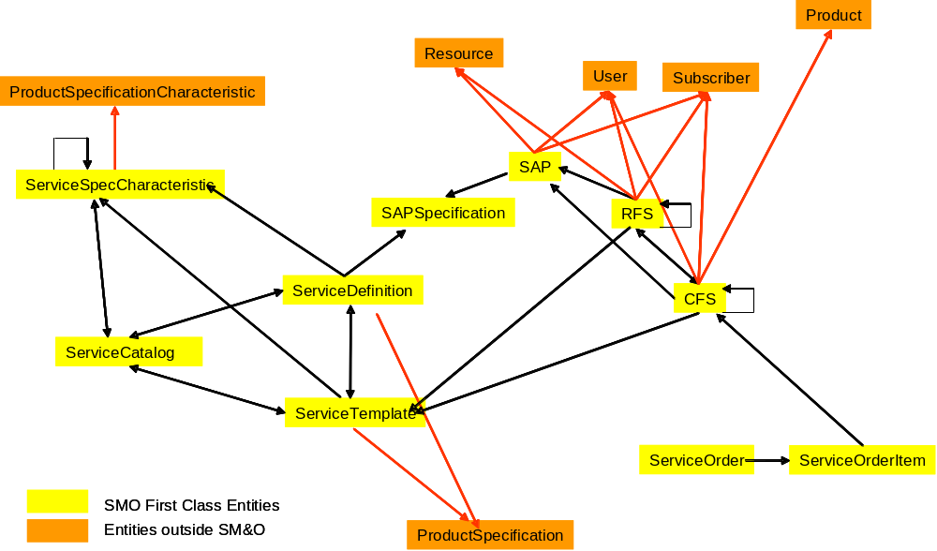

Figure 3-3. Service Inventory Layout

In the following requirements, the OS sending a request over the Interface is called the “requesting OS” and the OS receiving the request is called the “target OS”.

The operations related to the Service Inventory API must be organized into two separate interfaces with clear distinct objectives:
- Service Inventory Retrieval
- Service Inventory Update
Note that, in the present version, there is no exposed API to create/update/modify the following objects: ServiceSpecCharacteristic, ServiceDefinition, ServiceTemplate, ServiceCatalog, SAPSpecification.
The reason is that the Service Inventory API has been conceived, in a first step, to support the Service Activation stage (the client is typically a Service Activation OS).
New interfaces will be created in future releases to also support the Service Design and the Service Deployment stages (typical client being a Planning OS).

Service Inventory Retrieval

R_TMF518_MSI_II_0001 | The Service Inventory Interface shall support the capability for a requesting OS to retrieve the inventory from a target OS through a unique operation supporting instance and bulk inventory retrieval.  Support for bulk inventory retrieval can be done in any of the following ways:  - Batched responses – in this approach the server (target OS) sends the requested information back to the client (requesting OS) in a series of responses (batches). For example, using asynchronous communication over JMS.  - Batched retrieval – in this approach the client (requesting OS) retrieves the requested information from the server (target OS) via a series of requests using an iterator approach. For example, using http/s with synchronous communication.  - Batched File transfer – in this approach the requested inventory is delivered in the form of file(s). The approach allows the client (requesting OS) to designate the location of the file(s) (by providing a URI). For example, using FTP.  All of the above bulk inventory retrieval methods shall support the same Inventory output data structure schema, as well as, its batching capabilities.
Source | Similar to the requirement R_TMF518_MRI_II_0002

R_TMF518_MSI_II_0002 | Each of the bulk inventory mechanisms listed in R_TMF518_MSI_II_0001 may optionally support the ability to retrieve only the inventory that has been modified or added after a Diff Date and Time provided by the requesting OS.
Source | Similar to the requirement R_TMF518_MRI_II_0003

R_TMF518_MSI_II_0003 | Each of the bulk inventory mechanisms listed in R_TMF518_MSI_II_0001 shall support the ability to retrieve a subset of the inventory known by the target OS. This subset is defined by a filter provided by the requesting OS.  A filter is constituted of a list of  {scope qualifier, selection qualifier} pair.  The scope qualifyer is used to designate the entities present in the Service Inventory OS that must be returned.  The scope qualifyer shall be one of the following kinds:  - A SM&O object name:  it will determine a unique object present in the Service Inventory OS.  - One of the 8 object class names:  “CFS”,  “RFS”,  “SAP”,  “SAPSpecification”,  “ServiceCatalog”,  “ServiceDefinition”,  “ServiceTemplate”,  “ServiceSpecCharacteristic”  In this case, all the object instances of the selected class present in the Service Inventory OS must be returned.  - An attribute matching filter:  it is a logical expression conformant to the requirements R_TMF518_FMW_II_0023 and R_TMF518_FMW_II_0024 from.  All the instances matching this logical expression are considered.  In particular, this filter can specify a reference attribute.  The selection qualifier is used to designate which information contained in the objects of the scope or related to those objects must be returned.  The selection qualifier shall be one of the following values:  - NAME  Used to indicate that only the value of the “name” attribute of the entities in the scope must be returned.  - FULL  Used to indicate that the values of the specific attributes (including the “name”) and of the reference attributes of the objects in the scope must be returned  - DEREFERENCE_NOT_RECURSIVE  Used to indicate that:  - all the attributes of the objects in the scope must be returned (as in FULL above)  - also to be returned are all objects which are referenced by the objects in the scope (but only one level deep); for those pointed objects, the values of the specific attributes and the reference attributes must returned.  - DEREFERENCE_RECURSIVE  Same as for DEREFERENCE_NOT_RECURSIVE except that for entities of the 3 classes CFS, RFS and ServiceSpecCharacteristic, which are in the scope, the complete recursive structure must be returned:  - for ServiceSpecCharacteristic objects the “containsSSCReferenceList” attribute must be recursively dereferenced,  - for RFS objects the “containsRFSReferenceList” attribute must be recursively dereferenced,  - for CFS objects the attribute “containsCFSReferenceList”must be recursively dereferenced.
Source | Inspired from the requirement R_TMF518_MRI_II_0004

Service Inventory Update
For further study.

Category III: Abnormal or Exception Conditions, Dynamic Requirements
None have been identified thus far.

Category IV: Expectations and Non-Functional Requirements
None have been identified thus far.

Category V: System Administration Requirements
None have been identified thus far.

Use Cases
For further study.

Traceability Matrices
Will be supplied in a future version when Use Cases are defined.

Future Directions
- Service Inventory Notifications
- Service Inventory Update

References

References
- TMF518_FMW, Framework DDP BA
- TMF518_SB, Service Basic DDP BA
- TMF518_MRI, Manage Resource Inventory DDP BA
- SD0-1, Dictionary
- SD2-12, Resource Inventory Layout
- TMF517, Multi-Technology Operations System Interface (MTOSI) Business Agreement, Version 1.2, December 2006

IPR Releases and Patent Disclosure
There are no known IPR claims on the material in this document. As per the TM Forum bylaws, any TM Forum member company that has IPR claims on this or any TM Forum specification needs to make the claims known to the TM Forum membership immediately.

Administrative Appendix
This Appendix provides additional background material about the TM Forum and this document.

About this document
This document has been generated from the SD0-3_Template_BA.dot Word template.

Use and Extension of a TM Forum Business Agreement
This document defines the business problem and requirement model for Service Management. The Business Agreement is used to gain consensus on the business requirements for exchanging information among processes and systems in order to solve a specific business problem. The Business Agreement should feed the development of Information Agreement(s), which is a technology-neutral model of one or more interfaces. While the Business Agreement contains sufficient information to be a “stand alone” document, it is better read together with the Information Agreement document TMF612_SB when the Information Agreement is available. Reviewing the two documents together helps in gaining a full understanding of how the technology neutral information model solution is defined for this requirement model. An initial Business Agreement may only deal with a subset of the requirements. It is acceptable for subsequent issues of the document to add additional requirements not addressed by earlier releases of the BA. Business Agreements are the basis for requirement traceability for information models.
It is expected that this document will be used:
- As the foundation for a TM Forum Information Agreement(s)
- To facilitate requirement agreement between Service Providers and vendors
- As input to a service Provider’s Request for Information / Request for Proposal (RFI/RFP—RFX)
- As input for vendors developing COTS products
- As a source of requirements for other bodies working in this area

Document History
Version | Date Modified | Description of changes
1.0 | May 2008 | This is the first version of the document and as such, there are no changes to report.
1.1 | September 2011 | Updated sections 1.1 and 2.  Replaced mTOP by MTNM / MTOSI everywhere in the document.

Company Contact Details
Document Contact
Michel Besson
Amdocs OSS Division
Email: michel.besson@amdocs.com
Phone: +44 7717 692178

Acknowledgments
This document was prepared by the members of the TM Forum MTNM / MTOSI RM team.
- Steve Fratini, Telcordia Technologies, MTNM / MTOSI Program Director
- Shlomo Cwang, Amdocs, mTOP-SM Lead
- Gary Munson, AT&T
- Jessie Jewitt, Alcatel-Lucent
- Wudy Wu, Chunghwa Telecom Lab
- Giuseppe Riccuci, Telecom Italia

