Network Resource Basic - DDP BA

TMF518_NRB
Version 1.2


September, 2011

Notice
No recipient of this document and code shall in any way interpret this material as representing a position or agreement of TM Forum or its members. This material is draft working material of TM Forum and is provided solely for comments and evaluation. It is not “Forum Approved” and is solely circulated for the purposes of assisting TM Forum in the preparation of final material in furtherance of the aims and mission of TM Forum.
Although it is copyrighted material of TM Forum:
- Members of TM Forum are only granted the limited copyright waiver to distribute this material within their companies and may not make paper or electronic copies for distribution outside of their companies.
- Non-members of the TM Forum are not permitted to make copies (paper or electronic) of this draft material other than for their internal use for the sole purpose of making comments thereon directly to TM Forum.
- If this material forms part of a supply of information in support of an Industry Group Liaison relationship, the document may only be used as part of the work identified in the Liaison and may not be used or further distributed for any other purposes
Any use of this material by the recipient, other than as set forth specifically herein, is at its own risk, and under no circumstances will TM Forum be liable for direct or indirect damages or any costs or losses resulting from the use of this material by the recipient.
This material is governed, and all recipients shall be bound, by all of the terms and conditions of the Intellectual Property Rights Policy of the TM Forum (http://www.tmforum.org/Bylaws/1094/home.html) and may involve a claim of patent rights by one or more TM Forum members or by non-members of TM Forum.
Direct inquiries to the TM Forum office:
240 Headquarters Plaza,
East Tower – 10th Floor,
Morristown, NJ 07960 USA
Tel No. +1 973 944 5100
Fax No. +1 973 944 5110
TM Forum Web Page: www.tmforum.org

Table of Contents

Notice 2
Table of Contents 3
List of Requirements 5
List of Use Cases 6
List of Figures 7
List of Tables 8
Executive Summary 9
1 Introduction 10
1.1 DDP Structure 10
1.2 Document Structure 10
1.3 Terminology Used In This Document 11
2 Business Problem Description, Project Scope 12
2.1 Project Scope 12
2.2 Benefits 13
2.2.1 Service Provider Benefits 13
2.2.2 Supplier Benefits 14
3 Business Processes 15
3.1 Category I: Static and Structural Requirements 15
3.1.1 Resource State 17
3.1.2 Layer Rate 18
3.1.3 ITU-T State and Status 19
3.1.4 Transmission Parameter 19
3.2 Category II: Normal Sequences, Dynamic Requirements 19
3.3 Category III: Abnormal or Exception Conditions, Dynamic Requirements 19
3.4 Category IV: Expectations and Non-Functional Requirements 20
3.5 Category V: System Administration Requirements 20
4 Use Cases 21
5 Traceability Matrices 22
6 Future Directions 23
7 References 24
7.1 References 24
7.2 IPR Releases and Patent Disclosure 24
8 Administrative Appendix 25
8.1 About this document 25
8.2 Use and Extension of a TM Forum Business Agreement 25
8.3 Document History 25
8.4 Company Contact Details 26
8.5 Acknowledgments 26
List of Requirements
R_TMF518_NRB_I_0001 16
R_TMF518_NRB_I_0002 17
R_TMF518_NRB_I_0003 18
R_TMF518_NRB_I_0004 19
R_TMF518_NRB_I_0005 19

List of Use Cases
Not Applicable.

List of Figures
Figure 2-1. Inputs to the TM Forum Integration Program 12
Figure 2-2. TM Forum Integration Program 13
List of Tables
Table 3-1: Objects with common attributes 15

Executive Summary
This document is the Business Agreement (BA) part of the Network Resource Basic (NRB) Document Delivery Package (DDP). It covers the requirements for the general aspects of the network resources.

See Section 1 for additional introductory material related to this document.

Introduction

DDP Structure
In order to allow for more efficient release delivery, the previous monolithic BA, IA and SS documents have been partitioned into smaller self-contained (though not independent) units called Document Delivery Packages (DDPs).
This is similar to the 3GPP concept of Integration Reference Point (IRP). The basic idea is that the Interface, which is specified by the entire document set (of a release), is partitioned into DDPs where each DDP specifies “a certain aspect” of the Interface, which needs to be very clearly scoped.
There are three kinds of DDPs:
  - the FrameWork DDP (FMW) – this DDP contains the generic artifacts that are applicable to all the other DDPs.
  - Data Model DDP (DM-DDP) – a DDP that concerns a data model (entities, data structures, attributes, state, but no operations)
  - Operation Model DDP (OM-DDP) – a DDP that concerns a computational model (operations, notifications, transactions) for a given functional area (such as resource inventory management)
The unified deliverables structure for any given MTOSI / MTNM product release is as follows:
  - Product Release Notes:
    - a scope specification for the type and extent of the delivered product,
    - the partitioning of the release into DDPs (i.e., definitions of various aspects of the release),
    - and an overview of the release’s (delta) deliverables;
  - For each DDP:
    - Business Agreements (BAs): a business view specification
    - Information Agreements (IAs): a system view specification
    - Interface Implementation Specifications (ISSs): implementation and deployment view specification per supported enabling technology (mapping of the IA to either CORBA (IDL, services usage) or XML (WSDL, XSD, bindings…)
    - Supporting Documentation: normative and informative supporting documents.
  - Reference Implementation (optional) of core IIS fragments for selected interfaces and enabling technologies.

Document Structure
This document is divided into the following sections:
- Section 1 is this introduction.
- Section 2 defines the business problem and project scope.
- Section has the requirements and associated descriptive text.
- Section 4 contains the use cases.
- Section 5 has traceability matrices between the use cases and associated requirements, and vice versa.
- Section 6 provides a summary and list of open issues to be considered in later versions of this document.
- Section 7 lists references and states IPR claims, if any.
- Section 8 provides administrative details such as author contact information, document history and acknowledgements.

Terminology Used In This Document
Refer to the SD0-1 supporting document.
.

Business Problem Description, Project Scope

Project Scope
The TM Forum Integration Program is responsible for all of the interface and business services work within the TM Forum. In some cases, interface work is delegated to other teams but the final verification for technical uniformity and integrity is the responsibility of the TM Forum Integration Program.
Initially, the TM Forum Integration Program was formed to coordinate the various existing TM Forum interfaces activities (as shown in Figure 2-1). In particular, the responsibility for maintaining MTOSI and MTNM is now covered by the MTOSI-MTNM Users Group which is a team within the TM Forum Integration Program. The long term plan (which is already well under progress) is to migration the various input work to a single harmonized suite of interfaces.

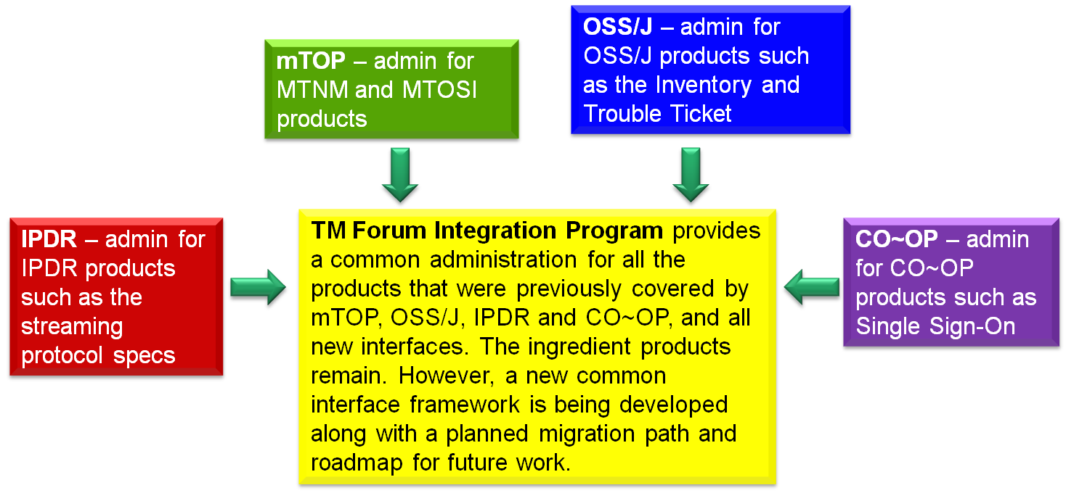
Figure 2-1. Inputs to the TM Forum Integration Program

Figure 2-2 provides a summary of the team within the TM Forum Integration Program as well as a few teams outside of the program but which also do some interface work. In terms of MTOSI and MTNM, the main input for updates come from the Resource and Service Management Team.

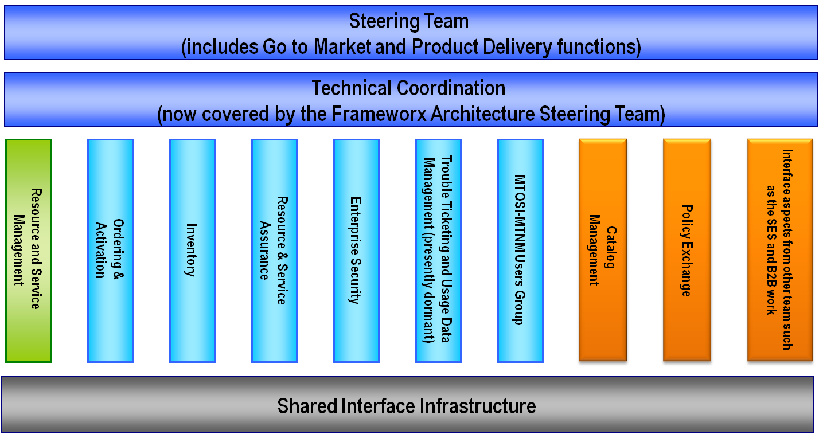
Figure 2-2. TM Forum Integration Program

Benefits
MTOSI and MTNM provide a set of Interface specifications that allow for resource and service management (with only MTOSI covering service management, but with MTOSI and MTNM both covering resource management, using very much the same information model).
These specifications are intended to lower design, implementation, Verification Validation & Testing (VVT), and maintenance costs for management interfaces. These Interfaces are intended for use by service providers, suppliers of equipment and OSS suppliers. The intention is to also encourage system integrator usage of management systems that make use of the Interfaces.
In particular, the followed approach tends to minimize the cost of integration, provide access to all necessary information and control, and support all vendor/operator differentiation. The intent of the interface is to provide compatibility among different version, for a detailed description see SD2-6_VersioningAndExtensibility.

Service Provider Benefits
The service provider benefits are as follows:
- One stop shopping concerning feature requests for much of the TM Forum contract specification work is part of the defined Change Control Group (CCG) process that TM Forum makes available in order to control the interface.
- The technical deliverables are also of high value to the service provider. The Interface specifications allow for an open, multi-supplier environment, shorten delivery times and lower integration costs.
- The MTOSI and MTNM products provide an integrated, multi-technology interface with support for most key layer 1 and layer 2 transport technologies. This is in contrast to earlier approaches where each technology-specific forum provided a single-technology management interface. The service provider was faced with having to use many different, uncoordinated management interfaces.
- These products are not bound to any one middleware, transport or computing language. So, the service provider will be able to evolve to new technologies as they arise.

Supplier Benefits
The supplier benefits are as follows:
- Fewer Adapters leads to Lower Costs – in as much as MTOSI and MTNM gain market penetration (and there has already been significant market acceptance of these interfaces), the supplier is faced with the need to build fewer adapters between their products and the products of their partners. A supplier can also directly see cost savings in the use of the Interfaces among its own products (as the need for an open interface arises).
- Lower Middleware Transitions Costs – the Interfaces are defined to be middleware and transport independent. So, the supplier can migrate from one middleware or transport technology to another without changing the supporting business logic in the code.
- Increase Usage by System Integrators (SIs) – a supplier’s support of their own “open” interfaces goes only so far to encourage SIs. Clearly, an SI would like to make use of supplier products (both equipment and OSS suppliers) that make use of well supported standard interfaces rather than supplier specific interfaces. The latter case forces the SI into a situation characterized by many pair-wise negotiations between various suppliers.
- Lower Training Cost – in as much as a supplier re-uses the Interfaces for multiple products and for multiple customers, the various training costs are lower because the designers, system engineers, developers and testers are using the same Interfaces over and over again.

Business Processes

Category I: Static and Structural Requirements
The requirements for the Interface have been specified in terms of the managed entities (objects) that are visible across the Interface and the service requests that may be invoked across the Interface. A number of the objects visible across the Interface are required to have a common set of attributes. Table 3-1 identifies the objects that shall have a common set of attributes.
Table 3-1 is provided for information only and provides a list of the managed entities to which the common attributes apply and is not intended to serve as definition for these managed entities. The definitions for the managed entities are to be found in other Business Agreement (BA) documents.

Table 3-1: Objects with common attributes
# | Object Name
1 | Alarm Severity Assignment Profile (ASAP)
2 | Element Management System (EMS)
3 | Equipment
4 | Equipment Holder (EH)
5 | Equipment Protection Group (EPGP)
6 | Flow Domain (FD)
7 | Flow Domain Fragment (FDFr)
8 | Group Termination Point (GTP)
9 | Managed Element (ME)
10 | Matrix Flow Domain (MFD)
11 | Operations System (OS)
12 | Performance Monitoring Point (PMP)
13 | Protection Group (PGP)
14 | MultiLayer Subnetwork (MLSN)
15 | Subnetwork Connection (SNC)
16 | Termination Point (TP)
17 | Termination Point Pool (TP Pool)
19 | Threshold Crossing Alert (TCA) Parameter Profile
20 | Topological Link (TL)
21 | Traffic Conditioning (TC) Profile
22 | Transmission Descriptor (TMD)

R_TMF518_NRB_I_0001 | All objects that represent managed resources across the Interface shall have in addition to the attributes defined in requirement TMF518_FMW_I_001 the following attributes:  - source - this attribute shall indicate whether the object was discovered from the network, or was entered into the OS’s inventory. The possible values for this attribute are, i.e.,  - network ME – the object was discovered directly from an NE.  - network OS – the object was discovered from an OS communicating directly with an NE.  - OS – the object was entered into an OS on the CCV, that was not communicating directly with an NE, e.g., OS GUI or file transfer to the OS from some other system.  - Unknown – the source of the object is not available or known by the OS.  - resource state - this attribute shall represent the lifecycle state of a physical resource. The possible values for this attribute are:  - planning – the resource is scheduled for deployment in accordance with a specific plan.  - installing – the resource undergoes a full commissioning process until it is finally ready for work and support services.  - working – the resource has been physically installed and all necessary firmware and software have been installed, all commissioning tests have been performed,  - retiring – the resource undergoes all necessary procedures for its decommissioning and phasing out.  - unknown - the resource state is not known.  Refer to Section 3.1.1 for more information regarding the resource state attribute.  - network access domain – this attribute shall represent the (identifier of) Network Access Domain (NAD) to which the resource has been assigned.  A NAD provides a way for a Network Operator to partition the resources in the network into different administrative domains.
Source | TMF 517, Version 1.1, Requirement I. 1 and Requirement I. 5

Note:
- A single network entity can be represented by more than one instance of a managed entity. For example, a Network Element (NE) could be represented as a layer 1 Managed Element (ME) and a layer 2 ME. One OS could be the steward for the layer 1 ME and another OS could be the steward for the layer 2 ME.

Resource State
Some OSs (e.g., Inventory Management, Network Planning, Service Provisioning, etc.) are required to track the status of network resources over their entire lifecycle, prior to actual installation and also after deactivation.
The resource state attribute has been defined to model the lifecycle phases of a resource and as such can be considered as representing a “coarse grained” resource state model. The states are in fact compound states in that they encapsulate a series of sub-states. The details of the sub-states can be found in supporting document SD2-17_EnhancedResourceStates.

R_TMF518_NRB_I_0002 | The resource state attribute of an object shall be qualified through the use of a number of sub-states. The possible values for these sub-states are in the case of:  - planning:  - initial plan - a requirement for the resource has been identified.  - planned - the characteristics of the resource and its deployment have been completely identified but nothing exists in the network.  - ordered - an order for delivery of the resource has been agreed between the network provider and supplier.  - installing:  - delivered - the resource has been accepted by the network provider as delivered to site by the supplier  - installed - the resource has been unpacked and installed by the supplier/ installer.  - commissioned - the resource has commissioned by the supplier/ commissioner.  - integrated - the resource management has been integrated by the supplier/ integrator.  - accepted - the resource has been accepted by the network provider as ready for network use.  - rejected - the resource was rejected by the network provider and has been returned from site to the supplier  - working:  - activated - the resource is working, has been configured and is available for use.  - deactivated - the resource is working but is not available for use.  - retiring:  - withdrawn-active - the resource is not available to carry any new traffic. Existing traffic is to be removed/offloaded to other resources.  - withdrawn-unavailable – the resource is not available to carry any new traffic. Existing traffic has been removed/offloaded.  - de-integrated - all physical and logical entities in support of the resource are still in place. The resource is still visible to an OS for remote administration.  - decommissioned - the resource no longer visible to an OS for remote administration.  - de-installed - the resource is physically in place but physical and logical entities in support of the resource have been withdrawn.  - stored - the resource has been packed and removed from its location to a designated storage location.  - recovered - the resource has been recovered from site for disposal.
Source | Adapted from TMF 517, Version 1.1, Requirement I.6

Layer Rate

R_TMF518_NRB_I_0003 | Certain objects representing managed resources shall have an attribute that represents the network layer rates that are encapsulated by the resource for the purposes of management.  The values for these layer rate shall be defined in the supporting document SD1-17.  If a layer rate is not defined in SD1-17 then a mechanism shall be defined that enables the definition of proprietary values (refer to SD1-17 for the details of defining proprietary layer rates).
Source | Adapted from TMF 513, Version 3.0, Requirement I. 022

ITU-T State and Status

R_TMF518_NRB_I_0004 | To allow an object that represents a managed resources across the Interface to support the ITU-T state and status values (as defined in the ITU-T X.731 and M.3100) in a consistent manner the attribute names and values have been predefined (refer to SD1-8 for the defined names and values).  If it is required (by an implementer of the Interface) that an object support an ITU-T X.731 or M.3100 state or status value then the attribute identifier and the values to be used shall be those identified in SD1-8. The ITU-T state and status values may be used in addition to the resource state attribute. That is the resource state is the primary attribute and the ITU-T state and status attributes are optional additional attributes.
Source | TMF 518_NRB, Version 1.0.

Transmission Parameter

R_TMF518_NRB_I_0005 | A Transmission Parameter is a characteristic that shall be identified by a name value pair.  Refer to supporting document SD1-16 for the currently identified TP parameters.
Source | Amended from TMF 513, Version 3.0, Requirement I. 024

Category II: Normal Sequences, Dynamic Requirements
Not Applicable.

Category III: Abnormal or Exception Conditions, Dynamic Requirements
Not Applicable.

Category IV: Expectations and Non-Functional Requirements
Not Applicable.

Category V: System Administration Requirements
Not Applicable.

Use Cases
Not Applicable.

Traceability Matrices
Not Applicable.

Future Directions
None identified at this time.

References

References
[1] TMF513, Multi-Technology Network Management (MTNM) Business Agreement, Version 3.1, March 2007
[2] TMF518_FMW, Framework DDP-BA
[3] SD1-8, Coding of X.731 and M.3100 State and Status Information
[4] SD1-16, Layered Parameters
[5] SD1-17, Layer Rates
[6] SD0-1, Dictionary
[7] SD2-17, MTOSI Enhanced Resource States

IPR Releases and Patent Disclosure
There are no known IPR claims on the material in this document. As per the TM Forum bylaws, any TM Forum member company that has IPR claims on this or any TM Forum specification needs to make the claims known to the TM Forum membership immediately.

Administrative Appendix
This Appendix provides additional background material about the TM Forum and this document.

About this document
This document has been generated from the SD0-3_Template_BA.dot Word template.

Use and Extension of a TM Forum Business Agreement
This document defines the business problem and requirement model for resource management The Business Agreement is used to gain consensus on the business requirements for exchanging information among processes and systems in order to solve a specific business problem. The Business Agreement should feed the development of Information Agreement(s), which is a technology-neutral model of one or more interfaces. While the Business Agreement contains sufficient information to be a “stand alone” document, it is better read together with the Information Agreement document TMF612_NRB when the Information Agreement is available. Reviewing the two documents together helps in gaining a full understanding of how the technology neutral information model solution is defined for this requirement model. An initial Business Agreement may only deal with a subset of the requirements. It is acceptable for subsequent issues of the document to add additional requirements not addressed by earlier releases of the BA. Business Agreements are the basis for requirement traceability for information models.
It is expected that this document will be used:
- As the foundation for a TM Forum Information Agreement(s)
- To facilitate requirement agreement between Service Providers and vendors
- As input to a service Provider’s Request for Information / Request for Proposal (RFI/RFP—RFX)
- As input for vendors developing COTS products
- As a source of requirements for other bodies working in this area

Document History
Version | Date Modified | Description of changes
1.0 | September 2007 | This is the first version of the document and as such, there are no changes to report.
1.1 | May 2008 | Updated based on review and consolidation comments for the preparation of the MTOSI 2.0 release.
1.2 | September 2011 | Updated sections 1.1 and 2.  Replaced mTOP by MTNM / MTOSI everywhere in the document.

Company Contact Details
Document Contact
Keith Dorking
Ciena Corporation
Email: kdorking@ciena.com
Phone: +1 678 867 5007

Acknowledgments
This document was prepared by the members of the TM Forum MTNM / MTOSI RM team.
- Keith Dorking, Ciena Corporation, document editor
- Steve Fratini, Telcordia Technologies, MTNM / MTOSI Program Director
- Michel Besson, Amdocs, MTOSI Product Manager
Additional input was provided by the following people:
- Gerard Vila, Alcatel-Lucent

This includes all types of TP (i.e. PTPs, CTPs and FTPs)

