This document compares BA, IA and IIS of the Flow Domain Control Service within the Resource Provisioning DDP

References:
BA: TMF518_NRB.doc 1231 05.12.07 besson
IA: ResourceProvisioning.emx 1572 08.04.08 zeuner
IIS: FlowDomainControlMessages.xsd 1511 14.03.08 jeromem
SDs:

Conventions:
yellow marked items need discussion
turquoise marked items are obvious (from my point of view) and need to be added/changed/deleted

Content:
1 High level UML diagrams 3
1.1 Flow Domain Control Service Interface Diagram 3
2 Flow Domain Control Service 4
2.1 assignConnectionlessPortTerminationPointsToMfd 4
2.2 associateConnectionlessPortTerminationPointsWithFd 6
2.3 associateMatrixFlowDomainsWithFd 9
2.4 createAndActivateFlowDomainFragment 12
2.5 createFlowDomain 21
2.6 createMatrixFlowDomain 25
2.7 deactivateAndDeleteFlowDomainFragment 27
2.8 deAssociateConnectionlessPortTerminationPointsFromFd 30
2.9 deAssociateMatrixFlowDomainsFromFd 32
2.10 deleteFlowDomain 35
2.11 deleteMatrixFlowDomain 38
2.12 modifyFlowDomain 41
2.13 modifyFlowDomainFragment 43
2.14 modifyMatrixFlowDomain 48
2.15 unassignConnectionlessPortTerminationPointsFromMfd 51
3 Data Types 55
3.1 FlowDomainCreateData Type 55
3.2 FlowDomainModifyData Type 57
3.3 FlowDomainFragmentCreateData Type 59
3.4 FlowDomainFragmentModifyData Type 62
3.5 FlowDomainFragmentSetData Type 65
3.6 MatrixFlowDomainCreateData Type 70
3.7 MatrixFlowDomainModifyData Type 72

Figures:
Figure 1: RP Connection Control Service Interface Diagram 3

History:
Version | Date | Description of Change
0.1 | 08.04.2008 | Initial version.
0.2 | 09.04.08 | Jerome: Updated the FlowDomainControl SI XSD/WSDL based on cross-references findings.  Michel: Blue comments related to the BA partially processed.  Michel: Reinserted the modification on the BA on top of Jerome's comments.
0.3 | 21.04.08  23.04.08  24.04.08 | Decisions made during mTOP RM conference calls included. Stopped at page 14.
0.4 | 28.04.08 | Decisions made during conference call on 28th of April included. Stopped at page 55.
0.5 | 05.05.08 | Decisions made during conference call on 5th of May included. Stopped at page 63.
0.6 | 09.05.08 | Some blue marked items corrected in the IA.
General:
BA: "call-end-point" has to be replaced by CPTP. done
BA: tpDataListToModify not defined in Requirements. done
BA: 3.3.3.1.5 Transmission Descriptor (TMD) Management should be moved to TransmissionDescriptorControlService.
BA: 3.3.3.3 Traffic Conditioning (TC) Profile Management should be moved to TrafficConditioningProfileControlService.
BA: Use Case Exceptions: "Category III: Abnormal or Exception Conditions, Dynamic Requirements" but "No requirements have been identified for this category."
done
IIS: CamelCase not necessary in descriptions.

High level UML diagrams

Flow Domain Control Service Interface Diagram
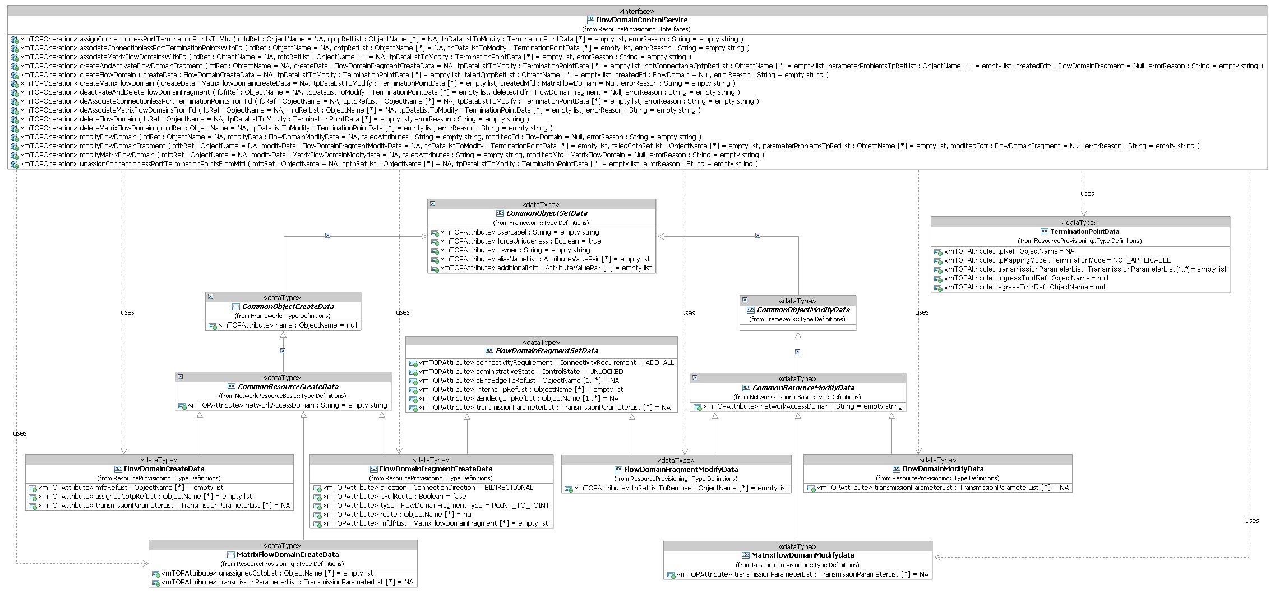
Figure 1: RP Flow Domain Control Service Interface Diagram

Flow Domain Control Service

assignConnectionlessPortTerminationPointsToMfd

BA (assignConnectionlessPortTerminationPointsToMfd) | IA | IIS | Comments
R_TMF518_RP_II_0042  The Interface shall allow the requesting OS to assign call-end-points to a Matrix Flow Domain (MFD).  The requesting OS shall provide a list of unassigned call-end-point names to be associated to the MFD. The provided call-end-points must be potential call-end-points for this MFD (e.g. have to be on the same equipment or same rack with backplane connectivity).  The request shall be denied if the MFD is “fixed”. | This operation assigns Connectionless Port Terminations Points (CPTPs) to ae Matrix Flow Domain (MFD). The provided CPTPs must be potential CPTPs for this MFD (e.g. have to be on the same equipment or same rack with backplane connectivity).  Traceability: R_TMF518_RP_II_0042, UC_TMF518_RP_0025. | assignConnectionlessPortTerminationPointsToMFD  This operation assigns Connectionless Port Terminations Points (CPTPs) to ae Matrix Flow Domain (MFD). The provided CPTPs must be potential CPTPs for this MFD (e.g. have to be on the same equipment or same rack with backplane connectivity).
 | mfdRef (ObjectName)  This parameter provides the name of the Matrix Flow Domain to which the CPTPs shall be assigned to. | (in) element name="mfdRefName" type="nam:NamingAttributeType"  The name of the matrix flow domain to be modified.
 | cptpRefList (*) (ObjectName)  This parameter provides the names of the Connectionless Port Terminations Points (CPTPs) to be assigned to the Matrix Flow Domain. | (in) element name="cptpRefList" type="nam:NamingAttributeListType"  This parameter provides the names of the Connectionless Port Terminations Points (CPTPs) to be assigned to the Matrix Flow Domain | bz:  List can not be empty in IA.
?? | tpDataListToModify (in/out) (*) (TerminationPointData)  This parameter, when used in the request,  (in) identifies a list of TPs with associated parameters to be applied;  (out) identifies the list of TPs with associated applied parameters.  +++++++++++++++++  see TerminationPointData Type in section 12.1 of Comparison-RP-ConnectionControlService.doc | (in) element name="tpDataListToModify" type="tpdata:TerminationPointDataListType"  The list of TPs with associated parameters to be applied.  +++++++++++++++++  see TerminationPointData Type in section 12.1 of Comparison-RP-ConnectionControlService.doc
(out) element name="tpDataListToModify" type="tpdata:TerminationPointDataListType"
This parameter, when used in the request,
identifies a list of TPs with associated parameters to be applied; identifies the list of TPs with associated applied parameters.
+++++++++++++++++
see TerminationPointData Type in section 12.1 of Comparison-RP-ConnectionControlService.doc

 | errorReason (out)  This parameter returns the error(s) if any. | (out) element name="errorReason" type="xsd:string"  Specifies the fault reason if any.
UC_TMF518_RP_0025  Pre-Conditions:  The requesting OS and target OS have executed the Use Case 0001 OS (Re) Starts as defined in the TMF518_FMW BA document  Are you suggesting that I should write “have successfully executed” instead of simply “have executed”? | None
UC_TMF518_RP_0025  Post-Conditions:  In case of success:  The requested call-end-points have been assigned to the MFD.  In case of failure:  Nothing has changed in the System, i.e., no change in the call-end-point assignment to the MFD. | The requested CPTPs have been assigned to the MFD.
UC_TMF518_RP_0025  Exceptions:  Refer to Category III: Abnormal or Exception Conditions, Dynamic Requirements | 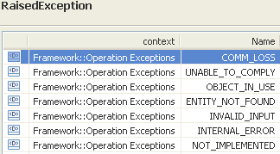  EXCPT_OBJECT_IN_USE - Raised when a CPTP is already assigned to another matrix flow domain | restriction base="msg:AllExceptionsType"  element ref="msg:communicationFailure"  element ref="msg:entityNotFound"  element ref="msg:internalError"  element ref="msg:invalidInput"  element ref="msg:notImplemented"  element ref="msg:notInValidState"  element ref="msg:objectInUse"  element ref="msg:unableToComply" | bz:  "notInValidState" and "objectInUse" are not required by the Use Case.  Should be added to Use Case.

associateConnectionlessPortTerminationPointsWithFd

BA (associateConnectionlessPortTerminationPointsWithFd) | IA | IIS | Comments
R_TMF518_RP_II_0051  The Interface shall allow the requesting OS to associate call-end-points to a Flow Domain (FD).The requesting OS shall provide a list of assigned call-end-points to be associated to the FD. These call-end-points have to be already assigned to one of the Matrix Flow Domain (MFD)s that are associated to the FD.  The successful association of the call-end-points shall update the Port TP role state of the call-end-points (i.e., newly associated call-end-points become “FD Edge”).  The association of the call-end-points to the FD shall be done on a best effort basis. | This operation associates Connectionless Port Terminations Points (CPTPs) with the Flow Domain (FD).  The provided CPTPs must be already assigned to one of the Matrix Flow Domains that are associated to the FD.  Traceability: R_TMF518_RP_II_0051, UC_TMF518_RP_0020. | associateConnectionlessPortTerminationPointsWithFdRequest  This operation associates Connectionless Port Terminations Points (CPTPs) with the Flow Domain (FD).  The provided CPTPs must be already assigned to one of the Matrix Flow Domains that are associated to the FD.
 | fdRef (ObjectName)  This parameter provides the name of the Flow Domain to which the CPTPs shall be associated to. | (in) element name="fdRefName" type="nam:NamingAttributeType"  The name of the flow domain to be modified.
 | cptpRefList (*) (ObjectName)  This parameter provides the names of the Connectionless Port Terminations Points (CPTPs) to be associated with the Flow Domain. | (in) element name="cptpRefList" type="nam:NamingAttributeListType"  This parameter provides the names of the Connectionless Port Terminations Points (CPTPs) to be associated with the Flow Domain. | bz:  List can not be empty in IA.
?? | tpDataListToModify (in/out) (*) (TerminationPointData)  This parameter, when used in the request,  (in) identifies a list of TPs with associated parameters to be applied;  (out) identifies the list of TPs with associated applied parameters.  +++++++++++++++++  see TerminationPointData Type in section 12.1 of Comparison-RP-ConnectionControlService.doc | (in) element name="tpDataListToModify" type="tpdata:TerminationPointDataListType"  The list of TPs with associated parameters to be applied.  +++++++++++++++++  see TerminationPointData Type in section 12.1 of Comparison-RP-ConnectionControlService.doc
(out) element name="tpDataListToModify" type="tpdata:TerminationPointDataListType"
This parameter, when used in the request,
identifies a list of TPs with associated parameters to be applied; identifies the list of TPs with associated applied parameters.
+++++++++++++++++
see TerminationPointData Type in section 12.1 of Comparison-RP-ConnectionControlService.doc

 | errorReason (out)  This parameter returns the error(s) if any. | (out) element name="errorReason" type="xsd:string"  Specifies the fault reason if any.
UC_TMF518_RP_0020  Pre-Conditions:  The requesting OS and target OS have executed .  Missing text added | None |  | bz:  The Execution of the Use Case is not enough, because this can fail. There has to be a communication connection between the OSes.
UC_TMF518_RP_0020  Post-Conditions:  In case of success:  The requested call-end-points (except the ones returned in the list of not associated ??? call-end-points) have been associated as FD Edge call-end-points to the FD.  In case of failure:  Nothing has changed in the System, i.e., no change in the call-end-point association to the FD. | The requested CPTPs have been associated to the FD. |  | bz:  No "list of not associated CPTPs" returned in IA and IIS.
UC_TMF518_RP_0020  Exceptions:  Refer to Category III: Abnormal or Exception Conditions, Dynamic Requirements | 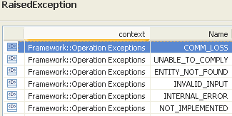 | restriction base="msg:AllExceptionsType"  element ref="msg:communicationFailure"  element ref="msg:entityNotFound"  element ref="msg:internalError"  element ref="msg:invalidInput"  element ref="msg:notImplemented"  element ref="msg:unableToComply"

associateMatrixFlowDomainsWithFd

BA (associateMatrixFlowDomainsWithFd) | IA | IIS | Comments
R_TMF518_RP_II_0053  The Interface shall allow the requesting OS to associate Matrix Flow Domain (MFD)s to a Flow Domain (FD).  The requesting OS shall provide a list of existing MFDs to be associated to the FD.  The MFDs to be associated must not be associated to another FD | This operation associates Matrix Flow Domains (MFDs) with a Flow Domain (FD).  The MFDs to be associated must not be associated to another FD.  Traceability: R_TMF518_RP_II_0053, UC_TMF518_RP_0018. | This operation associates Matrix Flow Domains (MFDs) with a Flow Domain (FD).  The MFDs to be associated must not be associated to another FD.
 | fdRef (ObjectName)  This parameter provides the name of the Flow Domain to which the Matrix Flow Domains shall be associated to. | (in) element name="fdRefName" type="nam:NamingAttributeType"  The name of the flow domain to be modified.
 | mfdRefList (*) (ObjectName)  This parameter provides the names of the Matrix Flow Domains to be associated with the Flow Domain. | (in) element name="mfdRefList" type="nam:NamingAttributeListType"  This parameter provides the names of the Matrix Flow Domains to be associated with the Flow Domain | bz:  List can not be empty in IA.
?? | tpDataListToModify (in/out) (*) (TerminationPointData)  This parameter, when used in the request,  (in) identifies a list of TPs with associated parameters to be applied;  (out) identifies the list of TPs with associated applied parameters.  +++++++++++++++++  see TerminationPointData Type in section 12.1 of Comparison-RP-ConnectionControlService.doc | (in) element name="tpDataListToModify" type="tpdata:TerminationPointDataListType"  The list of TPs with associated parameters to be applied.
(out) element name="tpDataListToModify" type="tpdata:TerminationPointDataListType"
This parameter, when used in the request,
identifies a list of TPs with associated parameters to be applied; identifies the list of TPs with associated applied parameters.

 | errorReason (out)  This parameter returns the error(s) if any. | (out) element name="errorReason" type="xsd:string"  Specifies the fault reason if any.
UC_TMF518_RP_0018  Pre-Conditions:  The requesting OS and target OS have executed the Use Case 0001 OS (Re) Starts as defined in the TMF518_FMW BA document. | None |  | bz:  The Execution of the Use Case is not enough, because this can fail. There has to be a communication connection between the OSes.
UC_TMF518_RP_0018  Post-Conditions:  In case of success:  The FD has been modified as requested.  In case of failure:  Nothing has changed in the System, i.e., the FD has not been modified. | The requested MFDs have been associated with the FD.
UC_TMF518_RP_0018  Exceptions:  Refer to Category III: Abnormal or Exception Conditions, Dynamic Requirements | 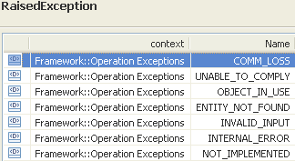 | restriction base="msg:AllExceptionsType"  element ref="msg:communicationFailure"  element ref="msg:entityNotFound"  element ref="msg:internalError"  element ref="msg:invalidInput"  element ref="msg:notImplemented"  element ref="msg:objectInUse"  element ref="msg:unableToComply"

createAndActivateFlowDomainFragment

BA (createAndActivateFlowDomainFragment) | IA | IIS | Comments
R_TMF518_RP_II_0060  The Interface shall allow the requesting OS to create a Flow Domain Fragment (FDFr) given the requesting OS specified data listed in R_TMF518_RP_II_0061.  This includes FDFrs for flows of untagged frames.  The target OS shall create all necessary Flow Point (FP)s and Matrix Flow Domain Fragment (MFDFr)s (not visible as separate named objects at the interface) comprising the FDFr.  The request is successful if at least two (edge) FPs can be created. In case not all requested (edge) FPs can be connected when the FDFr is created, the target OS returns the list of the not connectable CPTPs and FPs in the success reply.  If internal call-end-points are provided by the requesting OS and if it is not possible to include all provided internal call-end-points to the route of the FDFr, the operation will be rejected.  If the target OS works in the “connectivity-aware” mode, the requesting OS can request one of two creation results when not all FPs have potential connectivity to one another:  1) reject the creation request  2) add all Flow Points regardless of potential connectivity.  The target OS shall check if the new requested FDFr already exists, either entirely or partially or differently. The following cases have to be respected:  1) An existing FDFr matches the FDFr being requested (“matches” means that the set of flow points resulting from the activation of the FDFr is the same. Creation of two successive FDFr's on the same set of call-end-points, but with different VLAN IDs do NOT match).  a) If the name specified by the requesting OS is the same as the name of the existing FDFr, or no name is specified:  The operation will succeed (if all goes well). In this case (same name, or no name) the FDFr will be returned with the original name.  b) If the name specified by the requesting OS is not the same as the name of the existing FDFr, the operation is rejected with exception Object In Use.  2) The existing FDFr is a subset or superset of the requested FDFr.  a) If the requesting OS did not give a name, or if the requesting OS name is different from the name of the existing FDFr the operation is rejected with exception Object In Use.  b) If the requesting OS name is the same as the name of the existing FDFr, the operation is rejected (because this operation does not allow to change the endpoints).  Note:  The above does not depend on the “ACTIVE” or “PARTIAL” state of the previous FDFr, but on the set of endpoints and where applicable the set of MFDFrs, of each FDFr. | This operation creates a Flow Domain Fragment (FDFr) within the Flow Domain (FD).  The target OS creates all necessary Flow Points and Matrix Flow Domain Fragments comprising the FDFr.  The request is successful if at least two edge Flow Points can be created.  In case not all requested (edge) Flow Points can be connected when the FDFr is created, the target OS returns the list of the not connectable Connectionless Port Termination Points (CPTPs) and Flow Points in the success reply.  If internal CPTPs are provided by the requesting OS and if it is not possible to include all provided internal CPTPs to the route of the FDFr, the operation will be rejected.  Traceability: R_TMF518_RP_II_0060, R_TMF518_RP_II_0061, UC_TMF518_RP_0031. | This operation creates a Flow Domain Fragment (FDFr) within the Flow Domain (FD).  The target OS creates all necessary Flow Points and Matrix Flow Domain Fragments comprising the FDFr.  The request is successful if at least two edge Flow Points can be created.  In case not all requested (edge) Flow Points can be connected when the FDFr is created, the target OS returns the list of the not connectable Connectionless Port Termination Points (CPTPs) and Flow Points in the success reply.  If internal CPTPs are provided by the requesting OS and if it is not possible to include all provided internal CPTPs to the route of the FDFr, the operation will be rejected.
 | containingFdRef (ObjectName)  This parameter provides the name of the Flow Domain in which the Flow Domain Fragment has to be created. |  | Description on how to calculate the name of the containing Flow Domain using the createData parameters has to be provided and added to the IA Guidelines.  This is also valid for the MultiLayerSubnetwork and others …
R_TMF518_RP_II_0061  The Interface shall allow the requesting OS to specify the following parameters when it requests that a target OS creates a Flow Domain Fragment (FDFr):  +++++++++++++++++  see FlowDomainFragmentCreateData Type in section 3.3 | createData (FlowDomainFragmentCreateData)  This parameter provides the create attributes describing the Flow Domain Fragment to be established.  Traceability: R_TMF518_RP_II_0061.  +++++++++++++++++  see FlowDomainFragmentCreateData Type in section 3.3 | (in) element name="createData" type="tns:FlowDomainFragmentCreateDataType"  Structure describing the FDFr structure to be created. Setting of connectionless parameters is best effort (except where specified otherwise for a particular parameter).  +++++++++++++++++  see FlowDomainFragmentCreateData Type in section 3.3
 |  | (in) element name="connectivityRequirement" type="fd:ConnectivityRequirementType"  For a "connectivity-aware" Target OS, this parameter shall identify the requested operation mode in case not all FPs have potential connectivity to one another. If the Target OS is not connectivity-aware, this parameter is ignored. | bz:  Part of FlowDomainFragmentSetData.
 |  | (in) element name="aEndRefList" type="nam:NamingAttributeListType"  A list of of CPTP names that delimit the FDFr and characterize its edges (entrance and/or exit points). As a result of creating the FDFr, FPs are created as clients of the Fd Edge CPTPs. In case of a unidirectional FDFr this attribute contains the list of source Fd Edge CPTPs. In case of a bidirectional FDFr this attribute may be combined with the zEnd TPs attribute to obtain all the Fd Edge CPTPs that are associated to the FDFr. (N.B. For a bidirectional point to point FDFr it is suggested, but not mandatory, to put one TP in the aEnd and one in the zEnd, as with SNCs and TLs. For a multipoint FDFr, or a point-to-point FDFr that may be expanded to multipoint, it is suggested to put all the TPs in the aEnd.) | bz:  Part of FlowDomainFragmentSetData.
 |  | (in) element name="zEndRefList" type="nam:NamingAttributeListType"  In case of a unidirectional FDFr this attribute contains the list of sink Fd Edge CPTPs that delimit the FDFr and characterize its edges (exit points). As a result of creating the FDFr, FPs are created as clients of the Fd Edge CPTPs. In case of a bidirectional FDFr this attribute may be combined with the aEnd TPs attribute to obtain all the Fd Edge CPTPs that are associated to the FDFr. | bz:  Part of FlowDomainFragmentSetData.
 |  | (in) element name="internalTpRefList" type="nam:NamingAttributeListType"  A (possibly empty) list of internal CPTP names that must be included in the route of the FDFr. As a result of creating the FDFr, FPs are created as clients of the internal CPTPs. | bz:  Part of FlowDomainFragmentSetData.
MFDFrs  An optional (possibly empty) list of MFDFrs that make up the route of the FDFr. This attribute may be omitted if the FDFr is routed by the network. As a result of creating the FDFr, MFDFrs are created in the various MFDs. | (inout) mfdfrList (*) (MatrixFlowDomainFragment)  This parameter,  (in) provides the (possibly empty) list of Matrix Flow Domain Fragments (MFDFrs) that make up the route of the Flow Domain Fragment (FDFr). This attribute may be omitted if the FDFr is routed by the network. As a result of creating the FDFr, MFDFrs are created in the various Matrix Flow Domains.  (out) returns the (possibly empty) list of Matrix Flow Domain Fragments (MFDFrs) that make up the route of the FDFr. This attribute may be omitted if the FDFr is routed by the network. As a result of creating the FDFr, MFDFrs are created in the various MFDs. | (in) element name="mfdfrList" type="mfdfr:MatrixFlowDomainFragmentListType"  An optional (possibly empty) list of MFDMFDFrs that make up the route of the FDFr. This attribute may be omitted if the FDFr is routed by the network. As a result of creating the FDFr, MFDMFDFrs are created in the various MFDs.
(out) element name="mfdfrList" type="mfdfr:MatrixFlowDomainFragmentListType"
An optional (possibly empty) list of MFDMFDFrs that make up the route of the FDFr. This attribute may be omitted if the FDFr is routed by the network. As a result of creating the FDFr, MFDMFDFrs are created in the various MFDs.

13) Termination Point(s) to configure  This parameter shall identify a list of call-end-points and FPs that are to be configured as part of the creation request. Only call-end-points and FPs related to the new FDFr can be configured. Each item in the list shall contain the following:  • termination point name  • transmission parameters (incl. Traffic Mapping Table, Alarm Severity Assignment Profile names and TCA Parameter Profile names)  • ingress/egress transmission descriptor names | tpDataListToModify (in/out) (*) (TerminationPointData)  This parameter, when used in the request,  (in) identifies a list of TPs (limited to FPs that are being created during this operation or to the containing CPTPs) with associated parameters to be applied;  (out) identifies the list of TPs with associated applied parameters.  +++++++++++++++++  see TerminationPointData Type in section 12.1 of Comparison-RP-ConnectionControlService.doc | (in) element name="tpDataListToModify" type="tpdata:TerminationPointDataListType"  A list of TPs and parameters to apply. On method return the list is updated to provide the resulting parameters. The list may refer to flow points that are being created during the createAndActivateFDFr request or to the containing CPTPs.  +++++++++++++++++  see TerminationPointData Type in section 12.1 of Comparison-RP-ConnectionControlService.doc
(out) element name="tpDataListToModify" type="tpdata:TerminationPointDataListType"
A list of TPs and parameters. On method return the list is updated to provide the resulting parameters. The list may refer to flow points that are being created during the createAndActivateFDFr request or to the containing CPTPs.
+++++++++++++++++
see TerminationPointData Type in section 12.1 of Comparison-RP-ConnectionControlService.doc

 |  | (out) element name="aEndRefList" type="nam:NamingAttributeListType"  A list of of CPTP names that delimit the FDFr and characterize its edges (entrance and/or exit points). As a result of creating the FDFr, FPs are created as clients of the Fd Edge CPTPs. In case of a unidirectional FDFr this attribute contains the list of source Fd Edge CPTPs. In case of a bidirectional FDFr this attribute may be combined with the zEnd TPs attribute to obtain all the Fd Edge CPTPs that are associated to the FDFr. (N.B. For a bidirectional point to point FDFr it is suggested, but not mandatory, to put one TP in the aEnd and one in the zEnd, as with SNCs and TLs. For a multipoint FDFr, or a point-to-point FDFr that may be expanded to multipoint, it is suggested to put all the TPs in the aEnd.) | bz:  not reqired.
 |  | (out) element name="zEndRefList" type="nam:NamingAttributeListType"  In case of a unidirectional FDFr this attribute contains the list of sink Fd Edge CPTPs that delimit the FDFr and characterize its edges (exit points). As a result of creating the FDFr, FPs are created as clients of the Fd Edge CPTPs. In case of a bidirectional FDFr this attribute may be combined with the aEnd TPs attribute to obtain all the Fd Edge CPTPs that are associated to the FDFr. | bz:  not reqired.
 |  | (out) element name="internalTpRefList" type="nam:NamingAttributeListType"  A (possibly empty) list of internal CPTP names that must be included in the route of the FDFr. As a result of creating the FDFr, FPs are created as clients of the internal CPTPs. | bz:  not reqired.
 | createdFdfr  This parameter returns the newly created Flow Domain Fragment object. | (out) element name="createdFdfr" type="fdfr:FlowDomainFragmentType"  This parameter returns the newly created Flow Domain Fragment object.
 | notConnectableCptpRefList (*) (ObjectName)  This parameter returns the list of Connectionless Port Termination Points that could not be connected. | (out) element name="notConnectableCPTPRefList" type="nam:NamingAttributeListType"  The list of Connectionless Port Termination Points that could not be connected.
 | parameterProblemsTpRefList (*) (ObjectName)  This parameter returns the list of Connectionless Port Termination Points and Flow Points FPs for which only best-effort transmission parameters could not be set. | (out) element name="parameterProblemsTpRefList" type="nam:NamingAttributeListType"  The list of Connectionless Port Termination Points and Flow Points FPs for which only best-effort transmission parameters could not be set.
 | errorReason (out)  This parameter returns the error(s) if any. | (out) element name="errorReason" type="xsd:string"  This parameter returns the error(s) if any.
UC_TMF518_RP_0031  Pre-Conditions:  The requesting OS and target OS have successfully executed the Use Case 0001 OS (Re) Starts as defined in the TMF518_FMW BA document. | None
UC_TMF518_RP_0031  Post-Conditions:  In case of success:  1) The FDFr and its FPs have been created.  2) The FDFr has been activated, or it has been partially activated, i.e., some but not all the necessary provisioning operations have been performed.  3) All requested call-end-points which are not contained in the "failed TP list" list have been associated to the new FDFr.  4) The transmission parameters have been set, as requested, to all call-end-points and FPs which are not contained in the “parameter problems TP list”.  In case of failure:  Nothing has changed in the System, i.e., the FDFr has not been created. | 1. The FDFr and the related MFDFr and FP objects have been created.  2. The FDFr has been activated, or it has been partially activated, i.e., some but not all the necessary provisioning operations have been performed.  3. All requested CPTPs which are not contained in the notConnectableCptpRefList list have been associated to the new FDFr.  4. The provided layered parameters have been set for all CPTPs and FPs which are not contained in the parameterProblemsTpRefList.
UC_TMF518_RP_0031  Exceptions:  Refer to Category III: Abnormal or Exception Conditions, Dynamic Requirements | 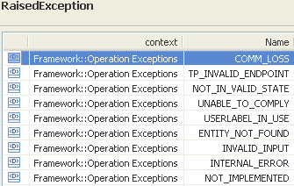 | restriction base="msg:AllExceptionsType"  element ref="msg:communicationFailure"  element ref="msg:entityNotFound"  element ref="msg:internalError"  element ref="msg:invalidInput"  element ref="msg:notImplemented"  element ref="msg:notInValidState"  element ref="msg:unableToComply"  element ref="msg:userlabelInUse"  element ref="msg:tpInvalidEndpoint"

createFlowDomain

BA (createFlowDomain) | IA | IIS | Comments
R_TMF518_RP_II_0046  The Interface shall allow the requesting OS to create a Flow Domain (FD) within the target OS; given the requesting OS specified data listed in R_TMF518_RP_II_0047  The association of the call-end-points to the FD shall be done on a best effort basis. | This operation creates a Flow Domain (FD) within the target OS. The operation allows also to associate Matrix Flow Domains and Connectionless Port Termination Points (CPTPs) to the new FD.  Traceability: R_TMF518_RP_II_0046, R_TMF518_RP_II_0047, UC_TMF518_RP_0015. | This operation creates a Flow Domain (FD) within the target OS. The operation allows also to associate Matrix Flow Domains and Connectionless Port Termination Points (CPTPs) to the new FD.
R_TMF518_RP_II_0047  The Interface shall allow the requesting OS to specify the following parameters when it requests the creation of a Flow Domain (FD):  +++++++++++++++++  see FlowDomainCreateData Type in section 3.1 | createData (FlowDomainCreateData)  This parameter provides the attributes describing the Flow Domain to be established.  Traceability: R_TMF518_RP_II_0047.  +++++++++++++++++  see FlowDomainCreateData Type in section 3.1 | (in) element name="createData" type="tns:FlowDomainCreateDataType"  Structure describing the flow domain structure to be created.  +++++++++++++++++  see FlowDomainCreateData Type in section 3.1
?? | tpDataListToModify (in/out) (*) (TerminationPointData)  This parameter, when used in the request,  (in) identifies a list of TPs with associated parameters to be applied;  (out) identifies the list of TPs with associated applied parameters.  +++++++++++++++++  see TerminationPointData Type in section 12.1 of Comparison-RP-ConnectionControlService.doc | (in) element name="tpDataListToModify" type="tpdata:TerminationPointDataListType"  The list of TPs with associated parameters to be applied.  +++++++++++++++++  see TerminationPointData Type in section 12.1 of Comparison-RP-ConnectionControlService.doc
(out) element name="tpDataListToModify" type="tpdata:TerminationPointDataListType"
The list of TPs with associated parameters.
+++++++++++++++++
see TerminationPointData Type in section 12.1 of Comparison-RP-ConnectionControlService.doc

?? | (inout) assignedCptpRefList (*) (Objectname)  This parameter,  (in) provides the list of assigned CPTPs to be associated as Flow Domain edge CPTPs to the Flow Domain. This may be an empty list. Associating CPTPs to the Flow Domain is done on a best effort basis.  (out) returns the list of Connectionless Port Termination Points (requested in the createData parameter) that could not be added or could not be associated with the Flow Domain. | (in) element name="assignedCptpRefList" type="nam:NamingAttributeListType"  Identifies the list of assigned CPTPs to be associated as flow domain edge CPTPs to the flow domain. This may be an empty list. Associating CPTPs to the flow domain is done on a best effort basis.
(out) element name="assignedfailedCptpRefList" type="nam:NamingAttributeListType"
The list contains the names of the CPTPs that could not be associated with the flow domain.

 | createdFd  This parameter returns the newly created Flow Domain object. | (out) element name="createdFd" type="fd:FlowDomainType"  This parameter returns the newly created Flow Domain object.
 | errorReason (out)  This parameter returns the error(s) if any. | (out) element name="errorReason" type="xsd:string"  This parameter returns the error(s) if any.
UC_TMF518_RP_0015  Pre-Conditions:  The requesting OS and target OS have successfully executed the Use Case 0001 OS (Re) Starts as defined in the TMF518_FMW BA document. | None
UC_TMF518_RP_0015  Post-Conditions:  In case of success:  1) The FD has been created.  2) The MFDs have been associated to the new FD.  3) The call-end-points have been associated to the FD (i.e., the Port TP role state attribute of the call-end-points has been set to "fdEdge") or have been returned in the reply.  In case of failure:  Nothing has changed in the System, i.e., the FD has not been created and the appropriate exception is reported to the requesting OS. | 1. The FD object has been created.  2. The requested MFDs have been associated to the FD.  3. The requested CPTPs have been associated to the FD.  4. The provided parameters have been set for the FD.  5. The provided layered parameters have been set for the TPs.
UC_TMF518_RP_0015  Exceptions:  Refer to Category III: Abnormal or Exception Conditions, Dynamic Requirements | 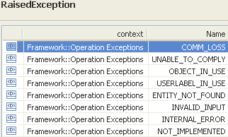 | restriction base="msg:AllExceptionsType"  element ref="msg:communicationFailure"  element ref="msg:entityNotFound"  element ref="msg:internalError"  element ref="msg:invalidInput"  element ref="msg:notImplemented"  element ref="msg:objectInUse"  element ref="msg:unableToComply"  element ref="msg:userlabelInUse"

createMatrixFlowDomain

BA (createMatrixFlowDomain) | IA | IIS | Comments
R_TMF518_RP_II_0037  The Interface shall allow the requesting OS to create a Matrix Flow Domain (MFD) within an Managed Element (ME); given the requesting OS specified data listed in R_TMF518_RP_II_0038 | This operation creates a Matrix Flow Domain (MFD) within a Managed Element. The operation allows also assigning Connectionless Port Termination Points (CPTPs) to the new MFD.  Traceability: R_TMF518_RP_II_0037, R_TMF518_RP_II_0038, UC_TMF518_RP_0022. | This operation creates a Matrix Flow Domain (MFD) within a Managed Element. The operation allows also assigning Connectionless Port Termination Points (CPTPs) to the new MFD.
containingMeRef (ObjectName)
This parameter provides the name of the Managed Element in which the Matrix Flow Domain has to be created.

R_TMF518_RP_II_0038  The Interface shall allow the requesting OS to specify the following parameters when it requests the creation of a Matrix Flow Domain (MFD):  +++++++++++++++++  see MatrixFlowDomainCreateData Type in section 3.6 | createData (MatrixFlowDomainCreateData)  This parameter provides the attributes describing the Matrix Flow Domain to be established.  Traceability: R_TMF518_RP_II_0038.  +++++++++++++++++  see MatrixFlowDomainCreateData Type in section 3.6 | (in) element name="createData" type="tns:MatrixFlowDomainCreateDataType"  Structure describing the matrix flow domain structure to be created.  +++++++++++++++++  see MatrixFlowDomainCreateData Type in section 3.6
?? | tpDataListToModify (in/out) (*) (TerminationPointData)  This parameter, when used in the request,  (in) identifies a list of TPs with associated parameters to be applied;  (out) identifies the list of TPs with associated applied parameters.  +++++++++++++++++  see TerminationPointData Type in section 12.1 of Comparison-RP-ConnectionControlService.doc | (in) element name="tpDataListToModify" type="tpdata:TerminationPointDataListType"  The list of TPs with associated parameters to be applied.  +++++++++++++++++  see TerminationPointData Type in section 12.1 of Comparison-RP-ConnectionControlService.doc
(out) element name="tpDataListToModify" type="tpdata:TerminationPointDataListType"
The list of TPs with associated parameters.
+++++++++++++++++
see TerminationPointData Type in section 12.1 of Comparison-RP-ConnectionControlService.doc

 | createdMfd  This parameter returns the newly created Matrix Flow Domain object. | (out) element name="createdMfd" type="mfd:MatrixFlowDomainType"  This parameter returns the newly created Matrix Flow Domain object.
 | errorReason (out)  This parameter returns the error(s) if any. | (out) element name="errorReason" type="xsd:string"  Specifies the creation error(s) if any.
UC_TMF518_RP_0022  Pre-Conditions:  The requesting OS and target OS have successfully executed the Use Case 0001 OS (Re) Starts as defined in the TMF518_FMW BA document. | None
UC_TMF518_RP_0022  Post-Conditions:  In case of success:  1) The MFD has been created.  2) The requested TPs have been associated with the MFD.  3) The provided parameters have been set for the MFD.  4) The requested FD Edge call-end-points have been associated with the FD.  In case of failure:  Nothing has changed in the System, i.e., the MFD has not been created. | 1. The MFD object has been created.  2. The requested CPTPs have been assigned to the MFD.  3. The provided parameters have been set for the MFD.  4. The provided layered parameters have been set for the TPs.
UC_TMF518_RP_0022  Exceptions:  Refer to Category III: Abnormal or Exception Conditions, Dynamic Requirements | 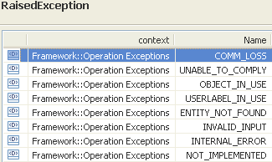 | restriction base="msg:AllExceptionsType"  element ref="msg:communicationFailure"  element ref="msg:entityNotFound"  element ref="msg:internalError"  element ref="msg:invalidInput"  element ref="msg:notImplemented"  element ref="msg:objectInUse"  element ref="msg:unableToComply"  element ref="msg:userlabelInUse"

deactivateAndDeleteFlowDomainFragment

BA (deactivateAndDeleteFlowDomainFragment) | IA | IIS | Comments
R_TMF518_RP_II_0064  The interface shall allow the requesting OS to delete a Flow Domain Fragment (FDFr)given the requesting OS specified FDFr name. | This operation deletes a Flow Domain Fragment (FDFr) from the Flow Domain.  The target OS deletes all associated Flow Points and Matrix Flow Domain Fragments comprising the FDFr.  Traceability: R_TMF518_RP_II_0064, UC_TMF518_RP_0032. | This operation deletes a Flow Domain Fragment (FDFr) from the Flow Domain. The target OS deletes all associated Flow Points and Matrix Flow Domain Fragments comprising the FDFr .
 | fdfrRef (ObjectName)  This parameter provides the name of the Flow Domain Fragment to be deleted. | (in) element name="fdfrRefName" type="nam:NamingAttributeType"  The name of the flow domain fragment to be deactivated and deleted.
?? | tpDataListToModify (in/out) (*) (TerminationPointData)  This parameter, when used in the request,  (in) identifies a list of TPs (limited to TPs that take part in the FDFr deletion process) with associated parameters to be applied;  (out) identifies the list of TPs with associated applied parameters.  +++++++++++++++++  see TerminationPointData Type in section 12.1 of Comparison-RP-ConnectionControlService.doc | (in) element name="tpDataListToModify" type="tpdata:TerminationPointDataListType"  A list of TPs and parameters to apply. The list may refer only to TPs that take part in the flow domain fragment deletion process.
(out) element name="tpDataListToModify" type="tpdata:TerminationPointDataListType"
A list of TPs and parameters. On method return the list is updated to provide the resulting parameters. The list may refer only to TPs that take part in the flow domain fragment deletion process.

 | deletedFdfr  This parameter returns complete information (that it had before it was deleted) of the Flow Domain Fragement object. | (out) element name="deletedFdfr" type="fdfr:FlowDomainFragmentType"  The deleted flow domain fragment.
 | errorReason (out)  This parameter returns the error(s) if any. | (out) element name="errorReason" type="xsd:string"  Specifies the fault reason if any.
UC_TMF518_RP_0032  Pre-Conditions:  The requesting OS and target OS have successfully executed the Use Case 0001 OS (Re) Starts as defined in the TMF518_FMW BA document. | None
UC_TMF518_RP_0032  Post-Conditions:  In case of success:  1) For all MFDFrs which are removed, the assocated FPs have been deleted.  2) If all MFDFrs were removed, the FDFr has been deleted.  3) If the FDFr was not deleted, it is marked as “Failed”.  In case of failure:  Nothing has changed in the System, i.e., the FDFr has not been created. | 1. The FDFr related MFDFr and FP objects have been deleted.  2. The FDFr object has been deleted.
UC_TMF518_RP_0032  Exceptions:  Refer to Category III: Abnormal or Exception Conditions, Dynamic Requirements | 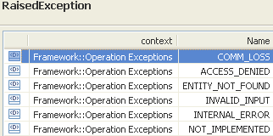  ACCESS_DENIED - Raised when the Flow Domain Fragment is fixed. | restriction base="msg:AllExceptionsType"  element ref="msg:communicationFailure"  element ref="msg:entityNotFound"  element ref="msg:internalError"  element ref="msg:invalidInput"  element ref="msg:notImplemented"  element ref="msg:objectInUse"  element ref="msg:unableToComply" | bz:  Access denied, object in use and unable to comply are not requested by the Use Case.

deAssociateConnectionlessPortTerminationPointsFromFd

BA (deAssociateConnectionlessPortTerminationPointsFromFd) | IA | IIS | Comments
R_TMF518_RP_II_0052  The Interface shall allow the requesting OS to dissociate Flow Domain Edge call-end-point (FD Edge call-end-point)s from a Flow Domain (FD).  The requesting OS shall provide a list of FD Edge call-end-points to be dissociated from the FD.  The request shall be denied if a Flow Domain Fragment (FDFr) uses this FD Edge call-end-point.  The successful dissociation of the call-end-points shall update the Port TP role state of the call-end-points (i.e., newly dissociated call-end-points lose their “FD Edge” property, i.e., become “assigned”). | This operation dissociates de-associates Flow Domain Edge Connectionless Port Terminations Points (FD Edge CPTPs) from a Flow Domain (FD).  Traceability: R_TMF518_RP_II_0052, UC_TMF518_RP_0021. | deAssociateConnectionlessPortTerminationPointsFromFdRequest  This operation dissociates Flow Domain Edge Connectionless Port Terminations Points (FD Edge CPTPs) from a Flow Domain (FD).
 | fdRef (ObjectName)  This parameter provides the name of the Flow Domain from which the Connectionless Port Terminations Points shall be dissociated de-associated. | (in) element name="fdRefName" type="nam:NamingAttributeType"  The name of the flow domain to be modified.
 | cptpRefList (*) (ObjectName)  This parameter provides the names of the Connectionless Port Terminations Points (CPTPs) to be dissociated de-associated from the Flow Domain. | (in) element name="cptpRefList" type="nam:NamingAttributeListType"  This parameter provides the names of the Connectionless Port Terminations Points (CPTPs) to be dissociated from the Flow Domain.
?? | tpDataListToModify (in/out) (*) (TerminationPointData)  This parameter, when used in the request,  (in) identifies a list of TPs with associated parameters to be applied;  (out) identifies the list of TPs with associated applied parameters.  +++++++++++++++++  see TerminationPointData Type in section 12.1 of Comparison-RP-ConnectionControlService.doc | (in) element name="tpDataListToModify" type="tpdata:TerminationPointDataListType"  The list of TPs with associated parameters to be applied.  +++++++++++++++++  see TerminationPointData Type in section 12.1 of Comparison-RP-ConnectionControlService.doc
(out) element name="tpDataListToModify" type="tpdata:TerminationPointDataListType"
The list of TPs with associated parameters.
+++++++++++++++++
see TerminationPointData Type in section 12.1 of Comparison-RP-ConnectionControlService.doc

 | errorReason (out)  This parameter returns the error(s) if any. | (out) element name="errorReason" type="xsd:string"  Specifies the fault reason if any.
UC_TMF518_RP_0021  Pre-Conditions:  The requesting OS and target OS have successfully executed the Use Case 0001 OS (Re) Starts as defined in the TMF518_FMW BA document. | None
UC_TMF518_RP_0021  Post-Conditions:  In case of success:  The requested FD Edge call-end-points have been disassociated from the FD.  In case of failure:  Nothing has changed in the System, i.e., no change in the FD Edge call-end-point association to the FD. | The requested CPTPs have been dissociated de-associated from the FD.
UC_TMF518_RP_0021  Exceptions:  Refer to Category III: Abnormal or Exception Conditions, Dynamic Requirements | 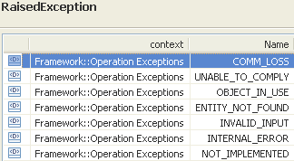 | restriction base="msg:AllExceptionsType"  element ref="msg:communicationFailure"  element ref="msg:entityNotFound"  element ref="msg:internalError"  element ref="msg:invalidInput"  element ref="msg:notImplemented"  element ref="msg:unableToComply"  element ref="msg:userlabelInUse" | bz:  notInValidState not required in Use Case.

deAssociateMatrixFlowDomainsFromFd

BA (deAssociateMatrixFlowDomainsFromFd) | IA | IIS | Comments
R_TMF518_RP_II_0054  The Interface shall allow the requesting OS to dissociate Matrix Flow Domain (MFD)s from a Flow Domain (FD)..  The requesting OS shall provide a list of associated MFDs to be dissociated from the FD.  The request shall be denied if a Flow Domain Fragment (FDFr) uses Flow Point (FP)s that are served by an Flow Domain Edge call-end-point (FD Edge call-end-point) which is assigned to this (edge) MFD. A target OS working in the “connectivity-aware” mode shall also deny the request if the MFD to be dissociated is not at the edge of an FD but is used by an FDFr.  The request dissociates all FD Edge call-end-points which are associated to the MFD to be dissociated from the FD and sets the Port TP role state indication of the call-end-points to “assigned | This operation dissociates de-associates Matrix Flow Domains (MFDs) from a Flow Domain (FD).  Traceability: R_TMF518_RP_II_0054, UC_TMF518_RP_0019. | This operation dissociates Matrix Flow Domains (MFDs) from a Flow Domain (FD).
 | fdRef (ObjectName)  This parameter provides the name of the Flow Domain from which the Matrix Flow Domains shall be dissociated de-associated. | (in) element name="fdRefName" type="nam:NamingAttributeType"  The name of the flow domain to be modified.
 | mfdRefList (*) (ObjectName)  This parameter provides the names of the Matrix Flow Domains to be dissociated de-associated from the Flow Domain. | (in) element name="mfdRefList" type="nam:NamingAttributeListType"  This parameter provides the names of the Matrix Flow Domains to be dissociated from the Flow Domain.
?? | tpDataListToModify (in/out) (*) (TerminationPointData)  This parameter, when used in the request,  (in) identifies a list of TPs with associated parameters to be applied;  (out) identifies the list of TPs with associated applied parameters.  +++++++++++++++++  see TerminationPointData Type in section 12.1 of Comparison-RP-ConnectionControlService.doc | (in) element name="tpDataListToModify" type="tpdata:TerminationPointDataListType"  The list of TPs with associated parameters to be applied.  +++++++++++++++++  see TerminationPointData Type in section 12.1 of Comparison-RP-ConnectionControlService.doc
(out) element name="tpDataListToModify" type="tpdata:TerminationPointDataListType"
The list of TPs with associated parameters.
+++++++++++++++++
see TerminationPointData Type in section 12.1 of Comparison-RP-ConnectionControlService.doc

 | errorReason (out)  This parameter returns the error(s) if any. | (out) element name="errorReason" type="xsd:string"  Specifies the fault reason if any.
UC_TMF518_RP_0019  Pre-Conditions:  The requesting OS and target OS have successfully executed the Use Case 0001 OS (Re) Starts as defined in the TMF518_FMW BA document. | None
UC_TMF518_RP_0019  Post-Conditions:  In case of success:  1) The requested MFD(s) have been dissociated from the FD.  2) The corresponding FD Edge call-end-points have been dissociated from the FD.  In case of failure:  Nothing has changed in the System, i.e., no change in the MFD association to the FD. | 1. The requested MFDs have been dissociated de-associated from the FD.  2. The corresponding FD Edge CPTPs have been dissociated de-associated from the FD.
UC_TMF518_RP_0019  Exceptions:  Refer to Category III: Abnormal or Exception Conditions, Dynamic Requirements | 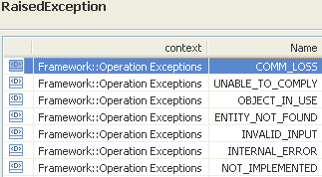 | restriction base="msg:AllExceptionsType"  element ref="msg:communicationFailure"  element ref="msg:entityNotFound"  element ref="msg:internalError"  element ref="msg:invalidInput"  element ref="msg:notImplemented"  element ref="msg:objectInUse"  element ref="msg:unableToComply"

deleteFlowDomain

BA (deleteFlowDomain) | IA | IIS | Comments
R_TMF518_RP_II_0050  The Interface shall allow the requesting OS to request the deletion of a Flow Domain (FD) from the target OS given the requesting OS specified FD name.  The request shall de-associate all Matrix Flow Domain (MFD)s and Flow Domain Edge call-end-point (FD Edgecall-end-point)s from the FD and then delete the FD. The Port TP role state indication of the call-end-points which corresponds to the de-associated FD Edge call-end-points shall be set to “assigned”.  The request shall be denied if Flow Domain Fragment (FDFr)s are provisioned on any of the FD Edge call-end-points associated to the FD | This operation deletes a Flow Domain (FD) from the target OS.  The operation de-associates all Matrix Flow Domains and FD Edge Connectionless Port Termination Points (CPTPs) from the FD and then deletes the FD.  Traceability: R_TMF518_RP_II_0050, UC_TMF518_RP_0016. | This operation deletes a Flow Domain (FD) from the target OS.  The operation de-associates all Matrix Flow Domains and FD Edge Connectionless Port Termination Points (CPTPs) from the FD and then deletes the FD.
 | fdRef (ObjectName)  This parameter provides the name of the Flow Domain to be deleted. | (in) element name="fdRefName" type="nam:NamingAttributeListType"  The name of the flow domain to be deleted.
?? | tpDataListToModify (in/out) (*) (TerminationPointData)  This parameter, when used in the request,  (in) identifies a list of TPs with associated parameters to be applied;  (out) identifies the list of TPs with associated applied parameters.  +++++++++++++++++  see TerminationPointData Type in section 12.1 of Comparison-RP-ConnectionControlService.doc | (in) element name="tpDataListToModify" type="tpdata:TerminationPointDataListType"  The list of TPs with associated parameters to be applied.  +++++++++++++++++  see TerminationPointData Type in section 12.1 of Comparison-RP-ConnectionControlService.doc
(out) element name="tpDataListToModify" type="tpdata:TerminationPointDataListType"
The list of TPs with associated parameters.
+++++++++++++++++
see TerminationPointData Type in section 12.1 of Comparison-RP-ConnectionControlService.doc

 | errorReason (out)  This parameter returns the error(s) if any. | (out) element name="errorReason" type="xsd:string"  Specifies the fault reason if any.
UC_TMF518_RP_0016  Pre-Conditions:  The requesting OS and target OS have successfully executed the Use Case 0001 OS (Re) Starts as defined in the TMF518_FMW BA document. | None
UC_TMF518_RP_0016  Post-Conditions:  In case of success:  1) The FD Edge call-end-points associated to the FD have been de-associated (i.e., the Port TP role state attribute of the call-end-points has been set to "assigned").  2) The MFDs associated to the FD have been de-associated.  3) The FD has been deleted.  In case of failure:  Nothing has changed in the System, i.e., the FD has not been deleted and the appropriate exception is reported to the requesting OS. | 1. The associated CPTPs have been de-associated from the MFD.  2. The associated MFDs have been de-associated from the MFD.  3. The FD object has been deleted.
UC_TMF518_RP_0016  Exceptions:  Refer to Category III: Abnormal or Exception Conditions, Dynamic Requirements | 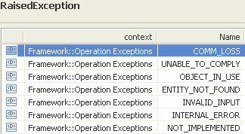 | restriction base="msg:AllExceptionsType"  element ref="msg:communicationFailure"  element ref="msg:entityNotFound"  element ref="msg:internalError"  element ref="msg:invalidInput"  element ref="msg:notImplemented"  element ref="msg:objectInUse"  element ref="msg:unableToComply"

deleteMatrixFlowDomain

BA (deleteMatrixFlowDomain) | IA | IIS | Comments
R_TMF518_RP_II_0041  The Interface shall allow the requesting OS to delete a Matrix Flow Domain (MFD) from a Managed Element (ME) given the requesting OS specified MFD name.  The request shall be denied if the MFD to be deleted is still associated to a Matrix Flow Domain (MFD)  The request shall be denied if the MFD to be deleted is fixed.  The call-end-points shall be automatically de-assigned from the MFD (i.e., change the TP role to unassigned) before the MFD is deleted. | This operation deletes a Matrix Flow Domain (MFD) within a Managed Element. The operation will be denied when the MFD to be deleted is still associated to a Flow Domain or when it is fixed.  Traceability: R_TMF518_RP_II_0041, UC_TMF518_RP_0023. | This operation deletes a Matrix Flow Domain (MFD) within a Managed Element. The operation will be denied when the MFD to be deleted is still associated to a Flow Domain or when it is fixed.
 | mfdRef (ObjectName)  This parameter provides the name of the Matrix Flow Domain to be deleted. | (in) element name="mfdRefName" type="nam:NamingAttributeListType"  The name of the matrix flow domain to be deleted.
?? | tpDataListToModify (in/out) (*) (TerminationPointData)  This parameter, when used in the request,  (in) identifies a list of TPs with associated parameters to be applied;  (out) identifies the list of TPs with associated applied parameters.  +++++++++++++++++  see TerminationPointData Type in section 12.1 of Comparison-RP-ConnectionControlService.doc | (in) element name="tpDataListToModify" type="tpdata:TerminationPointDataListType"  The list of TPs with associated parameters to be applied.  +++++++++++++++++  see TerminationPointData Type in section 12.1 of Comparison-RP-ConnectionControlService.doc
(out) element name="tpDataListToModify" type="tpdata:TerminationPointDataListType"
The list of TPs with associated parameters.
+++++++++++++++++
see TerminationPointData Type in section 12.1 of Comparison-RP-ConnectionControlService.doc

 | errorReason (out)  This parameter returns the error(s) if any. | (out) element name="errorReason" type="xsd:string"  This parameter returns the error(s) if any.
UC_TMF518_RP_0023  Pre-Conditions:  The requesting OS and target OS have successfully executed the Use Case 0001 OS (Re) Starts as defined in the TMF518_FMW BA document. | None
UC_TMF518_RP_0023  Post-Conditions:  In case of success:  The assigned TPs have become unassigned and the MFD has been deleted.  In case of failure:  Nothing has changed in the System, i.e., the MFD has not been deleted and no TPs have been modified. | 1. The assigned CPTPs have been un-assigned from the MFD.  2. The MFD object has been deleted.
UC_TMF518_RP_0023  Exceptions:  Refer to Category III: Abnormal or Exception Conditions, Dynamic Requirements | 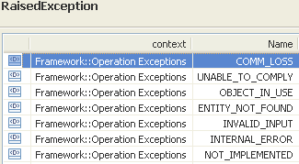 | restriction base="msg:AllExceptionsType"  element ref="msg:communicationFailure"  element ref="msg:entityNotFound"  element ref="msg:internalError"  element ref="msg:invalidInput"  element ref="msg:notImplemented"  element ref="msg:objectInUse"  element ref="msg:unableToComply"

modifyFlowDomain

BA (modifyFlowDomain) | IA | IIS | Comments
R_TMF518_RP_II_0048  The Interface shall allow the requesting OS to modify a Flow Domain (FD); given the requesting OS specified data listed in R_TMF518_RP_II_0049. | This operation modifies a Flow Domain (FD). The modification of the Flow Domain is done on a best effort basis. All attributes that could not be modified shall be returned in the reply.  Traceability: R_TMF518_RP_II_0048, R_TMF518_RP_II_0049, UC_TMF518_RP_0017. | This operation modifies a Flow Domain (FD). The modification of the Flow Domain is done on a best effort basis. All attributes that could not be modified shall be returned in the reply.
?? | fdRef (ObjectName)  This parameter provides the name of the Flow Domain to be modified. | (in) element name="fdRefName" type="nam:NamingAttributeType"  The name of the flow domain to modify.
R_TMF518_RP_II_0049  The Interface shall allow the requesting OS to specify the following parameters when it requests that a target OS modify an Flow Domain (FD):  +++++++++++++++++  see FlowDomainModifyData Type in section 3.2 | modifyData (FlowDomainModifyData)  This parameter provides the parameters that shall be modified in the Flow Domain.  Traceability: R_TMF518_RP_II_0049.  +++++++++++++++++  see FlowDomainModifyData Type in section 3.2 | (in) element name="modifyData" type="tns:FlowDomainModifyDataType"  This parameter provides the parameters that shall be modified in the Flow Domain  +++++++++++++++++  see FlowDomainModifyData Type in section 3.2
 | modifiedFDFr  This parameter returns the modified Flow Domain object. | (out) element name="modifiedFd" type="fd:FlowDomainType"  The modified flow domain.
 | failedAttributes (String)  This parameter returns the list of attributes that could not be modified. | (out) element name="failedAttributes" type="xsd:string"  The list of attributes that could not be modified.
 | errorReason (out)  This parameter returns the error(s) if any. | (out) element name="errorReason" type="xsd:string"  Specifies the fault reason if any.
UC_TMF518_RP_0017  Pre-Conditions:  The requesting OS and target OS have successfully executed the Use Case 0001 OS (Re) Starts as defined in the TMF518_FMW BA document. | None
UC_TMF518_RP_0017  Post-Conditions:  In case of success:  The FD has been modified as requested.  In case of failure:  Nothing has changed in the System, i.e., the FD has not been modified. | The Flow Domain has been modified as requested.
UC_TMF518_RP_0017  Exceptions:  Refer to Category III: Abnormal or Exception Conditions, Dynamic Requirements | 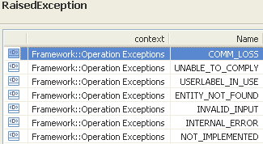 | restriction base="msg:AllExceptionsType"  element ref="msg:communicationFailure"  element ref="msg:entityNotFound"  element ref="msg:internalError"  element ref="msg:invalidInput"  element ref="msg:notImplemented"  element ref="msg:unableToComply"  element ref="msg:userlabelInUse" | bz:  objectInUse not defined in Use Case.

modifyFlowDomainFragment

BA (modifyFlowDomainFragment) | IA | IIS | Comments
R_TMF518_RP_II_0062  The interface shall allow the requesting OS to modify a Flow Domain Fragment (FDFr); given the requesting OS specified data listed in R_TMF518_RP_II_0063.  R_TMF518_RP_II_0065  The Interface shall allow the requesting OS to add Flow Point (FP)s, identified by their server Flow Domain Edge call-end-point (FD Edge call-end-point)s, or by their FD Internal call-end-points, to a Flow Domain Fragment (FDFr).  The requesting OS provides a list of FD Edge call-end-points to be added to the FDFr as additional end points. As a result of adding the call-end-points, FPs are created as clients of the call-end-points.  The requesting OS provides a list of FD Internal call-end-points to be added to the FDFr as additional internal points.  It shall be possible for the requesting OS to configure each Flow Point to be added (created) with the following Parameters:  • transmission parameters (incl. Traffic Mapping Table, Alarm Severity Assignment Profile names and TCA Parameter Profile names)  • ingress/egress transmission descriptor names  If the target OS works in the “connectivity-aware” mode, the requesting OS can request one of two results when not all FPs have potential connectivity to all FPs already in the FDFr:  • reject the request  add all Flow Points regardless of potential connectivity  R_TMF518_RP_II_0066  The Interface shall allow the requesting OS to remove Flow Point (FP)s from a Flow Domain Fragment (FDFr).  The requesting OS provides a list of existing call-end-points to be removed from the FDFr. The Flow Points who are clients of the removed call-end-points and are associated with the FDFr are deleted.  The removal of call-end-points shall be rejected if less than two end Flow Points would remain after successful completion of the request. | This operation modifies a Flow Domain Fragment (FDFr).  The operation is able to modify  - the attributes and parameters of the FDFr  - the parameters of other involved Connectionless Port Termination Points (CPTPs) and Flow Points (FPs)  - the FDFr by addition/removal of FPs.  FPs are added by designating the FD Edge CPTPs and FD Internal CPTPs to be added in two separate lists (one for edge and one for internal). FPs are removed by designating their server CPTPs (edge and internal) in a third list. The removal of CPTPs shall be rejected if less than two end Flow Points would remain after successful completion of the operation.  Traceability: R_TMF518_RP_II_0062, R_TMF518_RP_II_0063, R_TMF518_RP_II_0065, R_TMF518_RP_II_0066, UC_TMF518_RP_0033. | This operation modifies a Flow Domain Fragment (FDFr).  The operation is able to modify  - the attributes and parameters of the FDFr  - the parameters of other involved Connectionless Port Termination Points (CPTPs) and Flow Points (FPs)  - the FDFr by addition/removal of FPs.  FPs are added by designating the FD Edge CPTPs and FD Internal CPTPs to be added in two separate lists (one for edge and one for internal). FPs are removed by designating their server CPTPs (edge and internal) in a third list. The removal of CPTPs shall be rejected if less than two end Flow Points would remain after successful completion of the operation.
?? | fdfrRef (ObjectName)  This parameter provides the name of the Flow Domain Fragment to be modified. | (in) element name="fdfrRefName" type="nam:NamingAttributeType"  The name of the flow domain fragment to modify.
R_TMF518_RP_II_0063  The Interface shall allow the requesting OS to specify the following parameters when it requests that a target OS modify a Flow Domain Fragment (FDFr): …  +++++++++++++++++  see FlowDomainFragmentModifyData Type in section 3.4 | modifyData (FlowDomainFragmentModifyData)  This parameter provides the parameters that shall be modified in the Flow Domain Fragment.  Traceability: R_TMF518_RP_II_0063.  +++++++++++++++++  see FlowDomainFragmentModifyData Type in section 3.4 | (in) element name="fdfrMmodifyData" type="tns:FlowDomainFragmentModifyDataType"  Structure describing how the flow domain fragment should be modified. Modification of connectionless parameters is best effort (except where specified otherwise for a particular parameter).  +++++++++++++++++  see FlowDomainFragmentModifyData Type in section 3.4
 |  | (in) element name="connectivityRequirement" type="fd:ConnectivityRequirementType"  For a "connectivity-aware" Target OS, this parameter shall identify the requested operation mode in case not all FPs have potential connectivity to one another. This parameter is only significant if the fdfrModifyData parameter contains flow points to be added or removed, otherwise it shall be ignored by theTarget OS. If the Target OSis not connectivity-aware, this parameter is also ignored. | bz:  Part of FlowDomainFragmentSetData.
10) Termination Point(s) to modify  This parameter shall identify a list of Flow Points (FPs) that are to be modified as part of the modification request. Only FPs related to the FDFr can be modified. Each item in the list shall contain the following:  • termination point name  • transmission parameters (incl. Traffic Mapping Table, Alarm Severity Assignment Profile names and TCA Parameter Profile names)  • ingress/egress transmission descriptor names | tpDataListToModify (in/out) (*) (TerminationPointData)  This parameter, when used in the request,  (in) identifies a list of TPs (limited to FPs or the containing CPTPs) with associated parameters to be applied;  (out) identifies the list of TPs with associated applied parameters.  +++++++++++++++++  see TerminationPointData Type in section 12.1 of Comparison-RP-ConnectionControlService.doc | (in) element name="tpDataListToModify" type="tpdata:TerminationPointDataListType"  A list of TPs and parameters to apply.. The list may refer to flow points or to the containing CPTPs.
(out) element name="tpDataListToModify" type="tpdata:TerminationPointDataListType"
A list of TPs and parameters. On method return the list is updated to provide the resulting parameters. The list may refer to flow points that are being created during the createAndActivateFlowDomainFragment request or to the containing CPTPs.

 | failedCptTpRefList (*) (ObjectName)  This parameter returns the list of Connectionless Port Termination Points or Flow Points (requested in the modifyData parameter) that could not be added or could not be removed, whichever was requested. | (out) element name="failedTpRefList" type="nam:NamingAttributeListType"  The list of Connectionless Port Termination Points or Flow Points (requested in the fdfrModifyData parameter) that could not be added or could not be removed, whichever was requested.
 | parameterProblemsTpRefList (*) (ObjectName)  This parameter returns the list of Connectionless Port Termination Points and Flow Points FPs for which only best-effort transmission parameters could not be set. | (out) element name="parameterProblemsTpRefList" type="nam:NamingAttributeListType"  The list of Connectionless Port Termination Points and Flow Points FPs for which only best-effort transmission parameters could not be set.
 | modifiedFdfr  This parameter returns the modified Flow Domain Fragment object. | (out) element name="modifiedFdfr " type="fdfr:FlowDomainFragmentType"  The modified flow domain fragment.
 | errorReason (out)  This parameter returns the error(s) if any. | (out) element name="errorReason" type="xsd:string"  This parameter returns the error(s) if any.
UC_TMF518_RP_0033  Pre-Conditions:  The requesting OS and target OS have successfully executed the Use Case 0001 OS (Re) Starts as defined in the TMF518_FMW BA document. | None
UC_TMF518_RP_0033  Post-Conditions:  In case of success:  1) The Flow Domain Fragment has been modified as requested.  2) The transmission parameters have been set/modified, as requested, to all call-end-points and FPs which are not contained in the “parameter problems TP list” or “failed TP list”.  3) The TPs which could not be added to the FDFr are returned in the “failed TP list”.  4) The target OS has forwarded a Flow Domain Fragment object modification notification and notifications for all objects which were added, removed, or modified.  In case of failure:  Nothing has changed in the System, i.e., the FDFr has not been created. | 1. The Flow Domain Fragment has been modified as requested.  2. The transmission parameters have been set/modified, as requested, to all CPTPs and FPs which are not contained in the failedCptTpRefList or parameterProblemsTpRefList.  3. The TPs which could not be added to the FDFr are returned in the failedCptTpRefList.
UC_TMF518_RP_0033  Exceptions:  Refer to Category III: Abnormal or Exception Conditions, Dynamic Requirements | 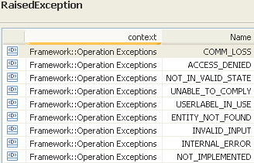  ACCESS_DENIED - Raised when the Flow Domain Fragment is fixed. | restriction base="msg:AllExceptionsType"  element ref="msg:communicationFailure"  element ref="msg:entityNotFound"  element ref="msg:internalError"  element ref="msg:invalidInput"  element ref="msg:notImplemented"  element ref="msg:notInValidState"  element ref="msg:unableToComply"  element ref="msg:userlabelInUse" | bz:  AccessDenied not in Use Case.

modifyMatrixFlowDomain

BA (modifyMatrixFlowDomain) | IA | IIS | Comments
R_TMF518_RP_II_0039  The Interface shall allow the requesting OS to modify a Matrix Flow Domain (MFD); given the requesting OS specified data listed in R_TMF518_RP_II_0040  The modification of the MFD shall be done on a best effort basis. All attributes that could not be modified shall be returned in the reply.  1) User label  Refer to R_TMF518_FMW_I_0001 in the TMF518_FMW BA .  2) User label uniqueness  This parameter shall indicate to the target OS that the value of the user label attribute must be unique amongst the MFDs within the target OS.  3) Owner  Refer to R_TMF518_FMW_I_0001 in the TMF518_FMW BA .  4) Network Access Domain  This attribute represents the new Network Access Domain (NAD) to which the MFD shall be assigned to.  5) Connectionless Layered Parameters  This parameter shall represent the connectionless technology parameters associated with the different layers (e.g. Ethernet, DVB) that are to be changed in the MFD. Refer to chapter “Connectionless Technology Parameters” of the supporting document SD1-16_LayeredParameters for details of the currently defined connectionless parameters.  6) VendorExtensions  Refer to R_TMF518_FMW_I_0001 in the TMF518_FMW BA. | This operation modifies a Matrix Flow Domain (MFD). The modification of the Matrix Flow Domain is done on a best effort basis. All attributes that could not be modified shall be returned in the reply.  Traceability: R_TMF518_RP_II_0039, R_TMF518_RP_II_0040, UC_TMF518_RP_0024. | This operation modifies a Matrix Flow Domain (MFD). The modification of the Matrix Flow Domain is done on a best effort basis. All attributes that could not be modified shall be returned in the reply.
?? | mfdRef (ObjectName)  This parameter provides the name of the Matrix Flow Domain to be modified. | (in) element name="mfdRefName" type="nam:NamingAttributeType"  The name of the matrix flow domain to modify.
R_TMF518_RP_II_0040  The Interface shall allow the requesting OS to specify the following parameters when it requests that a target OS modify an Matrix Flow Domain (MFD):  +++++++++++++++++  see MatrixFlowDomainModifyData Type in section 3.7 | modifyData (MatrixFlowDomainModifyData)  This parameter provides the parameters that shall be modified in the Matrix Flow Domain.  Traceability: R_TMF518_RP_II_0040.  +++++++++++++++++  see MatrixFlowDomainModifyData Type in section 3.7 | (in) element name="mfdModifyData" type="tns:MatrixFlowDomainModifyDataType"  This parameter provides the parameters that shall be modified in the Matrix Flow Domain.  +++++++++++++++++  see MatrixFlowDomainModifyData Type in section 3.7
 | modifiedMfd  This parameter returns the modified Matrix Flow Domain object. | (out) element name=" modifiedMfd " type="mfd:MatrixFlowDomainType"  The modified matrix flow domain.
 | failedAttributes (String)  This parameter returns the list of attributes that could not be modified. | (out) element name="failedAttributes" type="xsd:string"  The list of attributes that could not be modified.
 | errorReason (out)  This parameter returns the error(s) if any. | (out) element name="errorReason" type="xsd:string"  This parameter returns the error(s) if any.
UC_TMF518_RP_0024  Pre-Conditions:  The requesting OS and target OS have successfully executed the Use Case 0001 OS (Re) Starts as defined in the TMF518_FMW BA document. | None
UC_TMF518_RP_0024  Post-Conditions:  In case of success:  The MFD has been modified as requested.  In case of partial success:  The MFD has been modified but not all requested modifications have been completed.  In case of failure:  Nothing has changed in the System, i.e., the MFD has not been modified. | The Matrix Flow Domain has been modified as requested.
UC_TMF518_RP_0024  Exceptions:  Refer to Category III: Abnormal or Exception Conditions, Dynamic Requirements | 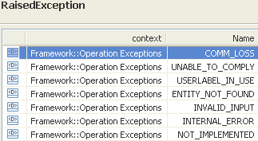 | restriction base="msg:AllExceptionsType"  element ref="msg:communicationFailure"  element ref="msg:entityNotFound"  element ref="msg:internalError"  element ref="msg:invalidInput"  element ref="msg:notImplemented"  element ref="msg:unableToComply"  element ref="msg:unserLabelInUse"

unassignConnectionlessPortTerminationPointsFromMfd

BA (unassignConnectionlessPortTerminationPointsFromMfd) | IA | IIS | Comments
R_TMF518_RP_II_0043  The Interface shall allow the requesting OS to un-assign call-end-points from a Matrix Flow Domain (MFD).  The requesting OS shall provide a list of assigned call-end-points to be un-assigned from the MFD.  The request shall be denied if the MFD is “fixed”.  A request to un-assign an FD Edge call-end-point from a MFD shall be denied if a Flow Domain Fragment uses this call-end-point.  The call-end-points which are also associated as Flow Domain Edge call-end-point (FD Edge call-end-point)s to a Flow Domain (FD) shall automatically be de-associated from the FD; refer to Figure “State diagram for Port TP Role State” of the supporting document SD1-44_ConnectionlessTechnologyManagement. | This operation un-assigns Connectionless Port Terminations Points (CPTPs) from the Matrix Flow Domain (MFD). The provided CPTPs must be potential CPTPs for this MFD (e.g. have to be on the same equipment or same rack with backplane connectivity).  Traceability: R_TMF518_RP_II_0043, UC_TMF518_RP_0026. | This operation un-assigns Connectionless Port Terminations Points (CPTPs) from the Matrix Flow Domain (MFD). The provided CPTPs must be potential CPTPs for this MFD (e.g. have to be on the same equipment or same rack with backplane connectivity)  .
 | mfdRef (ObjectName)  This parameter provides the name of the Matrix Flow Domain from which the CPTPs shall be unassigned. | (in) element name="mfdRefName" type="nam:NamingAttributeType"  The name of the matrix flow domain to be modified.
 | cptpRefList (*) (ObjectName)  This parameter provides the names of the Connectionless Port Terminations Points (CPTPs) to be un-assigned from the Matrix Flow Domain. | (in) element name="tpRefList" type="nam:NamingAttributeListType"  This parameter provides the names of the Connectionless Port Terminations Points (CPTPs) to be un-assigned from the Matrix Flow Domain.
?? | tpDataListToModify (in/out) (*) (TerminationPointData)  This parameter, when used in the request,  (in) identifies a list of TPs with associated parameters to be applied;  (out) identifies the list of TPs with associated applied parameters.  +++++++++++++++++  see TerminationPointData Type in section 12.1 of Comparison-RP-ConnectionControlService.doc | (in) element name="tpDataListToModify" type="tpdata:TerminationPointDataListType"  The list of TPs with associated parameters to be applied.  +++++++++++++++++  see TerminationPointData Type in section 12.1 of Comparison-RP-ConnectionControlService.doc
(out) element name="tpDataListToModify" type="tpdata:TerminationPointDataListType"
The list of TPs with associated parameters.
+++++++++++++++++
see TerminationPointData Type in section 12.1 of Comparison-RP-ConnectionControlService.doc

 | errorReason (out)  This parameter returns the error(s) if any. | (out) element name="errorReason" type="xsd:string"  Specifies the fault reason if any.
UC_TMF518_RP_0026  Pre-Conditions:  The requesting OS and target OS have successfully executed the Use Case 0001 OS (Re) Starts as defined in the TMF518_FMW BA document. | None
UC_TMF518_RP_0026  Post-Conditions:  In case of success:  The requested call-end-points have been assigned to the MFD.  In case of failure:  Nothing has changed in the System, i.e., no change in the call-end-point assignment to the MFD. | The requested CPTPs have been un-assigned from the MFD.
UC_TMF518_RP_0026  Exceptions:  Refer to Category III: Abnormal or Exception Conditions, Dynamic Requirements | 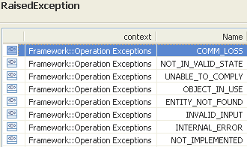 | restriction base="msg:AllExceptionsType"  element ref="msg:capacityExceeded"  element ref="msg:communicationFailure"  element ref="msg:entityNotFound"  element ref="msg:internalError"  element ref="msg:invalidInput"  element ref="msg:notImplemented"  element ref="msg:objectInUse"  element ref="msg:unableToComply"  element ref="msg:userlabelInUse" | bz:  capacityExceeded not in Use Case.

Data Types

FlowDomainCreateData Type

BA | IA | IIS (FlowDomainCreateDataType) | Comments
R_TMF518_RP_II_0047  The Interface shall allow the requesting OS to specify the following parameters when it requests the creation of a Flow Domain (FD): | This data type represents the specific parameters that may be provided when creating a Flow Domain.  Traceability: R_TMF518_RP_II_0047.  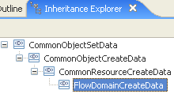  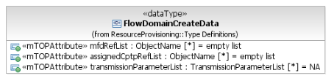 | This data type represents the specific parameters that may be provided when creating a Flow Domain.  extension base="crcd:CommonResourceCreateDataType" | 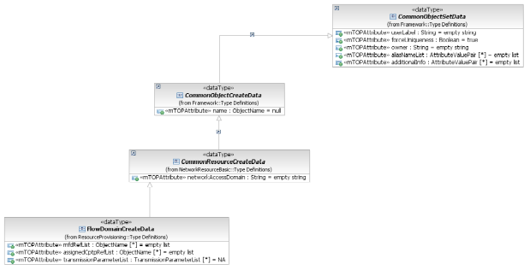
1. Name  This parameter defines the identifier of the new FD which will be used over the interface. The target OS has to make sure that the name of the FD is unique within the target OS domain. If no name is provided by the requesting OS, the target OS has to define a unique name. | Inherited from CommonObjectCreateData. | Inherited from CommonObjectCreateDataType.
2. User label  Refer to R_TMF518_FMW_I_0001 in the TMF518_FMW BA.  3. User label uniqueness  This parameter shall indicate to the target OS that the value of the user label attribute must be unique amongst the FDs within the target OS domain.  4. Owner  Refer to R_TMF518_FMW_I_0001 in the TMF518_FMW BA .  aliasNameList  <MB>Is it not needed more generally in all the requirements where the common attributes are used?</MB>  additionalInfo  <MB>???</MB> | Inherited from CommonObjectSetData.  This includes in addition:  - aliasNameList  - additionalInfo. | Inherited from CommonObjectSetDataType.  This includes in addition:  - aliasNameList  - vendorExtensions.
5. Network Access Domain  This parameter shall indicate the Network Access Domain (NAD) to which this FD will be associated to. | Inherited from CommonResourceCreateData. | Inherited from CommonResourceCreateDataType.
6. List of Matrix Flow Domains  This parameter identifies the list of MFDs to be associated to the new FD. The MFDs to be associated must exist and must not be associated to another FD, i.e., they have to be un-associated. | mfdRefList (*) (ObjectName)  This attribute identifies the list of Matrix Flow Domains (MFDs) to be associated to the new Flow Domain (FD).  The MFDs to be associated must not be associated to another FD, i.e., have to be un-associated. | element name="mfdRefList" type="nam:NamingAttributeListType"  Identifies the list of existing matrix flow domains to be associated to the flow domain. The MFDs must not already be associated to another flow domain. This may be an empty list.
 | assignedCptpRefList (*) (ObjectName)  This attribute identifies the list of Connectionless Port Termination Points (CPTPs) to be associated to the new Flow Domain (FD).  The request is denied, if a CPTP (to be associated) is not already assigned to one of the Matrix Flow Domains (MFDs) provided. | not part of create data; separate input parameter  (in) element name="assignedCptpRefList" type="nam:NamingAttributeListType"  This attribute identifies the list of Connectionless Port Termination Points (CPTPs) to be associated to the new Flow Domain (FD).  The request is denied, if a CPTP (to be associated) is not already assigned to one of the Matrix Flow Domains (MFDs) provided.
7. Connectionless layered parameters  This parameter shall represent the connectionless technology parameters associated with the different layers (e.g. Ethernet, DVB, Fiber Channel) that are supported by the FD. Refer to chapter “Connectionless Technology Parameters” of the supporting document SD1-16_LayeredParameters for details of the currently defined connectionless parameters. | transmissionParameterList (*)  This attribute contains the layer rate on which connectivity is established and a related set of connectionless parameters.  Refer to chapter "Connectionless Technology Parameters" of the attached supporting document SD1-16_LayeredParameters for details of the currently defined connectionless parameters. | element ref="lp:transmissionParametersList"  A list of layer rates on which connectivity can be established in the flow domain together with a set of connectionless technology parameters for each layer rate. Refer to chapter "Connectionless Technology Parameters" of the supporting document LayeredParameters.pdf for details of the currently defined connectionless parameters.
8. VendorExtensions  Refer to R_TMF518_FMW_I_0001.  <MB>Is it not needed more generally in all the requirements where the common attributes are used?</MB> |  |  | bz:  Is XML specific; will be covered by additionalInfo.

FlowDomainModifyData Type

BA | IA | IIS (FlowDomainModifyDataType) | Comments
R_TMF518_RP_II_0049  The Interface shall allow the requesting OS to specify the following parameters when it requests that a target OS modify an Flow Domain (FD): | This data type represents the specific parameters that may be provided to modify a Flow Domain.  Traceability: R_TMF518_RP_II_0049.  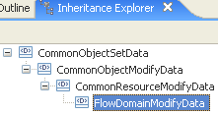  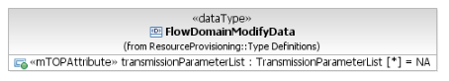 | This data type represents the specific parameters that may be provided to modify a Flow Domain.  extension base="crmd:CommonResourceModifyDataType" | 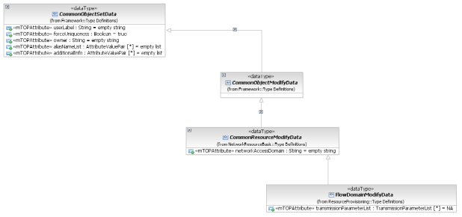
1) User label  Refer to R_TMF518_FMW_I_0001 in the TMF518_FMW BA .  2) User label uniqueness  This parameter shall indicate to the target OS that the value of the user label attribute must be unique amongst the MFDs within the target OS.  3) Owner  Refer to R_TMF518_FMW_I_0001 in the TMF518_FMW BA .  aliasNameList  additionalInfo | Inherited from CommonObjectSetData.  This includes in addition:  - aliasNameList  - additionalInfo. | Inherited from CommonObjectSetDataType.  This includes in addition:  - aliasNameList  - vendorExtensions.
4) Network Access Domain  This parameter shall indicate the Network Access Domain (NAD) to which this FD will be associated to. | Inherited from CommonResourceModifyData. | Inherited from CommonResourceModifyDataType.
5) Connectionless layered parameters  This parameter shall represent the connectionless technology parameters associated with the different layers (e.g. Ethernet, DVB, Fiber Channel) that are to be changed in the FD. Refer to chapter “Connectionless Technology Parameters” of the supporting document SD1-16_LayeredParameters for details of the currently defined connectionless parameters. | transmissionParameterList (*)  This attribute contains the layer rate on which connectivity is established and a related set of connectionless parameters.  Refer to chapter "Connectionless Technology Parameters" of the attached supporting document SD1-16_LayeredParameters for details of the currently defined connectionless parameters. | element ref="lp:transmissionParametersList"  A list of layer rates on which connectivity can be established in the flow domain together with a set of connectionless technology parameters for each layer rate. Refer to chapter "Connectionless Technology Parameters" of the supporting document LayeredParameters.pdf for details of the currently defined connectionless parameters.
6) VendorExtensions  Refer to R_TMF518_FMW_I_0001 in the TMF518_FMW BA . |  |  | bz:  Is XML specific; will be covered by additionalInfo.

FlowDomainFragmentCreateData Type

BA | IA | IIS (FlowDomainFragmentCreateDataType) | Comments
R_TMF518_RP_II_0061  The Interface shall allow the requesting OS to specify the following parameters when it requests that a target OS creates a Flow Domain Fragment (FDFr): | This data type represents the parameters that may be provided when creating a Flow Domain Fragment (FDFr).  Traceability: R_TMF518_RP_II_0061.  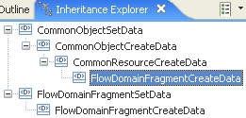  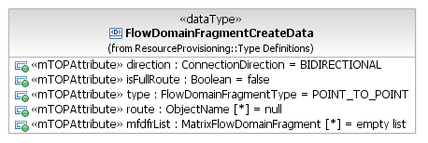 | This data type represents the parameters that may be provided when creating a Flow Domain Fragment (FDFr).  extension base="crcd:CommonResourceCreateDataType" | 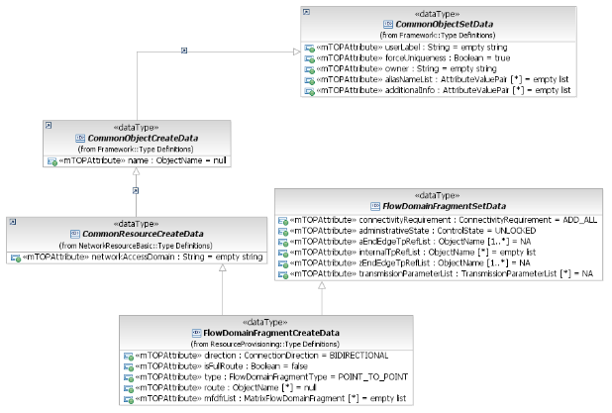  bz:  BA should also refer to common attributes.
1) Name  This parameter defines the identifier of the new FDFr which will be used over the interface. The target OS has to make sure that the name of the FDFr is unique within the containing Flow Domain. If no name is provided by the requesting OS, the target OS has to define a unique name.  Note:The name of the FDFr is not changeable after the FDFr is created. | Inherited from CommonObjectCreateData. | Inherited from CommonObjectCreateDataType.
2) User label  Refer to R_TMF518_FMW_I_0001 in the TMF518_FMW BA .  3) User label uniqueness  This parameter shall indicate to the target OS that the value of the user label attribute must be unique amongst the FDFrs within the target OS.  4) Owner  Refer to R_TMF518_FMW_I_0001 in the TMF518_FMW BA .  aliasNameList  additionalInfo | Inherited from CommonObjectSetData.  This includes in addition:  - aliasNameList  - additionalInfo. | Inherited from CommonObjectSetDataType.  This includes in addition:  - aliasNameList  - vendorExtensions.
5) Network Access Domain  This parameter indicates the Network Access Domain to which this FDFr has to be assigned. | Inherited from CommonResourceCreateData. | Inherited from CommonResourceCreateDataType.
7) Directionality  This parameter shall indicate the directionality of the new FDFr (bidirectional or unidirectional).  Note:  In the case of Ethernet, Directionality is always bidirectional. | direction (ConnectionDirection)  This attribute defines the directionality of the Flow Domain Fragment (bidirectional or unidirectional). | element name="direction" type="com:ConnectionDirectionType"  This attribute shall represent the directionality of the FDFr (bidirectional or unidirectional). Note: In the case of Ethernet, the directionality is always bidirectional.
 |  | element name="administrativeState" type="itu:X721.AdministrativeStateType"  Indicates whether the FDFr is locked (i.e., traffic units cannot flow through the FDFr) or unlocked (i.e., traffic units are allowed to flow through the FDFr). | bz:  Part of FlowDomainFragmentSetData.
 |  | element ref="lp:transmissionParametes"  The layer rate on which connectivity is established and a related set of connectionless parameters. Refer to chapter "Connectionless Technology Parameters" of the supporting document LayeredParameters.pdf for details of the currently defined connectionless parameters. | bz:  Part of FlowDomainFragmentSetData.
12) Full route  This parameter shall identify if the internal TPs and MFDFrs describe the full route of the FDFr (as opposed to only a partial constraint). When no routing constraints are specified,the done value of false must be used. | isFullRoute (Boolean)  This attribute identifies if the provided internal TPs and MFDFrs describe the full Route of the Flow Domain Fragment (as opposed to only a partial constraint). When no routing constraints are specified, false must be used. | element name="isFullRoute" type="xsd:boolean"  This parameter identifies if the internalTPs and mfdfrs parameters of the createAndActivateFDFr operation describe the full route of the Flow Domain Fragment (as opposed to only a partial constraint). When no routing constraints are specified, false must be used.
14) FDFr type  This parameter shall identify the type of the new FDFr (point-to-point, point-to-multipoint (E-tree), multipoint). | type (FlowDomainFragmentType)  This attribute identifies the type of the new Flow Domain Fragment. | element name="fdfrTtype" type="com:FlowDomainFragmentTypeType"  Represents the type of the FDFr
11) MFDFrs  An optional (possibly empty) list of MFDFrs that make up the route of the FDFr. This attribute may be omitted if the FDFr is routed by the network. As a result of creating the FDFr, MFDFrs are created in the various MFDs. | mfdfrList (*)  This attribute identifies the (possibly empty) list of Matrix Flow Domain Fragments (MFDFrs) that make up the route of the Flow Domain Fragment (FDFr). This attribute may be omitted if the FDFr is routed by the network. As a result of creating the FDFr, MFDFrs are created in the various Matrix Flow Domains.
17) VendorExtensions  Refer to R_TMF518_FMW_I_0001 in the TMF518_FMW BA. |  |  | bz:  Is XML specific; will be covered by additionalInfo.

FlowDomainFragmentModifyData Type

BA | IA | IIS (FlowDomainFragmentModifyDataType) | Comments
R_TMF518_RP_II_0063  The Interface shall allow the requesting OS to specify the following parameters when it requests that a target OS modify a Flow Domain Fragment (FDFr): | This data type represents the specific parameters that may be provided to modify a Flow Domain Fragment.  Traceability: R_TMF518_RP_II_0063.  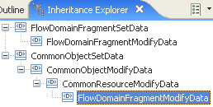  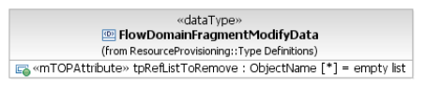 | This data type represents the specific parameters that may be provided to modify a Flow Domain Fragment.  extension base="crmd:CommonResourceModifyDataType" | 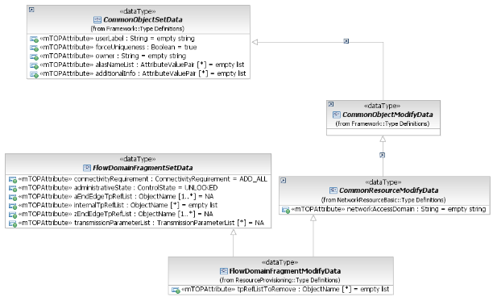  bz:  BA should also refer to common attributes.
1) User label  Refer to R_TMF518_FMW_I_0001 in the TMF518_FMW BA .  2) User label uniqueness  This parameter shall indicate to the target OS that the value of the new user label attribute must be unique amongst all FDFrs within the target OS domain.  3) Owner  Refer to R_TMF518_FMW_I_0001 in the TMF518_FMW BA .  aliasNameList  additionalInfo | Inherited from CommonObjectSetData.  This includes in addition:  - aliasNameList  - additionalInfo. | Inherited from CommonObjectSetDataType.  This includes in addition:  - aliasNameList  - vendorExtensions.
4) Network Access Domain  This parameter indicates the new Network Access Domain to which this FDFr has to be assigned. | Inherited from CommonResourceModifyData. | Inherited from CommonResourceModifyDataType.
 |  | element name="administrativeState" type="itu:X721.AdministrativeStateType"  Indicates whether the FDFr is locked (i.e., traffic units cannot flow through the FDFr) or unlocked (i.e., traffic units are allowed to flow through the FDFr). | bz:  Part of FlowDomainFragmentSetData.
 |  | element ref="lp:transmissionParameters"  The layer rate on which connectivity is established and a related set of connectionless parameters. Refer to chapter "Connectionless Technology Parameters" of the supporting document LayeredParameters.pdf for details of the currently defined connectionless parameters. | bz:  Part of FlowDomainFragmentSetData.
6) TPs to remove  This parameter shall represent a list of call-end-point names that must be removed from the Flow Domain Fragment (FDFr). As a result of modifying the FDFr, the client Flow Points are deleted. | tpRefListToRemove (*) (ObjectName)  This attribute identifies the list of Connection Port Termination Point (CPTP) names that must be removed from the Flow Domain Fragment (FDFr). As a result of modifying the FDFr, the client Flow Points are deleted. | element name="tpRefListToRemove" type="nam:NamingAttributeListType"  A list of Connection Port Termination Point (CPTP) names that must be removed from the Flow Domain Fragment (FDFr).  As a result of modifying the FDFr, the client Flow Points are deleted.
 |  | element name="aEndTpRefList" type="nam:NamingAttributeListType"  A list of additional Connection Port Termination Point (CPTP) names that delimit the Flow Domain Fragment (FDFr) and characterize its edges (entrance and/or exit points). As a result of modifying the FDFr, Flow Points are created as clients of the FD Edge CPTPs. | bz:  Part of FlowDomainFragmentSetData.
 |  | element name="zEndTpRefList" type="nam:NamingAttributeListType"  A list of additional Connection Port Termination Point (CPTP) names that delimit the Flow Domain Fragment (FDFr) and characterize its edges (entrance and/or exit points). As a result of modifying the FDFr, Flow Points are created as clients of the FD Edge CPTPs. | bz:  Part of FlowDomainFragmentSetData.
 |  | element name="internalTpRefList" type="nam:NamingAttributeListType"  A list of additional internal Connection Port Termination Point (CPTP) names that must be added to the route of the Flow Domain Fragment (FDFr). As a result of modifying the FDFr, Flow Points are created as clients of the internal CPTPs. | bz:  Part of FlowDomainFragmentSetData.
12) VendorExtensions  Refer to R_TMF518_FMW_I_0001 in the TMF518_FMW BA . |  |  | bz:  Is XML specific; will be covered by additionalInfo.

FlowDomainFragmentSetData Type

BA | IA (FlowDomainFragmentSetData Type) | IIS | Comments
no such common type in BA  R_TMF518_RP_II_0061  The Interface shall allow the requesting OS to specify the following parameters when it requests that a target OS creates a Flow Domain Fragment (FDFr):  R_TMF518_RP_II_0063  The Interface shall allow the requesting OS to specify the following parameters when it requests that a target OS modify a Flow Domain Fragment (FDFr): | This data type contains the parameters that can be passed when a Flow Domain Fargement is created or modified.  Traceability: R_TMF518_RP_II_0061, R_TMF518_RP_II_0063.  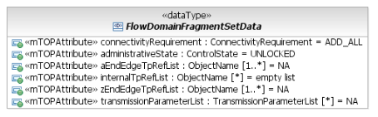 | no such common type in IIS
0061: 15) Connectivity requirement  This parameter shall identify (for a “connectivity-aware” target OS) the requested operation mode in case not all FPs have potential connectivity to one another:  • reject the creation request  • add all Flow Points regardless of potential connectivity.  If the target OS is not connectivity-aware, this parameter is ignored. | connectivityRequirement (ConnectivityRequirement)  This attribute identifies for a "connectivity-aware" target OS the requested operation mode in case not all Flow Points have potential connectivity to one another.  If the target OS is not connectivity-aware, this parameter is ignored. | not part of set data; separate input parameter  (in) element name="connectivityRequirement" type="fd:ConnectivityRequirementType"  For a "connectivity-aware" Target OS, this parameter shall identify the requested operation mode in case not all FPs have potential connectivity to one another. If the Target OSis not connectivity-aware, this parameter is ignored. | bz:  Not part of CommonResourceModifyDataType.
0061: 16) Administrative state  This parameter shall indicate whether the FDFr shall be locked (i.e., traffic units cannot flow through the FDFr) or unlocked (i.e., traffic units are allowed to flow through the FDFr).  0063: 11) Administrative state  This parameter shall indicate whether the FDFr shall be locked (i.e., traffic units cannot flow through the FDFr) or unlocked (i.e., traffic units are allowed to flow through the FDFr). | administrativeState (ControlState)  This attribute indicates whether the Flow Domain Fragment (FDFr) shall be locked (i.e., traffic units cannot flow through the FDFr) or unlocked (i.e., traffic units are allowed to flow through the FDFr). | not part of set data; contained in create data  element name="administrativeState" type="itu:X721.AdministrativeStateType"  Indicates whether the FDFr is locked (i.e., traffic units cannot flow through the FDFr) or unlocked (i.e., traffic units are allowed to flow through the FDFr).  not part of set data; contained in mofify data  element name="administrativeState" type="itu:X721.AdministrativeStateType"  Indicates whether the FDFr is locked (i.e., traffic units cannot flow through the FDFr) or unlocked (i.e., traffic units are allowed to flow through the FDFr).
0061: 8) aEnd TPs  This parameter shall represent a list of of call-end-point names that delimit the FDFr and characterize its edges (entrance and/or exit points). As a result of creating the FDFr, FPs are created as clients of the FD Edge call-end-points.  In case of a unidirectional FDFr this attribute contains the list of source FD Edge call-end-points. In case of a bidirectional FDFr this attribute may be combined with the zEnd TPs attribute to obtain all the FD Edge call-end-points that are associated to the FDFr.  Note:  For a bidirectional point to point FDFr it is suggested, but not mandatory, to put one TP in the aEnd and one in the zEnd, as with SNCs and TLs. For a multipoint FDFr, or a point-to-point FDFr that may be expanded to multipoint, it is suggested to put all the TPs in the aEnd.  0063: 7) aEnd TPs  This parameter shall represent a list of additional call-end-point names that delimit the Flow Domain Fragment (FDFr) and characterize its edges (entrance and/or exit points). As a result of modifying the FDFr, Flow Points are created as clients of the FD Edge call-end-points. | aEndEdgeTpRefList (1..*) (ObjectName)  This attribute identifies the list of Connection Port Termination Point (CPTP) names that delimit the Flow Domain Fragment (FDFr) and characterize its edges (entrance and/or exit points). As a result of creating/modifying the FDFr, Flow Points are created as clients of the FD Edge CPTPs.  In case of a unidirectional FDFr this attribute contains the list of source FD Edge CPTPs. In case of a bidirectional FDFr this attribute may be combined with the zEndEdgeTPs relationship to obtain all the FD Edge CPTPs that have to be associated to the FDFr. | not part of set data; separate create input parameter  (in) element name="aEndRefList" type="nam:NamingAttributeListType"  A list of of CPTP names that delimit the FDFr and characterize its edges (entrance and/or exit points). As a result of creating the FDFr, FPs are created as clients of the Fd Edge CPTPs. In case of a unidirectional FDFr this attribute contains the list of source Fd Edge CPTPs. In case of a bidirectional FDFr this attribute may be combined with the zEnd TPs attribute to obtain all the Fd Edge CPTPs that are associated to the FDFr. (N.B. For a bidirectional point to point FDFr it is suggested, but not mandatory, to put one TP in the aEnd and one in the zEnd, as with SNCs and TLs. For a multipoint FDFr, or a point-to-point FDFr that may be expanded to multipoint, it is suggested to put all the TPs in the aEnd.)  not part of set data; contained in mofify data  element name="aEndTpRefList" type="nam:NamingAttributeListType"  A list of additional Connection Port Termination Point (CPTP) names that delimit the Flow Domain Fragment (FDFr) and characterize its edges (entrance and/or exit points). As a result of modifying the FDFr, Flow Points are created as clients of the FD Edge CPTPs.
0061: 9) zEnd TPs  In case of a unidirectional FDFr this attribute contains the list of sink FD Edge call-end-points that delimit the FDFr and characterize its edges (exit points). As a result of creating the FDFr, FPs are created as clients of the FD Edge call-end-points.  In case of a bidirectional FDFr this attribute may be combined with the aEnd TPs attribute to obtain all the FD Edge call-end-points that are associated to the FDFr.  0063: 8) zEnd TPs  This parameter shall represent a list of additional call-end-point names that delimit the Flow Domain Fragment (FDFr) and characterize its edges (exit points). As a result of modifying the FDFr, Flow Points are created as clients of the FD Edge call-end-points. | zEndEdgeTpRefList (1..*) (ObjectName)  This attribute identifies the list of Connection Port Termination Point (CPTP) names that delimit the Flow Domain Fragment (FDFr) and characterize its edges (exit points). As a result of creating/modifying the FDFr, Flow Points are created as clients of the FD Edge CPTPs.  In case of a unidirectional FDFr this attribute contains the list of sink FD Edge CPTPs. In case of a bidirectional FDFr this attribute may be combined with the aEndEdgeTPs relationship to obtain all the FD Edge CPTPs that have to be associated to the FDFr. | not part of set data; separate create input parameter  (in) element name="zEndRefList" type="nam:NamingAttributeListType"  In case of a unidirectional FDFr this attribute contains the list of sink Fd Edge CPTPs that delimit the FDFr and characterize its edges (exit points). As a result of creating the FDFr, FPs are created as clients of the Fd Edge CPTPs. In case of a bidirectional FDFr this attribute may be combined with the aEnd TPs attribute to obtain all the Fd Edge CPTPs that are associated to the FDFr.  not part of set data; contained in mofify data  element name="zEndTpRefList" type="nam:NamingAttributeListType"  A list of additional Connection Port Termination Point (CPTP) names that delimit the Flow Domain Fragment (FDFr) and characterize its edges (entrance and/or exit points). As a result of modifying the FDFr, Flow Points are created as clients of the FD Edge CPTPs.
0061: 10) Internal TPs  An optional (possibly empty) list of internal call-end-point names that must be included in the route of the FDFr. As a result of creating the FDFr, FPs are created as clients of the internal call-end-points.  0063: 9) Internal TPs  This parameter shall represent a list of additional internal call-end-point names that must be added to the route of the Flow Domain Fragment (FDFr). As a result of modifying the FDFr, Flow Points are created as clients of the internal call-end-points. | internalTpRefList (*) (ObjectName)  This attribute identifies the list of internal Connection Port Termination Point (CPTP) names that must be included in / or added to the route of the Flow Domain Fragment (FDFr). As a result of creating/modifying the FDFr, Flow Points are created as clients of the internal CPTPs. | not part of set data; separate input parameter  (in) element name="internalTpRefList" type="nam:NamingAttributeListType"  A (possibly empty) list of internal CPTP names that must be included in the route of the FDFr. As a result of creating the FDFr, FPs are created as clients of the internal CPTPs.  not part of set data; contained in mofify data  element name="internalTpRefList" type="nam:NamingAttributeListType"  A list of additional internal Connection Port Termination Point (CPTP) names that must be added to the route of the Flow Domain Fragment (FDFr). As a result of modifying the FDFr, Flow Points are created as clients of the internal CPTPs.
00061 6) Connectionless layered parameters  This parameter shall represent the connectionless technology parameters associated with the different layers (e.g. Ethernet, DVB, Fiber Channel) that are to be changed in the FD. Refer to chapter “Connectionless Technology Parameters” of the supporting document SD1-16_LayeredParameters for details of the currently defined connectionless parameters.  0063 5) Connectionless layered parameters  This parameter shall represent the connectionless technology parameters associated with the layer (e.g., Ethernet, DVB) that the FDFr is connecting. Refer to chapter “Connectionless Technology Parameters” of the supporting document SD1-16_LayeredParameters for details of the currently defined connectionless parameters. | transmissionParameterList (*)  This attribute contains the layer rate on which connectivity is established and a related set of connectionless parameters.  Refer to chapter "Connectionless Technology Parameters" of the attached supporting document SD1-16_LayeredParameters for details of the currently defined connectionless parameters. | not part of set data; contained in create data  element ref="lp:transmissionParameters"  The layer rate on which connectivity is established and a related set of connectionless parameters. Refer to chapter "Connectionless Technology Parameters" of the supporting document LayeredParameters.pdf for details of the currently defined connectionless parameters.  not part of set data; contained in modify data  element ref="lp:transmissionParameters"  The layer rate on which connectivity is established and a related set of connectionless parameters. Refer to chapter "Connectionless Technology Parameters" of the supporting document LayeredParameters.pdf for details of the currently defined connectionless parameters.

MatrixFlowDomainCreateData Type

BA | IA | IIS (MatrixFlowDomainCreateDataType) | Comments
R_TMF518_RP_II_0038  The Interface shall allow the requesting OS to specify the following parameters when it requests the creation of a Matrix Flow Domain (MFD): | This data type represents the parameters that may be provided when creating a Matrix Flow Domain.  Traceability: R_TMF518_RP_II_0038.  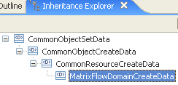  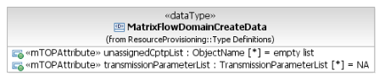 | This data type represents the parameters that may be provided when creating a Matrix Flow Domain.  extension base="crcd:CommonResourceCreateDataType" | 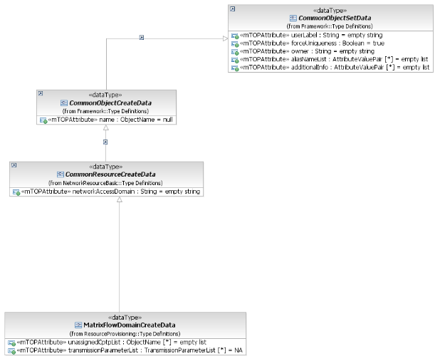
Name ?? | Inherited from CommonObjectCreateData. | Inherited from CommonObjectCreateDataType.
1) User label  Refer to R_TMF518_FMW_I_0001 in the TMF518_FMW BA.  2) User label uniqueness  This parameter shall indicate to the target OS that the value of the user label attribute must be unique amongst the MFDs within the target OS domain.  3) Owner  Refer to R_TMF518_FMW_I_0001 in the TMF518_FMW BA.  aliasNameList  additionalInfo | Inherited from CommonObjectSetData.  This includes in addition:  - aliasNameList  - additionalInfo. | Inherited from CommonObjectSetDataType.  This includes in addition:  - aliasNameList  - vendorExtensions.
4) Network Access Domain  This attribute represents the Network Access Domain (NAD) to which the new MFD shall be assigned to. | Inherited from CommonResourceCreateData. | Inherited from CommonResourceCreateDataType.
5) List of unassigned call-end-points  This parameter contains the list of unassigned call-end-points which shall be assigned to the MFD to be created. | unassignedCptpRefList (*) (ObjectName)  This attribute identifies the list of unassigned Connectionless Port Termination Points (CPTPs) which shall be assigned to the new Matrix Flow Domain (MFD). | element name="unassignedCptpRefList" type="nam:NamingAttributeListType"  A list of names of unassigned CPTPs that shall be assigned to the matrix flow domain.
6) Connectionless Layered Parameters  This parameter shall represent the connectionless technology parameters associated with the different layers (e.g. Ethernet, DVB) that are supported by the MFD. Refer to chapter “Connectionless Technology Parameters” of the supporting document SD1-16_LayeredParameters for details of the currently defined connectionless parameters. | transmissionParameterList (*)  This attribute contains the layer rate on which connectivity is established and a related set of connectionless parameters.  Refer to chapter "Connectionless Technology Parameters" of the attached supporting document SD1-16_LayeredParameters for details of the currently defined connectionless parameters. | element ref="lp:transmissionParametersList"  A list of layer rates on which connectivity can be established in the flow domain together with a set of connectionless technology parameters for each layer rate. Refer to chapter "Connectionless Technology Parameters" of the supporting document LayeredParameters.pdf for details of the currently defined connectionless parameters.
7) VendorExtensions  Refer to R_TMF518_FMW_I_0001 in the TMF518_FMW BA . |  |  | bz:  Is XML specific; will be covered by additionalInfo.

MatrixFlowDomainModifyData Type

BA | IA | IIS (MatrixFlowDomainModifyDataType) | Comments
R_TMF518_RP_II_0040  The Interface shall allow the requesting OS to specify the following parameters when it requests that a target OS modify an Matrix Flow Domain (MFD): | This data type represents the specific parameters that may be provided to modify a Matrix Flow Domain.  Traceability: R_TMF518_RP_II_0040.  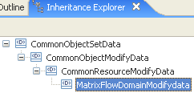  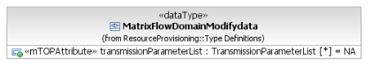 | This data type represents the specific parameters that may be provided to modify a Matrix Flow Domain.  extension base="crmd:CommonResourceModifyDataType" | 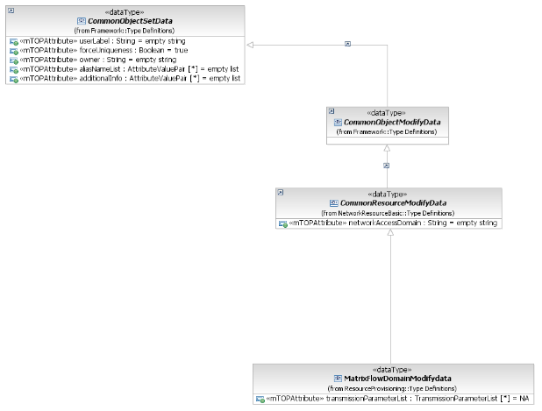
1) User label  Refer to R_TMF518_FMW_I_0001 in the TMF518_FMW BA .  2) User label uniqueness  This parameter shall indicate to the target OS that the value of the user label attribute must be unique amongst the MFDs within the target OS.  3) Owner  Refer to R_TMF518_FMW_I_0001 in the TMF518_FMW BA .  aliasNameList  additionalInfo | Inherited from CommonObjectSetData.  This includes in addition:  - aliasNameList  - additionalInfo. | Inherited from CommonObjectSetDataType.  This includes in addition:  - aliasNameList  - vendorExtensions.
4) Network Access Domain  This attribute represents the new Network Access Domain (NAD) to which the MFD shall be assigned to. | Inherited from CommonResourceModifyData. | Inherited from CommonResourceModifyDataType.
5) Connectionless Layered Parameters  This parameter shall represent the connectionless technology parameters associated with the different layers (e.g. Ethernet, DVB) that are to be changed in the MFD. Refer to chapter “Connectionless Technology Parameters” of the supporting document SD1-16_LayeredParameters for details of the currently defined connectionless parameters. | transmissionParameterList (*)  This attribute contains the layer rate on which connectivity is established and a related set of connectionless parameters.  Refer to chapter "Connectionless Technology Parameters" of the attached supporting document SD1-16_LayeredParameters for details of the currently defined connectionless parameters. | element ref="lp:transmissionParametersList"  A list of layer rates on which connectivity can be established in the flow domain together with a set of connectionless technology parameters for each layer rate. Refer to chapter "Connectionless Technology Parameters" of the supporting document LayeredParameters.pdf for details of the currently defined connectionless parameters.
6) VendorExtensions  Refer to R_TMF518_FMW_I_0001 in the TMF518_FMW BA. |  |  | bz:  Is XML specific; will be covered by additionalInfo.

