Subnetwork Connection States

The possible subnetwork connection states and transitions as a result of NMS requests to create, activate, create and activate, deactivate, delete and deactivate delete subnetwork connections are illustrated in the following state transition diagrams:

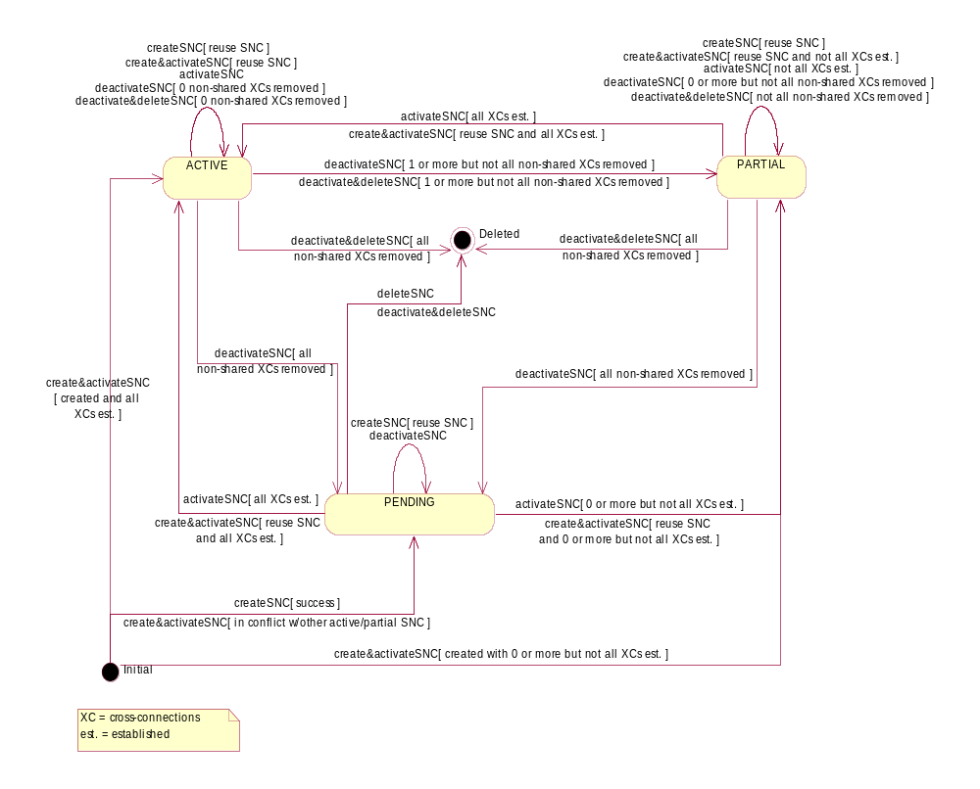

Figure 1: Statechart Diagram - SubnetworkConnection.sncState [Pending Supported]

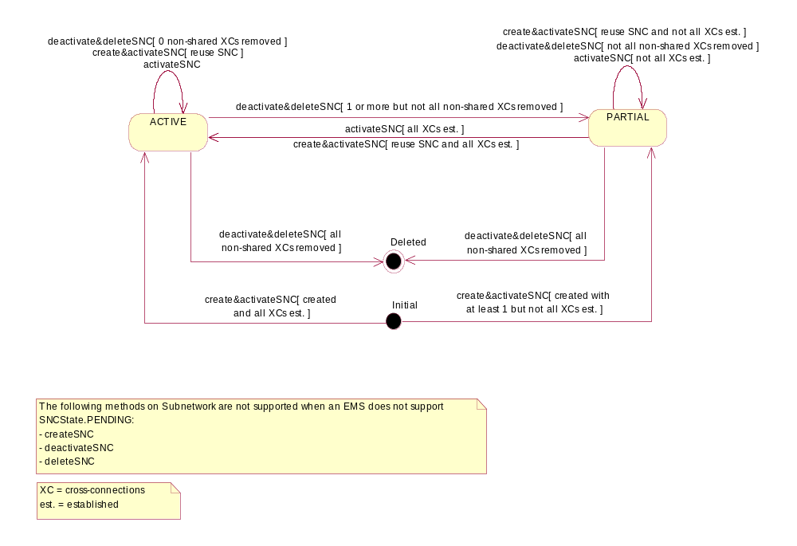

Figure 2: Statechart Diagram - SubnetworkConnection.sncState [Pending Not Supported]

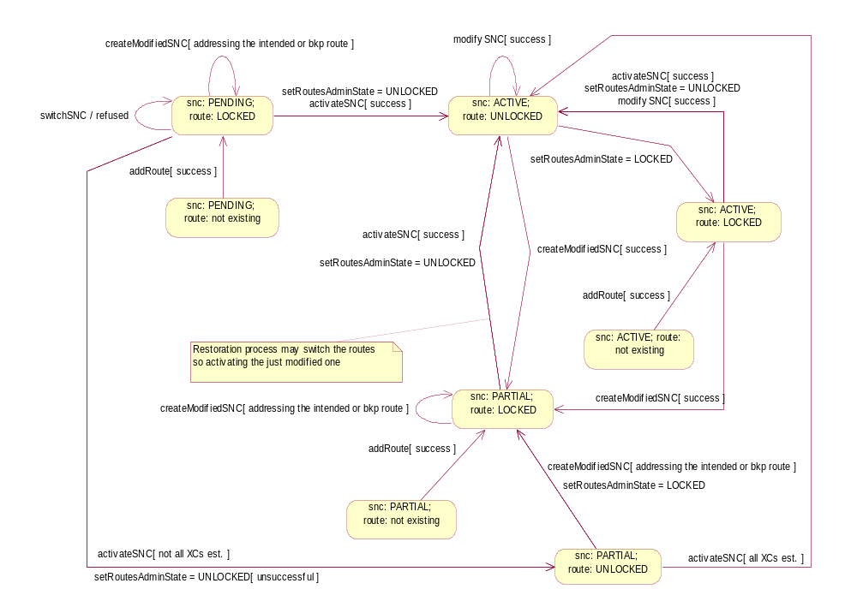
Figure 3:
Statechart Diagram - Modification of a SNC with multiple routes and SNC name preserved

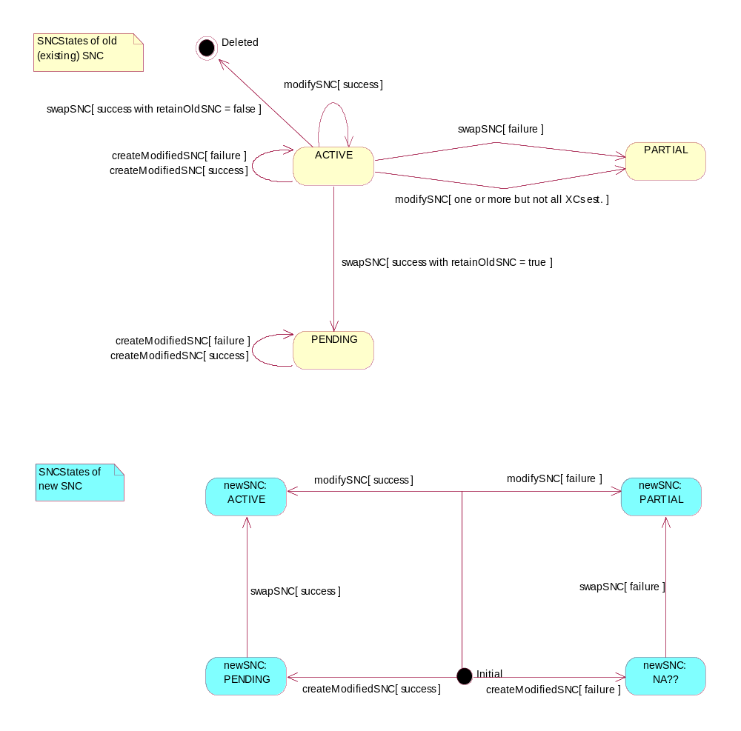
Figure 4: Statechart Diagram - Modification of a SNC with SNC name not preserved

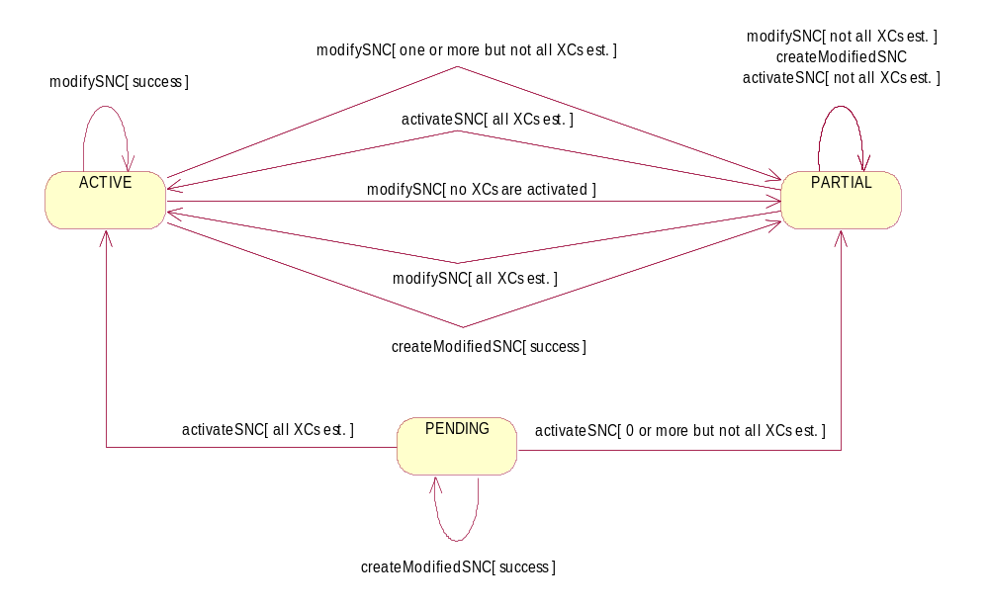
Figure 5: Statechart Diagram - Modification of a SNC with SNC name preserved

