Maintenance Commands
The following Figure shows the maintenance operation signal flow for the maintenance commands supported by TMF NML-EML interface.

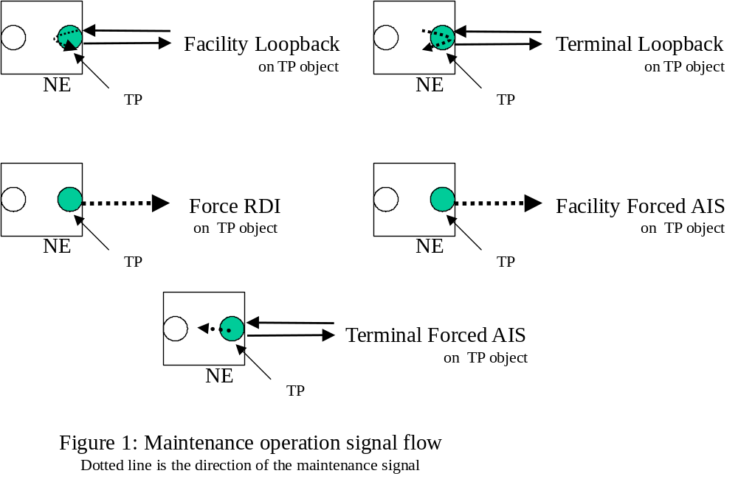

The following is a list of maintenance of operations that shall be supported:
- Facility Loopback
- Terminal Loopback
- Facility Forced AIS
- Terminal Forced AIS
- Force RDI
It will be possible to add additional commands, as required for other technologies or to support more robust maintenance needs.

When specifying the operation it will be possible to indicate a specific object that is encapsulated by the MTNM Object. This may be done by specifying the layer rate. For example, for a PTP that encapsulates the RS and MS objects into a single PTP the command will indicate the layer rate of the object on which to apply the operation. If no specification (layer rate) is provided then the EMS may reject the operation or apply the operation to a default object (i.e. the EMS will always use the MS object in the previous example.).

