Equipment Model

Equipment Model Overview
The equipment model represents the various manageable physical components of the Network Element (circuit packs or field replaceable units or also, fan, fuse panel, power supply, etc.).
The Equipment Holder Class represents an abstraction of Rack, Shelf, Subshelf, Slot and Subslot.
Figure 1 describes the containment and support/supporting relationship of the equipment model. In the solution set (IDL) the Managed Element manager object is a first class IDL object (i.e. an interface) (not shown is this diagram), the Equipment Holder, the Equipment and the Managed Element object classes are also IDL structures.
Note that an equipment is always a leaf in the containment tree. See also examples in Figure 3 and Figure 4 for further explanation of the model.
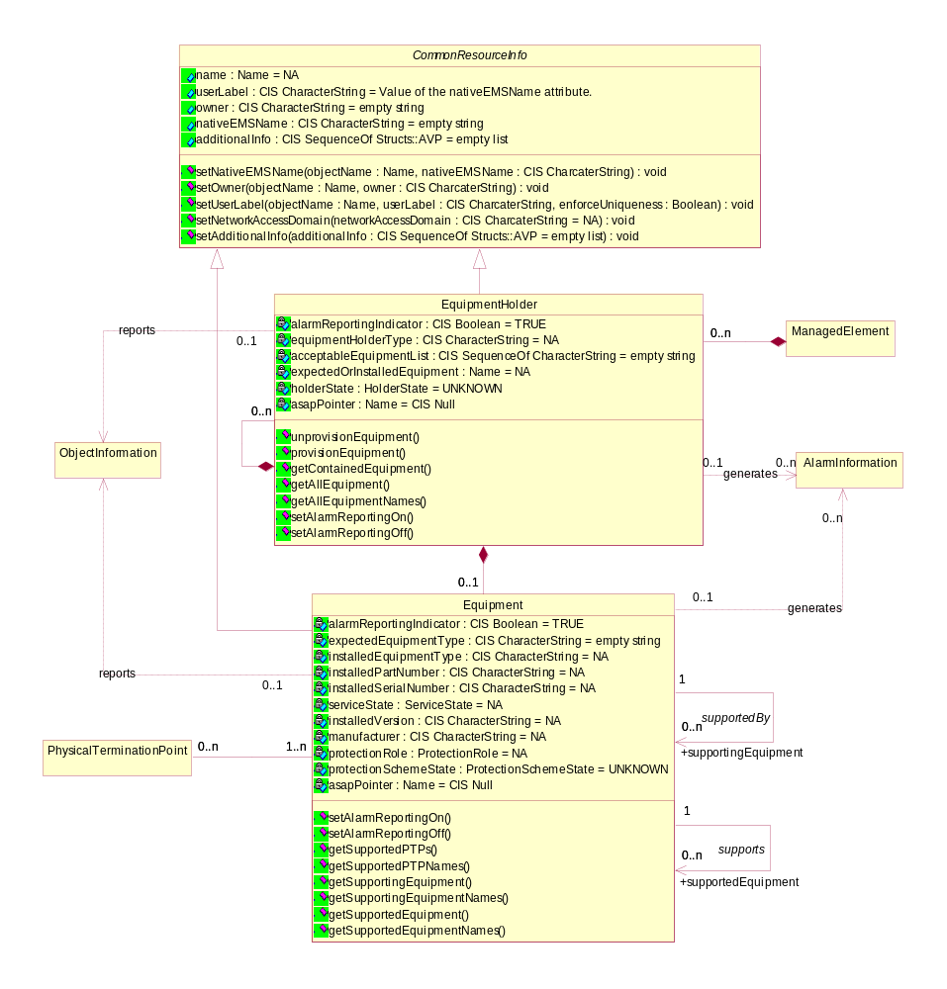Figure 1: Equipment Model overview

Naming Attribute Structure
The naming attribute structure follows the containment hierarchy of the equipment model. When the Equipment Holder object is named by the Managed Element, the Equipment Holder objects are named recursively, (Rack, Shelf, Subshelf, Slot, and Subslot) and the Equipment objects are named by the Equipment Holder object directly containing it. See supporting document objectNaming.pdf for further details and examples on equipment naming.

Equipment Protection
The modeling of the equipment protection scheme is shown in Figure 2. In the solution set (IDL) the management of the equipment protection is done through the first class IDL object ProtectionMgr_I (i.e. an interface) (not shown is the diagram).
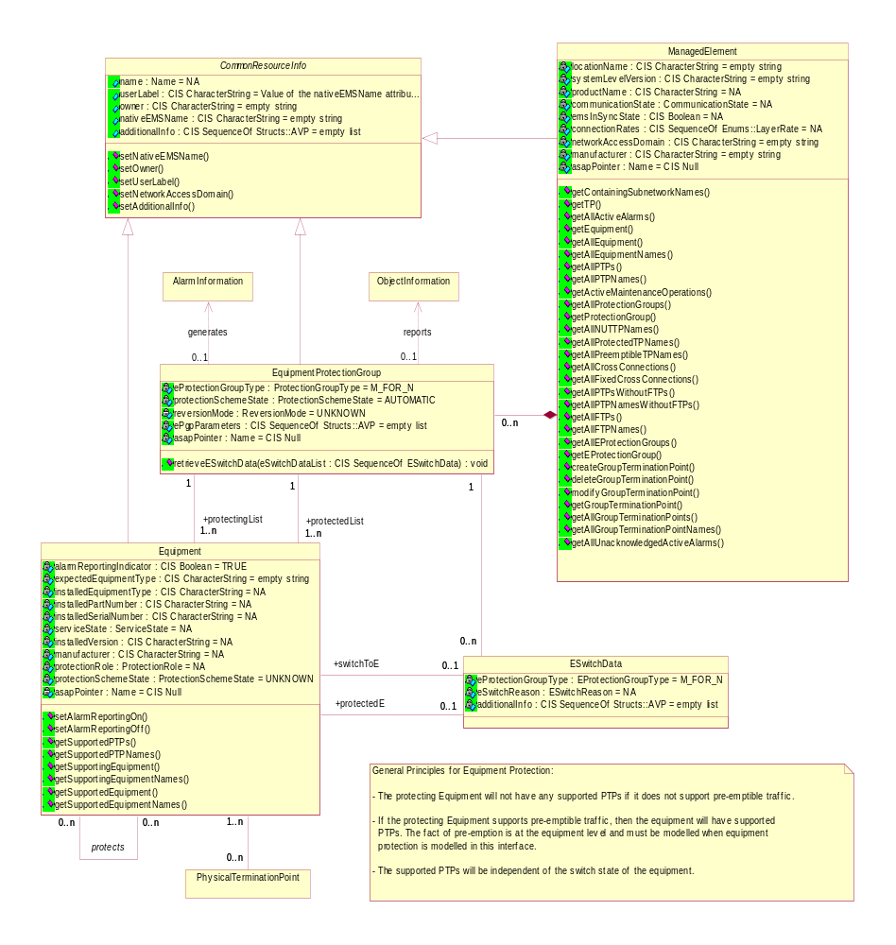Figure 2: Equipment Protection Model overview

Equipment Model Examples
The following diagrams illustrate the model and show how to apply it.
Figure 3 shows a Managed Element with a shelf that is composed of four slots. Slot #2 shows a slot containing a card with sub-slots where only the sub-slot on the top is equipped with circuitry.

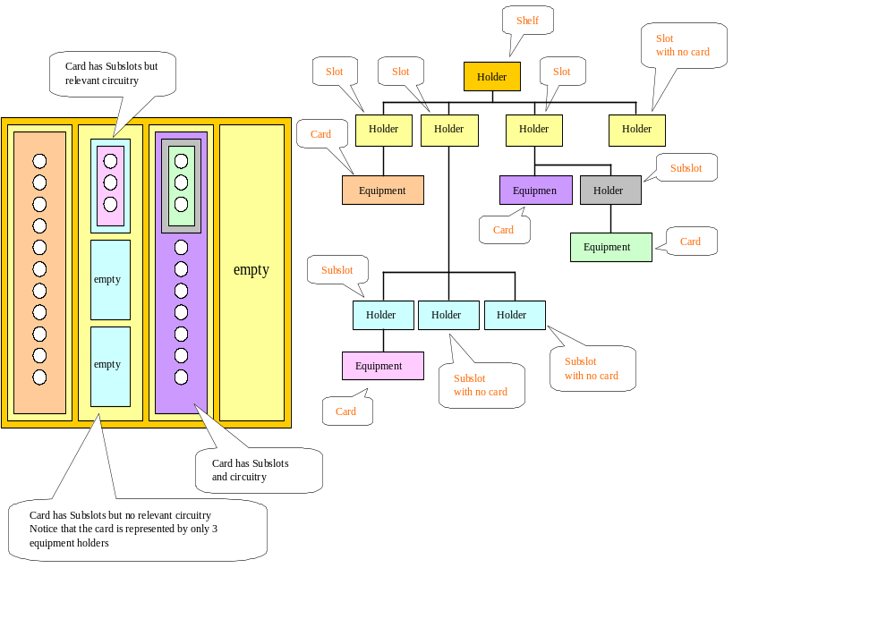
Figure 3: Example equipment object model #1

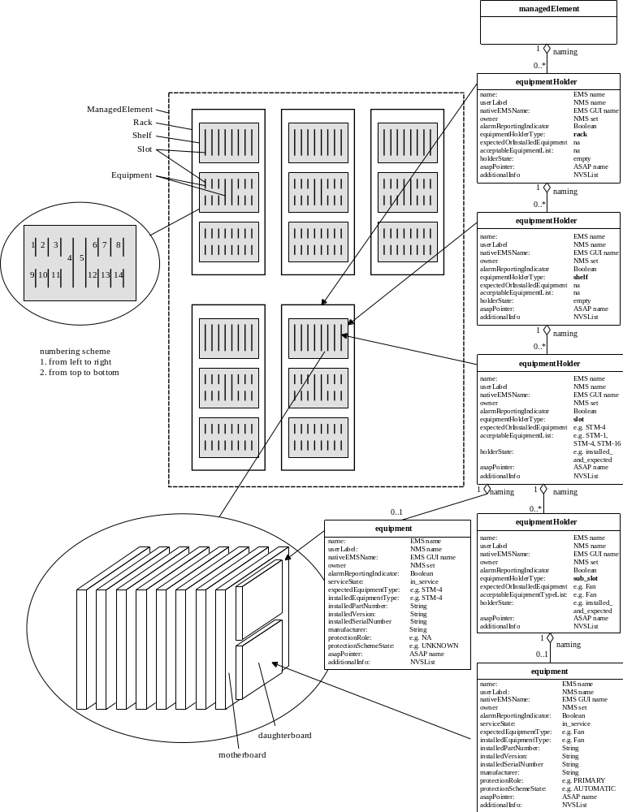
Figure 4: Example explaining object model #2

The interface will allow the NMS to determine for each equipment holder:
- the card that has been physically installed in a holder
- the card that was provisioned (i.e. set as Expected) to be in the specific equipment holder.
Note: the term card refers to any equipment that may be installed and or provisioned (i.e. set as Expected).

Modelling of DSL modems as virtual equipment holders
The DSLAM contains a virtual equipment holder (TU-R shelf) that contains virtual equipment holders (slots) each containing a TU-R as virtual equipment. In this case "internal" Topological Links (TLs) are used to represent the DSL lines between the TU-C/O PTPs on PIUs of the main shelf and the TU-R PTPs on PIUs of the TU-R shelf.
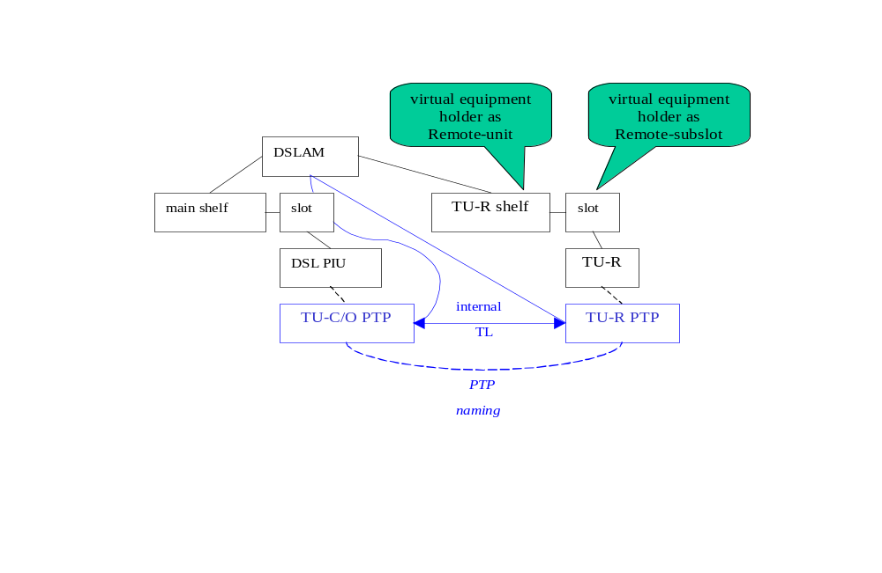
Figure 5: Modeling of external equipment as Remote-Units

Equipment Holder State Machine
There exists a state machine (see Figure 6) for the values of the holder state:
- Empty – no equipment is installed and no expected equipment has been identified
- Installed & not expected – physically inserted in the ME but not expected
- Expected & not Installed – expected but not currently installed
- Installed & Expected – expected and currently installed
- Mismatch of Installed & Expected – there is an inconsistency between the expected equipment and the installed equipment
- Unavailable –this holder cannot accept the installation or provisioning of equipment (this is typically caused by a double width card installed next to this slot)
- Unknown – the EMS does not know the state of the equipment

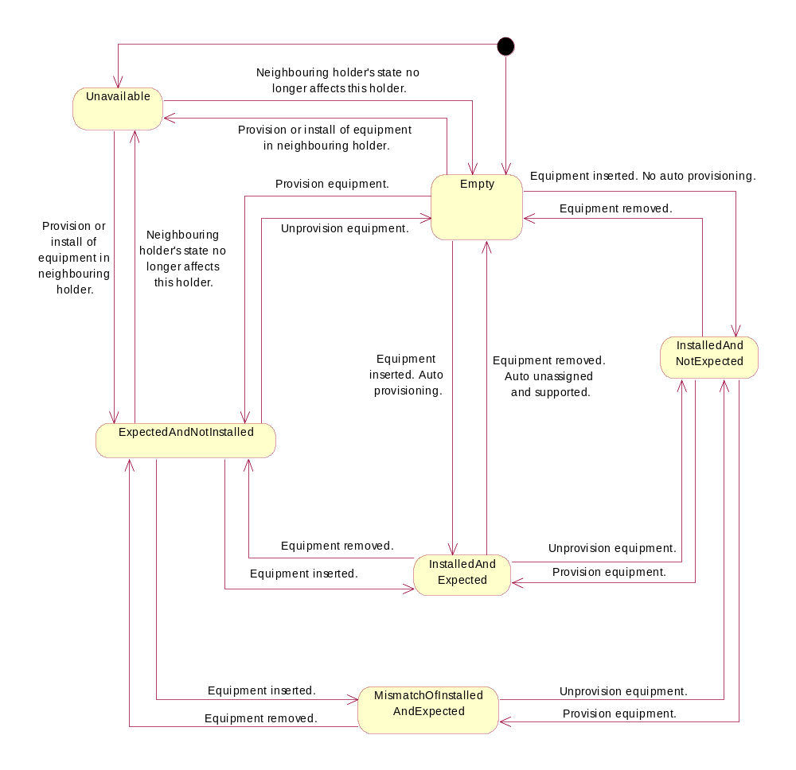
Figure 6: State Chart Diagram of Equipment Holder State

