PM Threshold Types

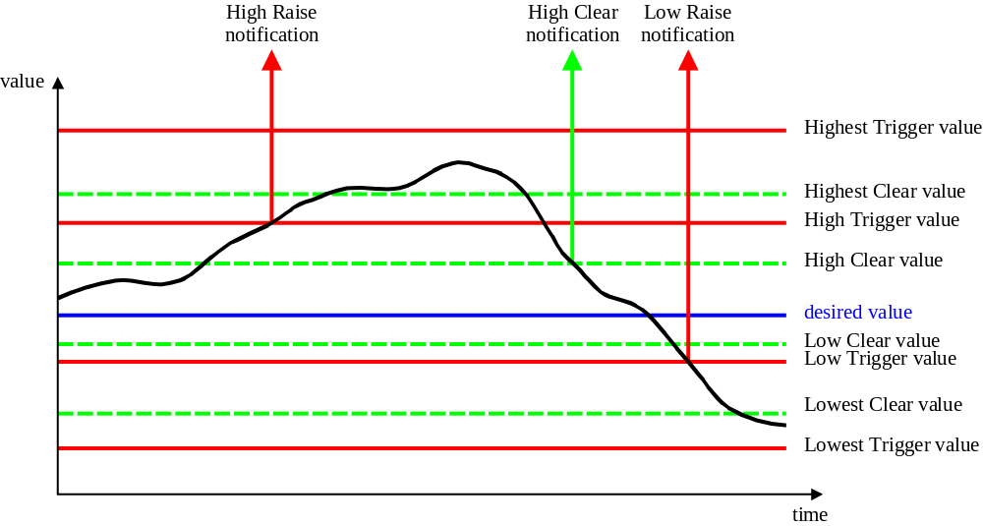
Note: Identification of Trigger/Clear for each threshold type is modelled by the attribute triggerFlag

