MTOSI Enhanced Resource States

Table of Contents

MTOSI Enhanced Resource States 1
Table of Contents 1
1 Introduction 2
2 References 2
3 Resource Lifecycle & State Diagram 3
4 Resource States 4
4.1 Planning Phase 4
4.2 Installing Phase 4
4.3 Working Phase 4
4.4 Non-working Phase 4
4.5 Retiring Phase 4
5 Proposed Resource Sub-states 5
5.1 The Planning resourceStateQualifier: 5
5.2 The Installing resourceStateQualifier: 5
5.3 The Working resource Activation resourceStateQualifier: 6
5.4 The Non-working resourceStateQualifier: 6
5.5 The Retiring resourceStateQualifier: 6
6 State Diagram 8
6.1 State Diagram Notes 8
7 Compatibility and Mapping 10
7.1 Mapping to MTOSI v1.0 10
7.2 MTNM Compatibility 10
7.3 Mapping to ITU-T X.731 and M.3100 States 11
7.4 Alignment with ETSI TSPAN Equipment Lifecycle 11
8 Administrative Appendix 14
8.1 Document History 14
8.2 Acknowledgments 14
8.3 How to comment on this document 14

Introduction
The simple static states Planned, Installed Retired need to be replaced by complex dynamic super-states 'Planning' 'Installing' 'Retiring' each refined into a number of substates.

Operational Support Systems (OSS) can support modelling of planning as well as deployment lifecycle of managed network components. Different behaviours of interaction between the OSS and managed network components are required during the planning, installation, commissioning, integration, de-integration, de-commissioning and de-installation of those components. This needs to be communicated between the element management systems and the OSS and also between OSS using the MTOSI data model.

There is therefore a need to define the CommonResourceInfo.resourceState in finer granularity than currently supported, and to rename the existing simple states to reflect this.
Planned → Planning
Installed → Installing
Retired → Retiring
Only the minimum of generic sub-states will be identified, existing vendor extension mechanism will allow vendors to refine the valid sub-states further.

References
This contribution references the following documents:
- TMF’s eTOM GB 921D version 4.5 – Addendum D – Process Decomposition and Descriptions – November 2005
- ETSI TISPAN – Telecommunications Equipment Life Cycle
TR 102 450 – DTR/TISPAN-08010V0.0.10c (2005-11)
- MTNM V3.0 – Coding of X.731 and M.3100 State and Status Information
encodingX731M3100v0[1].0.1.pdf

Resource Lifecycle & State Diagram
Based on discussions during past mTOP resource management calls, the resource lifecycle contains the following phases:
a) Planning phase
b) Installation phase
c) Working phase
d) Non-working phase
e) Retirement phase
These phases are incorporated into the basic Resource State and are considered the coarse-grain state values.. Note that the phases are in fact compound states as reflected by the names. For example, the term “planning” is used instead of “planned” to emphasize that multiple transitions can occur among the substates within the compound state “planning”. The following state transition diagram is proposed:
Planning
Working
Installing
Non-Working
Retiring
This supporting documentation details the substates for Planning, Installing Working and Retiring.
The Non-working phase is out of scope in this document and not fully specified.

Resource States

Planning Phase
During the Planning phase the resource is scheduled for deployment in accordance with a specific plan
During this phase, the resource is assigned the composite state value of “Planning”.
The resource state in the Inventory Management OS provides the other OSs with the information regarding the resources’ planning state.

Installing Phase
During this phase, the Resource undergoes a full commissioning process until it is finally ready for work and support services. takes the Resource State value of “Installed”.
During this phase, the resource is assigned the composite Inventory state value of “Installing”.
Resources may also be installed in the network regardless of any specific plan.

Working Phase
After the resource has been physically installed and all necessary Firmware and Software have been installed, all the commissioning testing has been performed and is running, it enters the working phase.
During this phase, the Resource is assigned the composite state value “Working”.

Non-working Phase
The Non-working phase designates the resource assurance states, namely, all possible states in which the resource is put out of work, either by intrinsic internal reasons, e.g., a resource that becomes faulty, or intentionally by the operator, e.g, for maintenance purposes.
During this phase, the Resource is assigned the composite state value “Non-working”.

Retiring Phase
During this phase, the resource undergoes all necessary procedures for its decommissioning and phasing out.
During this phase, the resource is assigned the composite state value “Retiring”

Proposed Resource Sub-states
The sub-states represent completed activities rather than processes. For example, Commissioned instead of Commission. Sub-states are only identified whose behavior can be defined fairly well and are significant to how the resource is treated.
A given OSS would typically use a subset of all resource states depending on the task at hand. For example, event management and service configuration OSS behavoiur may be interested in some of the Installing qualifiers (integrated and accepted) but not others (ordered, installed, commissioned, rejected).
This supporting documentation specifies the resource state values but doesn’t specify the triggers of the transition from one state value to another. This is an issue that is left for specific user definitions.

The Planning resourceStateQualifier:
- Initial Plan - a requirement for the resource has been identified, and the resource has been proposed to address the requirement, but resource characteristics or deployment details have not been agreed.
- Planned – the characteristics of the resource and its deployment have been completely identified but nothing exists in the network at this point in support of the resource. Firm agreement has been reached to satisfy a requirement using the resource.
- Ordered – an order for delivery of the resource has been agreed between the network provider and supplier. as required, any orders for installation and/or commissioning of the resource have also been agreed between the network provider and installers and/or commissioners.

The Installing resourceStateQualifier:
- Delivered - the resource has been accepted by the network provider as delivered to site by the supplier
- Installed - the resource has been unpacked and installed by the supplier/ installer. The resource is physically in place.
- Commissioned - the resource has commissioned by the supplier/ commissioner. All physical and logical entities in support of the resource as standalone entity are in place and have been assigned to the resource (software, power, synchronisation, management connectivity).
This state is most significant for deploying Managed Elements, as up to this point the Operational Support Systems do not have any visibility of the resource for configuration or event management (configuration usually being performed using a local management interface).
- Integrated - the resource management has been integrated by the supplier/ integrator. All physical and logical entities and connectivity in support of the resource are in place and have been assigned to the resource. Resource visible to operational support systems for remote administration (configuration and event management). The resource can be used to deliver service.
This state is most significant for deploying Managed Elements, as following integration into the rest of the management domain it becomes visible to remote configuration and event management systems.
- Accepted - the resource has been accepted by the network provider as ready for network use. All physical and logical entities and connectivity in support of the resource are in place and have been assigned to the resource. Resource is supported by operational support systems for remote administration (configuration and event management). Resource available to carry customer traffic. Resource is accepted into assurance (maintenance).
- Rejected - the resource was rejected by the network provider and has been returned from site to the supplier. (Prior to the being returned, the resource may have to be regressed back from integrated, commissioned or installed to the delivered state qualifier).

The Working resource Activation resourceStateQualifier:
Working Resource may go through additional phases that may be considered as fine-grain states of the existing coarse-grain state values. The following additional phases have been identified:
a) Activation – the management of resource allocation to services
b) Assurance – Fault Management and Maintenance
The scope of this document is in the Activation Phase.
During Activation, the resource is always in a “Working” resource state value and its state needs to be additionally qualified. We adopt the ITU-T policy of qualifying states with the help of a status fine-grain resourceStateQualifier we shall call the Activation Status. It corresponds to MTNM Release 3 ‘Service State’: in_service. Note that the resource state is distinct to the states of any service(s) using the resource.
- Activated- the resource is working, has been configured and activated and can be used by client(s)
- Deactivated - the resource is working, but cannot be used by a client

The Non-working resourceStateQualifier:
ResourceStateQualifiers for this phase is out-of-scope in this document and is not fully specified.
It corresponds to MTNM Release 3 Service States: serv_na, out_of_service and out_of_service_by_maintenance.

The Retiring resourceStateQualifier:
- Withdrawn-active- the resource has been identified for retiring, Resource is not available to carry any new customer traffic. Existing Customer Traffic is to be removed/offloaded to other resources
- Withdrawn-unavailable- the resource has been identified for retiring, Resource is not available to carry any new customer traffic. Existing Customer Traffic has been removed/offloaded to other resources.
- De-integrated - the resource has been de-integrated by the supplier/ integrator. All customer traffic has been removed/offloaded to other resources. All physical and logical entities and connectivity in support of the resource are still in place and have been assigned to the resource. Resource visible to operational support systems for remote administration (configuration and event management).
- Decommissioned - the resource has de-commissioned by the supplier/ commissioner. All physical and logical entities in support of the resource as standalone entity are still assigned to the resource (software, power, synchronisation, management connectivity). Resource not visible to operational support systems for remote administration (configuration and event management).
- Deinstalled - the resource has been de-installed by the supplier/ installer. The resource is physically in place. Physical and logical entities in support of the resource have been withdrawn.
- Stored– the resource has been packed and removed from its location by the supplier or third party agent to a designated storage location
- Recovered - the resource has been recovered from site by the supplier or third party agent for disposal. All entities in support of the resource has now be disassociated from the resource. Only a record of the resource exists at this point.

State Diagram
The ResourceState Qualifiers for Working are shown for completeness
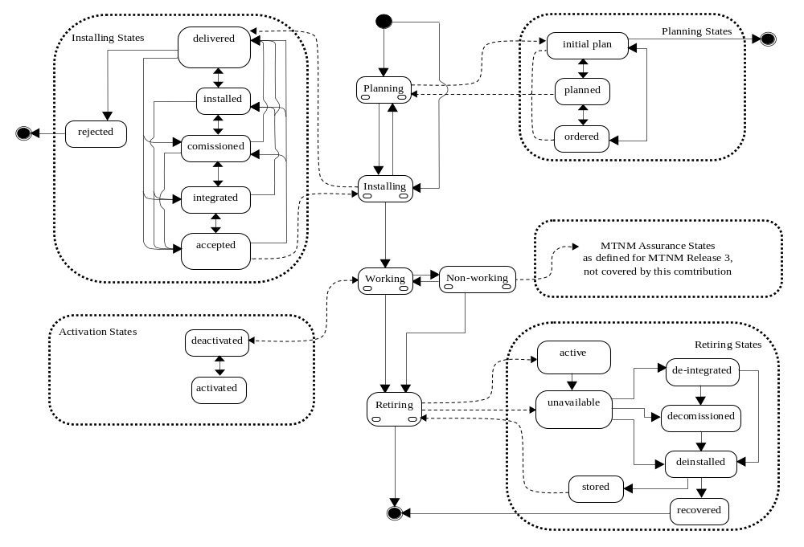

State Diagram Notes
- The state transitions to Retiring needs to allow for a resource has been identified for retiring, when it is still operational. The following are the stateQualifier transitions required to allow for this behaviour:
working[active] -> Retiring[withdrawn-active]
working[inactive] or [available] or [reserved] or [available] -> Retiring[withdrawn-unavailable]
Retiring[withdrawn-active] -> Retiring[withdrawn-unavailable]
non-working -> Retiring[withdrawn-unavailable]

- The scope of this contribution considers the state of the resource being deployed. It does not model the state of any plan(s) that may exist for a resource.
From an Operational Support View, there can be more than one plan for a resource which can be passed between Operational Support Systems. For example. There may be a plan to retire a resource or to reconfigure a resource (such as a rearrangement, or a protection upgrade or downgrade of a connectivity). These plans for resources can chronologically overlap.
If a resource is represented in such plans, then the data model of the resource needs to reflect a planning resource state until the plan is realized. (Indeed the initial deployment plan may often refer to a resource that does not exist - has not yet been manufactured).
Once the plan is implemented (realized), the resource state represented in the plan needs to be the state of the deployed resource.
Therefore, for a resource representation within a plan, additional resource state transitions are permitted:
Planning to Non-working (E.g.: planned network intervention affecting a resource)
Planning to Working (E.g.: service delivery using a resource)
Planning to Retiring (E.g.: planned of retirement of a resource)

- Reconfiguring of a resource and planning for it (required particularly in the case of connectivity) is not covered by the current state model.

- A supplier may supply resources from a ‘call-off’ pool to be used without a formal planning phase, therefore progression is permitted directly to Installing for such resources.

Compatibility and Mapping

Mapping to MTOSI v1.0
The MTOSI v1.0 specifications define a generic resource state with only three values: PLANNED, INSTALLED and RETIRED. The very basic WORKING state value was missing and is now fixed. Suggest you mention that we still have the UNKNOWN resourceState.
In addition, the MTOSI v1.0 specifies only the final values of a composite state. It is more appropriate to refer to the actual composite state values and allow for further qualification in other documents with the required scope. For this purpose, we replace the existing MTOSI v1.0 resource state values with the following:
PLANNED → PLANNING (replacing value)
INSTALLED → INSTALLING (replacing value)
WORKING (new value)
NON-WORKING (new value)
RETIRED → RETIRING (replacing value)

MTNM Compatibility
From “SD2-6_VersioningAndExtensibility.doc”, “SD2-3_v1.0_MTOSI_Guidelines.doc” and TMF854.v1.0, resourceState has been defined as qualifiable (as specified in the TMF 517 Business Agreement “SD2-13 Attribute Extensibility”).

The MTNM specifications define a serviceState to designate the availability of the MTNM resources. Since the MTOSI makes a distinction between Service Management and Resource Management, it specifies their corresponding Service States and Resource States. Consequently, the MTNM serviceState name doesn’t seem appropriate and it’s proposed here to change this name to resourceFulfillmentState to avoid any confusion with the MTOSI serviceState for Service Management. The state values would remain as they are.

In this document, we propose a separation of the resource assurance state aspects from the service fulfilment state aspects and in particular from the resource activation state. The MTNM serviceState and MTNM SNCState are mapped to the Resource Assurance and Resource Activation States as follows.

MTNM SNCState | Resource State – MTOSI v2.0 | ResourceStateQualifier Activation Status – MTOSI v2.0
SNCS_PENDING | PLANNING | Not applicable
SNCS_ACTIVE | WORKING | ACTIVATED or DEACTIVATED
SNCS_PARTIAL | WORKING*
SNCS_NONEXISTING | RETIRING | Not applicable
*When an SNC state is partial, then one (can be zero according to TMF 814) or more, but not all the XCs are active in the network.

MTNM serviceState | Resource State – MTOSI v2.0 | ResourceStateQualifier Activation Status – MTOSI v2.0
IN_SERVICE | WORKING | Any state value is legal
OUT_OF_SERVICE | NON-WORKING | Not applicable
OUT_OF_SERVICE_BY_MAINTENANCE | NON-WORKING | Not applicable
SERV_NA | Not applicable | Not applicable

Mapping to ITU-T X.731 and M.3100 States
The mapping of MTOSI V2.0 Non-working resourceStateQualifiers to permitted X.731 and M.3100 states has not been assessed.

The ITU-T X.731 recommendation specifies a set of states and a set of status qualifiers for these states. There are no status qualifiers for the Activation Phase state values in the X.731. The only possible ways to describe the Activation State values would be:
- either explicitly to introduce an ‘activationStatus’ into the X.731, as in the following table,
Activation States | operationalState | adminState | activationStatus
Activated | ENABLED | UNLOCKED | ACTIVATED
Deactivated | ENABLED | LOCKED | DEACTIVATED
- or implicitly as a combination of operationalState and adminState as shown above.

Alignment with ETSI TSPAN Equipment Lifecycle
The following identifies the alignment between this proposal and ETSI Technical Report ETSI TR 102 450 V1.1.1 (2006-01).

ETSI TSPAN uses the concepts from the SCOR model to describe the suppliers processes involved in a resource’s life cycle and TMF eTOM to describe the service providers processes involved in the equipment life cycle.
For Planning Installing and Retiring of a resource we are considering the resource’s life cycle from the service provider’s process view.

The scope of the Resource States for MTOSI v2.0 is confined to the aspects of Deliver, Installation and Activation only. Usage and Assurance are planned for further study.

In the ETSI document specifies the following resource lifecycle activities:
A) Preparation and Development - out of the MTOSI v2.0 scope
B) Manufacturing - out of the MTOSI v2.0 scope
C) Delivery - partially within MTOSI v2.0 scope
D) Installation - within the MTOSI v2.0 scope
E) In-Service Operations - partially within the MTOSI v2.0 scope
F) Replacement/Update - not in the MTOSI v2.0 scope
G) Maintenance and Repair - out of the MTOSI v2.0 scope, will be included in the Resource Assurance
H) End of Life or Phased-out - within the MTOSI v2.0 scope

Regarding item C, Delivery, the ETSI document specifies the following activities:
C.1) Plan - reflected in the Resource Planning State
C.2) Deliver - reflected in the Resource Installing State, Delivered Qualifier
C.3) Return - reflected in the Resource Installing State, Returned Qualifier

Regarding item D, Installation, the ETSI document specifies the following activities:
D.1) Preparation - out of the MTOSI v2.0 scope
D.2) Equipment Installation - reflected in the Resource Installing State Installed Qualifier
D.3) Software Installation - reflected in the Resource Installing State Commissioned Qualifier
D.4) Verification - reflected in the Resource Installing State Verified Qualifier

Regarding item E, In-Service Operations, the ETSI document refers to the following eTOM processes:
E.1) Support and Readiness - partially reflected in the Resource Installing State Verified Qualifier
E.2) Resource Provisioning - within the MTOSI v2.0 scope
E.3) Resource Trouble Management - out of the MTOSI v2.0 scope, will be included in the Resource Assurance
E.4) Supplier/Partner Relationship Management - out of the MTOSI v2.0 scope
E.5) Enterprise Management- Financial and Asset Management - out of the MTOSI v2.0 scope
E.6) Customer Relationship Management - out of the MTOSI v2.0 scope

Regarding item E.1, Support and Readiness, the following discrepancies have been identified:
E.1.1) The Resource States don't describe the ordering of equipment by suppliers/partners (this is not in the scope of MTOSI v2.0). (The availability of operational support is implicit in the Resource Installing State Verified Qualifier.)
E.1.2) Missing distinction between installed-active and installed-spare resources (requires update)
E.1.3) Missing indication of performance level - not in the scope of MTOSI v2.0 (will be included in the Resource Assurance)
E.1.4) Missing indication of correct customer assignment (requires further discussion to check relevance)

Regarding item F, Replacement/Update, the following discrepancies have been identified
- the upgrade of a Resource is not in the MTOSI v2.0 scope
- the replacement of a Resource is equivalent to the ‘End of Life’ for that resource with a new resource being used to replace it.

Regarding item H, End of Life or Phased-out, the Resource State details this lifecycle stage. It is not documented in detail in the ETSI document.

Administrative Appendix

Document History

Version Number | Date Modified | Modified by: | Description of changes
1.0 | Oct 2007 |  | This is the first version of this document

Acknowledgments

First Name | Last Name | Company
Shlomo | Cwang | Cramer > Amdocs OSS Division
Steve | Fratini | Telcordia Technologies Inc.

How to comment on this document
Comments and requests for information must be in written form and addressed to the contact identified below:

Colin | Barker | BT Group plc
Phone: | +44 (0)1753 880 169
Fax: | +44 (0)1494 510 691
e-mail: | colin.barker@bt.com

Please be specific, since your comments will be dealt with by the team evaluating numerous inputs and trying to produce a single text. Thus we appreciate significant specific input. We are looking for more input than wordsmith” items, however editing and structural help are greatly appreciated where better clarity is the result.

