IA open issues
- Definition of Write access to attributes:
Which attributes are needed to define the write access to the attributes?
See also
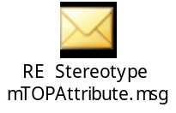
mTOPmeth CC (22 Oct.) agreed to the following solution:
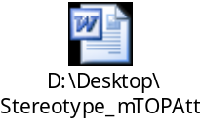
- Naming relationship:
Naming relationships are defined using the composition association with:
a private role name at the subordinate class
stereotype = <<naming>>
abstract = true
no relationship name.
The attribute which is used for naming is identified by an additional stereotype <<objectRefKey>>.
mTOPmeth CC (05 Nov.) agreed to keep the current solution.
- Definition of a Data Type list:
MTNM and MTOSI so far need
- String
- Integer
- unsigned Integer
- Boolean
- Real
and a yet to be defined data type for Date/Time.
May be SID needs more types?
See also section 3.4.2 in the IA Guideline document and

mTOPmeth CC (05 Nov.) agreed to use the 6 primitive data types as mentioned before.
- Return types vs. output parameters:
Return Type : always "void".
mTOPmeth CC (05 Nov.) agreed to use the input and output parameters and not the return parameter.
- inheritance and multiple inheritance may be used.
mTOPmeth CC (05 Nov.) agreed that multiple inheritance can be used in the IA.
- OM Service description structure:
A simplified version of the OASIS "SOA Reference Model" has to be defined.
mTOPmeth CC (05 Nov.) agreement that this Reference Model is not applicable for MTOSI Rel. 2.0.
- "passedBy" problem:
see attached file
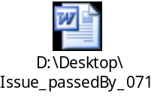
mTOPmeth CC (05 Nov.) agreed to the proposed solution.

