setTransmissionDescriptorAssociation() in MTNM 3.5

BA

{Requirement II. 194} | The NML-EML Interface shall allow the NMS to associate an ingress and/or egress Transmission Descriptor (TMD) with a given Termination Point (TP) identified by an NMS specified TP name.
 | Source: Version 3.0

{Requirement II. 312} | The NML-EML Interface shall allow the NMS to associate a Transmission Descriptor (TMD) to a given Matrix Flow Domain (MFD) identified by an NMS specified MFD name.  The association will overwrite specific transmission parameters of the MFD with the corresponding parameter values contained in the TMD. The Behaviour is defined in {Requirement II. 277}.
 | Source: Version 3.5

{Requirement II. 313} | The NML-EML Interface shall allow the NMS to de-associate a Transmission Descriptor (TMD) from a given Matrix Flow Domain (MFD) identified by an NMS specified MFD name.  The de-association shall not influence any transmission parameter configured in the MFD. The Behaviour is defined in {Requirement II. 277}.
 | Source: Version 3.5

{Requirement II. 277} | The assignment of a Transmission Descriptor (TMD) to a Termination Point (TP) or Matrix Flow Domain (MFD) by using the TMD's name amounts to an overwriting of the layered transmission parameters of the TP or MFD by the layered transmission parameters of the TMD and to an overwriting of the additional information parameters of the TP or MFD by the additional Object information parameters of the TMD.  Note that these parameters may also be set according to {Requirement II. 072}, {Requirement II. 223} and {Requirement II. 307} without using a TMD. Current parameters of the TP or MFD that are not present as parameters of the TMD are left unchanged by the TMD assignment.  The unassignment of a TMD from a TP or MFD (by using the empty TMD name) has no effect on the parameters of the TP or MFD, i.e. the layered transmission parameters and additional info parameters of the TP or MFD remain unchanged.
 | Source: Version 3.5

7.5.13 NMS modifies a Transmission Descriptor (TMD) on a TP

Use Case Name | NMS modifies a Transmission Descriptor (TMD) on a TP
Summary | The NMS changes the Transmission Descriptor (TMD) (ingress and/or egress) for a TP.
Actors | NMS
Pre-conditions | 1) The NMS has executed Use Case 7.2.2: NMS creates a session with EMS.  2) TransmissionDescriptor to be associated has to exist.
Begins when | The NMS sends the modify TP request to the EMS.
Description | - The NMS sends the modify TP request to the EMS.  - The EMS validates the TP identifier.  - The EMS validates the TMD Name(s).  - The EMS communicates with the Network Elements (NE).  - The EMS changes the TMD(s) if possible. This will fail under the following conditions:  - The TP is terminating, but was not explicitly created.  - The input data is valid but the EMS cannot change the TMD because resources are not available on the NE.  - The input data is valid but the EMS cannot change the TMD because the new TMD does not provide enough resources for the existing SNCs running over the TP.  - The EMS replies with a success indication.  - The EMS will generate an AVC for the TP with the new TMD name.
Ends when | The EMS sends a reply to the NMS.
Post-conditions | The TMD(s) on the TP has been updated.
Exceptions | 1) Not implemented: The EMS does not support this service.  2) Internal Error: The request has resulted in an EMS internal error.  3) Invalid Input: The request contains an input parameter that is syntactically incorrect or identifies an object of the wrong type or is out of range.  4) Entity Not Found: The specified object instance does not exist.  5) Unable To Comply: The EMS cannot perform the the request.  6) NE communication loss: The EMS is unable to communicate with the NE and communication is required to complete the request.
Traceability | {Requirement II. 194}

7.5.14 NMS sets the Transmission Descriptor (TMD) Profile Pointer

Use Case Name | NMS sets the Transmission Descriptor (TMD) Profile Pointer
Summary | The purpose of this use case is to configure the Layered Transmission Parameters of a Termination Point (TP) or a Matrix Flow Domain (MFD) by modifying the assignment of the Transmission Descriptor (TMD) to this TP/MFD.
Actors | NMS
Pre-conditions | The NMS has executed Use Case 7.2.2: NMS creates a session with EMS.
Begins when | The NMS sends the request to the EMS.
Description | - The NMS sends the request to the EMS to set the TMD pointer.  - The NMS may provide:  - an ingress TMD name (in case of a TP) or  - an egress TMD name (in case of a TP)or  - a TMD name (in case of an MFD)  If a TMD has to be removed, the NMS has to provide an “empty TMD name” instead of the TMD name.  - The EMS checks the syntax of the request. If the request is not valid, an Invalid Input exception is raised.  - If a TMD has to be removed:  The EMS checks the existence of the TMD to be removed. If the TMD is not associated, an Entity Not Found exception is raised.  Only the pointer attribute in the TP/MFD which contains the name of this TMD hasto be updated and an AVC notification has to be send.  Note: The parameter values in the TP/MFD remain unchanged.  - If a TMD has to be added:  The EMS checks the existence of the TMD to be added. If the TMD does not exist, an Entity Not Found exception is raised.  If the TMD to be added is already associated to the TP/MFD, the EMS shall overwrite all corresponding parameters in the TP/MFD with the values contained in the TMD.  Parameters which are not already in the TP/MFD will be added to the TP/MFD. This request ensures consistency between the parameter values of the TMD and the parameter values of the TP/MFD.  (Note: Individual values may have been changed in the TP/MFD before via the use cases "NMS provisions the TP Transmission Parameters" and "NMS modifies a Matrix Flow Domain".)  If the parameter values can not be set on the TP/MFD, an Unable To Comply exception is raised.  If the TMD is not already assigned to the TP/MFD the EMS shall set all parameter values as defined in the TMD profile.  If the parameter values can not be set on the TP/MFD, an Unable To Comply exception is raised. The pointer attribute in the TP/MFD which contains the name of this TMD has to be updated and an AVC notification has to be send.
Ends when | In case of success:  The parameter values of the TP/MFD are consistent with the parameter values of the (newly) associated TMD profile.  In case of failure:  The NMS receives an exception as an indication of the failure of the request.
Post-conditions | In case of success:  The parameter values of the TP/MFD are consistent with the parameter values of the (newly) associated TMD profile.  In case of failure:  Nothing has changed in the System.
Exceptions | Refer to Table 7.1
Traceability | {Requirement II. 194}, {Requirement II. 277}, {Requirement II. 312}, {Requirement II. 313}

IDL

struct TerminationPoint_T
{
globaldefs::NamingAttributes_T name;
string userLabel;
string nativeEMSName;
string owner;
globaldefs::NamingAttributes_T ingressTrafficDescriptorName;
globaldefs::NamingAttributes_T egressTrafficDescriptorName;
TPType_T type;
TPConnectionState_T connectionState;
TerminationMode_T tpMappingMode;
Directionality_T direction;
transmissionParameters::LayeredParameterList_T transmissionParams;
TPProtectionAssociation_T tpProtectionAssociation;
boolean edgePoint;
globaldefs::NVSList_T additionalInfo;
};

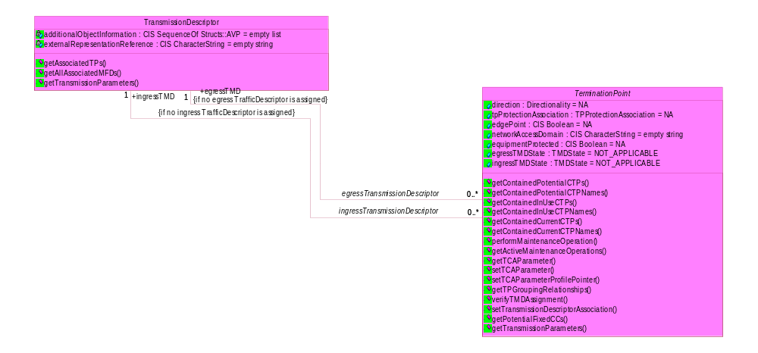

additionalInfo:
“EgressTMDstate” PTP, FTP, CTP
“IngressTMDstate” PTP, FTP, CTP
“EgressTMD”
“IngressTMD”

ParameterName | Objects | Legal values | Potentially settable from | Comment / Example
“TransmissionDescriptorPointer” | TP, MFD | String | EMS & NMS  see also restriction in comment | Name value of a layer-specific transmission descriptor.  For MFD only settable via the setTransmissionDescriptorAssociation () operation.  For TP, it is recommended to set the value only via the setTransmissionDescriptorAssociation () operation..
“TransmissionDescriptorState” | TP, MFD | "TMD_MISSING",  "NOT_APPLICABLE",  "PENDING",  "APPLIED",  "MISMATCH" | EMS | Indicates the state of consistency between the layered parameters of the object and its associated Transmission Descriptor (TMD).  See also the statechart diagram for TMDState in the UML specification.

struct MatrixFlowDomain_T
{
globaldefs::NamingAttributes_T name;
string userLabel;
string nativeEMSName;
string owner;
transmissionParameters::LayeredParameterList_T transmissionParams;
string networkAccessDomain;
boolean flexible;
globaldefs::NVSList_T additionalInfo;
};

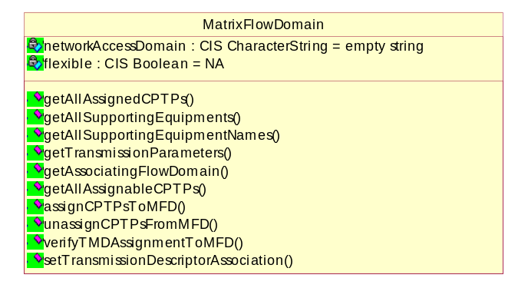

void setTMDAssociation (
in globaldefs::NamingAttributes_T tmdName,
inout TPorMFDorFDFr_T tPorMFDorFDFr)
raises (globaldefs::ProcessingFailureException);
};
union TPorMFDorFDFr_T switch (TPorMFDorFDFrQualifier_T)
{
case aTP: terminationPoint::TerminationPoint_T tp;
case aMFD: flowDomain::MatrixFlowDomain_T mfd;
case aFDFr: flowDomainFragment::FlowDomainFragment_T fdfr;
};

void setTPData(
in subnetworkConnection::TPData_T tpInfo,
out terminationPoint::TerminationPoint_T modifiedTP)
raises(globaldefs::ProcessingFailureException);

setTransmissionDescriptorAssociation() in MTOSI 2.0

BA

{R_TMF518_RP_II_0097} | The Interface shall allow the requesting OS to associate an ingress and/or egress Transmission Descriptor (TMD) with a given Termination Point (TP) identified by its TP name specified by the requesting OS.
Source | TMF 513 v3.1, Requirement II.194

{R_TMF518_RP_II_0044} | The Interface shall allow the requesting OS to associate a Transmission Descriptor (TMD) to a given Matrix Flow Domain (MFD) identified by a requesting OS specified MFD name.  The association will overwrite specific transmission parameters of the MFD with the corresponding parameter values contained in the TMD. The Behaviour is defined in R_TMF518_RP_II_0098.
Source | TMF 513 v3.1, Requirement II. 312

{R_TMF518_RP_II_0045} | The Interface shall allow the requesting OS to de-associate a Transmission Descriptor (TMD) from a given Matrix Flow Domain (MFD) identified by a requesting OS specified MFD name.  The de-association shall not influence any transmission parameter configured in the MFD. The Behaviour is defined in R_TMF518_RP_II_0098.
Source | TMF 513 v3.1, Requirement II. 313

{R_TMF518_RP_II_0098} | The assignment of a Transmission Descriptor (TMD) to a Termination Point (TP) or Matrix Flow Domain (MFD) by using the TMD's name amounts to an overwriting of the layered transmission parameters of the TP or MFD by the layered transmission parameters of the TMD and to an overwriting of the additional information parameters of the TP or MFD by the additional Object information parameters of the TMD.  Note that these parameters may also be set according to R_TMF518_RP_II_0088 and without using a TMD. Current parameters of the TP or MFD that are not present as parameters of the TMD are left unchanged by the TMD assignment.  The unassignment of a TMD from a TP or MFD (by using the empty TMD name) has no effect on the parameters of the TP or MFD, i.e. the layered transmission parameters and additional info parameters of the TP or MFD remain unchanged.
Source | TMF 513 v3.0, Requirement II.277

Traceability
UC_TMF518_RP_0043 (The requesting OS modifies a Transmission Descriptor (TMD) on a TP)

Use Case Id | UC_TMF518_RP_0043
Use Case Name | The requesting OS modifies a Transmission Descriptor (TMD) on a TP
Summary | The requesting OS changes the Transmission Descriptor (TMD) (ingress and/or egress) for a TP.
Actors | The requesting OS
Pre-conditions | 1. The requesting OS and target OS have successfully executed the Use Case 0001 OS (Re) Starts as defined in the TMF518_FMW BA document.  2. TransmissionDescriptor to be associated has to exist.
Begins when | The requesting OS sends the modify TP request to the target OS.
Description | - The requesting OS sends the modify TP request to the target OS.  - The target OS validates the TP identifier.  - The target OS validates the TMD Name(s).  - The target OS communicates with the Network Elements (NE).  - The target OS changes the TMD(s) if possible. This will fail under the following conditions:  - The TP is terminating, but was not explicitly created.  - The input data is valid but the target OS cannot change the TMD because resources are not available on the NE.  - The input data is valid but the target OS cannot change the TMD because the new TMD does not provide enough resources for the existing SNCs running over the TP.  - The target OS replies with a success indication.  The target OS will generate an AVC for the TP with the new TMD name.
Ends when | The target OS sends a reply to the requesting OS.
Post-conditions | The TMD(s) on the TP has been updated.
Exceptions | 1. Not implemented: The target OS does not support this service.  2. Internal error: The requested operation could not be performed.  3. Invalid input: The requesting OS has supplied invalid input data (e.g. the TP or TMD identifier is invalid).  4. Entity not found: The TP or TMD does not exist.  5. Unable to comply: The transmission parameter values could not be configured in the TP.  6. Comm loss (Communication loss).
Traceability | R_TMF518_RP_II_0097  This use case is a generalization of Use Case 5.5.13 from TMF 513 v3.0

Use Case 7.5.14 NMS sets the Transmission Descriptor (TMD) Profile Pointer from MTNM 3.5 not in TMF518_RP.

XML

