Clarification of relationship between a TPPool and its TerminationPoints

The relationship between a TPPool and its associated TPs (not GTPs) is a "asymmetric" relationship; i.e. the execution of the operation getTPGroupingRelationships() on a TPPool will return all its member TPs/GTPs; the execution of the operation getTPGroupingRelationships() on a TP will return the TPPool containing this TP (if applicable) and in addition further associated TPPools (e.g., TPPools containing client CTPs of this TP).

The following example shows a "containing" ATM NI TPPool and for one of its members associated, but not "containing", ATM VP TPPools:
ATM NI CTPs "1" - "5" are grouped in TPPool "X" comprising two MEs.
ATM NI CTP "3" is terminated and its client ATM VP CTPs are grouped by TPPools "a", "b" and "c".
ATM NI CTP "5" is terminated and its client ATM VP CTPs are not grouped by any TPPool.
ATM NI CTPs "1", "2" and "4" are not terminated.
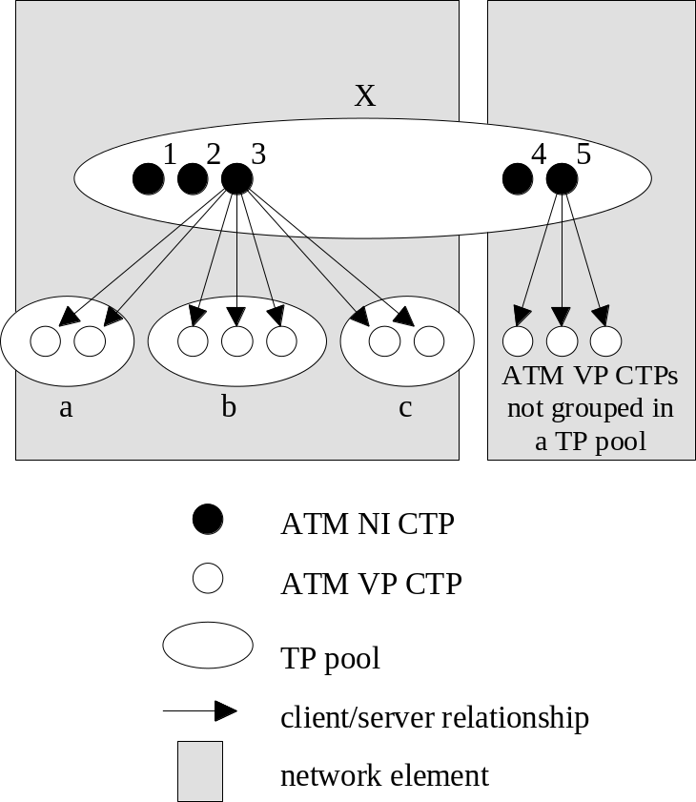

The following statements apply to the operation getTPGroupingRelationships() of class TerminationPoint:
- Execution of getTPGroupingRelationships() with tpName = ATM NI CTP "1" (or "2" or "4") will return the containing TPPool "X".
- Execution of getTPGroupingRelationships() with tpName = ATM NI CTP "5" will return the containing TPPool "X".
- Execution of getTPGroupingRelationships() with tpName = ATM NI CTP "3" will return the containing ATM NI TPPool "X" plus all associated TPPools containing potential or actual client ATM VP CTPs of the ATM NI CTP "3" (i.e. ATM VP TPPools "a", "b" and "c").

Clarification for model TDM Over Packet network
The following example shows how to model CES Circuit(TDM based on PW), which is an adaptation function like Circuit Emulation, and need consider as service. But It’s neither networking nor service properties:

Some principle in TMF and ITU-T
SNC object models all connection oriented technologies, and FDFr object models the Ethernet.
ITU-T ‘s rule: A representation at a given layer is independent by any possible server (and client) layer (ITU-T).

SDH Path Example
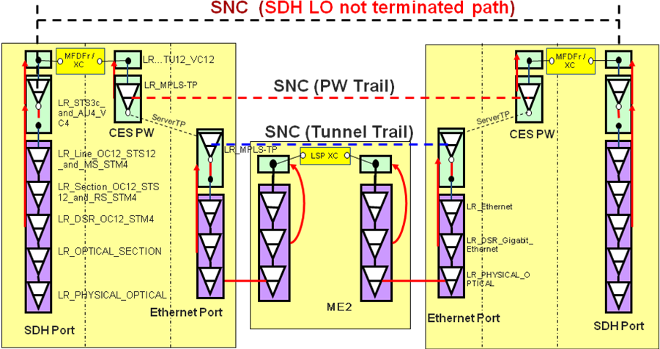

PDH Path example 1: no flexibility
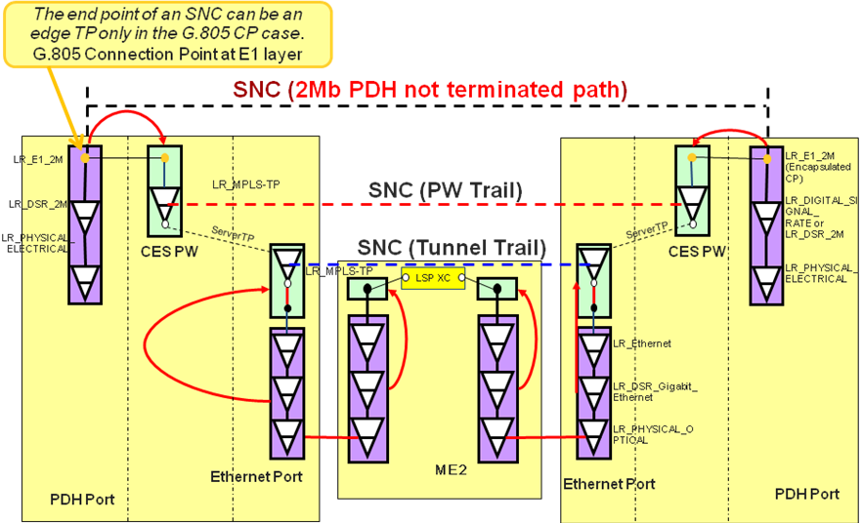

PDH Path example 2: flexibility
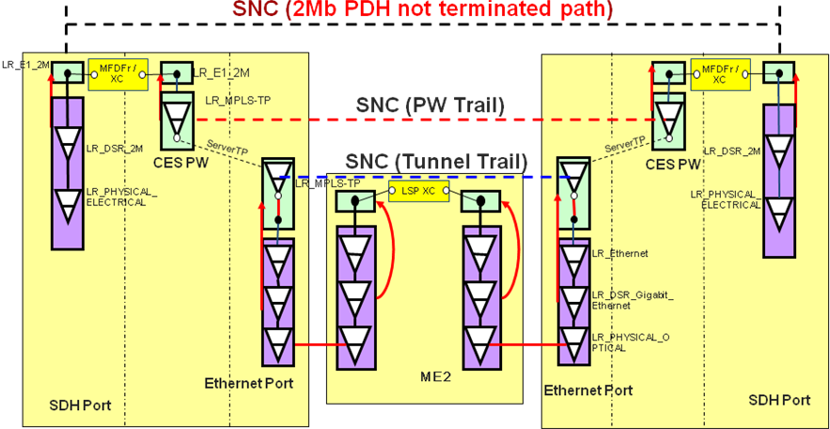

More Subnetworks
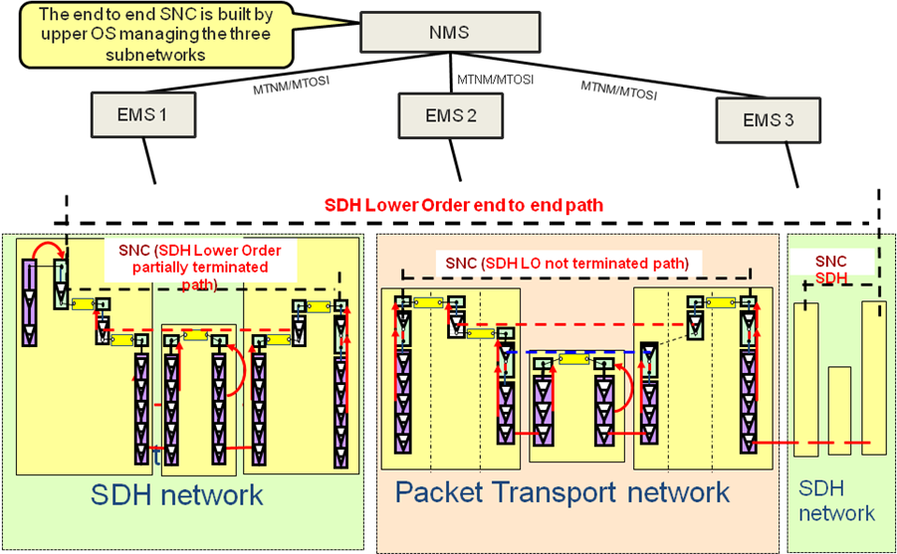
the Interaction between NMS-EMS is described in following map.
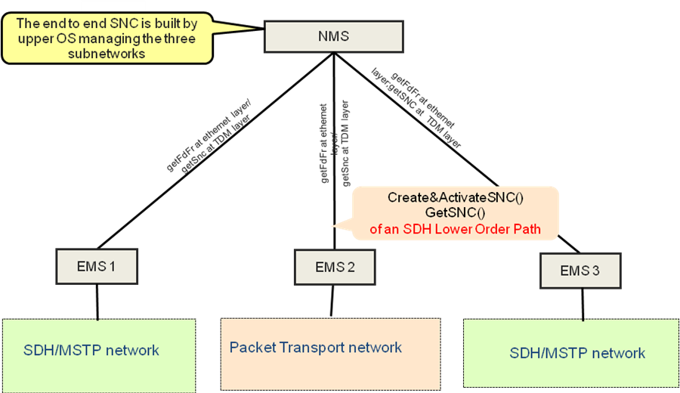

Revision History
Version | Date | Description of Change
3.0 | April 2005
3.1 | April 2014 | Add description on how to model TDM circuit over Packet network

Acknowledgements
<FirstName> | <LastName> | <Company>

How to comment on the document
Comments and requests for information must be in written form and addressed to the contact identified below:

Keith | Dorking | CIENA
Phone: | +1 678 867 5007
Fax: | +1 678 867 5010
e-mail: | Kdorking@ciena.com

Please be specific, since your comments will be dealt with by the team evaluating numerous inputs and trying to produce a single text. Thus we appreciate significant specific input. We are looking for more input than wordsmith” items, however editing and structural help are greatly appreciated where better clarity is the result.

