MTOSI Versioning and Extensibility

Abstract
This document addresses Versioning and Extendibility support for MTOSI. Through the versioning mechanism it is possible to evolve the interfaces in a controlled manner maintaining backward and forward compatibility for a class of changes considered minor. The extension mechanism allows a vendor (and\or an MTOSI architect) to tailor the specification to deal with future or specific concerns not addressed in the most current MTOSI release (latest version of the service interfaces).

Table of Contents
1 Introduction 2
2 Forward and Backward compatibility 2
3 Minor and Major version compatibility 3
4 Version Identifiers 4
5 Marking the XSD and XML messages 4
6 XSD namespace 6
7 Achieving minor version interoperability 6
7.1 Backward compatibility 7
7.2 Forward compatibility 7
7.2.1 Planned extensions 7
7.2.2 Validation by projection 7
7.3 MTOSI minor version mechanism 7
7.3.1 Minor Version Interoperability Use case set 8
8 Major Version Interoperability Transition 10
8.1.1 Major Version Interoperability Use Cases 11
9 MTOSI Schema Extensions 13
9.1 MTOSI Objects and Notifications 13
9.1.1 Definition of Vendor Extensions 13
9.1.2 Versioning the vendor extensions 15
9.1.3 How to use the vendor extensions. 15
9.1.4 Bridge pattern 16
9.1.5 Brute force 17
9.2 MTOSI Attributes 17
9.2.1 Definition of Attribute Extensions 18
9.3 Extendable Type Extension 20
9.3.2 Attribute Extension Examples 22
9.4 MTOSI Vendor Objects and Notifications 22
9.4.1 Definition of MTOSI Vendor Object 23
9.4.2 Definition of MTOSI Vendor Notification 24
9.5 MTOSI Extensions Usage Recommendations 25
9.5.1 Namespace 26
9.5.2 Extending an MTOSI Object vs. Using Vendor Object 26
9.5.3 Examples of XML Messages with Extensions 26
10 Advanced versioning features 27
11 MTOSI Requirements trace 27
12 Summary 29
13 Revision History 30
14 Acknowledgements 30
15 How to comment on the document 30

Introduction
Versioning entails rules and conventions for updating and supporting the MTOSI XML from one version to the next. Two classes of versions are identified each with different compatibility implications: minor and major versions. This contribution describes the mechanism for MTOSI versioning in order to guarantee the compatibility of minor versions and the possible migration strategies between major versions. The extensions mechanism is also addressed in order to allow a vendor (and/or an MTOSI architect) to extend the MTOSI specification with structures needed in any future or specific MTOSI deployment.

Forward and Backward compatibility
MTOSI defines a set of interfaces exposed as services.
An interface consists of a set of operations, which in turn consist of a set of messages
Within MTOSI we refer to the interface as “service interface”.
E.g., getTerminationPoint operation in the TerminationPointRetrieval interface of the ManagedResourceInventory DDP has:
- getTerminationPointRequest, the request message
- getTerminationPointResponse, the response message
All interface messages are XML instance documents with associated XSDs (XML Schema Definition) for validation.
A Service exposes one or more Interfaces (wsdl:portType and related bindings). A message processor processes an XML instance. In Client-Server architectures both Client and Server or Sender and Receiver in a Request/Response business activity will be processing an XML instance. For this reason Backward and Forward compatibility is defined in relation to the processor role in which a sender or a receiver is acting [ORC01].
Backward compatibility – The message processor works correctly when receiving an old version of a message.
Forward compatibility – The message processor works correctly when receiving a new version of a message.
Interfaces versions are fully compatible if the versions are both backward and forward compatible.

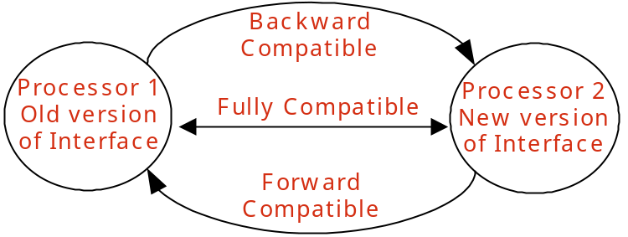
Figure 1 - Backward and Forward Compatibility

A major update is a change for which no meaningful communication between Sender and Receiver is possible with respect to the change, where the Sender and Receiver are using different versions. A message processor will not be able to natively process a message after a major update. After a major update the service will loose its backward compatibility (by definition).

A minor update is a change after which it is still possible for a processor to natively process a message. After a minor change the service will still be backward compatible.

Minor and Major version compatibility
The versioning of the release (MTOSI Release 2.0) has nothing to do with the compatibility of the included interface/data specifications. I would just remove it and explain the concepts of major and minor versions as a change in the interface/data specifications.

For example, we may deliver MTOSI R3.0 because some interfaces are not compatible with their previous versions (interface versioning here). But, others may be the same (same interface version as in MTOSI R2.0) or have changed of minor version. The same idea for the data definitions (some may change)

So, we need to decouple the versioning of the product release as a collection of interface specifications with their own versioning. It is the same for the data that is visible thru the interfaces. There is a distinct specification versioning for the definition of each managed entities.

Also, the previous section already cover the concepts of major/minor update and compatibility. Shall we merge section 2&3 together as Managing Interface Specifications Changes and describing Forward/Backward Compatibility and Minor/Major Version concepts?

In MTOSI we support both major and minor versioning as defined in the previous section 2.

Only the addition of new optional elements or optional structures in the XSD is both forward and backward compatible

Considering that compatible versions are classified as minor versions, the above axiom has the following implications:
- Adding a new optional interface to an MTOSI release is considered a minor change.
- Adding a new optional operation/notification to an interface is considered a minor change.
- Adding a new optional formal argument in an operation is considered a minor change.
- Adding a new optional element or structure to an MTOSI network object (TMF608) is considered a minor change.
- Adding or refining enumeration values as a minor change in a new release may be achieved by introducing an optional enumeration variable that specializes the base variable. Adding a new enumeration value directly in the enumeration set will result in a major version.
- Adding mandatory artifacts will result in a major version.
- Deleting artifacts by deprecating them will result in a minor version
- Deleting mandatory artifacts by removing them will result in a major version
- Deleting optional artifacts by removing them will result in a minor version

All minor versions of an interface within a major version are defined to be compatible with each other
- E.g., 1.0, 1.0.1, 1.1, 1.2 are compatible with each other.
It should be noted that minor versions of an interface are generally NOT identical but just compatible. Version 1.8 has different capabilities than 1.1. These differences make them different even though the addition of minor updates is still compatible. Any business activity supported by V1.1 should be supported by V1.8 with reasonable behaviors. The vice versa is also true. Note that the adjective “reasonable” refers to a contained semantic difference that can be tolerated in the context of a business activity. Section 9 explains the details on how to achieve minor version interoperability in MTOSI.

Different major versions of an interface are not compatible with each other
- E.g., 1.x and 2.x are not compatible versions
Although not normative, this document highlights (section 10) several possible migration strategies to bridge different major release of MTOSI.

Version Identifiers
Version identifiers are of the form “N.x”, where “N” represents the major version number and “x” represents the minor version string.
“N” must be a number
“x” must start with a number, but may also contain additional periods and numbers, e.g., “0”, “0.1”, “1.1”
Starting with version 1.0, each time a minor change is applied to the interface the minor string is changed. The new minor release string should be lexically greater than the previous.
Each time a major change is introduced in an interface, the major version number should be incremented.

Marking the XSD and XML messages

MTOSI IIS Namespace and Versioning
Two of the key factors to designing a successful XML-based interface are:

- The partitioning of the overall set of XML artifact definitions into manageable IIS namespaces
- The handling of the version controls to track the changes of the XML artifact definitions in these IIS namespaces

Namespace Design Guidelines
Rational for namespace partitioning of the MTOSI IIS.

Versioning Design Guidelines
Versioning of the MTOSI Interface Implementation Specifications (IIS) is carried out in the following ways (Refer to the SD0-5 Web Services Design Guidelines):

- All MTOSI IIS artifact definitions are version controlled using the XML namespace.
  - The versioning of the MTOSI WSDL artifacts includes the full version number.
  - The versioning of the MTOSI XML Schema artifacts only includes the major version number. This is based on the fact that XML documents generated by XML Schema of different minor versions are always compatible.
- All MTOSI service interface IIS definitions are bound to an independent version number. Hence, an MTOSI service interface can evolve independently of others through subsequent MTOSI release versions.
  - MTOSI R2.0 has the following service interfaces:
    - RTM DDP:
      - AlarmRetrieval Version 1.0
      - AlarmControl Version 1.0
    - MRI DDP:
      - ResourceInventoryRetrieval Version 1.0
      - TerminationPointRetrieval Version 1.0
  - Future MTOSI R2.1 may have (example only):
    - RTM DDP:
      - AlarmRetrieval Version 1.0 (unchanged)
      - AlarmControl Version 1.1 (minor change – new optional operations/attributes/parameters)
    - MRI DDP: (unchanged)
      - ResourceInventoryRetrieval Version 1.0
      - TerminationPointRetrieval Version 1.0
  - Future MTOSI R3.0 may have (example only):
    - RTM DDP:
      - AlarmRetrieval Version 2.0 (major change)
      - AlarmControl Version 1.1 (unchanged)
    - MRI DDP: (unchanged)
      - ResourceInventoryRetrieval Version 2.0 (major change)
      - TerminationPointRetrieval Version 1.0 (unchanged)
- Each MTOSI XML Schema namespace is bound to an independent version number. The MTOSI XML Schema definitions of any given namespace can evolve independently of other definitions from other namespaces.
  - There are XML Schema associations (dependencies) which have for effect to bind definitions between different namespaces. For instance, the extension of a complex type (represented from a UML inheritance) bind the child definition to its parent.

Versioning of a Service Interface Artifacts
The versioning of the specification artifacts that describe an MTOSI service interface are as followed:

- All WSDL definitions of an MTOSI service interface are assigned the
<< top be reviewed The MTOSI version information should appear at least in top-level XML elements as an XML attribute tmf854Version. The following example illustrates an MTOSI message version 1.0 extended by ACME with extension version 1.5. >>
The tmf854Version information must be copied to the communication header properties, e.g., JMS header, to allow for version specific subscriptions or routing. (see SD2-9 Using JMS as an MTOSI Transport). The extAuthor and extVersion may as well be copied in the transport communication header properties to speedup the vendor specific message processing.
Although this initial release allows multiple vendor extensions from different providers, versioning of multiple extensions has not been addressed yet and will most likely be part of Phase II.
All Interfaces and operations of an interface will have the same version number. This coarse granularity simplifies the versioning management for the MTOSI supplier and should address most of the MTOSI deployment needs. Nevertheless, this mechanism can be enhanced (feature possibly addresses in Phase II) to support a different (finer) versioning granularity.
Note that the XSD attribute in a specific major version will only enforce the correct major version and should allow for all minor version number to be used in the XML instances. In particular a specific message processor (e.g. v1.5) should be able to validate any message compliant to all the earlier minor versions (e.g. V1.1, V1.2, etc).

<soap:Envelope xmlns:soap="http://www.w3.org/2003/05/soap-envelope" xmlns="tmf854.v1" xmlns:xsi="http://www.w3.org/2001/XMLSchema-instance" xsi:schemaLocation="tmf854.v1 ../xsd/common/header.xsd tmf854.v1 ../xsd/interfaces/InventoryRetrieval.xsd http://www.w3.org/2003/05/soap-envelope http://www.w3.org/2003/05/soap-envelope">
<soap:Header>
<header tmf854Version="1.0" extAuthor="ACME" extVersion="1.5">
<activityName>getInventory</activityName>
<msgName>getInventory</msgName>
MTOSI version
<msgType>REQUEST</msgType>
<senderURI>/MTOSI/InventoryOS</senderURI>
<destinationURI>/MTOSI/EMS01</destinationURI>
<correlationId>0001</correlationId>
<communicationPattern>MultipleBatchResponse</communicationPattern>
<communicationStyle>MSG</communicationStyle>
<requestedBatchSize>0</requestedBatchSize>
<timestamp>20051004140305</timestamp>
</header>
</soap:Header>
<soap:Body>
<getInventory tmf854Version="1.0" extAuthor="ACME" extVersion="1.5">
<filter></filter>
</getInventory>
</soap:Body>
</soap:Envelope>
>>

Within the XSDs the proper version number (Major and Minor is accounted in the “version” attribute of the main namespace definition.

<!-- mTOP DDP - Framework - Copyright TeleManagement Forum 2008 -->
<xsd:schema xmlns:xsd="http://www.w3.org/2001/XMLSchema" xmlns:tns="http://www.tmforum.org/mtop/fmw/xsd/msg/v1" xmlns:hdr="http://www.tmforum.org/mtop/fmw/xsd/hdr/v1" xmlns:gen="http://www.tmforum.org/mtop/fmw/xsd/gen/v1" targetNamespace="http://www.tmforum.org/mtop/fmw/xsd/msg/v1" elementFormDefault="qualified" attributeFormDefault="unqualified" version="1.0">

XSD namespace

Each Service Interface is marked by a namespace with a major version number.
For example: EquipmentInventoryRetrievalMessages.xsd, one of the interfaces of the ManageResourceInventory DDP has the following namespace xmlns:tns=http://www.tmforum.org/mtop/mri/xsd/eir/v1

Within the DDPs, logical grouping of definitions are also versioned according to the DDP/XSD structure: e.g. in the Framework DDP MessageDefinitions.xsd which defines common definitions, has the namespace http://www.tmforum.org/mtop/fmw/xsd/msg/v1.

The purpose of the xsd namespace is to isolate major versions of similar XSDs and allow cross validation of minor version of the same major. Adding the major identifier in the namespace will prevent different major release to validate by mistake.
The top-level message (defining the root message in the body of an MTOSI message) defines and assign a namespace to the XML message: tmf854.v1
Adding an xsd namespace to the XSD definition allowed us to relax the directory structure.
It is now possible to reference to different versions of a message by using the proper namespace and without using a combination of prefix and directory structure.

<xsd:schema xmlns:xsd="http://www.w3.org/2001/XMLSchema" xmlns="tmf854.v1" targetNamespace="tmf854.v1">
<!-- ===================== Includes ========= -->
<xsd:include schemaLocation="../common/definitions.xsd"/>
<xsd:include schemaLocation="../networkResources/inventory.xsd"/>
<xsd:include schemaLocation="../networkResources/topologicalLink.xsd"/>

Achieving minor version interoperability
A Message processor knows and supports a specific version of an interface (major and minor number).
All messages with the same major version as the processor are compatible regardless of the minor version.
In this section we address the mechanism to achieve backward and forward compatibility in a minor version release.

Backward compatibility
By adding only optional element in an XSD for minor versions, the XML instances are backward compatible. A new version of a message processor will by default ignore any missing optional element in an old message instance.

Forward compatibility
Forward compatibility is exercised when an old processor receives a new version message. There are two main mechanisms to achieve forward compatibility: planning for extensions and Validation by projection.

Planned extensions
The XSD has a construct “ANY” that allows extending a schema maintaining forward compatibility. Nevertheless this construct has some side effects: it often introduces additional complexity (wrappers, namespaces) to deal with the intrinsic non-determinism, and it is often not realistic to know where and how an interface will be extended in the future. The “ANY” mechanism is best suited for well planned extensions such as the customer extensions under the UML vendorExtensions attribute.

Validation by projection
This technique advocates removing (projecting) all the unknown elements and structures not recognized in the message processor version, prior to validate and process the XML remains. [BAU04][ORC04 ].
In this way all the optional future tags added in minor release will be silently ignored by a current or earlier version message processor. While some of the current tools in the market allows this relax validation (e.g. Java XMLbeans), we can always achieve forward compatibility by pre-processing the XML instances before they reach the message processor. For example, an XSLT can be defined to pass through only those elements valid for a version of an interface. The same result can be achieved by materializing the XML message it a generic DOM structure and using for example XPATH to process the XML and only reference known elements. The implementation particulars of the above mentioned techniques are beyond the scope of MTOSI.

MTOSI minor version mechanism
In MTOSI we adopt the “planned extensions” to address the vendor extensibility dimension and the “validation by projection” technique to address the forward compatibility in the minor MTOSI releases.
In a nutshell, if a message minor version of an incoming message is greater than the processor’s supported minor version, the processor MUST silently ignore extra elements it does not know (as note previously, these must be optional elements).
Refer to the “Advanced versioning features” section in this document for some thoughts on how to modify this default behavior (this is not normative for MTOSI Release 1.0). Alternatively the processor in the warnings section of the reply message can provide a list of ignored tag elements.
If an interface is validated with XSD, the XSLT mapping must be used prior to the validation step.
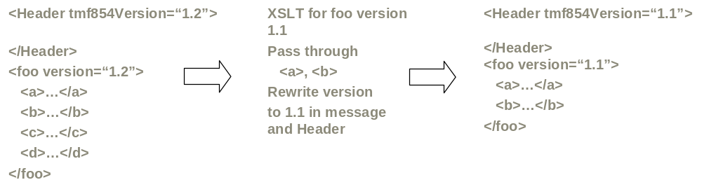
Figure 2 - Filtering the unknown elements

Minor Version Interoperability Use case set
Figure 3 shows a request/reply flow in the case both the client and processor support the exact same version.

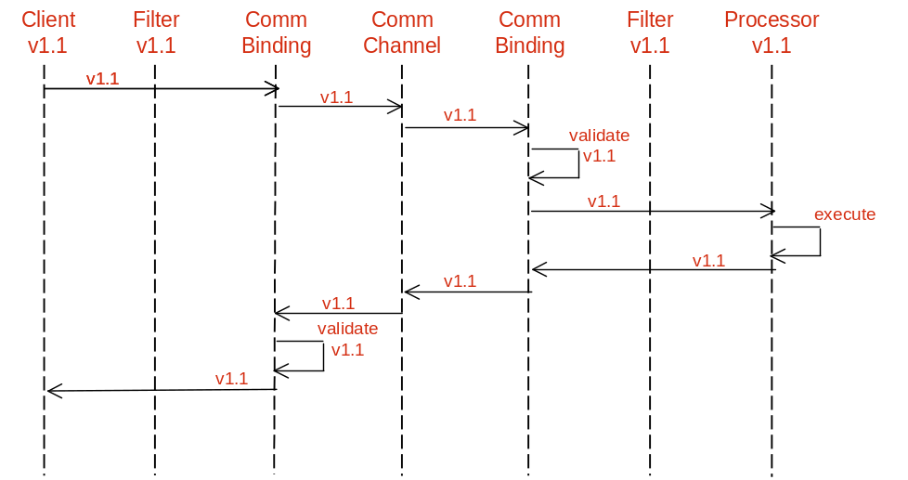
Figure 3 - Versions supported by client and processor match

Figure 4 shows a request/reply flow when the processor support a latter minor version than the client. Note that the filter on the client side transforms the v1.2 response into a v1.1 message, and the Communication Binding function on the processor side validates the v1.1 message against the v1.2 specification.
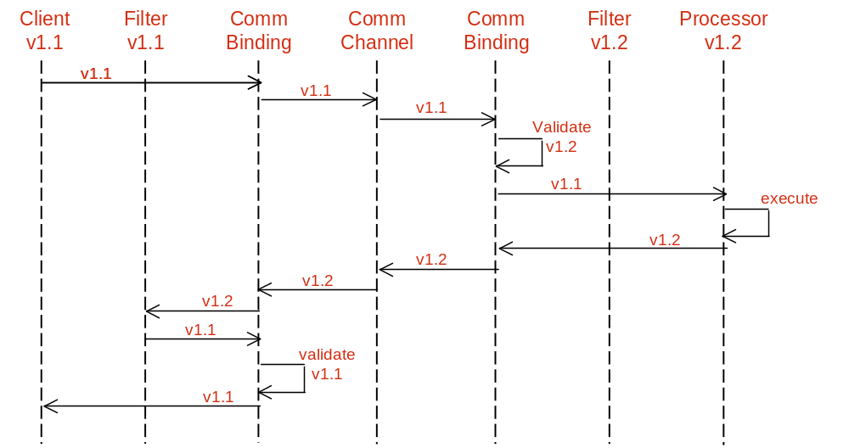
Figure 4 - Version supported by client older than that of processor

Figure 5 shows a request/reply flow when the client has a latter minor version than the processor. The filter on the processor side maps the message to v1.1 message and then the message is validated against the v1.1 XML and sent onto the processor. On the other side, the v1.1 message is validated against the v1.2 XML and then sent onto the client.

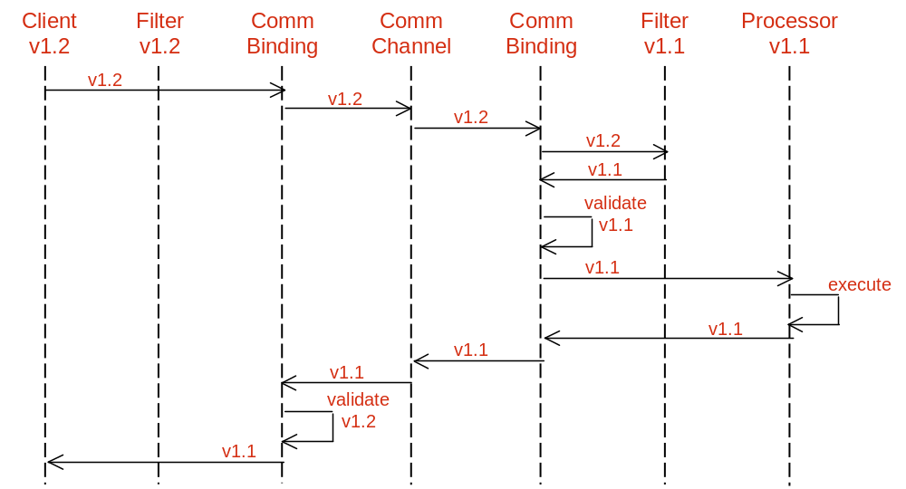
Figure 5 - Version supported by client newer than that of processor

The flows suggested in this section are not normative. They simply are meant to suggest a method for dealing with interoperability between MTOSI minor versions.

Major Version Interoperability Transition
The flows in this section and the next are not normative. They simply are meant to suggest a method for dealing with interoperability between MTOSI major versions.
Both Client and Server processors should have some degree of independence when upgrading. When a client or server upgrades to a new major version of an interface, the previous major version should also be supported. A major version of an interface supported by a client must be available from a server.
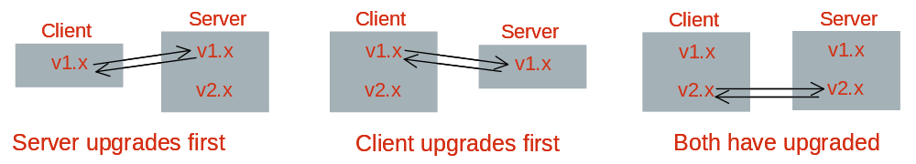
Figure 6 - Configurations showing multiple interface endpoints in clients and applications

Transition can be also accomplished through a mediation layer.
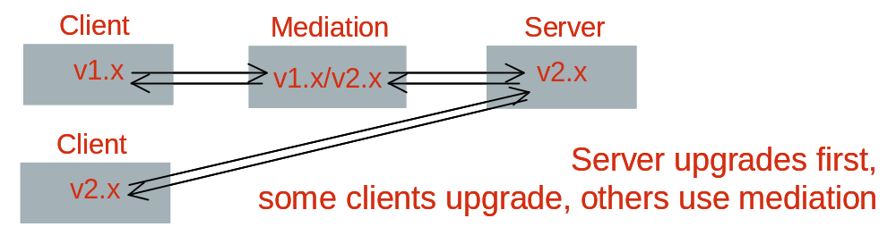
Figure 7 - Transition through a mediation layer

Notifications must be published in the major interface versions expected by subscribers.
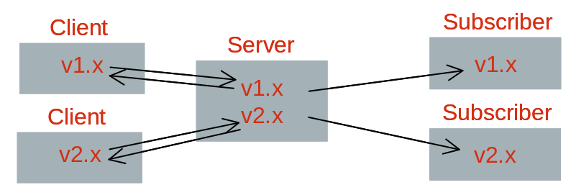
Figure 8 - Example of transition configuration with clients and subscribers on different major versions

If a server cannot support multiple major versions, mediation will also be required to generate notifications.
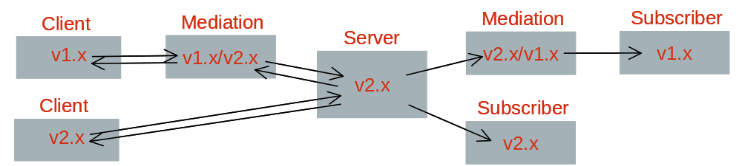
Figure 9 - Mediation layer for notifications

Major Version Interoperability Use Cases
The following diagram in Figure 10 shows how a Server may support two major versions with two interface endpoints offered through a common communication binding stack. Both old and new clients can access the proper service by routing the request to the proper communication channel.
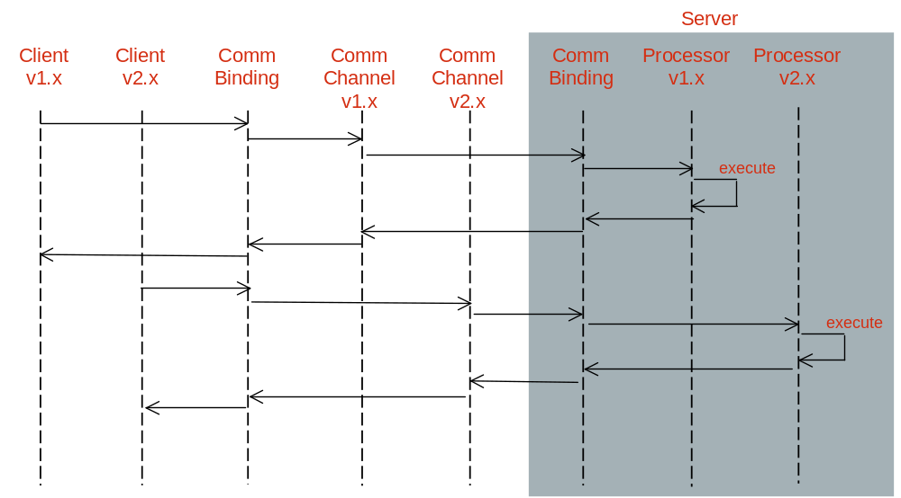
Figure 10 - Server supports two major versions with two interface endpoints, both old and new clients (Filters and validation not shown)

In the following diagram (Figure 11) a Server supports only one major version and uses a mediator layer during transition (Communication Binding not shown).
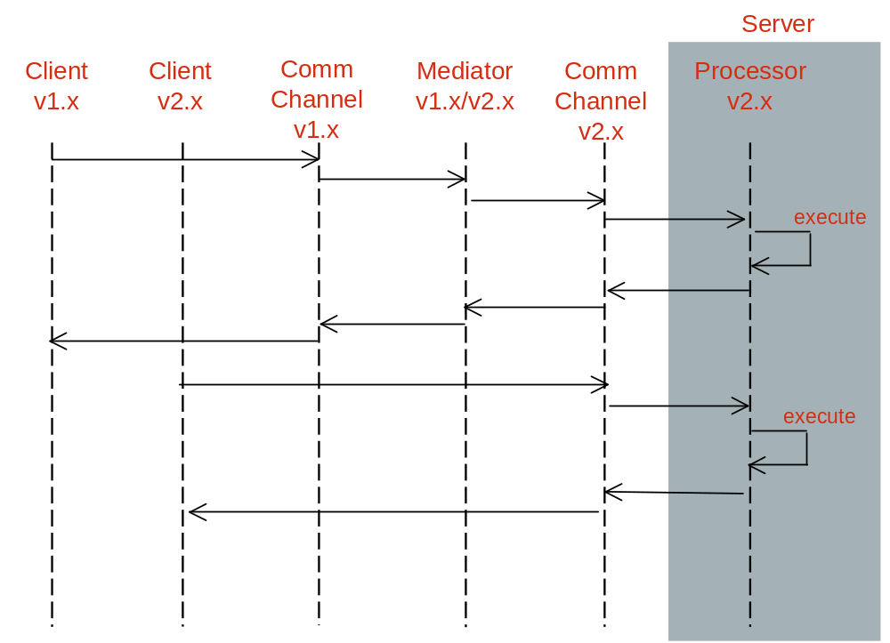
Figure 11 - Server supports only one major version, requires mediator during transition

The following diagram (Figure 12) shows how different communication channels and notification channels may be used during a transition from different major versions.
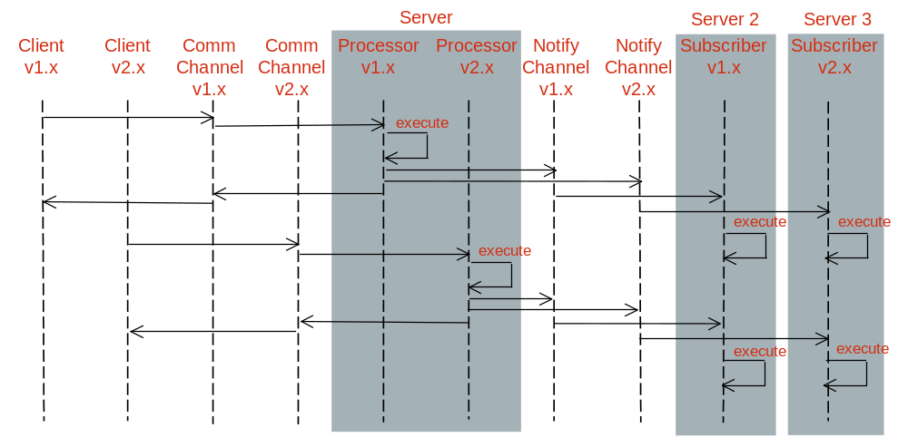
Figure 12 - Notification when there are subscribers on different major versions. Publication and subscription to Notify channels v1.x and v2.x is configurable

MTOSI Schema Extensions
Extensibility is one of the essential design characteristics that were applied in the definition of the MTOSI schema. Extensibility requirements are captured in the framework BA. The design of extension handlers in the MTOSI schema is based on the following two considerations:
- Allow vendor to customize by extension the interface definitions, and
- Allow evolution of the interface definitions with minimal impact on compatibility.

The specific interface definitions allowing MTOSI schema extension capabilities are covered in the following three sections:

- Section 11.1 for extension of MTOSI objects and notifications
- Section 11.2 for extension of MTOSI attributes and parameters (all specific data type definitions)
- Section 11.4 for specific definitions of vendor objects and notifications

Additionally, some XML examples are provided in the DDPs IIS XML directory.

MTOSI Objects and Notifications
This section describes the definitions used in the MTOSI schema to allow for extension of the MTOSI objects and notifications (events).
Any release of the MTOSI XSD should be customizable to fit the need of a specific solution. The UML model has already accounted for this extensibility identifying a placeholder in any significant object to allow customer extensions: vendorExtensions.
The customer extension mechanism should allow a processor to accept additional custom elements needed in a specific solution while maintaining syntactical compatibility with any processor outside the solution. In other words, a processor should be able to process the known extensions or silently ignore them if not known.

Definition of Vendor Extensions
After investigating the use of the ANY construct in all it’s variances, the MTOSI team reached the conclusion that in order to guarantee determinism in the XSD without introducing a new namespace it was necessary to wrap the xsd:ANY construct with an xsd element (<vendorExtensions>).

The following XML fragment illustrates the XSD extension mechanism used in the XML Schema definition of all MTOSI managed entities.

XSD Complex Type Vendor Extensions
<?xml version="1.0" encoding="UTF-8"?>
<xs:schema xmlns:xs="http://www.w3.org/2001/XMLSchema" elementFormDefault="qualified" attributeFormDefault="unqualified">
<xs:complexType name="ComplexEntity">
<xs:annotation>
<xs:documentation>Describe comples type based entity vendor (proprietary) extensions mechanism</xs:documentation>
</xs:annotation>
<xs:sequence>
<xs:element name="attribute1"/>
..
<xs:element name="vendorExtensions" minOccurs="0" nillable="true">
<xs:annotation>
<xs:documentation>Vendor (proprietary) extensions containment</xs:documentation>
</xs:annotation>
<xs:complexType>
<xs:sequence>
<xs:any namespace="##other" processContents="lax" maxOccurs="unbounded"/>
</xs:sequence>
</xs:complexType>
</xs:element>
</xs:sequence>
</xs:complexType>
</xs:schema>

Valid XML instance without extensions
<?xml version="1.0" encoding="UTF-8"?>
<ManagedElement_T xmlns:xsi="http://www.w3.org/2001/XMLSchema-instance" xsi:noNamespaceSchemaLocation="..\schema\MTOSI\Common.V1\ManagedElement_T.xsd">
<name>
<mdNm>732699</mdNm>
<meNm>OLT1</meNm>
</name>
</ManagedElement_T>

Valid XML example with unrecognized extension
<?xml version="1.0" encoding="UTF-8"?>
<ManagedElement_T xmlns:xsi="http://www.w3.org/2001/XMLSchema-instance" xsi:noNamespaceSchemaLocation="..\schema\MTOSI\Common.V1\ManagedElement_T.xsd" >
<name>
<mdNm>732699</mdNm>
<meNm>OLT1</meNm>
</name>
<vendorExtensions extAuthor="Acme" extVersion=”1.2 ” tmf854version=”1.0”>
<foo>ABCXYZ</foo>
<bar>NJAS3478</bar>
</vendorExtensions>
</ManagedElement_T>

Versioning the vendor extensions
When a base MTOSI object is extended by the vendor to customize it’s data structure, the top level message should be versioned according to the vendor solution versioning scheme but still maintain a trace of it’s base. We propose the use of the following attributes at any top level message:
- extVersion – the current version number
- extAuthor – the extension author
- tmf854Version – the original MTOSI base version number base of the extension
This mechanism allow to seamless integrate MTOSI in the context of a wide solution where versioning is governed by enterprise rules.

Any extensible object should have an optional aggregate (preferably at the end) called vendorExtensions. The aggregate type should be a <objName>vendorExtensions defined by default in the vendorExtensions.xsd.

The following examples illustrates the XSD extension mechanism for managedElement.xsd

Payload example:
<getTPResponse extVersion="V2.5" extAuthor="ACME" tmf854Version="1.0">
<TP>
<name>
<mdNm>ManagementDomain1</mdNm>
<meNm>MeName23</meNm>
<ptpNm>/shelf=1/slot=3/port=2</ptpNm>
</name>
<vendorExtensions extAuthor="ACME" extVersion="2.5" tmf854Version=”1.0”>
<foo>ABCXYZ</foo>
<bar>NJAS3478</bar>
</vendorExtensions>
</TP>
</getTPResponse>

How to use the vendor extensions.
There are three ways to extend the base MTOSI XSD with proprietary extensions:
- Redefine the type
- Bridge pattern
- Brute force
MTOSI allow for all three approaches and it is the MTOSI implementer responsibility to chose the more appropriate..
Note that the extension implementation mechanism is completely transparent to the MTOSI client: regardless of what method the provider chooses to implement the extensions, the XML instance will be identical.

Redefine the type
XSD has a construct that allows redefining of a type and propagating the changes in a pervasive way.
A proprietary extension can be defined according to the following example:

<?xml version="1.0"?>
<xs:schema xmlns:xs="http://www.w3.org/2001/XMLSchema">
<xs:redefine schemaLocation="VendorExtensions_T.xsd">
<xs:complexType name="meVendorExtensions_T.xsd">
<xs:complexContent>
<xs:extension base="Acme.Ext.meVendorExtensions_T"/>
</xs:complexContent>
</xs:complexType>
</xs:redefine>

<xs:complexType name="Acme.Ext.meVendorExtensions_T">
<xs:annotation>
<xs:documentation>Additional me attributes specific to the Acme Solution.</xs:documentation>
</xs:annotation>
<xs:sequence>
<xs:element name="CommonLanguageName" type="xs:string" minOccurs="0"/>
</xs:sequence>
<xsd:attribute name="extAuthor" type="xsd:string" use="optional"/>
<xsd:attribute name="extVersion" type="xsd:string" use="optional"/>
<xsd:attribute name="tmf854Version" type="xsd:string" use="optional" fixed="1.0"/>
</xs:complexType>

</xs:schema>
This is the most elegant solution but also the more difficult to implement due to the current limitations in the XML supporting tools. At the time of writing this document, the current version of JAXB JAVA binding tools do not support “xsd:redefine”.

Bridge pattern
Override the MTOSI vendorExtension.xsd with a file containing a definition of the extension type inherited from the custom extension.
<?xml version="1.0"?>
<xsd:schema xmlns:xsd="http://www.w3.org/2001/XMLSchema">
<xsd:include schemaLocation="../../../Acme/Ext/ehVendorExtensions_T.xsd"/>
<xsd:complexType name="ehVendorExtensions_T">
<xsd:annotation>
<xsd:documentation>This file imports in the MTOSI space the Acme extensions</xsd:documentation>
</xsd:annotation>
<xsd:complexContent>
<xsd:extension base="Acme.Ext.ehVendorExtensions_T">
<xsd:attribute name=" extAuthor " type="xsd:string" use="required" fixed="Acme"/>
<xsd:attribute name=" extVersion " type="xsd:string" use="optional"/>
<xsd:attribute name="tmf854Version" type="xsd:string" use="optional" fixed="1.0"/>
</xsd:extension>
</xsd:complexContent>
</xsd:complexType>
</xsd:schema>

Brute force
In this case, we define an extension type and override the default MTOSI type. The new file VendorExtensions.xsd will override the old file in the MTOSI distribution release.
EHVendorExtensions_T
<?xml version='1.0' ?>
<xsd:schema xmlns:xsd="http://www.w3.org/2001/XMLSchema">
<xsd:complexType name = "EHVendorExtensions_T" >
<xsd:annotation>
<xsd:documentation>Additional Equipment Holder attributes specific to the Acme Solution.</xsd:documentation>
</xsd:annotation>
<xsd:sequence>
<xsd:element name = "CommonLanguageName" type = "xsd:string" minOccurs="0" maxOccurs="1" />
</xsd:sequence>
<xsd:attribute name="extAuthor" type="xsd:string" fixed="Acme"/>
<xsd:attribute name="extVersion" type="xsd:string" use="optional"/>
<xsd:attribute name="tmf854Version" type="xsd:string" use="optional" fixed="1.0"/>
</xsd:complexType>
</xsd:schema>

example of XML compliant with the new extension
<?xml version="1.0" encoding="UTF-8"?>
<Equipment_T xmlns:xsi="http://www.w3.org/2001/XMLSchema-instance" xsi:noNamespaceSchemaLocation="..\schema\MTOSI\V1\Common\Equipment_T.xsd">
<name>
<mdNm>md1</mdNm>
<meNm>eq1</meNm>
<ehNm>eh1</ehNm>
<eqNm>eq1</eqNm>
</name>
<vendorExtensions extAuthor="Acme" tmf854version="1.0" extVersion="2.0">
<CommonLanguageName>12123434355rtrfd</CommonLanguageName>
</vendorExtensions>
</Equipment_T>

MTOSI Attributes
This section describes the definitions used in the MTOSI schema to allow for extension of the MTOSI attributes of the MTOSI objects and notifications (events).
As specified in the [TMF 517] and the SD2-13 Attribute Extensibility, the forms of manageable extensions are:
- Open - the MTOSI team has not specified any specific values for this attribute. The value set is left as decision for the software vendor. Many of the name related attributes are of this type, e.g., the name attribute for managed element.
- Closed - the MTOSI team has defined a discrete set of possible values for this attribute. For this type of attribute, no vendor extensions are allowed and the MTOSI team does not plan any extensions either. This is used for very stable attributes (a Boolean might be a good example).
- Qualifiable - the MTOSI team has determined that this attribute may need further qualification by the vendor. This means that for a given value of an attribute, the vendor may specify sub-values. For example, resourceState was determined to qualifiable. So, a vendor can further qualify the value "Planned" with the sub-values Planned-ordered, Planned-received, Planned-tested.
- Extendable - the MTOSI team has determined that the value set for this attribute can be extended by a vendor (i.e., an implementer of the MTOSI) or by the MTOSI team itself (in going from one version to the next). In this case, the additional values for the attribute do not overlap in meaning with the existing values defined for the attribute. Extendable-Vendor means only extendable for the vendor, Extendable-MTOSI means only extendable by the MTOSI team within a minor version update, and Extendable means both.
- Overlap - the MTOSI team has determined that the value set for this attribute can be extended by a vendor. In this case, the additional values overlap partially or completely with the MTOSI provided values for the attribute. Also, the vendor must provide a mapping between the overlapping values for the attribute and the MTOSI defined values.

Definition of Attribute Extensions
Each type of extension needs to be handled with a specific schema design pattern. The first two types can easily be associated with a simple schema definition. The other types are more challenging as they require a very special arrangement of their constraint settings.
Attributes can be extended by the MTOSI vendor in order to customize a deployment or by an MTOSI Interface editor in the context of a new release. A vendor should be able to extend (customize) the private MTOSI Interface while maintaining syntactic compatibility with the base MTOSI release.
When possible, it is important to adopt schema design patterns that allow an evolution of the object/event attribute constraint definition in the scope of a minor version. Any changes that imply a major version update are a significant impact to the MTOSI version compatibility scheme. As specified in section 3, the release of a major version interface is not backward compatible with any previous versions [ENUM].
The next sections will define how the various attribute extension are modeled in MTOSI.
See SD2-13 for a map of what is extendable.

Open Type Extension
Definition: Attribute is defined without any constraints.
This is only applicable to attribute that extend from following datatypes; string or any numerical. Booleans are excluded as they can be associated with a simple form of enumeration.

XSD:
- Type: <simpleType> any of the xsd:string or numericals datatypes.
- Constraint: None
- Extension: Free as it has no constraints.
- Caution: Adding to the schema some constraint settings (changing to another extension form) in the future can only be handled as a major version update! Backward compatibility would not work as the XML schema validation would be failing.

Example:
We identify that (EquipmentObjectType_T)Equipment.expectedEquipmentObjectType is Open

<xsd:simpleType name ="EquipmentObjectType_T">
<xsd:restriction base="xsd:string">
</xsd:restriction>
</xsd:simpleType>

But, changing it to the following is a Major version update (change to a Closed extension type)

<xsd:simpleType name ="EquipmentObjectType_T">
<xsd:restriction base="xsd:string">
<xsd:minLength value="1"/>
<xsd:maxLength value="1024"/>
</xsd:restriction>
</xsd:simpleType>

Consequently, an open attribute should be restricted (specialized) by an MTOSI vendor by introducing business rules rather than restricting the XSD in order to maintain syntactical compatibility with the base MTOSI release.

Closed
Closed Attributes cannot be extended by an MTOSI vendor and will trigger a Major release if extended by an MTOSI editor in the context of a new release.

Qualifiable Type Extension

Definition: Constraint is not relevant - But, sub-definition of values shall be offered to vendor.
This is only applicable to simple type attribute.

XSD:
- Type: <simpleType> any of the xsd base types.
- Constraint: Can be Open or Closed (enum).
- Extension: Another attribute of the same XSD type is required to allow carrying the sub-values.
  - Naming convention: "Qualifier"
  - Constraint: Must be Open.

Example:
We identify that (String)Common.resourceState is Qualifiable.
The following object attribute must be available as well: (String)qualifier
<ME>
<resourceState qualifier="IS_ACTIVE" > <!--note the extension here-->
INSTALLED
</resourceState>
</ME>

Extendable Type Extension
Definition: Schema can be extended by MTOSI team or vendor (as a minor version update)
This is applicable to the two possible types of attribute; simple and complex.

XSD:
Two scenarios based on the type of the attribute:
Simple Type Element:
- Type: <simpleType> of any of the xsd base types.
- Constraint: Applicable to Closed and Qualifiable types only.
- Extension: It is a limitation of XML schema. Changing the constraints breaks the validation of the schema, which would normally be handled as a major version update.

The following approach is suitable to handling vendor extensions as well as MTOSI extensions, as users are free to create as many customized values as long as they comply with the value prefix naming convention: “PROP_“ for vendor Extensions and MINOR_ for MTOSI editors.

Here is a brief description of the schema:
- Include all the initial (MTOSI) possible definitions with the schema enumeration constraint (same as with the Closed type)
- Use the pattern constraint style to allow any other values starting with PROP_ based on value pattern matching

Example:
<xsd:simpleType name="ColorType">
<xsd:union>
<xsd:simpleType>
<xsd:restriction base="xsd:string">
<xsd:enumeration value="BLUE" />
<xsd:enumeration value="WHITE" />
<xsd:enumeration value="RED" />
</xsd:restriction>
</xsd:simpleType>
<xsd:simpleType>
<xsd:restriction base="xsd:string">
<xsd:pattern value="PROP_([a-z]|[A-Z]|[0-9]|(_-))*" />
</xsd:restriction>
</xsd:simpleType>
</xsd:union>
</xsd:simpleType>

These values are valid: “WHITE”, “BLUE”, and “PROP_GREEN”

An enhanced version of this option is to include in the attribute definition union a third definition that is reserved to capture the vendor specific extended set of values. That third definition could be externalized to a specific schema file available in the vendorExtensions area of the local schema structure. This is also the pattern used for managing vendor extension of MTOSI Objects/Events. Vendor could replace the local vendor extension definition with there

The same mechanism is used with the prefix MINOR_ to allow MTOSI editors to add additional values within the same major version.

Complex Type Element:
- Type: <complexType> of any form.
- Extension: A special vendorExtension containment that can take any elements of any namespace can be used. The definition comes from an individual schema file (xsd) that the vendor can modify (extend) locally with its deployed systems. Same pattern as for extension of MTNM objects/events.

Any unplanned structural change in a complex type will trigger a major release.

Overlap Type Extension
Definition: Schema can be extended by the vendor. It is the most complex extension type as the vendor is allowed a complete re-definition of the scope and distribution of the possible values based on a mapping mechanism.
This is only applicable to simple type attribute.

XSD:
- Type: <simpleType> of any of the xsd base types.
- Constraint: Applicable to Closed type only (enum).
- Extension: A similar pattern as the one adopted for the Qualifable extension type can be used here. Another attribute is defined to hold the vendor value that is mapped from the initial MTOSI value.
Refer to the following convention:
  - Naming convention: "Overlap" attribute
  - Constraint: Must be Open.

Example: the same example proposed for the qualifiable extension applies replaving the attribute name “qualifier” with “overlap”.

Attribute Extension Examples
SD2-13 defines the following forms of attribute extensibility in the Overview sheet: Qualifiable, Extendable-Vendor, Extendable-MTOSI and Overlap. We use the resourceState attribute to provide examples for these four types of attribute extensibility.
First, we not that the resourceState has the following possible values:
- planned (without any supporting network resources)
- installed (supported by network resources)
- retired (no more supported by network resources)
- unknown is available for resources when other values are not applicable.
As that a service provider would like to extend these values as follows:
- The state “retired” is further qualified as retired-removed and retired-storedAway.
- New states “present” and “notPresent” are used instead of “planned” and “installed” but the semantics of the values are not the same. For example, let’s say the present means the equipment is in the service provider’s possession and notPresent has the opposite meaning.
- A new state “sold” is used to indicate the equipment has been sold. For the sake of argument, assume that the meaning of “sold” does not overlap any of the other MTOSI-defined values for resourceState.
The “retired” state is extended via qualification. The resourceStateQualifier would be set to retired-removed or retired-storedAway whenever the resourceState has the value “retired”.
The “planned” and “installed” states are extended (actually overlapped) by the present and notPresent states. In such cases, the resourceState would typically be populated with the value “unknown” and the resourceStateOverlap attribute would be set to present or notPresent.
The new state “sold” is used as a value of resourceState. The vendor uses the prefix PROP_ to denote that the value is vendor-defined. In particular, the value PROP_sold would be used. Now if the vendor took their new state to the MTOSI team and the team approved, the set of valid states for resourceState would be expanded. This can happen in one of two ways:
- The MTOSI team may only want to make a minor update (backward compatible). In this case the new value would be listed as MINOR_sold.
- On the other hand, the MTOSI team may decide to make a major update (not backward compatible). In this case, the new value would be just “sold”.

It should be noted that the difference between the two above mentioned options is that while in the first case, there is no “type checking” on the value, i.e., MINOR_xxx could be anything and message processor would pass it, in the second case, there is type checking and a valid value must be used or a validation exception will be raised.

MTOSI Vendor Objects and Notifications
This section describes the definitions used in the MTOSI schema to allow for the management of vendor specific objects and/or notifications.

Definition of MTOSI Vendor Object

VendorObject (Final) Element
Define a generic vendor object element (no global type visible): VendorObject with following elements:
- name (mandatory) the object instance name based on NamingAttributes_T (See naming below)
- vendorObjectType (mandatory) free string. However, it is recommended that vendors use following format convention: <vendorName>/<objectType> where:
  - <vendorName> is the string uniquely identifying a vendor
  - <objectType> is the string uniquely identifyin the vendor object type
- vendorExtensions All vendor object specific attributes must be embedded inside that generic vendor object element. The element type is externally defined. It can take any elements from any namespace. Emphasize that these extensions must have the vendor namespace to avoid conflict with other vendor object extensions (See example below).

The reason for having this vendor object base definition is to ensure that all vendor extensions are encapsulated in an MTOSI container (confinement to control vendor extensions). The element definition must use final=”#all” to ensure that no redefinitions are of the elements are possible.

VendorObject Naming
Naming of the VendorObject is optional (See above definition). Naming rules are as followed:

- Use the propNm RDN tag from NamingAttributes_T
- Name is absolute. The propNm must always be last component in the naming hierarchy. VendorObject SHALL NOT be the parent of any MTOSI object.
- Hierarchy of VendorObjects is allowed using the value separator “/” such as in ehNm or ctpNm RDN tags.

Example of an absolute name of VendorObjectB contained in VendorObjectA, which is directly contained in ManagementDomain myDomain.
<name>
<mdNm>myDomain</mdNm>
<propNm>VendorObjectA/VendorObjectB</propNm>
</name>

VendorObject Notifications
Notifications of the VendorObject are supported on the basis of a VendorObject instance name and the VendorObject class type (ObjectType_T definition). For example, the ObjectCreation notification attributes are set as followed:

- objectName is the absolute name of the VendorObject instance (see example above).
- objectType is always OT_VENDOR_OBJECT based on ObjectType_T. Note that on receiving a notification with objectType set to OT_VENDOR_OBJECT, the receiving OS needs has to check the vendorObjectType attribute of the object instance based on the objectName to determine the vendor object type.

VendorObject Inventory Retrieval
Inventory retrieval coarse-grained operation getInventory only supports the query for the VendorObject MTOSI object type as for any other MTOSI object types. The includedObjectType filter attribute does not support the specific setting of a vendorObjectType instance. And, for the same reason as stated above, the filter can only specify the enumerated value associated with an MTOSI object type. So, all of the VendorObject instances are returned for a given filter baseInstance context setting.
All the VendorObject instances are encapsulated in a specific list of the inventory layout data structure. There is no context retrieval for the VendorObject instances matching the filter criteria. The list is readily available from the InventoryData XML element. Consequently, the name of these VendorObject instances is absolute.

VendorObject Example
The example below is a simple XML VendorObject instance found directly under the domain “myDomain”. It is assigned a vendor object type “NortelObjectA”. And, the vendorExtensions encapsulates an instance of ObjectA element, which is defined from the vendor namespace; nortel.v1 with schema definitions in nortelDefinitions.xsd.

<?xml version="1.0" encoding="UTF-8"?>
<!--Sample XML file generated by XMLSpy v2005 rel. 3 U (http://www.altova.com)-->
<VendorObject xmlns="tmf854.v1" xmlns:nt1="nortel.v1" xmlns:xsi="http://www.w3.org/2001/XMLSchema-instance" xsi:schemaLocation="tmf854.v1 ..\..\xsd\networkResources\vendorObject.xsd nortel.v1 nortelDefinitions.xsd" extAuthor="jm" tmf854Version="1.0" extVersion="1.1">
<name>
<mdNm>myDomain</mdNm>
<propNm>myObjectA</propNm>
</name>
<vendorObjectType>NortelObjectA</vendorObjectType>
<vendorExtensions>
<nt1:ObjectA>
<nt1:attribute1>value1</nt1:attribute1>
<nt1:attribute2>
<nt1:attribute2-1>21</nt1:attribute2-1>
<nt1:attribute2-1>22</nt1:attribute2-1>
</nt1:attribute2>
</nt1:ObjectA>
</vendorExtensions>
</VendorObject>

Definition of MTOSI Vendor Notification

VendorNotification Element Definition
Define a generic vendor notification element as one of the supported event types. The definition of VendorNotification has the following elements:

- notificationId (mandatory)
- vendorNotificationType (mandatory) free string
Question: shall we constraint with pattern <vendorName>_* where <vendorName> must be a name selected by the vendor to ensure uniqueness of the definition
- vendorExtensions based on externally defined type which can take any elements from any namespace. Emphasize that these extensions must have the vendor namespace to avoid conflict with other vendor notification extensions (See example)

The reason for having this vendor notification base definition is the same as for the VendorObject.

Notification Topic Definition
To support the vendor notifications, they must be associated with an MTOSI topic. So, the following changes are to be made:
- A VendorNotification is supported in the Inventory and Fault MTOSI topics.
- A new VendorNotification MTOSI topic is created. Its capabilities are described through the DiscoveryServicethe same way as for the other MTOSI topics.

VendorNotification Example
The following example describes the instance of a VendorNotification with the vendor notification type value “NortelNotificationA”. The entire structure of this notification is defined in vendor schema nortelDefinitions.xsd with the vendor namespace; nortel.v1.

<?xml version="1.0" encoding="UTF-8"?>
<event xmlns="tmf854.v1" xmlns:nt1="nortel.v1" extAuthor="jm" tmf854Version="1.0" extVersion="1.1">
<VendorNotification>
<notificationId>notifID</notificationId>
<vendorNotificationType>NortelNotificationA</vendorNotificationType>
<vendorExtensions>
<nt1:NotificationA>
<nt1:attribute1>value1</nt1:attribute1>
<nt1:attribute2>
<nt1:attribute2-1>21</nt1:attribute2-1>
<nt1:attribute2-1>22</nt1:attribute2-1>
</nt1:attribute2>
<nt1:attribute3>
<nt1:attribute3-1>false</nt1:attribute3-1>
<nt1:attribute3-2>string</nt1:attribute3-2>
</nt1:attribute3>
</nt1:NotificationA>
</vendorExtensions>
</VendorNotification>
</event>

MTOSI Extensions Usage Recommendations
The MTOSI schema is designed to provide maximum extension capabilities in order to allow a complete and successful integration of various OS solutions. However, the following sections suggest some usage recommendations. These recommendations should all be understood by any implementers who are designing proprietary schema that is going to be used in these MTOSI vendor extensions.

Finally, as a general recommendation, all vendor specific definitions of interest to the MTOSI user community should be presented to the MTOSI team as potential contributions for additions to the standard interface definitions.

Namespace
The choice of the namespace for the vendor’s proprietary schema is important. It must be unique to avoid any conflicts with another vendor’s schema. It is recommended to use the company’s name in its definition (e.g. “<company_name>.v1”).
It is also recommended to choose a distinct prefix with the vendor’s namespace. A short name or acronym easily associated with the company’s name should do it.

Extending an MTOSI Object vs. Using Vendor Object
Extension of an MTOSI object/notification is usually preferable to the use of an MTOSI vendor object/notification.

It is recommended to use the MTOSI object/notification extension method if the characteristics of the extension can be associated with one of the existing MTOSI objects/notifications. Extending the definition of an MTOSI object/notification with additional specific attributes has the following advantages:
- Simpler implementation effort (no specific naming handling)
- Greater management controls (retrieval, data lifecycle)
- Easier integration (the object/notification is a known entity)

For instance, if a network entity concept can be related to an MTOSI Physical Termination Point (PTP), the recommended option is to extend the schema definition of the PTP with specific additional attributes in the vendorExtension element.

Otherwise, a specific vendor object can be defined (as seen in 11.4.1) to describe that network entity concept, which cannot be mapped to any of the MTOSI objects.

Examples of XML Messages with Extensions
MTOSI comes with some XML examples within each XML directory of the DDP that can be used to support the various MTOSI extension techniques.

All the extension examples are based on a vendor schema, which can be found in xml\vendorSchema\vendorDefinitions.xsd

The following XML messages have extensions:
- getInventory_response.xml with
  - one PTP object extension, and
  - one vendor object
- objectCreation.xml extension of the ObjectCreation notification
- vendorNotification.xml a specific vendor notification

Advanced versioning features
The present MTOSI mechanism describes versioning at the MTOSI interface level. While this granularity should address most of the concerns, the provider may implement a finer granularity. In a finer granularity scenario, an interface or even an operation may be partially compatible depending on the formal attributes or on the operation invoked in the interface. This fine grain versioning may widen the base of compatible services, allowing a service consumer to engage on a “conversation” with a mediation service checking compatibility each step in the flow. Since a fine grain versioning has a more relaxed notion of minor version compatibility, it is useful for a service consumer to modify the default behavior of the service provider to silently ignore all the unsupported tag. A way for a consumer to accomplish this is by identifying and marking the critical data with “MUST_UNDERSTAND” and triggering an exception if any of this data gets dropped in the service provider. The marking of the XML data can be accomplished by adding a list in the Header or by adding an attribute in each element. Given the complex nature of these extensions, the MTOSI Release 1.0 specifications do not support this mechanism.

. Mapping of Versioning Requirements to Support in TMF 854

Summary
This supporting document classifies the changes to a release in two main categories: minor and major. Any minor change will result in a minor version increment in the Interfaces and will still guarantee full compatibility.
Three prerequisite must be met in order to implement the MTOSI versioning mechanism:
- Mark the XSDs with comments including the major and minor version number.
- Mark the XML messages with the major and minor version number (both header and body)
- Maintain the same major XSD namespace across the set of minor releases
By adding only optional elements or structures in a minor release, the MTOSI minor releases will be backward compatible.
By adopting the “validation by projection” all the minor releases will also be forward compatible.
It is strongly advised to keep all the MTOSI modification in this class of versioning since it will minimize the migration activities.
A major change (even if only semantic) will not preserve the native service compatibility and will require a mechanism (described in section 10) to allow a smooth release transition.
A vendor extensibility mechanism has also been introduced to address any proprietary extension a vendor may require in a particular deployment of MTOSI.

References
[BAU04] – “Theory of Compatibility (Part 3)” – David Bau, http://davidbau.com/archives/2004/01/15/theory_of_compatibility_part_3.html
[ORC04] – “Providing Compatible Schema Evolution” - David Orchard, http://www.pacificspirit.com/Authoring/Compatibility/ProvidingCompatibleSchemaEvolution.html
[ORC01] – “Versioning XML Languages” - David Orchard, Norman Walsh, http://www.w3.org/2001/tag/doc/versioning-20031003-diff.html
[ENUM] -Managing Enumerations in W3C XML Schemas http://www.xml.com/lpt/a/2003/02/05/wxs-enum.html
[SD2-13] Attribute Extensibility map
[SD2-9] Using JMS as an MTOSI Transport
[TMF517] MTOSI Business Agreement
[TMF854] MTOSI XML Solution Set

Revision History
Version | Date | Description of Change
1.0 | MM/DD/YY
1.1 | November 2005 | Included comments from ME review
1.2 | Feb 2008 | Revised for MTOSI V.2.0 release

Acknowledgements
Francesco | Caruso | Telcordia Technologies Inc.
Tom | Kelley | Telcordia Technologies Inc.
Josephine | Micallef | Telcordia Technologies Inc.
Jerome | Magnet | Nortel

How to comment on the document
Comments and requests for information must be in written form and addressed to the contact identified below:

Francesco | Caruso | Telcordia Technologies Inc.
Phone: | +1 732 699 3072
Fax: | +1 732 336 7026
e-mail: | caruso@research.telcordia.com

Please be specific, since your comments will be dealt with by the team evaluating numerous inputs and trying to
produce a single text. Thus we appreciate significant specific input. We are looking for more input than wordsmith” items, however editing and structural help are greatly appreciated where better clarity is the result.

