TMF GForge Usage Guidelines for mTOP DDP
Contributors:
- Jérôme Magnet, Nortel, jeromem@nortel.com
Storage Location: Methodology folder of the TMF GForge mTOP project
Publication History:
Issue | Change Summary | Author(s) | Date
0.01 | Initial creation and update after review Methodology Call Nov13, 2006 | Jérôme Magnet | Dec 12, 2006
0.02 | Update of the Development & Deployment (release) views | Jérôme Magnet | Feb 26, 2007

Table of Contents
1 Introduction 2
2 TMF GForge and Subversion 2
2.1 Introduction 2
2.2 Subversion 2
2.3 Subversion Clients 2
2.3.1 Subversion Client for Web Browser 3
2.3.2 TortoiseSVN – Windows Explorer application 3
2.3.3 Subclipse - Eclipse Plug-in 3
3 mTOP Subversion Repository 5
3.1 mTOP SVN Repository Structure 5
3.1.1 Introduction 5
3.1.2 mTOP DDP Framework 5
3.1.3 DDP File Structure 5
3.1.4 DDPs Version Control 5
3.1.5 Products Releases 6
3.1.6 SVN Repository Structure Example 6
3.2 Issues & Recommendations 7
4 mTOP DDP Lifecycle Process Guidelines 8
4.1 mTOP DDP Development Activities 8
4.2 mTOP Product Releases 8
5 References 9

Introduction
The purpose of this document is to capture all the TMF GForge usage guidelines regarding the management of the mTOP DDP development lifecycle, including the management of the mTOP product releases.
The audience for this document includes:
- Members of mTOP Methodology team
- Product management leaders
- All mTOP DDP contributors
Note that this document does not cover the usage of all the TMF GForge tools. Some of these tools are used for other mTOP activities such as the Tracker for the PPC team and management of the Change Requests (CRs).

TMF GForge and Subversion

Introduction
The TMF GForge (Ref 1) is an integrated collaborative environment available to all TMF teams. Description of the TMF GForge is available at: http://gforge.tmforum.org/help/ecs/
See next section for important GForge mTOP usage registration instructions.

Usage Pre-requisites
In order to use the mTOP project in theTMF GForge, one must:
- Register to have a TMF GForge account. All instructions are available on the TMF GForge homepage: http://gforge.tmforum.org/
- Register as a member of the mTOP GForge project
  - Log in the TMF GForge (must have an valid account – See step 1)
  - Select the mTOP project by clicking on the “mTOP” project link in the list of Recently Registered Projects in the TMF GForge homepage.
  - Request to join the project by clicking on the [Request to join] link from the mTOP project Summary tab

Subversion
The TMF GForge has a source version control system based on Subversion, which is an evolution of the CVS. Refer to Ref 2 and Ref 3 for complete description and documentation.
The mTOP team has an mTOP project defined in the TMF GForge (See previous section), which has a Subversion (SVN) repository.

Subversion Clients
There are many ways to browse and/or work with a Subversion repository. This section covers the following three SVN clients:
- SVN HTTP Web browser
- TortoiseSVN the SVN client built-in Windows Explorer
- Subclipse the SVN Eclipse plug-in
The TortoiseSVN is probably the preferred way to access the mTOP SVN Repository. However, if you use Eclipse as your IDE of choice for coding/XML development, you might want to consider Subclipse as well.
Remarks:
- Access to the GForge mTOP SVN Repository using the encrypted method (svn+ssh) requires a firewall update. The GForge server IP (63.150.151.233) must be added to the “friendly” list to allow SSH connections.
- The local folders/files checked out from an SVN Repository (mTOP GForge) are compatible with either TortoiseSVN or Subsclipse as they both read/manage the .svn folder.
See below, for specific configuration details of these SVN clients.

Subversion Client for Web Browser
Navigation in the mTOP SVN repository can be done with any Web browser at this TMF GForge address: http://gforge.tmforum.org/plugins/scmsvn/viewcvs.php/?root=mtop
Note that it is just a read-only interface to navigate folder by folder (read slowly) through the mTOP Repository.

TortoiseSVN – Windows Explorer application
In you have a Windows compatible desktop, you can use TortoiseSVN as it nicely integrates with the Windows Explorer. This Windows based application supports all SVN commands for revision and source control management of the artifacts found in an SVN Repository as in mTOP GForge. Refer to the following links:
- Download from: http://tortoisesvn.net/downloads
- Manuals from: http://tortoisesvn.net/doc_release
Configuration:
TortoiseSVN configuration can be found in: http://tortoisesvn.net/docs/nightly/TortoiseSVN_en/tsvn-dug-settings.html
The following hints provide simple steps to configure the TortoiseSVN as SSH client to the TMF GForge server managing the mTOP repository. This configuration will avoid you from having to enter the password for each transaction, which is otherwise the case when navigating through the repository folders using the TortoiseSVN Repository-Browser.
- Select any folder in Windows Explorer
- Select in right mouse menu TortoiseSVN – Settings
- In the TortoiseSVN Settings dialog, select the Network icon
- Use of a proxy server may be configured
- In the SSH client field, enter the following:
C:\Program Files\TortoiseSVN\bin\TortoisePlink.exe -pw <password>
Where <password> is your password you have assigned to your username in TMF GForge.
Repository Browsing:
The following steps show use of the TortoiseSVN Repository Browser as the mTOP SVN repository navigation GUI tool:
- Select any folder in Windows Explorer
- Select in right mouse menu TortoiseSVN – Repo-browser
- enter the mTOP SVN repository URL as the following:
svn+ssh://<username>@svn.gforge.tmforum.org/svn/mtop
where the <username> is your TMF GForge registered username

Subclipse - Eclipse Plug-in
The mTOP SVN repository can also be accessed within the Eclipse IDE using Subclipse, which is a specific plug-in (See Ref 6). Note that Eclipse is an open source (free) product (Ref 5)
This SVN access from within Eclipse may be preferred by mTOP DDP contributors who use Eclipse for the development of the mTOP DDP XML artifacts (WSDL, XSD, and XML files). Indeed, Eclipse has plug-ins to allow edition/validation/testing of all forms of XML based artifacts such as WSDL, XSD, and XML file (See Ref 8)
Configuration:
The Subclipse configuration of the SVN interface is available from the Window / Preferences.. Eclipse menu. The SVN settings are located in the Team / SVN of the Preferences window. The JavaSVN must be set as the SVN interface type (See Figure 1).
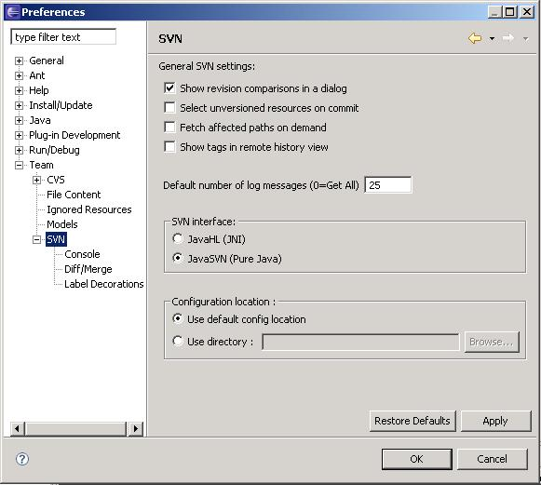
Figure 1 Subclipse Configuration
On-line help pages of the Subclipse plug-in are available on-line (See Ref 7).
Repository Browsing:
The following steps show use of the Eclipse SVN Repository Explorer as the mTOP SVN repository navigation GUI tool:
- In Eclipse, go to the SVN Repository Exploring view (button upper right hand),
- In the SVN Repository tab, click right mouse button and select New – Repository Location
- enter the mTOP SVN repository URL as the following:
svn+ssh://<username>@svn.gforge.tmforum.org/svn/mtop
where the <username> is your TMF GForge registered username

mTOP Subversion Repository

Overview
The design of the mTOP subversion repository is important to allow for the management of the following two concepts:
- Manage the versioning of the mTOP Guidelines and other tooling documents
- Manage the versioning of the DDP artifacts and the references to the specific DDP artifact SVN revisions for all mTOP product releases
So, the overall mTOP SVN repository file structure includes the following four top folders:
- mtosi_1.0 The folder with all the XML SS artifacts released in MTOSI R1.0
- mtosi_1.1 The folder with all the XML SS artifacts released in MTOSI R1.1
- Methodology – The folder with all the mTOP guidelines
- Product – The folder with the development (working) and deployment (released) views of all the DDP artifacts that make-up an mTOP product
Note that the mtosi_1.0 and mtosi_1.1 were created before the mTOP GForge usage guidelines were established by the mTOP Methodology team.

mTOP SVN Version Control
The management of all the mTOP documents stored in the TMF GForge is fully aligned with the SVN recommendations. The use of the following three folders provides a framework to allow for a complete version control of various sets (version managed units) of mTOP documents such as the DDPs and the guideline documents.
- branches – this folder is for all specific activities branched off the working folder (trunk). A branch could be created for a specific feature development or study. Once completed the content of the branch can be merged to another branch or the trunk.
- tags – this folder is to capture an copy of the mTOP SVN documents for all minor and major release versions.
- trunk – this is the working folder. It has the very latest SVN revision of an mTOP SVN document.
This approach is the recommended methodology in the subversion documentation (See SVN Book : Chapter 4 Branching and Merging or TortoiseSVN doc at http://tortoisesvn.net/docs/release/TortoiseSVN_en/tsvn-dug-import.html#tsvn-dug-import-1 ).

Methodology SVN Folder

Introduction
The purpose of the Methodology mTOP SVN repository folder is to capture all the mTOP documents that are used as guidelines and other tooling helper documents.
All other documents such as mTOP contributions or submitted and approved mTOP product release packages (e.g. TMF854_R1_1.zip) are stored in the mTOP project of the TMF CWS: http://www.tmforum.org/cws/view_folder.aspx?team_ID=81

Versioning and File Structure
These mTOP Methodology documents are not part of the mTOP products. The versioning of each document is independent of the others and of the mTOP DDP releases as well.
For that reason, each Methodology document is a single unit of the Methodology versioning management framework.
The file structure of the Methodology folder allows for the individual version control of these mTOP Methodology documents. The following two sub-folders are available:
- tags – To capture all copies of the SVN mTOP Methodology documents corresponding to a specific minor and major versions.
- trunk – To capture the latest working copies of all the SVN mTOP Methodology documents
Note that the branches folder does not exist as it has no real use.
The versioning of the mTOP Methodology documents (not SVN revision) is based on the following rules:
- A new minor version for a simple content change approved by the Methodology team during a review,
- A new major version when the overall document is approved by the Methodology team (a document can stay at major version X.0 until it needs to be re-visited and re-open because of an important Methodology change)
See picture below for an example of the Methodology folder structure and content shown in the Tortoise Repository Browser.
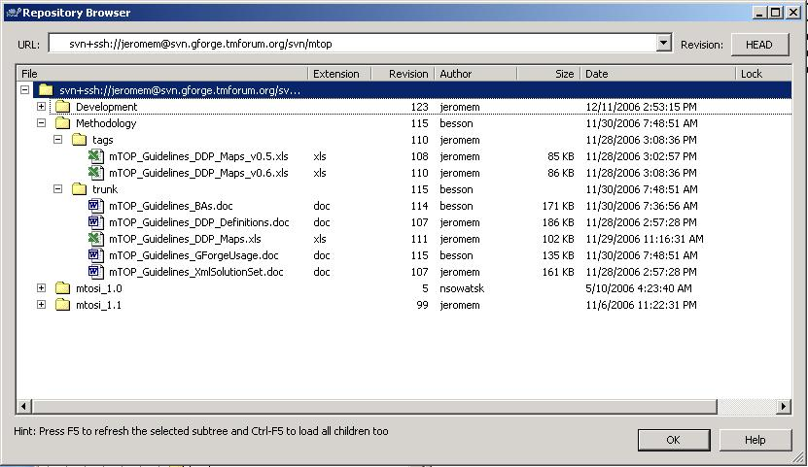
Above picture needs to be replaced (Development folder is now renamed to Product)

Product SVN Folder

Introduction
The purpose of the Product mTOP SVN repository folder is to be:
- The SVN context for the development of all the mTOP DDPs and their artifacts (mTOP Development View) and their deployment per product release (mTOP Deployment View). The SVN versioning controls are associated with the overall mTOP Product DDPs file structure (See notes below)
- The SVN context for the description of the mTOP products, which are captured in the ProductDescriptions sub-folder. !!!!!We need to confirm if this folder is still useful!!!!! We may want to rename it to ReleaseInfo?
Notes:
- The initial structure of this mTOP SVN repository folder had the versioning controls (trunk, branches, and tags) at the level of each DDP. The initial thought was that the mTOP release process would be DDP centric as opposed to product centric.
However, the following issues were found that lead to the present mTOP SVN repository structure.
  - Differences between the Development View & the Deployment View:
The presence of these SVN version control folders in the file structure of each DDP had a direct impact on the definition of all cross-references between artifacts from different DDPs.
These cross-references had to change when tagging (releasing) a DDP and all its artifacts from the Deployment View to the Development View. This change was not manageable for some of the artifact document types (PDF, XML).
For example, the relative path of the Framework BA from the NetworkResourceBasic BA was:
    - In the Development View; "../../../Framework/trunk/BA"
    - Changing to "../../../Framework/tags/R1.0/BA" in the Deployment View
  - Lack of visibility for the content of the mTOP product releases in terms of the mTOP DDPs. Because, the mTOP release process is still product based (not DDP-based), it is inappropriate to control the release of mTOP DDPs independently of the product releases.
- In conclusion, it has been decided that the structure of the mTOP Development and Deployment Views must remain the same (mTOP RM Feb15, 2007)

mTOP Development View
The scope and format of the mTOP Development View is defined by the file structure found in the trunk folder of the Development mTOP SVN repository (Figure 2).
The file structure of the mTOP Development View simply consists in the presence of all the mTOP DDP folders with their latest SVN revision (working) artifacts. The file structure of each DDP is identical (See 3.15).
Note that any work and submission (commit from SVN client) on these working artifacts must be controlled as they potentially may conflict with other updates from other team members (See section 3.18).

mTOP Deployment View
The scope and format of the mTOP Deployment View is defined by the file structure found in the tags folder of the Development mTOP SVN repository (Figure 2).
The file structure of the mTOP Deployment View is based on the following:
- A special folder is created with a name that shall indicate the associated product release number. The format of the product release name and number shall follow this pattern format: <ProductName>_R<MajorVersion>-<MinorVersion> (e.g. mtosi_R2-0).
- All DDPs that make up the product should be tagged to this product release folder from the working (trunk) folder. Basically, a reference to all (changed or unchanged) DDP artifacts latest SVN revision is captured from the working DDP folders at the time of the product release.
- A product release notes shall cover the details of all specification artifact changes per DDP. DDPs that are unchanged in a product release from the previous release should clearly be specified as well.

mTOP Product SVN Folder Example
The following figure captures an example of mTOP Product SVN repository folder. This example is available in the Test/ProductJM folder of the mTOP GForge SVN repository.
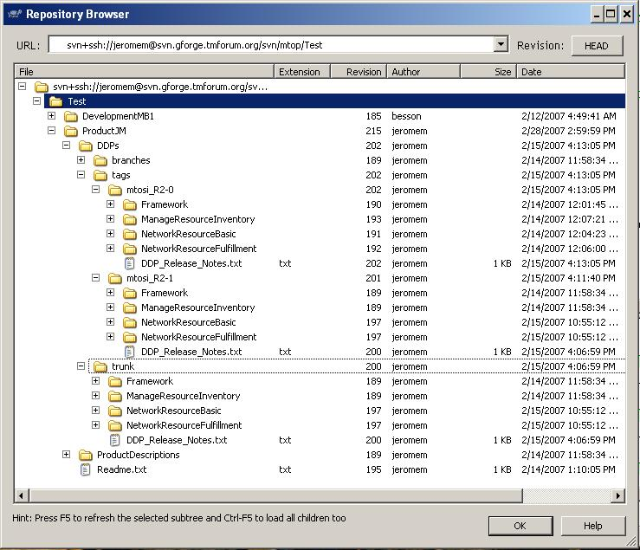
Figure 2 mTOP Product SVN Repository Example
In this example are captured the following:
- In the Development View (under ProductJM/DDPs/trunk)
  - Working (latest SVN revision) artifacts of 4 DDPs; Framework, ManagedResourceInventory, NetworkResourceBasic, and NetworkResourceFulfillment
  - The working product release notes
- In the Deployment view (under ProductJM/DDPs/tags)
  - The product release folder; mtosi_R2-0
All working DDPs and release notes document have been tagged to this folder at the time of the MTOSI R2.0 product release final approval (references to all the appropriate artifact SVN revisions). The release notes document captures all changes from previous product release per DDP (all DDPs are new as this is the first time introduction of all DDPs in an mTOP product)
  - The product release folder; mtosi_R2-1
All working DDPs and release notes document have been tagged to this folder at the time of the MTOSI R2.1 product release final approval (references to all the appropriate artifact SVN revisions). The release notes document captures all changes from previous product release (mtosi_R2-0) per DDP (NRB and NRF DDPs have changed with details listed – FMW and MRI DDPs are unchanged)

DDP File Structure
The mTOP DDP artifacts are partitioned in three folders representing the three main DDP constituents, which are namely:
- BA for Business Agreement,
- IA for Information Agreement, and
- IIS for Interface Implementation Specifications (IDL, XSD, WSDL, XML, etc)

The file structure details for each one of these folders are not relevant for this document.

Product Release Packaging
The Methodology team decided that all product release packages (in various forms; DDP based or specification based [BA/IA/IIS]) for all various status levels (submitted, approved, etc) are not captured in the mTOP SVN repository folder.
But, they will always be stored inside the TMF Collaboration Workspace.
Now this statement may change based on current evaluation/experimentation work carried out in the GForge TMF-LabMachine project, which has for objectives to automate product loadbuild and packaging tasks.

Issues & Recommendations
<Capture all recommendations to resolve potential issues>

References
Ref 1 TMF GForge http://gforge.tmforum.org/
Ref 2 Subversion http://subversion.tigris.org/
Ref 3 Subversion on-line book http://svnbook.red-bean.com/
Ref 4 TortoiseSVN http://tortoisesvn.net/
Ref 5 Eclipse IDE http://www.eclipse.org/
Ref 6 Subclipse - The Subversion Eclipse plug-in http://subclipse.tigris.org/
Ref 7 Subclipse - the help pages http://svn.collab.net/subclipse/help/index.jsp?topic=/org.tigris.subversion.subclipse.doc/html/toc.html
Ref 8 Eclipse Web Tools Project http://www.eclipse.org/webtools/

