Service Basic - DDP BA

TMF518_SB
Version 1.3


September, 2011

Notice
Copyright © TeleManagement Forum 2013. All Rights Reserved.
This document and translations of it may be copied and furnished to others, and derivative works that comment on or otherwise explain it or assist in its implementation may be prepared, copied, published, and distributed, in whole or in part, without restriction of any kind, provided that the above copyright notice and this section are included on all such copies and derivative works. However, this document itself may not be modified in any way, including by removing the copyright notice or references to TM FORUM, except as needed for the purpose of developing any document or deliverable produced by a TM FORUM Collaboration Project Team (in which case the rules applicable to copyrights, as set forth in the TM FORUM IPR Policy, must be followed) or as required to translate it into languages other than English.

The limited permissions granted above are perpetual and will not be revoked by TM FORUM or its successors or assigns.

This document and the information contained herein is provided on an "AS IS" basis and TM FORUM DISCLAIMS ALL WARRANTIES, EXPRESS OR IMPLIED, INCLUDING BUT NOT LIMITED TO ANY WARRANTY THAT THE USE OF THE INFORMATION HEREIN WILL NOT INFRINGE ANY OWNERSHIP RIGHTS OR ANY IMPLIED WARRANTIES OF MERCHANTABILITY OR FITNESS FOR A PARTICULAR PURPOSE.

Direct inquiries to the TM Forum office:

240 Headquarters Plaza,
East Tower – 10th Floor,
Morristown, NJ 07960 USA
Tel No. +1 973 944 5100
Fax No. +1 973 944 5110
TM Forum Web Page: www.tmforum.org
Table of Contents

Notice 2
Table of Contents 3
List of Requirements 5
List of Figures 6
List of Tables 7
Executive Summary 8
1 Introduction 9
1.1 DDP Structure 9
1.2 Document Structure 9
1.3 Terminology Used In This Document 10
2 Business Problem Description, Project Scope 11
2.1 Project Scope 11
2.2 Benefits 12
2.2.1 Service Provider Benefits 12
2.2.2 Supplier Benefits 13
3 Business Processes 14
3.1 Business Requirements 14
3.2 Category I: Static and Structural Requirements 14
3.2.1 State Attributes 15
3.2.2 Attributes Common to all MTOSI SM Objects 16
3.2.3 The Customer Facing Service (CFS) Object 17
3.2.4 The Resource Facing Service (RFS) Object 20
3.2.5 The Service Access Point (SAP) Object 22
3.2.6 The Service Access Point Specification (SAPSpecification) Object 25
3.2.7 The Service Catalog Object 26
3.2.8 The Service Definition Object 27
3.2.9 The Service Template Object 29
3.2.10 The Service Order Object 32
3.2.11 The Service Order Item Object 33
3.2.12 The Service Spec Characteristic (SSC) Object 34
3.2.13 Service Characteristic Value (SCV) 36
3.3 Category II: Normal Sequences, Dynamic Requirements 38
3.4 Category III: Abnormal or Exception Conditions, Dynamic Requirements 38
3.5 Category IV: Expectations and Non-Functional Requirements 38
3.6 Category V: System Administration Requirements 38
4 Use Cases 39
5 Traceability Matrices 40
6 Future Directions 41
7 References 42
7.1 References 42
7.2 IPR Releases and Patent Disclosure 42
8 Administrative Appendix 43
8.1 About this document 43
8.2 Use and Extension of a TM Forum Business Agreement 43
8.3 Document History 43
8.4 Company Contact Details 44
8.5 Acknowledgments 44
List of Requirements
R_TMF518_SB_I_0001 16
R_TMF518_SB_I_0002 17
R_TMF518_SB_I_0003 17
R_TMF518_SB_I_0004 17
R_TMF518_SB_I_0005 19
R_TMF518_SB_I_0006 20
R_TMF518_SB_I_0007 22
R_TMF518_SB_I_0008 22
R_TMF518_SB_I_0009 23
R_TMF518_SB_I_0010 24
R_TMF518_SB_I_0011 24
R_TMF518_SB_I_0012 24
R_TMF518_SB_I_0013 24
R_TMF518_SB_I_0014 25
R_TMF518_SB_I_0015 25
R_TMF518_SB_I_0016 27
R_TMF518_SB_I_0017 27
R_TMF518_SB_I_0018 29
R_TMF518_SB_I_0019 29
R_TMF518_SB_I_0020 31
R_TMF518_SB_I_0021 31
R_TMF518_SB_I_0022 32
R_TMF518_SB_I_0023 32
R_TMF518_SB_I_0024 33
R_TMF518_SB_I_0025 34

List of Figures
Figure 2-1. Inputs to the TM Forum Integration Program 11
Figure 2-2. TM Forum Integration Program 12
Figure 3-1. Entities involved in the mTOP Service Activation interaction. 14

List of Tables
Executive Summary
This document presents the MTOSI Service Management technology neutral data model. It initiates from the SID service management information model with several extensions and adaptations introduced to fit the business needs for service activation and inventory (those modifications will be proposed to the SID team as suggestion for improvement).
It defines the static and structural requirements of the managed objects that are visible across the Service Activation Interface(s) and the Service Component Activation Interface, and the Service Inventory interface.

Introduction

DDP Structure
In order to allow for more efficient release delivery, the previous monolithic BA, IA and SS documents have been partitioned into smaller self-contained (though not independent) units called Document Delivery Packages (DDPs).
This is similar to the 3GPP concept of Integration Reference Point (IRP). The basic idea is that the Interface, which is specified by the entire document set (of a release), is partitioned into DDPs where each DDP specifies “a certain aspect” of the Interface, which needs to be very clearly scoped.
There are three kinds of DDPs:
  - the FrameWork DDP (FMW) – this DDP contains the generic artifacts that are applicable to all the other DDPs.
  - Data Model DDP (DM-DDP) – a DDP that concerns a data model (entities, data structures, attributes, state, but no operations)
  - Operation Model DDP (OM-DDP) – a DDP that concerns a computational model (operations, notifications, transactions) for a given functional area (such as resource inventory management)
The unified deliverables structure for any given MTOSI / MTNM product release is as follows:
  - Product Release Notes:
    - a scope specification for the type and extent of the delivered product,
    - the partitioning of the release into DDPs (i.e., definitions of various aspects of the release),
    - and an overview of the release’s (delta) deliverables;
  - For each DDP:
    - Business Agreements (BAs): a business view specification
    - Information Agreements (IAs): a system view specification
    - Interface Implementation Specifications (ISSs): implementation and deployment view specification per supported enabling technology (mapping of the IA to either CORBA (IDL, services usage) or XML (WSDL, XSD, bindings…)
    - Supporting Documentation: normative and informative supporting documents.
  - Reference Implementation (optional) of core IIS fragments for selected interfaces and enabling technologies.

Document Structure
The following sections are included in this document:
- Section 1 is this introduction.
- Section 2 defines the business problem and project scope
- Section 3 has the requirements and associated descriptive text.
- Section 4 contains the use cases.
- Section 5 has traceability matrices between the use cases and the requirements.
- Section 6 provides a list of open issues to be considered in later versions of this document.
- Section 7 lists references and states IPR claims, if any.
- Section 8 provides administrative details such as document history and acknowledgements

Terminology Used In This Document
This DM DDP document introduces many terms for which a definition is presented. For those terms, the same definitions are also available in the SD0-1supporting document with many other terms commonly used in the MTNM / MTOSI products.

Business Problem Description, Project Scope

Project Scope
The TM Forum Integration Program is responsible for all of the interface and business services work within the TM Forum. In some cases, interface work is delegated to other teams but the final verification for technical uniformity and integrity is the responsibility of the TM Forum Integration Program.
Initially, the TM Forum Integration Program was formed to coordinate the various existing TM Forum interfaces activities (as shown in Figure 2-1). In particular, the responsibility for maintaining MTOSI and MTNM is now covered by the MTOSI-MTNM Users Group which is a team within the TM Forum Integration Program. The long term plan (which is already well under progress) is to migration the various input work to a single harmonized suite of interfaces.

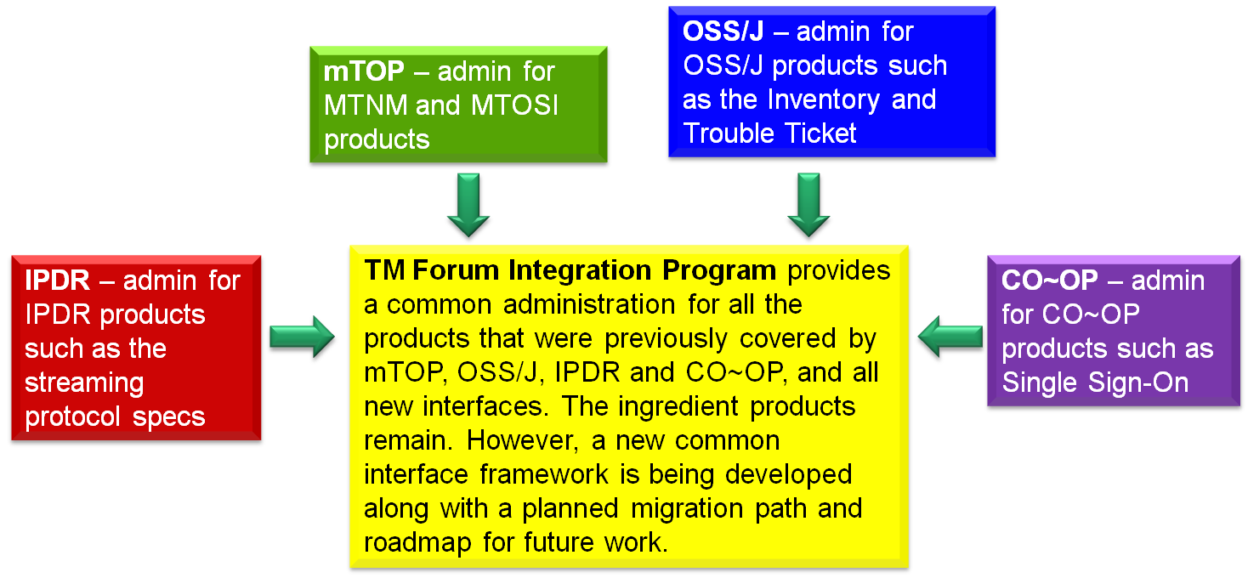
Figure 2-1. Inputs to the TM Forum Integration Program

Figure 2-2 provides a summary of the team within the TM Forum Integration Program as well as a few teams outside of the program but which also do some interface work. In terms of MTOSI and MTNM, the main input for updates come from the Resource and Service Management Team.

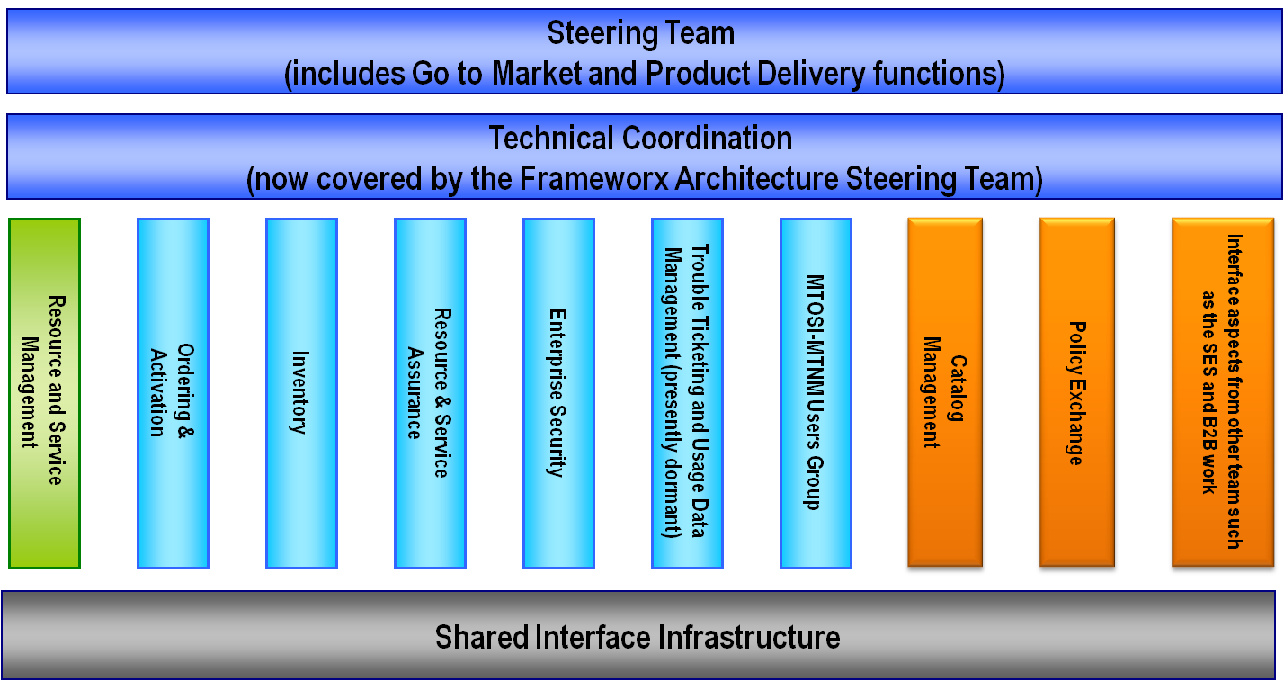
Figure 2-2. TM Forum Integration Program

Benefits
MTOSI and MTNM provide a set of Interface specifications that allow for resource and service management (with only MTOSI covering service management, but with MTOSI and MTNM both covering resource management, using very much the same information model).
These specifications are intended to lower design, implementation, Verification Validation & Testing (VVT), and maintenance costs for management interfaces. These Interfaces are intended for use by service providers, suppliers of equipment and OSS suppliers. The intention is to also encourage system integrator usage of management systems that make use of the Interfaces.
In particular, the followed approach tends to minimize the cost of integration, provide access to all necessary information and control, and support all vendor/operator differentiation. The intent of the interface is to provide compatibility among different version, for a detailed description see SD2-6_VersioningAndExtensibility.

Service Provider Benefits
The service provider benefits are as follows:
- One stop shopping concerning feature requests for much of the TM Forum contract specification work is part of the defined Change Control Group (CCG) process that TM Forum makes available in order to control the interface.
- The technical deliverables are also of high value to the service provider. The Interface specifications allow for an open, multi-supplier environment, shorten delivery times and lower integration costs.
- The MTOSI and MTNM products provide an integrated, multi-technology interface with support for most key layer 1 and layer 2 transport technologies. This is in contrast to earlier approaches where each technology-specific forum provided a single-technology management interface. The service provider was faced with having to use many different, uncoordinated management interfaces.
- These products are not bound to any one middleware, transport or computing language. So, the service provider will be able to evolve to new technologies as they arise.

Supplier Benefits
The supplier benefits are as follows:
- Fewer Adapters leads to Lower Costs – in as much as MTOSI and MTNM gain market penetration (and there has already been significant market acceptance of these interfaces), the supplier is faced with the need to build fewer adapters between their products and the products of their partners. A supplier can also directly see cost savings in the use of the Interfaces among its own products (as the need for an open interface arises).
- Lower Middleware Transitions Costs – the Interfaces are defined to be middleware and transport independent. So, the supplier can migrate from one middleware or transport technology to another without changing the supporting business logic in the code.
- Increase Usage by System Integrators (SIs) – a supplier’s support of their own “open” interfaces goes only so far to encourage SIs. Clearly, an SI would like to make use of supplier products (both equipment and OSS suppliers) that make use of well supported standard interfaces rather than supplier specific interfaces. The latter case forces the SI into a situation characterized by many pair-wise negotiations between various suppliers.
- Lower Training Cost – in as much as a supplier re-uses the Interfaces for multiple products and for multiple customers, the various training costs are lower because the designers, system engineers, developers and testers are using the same Interfaces over and over again.

Business Processes

Business Requirements
Not applicable for this DDP.

Category I: Static and Structural Requirements
The following diagram illustrates the relationship between some of the key MTOSI Service Management entities involved in service activation.

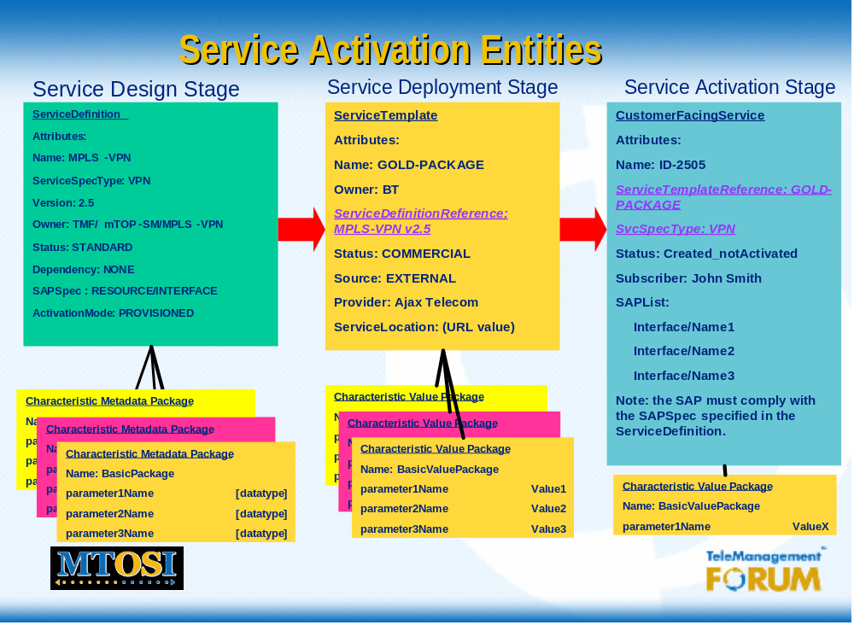
Figure 3-3. Entities involved in the MTOSI Service Activation interaction.

The “Service Definition” object is used at design time to define the service characteristics and their associated data types, as well as other information to describe the service. The “Service Template” is used in the service deployment phase to define the invariant characteristics of all associated services. The CFS and the RFS are used by the SAI and SCAI respectively at service activation time.

Some of the attributes specified in the objects or data structures presented in this DM DDP are used to make reference to another object by using its name (the unique name on the CCV).
References are typically used to represent associations between objects:
  - for example, the association between a ServiceTemplate instance and a ServiceDefinition instance - both SM&O objects -
  - or the association between a ServiceDefinition instance and a ProductSpecification instance (this latter object belongs to the CRM domain)
In particular, the MTOSI SM interfaces use references to CRM objects of the following classes:
      - Product
      - ProductSpecification
      - ProductOffering
      - ProductSpecificationCharacteristic
      - Subscriber
      - User

State Attributes
The ITU-T defines in specification X.731 a State Management Function. This specification dates back to the early days of OSI, and was implemented in systems supporting CMIP/CMIS. As part of this standard are two specific states:
- Administrative State
The administration of managed objects operates independently of the operability and usage of managed objects and is described by the administrative state attribute, which has three values: locked, unlocked and shutting down.
The original defiitions from X.731 state as follows:
locked means the entity is administratively prohibited from use.
shuttingDown means that usage is administratively limited to current instances of use.
unlocked means the entity is not administratively prohibited from use.

- Operational State
Defines the operability of a resource and may take two values: enabled, disabled.
disabled means the resource is totally inoperable.
enabled means the resource is partially or fully operable
One sees the mixing of the usage of these states in the convergence of telecommunications and data networks, and over time the same state concepts have been applied to services, due to lack of standardization in this area.

In addition to the two ITU-T X.731 states, the Service Activation interfaces use the notion of “service state”, which can take on one of the following values: Planning_FeasibilityCheck (PFC), Planning_Designed (PD), Reserved (RES) , Provisioned_Inactive (PI), Provisioned_Active (PA) and Terminated (TERM).
Those three states are used in the three entities: CFS, RFS, SAP.
The following table illustrates the relationships between the SAI service states, and ITU-T X.731 states:

SAI Service State > | PFC | PD | RES | PI | PA | TERM
ITU-T Admin State
Locked | N/A | N/A | N/A | X | N/A | N/A
Unlocked | N/A | N/A | N/A | N/A | X | N/A
Shutting Down | N/A | N/A | N/A | N/A | X | N/A
ITU-T Operational State
Enabled | N/A | N/A | X | X | X | N/A
Disabled | N/A | N/A | X | X | X | X

Note 1: N/A implies that there is no direct relationship between the ITU states and the SAI service states.
Note 2: The Administrative State attribute is included to preserve any backward compatibility with implementations using the ITU-T X.731 administrative state to represent actual service states.
- The "unlocked" value corresponds to a "Provisioned_Active" state, and indicates that the service has been provisioned and activated, or that the service was previously deactivated (suspended), and has been reactivated (resumed).
- The "locked" value corresponds to a "Provisioned_Inactive" state and indicates that the service has been successfully deactivated.
- The "shutting down" value corresponds to a service that was previously in a "Provisioned_Active" state, was deactivated, but has not yet successfully transitioned to a "Provisioned_Inactive" state. Once the transition is successful, the adminState would change to "locked".

Attributes Common to all MTOSI SM Objects
R_TMF518_SB_I_0001 | The requirement for the set of attributes common to all MTNM / MTOSI objects is specified in the TMF518_FMW BA (see requirement R_TMF518_FMW_I_0001). In summary, this requirement identifies the following attributes common to all the MTNM / MTOSI objects:  - name  - discovered name  - naming OS  - user label  - owner  - alias name list  - vendor extensions  The following MTOSI Service Management first class objects must contain all the attributes common to the MTOSI objects:  - CFS  - RFS  - SAP  - SAPSpecification  - ServiceCatalog  - ServiceDefinition  - ServiceTemplate  The following MTOSI Service Management first class objects must contain only the “name” attribute and not the other attributes common to the MTOSI objects  - ServiceSpecCharacteristic (SSC)
Source | TMF518_SB, Version 1.0

R_TMF518_SB_I_0002 | In addition to the attributes common to all the MTOSI objects, as required in R_TMF518_SB_I_0001 above, the following attribute is common to all the MTOSI SM objects  - description  Textual description of the object. (Optional)
Source | TMF518_SB, Version 1.0

The Customer Facing Service (CFS) Object
R_TMF518_SB_I_0003 | A CFS (Customer Facing Service) represents the instantiation of a given service that is bound to a particular product. It is an abstraction that defines the characteristics and behavior of a particular service as seen by the customer.
Source | TMF518_SB, Version 1.0

R_TMF518_SB_I_0004 | In addition to the attributes common to all the MTOSI objects or common to all the MTOSI SM objects (see R_TMF518_SB_I_0001 and R_TMF518_SB_I_0002), the CFS object shall have the following attributes:  - containedByCFSReference  Indicates the reference (the name) to the composite CFS object containing this CFS (a given CFS may be contained in at most one composite CFSs).  (Optional)  - containsCFSReferenceList  Used when the CFS is composite to  indicate the list of references (the names) to the CFS objects constituting the first level down the CFS hierarchy tree.  (Optional)  - hasStarted  This is a Boolean attribute that, if TRUE, signifies that this Service has already been started. If the value of this attribute is FALSE, then this signifies that this Service has NOT been Started.  - isMandatory  This is a Boolean attribute that, if TRUE, signifies that this Service is mandatory (i.e., this Service must be running when the managed environment is in a non-failed state). If the value of this attribute is FALSE, then this means that this Service is not required to run.  - startMode  This attribute is an enumerated integer that indicates how the Service is started. Values include: 0: Unknown 1: Automatically by the managed environment 2: Automatically by the owning device 3: Manually by the Provider of the Service 4: Manually by a Customer 5: Any of the above  - isStateful  This is a Boolean attribute that, if TRUE, means that this Service can be changed without affecting any other services.  - adminState (Mandatory)  This attribute is included to preserve any backward compatibility with implementations using the ITU-T X.731 administrative state to represent actual service states.  - The "unlocked" value corresponds to a "Provisioned_Active" state, and indicates that the service has been provisioned and activated, or that the service was previously deactivated (suspended), and has been reactivated (resumed).  - The "locked" value corresponds to a "Provisioned_Inactive" state and indicates that the service has been successfully deactivated.  - The "shutting down" value corresponds to a service that was previously in a "Provisioned_Active" state, was deactivated, but has not yet successfully transitioned to a "Provisioned_Inactive" state. One the transition is successful, the adminState would change to "locked".  - serviceState  Indicates the state of the service; refer to R_TMF518_SA_2_II_0010 from the TMF518_SA_2 BA (Mandatory)  - operationalState  Indicates whether the service is operational and takes on a value of “enabled”, or “disabled”. This value is set by the OS responsible for delivery of the service, and never by the activation OS. (Mandatory)  - serviceTemplateReference  Provides a reference (the name) to the associated Service Template object. (Mandatory)  - rFSReferenceList  Provides a list of references (the names) to the associated RFS objects. (Optional)  - productReference  Provides a reference (the name) to the product object (at in the CRM layer) associated with this CFS (Optional)  - subscriberReference  Provides a reference (the name) to the subscriber object (at the CRM layer) having subscribed to the service. (Optional)  - userReferenceList  Provides a set of references to the user objects (at the CRM layer) who could access the service. (Optional)  - sapList  Provides a set of associated service access point(s). (Mandatory)  - describedByList  (Mandatory for those SSCs in the associated ServiceDefinition which are NOT globally set or to override globally set SSCs)  This attribute is used to register the values specific to this CFS object which have been passed over the Activation Interface to convey the value of an individually set SSC (i.e. not reference in a ServiceTemplate) or to override the value of a globally set SSC (present in the associated ServiceTemplate)  Each of item of this attribute list is twofold:  - serviceSpecCharacteristicReference  Provides a reference (the name) to a ServiceSpecCharacteristic object  (Mandatory)  note that the same SSC reference must be present as well in the ServiceTemplate associated to the CFS – globally set –  or in the corresponding ServiceDefinition  – individually set, if not present in the ServiceTemplate -  - value  a ServiceCharacteristicValue used either as a value of an individually set service characteristic - i.e. not referenced in the associated ServiceTemplate - or to override a globally set characteristic value - present in the associated ServiceTemplate -  (Mandatory)
Source | TMF518_SB, Version 1.0

The Resource Facing Service (RFS) Object
R_TMF518_SB_I_0005 | A RFS (Resource Facing Service) is an abstraction that defines the characteristics and behavior of a service that is not directly seen or purchased by a customer. It is an “internal” service that is required to support one or more customer facing services.
Source | TMF518_SB, Version 1.0

R_TMF518_SB_I_0006 | In addition to the attributes common to all the MTOSI objects or common to all the MTOSI SM objects (see R_TMF518_SB_I_0001 and R_TMF518_SB_I_0002), the RFS object shall have the following attributes:  - containedByRFSReference  Indicates the reference (the name) to the composite RFS object containing this RFS (a given RFS may be contained in at most one composite RFSs).  (Optional)  - containsRFSReferenceList  Used when the RFS is composite to  indicate the list of references (the names) to the RFS objects constituting the first level down the RFS hierarchy tree.  (Optional)  - hasStarted  This is a Boolean attribute that, if TRUE, signifies that this Service has already been started. If the value of this attribute is FALSE, then this signifies that this Service has NOT been Started.  - isMandatory  This is a Boolean attribute that, if TRUE, signifies that this Service is mandatory (i.e., this Service must be running when the managed environment is in a non-failed state). If the value of this attribute is FALSE, then this means that this Service is not required to run.  - startMode  This attribute is an enumerated integer that indicates how the Service is started. Values include: 0: Unknown 1: Automatically by the managed environment 2: Automatically by the owning device 3: Manually by the Provider of the Service 4: Manually by a Customer 5: Any of the above  - isStateful  This is a Boolean attribute that, if TRUE, means that this Service can be changed without affecting any other services.  - adminState (Mandatory)  This attribute is used when one wishes to “suspend” or “resume” a service, and may take the values of “locked”, “unlocked” or “shutting down”. In the case of a multi-point service, this action takes effect on the entire service and will cause all connected subscribers to have their traffic suspended. It is set by an activation OS.  This attribute is included to preserve any backward compatibility with implementations using the ITU-T X.731 administrative state to represent actual service states.  - The "unlocked" value corresponds to a "Provisioned_Active" state, and indicates that the service has been provisioned and activated, or that the service was previously deactivated (suspended), and has been reactivated (resumed).  - The "locked" value corresponds to a "Provisioned_Inactive" state and indicates that the service has been successfully deactivated.  - The "shutting down" value corresponds to a service that was previously in a "Provisioned_Active" state, was deactivated, but has not yet successfully transitioned to a "Provisioned_Inactive" state. One the transition is successful, the adminState would change to "locked”.  - serviceState  Indicates the state of the service; refer to R_TMF518_SA_2_II_0010 from the TMF518_SA_2 BA. (Mandatory)  - operationalState  Indicates whether the service is operational and takes on a value of “enabled”, or “disabled”. This value is set by the OS responsible for delivery of the service, and never the activation OS. (Mandatory)  - serviceTemplateReference  Provides a reference (the name) to the associated Service Template object. (Mandatory)  - cFSReference  Provides a reference (the name) to the associated CFS object. (Mandatory)  - subscriberReference  Provides a reference (the name) to the subscriber object (at the CRM layer) having subscribed to the service. (Optional)  - userReferenceList  Provides a set of references to the user objects (at the CRM layer) who could access the service. (Optional)  - sapList  Provides a set of associated service access point(s). (Mandatory)  - describedByList  (Mandatory only if there are SSC in the ServiceDefinition which are NOT globally set)  This attribute is used to register the values specific to this RFS object which have been passed over the Service Component Activation Interface to convey the value of an individually set SSC (i.e. not referenced in a ServiceTemplate) or to override the value of a globally set SSC (present in the associated ServiceTemplate)  Each item of this attribute list is twofold:  - serviceSpecCharacteristicReference  Provides a reference (the name) to a ServiceSpecCharacteristic object  (Mandatory)  note that the same SSC reference must be present as well in the ServiceTemplate associated to the RFS – globally set –  or in the corresponding ServiceDefinition  – individually set, if not present in the ServiceTemplate -  - value  a ServiceCharacteristicValue used either as a value of an individually set service characteristic - i.e. not referenced in the associated ServiceTemplate - or to override a globally set characteristic value - present in the associated ServiceTemplate -  (Mandatory)
Source | TMF518_SB, Version 1.0

The Service Access Point (SAP) Object
R_TMF518_SB_I_0007 | A SAP (Service Access Point) represents a set of parameters associated (directly or indirectly) with a unique (logical and/or physical) resource where the single Service can be accessed.  A Service is often associated with a list of SAPs.
Source | TMF518_SB, Version 1.0

R_TMF518_SB_I_0008 | In addition to the attributes common to all the MTOSI objects or common to all the MTOSI SM objects (see R_TMF518_SB_I_0001 and R_TMF518_SB_I_0002), the Service Access Point object shall have the following attributes:  - type  Identifies the type of SAP. This attribute is used in the Service Definition to identify the type of SAP required at service activation time. (Optional)  - adminState (Optional)  This attribute is used when one wishes to “suspend” or “resume” a service, and may take the values of “locked”, “unlocked” or “shutting down”. It represents the suspension (or resumption) of traffic for a given subscriber. This value is only set by the activation OS.  This attribute is included to preserve any backward compatibility with implementations using the ITU-T X.731 administrative state to represent actual service states.  - The "unlocked" value corresponds to a "Provisioned_Active" state, and indicates that the service has been provisioned and activated, or that the service was previously deactivated (suspended), and has been reactivated (resumed).  - The "locked" value corresponds to a "Provisioned_Inactive" state and indicates that the service has been successfully deactivated.  - The "shutting down" value corresponds to a service that was previously in a "Provisioned_Active" state, was deactivated, but has not yet successfully transitioned to a "Provisioned_Inactive" state. One the transition is successful, the adminState would change to "locked”.  - serviceState  Indicates the state of the service associated to the SAP; refer to R_TMF518_SA_2_II_0010 from the TMF518_SA_2 BA. (Optional)  - operationalState  Shall represent the operational state of the service and may take on a value of “enabled” or “disabled”. This value is only set by the OS responsible for delivery of the service for a given subscriber. (Optional)  - subscriberReference  Provides a reference to the subscriber object (at the CRM layer) accessing the service through this SAP. (Optional)  - userReferenceList  Provides a set of references to the user objects (at the CRM layer) who could access the service through this SAP. (Optional)  - resourceReference  Reference to the resource by which the service is accessed. This attribute is the name of an object representing such things as a mobile phone, laptop, PDA, set-top box, physical or logical connection point. (Mandatory)  - sAPSpecReference  Provides a reference (the name) to the corresponding SAP Specification object. (Optional)  - describedByList  (Mandatory only if there are SSC in the ServiceDefinition which are NOT globally set)  This attribute is used to register the values specific to this SAP object which have been passed over the Activation Interface to convey the value of an individually set SSC (i.e. not reference in a ServiceTemplate) or to override the value of a globally set SSC (present in the associated Sap Specification)  Each of item of this attribute list is twofold:  - serviceSpecCharacteristicReference  Provides a reference (the name) to a ServiceSpecCharacteristic object  (Mandatory)  note that the same SSC reference must be present as well in the Sap Specification  – globally set  or in the corresponding ServiceDefinition  – individually set, if not present in the Sap Specification  - value  a ServiceCharacteristicValue used either as a value of an individually set service characteristic - i.e. not referenced in the associated Sap Specification - or to override a globally set characteristic value - present in the associated Sap Specification  (Mandatory)
Source | TMF518_SB, Version 1.0

R_TMF518_SB_I_0009 | The SAP shall support six service states that are options in the serviceState attribute of the service access point object:  - Created: All resources required for the delivery of a component service to a subscriber and his/her associated service access point are available. (They have yet to be allocated and reserved). Applicable only to RFSs.  - Waiting for components: At least one resource required for the service component activation for a particular subscriber and his/her associated service access point has yet to be fully activated. Applicable only to RFSs.  - Provisioned_active: The SAP in question is allowed to deliver services defined by the CFS/RFS allocated to it.  - Provisioned_inactive: The SAP in question is not allowed to deliver the services defined by the CFS/RFS allocated to it.  - Retired: The SAP in question has been to removed from the CFS/RFS it was allocated to.
Source | New

The Service Access Point Specification (SAPSpecification) Object
R_TMF518_SB_I_0010 | The SAP Specification defines a set of attributes and (optionally) associated values. A SAP Spec may be applied to one or more SAPs
Source | TMF518_SB, Version 1.0

R_TMF518_SB_I_0011 | In addition to the attributes common to all the MTOSI objects or common to all the MTOSI SM objects (see R_TMF518_SB_I_0001 and R_TMF518_SB_I_0002), the Service Access Point Specification object shall have the following attributes:  - applicableServices  Profides a list of serviceSpecificationTypes that could use this type of SAP  - applicableStateValues  Designates the set of the state values a SAP could have. Some SAPs may have different state values, depending on their type.  - serviceDefinitionReferenceList  A list of references to Service Definition objects that can be supported by this SAP Spec. (Optional)  - describedByList  This attribute specifies values (SSCVs) for the SSCs that are globally set and are to be used specifically for SAP specifications.  However, when activating a Service, it may be possible to specify over the Activation Interface a ServiceCharacteristicValue on the SAP which overrides the corresponding ServiceSpecCharacteristicValue available in the associated Sap Specification. In this case the new proposed value applies only to the SAP instance created, and the ServiceSpecCharacteristicValue in the Sap Specification is not modified.  The possibility to override or not must be specified for each ServiceSpecCharacteristic in the Sap Specification.  Each item of this attribute list is threefold:  - serviceSpecCharacteristicReference  a reference (the name) to a SSC object;  this SSC object must be referenced as well in the associated Service Definition object an its must be qualified as a globally set one. (Mandatory)  - serviceSpecCharacteristicUse  - indicates whether the value of this SSC can be overridden (through a SCV passed over the interface) or not (Mandatory)  - indicates the characteristic role, which in this case should be “Sap”, meaning it is used to defined a Sap and not the service.  - also indicates possible further restrictions in terms of minCardinality and maxCardinality compared to the SSC referenced in the Service Definition (Optional)  - value  the unique Service Characteristic Value data structure used to indicate the SSCV value associated with the referenced SSC. (Mandatory)
Source | TMF518_SB, Version 1.0

The Service Catalog Object
R_TMF518_SB_I_0012 | A Service Catalog represents a grouping of Service Specifications and SSCs. For example a catalog could group all internet related Service Specifications.
Source | TMF518_SB, Version 1.0

R_TMF518_SB_I_0013 | In addition to the attributes common to all the MTOSI objects or common to all the MTOSI SM objects (see R_TMF518_SB_I_0001 and R_TMF518_SB_I_0002), the Service Catalog object shall have the following attributes:  - serviceSpecCharacteristicReferenceList  Provides a set of reference (names) to the different ServiceSpecCharacteristic objects available in this catalog.  - serviceDefinitionReferenceList  Provides a set of references (names) to the Service Definition objects available in this Service Catalog.  - serviceTemplateReferenceList  Provides a set of references (names) to the Service Template objects available in this Service Catalog.
Source | TMF518_SB, Version 1.0

The Service Definition Object
R_TMF518_SB_I_0014 | A Service Definition represents a type of Service Specification (from the SID) introduced for the purposes of Service Fulfillment.  It defines ALL the ServiceSpecCharacteristics that must be used to create corresponding Service instances. This includes the SSCs which are:  - globally set (the corresponding values are defined only in ServiceTemplates and are sometimes designated as “invariant”) and  - set per instance (since the ServiceDefinition does not contain any value for such SSCs, the corresponding values can be defined only over the Activation Interface and are sometimes designated as “variant”)
Source | TMF518_SB, Version 1.0

R_TMF518_SB_I_0015 | In addition to the attributes common to all the MTOSI objects or common to all the MTOSI SM objects (see R_TMF518_SB_I_0001 and R_TMF518_SB_I_0002), the Service Definition object shall have the following attributes:  - serviceSpecificationType  Used to distinguish the kind of service.  It contains the following attributes:  - name  A short set of text readable characters to identify the kind of service - e.g. IPTV, VoIP, IMS…-  (Mandatory)  - description  A set of text readable characters giving some addition information  (Optional)  - version  Identifies the version of this service type  (Optional)  - version  Identifies the version of the Service Definition. (Optional)  - activationMode  Indicates whether the designed service is activated through provisioning, or is signaled. (Mandatory)  - sapSpecificationReferenceList  A lit of references to a service access point specifications that define the type of SAP allowed when accessing a given service. (Mandatory)  - describedByList  This attribute indicates ALL the SSCs that must be used to create corresponding Service instances; there are two kinds of SSCs:  - the ones which are globally set (the corresponding values are defined only in ServiceTemplates and are sometimes designated as “invariant”)  - and the ones which are set individually (the corresponding values can be defined only over the Activation Interface and are sometimes designated as “variant”).  Each item of this attribute list is threefold:  - serviceSpecCharacteristicReference  a reference (the name) to a SSC object (Mandatory)  - serviceSpecCharacteristicUse  - indicates whether the value of this SSC must be set globally (through a Service Template) or individually.  (Mandatory)  - also indicates possible restrictions in terms of minCardinality and maxCardinality compared to the SSC.  (Optional)  - valueList  list of Service Characteristic Value data structures used to indicate:  - either the exhaustive list of valid values (SSCVs) for the referenced SSC for this Service Definition  - or possible further restrictions compared to the valueList proposed in the SSC (Mandatory if no value is available in the SSC).  - containedByServiceSpecRef  Provides the relationship to a Service Definition that will contains this Service Definition. For example, a parent Service Definition may be IP-Services, and this Service Definition is for IP-VPN.  - containsServiceSpecRefList  Provides a list of Service Definitions that are contained by this Definition.  - status  The status of the Service Definition.  It may take on one of the following values: Draft, Standard, or Proprietary. (Optional)  - dependencies  Pre-requisite service definitions that are required in order to implement this service definition. (Optional)  - productSpecificationReference  Provides a reference (the name) to the productSpecification object (at the CRM layer) associated with this ServiceDefinition (Optional)  - serviceCatalogReferenceList  List of references (the name) to the Service Catalog objects which contain this Service Definition object.
Source | TMF518_SB, Version 1.0

The Service Template Object

R_TMF518_SB_I_0016 | A Service Template represents a type of Service Specification (from the SID) introduced for the purposes of Service Fulfillment.  It defines specific ServiceSpecCharacteristicsValues for the globally set ServiceSpecCharacteristics that can be dynamically referenced by multiple Service instances during their lifecycle span.  A ServiceTemplate is checked against its associated ServiceDefinition by verifying the presence of the ServiceSpecCharacteristics and the validity of the corresponding assigned ServiceSpecCharacteristicsValues.  Each of the associated Service instances will have the same invariant characteristics which values are taken from the ServiceTemplate.  However, when activating a Service, it may be possible to specify over the Activation Interface a ServiceCharacteristicsValue which overrides the corresponding ServiceSpecCharacteristicValue available in the associated ServiceTemplate. In this case the new proposed value applies only to the Service instance created, and the ServiceSpecCharacteristicValue in the ServiceTemplate is not modified.
Source | TMF518_SB, Version 1.0

R_TMF518_SB_I_0017 | In addition to the attributes common to all the MTOSI objects or common to all the MTOSI SM objects (see R_TMF518_SB_I_0001 and R_TMF518_SB_I_0002), the Service Template object shall have the following attributes:  - serviceSpecificationType  Used to distinguish the kind of service.  It contains the following attributes:  - name  A short set of text readable characters to identify the kind of service - e.g. IPTV, VoIP, IMS…-  (Mandatory)  - description  A set of text readable characters giving some addition information  (Optional)  - version  Identifies the version of this service type  (Optional)  - version  Identifies the version of the Service Template. (Optional)  - source  Determines whether the source of the OS providing the Service Template is “external” or “internal” to a given organization. (Optional)  - serviceLocation  Gives the URL of where the service component activation OS is actually located. (Optional)  - serviceDefinitionReference  A reference (the name) to the associated service Definition object.  - describedByList  This attribute specifies values (SSCVs) for the SSCs that are globally set and can be dynamically referenced by multiple Service instances during their lifecycle span.  Each of the associated Service instances will have the same invariant characteristics which values are taken from the ServiceTemplate.  However, when activating a Service, it may be possible to specify over the Activation Interface a ServiceCharacteristicValue which overrides the corresponding ServiceSpecCharacteristicValue available in the associated ServiceTemplate. In this case the new proposed value applies only to the Service instance created, and the ServiceSpecCharacteristicValue in the ServiceTemplate is not modified.  The possibility to override or not must be specified for each ServiceSpecCharacteristic in the ServiceTemplate.  Each item of this attribute list is threefold:  - serviceSpecCharacteristicReference  a reference (the name) to a SSC object;  this SSC object must be referenced as well in the associated Service Definition object an its must be qualified as a globally set one. (Mandatory)  - serviceSpecCharacteristicUse  - indicates whether the value of this SSC can be overridden (through a SCV passed over the interface) or not (Mandatory)  - indicates the characteristic role, which in this case should be “Service”, meaning it is used to defined a Service and not the SAP.  - also indicates possible further restrictions in terms of minCardinality and maxCardinality compared to the SSC referenced in the Service Definition (Optional)  - value  the unique Service Characteristic Value data structure used to indicate the SSCV value associated with the referenced SSC. (Mandatory)  - containedByServiceSpecRef  Provides the relationship to a Service Template that will contains this Service Template. For example, a parent Service Template may be IP-Services, and this Service Template is for IP-VPN  - containsServiceSpecRefList  Provides a list of Service Definitions that are contained by this Definition.  - status  The status of the Service Template.  It may take on one of the following values: Draft, Pilot, Commercial, Retired. (Optional)  - productOfferingReference  Provides a reference (the name) to the productOffering object (at in the CRM layer) associated with this ServiceTemplate (Optional)  - serviceCatalogReferenceList  List of references (the name) to the Service Catalog objects which contain this Service Template object.
Source | TMF518_SB, Version 1.0

The Service Order Object
R_TMF518_SB_I_0018 | A Service Order is a type of request (as defined in the SID model). In particular, a Service Order is used to track and control the progress of a request for some action (e.g., provision or activation) on the Services that comprise a given product instance.  It should be mentioned that the OSS/J Order Management API (JSR 264) defines Service Order as follows:  “A type of Request that represents a Customer Order's products decomposed into the services through which the products are realized. Service Orders are generated within the confines of the SM&O layer.”
Source | TMF518_SB, Version 1.0

R_TMF518_SB_I_0019 | This object is used for compatibility with the OSS/J Oder Management API. As such, it does not contain the attributes common to all the MTOSI objects or common to all the MTOSI SM objects.  The Service Order object shall have the following attributes:  - clientID  This identifies the OS that made the service request. As this may change, it may be necessary to track the various values.  (Mandatory)  - interactionDate  The date and time at which the client OS made the request.  (Mandatory)  - requestedCompletionDate  The date and time that the client OS has requested for completion of the service order.  (Mandatory)  - expectedCompletionDate  The date and time at which the target OS expects to complete the service order.  (Mandatory)  - interactionDateComplete  The actual date and time when the order was completed. Note that the requestedCompletionDate and the interactionDateComplete can be different, e.g., the service provider may be able to deliver the service before the requestedCompletionDate or the service provider may slip the date.  (Mandatory)  - validFor  An indication of how long the service order shall be valid if not completed or otherwise closed. The time duration starts from the interactionDate.  (Mandatory)  - description  Textual information related to the service request. This can be appended to or replaced.  (Mandatory)  - state  The state of the service order.  (Mandatory)  - priority  This attribute allows the request to specify a priority for execution of the service request. This attribute is a positive integer.  (Mandatory)  - purchaseOrder  Identifies the associated customer order.  (Optional)  - orderOwner  This is the person or object (e.g., work center) that has been assigned to track the order.  (Optional)  - serviceRequestID  This is the identifier of the service request that gave rise to this order. If the service order is not created via the Service Activation Interface, then this attribute is not relevant.  (Mandatory)  - serviceOrderItemReferenceList  Provides a set of references (the names) to the service order items related to this order.  (Mandatory)  - failedOrderItemReferenceList  Provides a set of references (the names) to the service order items for which the order attempt has failed.  (Mandatory)  Note: the “Name” attribute from common attributes serves as the Service Order Id.
Source | TMF518_SB, Version 1.0

The Service Order Item Object
R_TMF518_SB_I_0020 | A Service Order Item is used to represent the order aspects of the Service associated with a given Service Order. There is one Service Order Item for each Service associated with a Service Order.  This object is used for compatibility with the OSS/J Oder Management API.
Source | TMF518_SB, Version 1.0

R_TMF518_SB_I_0021 | This object is used for compatibility with the OSS/J Oder Management API. As such, it does not contain the attributes common to all the MTOSI objects or common to all the MTOSI SM objects.  The Service Order Item object shall have the following attributes:  - quantity  The number of such items involved in the order.  (Optional)  - action  The action to take for this item. The possible values are create, cancel and modify..  (Mandatory)  - description  This is a string, and defines a textual free-form description of the object.  (Mandatory)  - involvedRoles  This attribute references a set of 0 or more business interaction roles (Mandatory)  - references  A set of references to other (associated) order items which are not necessarily at the service level (Mandatory)  - places  This attribute references a set of 0 or more business interaction locations (Mandatory)  - cFSReference  Provides a reference (the name) to the single CFS instance associated to the Service Order Item.  (Mandatory)  - serviceTemplateReference  Provides a reference (the name) of the Service Template instance associated to the CFS.  (Mandatory)
Source | TMF518_SB, Version 1.0

The Service Spec Characteristic (SSC) Object
R_TMF518_SB_I_0022 | A SSC (Service Spec Characteristic) object represents a characteristic quality or distinctive feature of a Service as represented in a ServiceSpecification (specialized as ServiceDefinition or ServiceTemplate).  In particular it contains typing information which can be arbitrarily complex.  A SSC can be atomic or composite (also called “packages”). The components of a composite SSC can in turn be atomic or composite, thus constituting a hierarchy.  SSC objects are created at the design stage and exist on their own independently of the creation of Service Definitions and Service Templates.  Service Definition and Service Template objects contain reference associations to SSCs through their characterizedByList attribute. Indeed the same SSC can be referenced from several Service Definitions or Service Template objects.  CFS and RFS may also contain reference associations to SSCs through their describedByList attribute.
Source | TMF518_SB, Version 1.0

R_TMF518_SB_I_0023 | In addition to the “name” and the “description” attributes also present in all the MTOSI SM objects (see R_TMF518_SB_I_0001 and R_TMF518_SB_I_0002), the Service Spec Characteristic object shall have the following attributes:  - id  A unique identifier for the SSC (Optional)  - unique  An indicator that specifies if a value is unique for the specification. Possible values are; "unique while value is in effect" and "unique whether value is in effect or not" (Optional)  - valueType  Specifies the valid type for values of this characteristic (Mandatory if the SSC is atomic, not applicable for compositive SSCs).  - minCardinality (Optional)  - maxCardinality (Optional)  - extensible  An indicator that specifies that the values for the characteristic can be extended by adding new values when instantiating a characteristic for an entity.  - derivationFormula  A rule or principle represented in symbols, numbers, or letters, often in the form of an equation used to derive the value of a characteristic value (Optional, not applicable for composite SSC).  - validFor  The period of time for which this SSC is applicable (Optional).  - containedBySSCRefList  Indicates the list of references (the names) to the composite SSC objects containing the SSC (a SSC may be contained in 0, 1 or more composite SSCs).  (Optional)  - containsSSCRefList  Used when the SSC is a composite SSC (a package) to indicate the list of references (the names) to the SSC objects constituting the first level down the SSC hierarchy tree.  (Optional)  - productSpecCharacteristicReference  A reference (the name) to the associated Product Specification Characteristic (Optional)  - serviceCatalogRefList  List of references (the name) to the Service Catalog objects which contain this SSC  - valueList  list of Service Characteristic Value data structures used to indicate the exhaustive list of valid values (SSCVs) for this SSC (Optional).
Source | TMF518_SB, Version 1.0

An example of a discrete value type SSC that will contain a non empty valueList attribute is the “802.1P priority bit”. The list of the 8 possible valid values is fixed by the IEEE standard between 0 to 7. As a consequence it make sense to associate with a “802.1P priority bit” SSC this list of valid values.
An example a discrete value type SSC that will NOT contain any proposed valueList is “color”, leaving to the ServiceDefinition objects, using this SSC, the responsibility to chose a list of possible valid colors. Two different ServiceDefinition objects may chose a totally different list of valid colors.

Service Characteristic Value (SCV)
R_TMF518_SB_I_0024 | A SCV (ServiceCharacteristicValue) is used to define the values of a set of attributes that are associated with a corresponding set of attributes in a ServiceCharacteristic object or a ServiceSpecCharacteristic object.  A SCV can be used in two different roles always in association with a SSC reference:  - as a Service Spec Characteristic Value (SSCV):  - When associated with a SSC reference in a ServiceDefinition, it is used to restrict the typing information (in this case several SSCVs may be used) or to specify additional information (e.g. default value).  - When associated with a SSC reference in a ServiceTemplate, it is used to specify the value that will apply globally to all the Service instances conformant to this ServiceTemplate. In this case, the SSCV is set at the design stage when the ServiceTemplate is created, and it cannot be modified afterwards.  - as a Service Instance Characteristic Value (SICV):  a SCV may be passed over the Activation Interface to convey an individually set ServiceCharacteristic (i.e. not reference in a ServiceTemplate) or to override a globally set SSCV (present in a ServiceTemplate).  This value will apply only to the specific Service instance created and is stored in its describedByList attribute (see R_TMF518_SB_I_0004 and R_TMF518_SB_I_0006).
Source | TMF518_SB, Version 1.0

R_TMF518_SB_I_0025 | The only attributes of a SCV data structure shall be:  - valueType  A kind of value that the characteristic can take on, such as “discrete”, “range” or “derived” -from a formula - (Mandatory).  - default  - value  A discrete value that the characteristic can take on (Optional, required if the valueType is “discrete”)  - unitOfMeasure  Used to represent the unit in which the value attributes are expressed (e.g. Gbps, Mbps).  - valueFrom  The low range value that a characteristic can take on (Optional, required if the valueType is “range”).  - valueTo  The upper range value that a characteristic can take on (Optional, required if the valueType is “range”).  - validFor  The period of time for which the corresponding SSCV or SICV is applicable (Optional).  - rangeInterval  The range of values that a characteristic can take on (Optional)  - validFor  The time period for which the value is valid  - containsSSCVList  Used when the SSC is a composite SSC (a package) to indicate the list of associated SSCVs that are to be composite(Optional)
Source | TMF518_SB, Version 1.0

Category II: Normal Sequences, Dynamic Requirements
Not applicable for this DDP.

Category III: Abnormal or Exception Conditions, Dynamic Requirements
Not applicable for this DDP.

Category IV: Expectations and Non-Functional Requirements
Not applicable for this DDP.

Category V: System Administration Requirements
Not applicable for this DDP.

Use Cases
Not applicable for this DDP.

Traceability Matrices
Not applicable for this DDP.

Future Directions

References

References
- TMF518_FMW, Framework DDP-BA
- TMF518_SA_2, Service Activation DDP-BA, Service Activation Interface
- TMF518_SA_3, Service Activation DDP-BA, Service Component Activation Interface
- SD0-1, Dictionary

IPR Releases and Patent Disclosure
There are no known IPR claims on the material in this document. As per the TM Forum bylaws, any TM Forum member company that has IPR claims on this or any TM Forum specification needs to make the claims known to the TM Forum membership immediately.

Administrative Appendix
This Appendix provides additional background material about the TM Forum and this document.

About this document
This document has been generated from the SD0-3_Template_BA.dot Word template.

Use and Extension of a TM Forum Business Agreement
This document defines the business problem and requirement model for Service Management. The Business Agreement is used to gain consensus on the business requirements for exchanging information among processes and systems in order to solve a specific business problem. The Business Agreement should feed the development of Information Agreement(s), which is a technology-neutral model of one or more interfaces. While the Business Agreement contains sufficient information to be a “stand alone” document, it is better read together with the Information Agreement document TMF612_SB when the Information Agreement is available. Reviewing the two documents together helps in gaining a full understanding of how the technology neutral information model solution is defined for this requirement model. An initial Business Agreement may only deal with a subset of the requirements. It is acceptable for subsequent issues of the document to add additional requirements not addressed by earlier releases of the BA. Business Agreements are the basis for requirement traceability for information models.
It is expected that this document will be used:
- As the foundation for a TM Forum Information Agreement(s)
- To facilitate requirement agreement between Service Providers and vendors
- As input to a service Provider’s Request for Information / Request for Proposal (RFI/RFP—RFX)
- As input for vendors developing COTS products
- As a source of requirements for other bodies working in this area

Document History
Version | Date Modified | Description of changes
1.0 | October 2007 | This is the first version of the document and as such, there are no changes to report.
1.1 | May 2008 | Consolidation based on review comments from the team
1.2 | Dec 2010 | For CFS and RFS: change sapReferenceList into sapList  For SAP and SAP Specification: add describedByList  For Service Definition and Service Template:  change characterizedByList into describedByList,  add containedByServiceSpecRef and containsServiceSpecRefList  For SSC: add id, unique, extensible  For SCV: add rangeInterval, validFor, containsSSCVList
1.3 | September 2011 | Updated sections 1.1 and 2.  Replaced mTOP by MTNM / MTOSI everywhere in the document

Company Contact Details
Document Contact
Michel Besson
Cramer > Amdocs OSS division
Email: michel.besson@amdocs.com
Phone: +44 7717 692178

Acknowledgments
This document was prepared by the members of the TM Forum mTOP SM team
- Michel Besson, Amdocs, editor and co-leader of MTOSI SM team
- Jessie Jewitt, Ciena
- Shlomo Cwang, Amdocs, co-leader of MTOSI SM team
Additional input was provided by the following people:
- Stephen Fratini, Ericsson, MTNM / MTOSI Program Director and co-leader of MTOSI SM team
- Gary Munson, AT&T
- Giuseppe Ricucci, Telecom Italia
- Wudy Wu, Chunghwa Telecom
- John Reilly, TMForum
- Olga Havel, Amartus

