Specification of probableCause strings
The following probableCause strings (in capital letters) are pre-defined.
Probable Causes that have been added in Version 4.1 are in blue.

probableCause | Description | source standard | object
"UNIDENTIFIED" | For alarms that do not match any other string below. EMS shall in this case fill out the additional text field as much as possible.
"AIS" | alarm indication signal
"AMS" | Alternate modulation signal
"ATPC_FAIL" | This indication should report the internal failures of the Automatic Transmitted Power Control function.
"AU-AIS" | AU alarm indication signal
"BER" | Bit Error Ratio (TCA) | ITU-T G.806 | CPTP
"BER_SD" | signal degrade (includes receiver degrade)
"BER_SF" | signal fail (includes receiver failure and excessive BER)
"BLOCKED_FE" | When the FE reports that it is blocked.  Note: Used in IMA Group FTP on LR_Fragment's adaptation function.
"CFG_ABORT" | When the FE tries to use unacceptable configuration parameters.  Note: Used in IMA Group FTP on LR_Fragment's adaptation function.
"CFG_ABORT_FE" | When the FE reports unacceptable configuration parameters.  Note: Used in IMA Group FTP on LR_Fragment's adaptation function.
"DCC_FAILURE" | Data Communication Channel Failure
"DEMODULATION_FAIL" | This indication shall report the internal failures of the demodulation function affecting the demodulated signal.
"EMS" | EMS system alarm
"EMS_ALM_LOSS" | The 1st notification that the EMS may supply after 1 or more notifications for protection switch, TCA, alarm, or file transfer status have been discarded by the EMS while other events have not been discarded.
"EMS_LIFECYCLE_LOSS" | The 1st notification that an EMS may supply after 1 or more events of type OC/OD/AVC/SC/RC have been discarded by the EMS.
"EMS_ALM_AND_  LIFECYCLE_LOSS" | The 1st notification that an EMS may supply after 1 or more notifications for protection switch, TCA, alarm, or file transfer status, and 1 or more events of type OC/OD/AVC/SC/RC have been discarded by the EMS.
"EQPT" | equipment alarm
"ENV" | Environmental/external cause  This value can be used for telemetry interfaces, in cases where an EMS controls some devices which are able to monitor raw electrical contacts, e.g. properties of door contacts, fire detectors, batteries etc. Although these devices are not transmission related they report their states via particular (so called telemetry) interfaces of MEs to the EMS.  To provide maximum information, a particular telemetry interface alarm may (optionally) be represented by an NT_ALARM notification with  objectName = (("EMS",<EMSName>),("ME",<MEName>),("AID",<TIFName>))  probableCause = "ENV"  probableCauseQualifier = <DeviceAlarm>  where <MEName> is the ME with the telemetry interface,  <TIFName> is the telemetry interface within that ME and  <DeviceAlarm> is the ID of a single alarm which that interface may report.
"FF" | fragmentation fail
"FOP_APS" | failure of APS protocol
"INSUFF_LINKS" | When less than PTx transmit or PRx receive links are Active (see "MinNumTxLinks" and "MinNumRxLinks").  Note: Used in IMA Group FTP on LR_Fragment's adaptation function.
"INSUFF_LINKS_FE" | When the FE reports that less than PTx transmit or less than PRx receive links are Active.  Note: Used in IMA Group FTP on LR_Fragment's adaptation function.
"LCD" | loss of cell delineation (from TC Adapter part of ATM NI)
"LIF" | Persistence of a LIF (Loss of IMA Frame) defect at the NE.  Note: Used in IMA Link CTP on physical layer (e.g., E1, DS1, VC-12, SHDSL).
"LINK_DOWN" | LAG Link Down |  | CPTP
"LOA" | loss of alignment
"LOC" | loss of carrier
"LODS" | Persistence of a LODS (Link Out of Delay Synchronization) defect at the NE.  Note: Used in IMA Link CTP on physical layer (e.g., E1, DS1, VC-12, SHDSL).
"LOF" | loss of frame (when distinguished from LOS)
"LOM" | loss of multiframe (SDH only, since not an alarm in GR-253)
"LOP" | loss of pointer
"LOPC" | loss of partial capacity
"LOS" | loss of signal | IEEE 802.3 | PTP
"LOTC" | loss of total capacity
"MODULATION_FAIL" | This indication shall report the internal failures of the modulation function affecting the modulated signal, and the loss of incoming data to the modulation function.
"MS-AIS" | MS alarm indication signal
"OS" | OS system alarm
"OS_ALM_LOSS" | The 1st notification that the OS may supply after 1 or more notifications for protection switch, TCA, alarm, or file transfer status have been discarded by the OS while other events have not been discarded.
"OS_LIFECYCLE_LOSS" | The 1st notification that an OS may supply after 1 or more events of type OC/OD/AVC/SC/RC have been discarded by the OS.
"OS_ALM_AND_  LIFECYCLE_LOSS" | The 1st notification that an OS may supply after 1 or more notifications for protection switch, TCA, alarm, or file transfer status, and 1 or more events of type OC/OD/AVC/SC/RC have been discarded by the OS.
"OSC-AIS" | Optical Supervisory Channel alarm indication signal
"OSC_BER_SF" | Optical Supervisory Channel signal fail/RX fail/excessive BER
"OSC_FERF" | Optical Supervisory Channel Far End Receive Failure
"OSC_LOF" | Optical Supervisory Channel Loss of Frame
"OSC_LOS" | Optical Supervisory Channel Loss of Signal
"OSC_SD" | Optical Supervisiory Channel signal degrade
"PARTIAL_LINK_DOWN" | LAG Partial Link Down |  | CPTP
"PLM" | payload label mismatch (when reported as an alarm)
"RAI" | remote alarm indication (also used to report RDI or RFI)  RDI (Remote Defect Indication) used in IMA Link CTP on physical layer (e.g., E1, DS1, VC-12, SHDSL).  RFI-IMA (Remote Failure Indication via IMA reported inside ICP cells) used in IMA Link CTP on LR_Fragment's termination function.
"RX_FAIL" | This indication should report the internal failures of the RX-function affecting the received signal.  Input Fail Detect | IEEE 802.3 | PTP
"RX_MIS_CONNECT"  (conditional) | When the Rx link is detected as mis-connected.  This is reported when the IMA unit has determined that the Rx link is not connected to the same FE IMA unit as the other Rx links in the group. The detection is implementation-specific.  Note: Used in IMA Link CTP on LR_Fragment's termination function.
"RX_UNUSABLE_FE" | When the FE reports Rx-Unusable.  Note: Used in IMA Link CTP on LR_Fragment's termination function.
"SECURITY_VIOLATION" | security violation
"SQL" | loss of sequence
"SSF" | server signal fail
"STARTUP_FE" | When the FE is starting-up (the declaration of this failure alarm may be delayed to ensure the FE remains in Start-up).  Note: Used in IMA Group FTP on LR_Fragment's adaptation function.
"TCF" | transport connection (e.g. subnetworkConnection or topologicalLink) failure of unknown origin
"TCFE" | external transport connection (e.g. subnetworkConnection or topologicalLink) failure
"TCFI" | internal transport connection (e.g. subnetworkConnection or topologicalLink) failure
"TCM-AIS" | Tandem Connection Sink - Incoming Alarm Indication Signal
"TCM-LOS" | Tandem Connection Sink - Loss of Tandem Connection Signal
"TCM-OAI" | Tandem Connection Sink - Outgoing Defect Indication ( same / similar to Alarm Indication)
"TCM-RAI" | Tandem Connection Sink - Remote Defect Indication ( same / similar to Alarm Indication)
"TCM-SD" | Tandem Connection Sink - Signal Degrade
"TCM-SSF" | Tandem Connection Sink - Server Signal Fail
"TCM-TIM" | Tandem Connection Sink - Trace Identifier Mismatch
"TCM-UNEQ" | Tandem Connection Sink - Unequipped
"TCM_LEVEL<n>_LCK" | Tandem Connection Level <n> - Locked
"TCM_LEVEL<n>_LOS" | Tandem Connection Level <n> - Loss of Tandem Connection
"TCM_LEVEL<n>_OCI" | Tandem Connection Level <n> - Open Connection Indication
"TCM_LEVEL<n>_RAI" | Tandem Connection Level <n> - Backward Defect Indication (Remote Alarm Indication)
"TCM_LEVEL<n>_SD" | Tandem Connection Level <n> - Signal Degrade
"TCM_LEVEL<n>_SSF" | Tandem Connection Level <n> - Server Signal Fail
"TCM_LEVEL<n>_TIM" | Tandem Connection Level <n> - Trace Identifier Mismatch
"TIM" | trace identifier mismatch (when reported as an alarm)
"TIMING_SYNCH" | When the FE transmit clock mode is different than the NE transmit clock mode.  Note: Used in IMA Group FTP on LR_Fragment's adaptation function.
"TSD" | trail signal degrade | ITU-T G.806 | TP
"TSF" | trail signal fail | ITU-T G.806 | TP
"TU-AIS" | TU alarm indication signal
"TX_DEGRADE" | transmitter degrade, including laser degrade
"TX_FAIL" | transmitter failure, including laser failure
"TX_MIS_CONNECT"  (conditional) | When the Tx link is detected as mis-connected.  This is reported when the IMA unit has determined that the Tx link is not connected to the same FE IMA unit as the other Tx links in the group. The detection is implementation-specific.  Note: Used in IMA Link CTP on LR_Fragment's termination function.
"TX_UNUSABLE_FE" | When the FE reports Tx-Unusable.  Note: Used in IMA Link CTP on LR_Fragment's termination function.
"UAT" | Unavailable Time
"UNEQ" | payload unequipped
"VC-AIS" | VCL/VCC TP Alarm Indication Signal
"VC-RDI" | VCL/VCC TP Remote Defect Indication
"VP-AIS" | VPL/VPC TP Alarm Indication Signal
"VP-RDI" | VPL/VPC TP Remote Defect Indication
"XPIC_FAIL" | This indication should report the internal failures of the Cross Polar Interference Canceller function.
<n> = 1 | 2 | 3 | 4 | 5 | 6
Any extension to the list defined here will be agreed upon through a formal process.

Note:
All probable causes defined in the table above identify alarms detected on the signal which is related to the sink atomic function. For alarms detected on the signal which is related to the source atomic function, the prefix "Contra_" has to be used in the Name of the probable cause.
e.g. SSF → Contra_SSF or TCM_AIS → Contra_TCM_AIS
See following diagram depicting a 2 Mbit/s port as an example:
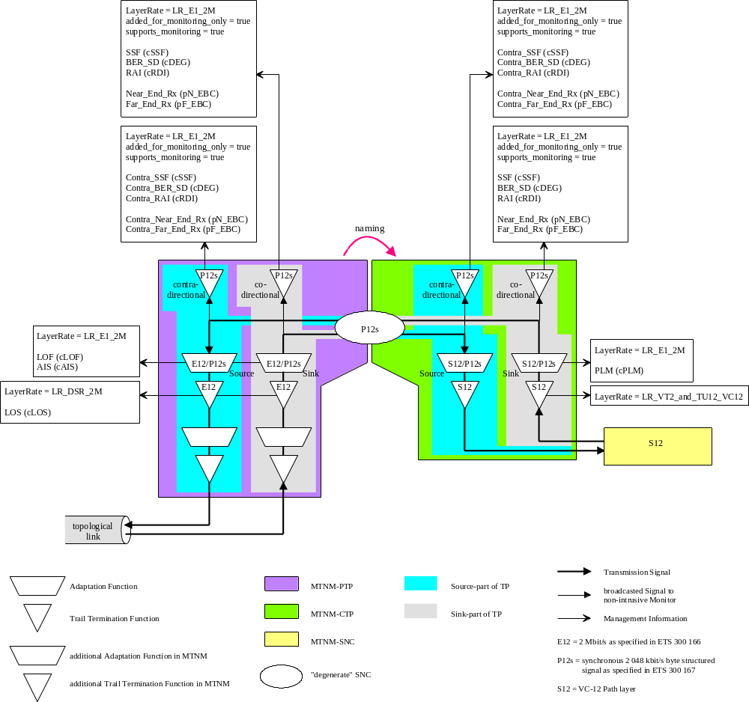
In addition it is also possible, that one Termination Point is physically located in two distinct located network elements (refer to DSL modelling as an example). This TP may detect the same probable cause in the local and in the remote network element.
In order to differentiate these two probable causes, an additional prefix "RU_" (RU for Remote Unit) has to be used in the Name of the probable cause.
e.g. SSF → RU_SSF or Contra_TCM_AIS → RU_Contra_TCM_AIS

Revision History
Version | Date | Description of Change
4.0 | April 2005 | OS related Probable Causes added.
4.1 | October 2006 | - Columns "source standard" and "object" added.  - Ethernet and LAG related Probable Causes added.

Acknowledgements
<FirstName> | <LastName> | <Company>

How to comment on the document
Comments and requests for information must be in written form and addressed to the contact identified below:

Keith | Dorking | CIENA
Phone: | +1 678 867 5007
Fax: | +1 678 867 5010
e-mail: | Kdorking@ciena.com

Please be specific, since your comments will be dealt with by the team evaluating numerous inputs and trying to produce a single text. Thus we appreciate significant specific input. We are looking for more input than wordsmith” items, however editing and structural help are greatly appreciated where better clarity is the result.

